# ONLINE CHAT APPLICATION

**By**

**ROHAN DSOUZA**

### Under Supervision Of

**Mr. Aravind R&D ENGINEER**

**EXPOSYS DATA LABS**

### To

**EXPOSYS DATA LABS**



### CERTIFICATE

**Candidate’s Declaration**

I hereby declare that the work presented in this report entitled **“online Chat Application”** in almost complete of the requirements for one month internship submitted to the Exposys Data Labs Limited is an authentic record of my own work carried out over a period from 11th February 2022 to 14th March 2022 under the supervision of **Mr. Aravind, R&D Engineer, Exposys Data Labs.**

The matter embodied in the report has not been submitted for the award of any other degree or diploma.

(Student Signature)

#### Rohan Dsouza

This is to certify that the above statement made by the candidate is true to the best of my knowledge.

(Supervisor Signature)

#### Mr. Aravind R&D Engineer

**Exposys Data Labs Date: 14 -03 -2022**

### ACKNOWLEDGEMENT

We would like to express our special thanks of gratitude to our supervisor **Mr. ARAVIND R&D ENGINEER EXPOSYS DATA LABS** who gave us the golden opportunity to do this wonderful project on Android Applications, which also helped us in doing a lot of research and we came to know about so many new things about android. We are really thankful to Exposys Data Labs for creating this wonderful opportunity to explore our potential in Software development.

Name Of The Student

Date: 14-03-2022 Rohan Dsouza

Table Of Contents

|  |  |  |
| --- | --- | --- |
| S.NO | Title | Page No |
| 1 | Abstract | 02 |
| 2 | Architecture | 03 |
| 3 | Django | 04 |
| 4 | Objective and Methodology | 05 |
| 5 | Implementation | 06 |
| 6 | Snap Shot | 07 |
| 7 | Conclusion and References | 10 |

### ABSTRACT

In recent years, the emergence ofsmart phones has changed the definition of mobile phones. Phoneis no longer just a communication tool, but also an essential part of the people's communication and daily life. Various applications added unlimited fun for people's lives. It is certain that the future of the network will be the mobile terminal. Now the Android system in the electronics market is becoming more and more popular, especially in the smartphone market. Because of the open source, some of the development tools are free, so there are plenty of applications generated.

So our aim is to develop an android application to give information about the details of People who are interested in the sports, in this application user can add their interested sports while building their profile. Also user can update their profile whenever they need..

## 

## python

Python is a high-level, general-purpose programming language. Its design philosophy emphasizes code readability with the use of significant indentation. Its language constructs and object-oriented approach aim to help programmers write clear, logical code for small- and large-scale projects.[29]

Python is dynamically-typed and garbage-collected. It supports multiple programming paradigms, including structured (particularly procedural), object-oriented and functional programming. It is often described as a "batteries included" language due to its comprehensive standard library



# Architecture

Login

Through Mobile Email and Password

FALSE

Verifies Email and Password Of The User

T R U E

Take To Main Page

End

END

They Can chat through web application.

### Django

**Django** ([/ˈdʒæŋɡoʊ/](https://en.wikipedia.org/wiki/Help:IPA/English) [*JANG-goh*](https://en.wikipedia.org/wiki/Help:Pronunciation_respelling_key); sometimes stylized as **django**)[[6]](https://en.wikipedia.org/wiki/Django_(web_framework)#cite_note-6) is a [Python](https://en.wikipedia.org/wiki/Python_(programming_language))-based [free and open-source](https://en.wikipedia.org/wiki/Free_and_open-source_software) [web framework](https://en.wikipedia.org/wiki/Web_framework) that follows the model–template–views (MTV) [architectural pattern](https://en.wikipedia.org/wiki/Architectural_pattern_(computer_science)).[[7]](https://en.wikipedia.org/wiki/Django_(web_framework)#cite_note-faq-mvc-7)[[8]](https://en.wikipedia.org/wiki/Django_(web_framework)#cite_note-djangobook-mvc-8) It is maintained by the [Django Software Foundation](https://en.wikipedia.org/wiki/Django_Software_Foundation) (DSF), an independent organization established in the US as a [501(c)(3)](https://en.wikipedia.org/wiki/501(c)(3)) non-profit.

Django's primary goal is to ease the creation of complex, database-driven websites. The framework emphasizes [reusability](https://en.wikipedia.org/wiki/Reusability) and "pluggability" of components, less code, low coupling, rapid development, and the principle of [don't repeat yourself](https://en.wikipedia.org/wiki/Don%27t_repeat_yourself).[[9]](https://en.wikipedia.org/wiki/Django_(web_framework)#cite_note-9) Python is used throughout, even for settings, files, and data models. Django also provides an optional administrative [create, read, update and delete](https://en.wikipedia.org/wiki/Create,_read,_update_and_delete) interface that is generated dynamically through [introspection](https://en.wikipedia.org/wiki/Type_introspection) and configured via admin models.

### python

Guido van Rossum began working on Python in the late 1980s as a successor to the ABC programming language and first released it in 1991 as Python 0.9.0.[32] Python 2.0 was released in 2000 and introduced new features such as list comprehensions, cycle-detecting garbage collection, reference counting, and Unicode support. Python 3.0, released in 2008, was a major revision that is not completely backward-compatible with earlier versions. Python 2 was discontinued with version 2.7.18 in 2020.[33]

Python consistently ranks as one of the most popular programming languages.

### Problem Statement:

To develop Meet up application to give information about the details of user with their interested sport. This application will allow all users to send and receive the message by their friends. User can access this application anywhere and anytime using his or her Smartphone.

### Objective

The system handles multiple users, lists all users in a chatbox, and a conversation box.

The active conversation has a feature that automatically loads the new chat or message.

The system also has a login and registration.

**Methodology**

This project is made by using paython and django. The programming languages used for building the application are django.

The other commands required are:

1. pip install Django
2. pip install django-crispy-forms
3. python manage.py migrate
4. python manage.py runserver

## Implementation

In this application I used django for user interface and design and java for programming to build the logic.

In this app first we have to register ourself by giving our name, email id and password, it’ll verify like whether the email id existing in database if it exists then it’ll give an error message like user existed with this email id.

Once registration Success it’ll redirect to login page and you have to login with email id and password, and it’ll redirect you to main page where You can enter secret code and join the video meeting.

On the Successful of that the it’ll ask for camera and mic permission for chatting purpose, you can also chat in this platform can also send emoji.

Snap Shot

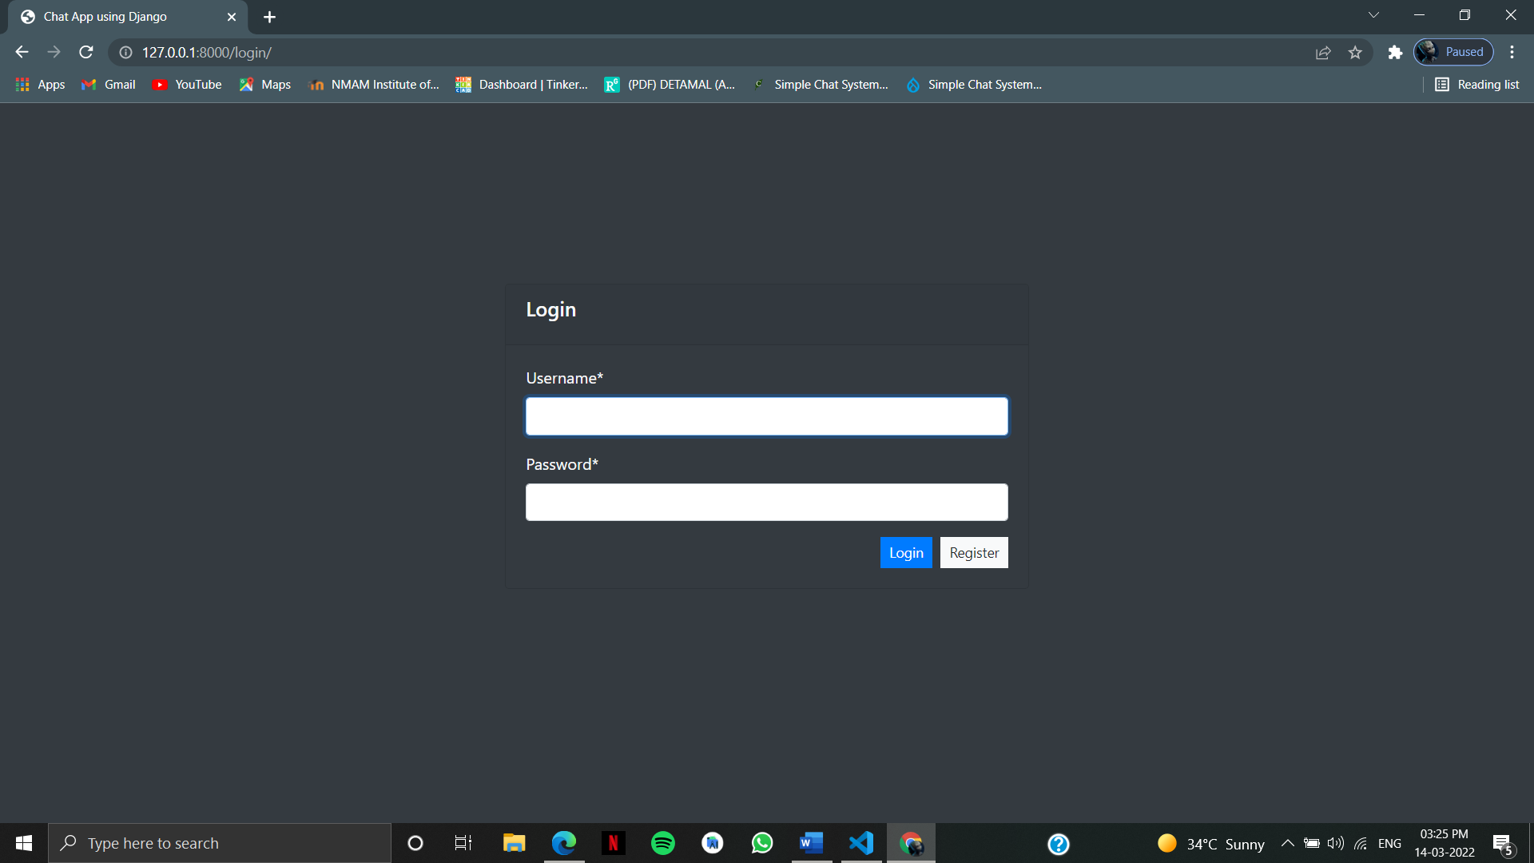

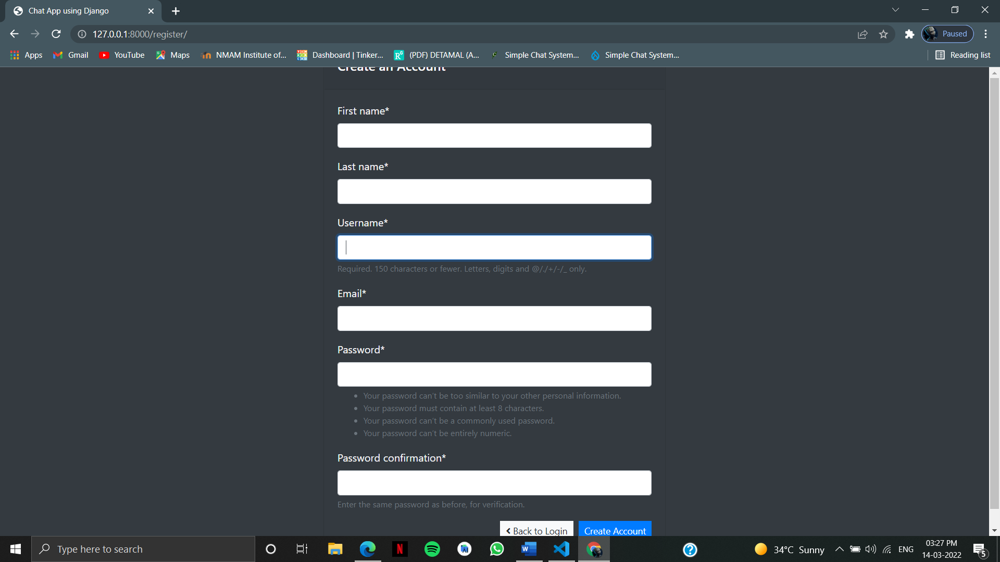

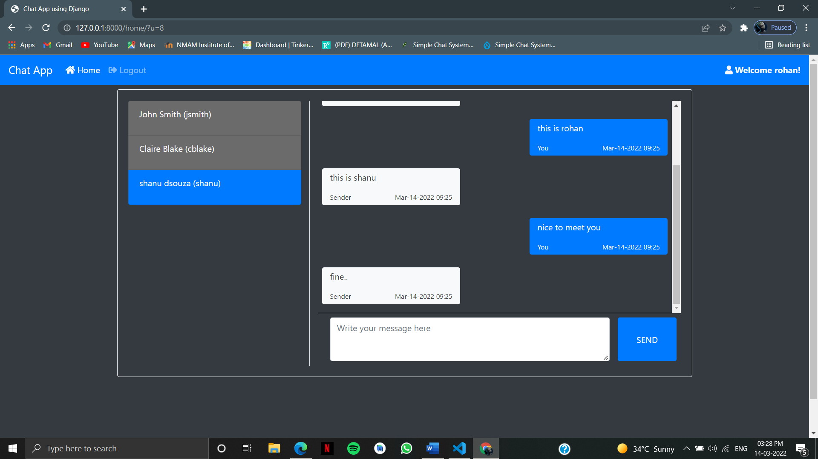

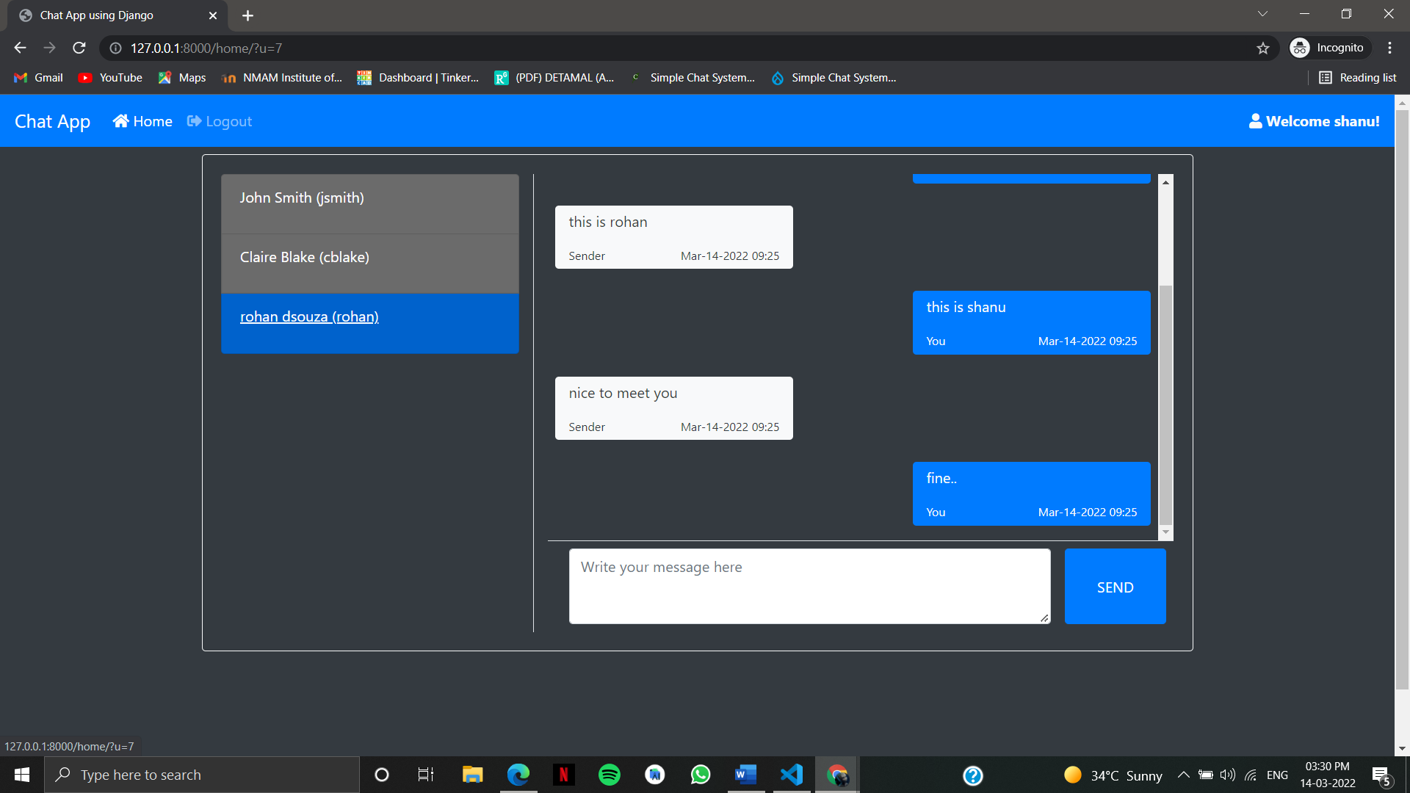

### Conclusion

django as a full, open and free device platform, with its powerful function and good user experience rapidly developed into the most popular operating system. This report gives an overview of the different challenges and issues faced in web app development The experience of developing an android app is quite challenging, motivating as well as satisfying.

### References:

* [www.youtube.com](http://www.youtube.com/)
* [www.google.com](http://www.google.com/)
* [www.stackoverflow.com](http://www.stackoverflow.com)
* https://ieeexplore.ieee.org/