CDL LAB 2: PRELIMINARY SCANNING APPLICATIONS

Rohan Shenoy
230905290
Roll no 32
D1 batch

Q1] That takes a file as input and replaces blank spaces and tabs by single space and writes the output to a file.

CODE]

#include <stdio.h>
#include <stdlib.h>

int main() {
FILE *fa, *fb;
int ca;

fa = fopen("q1in.c", "r");
if (fa == NULL) {
printf("cannot open input file\n");
exit(0);
}

fb = fopen("q1out.c", "w");
if (fb == NULL) {
printf("cannot open output file\n");
fclose(fa);
exit(0);
}

ca = getc(fa);
while (ca != EOF) {
if (ca == ' ' || ca == '\t') {

putc(' ', fb);

while ((ca = getc(fa)) == ' ' || ca == '\t');
continue;

} else {
putc(ca, fb);
ca = getc(fa);
}
}

fclose(fa);
fclose(fb);
printf("Processing complete. Check q1out.c\n");
return 0;
}

OUTPUT]

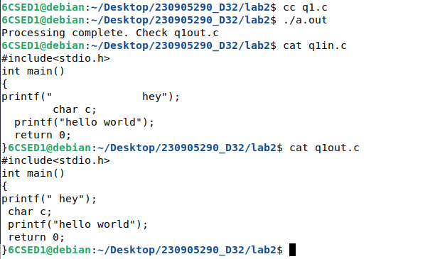

Q2] To discard the preprocessor directives from the given input C file.

CODE]

#include <stdio.h>
#include <stdlib.h>
#include <string.h>

int main() {
FILE *fa, *fb;
int ca, cb;
char buffer[20];

const char *targets[] = {"include", "define"};
int num_targets = sizeof(targets) / sizeof(targets[0]);

fa = fopen("q2in.c", "r");
fb = fopen("q2out.c", "w");
if (fa == NULL || fb == NULL) {
printf("Error opening files\n");
exit(0);
}

ca = getc(fa);
while (ca != EOF) {
if (ca == '#') {
long pos = ftell(fa);
int i = 0;

while ((cb = getc(fa)) != EOF && cb != ' ' && cb != '\n' && cb != '<' && cb != '\"') {
buffer[i++] = (char)cb;
}
buffer[i] = '\0';

int match = 0;
for (int j = 0; j < num_targets; j++) {
if (strcmp(buffer, targets[j]) == 0) {
match = 1;
break;
}
}

if (match) {
while (cb != '\n' && cb != EOF) cb = getc(fa);
ca = getc(fa);
continue;
} else {
putc('#', fb);
fseek(fa, pos, SEEK_SET);
ca = getc(fa);
continue;
}
}

putc(ca, fb);
ca = getc(fa);
}

fclose(fa);
fclose(fb);
printf("Processing complete. Check q2out.c\n");
return 0;
}

OUTPUT]

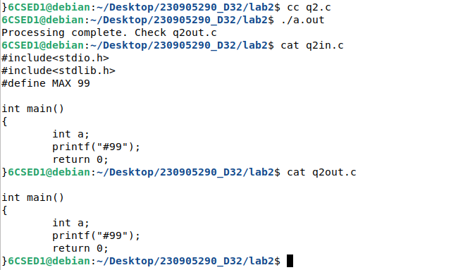

Q3] That takes C program as input, recognizes all the keywords and prints them in uppercase.

CODE]

#include <stdio.h>
#include <stdlib.h>
#include <string.h>
#include <ctype.h>

int main() {
FILE *fa, *fb;
int ca;
char buffer[50];

const char *keywords[] = {"break","continue", "else","for", "if","int", "long", "return","struct", "switch","while"};
int num_keywords = sizeof(keywords) / sizeof(keywords[0]);

fa = fopen("q3in.c", "r");
fb = fopen("q3out.c", "w");
if (fa == NULL || fb == NULL) {
printf("Error opening files\n");
exit(0);
}

ca = getc(fa);
while (ca != EOF) {
if (isalpha(ca) || ca == '_') {
int i = 0;
buffer[i++] = (char)ca;

while ((ca = getc(fa)) != EOF && (isalnum(ca) || ca == '_')) {
buffer[i++] = (char)ca;
}
buffer[i] = '\0';

int is_keyword = 0;
for (int j = 0; j < num_keywords; j++) {
if (strcmp(buffer, keywords[j]) == 0) {
is_keyword = 1;
break;
}
}

for (int k = 0; k < i; k++) {
if (is_keyword)
putc(toupper(buffer[k]), fb);
else
putc(buffer[k], fb);
}

if (ca != EOF) {
if (!(isalpha(ca) || ca == '_')) {
putc(ca, fb);
ca = getc(fa);
}
}
continue;
}

putc(ca, fb);
ca = getc(fa);
}

fclose(fa);
fclose(fb);
printf("Keywords have been converted to uppercase.Check q3out.c\n");
return 0;
}

OUTPUT]
