PPL LAB 1

Rohan Shenoy
230905290
Roll no 32
CSE D1

Q1] write a simple MPI program to find out pow(x,rank) for all the processes where x is the integer constant and rank is the rank of the process

CODE:

#include <mpi.h>
#include <stdio.h>
#include <math.h>

int main(int argc, char* argv[]) {
int rank, size;
int x=2;

MPI_Init(&argc, &argv);

MPI_Comm_rank(MPI_COMM_WORLD, &rank);

MPI_Comm_size(MPI_COMM_WORLD, &size);

double result = pow(x, rank);

printf("Process %d: %d raised to the power of %d is %.0f\n",
rank, x, rank, result);

MPI_Finalize();

return 0;
}

OUTPUT:

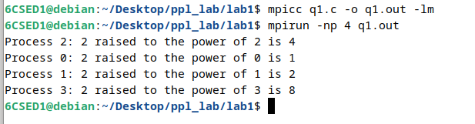

Q2] Write a program in MPI where even ranked process prints Hello and odd ranked process prints World

CODE]

#include <stdio.h>
#include <mpi.h>

int main(int argc, char** argv) {
int rank;

MPI_Init(&argc, &argv);

MPI_Comm_rank(MPI_COMM_WORLD, &rank);

if (rank % 2 == 0) {
printf("Rank %d: Hello\n", rank);
} else {
printf("Rank %d: World\n", rank);
}

MPI_Finalize();

return 0;
}

OUTPUT ]

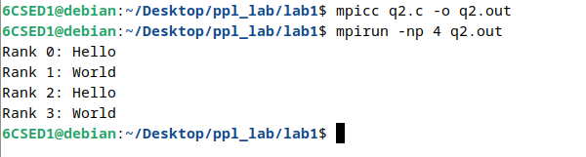

Q3] write a program in mpi to simulate a simple calculator perform each operation using different process in parallel

CODE]

#include <stdio.h>
#include <mpi.h>

int main(int argc, char** argv) {
int rank, size;
double a = 10.0, b = 5.0;

MPI_Init(&argc, &argv);
MPI_Comm_rank(MPI_COMM_WORLD, &rank);
MPI_Comm_size(MPI_COMM_WORLD, &size);

if (size < 4) {
if (rank == 0) printf("Error: This program requires at least 4 processes.\n");
MPI_Finalize();
return 0;
}

switch(rank) {
case 0:
printf("Rank 0: Addition -> %.1f + %.1f = %.1f\n", a, b, a + b);
break;
case 1:
printf("Rank 1: Subtraction -> %.1f - %.1f = %.1f\n", a, b, a - b);
break;
case 2:
printf("Rank 2: Multiplication -> %.1f * %.1f = %.1f\n", a, b, a * b);
break;
case 3:
if (b != 0)
printf("Rank 3: Division -> %.1f / %.1f = %.1f\n", a, b, a / b);
else
printf("Rank 3: Division Error -> Division by zero!\n");
break;
default:
break;
}

MPI_Finalize();
return 0;
}

OUTPUT ]

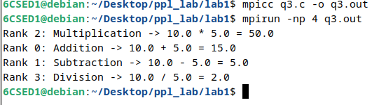

Q4] write a program in mpi to toggle the character of a given string indexed by the rank of a process. Suppose the string is HELLO and there are 5 processes, then the process 0 toggles H to h, process 1 toggles E to e and so on

CODE ]

#include <stdio.h>
#include <string.h>
#include <ctype.h>
#include <mpi.h>

int main(int argc, char** argv) {
int rank, size;
char str[100] = "HELLO";

MPI_Init(&argc, &argv);
MPI_Comm_rank(MPI_COMM_WORLD, &rank);
MPI_Comm_size(MPI_COMM_WORLD, &size);

MPI_Bcast(str, 100, MPI_CHAR, 0, MPI_COMM_WORLD);

int len = strlen(str);

if (rank < len) {
char original = str[rank];

if (isupper(str[rank])) {
str[rank] = tolower(str[rank]);
} else if (islower(str[rank])) {
str[rank] = toupper(str[rank]);
}

printf("Process %d toggled '%c' to '%c' -> Current state: %s\n",
rank, original, str[rank], str);
}

MPI_Finalize();
return 0;
}

OUTPUT:]

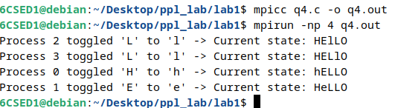

Q5] write a program in mpi where even ranked process prints factorial of the rank and odd ranked process prints ranks fibonacci number

CODE]

#include <stdio.h>
#include <mpi.h>

long long factorial(int n) {
if (n == 0) return 1;
long long res = 1;
for (int i = 1; i <= n; i++) res *= i;
return res;
}

long long fibonacci(int n) {
if (n <= 0) return 0;
if (n == 1) return 1;
long long a = 0, b = 1, temp;
for (int i = 2; i <= n; i++) {
temp = a + b;
a = b;
b = temp;
}
return b;
}

int main(int argc, char** argv) {
int rank;

MPI_Init(&argc, &argv);
MPI_Comm_rank(MPI_COMM_WORLD, &rank);

if (rank % 2 == 0) {
long long fact = factorial(rank);
printf("Rank %d (Even): Factorial is %lld\n", rank, fact);
} else {
long long fib = fibonacci(rank);
printf("Rank %d (Odd): Fibonacci number is %lld\n", rank, fib);
}

MPI_Finalize();
return 0;
}

OUTPUT]

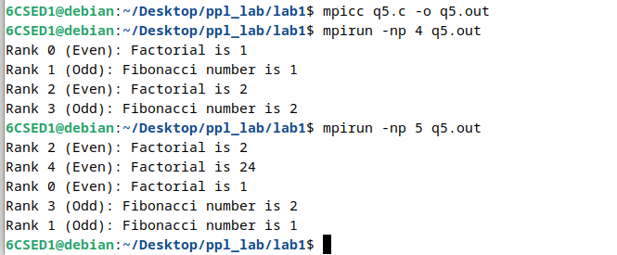

ADDITIONAL EXCERSIZES

Q1] write a program to reverse the digits of the following integer array of size 9 with 9 processes. initialize the array to the foll values input: 18,523,301,1234,2,14,108,150,1928 output: 81,325,103,4321,2,41,801,51,8291

CODE]

#include <stdio.h>
#include <mpi.h>

int reverse_integer(int n) {
int reversed = 0;
while (n != 0) {
reversed = reversed * 10 + n % 10;
n /= 10;
}
return reversed;
}

int main(int argc, char** argv) {
int rank, size;
int input_array[9] = {18, 523, 301, 1234, 2, 14, 108, 150, 1928};
int output_array[9];
int local_val;

MPI_Init(&argc, &argv);
MPI_Comm_rank(MPI_COMM_WORLD, &rank);
MPI_Comm_size(MPI_COMM_WORLD, &size);

if (size != 9) {
if (rank == 0) printf("Error: This program requires exactly 9 processes.\n");
MPI_Finalize();
return 0;
}

MPI_Scatter(input_array, 1, MPI_INT, &local_val, 1, MPI_INT, 0, MPI_COMM_WORLD);

int local_reversed = reverse_integer(local_val);

MPI_Gather(&local_reversed, 1, MPI_INT, output_array, 1, MPI_INT, 0, MPI_COMM_WORLD);

if (rank == 0) {
printf("Output: ");
for (int i = 0; i < 9; i++) {
printf("%d%s", output_array[i], (i == 8) ? "" : ", ");
}
printf("\n");
}

MPI_Finalize();
return 0;
}

OUTPUT ]

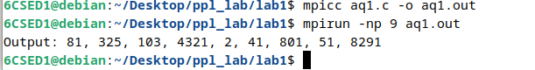

Q2] write a mpi program to find the prime numbers between 1 and 100 using 2 processes

CODE]

#include <stdio.h>
#include <mpi.h>

int is_prime(int n) {
if (n < 2) return 0;
for (int i = 2; i * i <= n; i++) {
if (n % i == 0) return 0;
}
return 1;
}

int main(int argc, char** argv) {
int rank, size;
int range_start, range_end;
int total_limit = 100;

MPI_Init(&argc, &argv);
MPI_Comm_rank(MPI_COMM_WORLD, &rank);
MPI_Comm_size(MPI_COMM_WORLD, &size);

if (size != 2) {
if (rank == 0) printf("This program requires exactly 2 processes.\n");
MPI_Finalize();
return 0;
}

range_start = (rank * 50) + 1;
range_end = (rank + 1) * 50;

printf("Rank %d checking range [%d, %d]:\n", rank, range_start, range_end);

for (int i = range_start; i <= range_end; i++) {
if (is_prime(i)) {
printf("Rank %d found prime: %d\n", rank, i);
}
}

MPI_Finalize();
return 0;
}

OUTPUT:

