WEEK 2 PPL LAB 230905290

Rohan Shenoy
230905290
CSE D1
Roll no 32

Q1] Write a MPI program using synchronous send. The sender process sends a word to the receiver. The second process receives the word, toggles each letter of the word and sends it back to the first process. Both processes use synchronous send operations.

CODE]

#include <mpi.h>
#include <stdio.h>
#include <string.h>
#include <ctype.h>

#define MAX_WORD_SIZE 100
#define TAG_WORD 1
#define TAG_TOGGLED_WORD 2

int main(int argc, char** argv) {
int world_rank, world_size;
MPI_Init(&argc, &argv);
MPI_Comm_rank(MPI_COMM_WORLD, &world_rank);
MPI_Comm_size(MPI_COMM_WORLD, &world_size);

if (world_size != 2) {
fprintf(stderr, "This program is meant to be run with exactly 2 processes.\n");
MPI_Finalize();
return 1;
}

if (world_rank == 0) {
char word[] = "HeLlO";
char toggled_word[MAX_WORD_SIZE];
int word_len = strlen(word) + 1;

printf("Process 0: Sending word: %s\n", word);
MPI_Ssend(word, word_len, MPI_CHAR, 1, TAG_WORD, MPI_COMM_WORLD);

MPI_Recv(toggled_word, MAX_WORD_SIZE, MPI_CHAR, 1, TAG_TOGGLED_WORD, MPI_COMM_WORLD, MPI_STATUS_IGNORE);
printf("Process 0: Received toggled word: %s\n", toggled_word);
} else {
char received_word[MAX_WORD_SIZE];
char toggled_word[MAX_WORD_SIZE];
int i;
MPI_Status status;

MPI_Recv(received_word, MAX_WORD_SIZE, MPI_CHAR, 0, TAG_WORD, MPI_COMM_WORLD, &status);
printf("Process 1: Received word: %s\n", received_word);

for (i = 0; i < strlen(received_word); i++) {
if (islower((unsigned char)received_word[i])) {
toggled_word[i] = toupper((unsigned char)received_word[i]);
} else if (isupper((unsigned char)received_word[i])) {
toggled_word[i] = tolower((unsigned char)received_word[i]);
} else {
toggled_word[i] = received_word[i];
}
}
toggled_word[i] = '\0';

MPI_Ssend(toggled_word, strlen(toggled_word) + 1, MPI_CHAR, 0, TAG_TOGGLED_WORD, MPI_COMM_WORLD);
}

MPI_Finalize();
return 0;
}

OUTPUT]

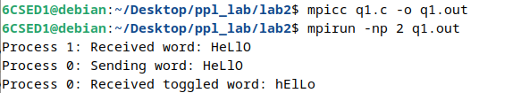

Q2] Write a MPI program where the master process (process 0) sends a number to each of the slaves and the slave process receive the number and prints it. Use standard send.

CODE]

#include <stdio.h>
#include <mpi.h>

int main(int argc, char** argv) {
int rank, size;
int data_to_send;

MPI_Init(&argc, &argv);
MPI_Comm_rank(MPI_COMM_WORLD, &rank);
MPI_Comm_size(MPI_COMM_WORLD, &size);

if (size < 2) {
if (rank == 0) printf("This program requires at least 2 processes.\n");
MPI_Finalize();
return 0;
}

if (rank == 0) {
printf("Master (Rank 0) starting distribution to %d slaves...\n", size - 1);

for (int i = 1; i < size; i++) {
data_to_send = i * 100;

printf("Master: Sending value %d to Slave %d\n", data_to_send, i);

MPI_Send(&data_to_send, 1, MPI_INT, i, 0, MPI_COMM_WORLD);
}
} else {
int received_number;

MPI_Recv(&received_number, 1, MPI_INT, 0, 0, MPI_COMM_WORLD, MPI_STATUS_IGNORE);

printf("Slave (Rank %d): I received the number %d from the Master.\n", rank, received_number);
}

MPI_Finalize();
return 0;
}

OUTPUT]

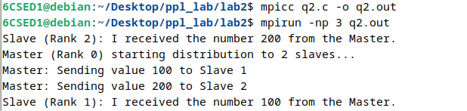

Q3] Write a MPI Program to read N elements of the array in the root process (process 0) where N is equal to the total number of processes. The root process sends one value to each of the slaves. Let even ranked process find squares of the received element and odd ranked processes find the cube root. Use buffered send.

CODE]

#include <mpi.h>
#include <stdio.h>
#include <stdlib.h>
#include <math.h>

int main(int argc, char** argv) {
int rank, size;
MPI_Init(&argc, &argv);
MPI_Comm_rank(MPI_COMM_WORLD, &rank);
MPI_Comm_size(MPI_COMM_WORLD, &size);

double *array = NULL;
double received_val, result;

int buffer_size = size * (sizeof(double) + MPI_BSEND_OVERHEAD);
double *buffer = (double*)malloc(buffer_size);
MPI_Buffer_attach(buffer, buffer_size);

if (rank == 0) {
array = (double*)malloc(size * sizeof(double));
printf("Root: Enter %d elements: ", size);
fflush(stdout);
for (int i = 0; i < size; i++) {
scanf("%lf", &array[i]);
}

for (int i = 0; i < size; i++) {
MPI_Bsend(&array[i], 1, MPI_DOUBLE, i, 0, MPI_COMM_WORLD);
}
}

MPI_Recv(&received_val, 1, MPI_DOUBLE, 0, 0, MPI_COMM_WORLD, MPI_STATUS_IGNORE);

if (rank % 2 == 0) {
result = received_val * received_val;
printf("Process %d (Even): Square of %.2f is %.2f\n", rank, received_val, result);
} else {
result = cbrt(received_val);
printf("Process %d (Odd): Cube root of %.2f is %.2f\n", rank, received_val, result);
}

if (rank == 0) free(array);
MPI_Buffer_detach(&buffer, &buffer_size);
free(buffer);
MPI_Finalize();
return 0;
}

OUTPUT]

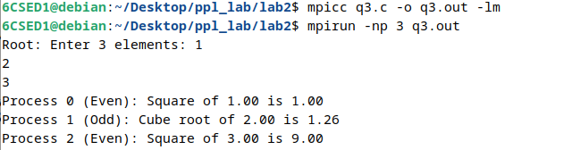

Q4] Write a MPI Program to read an integer value in the root process. Root process sends this value to process1 which sends it to process2 and so on. Last process sends it to the root process. While sending each process the value will increment the received value by 1. write the program using point to point communication routines.

CODE]

#include <mpi.h>
#include <stdio.h>

int main(int argc, char** argv) {
int rank, size;
int value;

MPI_Init(&argc, &argv);
MPI_Comm_rank(MPI_COMM_WORLD, &rank);
MPI_Comm_size(MPI_COMM_WORLD, &size);

if (size < 2) {
if (rank == 0) printf("Error: This program requires at least 2 processes.\n");
MPI_Finalize();
return 0;
}

if (rank == 0) {
printf("Root (Rank 0): Enter an integer: ");
fflush(stdout);
scanf("%d", &value);

value++;
printf("Rank 0: Incremented to %d, sending to Rank 1\n", value);
MPI_Send(&value, 1, MPI_INT, 1, 0, MPI_COMM_WORLD);

MPI_Recv(&value, 1, MPI_INT, size - 1, 0, MPI_COMM_WORLD, MPI_STATUS_IGNORE);
printf("Root (Rank 0): Final value received from Rank %d is %d\n", size - 1, value);

} else {
MPI_Recv(&value, 1, MPI_INT, rank - 1, 0, MPI_COMM_WORLD, MPI_STATUS_IGNORE);

value++;

int next = (rank + 1) % size;

printf("Rank %d: Incremented to %d, sending to Rank %d\n", rank, value, next);
MPI_Send(&value, 1, MPI_INT, next, 0, MPI_COMM_WORLD);
}

MPI_Finalize();
return 0;
}

OUTPUT]

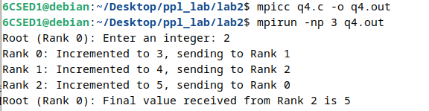

ADDITIONAL EXERCISES

Q1] Write a MPI program to read N elements of an array in the master process. Let N processes including master process check the array values are prime or not

CODE]

#include <mpi.h>
#include <stdio.h>
#include <stdlib.h>
#include <stdbool.h>
#include <math.h>

// Function to check if a number is prime
bool is_prime(int n) {
if (n <= 1) return false;
if (n <= 3) return true;
if (n % 2 == 0 || n % 3 == 0) return false;
for (int i = 5; i * i <= n; i = i + 6) {
if (n % i == 0 || n % (i + 2) == 0) return false;
}
return true;
}

int main(int argc, char** argv) {
int rank, size;
int N;
int *global_array = NULL;
int *global_results = NULL;

MPI_Init(&argc, &argv);
MPI_Comm_rank(MPI_COMM_WORLD, &rank);
MPI_Comm_size(MPI_COMM_WORLD, &size);

if (rank == 0) {
printf("Enter the number of elements (N): ");
fflush(stdout);
if (scanf("%d", &N) != 1 || N <= 0) {
printf("Invalid N. Using default N=10.\n");
N = 10;
}

global_array = (int*)malloc(N * sizeof(int));
global_results = (int*)malloc(N * sizeof(int));

printf("Enter %d elements:\n", N);
for (int i = 0; i < N; i++) {
scanf("%d", &global_array[i]);
}
}

MPI_Bcast(&N, 1, MPI_INT, 0, MPI_COMM_WORLD);

if (N % size != 0) {
if (rank == 0) {
printf("Warning: N is not divisible by the number of processes. This simple scatter might not work as expected.\n");
}
MPI_Finalize();
return 0;
}
int elements_per_proc = N / size;

int *local_array = (int*)malloc(elements_per_proc * sizeof(int));
int *local_results = (int*)malloc(elements_per_proc * sizeof(int));

MPI_Scatter(global_array, elements_per_proc, MPI_INT,
local_array, elements_per_proc, MPI_INT,
0, MPI_COMM_WORLD);

for (int i = 0; i < elements_per_proc; i++) {
if (is_prime(local_array[i])) {
local_results[i] = 1; // Mark as prime
} else {
local_results[i] = 0; // Mark as not prime
}
}

MPI_Gather(local_results, elements_per_proc, MPI_INT,
global_results, elements_per_proc, MPI_INT,
0, MPI_COMM_WORLD);

if (rank == 0) {
printf("\nPrimality check results:\n");
for (int i = 0; i < N; i++) {
printf("Element %d (%d) is %s\n", i, global_array[i],
(global_results[i] ? "prime" : "not prime"));
}
free(global_array);
free(global_results);
}

free(local_array);
free(local_results);

MPI_Finalize();
return 0;
}

OUTPUT]

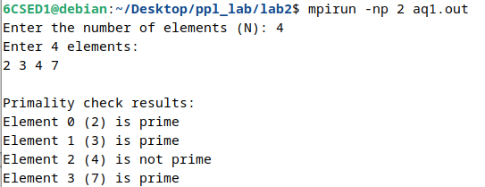

Q2]
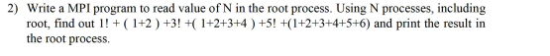

CODE]

#include <stdio.h>
#include <stdlib.h>
#include <mpi.h>

long long factorial(int n) {
long long res = 1;
for (int i = 2; i <= n; i++) {
res *= i;
}
return res;
}

long long triangular_sum(int n) {
return (long long)n * (n + 1) / 2;
}

int main(int argc, char** argv) {
int rank, size, N;
long long global_sum = 0;
long long local_term_value = 0;

MPI_Init(&argc, &argv);
MPI_Comm_rank(MPI_COMM_WORLD, &rank);
MPI_Comm_size(MPI_COMM_WORLD, &size);

if (rank == 0) {
printf("Enter the value of N (total terms): ");
fflush(stdout);
if (scanf("%d", &N) != 1 || N <= 0) {
fprintf(stderr, "Invalid N value. Exiting.\n");
N = 0;
}
}

MPI_Bcast(&N, 1, MPI_INT, 0, MPI_COMM_WORLD);

if (N <= 0) {
MPI_Finalize();
return 0;
}

if (size < N) {
if (rank == 0) {
fprintf(stderr, "Error: Need at least %d processes to cover all terms.\n", N);
}
MPI_Finalize();
return 1;
}

int term_index = rank + 1;

if (term_index <= N) {
if (term_index % 2 != 0) {
local_term_value = factorial(term_index);
printf("Process %d (Term %d): Calculated factorial(%d) = %lld\n", rank, term_index, term_index, local_term_value);
} else {
local_term_value = triangular_sum(term_index);
printf("Process %d (Term %d): Calculated sum to %d = %lld\n", rank, term_index, term_index, local_term_value);
}
}

MPI_Reduce(&local_term_value, &global_sum, 1, MPI_LONG_LONG_INT, MPI_SUM, 0, MPI_COMM_WORLD);

if (rank == 0) {
printf("\nAnswer:\n");
printf("The total sum for N=%d is: **%lld**\n", N, global_sum);
}

MPI_Finalize();
return 0;
}

OUTPUT]

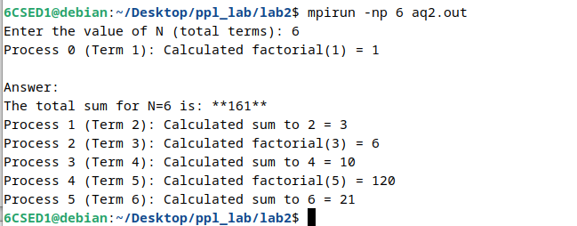

Q3] Implement at least 2 programs to identify deadlock conditions in synchronous send and standard send with multiple point to point communications between 2 processes

CODE]
SYNCHORONOUS SEND

#include <mpi.h>
#include <stdio.h>

int main(int argc, char **argv) {
int rank, size;
int send_data = 101;
int recv_data = 0;
MPI_Status status;

MPI_Init(&argc, &argv);
MPI_Comm_rank(MPI_COMM_WORLD, &rank);
MPI_Comm_size(MPI_COMM_WORLD, &size);

if (size != 2) {
if (rank == 0) {
printf("This program must be run with exactly 2 processes.\n");
}
MPI_Finalize();
return 1;
}

printf("Process %d attempting synchronous send and receive...\n", rank);

MPI_Ssend(&send_data, 1, MPI_INT, 1 - rank, 0, MPI_COMM_WORLD);
printf("Process %d finished sending (will not print if deadlocked here).\n", rank);

MPI_Recv(&recv_data, 1, MPI_INT, 1 - rank, 0, MPI_COMM_WORLD, &status);
printf("Process %d received data: %d\n", rank, recv_data);

MPI_Finalize();
return 0;
}

OUTPUT]

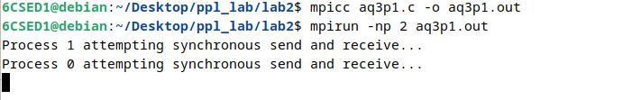

STANDARD SEND

#include <mpi.h>
#include <stdio.h>
#include <stdlib.h>

#define MESSAGE_SIZE 1000000

int main(int argc, char **argv) {
int rank, size;

int *send_buffer, *recv_buffer;
MPI_Status status;

MPI_Init(&argc, &argv);
MPI_Comm_rank(MPI_COMM_WORLD, &rank);
MPI_Comm_size(MPI_COMM_WORLD, &size);

if (size != 2) {
if (rank == 0) {
printf("This program must be run with exactly 2 processes.\n");
}
MPI_Finalize();
return 1;
}

send_buffer = (int*)malloc(MESSAGE_SIZE * sizeof(int));
recv_buffer = (int*)malloc(MESSAGE_SIZE * sizeof(int));

if (!send_buffer || !recv_buffer) {
printf("Memory allocation failed on process %d\n", rank);
MPI_Finalize();
return 1;
}

for(int i = 0; i < MESSAGE_SIZE; i++) send_buffer[i] = rank;

printf("Process %d attempting standard send and receive with large message...\n", rank);

MPI_Send(send_buffer, MESSAGE_SIZE, MPI_INT, 1 - rank, 0, MPI_COMM_WORLD);
printf("Process %d finished sending (unlikely to print).\n", rank);

MPI_Recv(recv_buffer, MESSAGE_SIZE, MPI_INT, 1 - rank, 0, MPI_COMM_WORLD, &status);
printf("Process %d received data.\n", rank);

free(send_buffer);
free(recv_buffer);

MPI_Finalize();
return 0;
}

OUTPUT]

