PPL LAB WEEK3

230905290
Rohan Shenoy
CSE D1 Roll no 32

Q1]
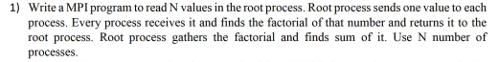

CODE]

#include <mpi.h>
#include <stdio.h>
#include <stdlib.h>

long long factorial(int n) {
long long fact = 1;
for (int i = 1; i <= n; i++) fact *= i;
return fact;
}

int main(int argc, char** argv) {
int rank, size;
int number_to_process;
long long my_factorial;

MPI_Init(&argc, &argv);
MPI_Comm_rank(MPI_COMM_WORLD, &rank);
MPI_Comm_size(MPI_COMM_WORLD, &size);

if (rank == 0) {
int *input_array = (int*)malloc(size * sizeof(int));
printf("Enter %d integers: ", size);
fflush(stdout);
for (int i = 0; i < size; i++) scanf("%d", &input_array[i]);

for (int i = 0; i < size; i++) {
if (i == 0) {
number_to_process = input_array[0];
} else {
MPI_Send(&input_array[i], 1, MPI_INT, i, 0, MPI_COMM_WORLD);
}
}
free(input_array);
} else {
MPI_Recv(&number_to_process, 1, MPI_INT, 0, 0, MPI_COMM_WORLD, MPI_STATUS_IGNORE);
}

my_factorial = factorial(number_to_process);
printf("Process %d calculated factorial: %lld\n", rank, my_factorial);

if (rank == 0) {
long long total_sum = my_factorial;
for (int i = 1; i < size; i++) {
long long received_val;
MPI_Recv(&received_val, 1, MPI_LONG_LONG, i, 0, MPI_COMM_WORLD, MPI_STATUS_IGNORE);
total_sum += received_val;
}
printf("Final Sum of Factorials: %lld\n", total_sum);
} else {
MPI_Send(&my_factorial, 1, MPI_LONG_LONG, 0, 0, MPI_COMM_WORLD);
}

MPI_Finalize();
return 0;
}

OUTPUT]

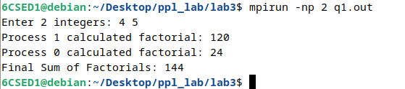

Q2]
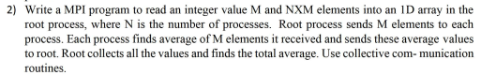
CODE]

#include <mpi.h>
#include <stdio.h>
#include <stdlib.h>

int main(int argc, char** argv) {
int rank, size;
int M;
float *full_array = NULL;
float *local_array = NULL;
float local_sum = 0.0, local_avg;
float *all_averages = NULL;
float total_avg_sum = 0.0;

MPI_Init(&argc, &argv);
MPI_Comm_rank(MPI_COMM_WORLD, &rank);
MPI_Comm_size(MPI_COMM_WORLD, &size);

if (rank == 0) {
printf("Enter the number of elements per process (M): ");
fflush(stdout);
scanf("%d", &M);
}

MPI_Bcast(&M, 1, MPI_INT, 0, MPI_COMM_WORLD);

local_array = (float*)malloc(M * sizeof(float));

if (rank == 0) {
int total_elements = size * M;
full_array = (float*)malloc(total_elements * sizeof(float));

printf("Enter %d elements:\n", total_elements);
for (int i = 0; i < total_elements; i++) {
scanf("%f", &full_array[i]);
}

all_averages = (float*)malloc(size * sizeof(float));
}

MPI_Scatter(full_array, M, MPI_FLOAT, local_array, M, MPI_FLOAT, 0, MPI_COMM_WORLD);

for (int i = 0; i < M; i++) {
local_sum += local_array[i];
}
local_avg = local_sum / M;
printf("Process %d: Local Average = %.2f\n", rank, local_avg);

MPI_Gather(&local_avg, 1, MPI_FLOAT, all_averages, 1, MPI_FLOAT, 0, MPI_COMM_WORLD);

if (rank == 0) {
for (int i = 0; i < size; i++) {
total_avg_sum += all_averages[i];
}
float final_avg = total_avg_sum / size;
printf("\n>>> Total Average of all elements: %.2f <<<\n", final_avg);

free(full_array);
free(all_averages);
}

free(local_array);
MPI_Finalize();
return 0;
}

OUTPUT]

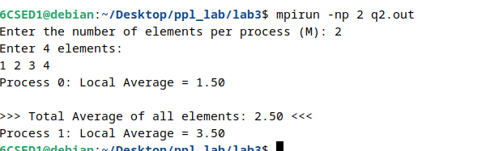

Q3]

CODE] #include <mpi.h>
#include <stdio.h>
#include <stdlib.h>
#include <string.h>
#include <ctype.h>

int is_non_vowel(char c) {
if (!isalpha(c)) return 0;
c = tolower(c);
if (c == 'a' || c == 'e' || c == 'i' || c == 'o' || c == 'u') {
return 0;
}
return 1;
}

int main(int argc, char** argv) {
int rank, size;
char *full_string = NULL;
char *local_string = NULL;
int n_per_process;
int local_count = 0;
int *all_counts = NULL;
int total_non_vowels = 0;

MPI_Init(&argc, &argv);
MPI_Comm_rank(MPI_COMM_WORLD, &rank);
MPI_Comm_size(MPI_COMM_WORLD, &size);

if (rank == 0) {
full_string = (char*)malloc(200 * sizeof(char));
printf("Enter a string (length divisible by %d): ", size);
fflush(stdout);
scanf("%s", full_string);

int total_len = strlen(full_string);
n_per_process = total_len / size;

all_counts = (int*)malloc(size * sizeof(int));
}

MPI_Bcast(&n_per_process, 1, MPI_INT, 0, MPI_COMM_WORLD);

local_string = (char*)malloc((n_per_process + 1) * sizeof(char));

MPI_Scatter(full_string, n_per_process, MPI_CHAR, local_string, n_per_process, MPI_CHAR, 0, MPI_COMM_WORLD);

for (int i = 0; i < n_per_process; i++) {
if (is_non_vowel(local_string[i])) {
local_count++;
}
}

MPI_Gather(&local_count, 1, MPI_INT, all_counts, 1, MPI_INT, 0, MPI_COMM_WORLD);

if (rank == 0) {
printf("\n--- Results ---\n");
for (int i = 0; i < size; i++) {
printf("Process %d found %d non-vowels\n", i, all_counts[i]);
total_non_vowels += all_counts[i];
}
printf("Total non-vowels in string: %d\n", total_non_vowels);

free(full_string);
free(all_counts);
}

free(local_string);
MPI_Finalize();
return 0;
}

OUTPUT]

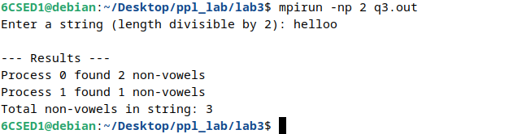

Q4]
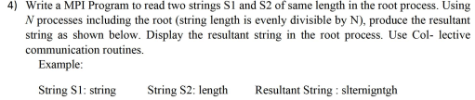

CODE]

#include <mpi.h>
#include <stdio.h>
#include <stdlib.h>
#include <string.h>

int main(int argc, char** argv) {
int rank, size;
char *s1 = NULL, *s2 = NULL, *result = NULL;
char *local_s1, *local_s2, *local_res;
int total_len, chunk_size;

MPI_Init(&argc, &argv);
MPI_Comm_rank(MPI_COMM_WORLD, &rank);
MPI_Comm_size(MPI_COMM_WORLD, &size);

if (rank == 0) {
s1 = (char*)malloc(200 * sizeof(char));
s2 = (char*)malloc(200 * sizeof(char));

printf("Enter string S1: ");
fflush(stdout);
scanf("%s", s1);
printf("Enter string S2: ");
fflush(stdout);
scanf("%s", s2);

total_len = strlen(s1);
chunk_size = total_len / size;

result = (char*)malloc((2 * total_len + 1) * sizeof(char));
}

MPI_Bcast(&chunk_size, 1, MPI_INT, 0, MPI_COMM_WORLD);

local_s1 = (char*)malloc(chunk_size * sizeof(char));
local_s2 = (char*)malloc(chunk_size * sizeof(char));
local_res = (char*)malloc((2 * chunk_size) * sizeof(char));

MPI_Scatter(s1, chunk_size, MPI_CHAR, local_s1, chunk_size, MPI_CHAR, 0, MPI_COMM_WORLD);
MPI_Scatter(s2, chunk_size, MPI_CHAR, local_s2, chunk_size, MPI_CHAR, 0, MPI_COMM_WORLD);

for (int i = 0; i < chunk_size; i++) {
local_res[2 * i] = local_s1[i];
local_res[2 * i + 1] = local_s2[i];
}

MPI_Gather(local_res, 2 * chunk_size, MPI_CHAR, result, 2 * chunk_size, MPI_CHAR, 0, MPI_COMM_WORLD);

if (rank == 0) {
result[2 * total_len] = '\0';
printf("\nString S1: %s", s1);
printf("\nString S2: %s", s2);
printf("\nResultant string: %s\n", result);

free(s1);
free(s2);
free(result);
}

free(local_s1);
free(local_s2);
free(local_res);

MPI_Finalize();
return 0;
}

OUTPUT]

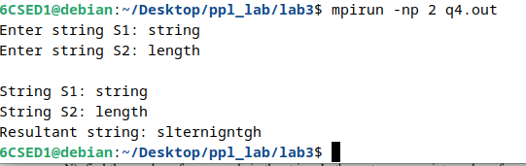

ADDITIONAL QUESTIONS

Q1] Write a MPI Program to read a value M and NxM number of elements into 1D array in the root, where N is the total number of processes. Find the square of the first M numbers, the cube of the next M numbers, and so on. Print the results in the root.

CODE]

#include <mpi.h>
#include <stdio.h>
#include <stdlib.h>
#include <math.h>

int main(int argc, char** argv) {
int rank, size, M;
int *full_array = NULL;
int *sub_array = NULL;
int *result_array = NULL;
int *final_results = NULL;

MPI_Init(&argc, &argv);
MPI_Comm_rank(MPI_COMM_WORLD, &rank);
MPI_Comm_size(MPI_COMM_WORLD, &size);

if (rank == 0) {
printf("Enter the value of M (elements per process): ");
fflush(stdout);
scanf("%d", &M);

full_array = (int*)malloc(size * M * sizeof(int));
final_results = (int*)malloc(size * M * sizeof(int));

printf("Enter %d elements:\n", size * M);
fflush(stdout);
for (int i = 0; i < size * M; i++) {
scanf("%d", &full_array[i]);
}
}

MPI_Bcast(&M, 1, MPI_INT, 0, MPI_COMM_WORLD);

sub_array = (int*)malloc(M * sizeof(int));
result_array = (int*)malloc(M * sizeof(int));

MPI_Scatter(full_array, M, MPI_INT, sub_array, M, MPI_INT, 0, MPI_COMM_WORLD);

int power = rank + 2;
for (int i = 0; i < M; i++) {
result_array[i] = (int)pow(sub_array[i], power);
}

MPI_Gather(result_array, M, MPI_INT, final_results, M, MPI_INT, 0, MPI_COMM_WORLD);

if (rank == 0) {
printf("\nProcessed results (Rank 0: squared, Rank 1: cubed, etc.):\n");
for (int i = 0; i < size * M; i++) {
printf("%d ", final_results[i]);
if ((i + 1) % M == 0) printf("| ");
}
printf("\n");

free(full_array);
free(final_results);
}

free(sub_array);
free(result_array);
MPI_Finalize();
return 0;
}

OUTPUT]
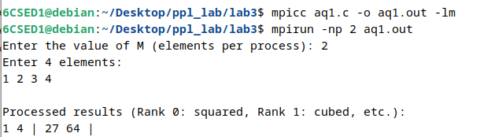

Q2] Write a MPI Program using collective communication functions to replace all even elements of array A to 1 and replace all odd elements to 0 of size N. Display the resultant array A, count of all even and odd numbers in root process. Assume N is evenly divisible by number of processes
eg.
ip array 1 2 3 4 5 6 7 8 9
resultant= 0 1 0 1 0 1 0 1 0
even count= 4 odd count =5

CODE]

#include <mpi.h>
#include <stdio.h>
#include <stdlib.h>

int main(int argc, char** argv) {
int rank, size, N;
int *A = NULL;
int *sub_A = NULL;
int local_even = 0, local_odd = 0;
int global_even = 0, global_odd = 0;

MPI_Init(&argc, &argv);
MPI_Comm_rank(MPI_COMM_WORLD, &rank);
MPI_Comm_size(MPI_COMM_WORLD, &size);

if (rank == 0) {
printf("Enter the total size of array N (must be divisible by %d): ", size);
fflush(stdout);
scanf("%d", &N);

A = (int*)malloc(N * sizeof(int));
printf("Enter %d elements:\n", N);
fflush(stdout);
for (int i = 0; i < N; i++) {
scanf("%d", &A[i]);
}
}

MPI_Bcast(&N, 1, MPI_INT, 0, MPI_COMM_WORLD);

int chunk_size = N / size;
sub_A = (int*)malloc(chunk_size * sizeof(int));

MPI_Scatter(A, chunk_size, MPI_INT, sub_A, chunk_size, MPI_INT, 0, MPI_COMM_WORLD);

for (int i = 0; i < chunk_size; i++) {
if (sub_A[i] % 2 == 0) {
local_even++;
sub_A[i] = 1;
} else {
local_odd++;
sub_A[i] = 0;
}
}

MPI_Gather(sub_A, chunk_size, MPI_INT, A, chunk_size, MPI_INT, 0, MPI_COMM_WORLD);

MPI_Reduce(&local_even, &global_even, 1, MPI_INT, MPI_SUM, 0, MPI_COMM_WORLD);
MPI_Reduce(&local_odd, &global_odd, 1, MPI_INT, MPI_SUM, 0, MPI_COMM_WORLD);

if (rank == 0) {
printf("\nResultant Array A: ");
for (int i = 0; i < N; i++) {
printf("%d ", A[i]);
}
printf("\nEven count = %d", global_even);
printf("\nOdd count = %d\n", global_odd);

free(A);
}

free(sub_A);
MPI_Finalize();
return 0;
}

OUTPUT]

