WPL LAB WEEK4

230905290
Rohan Shenoy
CSE D1 Roll no 32

Q1]
CODE]

#include <mpi.h>
#include <stdio.h>
#include <stdlib.h>

long long factorial(int n) {
long long fact = 1;
for (int i = 1; i <= n; i++) fact *= i;
return fact;
}

int main(int argc, char** argv) {
int rank, size, err_code;
long long local_fact, prefix_sum;

err_code = MPI_Init(&argc, &argv);
if (err_code != MPI_SUCCESS) {
fprintf(stderr, "Error starting MPI program. Terminating.\n");
MPI_Abort(MPI_COMM_WORLD, err_code);
}

MPI_Comm_set_errhandler(MPI_COMM_WORLD, MPI_ERRORS_RETURN);

err_code = MPI_Comm_rank(MPI_COMM_WORLD, &rank);
if (err_code != MPI_SUCCESS) goto handle_error;

err_code = MPI_Comm_size(MPI_COMM_WORLD, &size);
if (err_code != MPI_SUCCESS) goto handle_error;

local_fact = factorial(rank + 1);

err_code = MPI_Scan(&local_fact, &prefix_sum, 1, MPI_LONG_LONG, MPI_SUM, MPI_COMM_WORLD);

if (err_code != MPI_SUCCESS) {
handle_error: {
char err_buffer[MPI_MAX_ERROR_STRING];
int resultlen;
MPI_Error_string(err_code, err_buffer, &resultlen);
fprintf(stderr, "Rank %d encountered MPI Error: %s\n", rank, err_buffer);
MPI_Abort(MPI_COMM_WORLD, err_code);
}
}

if (rank == size - 1) {
printf("The total sum of factorials from 1! to %d! is: %lld\n", size, prefix_sum);
fflush(stdout);
}

MPI_Finalize();
return 0;
}

OUTPUT]

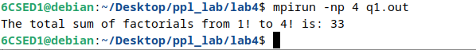

Q2]
CODE]

#include <stdio.h>
#include <stdlib.h>
#include "mpi.h"

int main(int argc, char *argv[]) {
int rank, size;
int matrix[3][3], row_buffer[3];
int search_element, local_count = 0, total_occurrences = 0;

MPI_Init(&argc, &argv);
MPI_Comm_rank(MPI_COMM_WORLD, &rank);
MPI_Comm_size(MPI_COMM_WORLD, &size);

if (size != 3) {
if (rank == 0) printf("Error: This program requires exactly 3 processes.\n");
MPI_Finalize();
return 0;
}

if (rank == 0) {
printf("Enter elements for the 3x3 matrix:\n");
fflush(stdout);
for (int i = 0; i < 3; i++) {
for (int j = 0; j < 3; j++) {
scanf("%d", &matrix[i][j]);
}
}

printf("Enter the element to be searched: ");
fflush(stdout);
scanf("%d", &search_element);
}

MPI_Bcast(&search_element, 1, MPI_INT, 0, MPI_COMM_WORLD);

MPI_Scatter(matrix, 3, MPI_INT, row_buffer, 3, MPI_INT, 0, MPI_COMM_WORLD);

for (int i = 0; i < 3; i++) {
if (row_buffer[i] == search_element) {
local_count++;
}
}

MPI_Reduce(&local_count, &total_occurrences, 1, MPI_INT, MPI_SUM, 0, MPI_COMM_WORLD);

if (rank == 0) {
printf("The element %d occurred %d times in the matrix.\n", search_element, total_occurrences);
}

MPI_Finalize();
return 0;
}

OUTPUT]
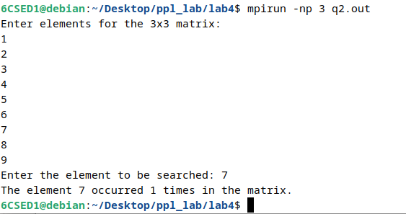

Q3]
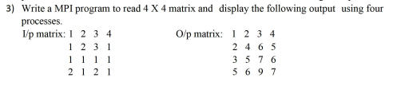

CODE]

#include <stdio.h>
#include <stdlib.h>
#include "mpi.h"

int main(int argc, char *argv[]) {
int rank, size;
int matrix[4][4], row[4], prev_row[4];

MPI_Init(&argc, &argv);
MPI_Comm_rank(MPI_COMM_WORLD, &rank);
MPI_Comm_size(MPI_COMM_WORLD, &size);

if (size != 4) {
if (rank == 0) printf("Error: This program requires exactly 4 processes.\n");
MPI_Finalize();
return 0;
}

if (rank == 0) {
printf("Enter elements for a 4x4 matrix:\n");
fflush(stdout);
for (int i = 0; i < 4; i++) {
for (int j = 0; j < 4; j++) {
scanf("%d", &matrix[i][j]);
}
}
}

MPI_Scatter(matrix, 4, MPI_INT, row, 4, MPI_INT, 0, MPI_COMM_WORLD);

if (rank == 0) {
MPI_Send(row, 4, MPI_INT, 1, 0, MPI_COMM_WORLD);
}
else {
MPI_Recv(prev_row, 4, MPI_INT, rank - 1, 0, MPI_COMM_WORLD, MPI_STATUS_IGNORE);

for (int i = 0; i < 4; i++) {
row[i] += prev_row[i];
}

if (rank < 3) {
MPI_Send(row, 4, MPI_INT, rank + 1, 0, MPI_COMM_WORLD);
}
}

MPI_Gather(row, 4, MPI_INT, matrix, 4, MPI_INT, 0, MPI_COMM_WORLD);

if (rank == 0) {
printf("\nOutput Matrix:\n");
for (int i = 0; i < 4; i++) {
for (int j = 0; j < 4; j++) {
printf("%d ", matrix[i][j]);
}
printf("\n");
}
}

MPI_Finalize();
return 0;
}

OUTPUT]

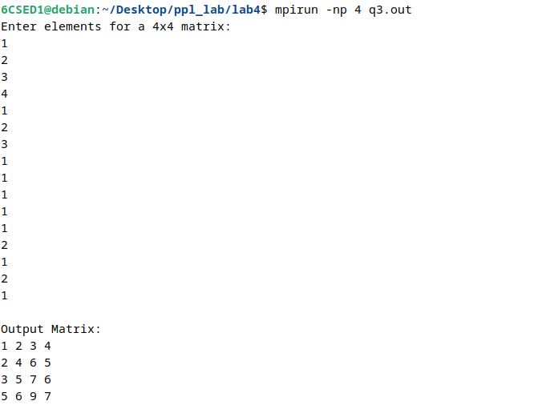

Q4]

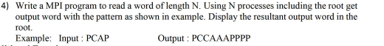

CODE]

#include <stdio.h>
#include <stdlib.h>
#include <string.h>
#include "mpi.h"

int main(int argc, char *argv[]) {
int rank, size;
char input_word[100];
char local_char;
char *local_string;
char *result_word = NULL;

MPI_Init(&argc, &argv);
MPI_Comm_rank(MPI_COMM_WORLD, &rank);
MPI_Comm_size(MPI_COMM_WORLD, &size);

if (rank == 0) {
printf("Enter a word of length %d: ", size);
fflush(stdout);
scanf("%s", input_word);
}

MPI_Scatter(input_word, 1, MPI_CHAR, &local_char, 1, MPI_CHAR, 0, MPI_COMM_WORLD);

int count = rank + 1;
local_string = (char *)malloc((count + 1) * sizeof(char));
for (int i = 0; i < count; i++) {
local_string[i] = local_char;
}
local_string[count] = '\0';

int *recv_counts = NULL;
int *displs = NULL;
int total_length = 0;

if (rank == 0) {
recv_counts = (int *)malloc(size * sizeof(int));
displs = (int *)malloc(size * sizeof(int));

for (int i = 0; i < size; i++) {
recv_counts[i] = i + 1;
displs[i] = total_length;
total_length += recv_counts[i];
}
result_word = (char *)malloc((total_length + 1) * sizeof(char));
}

MPI_Gatherv(local_string, count, MPI_CHAR,
result_word, recv_counts, displs, MPI_CHAR,
0, MPI_COMM_WORLD);

if (rank == 0) {
result_word[total_length] = '\0';
printf("Output word: %s\n", result_word);

free(recv_counts);
free(displs);
free(result_word);
}

free(local_string);
MPI_Finalize();
return 0;
}

OUTPUT]

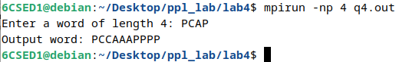

ADDITIONAL EXERCISES

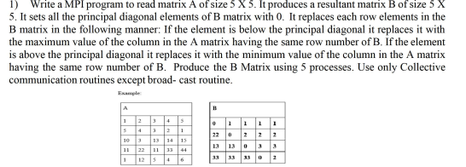
Q1]

CODE]

#include <stdio.h>
#include <stdlib.h>
#include "mpi.h"

int main(int argc, char *argv[]) {
int rank, size;
int A[5][5], B_row[5], final_B[5][5];

MPI_Init(&argc, &argv);
MPI_Comm_rank(MPI_COMM_WORLD, &rank);
MPI_Comm_size(MPI_COMM_WORLD, &size);

if (size != 5) {
if (rank == 0) printf("Error: Run with 5 processes.\n");
MPI_Finalize();
return 0;
}

if (rank == 0) {
printf("Enter elements for a 5x5 matrix A:\n");
fflush(stdout);
for (int i = 0; i < 5; i++) {
for (int j = 0; j < 5; j++) {
scanf("%d", &A[i][j]);
}
}
}

MPI_Bcast(A, 25, MPI_INT, 0, MPI_COMM_WORLD);

for (int j = 0; j < 5; j++) {
if (rank == j) {
B_row[j] = 0;
}
else {
int min_val = A[0][j];
int max_val = A[0][j];
for (int i = 1; i < 5; i++) {
if (A[i][j] < min_val) min_val = A[i][j];
if (A[i][j] > max_val) max_val = A[i][j];
}

if (rank > j) {
B_row[j] = max_val;
} else {
B_row[j] = min_val;
}
}
}

MPI_Gather(B_row, 5, MPI_INT, final_B, 5, MPI_INT, 0, MPI_COMM_WORLD);

if (rank == 0) {
printf("\nResultant Matrix B:\n");
for (int i = 0; i < 5; i++) {
for (int j = 0; j < 5; j++) {
printf("%d\t", final_B[i][j]);
}
printf("\n");
}
}

MPI_Finalize();
return 0;
}

OUTPUT]

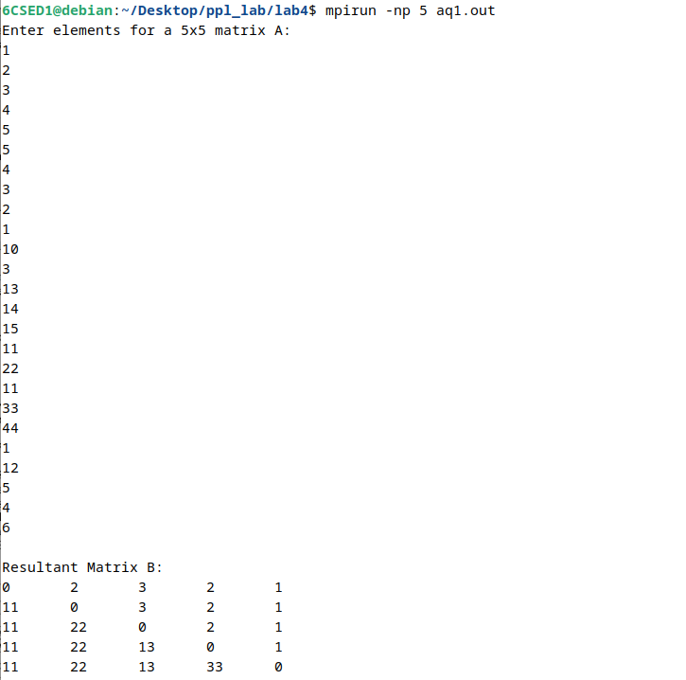
Q2]

CODE]

#include <stdio.h>
#include <stdlib.h>
#include <mpi.h>

int main(int argc, char *argv[]) {
int rank, size, n, local_n;
double pi_val, local_pi, h, sum, x;
double local_a, local_b, a = 0.0, b = 1.0;

MPI_Init(&argc, &argv);
MPI_Comm_rank(MPI_COMM_WORLD, &rank);
MPI_Comm_size(MPI_COMM_WORLD, &size);

if (rank == 0) {
printf("Enter the number of intervals (n): ");
fflush(stdout);
scanf("%d", &n);
}

MPI_Bcast(&n, 1, MPI_INT, 0, MPI_COMM_WORLD);

h = (b - a) / n;

local_n = n / size;
local_a = a + rank * local_n * h;
local_b = local_a + local_n * h;

sum = 0.0;
for (int i = 0; i < local_n; i++) {
x = local_a + (i + 0.5) * h;
sum += 4.0 / (1.0 + x * x);
}
local_pi = h * sum;

MPI_Reduce(&local_pi, &pi_val, 1, MPI_DOUBLE, MPI_SUM, 0, MPI_COMM_WORLD);

if (rank == 0) {
printf("With n = %d intervals, pi is approximately %.16f\n", n, pi_val);
}

MPI_Finalize();
return 0;
}

OUTPUT]

