PPL LAB 5 230905290

Rohan Shenoy
230905290
CSE D1
Roll no 32

Q1]

CODE]

#include <stdio.h>
#include <cuda_runtime.h>

__global__ void vectorAdd(int *a, int *b, int *c, int n) {
int i = blockIdx.x * blockDim.x + threadIdx.x;
if (i < n) {
c[i] = a[i] + b[i];
}
}

int main() {
int n;
printf("Enter vector length N: ");
scanf("%d", &n);

size_t size = n * sizeof(int);
int *h_a = (int*)malloc(size), *h_b = (int*)malloc(size), *h_c = (int*)malloc(size);

for (int i = 0; i < n; i++)
{
h_a[i] = i;
h_b[i] = i * 2;
}

int *d_a, *d_b, *d_c;
cudaMalloc((void**)&d_a, size);
cudaMalloc((void**)&d_b, size);
cudaMalloc((void**)&d_c, size);

cudaMemcpy(d_a, h_a, size, cudaMemcpyHostToDevice);
cudaMemcpy(d_b, h_b, size, cudaMemcpyHostToDevice);

printf("\n--- Output for Case A (1 Block, %d Threads) ---\n", n);
vectorAdd<<<1, n>>>(d_a, d_b, d_c, n);
cudaMemcpy(h_c, d_c, size, cudaMemcpyDeviceToHost);
for (int i = 0; i < n; i++) printf("%d ", h_c[i]);

printf("\n\n--- Output for Case B (%d Blocks, 1 Thread each) ---\n", n);
vectorAdd<<<n, 1>>>(d_a, d_b, d_c, n);
cudaMemcpy(h_c, d_c, size, cudaMemcpyDeviceToHost);
for (int i = 0; i < n; i++) printf("%d ", h_c[i]);
printf("\n");

free(h_a); free(h_b); free(h_c);
cudaFree(d_a); cudaFree(d_b); cudaFree(d_c);
return 0;
}

OUTPUT]

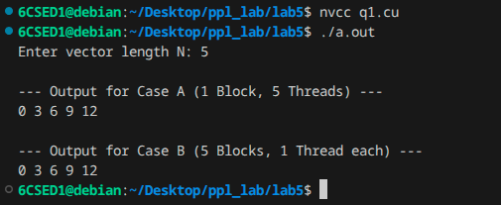

Q2]

CODE]

#include <stdio.h>
#include <cuda_runtime.h>

__global__ void vectorAdd(int *a, int *b, int *c, int n) {
int i = blockIdx.x * blockDim.x + threadIdx.x;
if (i < n) {
c[i] = a[i] + b[i];
}
}

int main() {
int n;
printf("Enter vector length N: ");
scanf("%d", &n);

size_t size = n * sizeof(int);
int *h_a = (int*)malloc(size), *h_b = (int*)malloc(size), *h_c = (int*)malloc(size);

for (int i = 0; i < n; i++) {
h_a[i] = i;
h_b[i] = i * 2;
}

int *d_a, *d_b, *d_c;
cudaMalloc((void**)&d_a, size);
cudaMalloc((void**)&d_b, size);
cudaMalloc((void**)&d_c, size);

cudaMemcpy(d_a, h_a, size, cudaMemcpyHostToDevice);
cudaMemcpy(d_b, h_b, size, cudaMemcpyHostToDevice);

int threadsPerBlock = 256;
int blocksPerGrid = (n + threadsPerBlock - 1) / threadsPerBlock;

printf("Launching with %d blocks and %d threads per block\n", blocksPerGrid, threadsPerBlock);

vectorAdd<<<blocksPerGrid, threadsPerBlock>>>(d_a, d_b, d_c, n);

cudaMemcpy(h_c, d_c, size, cudaMemcpyDeviceToHost);

for (int i = 0; i < (n < 10 ? n : 10); i++) printf("%d ", h_c[i]);
printf("\nDone.\n");

free(h_a); free(h_b); free(h_c);
cudaFree(d_a); cudaFree(d_b); cudaFree(d_c);
return 0;
}

OUTPUT]

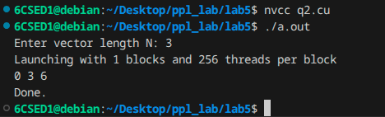

Q3]

CODE]

#include <stdio.h>
#include <cuda_runtime.h>
#include <math.h>

__global__ void computeSine(float *input, float *output, int n) {
int i = blockIdx.x * blockDim.x + threadIdx.x;
if (i < n) {
output[i] = sinf(input[i]);
}
}

int main() {
int n = 10;
size_t size = n * sizeof(float);

float *h_in = (float*)malloc(size);
float *h_out = (float*)malloc(size);

for (int i = 0; i < n; i++) {
h_in[i] = i * (M_PI / (n - 1));
}

float *d_in, *d_out;
cudaMalloc((void**)&d_in, size);
cudaMalloc((void**)&d_out, size);

cudaMemcpy(d_in, h_in, size, cudaMemcpyHostToDevice);

int threadsPerBlock = 256;
int blocksPerGrid = (n + threadsPerBlock - 1) / threadsPerBlock;

computeSine<<<blocksPerGrid, threadsPerBlock>>>(d_in, d_out, n);

cudaMemcpy(h_out, d_out, size, cudaMemcpyDeviceToHost);

printf("Radians \t Sine\n");
for (int i = 0; i < n; i++) {
printf("%.4f \t %.4f\n", h_in[i], h_out[i]);
}

free(h_in); free(h_out);
cudaFree(d_in); cudaFree(d_out);

return 0;
}

OUTPUT]

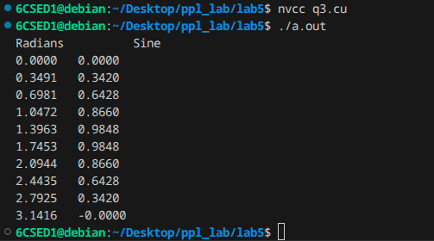

ADDITIONAL QUESTIONS

Q1]

CODE]

#include <stdio.h>
#include <cuda_runtime.h>

__global__ void saxpy(int n, float a, float *x, float *y) {
int i = blockIdx.x * blockDim.x + threadIdx.x;
if (i < n) {
y[i] = a * x[i] + y[i];
}
}

int main() {
int n = 1 << 20;
float a = 2.5f;
size_t size = n * sizeof(float);

float *h_x = (float*)malloc(size);
float *h_y = (float*)malloc(size);

for (int i = 0; i < n; i++) {
h_x[i] = 1.0f;
h_y[i] = 2.0f;
}

float *d_x, *d_y;
cudaMalloc(&d_x, size);
cudaMalloc(&d_y, size);

cudaMemcpy(d_x, h_x, size, cudaMemcpyHostToDevice);
cudaMemcpy(d_y, h_y, size, cudaMemcpyHostToDevice);

int threadsPerBlock = 256;
int blocksPerGrid = (n + threadsPerBlock - 1) / threadsPerBlock;

saxpy<<<blocksPerGrid, threadsPerBlock>>>(n, a, d_x, d_y);

cudaMemcpy(h_y, d_y, size, cudaMemcpyDeviceToHost);

printf("Result of first element: y[0] = %.2f (Expected: 4.50)\n", h_y[0]);

cudaFree(d_x);
cudaFree(d_y);
free(h_x);
free(h_y);

return 0;
}

OUTPUT]

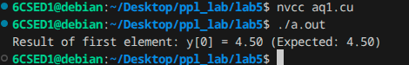

Q2]

CODE]

#include <stdio.h>
#include <cuda_runtime.h>

__global__ void selectionSortRows(int *matrix, int rows, int cols) {
int rowIdx = blockIdx.x * blockDim.x + threadIdx.x;

if (rowIdx < rows) {
int *row = &matrix[rowIdx * cols];

for (int i = 0; i < cols - 1; i++) {
int minIdx = i;
for (int j = i + 1; j < cols; j++) {
if (row[j] < row[minIdx]) {
minIdx = j;
}
}
int temp = row[minIdx];
row[minIdx] = row[i];
row[i] = temp;
}
}
}

int main() {
int rows = 4, cols = 5;
size_t size = rows * cols * sizeof(int);

int h_matrix[] = {
5, 3, 8, 1, 2,
9, 0, 4, 7, 6,
2, 8, 1, 5, 3,
6, 1, 9, 2, 4
};

printf("Initial unsorted matrix:\n");
for (int i = 0; i < rows; i++) {
for (int j = 0; j < cols; j++) {
printf("%d ", h_matrix[i * cols + j]);
}
printf("\n");
}

int *d_matrix;
cudaMalloc((void**)&d_matrix, size);
cudaMemcpy(d_matrix, h_matrix, size, cudaMemcpyHostToDevice);

int threadsPerBlock = 256;
int blocksPerGrid = (rows + threadsPerBlock - 1) / threadsPerBlock;

selectionSortRows<<<blocksPerGrid, threadsPerBlock>>>(d_matrix, rows, cols);

cudaMemcpy(h_matrix, d_matrix, size, cudaMemcpyDeviceToHost);

printf("Sorted Matrix:\n");
for (int i = 0; i < rows; i++) {
for (int j = 0; j < cols; j++) {
printf("%d ", h_matrix[i * cols + j]);
}
printf("\n");
}

cudaFree(d_matrix);
return 0;
}

OUTPUT]

