WEB PROGRAMMING LAB 1

Rohan Shenoy
230905290
Roll no 32
D1 Batch

Q1] CODE:

index.html

<!DOCTYPE html>
<html lang="en">
<head>
<meta charset="UTF-8">
<meta name="viewport" content="width=device-width, initial-scale=1.0">
<title>Poem for WPL LAB</title>
<link rel="stylesheet" href="style.css">
</head>
<body>

<div class="poem-container">
<h1>The Golden Light</h1>

<p>
The sun begins to <b>brighten</b>,<br>
As the heavy shadows <b>lighten</b>.<br>
The morning dew is <b>clear</b>,<br>
The singing birds are <b>near</b>.
</p>

<p>
The river starts to <b>flow</b>,<br>
With a soft and steady <b>glow</b>.<br>
The world begins to <b>wake</b>,<br>
Beside the silver <b>lake</b>.
</p>
</div>

</body>
</html>

style.css

body {
background-color: #f4f7f6;
font-family: 'Segoe UI', Tahoma, Geneva, Verdana, sans-serif;
display: flex;
justify-content: center;
align-items: center;
min-height: 100vh;
margin: 0;
}

.poem-container {
background: #ffffff;
padding: 70px;
border-radius: 0px;
box-shadow: 0 10px 30px rgba(0, 0, 0, 0.05);
text-align: center;
max-width: 400px;
border: 1px solid #e0e0e0;
}

h1 {
color: #2c3e50;
font-size: 2rem;
margin-bottom: 20px;
border-bottom: 2px solid #3498db;
display: inline-block;
padding-bottom: 5px;
}

p {
color: #555;
font-size: 1.1rem;
line-height: 1.8;
margin-bottom: 20px;
}

b {
color: #3498db;
font-weight: 700;
}

OUTPUT

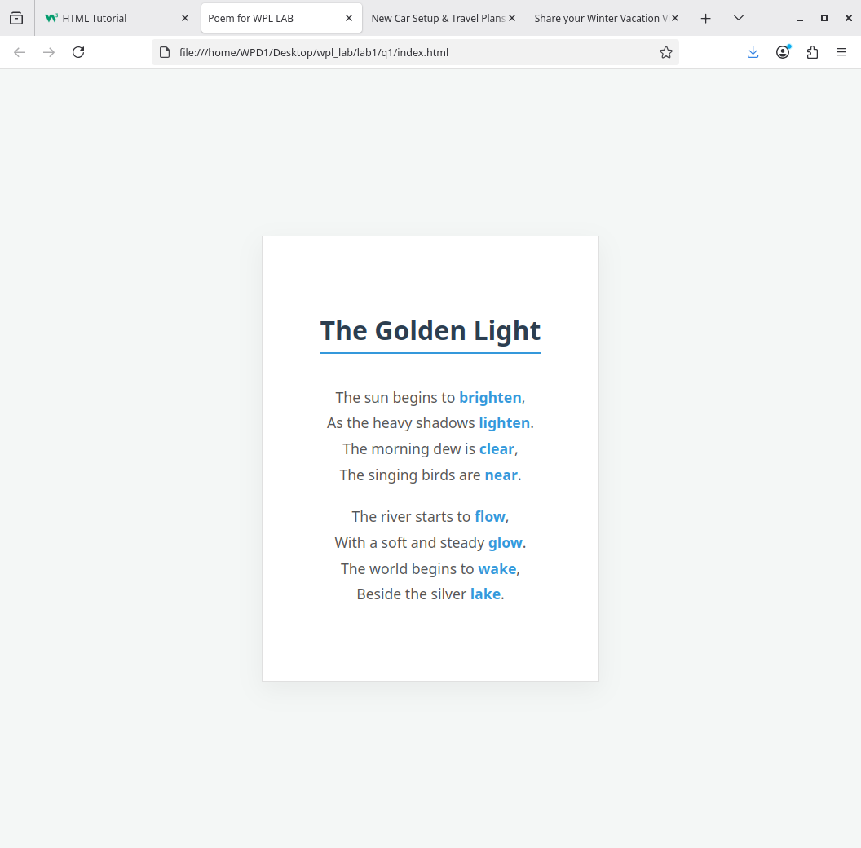

Q2]

CODE]

index.html

<!DOCTYPE html>
<html lang="en">
<head>
<title>New Car Setup & Travel Plans 2026</title>
<link rel="stylesheet" href="style.css">
</head>
<body>

<h2>Additional Car Accessories Needed</h2>
<p>Essential upgrades for safety, tech, and comfort:</p>
<ul>
<li><b>Smart Dash Camera:</b> For real-time 4K recording and incident safety.</li>
<li><b>Portable Tire Inflator:</b> Essential for maintaining optimal pressure and emergencies.</li>
<li><b>Wireless CarPlay/Android Auto Adapter:</b> To modernize infotainment without cables.</li>
<li><b>HEPA Car Air Purifier:</b> To maintain cabin air quality in urban environments.</li>
<li><b>Wireless Charging Phone Mount:</b> For hands-free navigation and battery upkeep.</li>
<li><b>First Aid & Emergency Escape Kit:</b> Including seatbelt cutters and window breakers.</li>
</ul>

<h2>Proposed Travel Plans for 2026</h2>
<p>Ranked travel destinations for the new vehicle's first year:</p>
<ol>
<li><b>Dolomites, Italy:</b> Scenic drives to witness the 2026 Winter Olympics.</li>
<li><b>The Indian Himalayas:</b> High-altitude road passes through Ladakh and Sikkim.</li>
<li><b>Portugal's Coastal Route:</b> A legendary drive from Viana do Castelo to Sagres.</li>
<li><b>The Oregon Coast, USA:</b> A bucket-list drive along US-101 with improved EV charging.</li>
<li><b>Oulu, Finland:</b> Visit the European Capital of Culture 2026 for a "slow travel" experience.</li>
</ol>

</body>
</html>

style.css

body {
background-color: #ffffff;
color: #333333;
font-family: Arial, sans-serif;
line-height: 1.6;
padding: 40px;
max-width: 700px;
margin: 0 auto;
}

h2 {
color: #2c3e50;
border-bottom: 1px solid #eeeeee;
padding-bottom: 8px;
margin-top: 30px;
font-size: 1.4rem;
}

ul, ol {
padding-left: 20px;
margin-bottom: 20px;
}

li {
margin-bottom: 10px;
}

ul {
list-style-type: square;
}

ol {
list-style-type: decimal;
}

b {
color: #000000;
}

p {
color: #666666;
font-style: italic;
}

OUTPUT

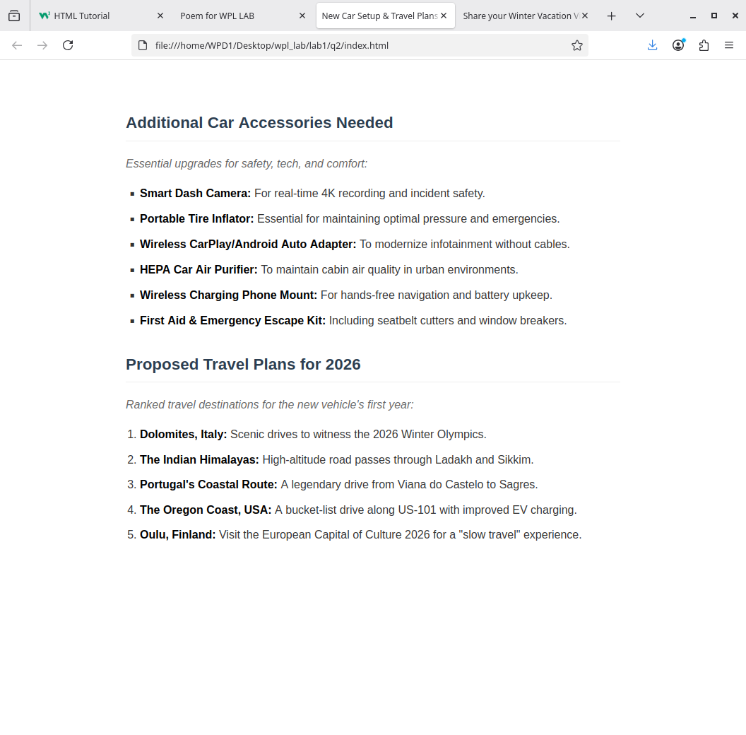

Q3]

CODE]

index.html

<!DOCTYPE html>
<html lang="en">
<head>
<meta charset="UTF-8">
<meta name="viewport" content="width=device-width, initial-scale=1.0">
<title>Share your Winter Vacation Videos</title>
<link rel="stylesheet" href="style.css">
</head>
<body>

<h1>Share your Winter Vacation Photos</h1>

<figure>

<img src="image1.jpg" alt="View of buildings in Paris" width="300">
<figcaption>Location 1: PARIS</figcaption>
</figure>

<figure>
<img src="image2.jpg" alt="View of the water and horizon" width="300">
<figcaption>Location 2: BEACH</figcaption>
</figure>

<figure>
<img src="image3.jpg" alt="View of a lake and trees at sunset" width="300">
<figcaption>Location 3: SUNSET SPOT</figcaption>
</figure>

</body>
</html>

style.css

body {
font-family: 'Arial', sans-serif;
background-color: #f4f4f4;
color: #333;
margin: 0;
padding: 20px;
display: flex;
flex-direction: column;
align-items: center;
justify-content: center;
min-height: 100vh;
}

h1 {
color: #2c3e50;
margin-bottom: 25px;
text-align: center;
}

figure {
background: #fff;
padding: 20px;
border-radius: 8px;
box-shadow: 0 4px 8px rgba(0,0,0,0.1);
text-align: center;
max-width: 640px;
width: 100%;
}

video {
max-width: 100%;
height: auto;
border-radius: 5px;
}

figcaption {
margin-top: 15px;
font-style: italic;
color: #666;
font-size: 0.9rem;
}

OUTPUT

