LAB2 WPL LAB

Rohan Shenoy
230905290
Roll no 32
D1 batch

Q1] Write a web page which contains table with 3 X 3 dimensions (fill some data) and one
image. Style the rows with alternate color. Move the table and image together from right
to left when button is clicked.

CODE]

<!DOCTYPE html>
<html lang="en">
<head>
<meta charset="UTF-8">
<title>jQuery Table & Image Animation</title>

<script src="https://code.jquery.com/jquery-3.6.0.min.js"></script>

<style>
body {
font-family: Arial, sans-serif;
padding: 20px;
}

#container {
position: relative;
left: 500px;
width: fit-content;
}

table {
border-collapse: collapse;
margin-bottom: 10px;
}

td {
border: 1px solid black;
padding: 10px;
text-align: center;
}

/* Alternate row colors */
tr:nth-child(even) {
background-color: #d6eaff;
}

tr:nth-child(odd) {
background-color: #ffffff;
}

img {
width: 150px;
display: block;
margin-top: 10px;
}

button {
margin-top: 20px;
padding: 8px 15px;
}
</style>
</head>

<body>

<button id="moveBtn">Move Left</button>

<div id="container">
<table>
<tr>
<td>A</td>
<td>B</td>
<td>C</td>
</tr>
<tr>
<td>D</td>
<td>E</td>
<td>F</td>
</tr>
<tr>
<td>G</td>
<td>H</td>
<td>I</td>
</tr>
</table>

<img src="car.jpg" alt="car Image">
</div>

<script>
$("#moveBtn").click(function () {
$("#container").animate({
left: "0px"
}, 1000);
});
</script>

</body>
</html>

OUTPUT]

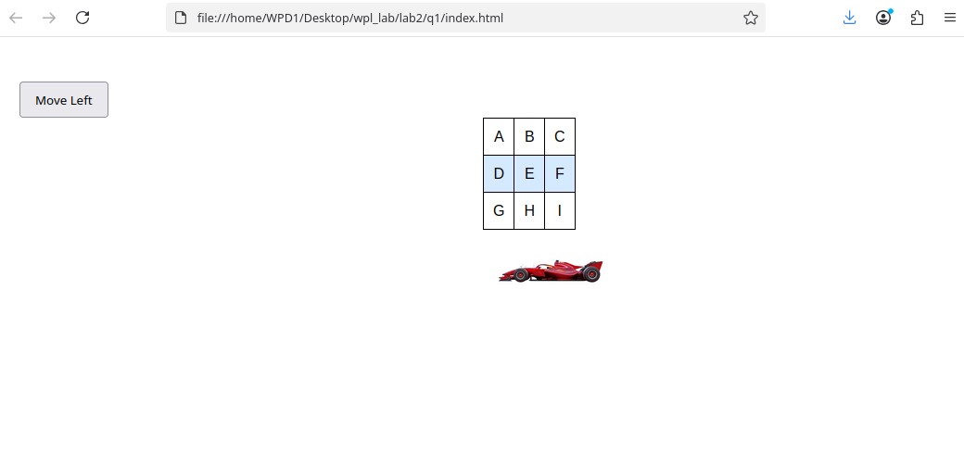

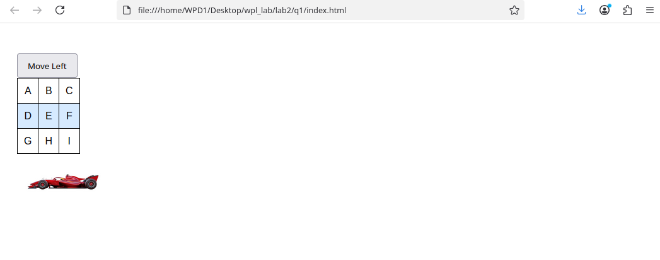

Q2] Design a calculator to perform basic arithmetic operations. Use textboxes and buttons to design web page.

CODE]

<!DOCTYPE html>
<html lang="en">
<head>
<meta charset="UTF-8">
<title>jQuery Calculator</title>

<script src="https://code.jquery.com/jquery-3.6.0.min.js"></script>

<style>
body {
font-family: Arial, sans-serif;
text-align: center;
padding-top: 50px;
}

input[type="text"] {
width: 150px;
padding: 8px;
margin: 5px;
font-size: 16px;
}

button {
padding: 10px 15px;
margin: 5px;
font-size: 16px;
cursor: pointer;
}

#result {
margin-top: 15px;
font-size: 18px;
font-weight: bold;
}
</style>
</head>

<body>

<h2>Simple Calculator</h2>

<input type="text" id="num1" placeholder="Enter first number">
<input type="text" id="num2" placeholder="Enter second number">
<br><br>

<button id="add">+</button>
<button id="sub">−</button>
<button id="mul">×</button>
<button id="div">÷</button>

<div id="result">Result: </div>

<script>
$(document).ready(function () {

$("#add").click(function () {
let a = parseFloat($("#num1").val());
let b = parseFloat($("#num2").val());
$("#result").text("Result: " + (a + b));
});

$("#sub").click(function () {
let a = parseFloat($("#num1").val());
let b = parseFloat($("#num2").val());
$("#result").text("Result: " + (a - b));
});

$("#mul").click(function () {
let a = parseFloat($("#num1").val());
let b = parseFloat($("#num2").val());
$("#result").text("Result: " + (a * b));
});

$("#div").click(function () {
let a = parseFloat($("#num1").val());
let b = parseFloat($("#num2").val());

if (b === 0) {
$("#result").text("Result: Cannot divide by zero");
} else {
$("#result").text("Result: " + (a / b));
}
});

});
</script>

</body>
</html>

OUTPUT]

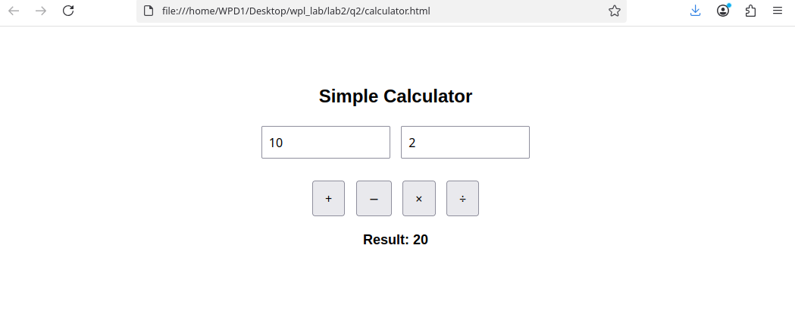

Q3] Create a web page to design a birthday card shown below.

CODE]

<!DOCTYPE html>
<html lang="en">
<head>
<meta charset="UTF-8">
<title>Birthday Card Designer</title>

<script src="https://code.jquery.com/jquery-3.6.0.min.js"></script>

<style>
body {
font-family: Arial, sans-serif;
}

.main {
display: flex;
gap: 20px;
padding: 20px;
}

.controls {
width: 250px;
background-color: #fff8dc;
padding: 15px;
border: 1px solid #ccc;
}

.controls label {
font-size: 14px;
font-weight: bold;
}

.controls select,
.controls input,
.controls textarea {
width: 100%;
margin-bottom: 10px;
}

.card {
width: 300px;
height: 400px;
background-color: yellow;
border: 3px solid black;
text-align: center;
padding: 15px;
}

.card h2 {
margin-top: 10px;
}

.card img {
width: 150px;
margin-top: 20px;
}
</style>
</head>

<body>

<div class="main">

<div class="controls">
<label>Choose a background color</label>
<select id="bgColor">
<option value="yellow">Yellow</option>
<option value="pink">Pink</option>
<option value="lightblue">Light Blue</option>
<option value="lightgreen">Light Green</option>
</select>

<label>Choose a font</label>
<select id="font">
<option value="Verdana">Verdana</option>
<option value="Arial">Arial</option>
<option value="Times New Roman">Times New Roman</option>
</select>

<label>Specify a numeric font size</label>
<input type="number" id="fontSize" value="20">

<label>Choose a border style</label><br>
<input type="radio" name="border" value="solid" checked> Solid<br>
<input type="radio" name="border" value="double"> Double<br>
<input type="radio" name="border" value="dashed"> Dashed<br><br>

<label>Enter the greeting text below</label>
<textarea id="message" rows="3">Happy Birthday, and many more</textarea>

<button id="update">Update</button>
</div>

<div class="card" id="card">
<h2 id="cardText">Happy Birthday,<br>and many more</h2>
<img src="birthday.jpg" alt="Birthday Image">

</div>

</div>

<script>
$("#update").click(function () {

$("#card").css("background-color", $("#bgColor").val());

$("#cardText").css({
"font-family": $("#font").val(),
"font-size": $("#fontSize").val() + "px"
});

let borderStyle = $("input[name='border']:checked").val();
$("#card").css("border", "4px " + borderStyle + " black");

$("#cardText").html($("#message").val().replace(/\n/g, "<br>"));
});
</script>

</body>
</html>

OUTPUT]

