LAB 3 230905290 WPL LAB

Rohan Shenoy
230905290
CSE D1 32

Q1] Design the student bio-data form using button, label, textbox, radio button, table
and checkbox.

CODE]

<!DOCTYPE html>
<html lang="en">
<head>
<title>Student Bio-Data</title>
<meta charset="utf-8">
<meta name="viewport" content="width=device-width, initial-scale=1">
<link rel="stylesheet"
href="https://maxcdn.bootstrapcdn.com/bootstrap/4.4.1/css/bootstrap.min.css">
</head>

<body>
<div class="container mt-4">
<h2 class="text-center text-primary">Student Bio-Data Form</h2>

<form>
<div class="form-group">
<label>Name</label>
<input type="text" class="form-control" placeholder="Enter name">
</div>

<div class="form-group">
<label>Email</label>
<input type="email" class="form-control" placeholder="Enter email">
</div>

<label>Gender</label><br>
<div class="form-check form-check-inline">
<input class="form-check-input" type="radio" name="gender">
<label class="form-check-label">Male</label>
</div>
<div class="form-check form-check-inline">
<input class="form-check-input" type="radio" name="gender">
<label class="form-check-label">Female</label>
</div>

<br><br>

<label>Skills</label><br>
<div class="form-check">
<input class="form-check-input" type="checkbox"> C++
</div>
<div class="form-check">
<input class="form-check-input" type="checkbox"> Java
</div>
<div class="form-check">
<input class="form-check-input" type="checkbox"> Python
</div>

<br>

<h5>Academic Details</h5>
<table class="table table-bordered">
<tr>
<th>Course</th>
<th>Year</th>
<th>Percentage</th>
</tr>
<tr>
<td>B.Tech</td>
<td>2026</td>
<td>85%</td>
</tr>
</table>

<button class="btn btn-success">Submit</button>
<button class="btn btn-danger">Reset</button>
</form>
</div>
</body>
</html>

OUTPUT]

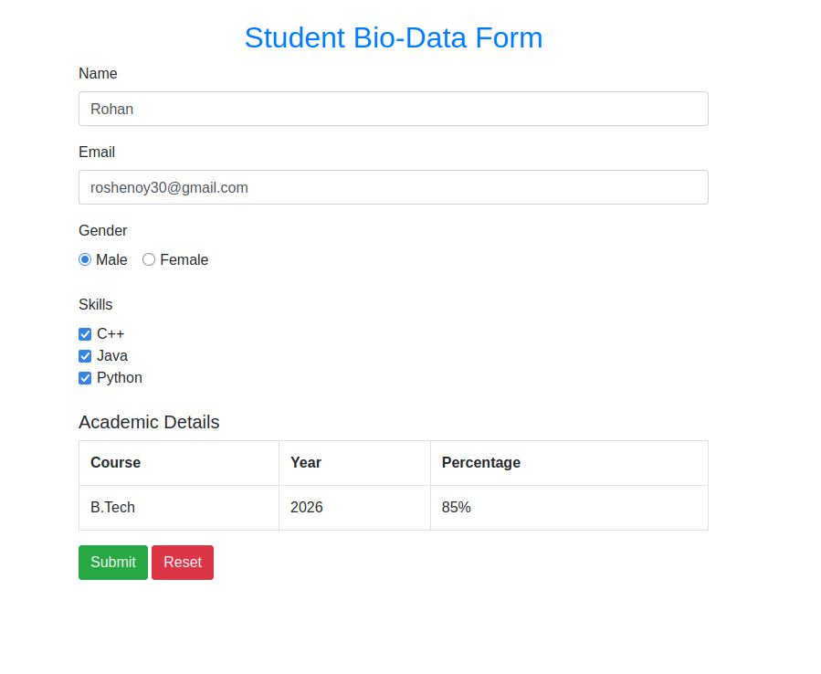
Q2] Design a web page which shows the database-oriented CRUD operation. Consider
Employee data.

CODE]

<!DOCTYPE html>
<html lang="en">
<head>
<title>Employee CRUD</title>
<meta charset="utf-8">
<meta name="viewport" content="width=device-width, initial-scale=1">

<link rel="stylesheet"
href="https://maxcdn.bootstrapcdn.com/bootstrap/4.4.1/css/bootstrap.min.css">
</head>

<body>

<div class="container mt-4">
<h2 class="text-center text-info">Employee Management System</h2>

<div class="form-row mb-3">
<div class="col">
<input type="text" id="empId" class="form-control" placeholder="Employee ID">
</div>
<div class="col">
<input type="text" id="empName" class="form-control" placeholder="Employee Name">
</div>
<div class="col">
<input type="text" id="empDept" class="form-control" placeholder="Department">
</div>
</div>

<button class="btn btn-primary" onclick="createEmployee()">Create</button>
<button class="btn btn-success" onclick="readEmployees()">Read</button>
<button class="btn btn-warning" onclick="updateEmployee()">Update</button>
<button class="btn btn-danger" onclick="deleteEmployee()">Delete</button>

<br><br>

<table class="table table-striped table-dark" id="empTable">
<thead>
<tr>
<th>ID</th>
<th>Name</th>
<th>Department</th>
</tr>
</thead>
<tbody>
</tbody>
</table>
</div>

<script>
let employees = [];

function createEmployee() {
let id = empId.value;
let name = empName.value;
let dept = empDept.value;

if (id === "" || name === "" || dept === "") {
alert("Please fill all fields");
return;
}

employees.push({ id, name, dept });
readEmployees();
clearFields();
}

function readEmployees() {
let tableBody = document.querySelector("#empTable tbody");
tableBody.innerHTML = "";

employees.forEach(emp => {
let row = `<tr>
<td>${emp.id}</td>
<td>${emp.name}</td>
<td>${emp.dept}</td>
</tr>`;
tableBody.innerHTML += row;
});
}

function updateEmployee() {
let id = empId.value;

employees.forEach(emp => {
if (emp.id === id) {
emp.name = empName.value;
emp.dept = empDept.value;
}
});

readEmployees();
clearFields();
}

function deleteEmployee() {
let id = empId.value;
employees = employees.filter(emp => emp.id !== id);
readEmployees();
clearFields();
}

function clearFields() {
empId.value = "";
empName.value = "";
empDept.value = "";
}
</script>

</body>
</html>

OUTPUT]

Q3] Create a web page using bootstrap as mentioned. Divide the page into 2 parts top
and bottom, then divide the bottom into 3 parts and design each top and bottom part using
different input groups, input, badges, buttons and button groups. Make the design more
attractive.

CODE]

<!DOCTYPE html>
<html lang="en">
<head>
<title>Bootstrap Layout</title>
<meta charset="utf-8">
<meta name="viewport" content="width=device-width, initial-scale=1">

<link rel="stylesheet"
href="https://maxcdn.bootstrapcdn.com/bootstrap/4.4.1/css/bootstrap.min.css">
</head>

<body>

<div class="container-fluid">

<div class="row">
<div class="col-12 bg-primary text-white text-center p-4">
<h2>Bootstrap Web Page</h2>
<p>Lab Assignment – Q3</p>
<span class="badge badge-warning">Top Section</span>
<span class="badge badge-light text-dark">Responsive Design</span>
</div>
</div>

<div class="row mt-4 text-center">

<div class="col-md-4 mb-3">
<div class="card shadow">
<div class="card-body">
<h5 class="card-title text-primary">Login</h5>

<div class="input-group mb-2">
<div class="input-group-prepend">
<span class="input-group-text">@</span>
</div>
<input type="text" class="form-control" placeholder="Username">
</div>

<input type="password" class="form-control" placeholder="Password">
</div>
</div>
</div>

<div class="col-md-4 mb-3">
<div class="card bg-secondary text-white shadow">
<div class="card-body">
<h5 class="card-title">Actions</h5>

<div class="btn-group">
<button class="btn btn-success">Save</button>
<button class="btn btn-warning">Edit</button>
<button class="btn btn-danger">Delete</button>
</div>

<br><br>

<button class="btn btn-outline-light">Submit</button>
</div>
</div>
</div>

<div class="col-md-4 mb-3">
<div class="card shadow">
<div class="card-body">
<h5 class="card-title text-info">Status</h5>

<p>
<span class="badge badge-success p-2">Active</span>
<span class="badge badge-danger p-2">Inactive</span>
<span class="badge badge-warning p-2">Pending</span>
</p>

<button class="btn btn-info btn-block">Check Status</button>
</div>
</div>
</div>

</div>

</div>

</body>
</html>

OUTPUT]

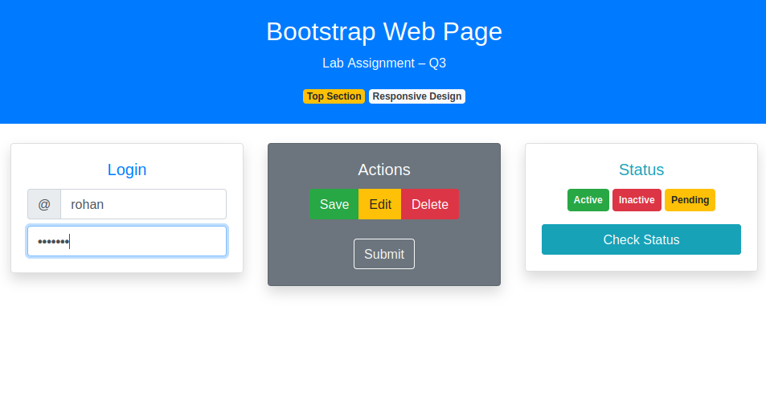

Q4] Design your class timetable using bootstrap table and carousel.

CODE]

<!DOCTYPE html>
<html lang="en">
<head>
<title>Class Timetable</title>
<meta charset="utf-8">
<meta name="viewport" content="width=device-width, initial-scale=1">

<link rel="stylesheet"
href="https://maxcdn.bootstrapcdn.com/bootstrap/4.4.1/css/bootstrap.min.css">

<script src="https://ajax.googleapis.com/ajax/libs/jquery/3.4.1/jquery.min.js"></script>
<script src="https://maxcdn.bootstrapcdn.com/bootstrap/4.4.1/js/bootstrap.min.js"></script>
</head>

<body>

<div class="container mt-4">

<h2 class="text-center text-primary mb-4">Class Timetable</h2>

<table class="table table-bordered table-striped table-hover text-center">
<thead class="thead-dark">
<tr>
<th>Day</th>
<th>9:00 – 10:00</th>
<th>10:00 – 11:00</th>
<th>11:00 – 12:00</th>
</tr>
</thead>
<tbody>
<tr>
<td><b>Monday</b></td>
<td>Mathematics</td>
<td>DBMS</td>
<td>Operating Systems</td>
</tr>
<tr>
<td><b>Tuesday</b></td>
<td>Java</td>
<td>Computer Networks</td>
<td>Mathematics</td>
</tr>
<tr>
<td><b>Wednesday</b></td>
<td>DBMS</td>
<td>Java</td>
<td>OS</td>
</tr>
</tbody>
</table>

<div id="timetableCarousel" class="carousel slide mt-5" data-ride="carousel">

<ul class="carousel-indicators">
<li data-target="#timetableCarousel" data-slide-to="0" class="active"></li>
<li data-target="#timetableCarousel" data-slide-to="1"></li>
<li data-target="#timetableCarousel" data-slide-to="2"></li>
</ul>

<div class="carousel-inner text-center">

<div class="carousel-item active">
<div class="bg-primary text-white p-4 rounded">
<h4>Monday</h4>
<p>Math | DBMS | OS</p>
</div>
</div>

<div class="carousel-item">
<div class="bg-success text-white p-4 rounded">
<h4>Tuesday</h4>
<p>Java | CN | Math</p>
</div>
</div>

<div class="carousel-item">
<div class="bg-warning text-dark p-4 rounded">
<h4>Wednesday</h4>
<p>DBMS | Java | OS</p>
</div>
</div>

</div>

<a class="carousel-control-prev" href="#timetableCarousel" data-slide="prev">
<span class="carousel-control-prev-icon"></span>
</a>

<a class="carousel-control-next" href="#timetableCarousel" data-slide="next">
<span class="carousel-control-next-icon"></span>
</a>

</div>

</div>

</body>
</html>

OUTPUT]

