WPL LAB 4
Rohan Shenoy
230905290
CSED1 32

Q1] Write a python program to reverse a content a file and store it in another file.

CODE]

with open("source_filename.txt", "r") as file:
content = file.read()

with open("output1.txt", "w") as outfile:
outfile.write(content[::-1])

OUTPUT]

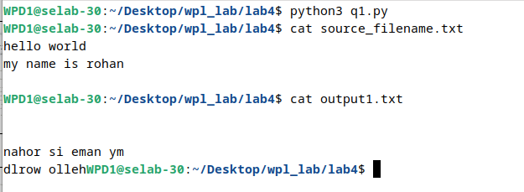

Q2] Write a python program to implement binary search with recursion.

CODE]

class BinarySearch:
def search(self,arr,l,r,num):
m=(l+r)//2
if arr[m]==num:
print(str(num)+" found at posn "+str(m))

elif arr[m]>num:
self.search(arr,l,m-1,num)
else:
self.search(arr,m+1,r,num)

arr=[1,2,3,4,5,324,34,124,14,124]
arr.sort()
size=len(arr)
num=14
search1=BinarySearch()
search1.search(arr,0,size-1,num)

OUTPUT]

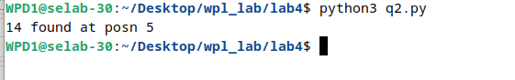

Q3] Write a python program to sort words in alphabetical order.

CODE]

sentence=input("enter a sentence:\n")
arr=sentence.split()
arr.sort()
print(arr)

OUTPUT]

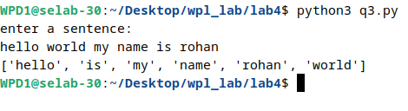

Q4] Write a Python class to get all possible unique subsets from a set of distinct integers Input:[4,5,6]
Output : [[], [6], [5], [5, 6], [4], [4, 6], [4, 5], [4, 5, 6]]

CODE]

class SubsetGenerator:
def get_subsets(self, nums):
subsets = [[]]

for n in nums:
new_subsets = []
for current_subset in subsets:
new_subsets.append(current_subset + [n])

subsets.extend(new_subsets)

return subsets

nums=[]
size=int(input("Enter the number of elements:"))
print("Enter the elements:")
for i in range(size):
element=int(input())
nums.append(element)
gen = SubsetGenerator()
print(gen.get_subsets(nums))

OUTPUT]
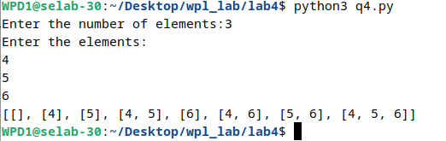

Q5] Write a Python class to find a pair of elements (indices of the two numbers) from a given array whose sum equals a specific target number.
Input: numbers= [10,20,10,40,50,60,70], target=50
Output: 3, 4.

CODE]

def TwoSum(arr,target):
flag=0
for i in range(0,len(arr)):
for j in range(i+1,len(arr)):
if arr[i]+arr[j]==target:
print([i,j])
flag=1
if flag==0:
print("does not exist\n")

arr=[]
num=input("enter no of numbers in the array:")

print("enter array elements:")
for i in range(int(num)):
element=int(input())
arr.append(element)

target=int(input("Enter the target:"))
TwoSum(arr,target)

OUTPUT]

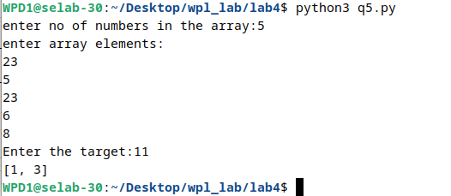
Q6] Write a Python class to implement pow(x, n).

CODE]

class POW:
def power(self,x,n):
return pow(x,n)

x=int(input("enter x:"))
n=int(input("enter x:"))

pow1=POW()
answer=pow1.power(x,n)
print(answer)

OUTPUT]

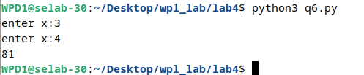

Q7] Write a Python class which has two methods get_String and print_String. The get_String accept a string from the user and print_String print the string in upper case.

CODE]

class Seven:
def get_String(self):
str=input("Enter a string:")
return str

def print_String(self,str):
strupper=str.upper()
print(strupper)

sev=Seven()
str=sev.get_String()
sev.print_String(str)

OUTPUT]

