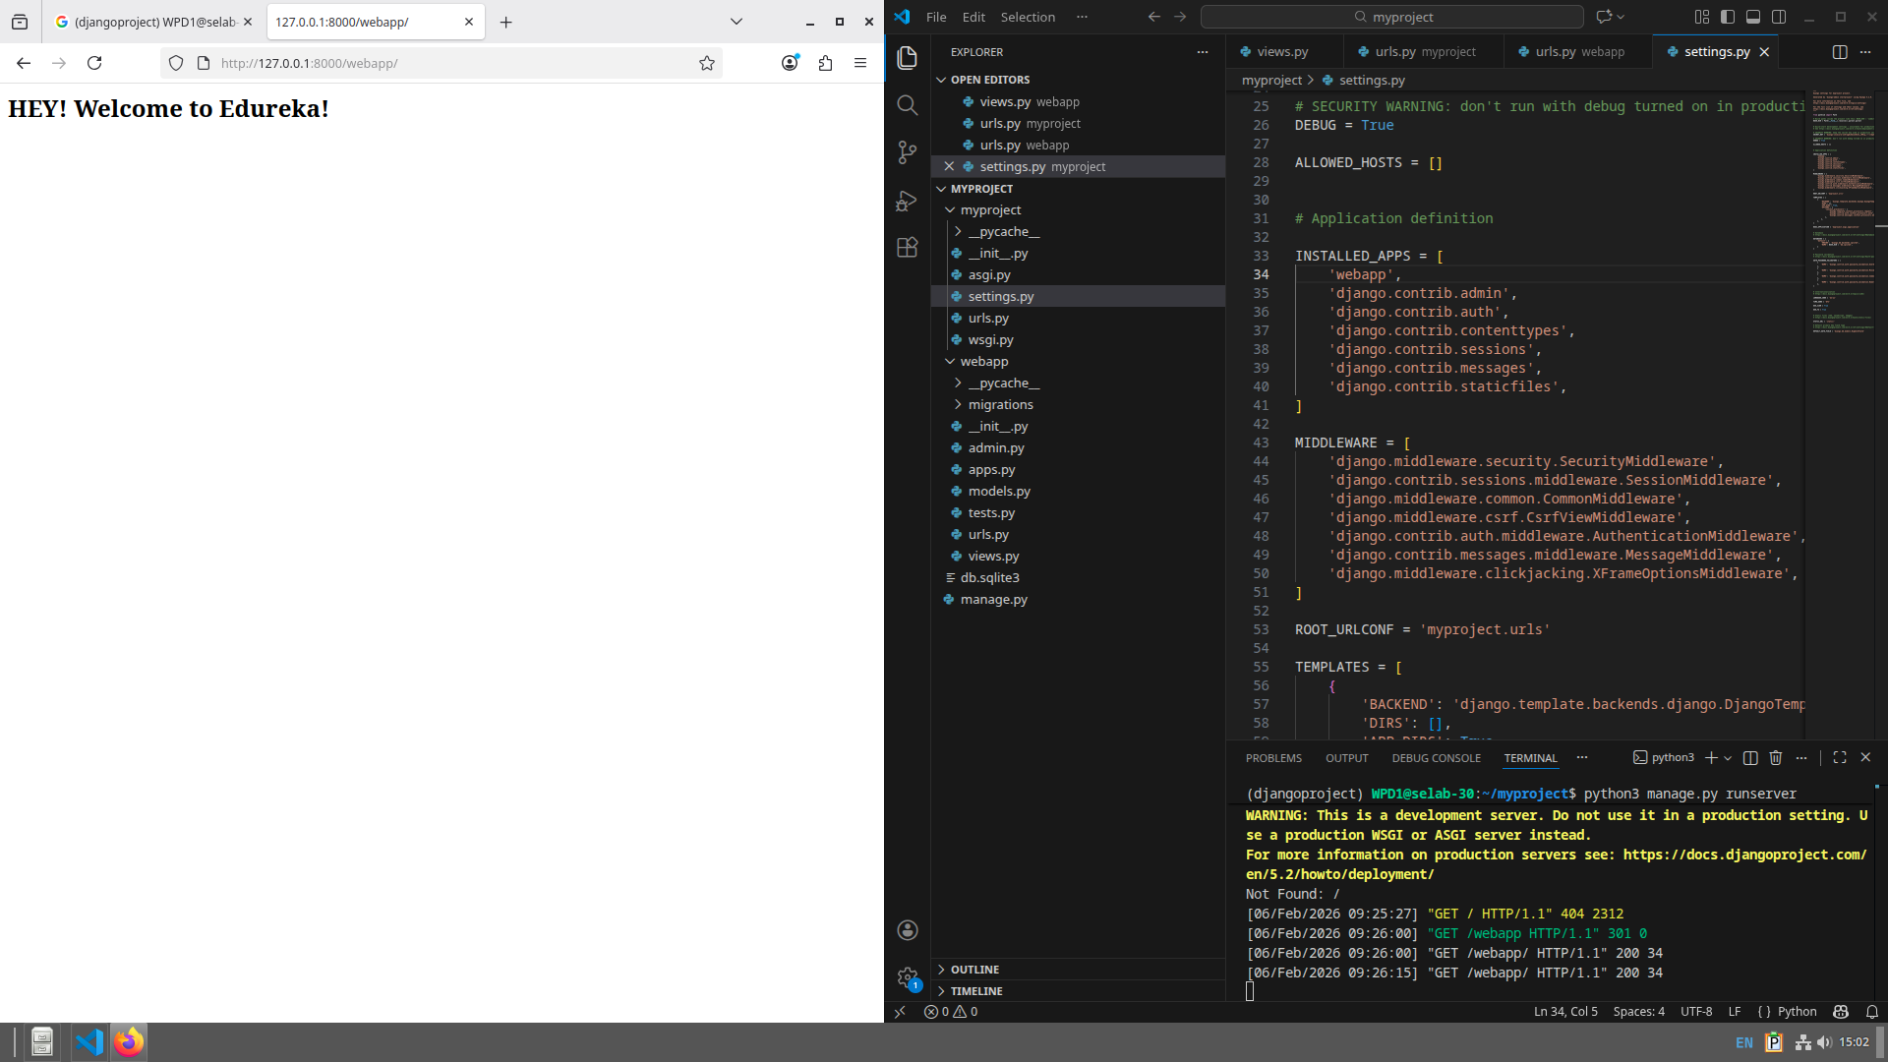
WEEK 5 WPL LAB
230905290
Rohan Shenoy
Roll no 32
CSE D1

