WPL LAB6 230905290 Rohan Shenoy Rollno 32

Q1] Develop a simple web page to perform basic arithmetic operations. Take two
integer inputs from the user, select the operation to be performed using a
dropdown. Include a button “Calculate” to perform the selected operation, and
then display the result in the same web page.

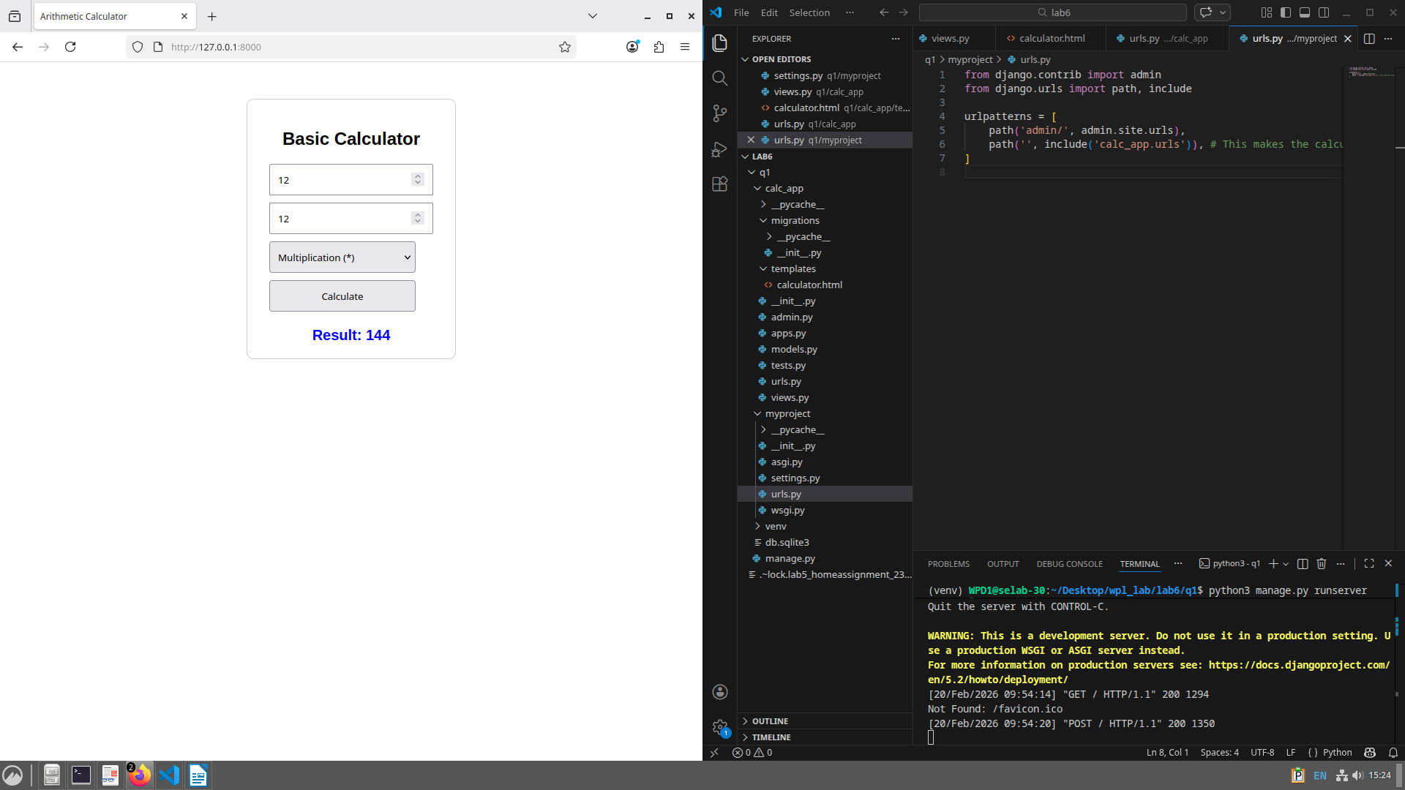

Q2] Develop a simple web form that generates the front cover for a magazine. The
form should provide the options for selecting the image, background color,
changing font size, color etc. Input messages must be taken from the user so
as to display it on the front cover with legible font family and font size. The
front cover developed should be proportionate to the web page size. Place the
css files inside static folder.

