Machine-Learning Prediction and Game-Theoretic Optimization of Sweetcrete, a Low-Carbon Concrete Incorporating Precipitated Calcium Carbonate
[Author Name(s)]
Department of Civil and Environmental Engineering, Idaho State University

Abstract
Sweetcrete is a low-carbon concrete that replaces a portion of Portland cement with precipitated calcium carbonate (PCC), a byproduct of sugar-beet refining. Using 178 laboratory specimens spanning PCC replacement levels of 0–50% and curing ages of 1–90 days, we developed a machine-learning model to predict compressive strength from a proposed mix. Shapley-value analysis (cooperative game theory) guided the selection of five deployment-valid features, deliberately excluding cured-specimen measurements that would leak the outcome. Among eight candidate models, a tuned Random Forest achieved a held-out test R² of 0.966 (RMSE 2.45 MPa), with a conservative cross-validated R² of approximately 0.89. SHAP interpretation confirmed the model captures established concrete physics. Framing mix design as a two-objective game between sustainability (maximizing PCC) and performance (maximizing strength), the Nash bargaining solution identifies approximately 30% PCC replacement as the balanced optimum. The complete pipeline is deployed as an interactive decision-support tool.

1. Introduction
Cement production is both costly and carbon-intensive, motivating partial-replacement materials that retain structural performance while reducing environmental impact. Sweetcrete addresses this by substituting a fraction of Portland cement with precipitated calcium carbonate (PCC), an abundant byproduct of regional sugar-beet refining, alongside upcycled aggregate. Beyond its environmental benefits, diverting PCC from disposal converts an industrial liability into a construction resource.
Selecting an optimal Sweetcrete mix is a multi-objective problem: increasing PCC replacement improves sustainability and cost but tends to reduce strength. Traditional trial-and-error mix design is slow and explores only a fraction of the design space. This work develops a data-driven alternative: a machine-learning model that predicts compressive strength from a recipe, an interpretability layer that explains its reasoning, and a game-theoretic optimizer that recommends balanced mixes.

2. Materials and Methods

2.1 Dataset and cleaning
Laboratory compression tests were arranged as a grid of PCC replacement level (0–50% in 5% increments) and curing age (1, 7, 28, 56, and 90 days), with replicate specimens per combination. Two data-quality issues were corrected: one physically impossible strength value (~506 MPa) was traced to a corrupted stress field and recomputed from load and area, and one internally inconsistent record was removed. The cleaned dataset comprised 178 specimens spanning 2.2–52.6 MPa.

2.2 Feature selection via Shapley values
Shapley values, a concept from cooperative game theory that fairly attributes a prediction among input features, were used to rank candidate variables. Five features were retained, balancing importance, non-redundancy, and deployment validity: curing age, cement content, PCC fraction, water-to-cement ratio, and coarse-aggregate content. Cured-specimen measurements (density, weight, and cylinder dimensions) were deliberately excluded because they are unknown at the design stage; including them would constitute data leakage and render the model unusable as a true design tool.
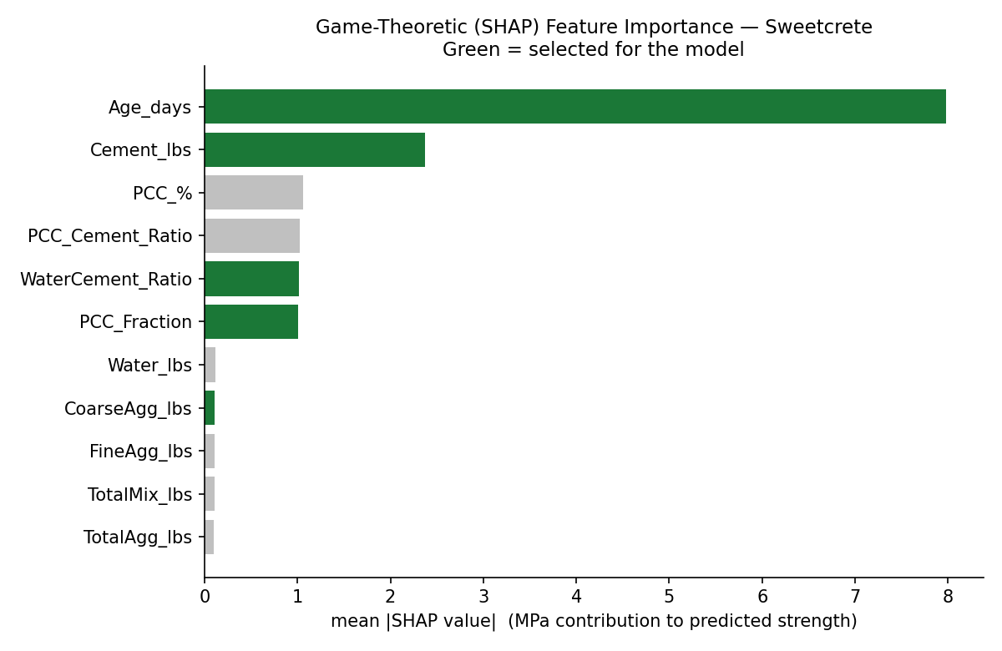
Figure 1. SHAP-based feature importance. Selected features in green.

2.3 Preprocessing and validation
Data were split 80/20 into training and test sets, stratified by PCC level so every replacement level appears in both partitions. Feature standardization was wrapped inside the model pipeline so the scaler is fit only on each fold’s training data, preventing leakage. Model selection used repeated five-fold cross-validation (three repeats) for stable estimates on the modest sample size.

2.4 Modeling
Eight regression models were compared under identical cross-validation: linear and ridge regression, k-nearest neighbors, support vector regression, random forest, extremely randomized trees, gradient boosting, and XGBoost. The leading tree-based and boosting models were tuned by randomized hyperparameter search, and the model with the best held-out performance was selected as final.

3. Results

3.1 Exploratory analysis
Strength followed the expected concrete curing curve—rising steeply through 28 days, then plateauing—while higher PCC replacement systematically lowered strength. At the 28-day benchmark, strength remained usable up to roughly 20–30% PCC before declining sharply beyond 40%.
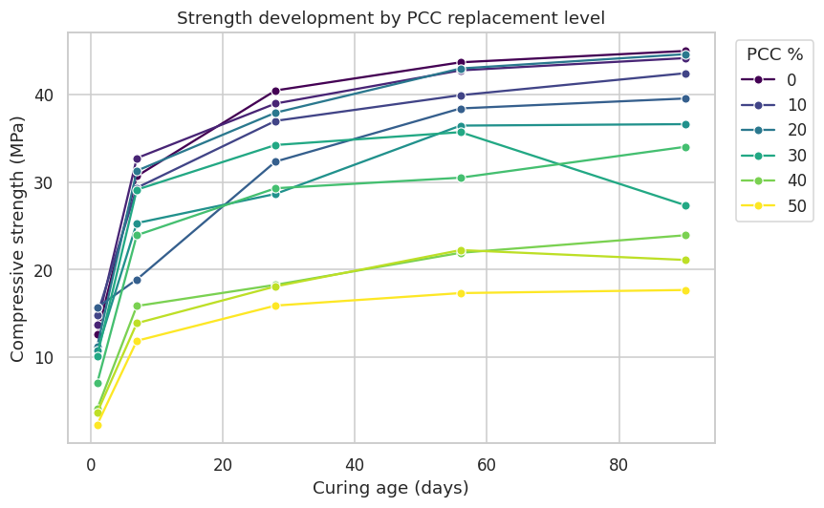
Figure 2. Strength development by curing age across PCC replacement levels.

3.2 Model comparison and performance
Tree-based and boosting models substantially outperformed linear and distance-based models, confirming that strength depends non-linearly on the inputs. After tuning, a Random Forest was selected as the final model.
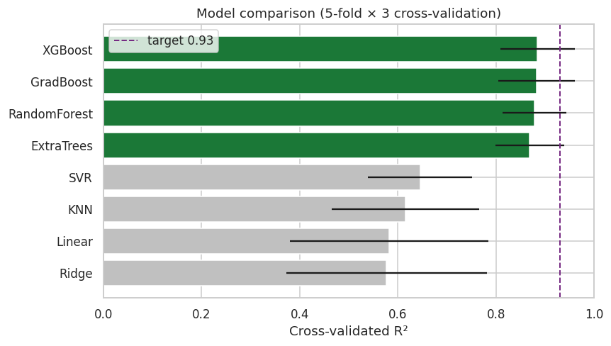
Figure 3. Cross-validated R² across eight candidate models; target 0.93 dashed.
The final model exceeded the 0.93 target on the held-out test set. The test R² is higher than the cross-validated value because the test set is small (36 specimens) and shares mix and age combinations with training; both figures are reported for transparency, with the cross-validated value taken as the conservative estimate.
Metric | Value
Test R² | 0.966
Test RMSE | 2.45 MPa
Test MAE | 1.54 MPa
Cross-validated R² | ≈ 0.89
Table 1. Final model (tuned Random Forest) performance.
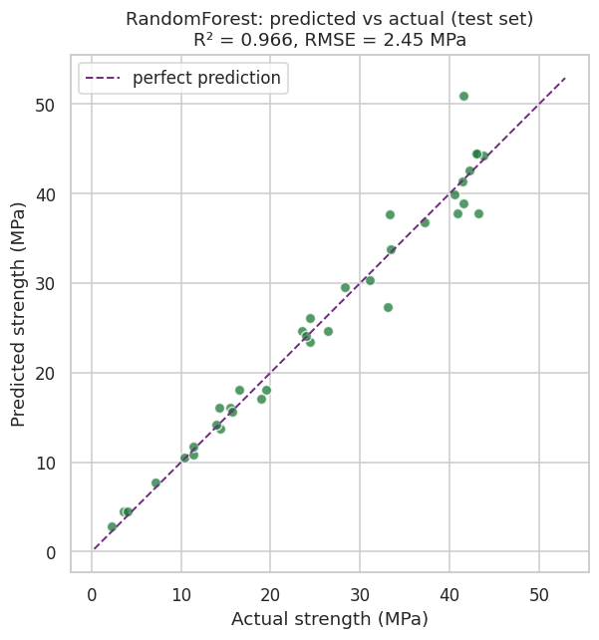
Figure 4. Predicted versus actual strength on the held-out test set.

3.3 Interpretability
Applying SHAP to the trained model shows it learned established concrete physics: greater curing age increases predicted strength, while higher PCC replacement and higher water-to-cement ratio decrease it, consistent with Abrams’ law. The model is therefore interpretable rather than a black box, and every prediction decomposes into additive feature contributions.
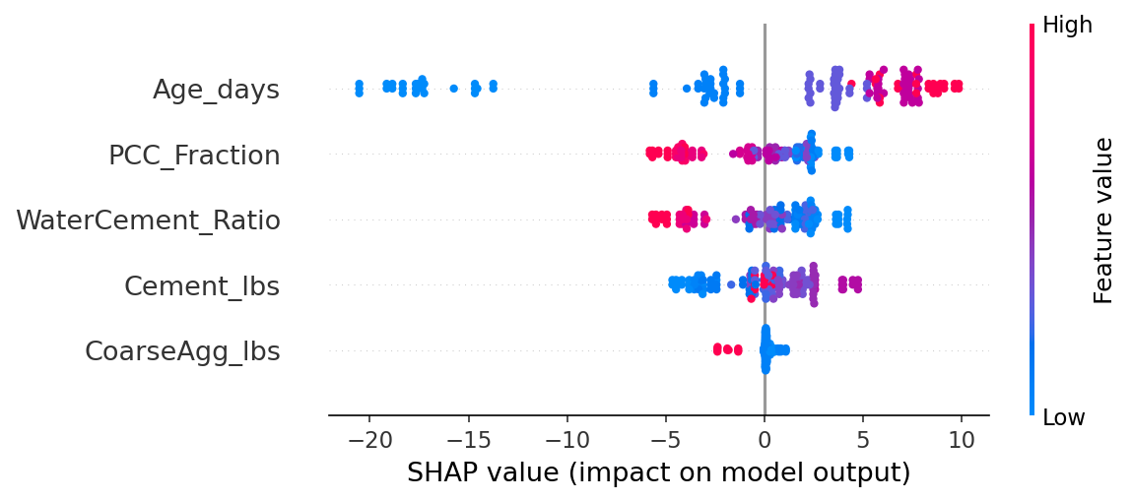
Figure 5. SHAP summary (beeswarm): direction and magnitude of each feature’s effect.

3.4 Game-theoretic optimization
Mix design was framed as a two-player game between sustainability (maximizing PCC) and performance (maximizing strength), with the trained model as the objective. The Pareto-efficient frontier captures the non-dominated trade-offs, and the Nash bargaining solution—maximizing the product of both players’ normalized gains—identifies approximately 30% PCC as the balanced optimum, located at the knee of the frontier before a sharp strength decline beyond 35%.
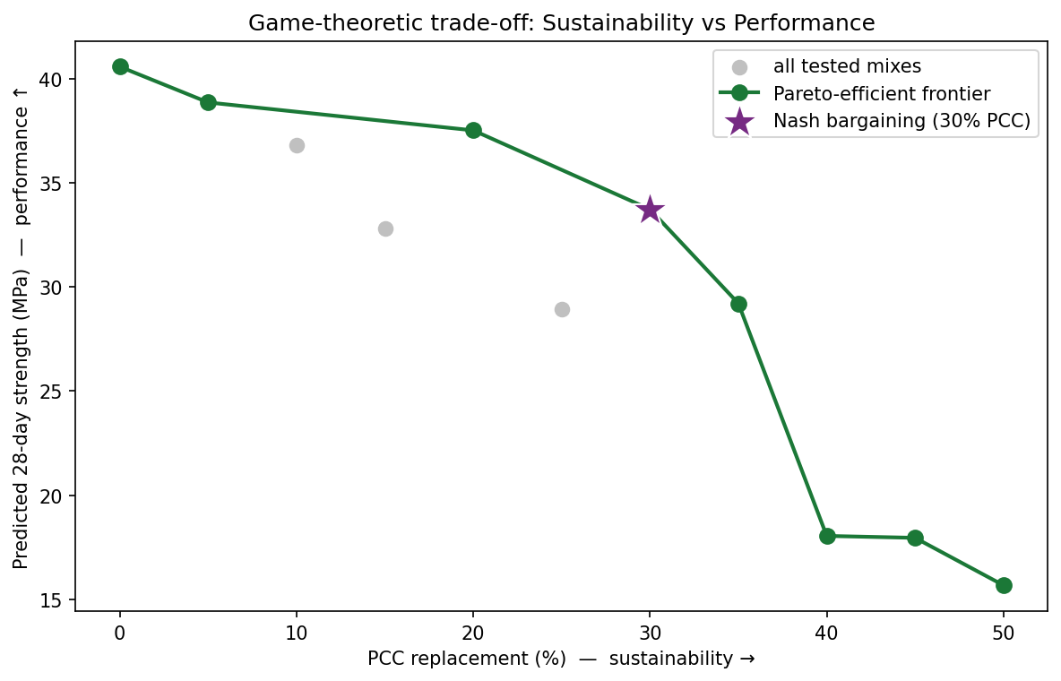
Figure 6. Sustainability–performance frontier with the Nash bargaining solution (★).

4. Discussion
The results demonstrate that a compact, interpretable model can predict Sweetcrete strength accurately and support principled mix selection. A key limitation is that, in this dataset, mix proportions were fixed per PCC level, so water-to-cement ratio and PCC move together; the independent predictive signal therefore derives mainly from age, PCC, and cement content. Experiments that vary water-to-cement ratio independently—and that incorporate the project’s planned use of treated wastewater—would let the model resolve these effects separately and strengthen the optimization.

5. Conclusion and Future Work
A Random-Forest model predicts Sweetcrete compressive strength with a test R² of 0.966, and a game-theoretic analysis identifies approximately 30% PCC replacement as the balanced optimum between sustainability and strength. The pipeline is deployed as an interactive tool for engineers. Future work includes decoupling water-to-cement ratio from PCC level, adding cost and durability objectives, quantifying prediction uncertainty, group-wise validation against unseen mixes, and field validation against full-scale pours.

References
Breiman, L. (2001). Random Forests. Machine Learning, 45(1), 5–32.
Chen, T., & Guestrin, C. (2016). XGBoost: A Scalable Tree Boosting System. Proceedings of KDD, 785–794.
Lundberg, S. M., & Lee, S.-I. (2017). A Unified Approach to Interpreting Model Predictions. Advances in Neural Information Processing Systems, 30.
Nash, J. F. (1950). The Bargaining Problem. Econometrica, 18(2), 155–162.
Pedregosa, F., et al. (2011). Scikit-learn: Machine Learning in Python. Journal of Machine Learning Research, 12, 2825–2830.

