Snapshot of steps to deploy the Spring Boot application on AWS using AWS EC2

1. Create the instance “Loan Application”  
     
   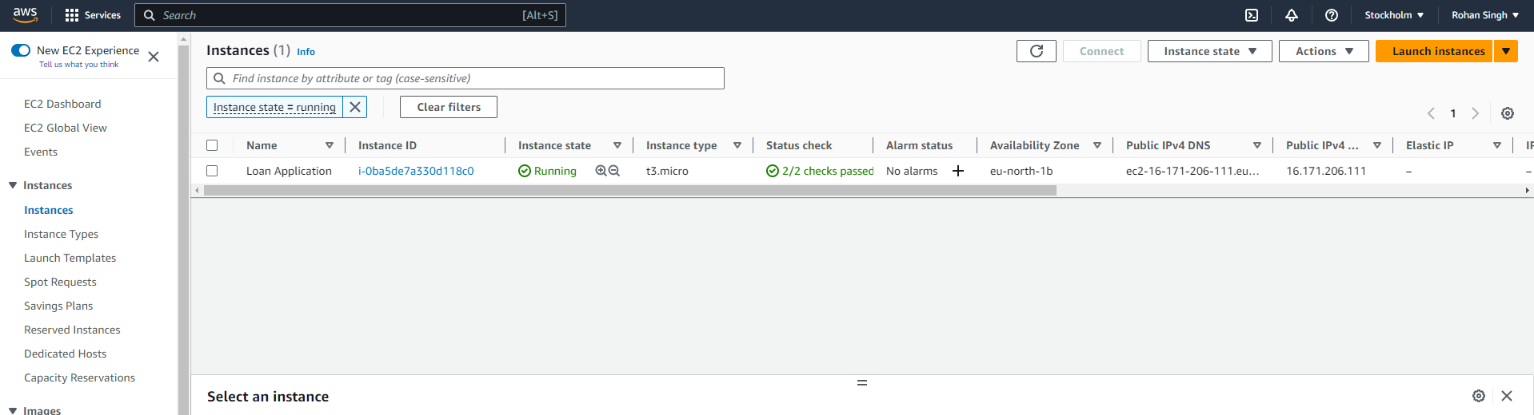
2. Add the rule with Custom TCP type and port 9090 for our application  
     
   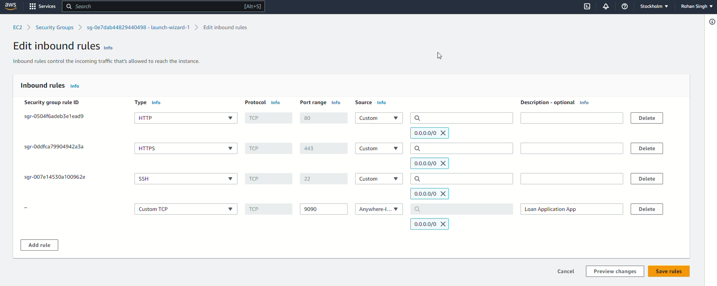
3. After connecting to the instance, install java 17 as below:  
    sudo yum install java-17-amazon-corretto

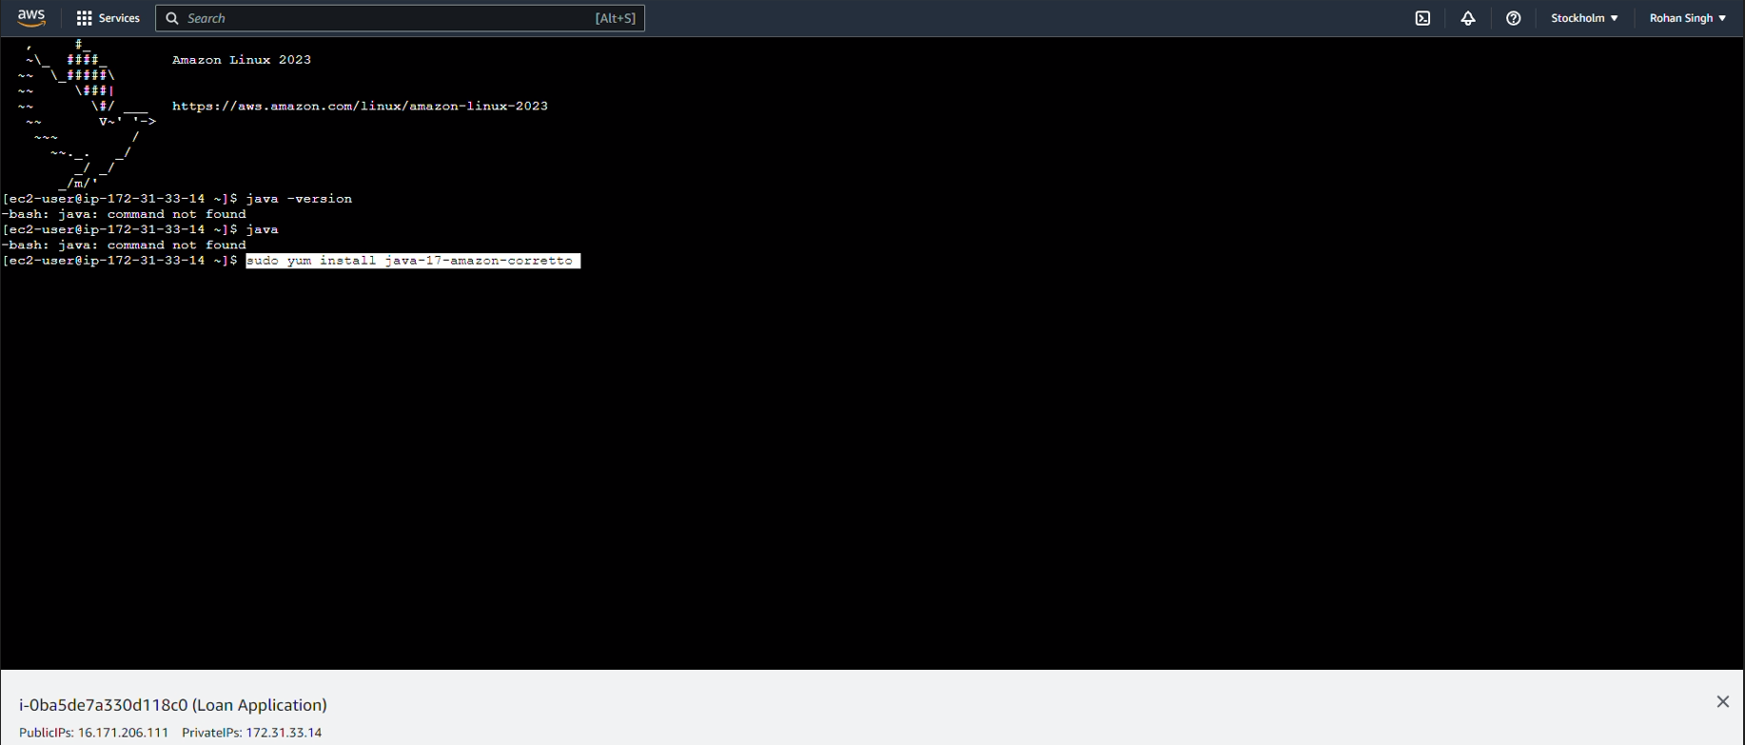

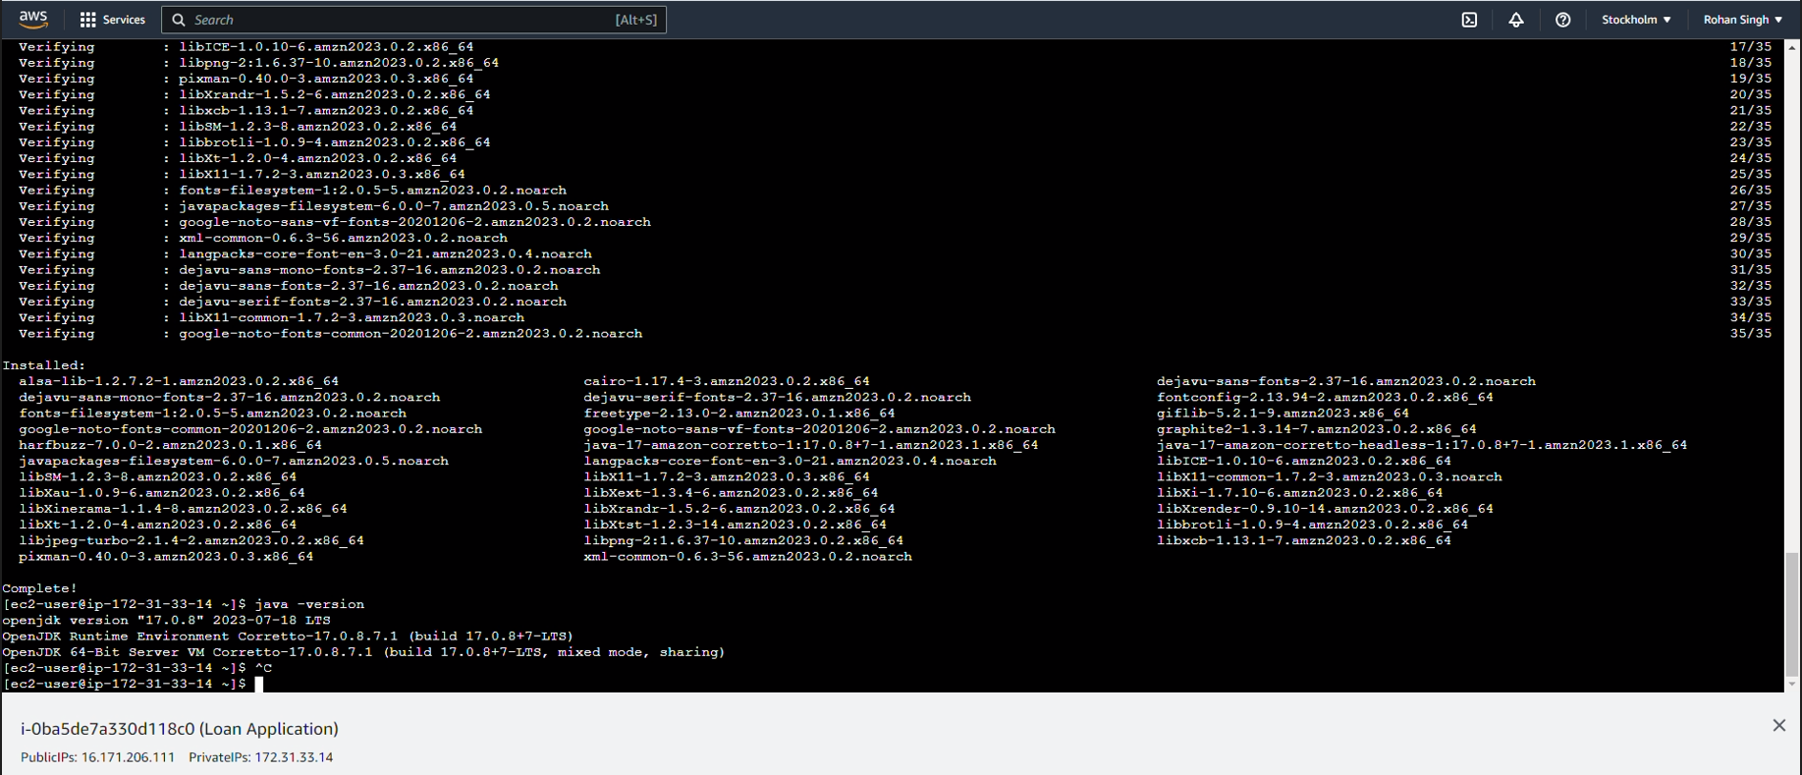

1. Copy the jar file to AWS EC2

We can use WinSCP to upload the Spring Boot JAR/WAR file to the EC2 instance.

We need to use the public IPv4 DNS of the created instance as hostname and username as below:

```bash

Hostname: ec2-16-171-206-111.eu-north-1.compute.amazonaws.com

Username: ec2-user

```

I have copied a demo application for printing "Hello World" and the jar is named as demo-0.0.1-SNAPSHOT.jar.

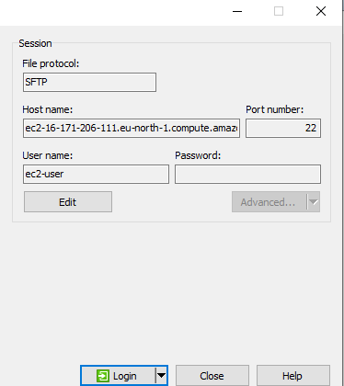

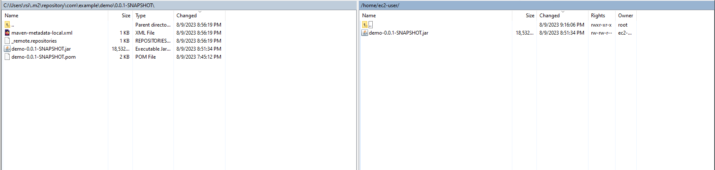

1. Connect to EC2 instance using putty  
     
   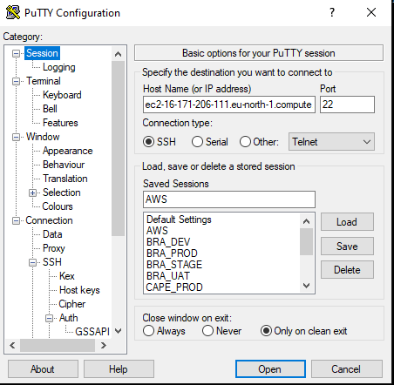

Use the ppk in auth tab   
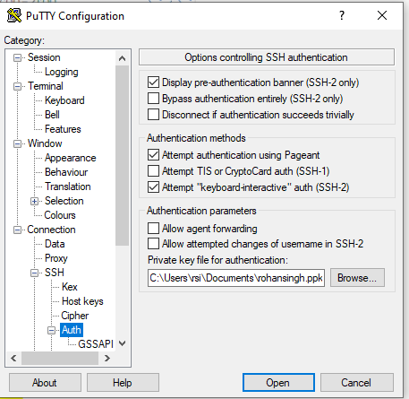

1. Run Your Application:

- We need to use tools like Putty to run the application.

- Connect to EC2 instance using Putty

- Use the SSH key pair (rohansingh.ppk) that you've configured during the instance creation. For eg. rohansingh.ppk in my case. Provide the path of the ppk in Auth section of the configuration.

- Hostname is same as above

Hostname: ec2-16-171-206-111.eu-north-1.compute.amazonaws.com

* After connecting to the SSH, use the login as : ec2-user

- Start your Spring Boot application using a command like:

```bash

java -jar demo-0.0.1-SNAPSHOT.jar

```

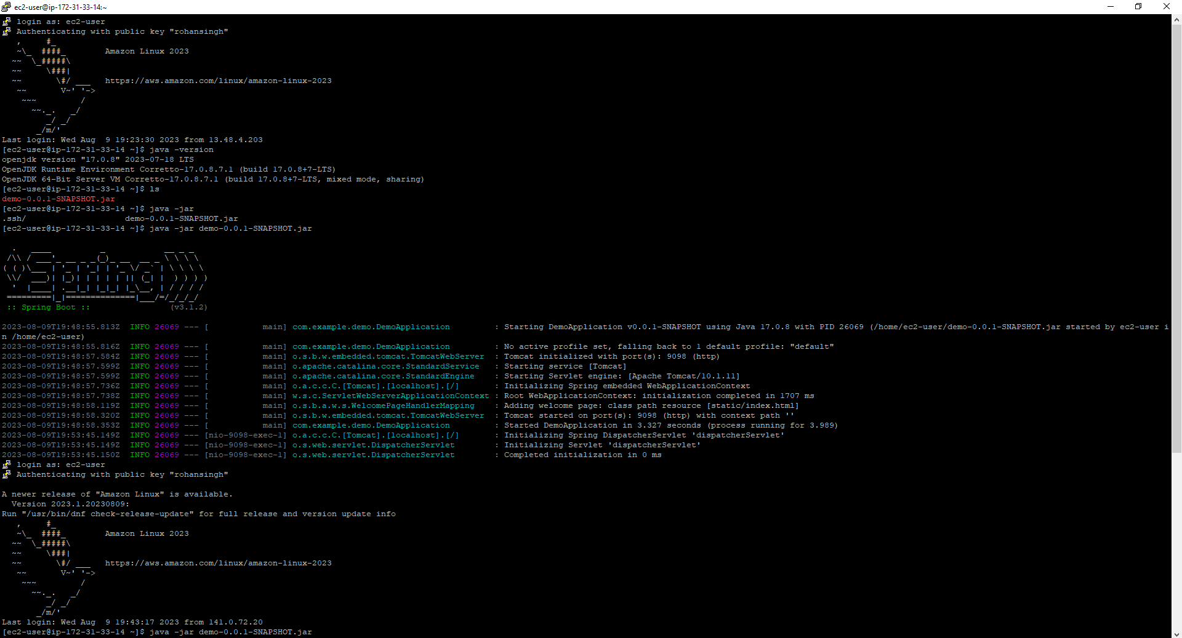

7. Access Your Application:

- Once the deployment is successful, you can access your application using the environment URL provided by EC2.

<http://ec2-16-171-206-111.eu-north-1.compute.amazonaws.com:9098/>

