**Project 2**

ENPM 661

2nd April, 2019

Rohan Singh

UID: 116166331

The code is written in Python3 (and tested only in Python3). The imported packages are as follows:

* import argparse
* import os, sys
* import math
* import numpy as np
* import cv2
* import matplotlib.pyplot as plt
* import matplotlib
* import time
* import heapq

**How to run the code:**

In the directory, open terminal.

1. Type in the command : “python3 proj2.py”
2. All the functionality is built into a single code. The code will ask for input one by one like this :

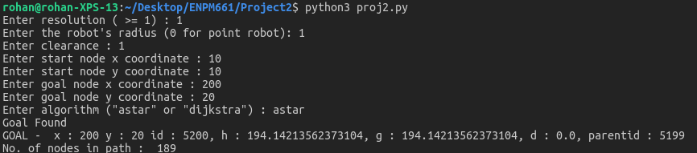

The code will ask for resolution(>=1), robot’s radius(>=0, 0 for point robot), clearance(<=0, 0 for no clearance), start coordinates, end coordinates (limits (0-250,0-250)), algorithm (‘astar’ for A* and ‘dijkstra’ for Dijkstra).

**NOTE:**

The code will also output goal state info and how many nodes are in the path (exluding start node).

The heuristic for A* is euclidean distance.

The GUI follows following color scheme :

1. Green : Start Node
2. Blue : Goal Node
3. Magenta : Visited(closed) nodes
4. Yellow : Active(open) nodes
5. Red : Path
6. Black : Obstacles (with minkowski sum)
7. White : Unexplored and free map

In case of incorrect output the program will display error.