**Case Study 1: How Does a Bike-Share Navigate Speedy Success?**

**Step 1: Ask**

**The Business Task:**

* Design marketing strategies aimed at converting casual riders into annual members with the aim of keeping sustainable growth and profit for the company.
* Identify the motivations and incentives that would drive casual riders to purchase Cyclistic annual memberships.
* How digital media can be effectively leveraged to influence casual riders to become annual members.

**Key stakeholders**

* **Cyclistic executive team** - will decide whether to approve the recommended marketing program.
* **Lily Moreno -** director of marketing - responsible for the development of campaigns and initiatives to promote the bike-share program.

The problem I am trying to solve:

**How can we convert casual members into annual members?**

We need to analyze first how casual members and annual members use Cyclistic for their needs. What can Cyclistic offer their casual riders so that they convert into annual members. ( Loyalty programs, incentives or deals )

**Step 2: Prepare**

**Data Sources Used**: We will be using historical trip data, i.e., Cyclistic Trip data from Dec 2022 to July 2023 from:

<https://divvybikes.com/system-data>, and

<https://divvy-tripdata.s3.amazonaws.com/index.html>.

Each data file contains historical information about the following:

1. Ride ID (ride_id)
2. Type of Ride – Electric/Classic Bikes (rideable_type)
3. Start time of ride (started_at)
4. End time of ride (ended_at)
5. Name of Starting station (start_station_name)
6. ID of starting station (start_station_id )
7. Name of Ending station (end_station_name)
8. ID of Ending station (end_station_id)
9. Starting Latitude (start_lat)
10. Starting Longitude (start_long)
11. Ending Latitude ( end_lat )
12. Ending Longitude ( end_long )
13. Membership – Casual or Annual (member_casual)

The data was loaded for analysis into two programming languages:

1. Big Query
2. R

However, we’ll be using R for the majority of analysis.

I installed and loaded packages: Tidyverse, dplyr, modeest, lubridate and janitor.

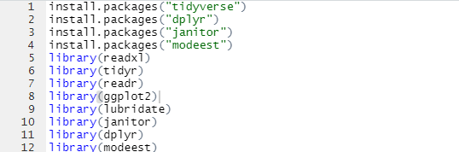

I then imported my data using read.csv:

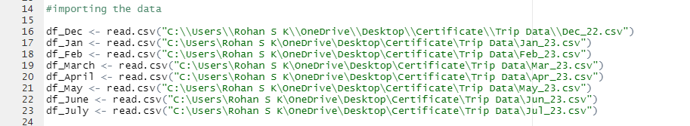

I checked for consistency of columns.

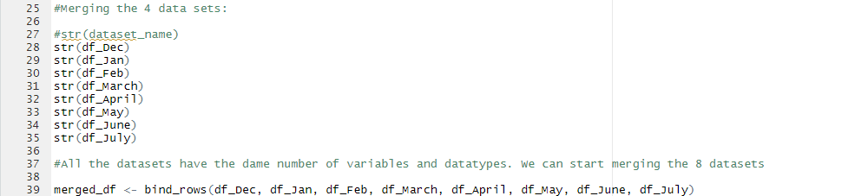

And merged them into a single dataframe.



**Step 3: Process**

I cleaned the data by removing parantheses, names and spaces. I also dropped empty rows and columns.

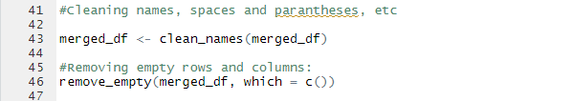

6. Created a ride length column to calculate the length of each ride.



7. Also created a day of the week column to record the day on which each ride was started.



I also created a starting hour and a starting month column for detailed analysis.

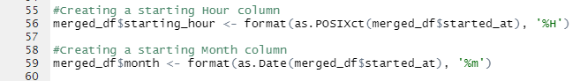

My dataset is now finally ready for analysis:

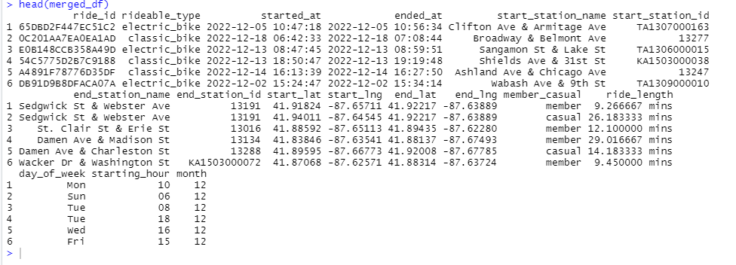

**Step 4: Analyze**

**Descriptive Analysis:**

First I dropped any null values from the data set. Then I performed descriptive statistics.

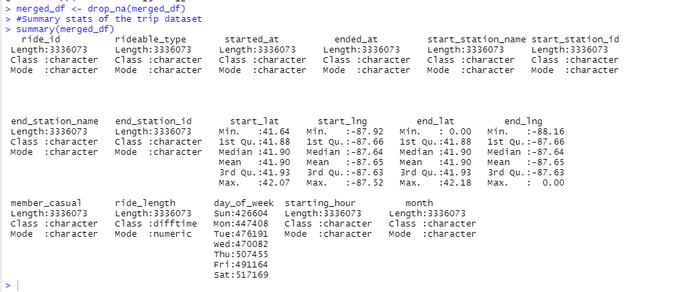

1. By Looking at the day of the week column, we can see that there were more rides on the weekends ( Fri, Sat & Sun ) than the other days. But how many of these are from Casual and annual members?

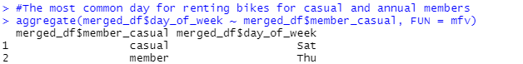

1. The average ride length



1. The average ride length for casual and annual members

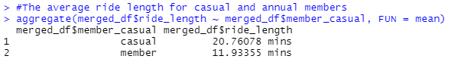

We can see that causal members spend almost twice as much time riding bikes than annual members. Let’s break that down by days of the week.

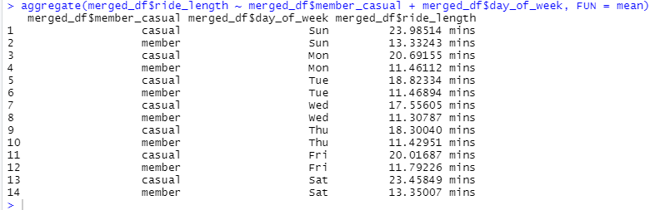

1. The median ride length for casual and annual members:

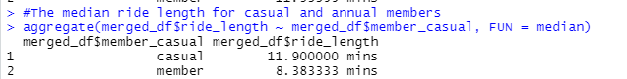

**Data Visualisations:**

I am using ggplot() to create visualizations

1. The number of rides by member type:

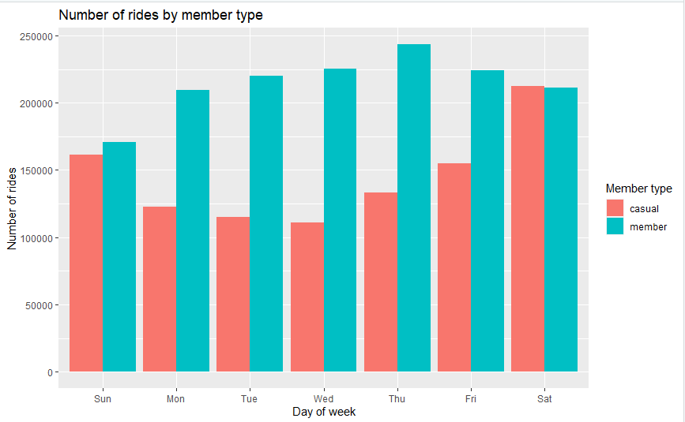

1. Number of rides month over month 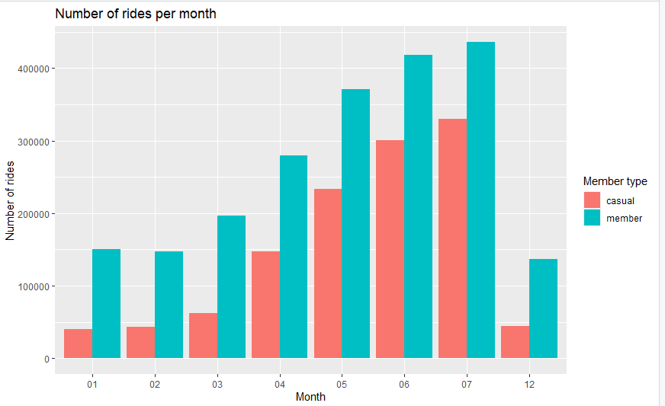

We see that there is an increasingly high usage as we move towards the middle of **the year.**

1. Hourly use of bikes throughout the week.

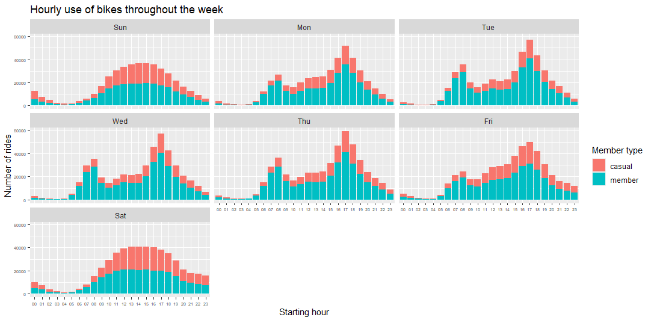

1. Let’s check the most popular riding stations:

For members, the most popular starting stations are: 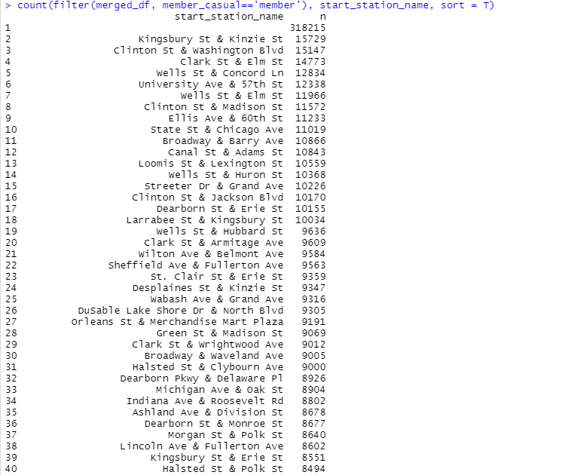

For members, the most popular ending stations are:

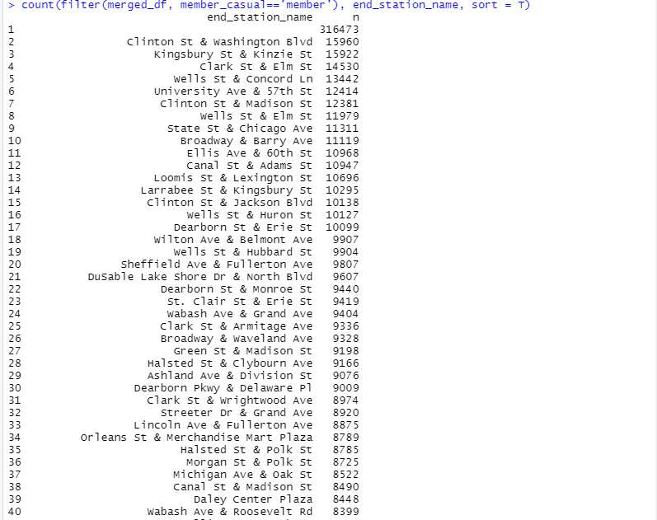

For casual members, the most popular starting stations are:

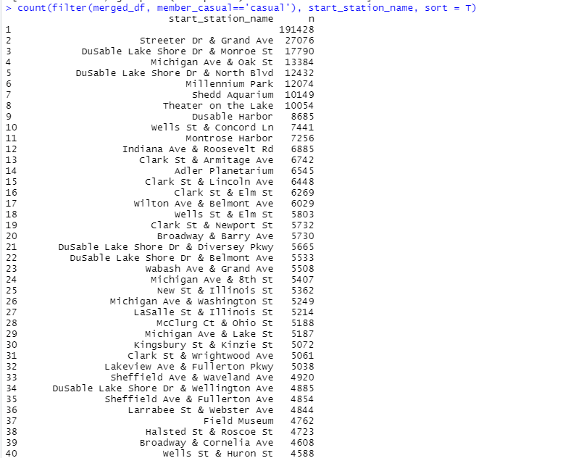

For casual members, the most popular ending stations are:

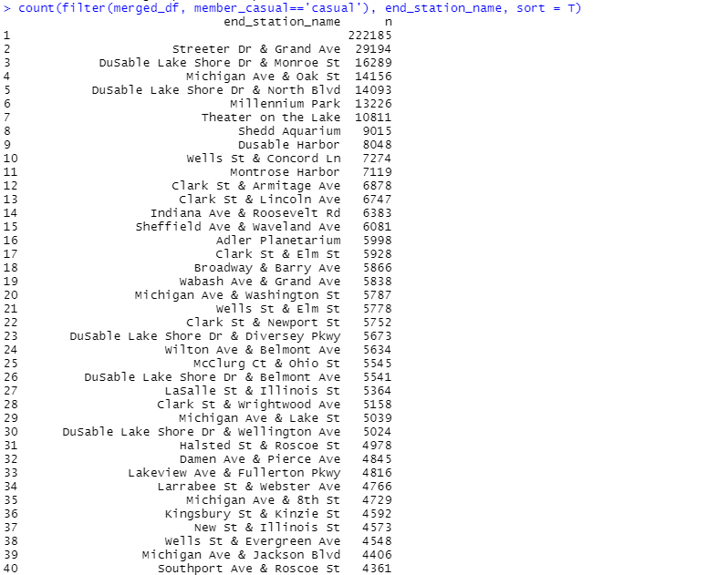

**Step 5: Share**

**Visualizations:**

1. **Total rides by members over the week**

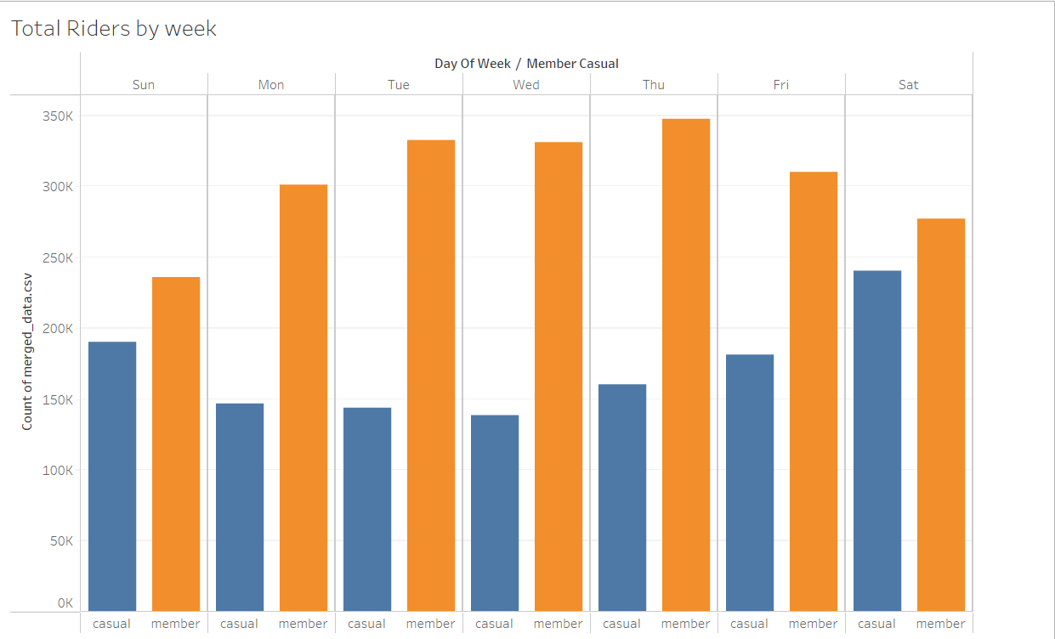

Annual members use bikes throughout the week – especially Tuesday, Wednesday and Thursdays. This might be because they use bikes to commute to work. Whereas casual members use bikes more on the Weekends – Saturday and Sunday.

1. **Average Trip Duration**

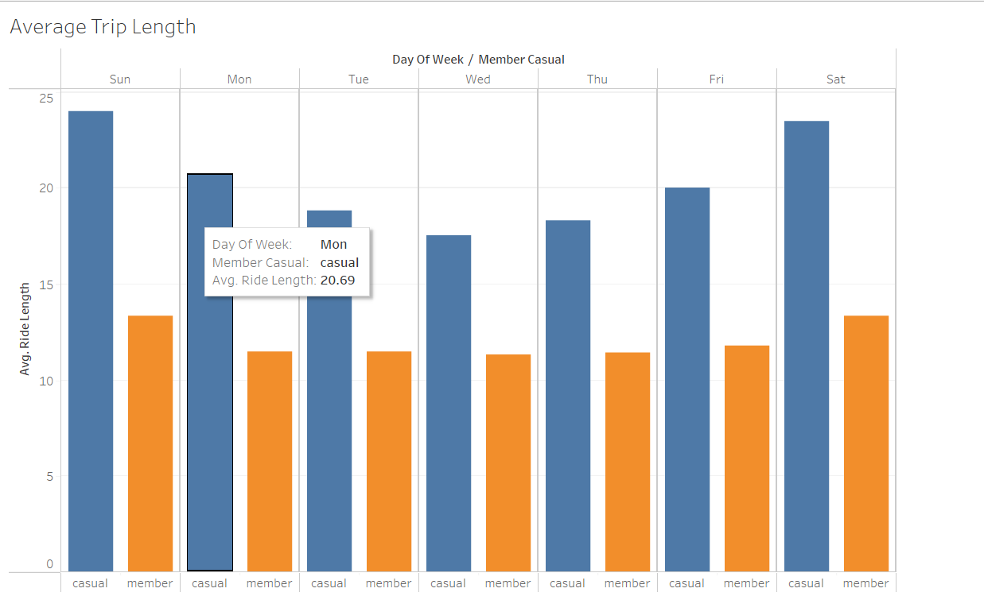

Casual Members spend more time on the bikes than annual members. This could be partly due to the fact that most casual bike riders use bikes for recreation or for exploring since they maybe tourists. Whereas annual members use it to commute to work spaces and grocery runs.

1. **Number of rides in a month**

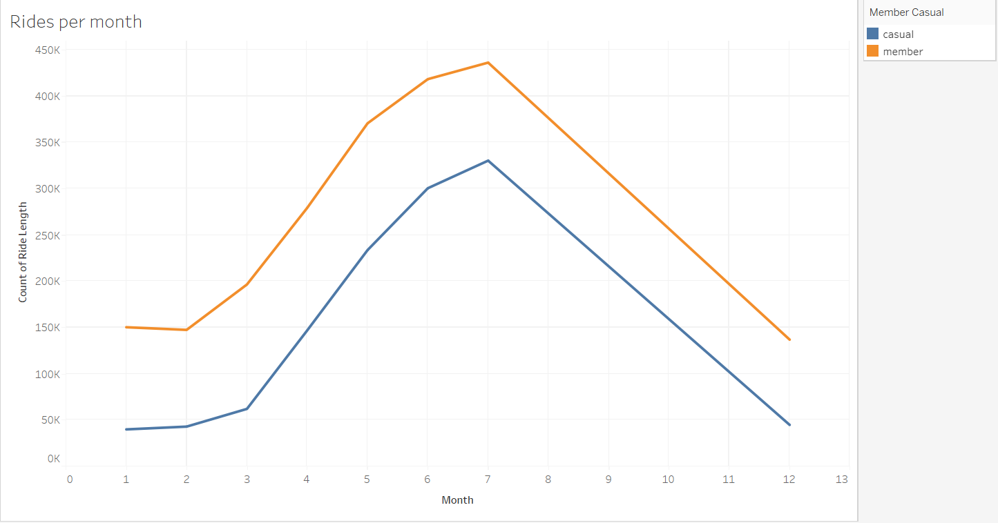

Seems like the number of rides for both annual and casual members peak at the middle of the year and fall towards the end. This could be due to the fact that winter sets in during the later part of the year and most people would rather use other modes of transport.

1. **Hourly use of bikes**

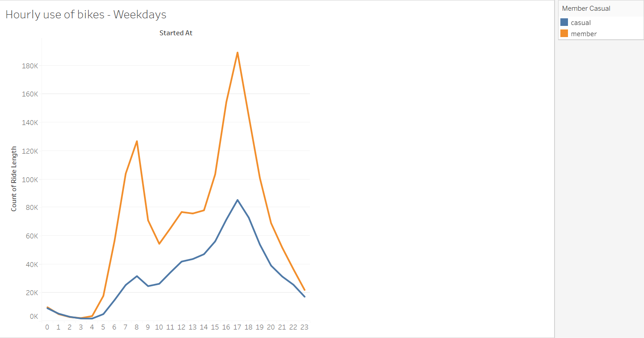

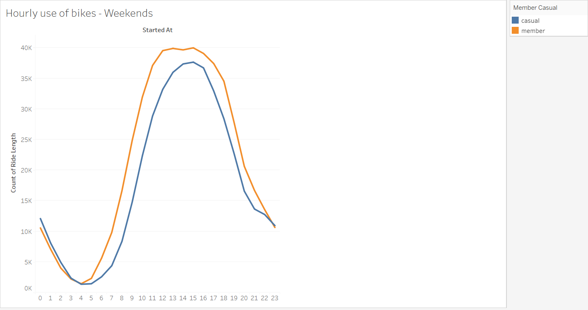

Based on the hourly usage of bikes on the weekdays, we can see that annual members ride in the morning hours between 6 to 8 AM. There is then a slight peak around 12 PM which is lunchtime followed by a bigger peak during the evening hours between 4PM to 8PM. This could suggest that most annual members are working class who commute to work and back.

Based on the hourly usage of bikes on the weekends, we see that casual members use bikes almost as much as annual members, starting from 9 AM and peaks in the evening at around 4PM.

**Step 6 Act:**

Recalling the Business Task: How can we convert casual members into annual members?

To help Moreno answer this question, I’ve some suggestions:

* **Design marketing strategies aimed at converting casual riders into annual members with the aim of keeping sustainable growth and profit for the company.**

1. Making one day passes more expensive so that owning a membership would be a better deal than purchasing a one day pass.
2. Advertise in the months leading to May, June and July, since we see an increase in the number of riders in those months.

* **How digital media can be effectively leveraged to influence casual riders to become annual members.**

1. Advertise based on location on Social Media – Instagram and Facebook to target casual members around popular stations to want to upgrade to annual memberships.

* **Identify the motivations and incentives that would drive casual riders to purchase Cyclistic annual memberships.**

1. Offering casual members eco-friendly alternatives to commute to work.

( Ex: Advertise based on the amount spent on cabs and gas as compared to bikes)

Based on my findings, I believe, these marketing strategies would help Cyclistic convert casual members to annual members