**A PROJECT REPORT ON**

**ONE-STOP PLATFORM**

SUBMITTED TO THE SAVITRIBAI PHULE PUNE UNIVERSITY, PUNE

IN THE PARTIAL FULFILLMENT OF THE REQUIREMENTS

FOR THE AWARD OF THE DEGREE

**BACHELOR OF ENGINEERING**

**(COMPUTER ENGINEERING)**

##### SUBMITTED BY

**STUDENT NAME Exam No**

**SHIFA KHAN B191034233**

**REVATI PANDE B191034248**

**SAYLI PANSARE B191034250**

**VRUSHANK BHOSALE B191034273**

**Under the Guidance of**

**Prof. Anita Mahajan**

## 

## DEPARTMENT OF COMPUTER ENGINEERING

**DR D.Y. PATIL SCHOOL OF ENGINEERING AND TECHNOLOGY**

CHARHOLI BUDRUK, LOHEGAON, PUNE 412105

## SAVITRIBAI PHULE PUNE UNIVERSITY

## 2023 -2024



**DR D.Y. PATIL SCHOOL OF ENGINEERING AND TECHNOLOGY**

CHARHOLI BUDRUK, LOHEGAON, PUNE 412105

## DEPARTMENT OF COMPUTER ENGINEERING

**CERTIFICATE**

This is to certify that the Project Report Entitled

**“ONE-STOP PLATFORM”**

Submitted by

STUDENT NAME Exam No

**SHIFA KHAN B191034233**

**REVATI PANDE B191034248**

**SAYLI PANSARE B191034250**

**VRUSHANK BHOSALE B191034273**

are bonafide students of this institute and the work has been carried out by them under the supervision of **Prof. Anita Mahajan** and it is approved for the partial fulfillment of the requirement of Savitribai Phule Pune University, for the award of the degree of **Bachelor of Engineering** in Computer Engineering.

**Prof. Anita Mahajan** **Dr. Pankaj Agarkar**

Guide H.O.D

Department of Computer Engineering Department of Computer Engineering

Signature of Internal Examiner: Signature of External Examiner:

**Dr. F. B .Sayyad**

Principal

AJEENKYA DY PATIL SCHOOL OF ENGINEERING, Lohegaon, Pune-412015

Place : Pune

Date : 22/11/23

**ACKNOWLEDGEMENT**

It gives us great pleasure in presenting the preliminary project report on “One-Stop”.

We would like to take this opportunity to thank our Internal Guide **Prof. Anita Mahajan** for giving us all the help and guidance we needed. We are really grateful to her for her kind support. Her valuable suggestions were very helpful.

We are also grateful **to Dr. Pankaj Agarkar**, Head of Computer Engineering Department,

ADYPSOE, Lohegaon, Pune and to our Project Co-ordinator **Prof. Bhagyashri Vyas** for their

indispensable support, suggestions and motivation during the entire course of the project.

We would also be grateful to our Principal Dr. F.B.Sayyad who encouraged us and created a

healthy environment for all of us to learn in best possible way.

We also thank all the staff members of our college and technicians for their help in making this

project a successful one.

**NAME OF THE STUDENTS**

**SHIFA KHAN**

**REVATI PANDE**

**SAYLI PANSARE**

**VRUSHANK BHOSALE**

**ABSTRACT**

**“One-Stop - The All-in-One Academic and Professional Networking Platform"**

In today's dynamic educational and professional landscape, the need for effective networking and mentorship is paramount. “Our project, “One-Stop”, addresses this critical issue by creating an innovative platform that acts as a link between alumni and current students. This portal not only allows alumni and students to network, but it also provides a full solution for mentorship, resource sharing, employment updates, and interactive live sessions.

The project's primary objective is to create a digital ecosystem that seamlessly connects alumni and students from various academic disciplines. It aims to foster meaningful connections, bridging the gap between academic knowledge and real-world insights. By leveraging the power of technology and social networking, our platform aims to empower students with mentorship opportunities, access to valuable resources, and timely updates on job and internship opportunities.

What sets this project apart is its unique approach to alumni-student connectivity. Unlike existing solutions, our platform combines networking with mentorship, enabling students to pair with alumni in their respective fields. Through a sophisticated matching algorithm, students are connected with alumni who share their academic interests and career goals. This personalized approach ensures that mentorship is tailored to each student's needs and aspirations.To achieve these objectives, our project leverages a stack of cutting-edge technologies and methodologies. The platform combines the power of Next.js and React for a responsive and interactive user interface. Machine learning algorithms, powered by Python and AI, are employed for precise alumni-student matching, ensuring the most relevant connections. Additionally, real-time chat functionality, hosted on a scalable cloud infrastructure, enhances user engagement and facilitates seamless knowledge sharing. Our project also incorporates data science techniques to analyze user behavior and optimize the platform's performance.The expected outcomes of this project are twofold: first, a thriving online community where students can seek guidance, share resources, and explore career opportunities; second, a network of empowered alumni who actively contribute to the academic and professional growth of the next generation.

In conclusion, "OneStop" presents an innovative solution to a critical problem in education and career development. By seamlessly integrating networking and mentorship, this project aims to create a vibrant ecosystem that empowers students and enriches alumni's engagement with their alma mater. Its potential implications extend beyond individual growth, contributing to the broader field of education and professional development.

Technical Keywords: Alumni-Student Networking, Mentorship, Resource Sharing, Machine Learning, Real-time Chat, Education, Career Development, Social Networking, Digital Ecosystem.

**TABLE OF CONTENTS**

1. LIST OF ABBREVATIONS
2. LIST OF FIGURES
3. LIST OF TABLES

|  |  |  |  |  |  |  |  |
| --- | --- | --- | --- | --- | --- | --- | --- |
| **Sr. No.** | | | | **Title of Chapter** | | | **Page No.** |
| **01** | | | | **Introduction** | | |  |
|  | 1.1 | | | Overview | | |  |
|  | 1.2 | | | Motivation | | |  |
|  | 1.3 | | | Problem Definition and Objectives | | |  |
|  | 1.4 | | | Project Scope & Limitations | | |  |
|  | 1.5 | | | Methodologies of Problem solving | | |  |
| **02** | | | | Literature Survey | | |  |
| **03** | | | | Software Requirements Specification | | |  |
|  | | 3.1 | | Assumptions and Dependencies | | |  |
|  | | 3.2 | | Functional Requirements | | |  |
|  | |  | | 3.2.1 | | System Feature 1(Functional Requirement) |  |
|  | |  | | 3.2.2 | | System Feature2 (Functional Requirement) |  |
|  | |  | |  | | …… |  |
|  | |  | |  | | …… |  |
|  | | 3.3 | | External Interface Requirements (If Any) | | |  |
|  | |  | | 3.3.1 | | User Interfaces |  |
|  | |  | | 3.3.2 | | Hardware Interfaces |  |
|  | |  | | 3.3.3 | | Software Interfaces |  |
|  | |  | | 3.3.4 | | Communication Interfaces |  |
|  | | 3.4 | | Nonfunctional Requirements | | |  |
|  | |  | | 3.4.1 | | Performance Requirements |  |
|  | |  | | 3.4.2 | | Safety Requirements |  |
|  | |  | | 3.4.3 | | Security Requirements |  |
|  | |  | | 3.4.4 | | Software Quality Attributes |  |
|  | | 3.5 | | System Requirements | | |  |
|  | |  | | 3.5.1 | | Database Requirements |  |
|  | |  | | 3.5.2 | | Software Requirements (Platform Choice) |  |
|  | |  | | 3.5.3 | | Hardware Requirements |  |
|  | | 3.6 | | Analysis Models: SDLC Model to be applied | | |  |
| **04** | | | | System Design | | |  |
|  | | 4.1 | | System Architecture | | |  |
|  | | 4.2 | | Mathematical Model | | |  |
|  | | 4.3 | | Data Flow Diagrams | | |  |
|  | | 4.4 | | Entity Relationship Diagrams | | |  |
|  | | 4.5 | | UML Diagrams | | |  |
| **05** | | | | Project Plan | | |  |
|  | | | 5.1 | Project Estimate | | |  |
|  | | |  | 5.1.1 | Reconciled Estimates | |  |
|  | | |  | 5.1.2 | Project Resources | |  |
|  | | | 5.2 | Risk Management | | |  |
|  | | |  | 5.2.1 | Risk Identification | |  |
|  | | |  | 5.2.2 | Risk Analysis | |  |
|  | | |  | 5.2.3 | Overview of Risk Mitigation, Monitoring, Management | |  |
|  | | | 5.3 | Project Schedule | | |  |
|  | | |  | 5.3.1 | Project Task Set | |  |
|  | | |  | 5.3.2 | Task Network | |  |
|  | | |  | 5.3.3 | Timeline Chart | |  |
|  | | | 5.4 | Team Organization | | |  |
|  | | |  | 5.4.1 | Team structure | |  |
|  | | |  | 5.4.2 | Management reporting and communication | |  |
| **06** | | | | Project Implementation | | |  |
|  | | | 6.1 | Overview of Project Modules | | |  |
|  | | | 6.2 | Tools and Technologies Used | | |  |
|  | | | 6.3 | Algorithm Details | | |  |
|  | | |  | 6.3.1 | Algorithm 1 | |  |
|  | | |  | 6.3.2 | Algorithm 2 | |  |
|  | | |  | 6.3.3 | … | |  |
| **07** | | | | Software Testing | | |  |
|  | | | 7.1 | Type of Testing | | |  |
|  | | | 7.2 | Test cases & Test Results | | |  |
| **08** | | | | Results | | |  |
|  | | | 8.1 | Outcomes | | |  |
|  | | | 8.2 | Screen Shots | | |  |
| **09** | | | | Conclusions | | |  |
|  | | 9.1 | | Conclusions | | |  |
|  | | 9.2 | | Future Work | | |  |
|  | | 9.3 | | Applications | | |  |
|  | | | | **Appendix A**: Problem statement feasibility assessment using, satisfiability analysis and NP Hard, NP-Complete or P type using modern algebra and relevant mathematical models.  **Appendix B**: Details of paper publication: name of the conference/journal, comments of reviewers, certificate, paper.  **Appendix C**: Plagiarism Report of project report. | | |  |
|  | | | | **References**  Thomas Noltey, Hans Hanssony, Lucia Lo Belloz,”Communication Buses for Automotive Applications” In *Proceedings of the* 3rd *Information Survivability Workshop (ISW-2007)*, Boston, Massachusetts, USA, October 2007. IEEE Computer Society. | | |  |

**LIST OF ABBREVATIONS**

|  |  |
| --- | --- |
| **Abbreviation** | **Illustration** |
|  |  |
| VPN | Virtual Private Network |
| IP | Internet Protocol |
| IDS | Intrusion Detection System |
| TCP | Transmission Control Protocol |

**LIST OF FIGURES**

|  |  |  |
| --- | --- | --- |
| **Figure** | **Illustration** | **Page No.** |
|  |  |  |
| 1.1 | System Overview | 3 |
| 1.2 | System Behavior | 5 |
| 2.1 | TCP Header | 11 |
| 4.1 | Waterfall Model | 27 |
| 4.2 | Timeline Chart | 30 |
| 4.3 | DFD Level – 0 | 31 |
| 4.4 | DFD Level – 1 | 32 |
| 4.5 | DFD Level – 2 | 33 |
| 4.6 | Use case Diagram | 34 |
| 4.7 | Sequence Diagram | 35 |
| 4.8 | ER Diagram | 36 |
| 4.9 | Class Diagram | 37 |
| 4.10 | Component Diagram | 38 |
| 4.11 | Deployment Diagram | 39 |
| 4.12 | State Machine Diagram | 40 |
|  |  |  |

**LIST OF TABLES**

|  |  |  |
| --- | --- | --- |
| **Table** | **Illustration** | **Page No.** |
|  |  |  |
| 4.1 | Project Plan | 29 |
| 3.1 | Packet Information | 47 |
| 3.2 | Network Error | 48 |
| 3.3 | IP Configuration | 48 |
|  |  |  |
|  |  |  |
|  |  |  |
|  |  |  |

**01.** **INTRODUCTION**

**1.1 OVERVIEW**

OneStop is a dynamic web platform designed to revolutionize the college experience by offering a comprehensive suite of features tailored to the needs of students, alumni, and administrators. At its core, OneStop serves as a centralized hub for networking, mentorship, and resource-sharing, fostering meaningful connections and facilitating collaboration within the college community. Through real-time messaging, job/internship listings, educational resources, and mentorship opportunities, OneStop empowers users to engage actively in their academic and professional development journey.

Built on a robust technological foundation, OneStop leverages cutting-edge frontend technologies such as Next.js and React.js to deliver a seamless user experience. The backend infrastructure, powered by Django and Python, ensures secure user authentication and efficient data management. With a user-friendly interface and intuitive design, OneStop provides a cohesive platform where users can connect, learn, and grow together. As digital platforms continue to reshape the landscape of education and professional networking, OneStop stands out as an innovative solution poised to redefine the college experience for generations to come.

**1.2 MOTIVATION**

The journey of education and career development is often marked by key transitions: from student to professional, from novice to expert. In this path, connections, guidance, and resources play pivotal roles. Alumni, who have successfully navigated this journey, represent a valuable resource for current students. However, these interactions are often limited by traditional networking and communication channels.

Our project takes inspiration from the changing dynamics of education and career development in the digital age. It's driven by a recognition that technology can transform and enhance how students and alumni engage with each other.

One of the primary motivations for this project is the realization that existing solutions, while valuable, often provide only fragmented experiences. Students might find it challenging to connect with alumni, seek guidance, access resources, or stay informed about job opportunities due to the scattered nature of these offerings. This fragmentation not only hampers their educational and career development but also leaves a wealth of untapped potential among alumni who are eager to give back.

The project's motivation stems from the idea that a one-stop platform can bring cohesion to these fragmented experiences. It can offer students a singular, intuitive space where they can connect with alumni, seek mentorship, access resources, stay informed about job and internship opportunities, and engage in live sessions. In doing so, we aim to create a vibrant, synergistic ecosystem that benefits all users.

Furthermore, our project recognizes that the impact of alumni networks and mentorship programs on student success is well-documented in academic literature. The motivation is strengthened by a thorough literature survey that highlighted the potential of such platforms. By integrating the best practices from these studies and addressing the gaps in current solutions, we can create a platform that truly caters to the diverse needs of students and alumni.

In conclusion, the motivation behind this project is rooted in the belief that technology can be a transformative force in education and career development. By providing students and alumni with a unified, user-friendly, and feature-rich platform, we aim to empower them with the resources and connections needed to thrive in an ever-changing world.

**1.3** **PROBLEM DEFINATION AND OBJECTIVE**

In today's ever-evolving educational and professional landscape, the absence of a unified and user-centric platform that seamlessly connects students and alumni remains a significant challenge. Current solutions are fragmented, focusing on only one aspect of this multifaceted problem, which results in a disjointed user experience.

This project addresses the pressing need for a one-stop platform that effectively links students and alumni while providing comprehensive features including mentorship, resource-sharing, real-time job and internship updates, and live knowledge-sharing sessions. Such platforms are essential because they recognize that students require continuous support throughout their educational and career journeys, and alumni represent a wealth of experience and expertise that can significantly impact students' success.

The project's scope encompasses the creation of a web-based platform accessible to both students and alumni. It aims to provide a seamless, intuitive user experience, enabling connections, mentorship, resource-sharing, real-time job updates, and interactive live sessions. User-centered design and agile methodologies will be employed to ensure efficiency and adaptability.

By solving this problem, the project will contribute to the educational and career development of students, encourage meaningful connections, and harness the potential of alumni networks. It seeks to create a comprehensive solution that brings coherence and convenience to the alumni-student networking experience, benefiting users and society at large.

**OBJECTIVES**

The platform's primary objectives include:

1. User-Centric Experience: Develop an intuitive, user-friendly interface that caters to the distinct needs of both students and alumni, ensuring a seamless navigation and interaction experience.

2. Robust Mentorship Matching: Implement a sophisticated matchmaking algorithm that pairs students with alumni based on their shared fields and interests, fostering effective mentorship relationships.

3.Resource Sharing: Establish a resource-sharing system that allows students and alumni to contribute and access e-books, notes, practice questions, and other learning materials.

4. Real-Time Job and Internship Updates: Enable a feature that provides timely notifications to students and alumni about job openings and internship opportunities, helping them stay ahead in their career pursuits.

5. Interactive Live Sessions: Facilitate live and recorded sessions hosted by accomplished alumni, offering a dynamic space for knowledge sharing and interaction.

6. Community Building: Encourage the growth of a vibrant online community of students and alumni by facilitating discussions, forums, and user-generated content.

**1.4 PROJECT SCOPE AND LIMITATION**

The scope of this project encompasses the design, development, and deployment of a web-based platform that offers a user-centric, integrated solution for students and alumni. This comprehensive platform seeks to address their diverse needs by providing a singular point of access for networking, mentorship, resource-sharing, real-time job and internship updates, and interactive live sessions. The scope is designed to ensure the platform's efficiency, usability, and adaptability.

The platform's central components include:

1. User-Centric Design: The project will focus on creating a user-friendly interface accessible to both students and alumni. The interface will be intuitive and engaging, ensuring that users can seamlessly navigate the platform.
2. Matchmaking Algorithm: To facilitate effective mentorship, the platform will implement a matchmaking algorithm that pairs students with alumni who share similar fields of interest and expertise.
3. Resource Sharing System: A resource-sharing system will enable both students and alumni to contribute and access a wide range of materials, including e-books, notes, practice questions, and more.
4. Real-Time Updates: The platform will provide timely job and internship updates to keep users informed about career opportunities and industry developments.
5. Live and Recorded Sessions: Interactive live and recorded sessions will be available, hosted by accomplished alumni, offering a dynamic space for knowledge sharing and interaction.

The scope of this project excludes extensive AI or machine learning components, focusing instead on efficient and reliable solutions. Scalability, security, and mobile accessibility will be key considerations to ensure the platform's adaptability and robustness. Additionally, the project will not encompass exhaustive content creation but will offer a framework for users to contribute and share their knowledge adaptability.

**1.5** **METHODOLOGIES OF PROBLEM SOLVING**

To navigate the multifaceted challenges presented by this project, a blend of agile methodologies, modern web development technologies, and cloud-based solutions will be employed to ensure problem-solving and efficiency.

Agile Development Methodologies: The project will adopt agile methodologies, including Scrum or Kanban, to enable iterative development and user-centered design. Regular sprints and iterative feedback loops will empower the team to adapt to changing user needs and deliver incremental improvements. This approach enhances problem-solving by allowing for flexibility and responsiveness throughout the project's lifecycle.

Modern Web Development Technologies: The platform will leverage the latest web development technologies, including Next.js for the frontend and Django or Flask for the backend. These technologies offer robust features, efficient data handling, and enhanced user experiences. Using Next.js will facilitate server-side rendering for speed and SEO optimization, while Django or Flask will provide a scalable and secure backend foundation.

Cloud-Based Solutions: Cloud computing platforms, such as Amazon Web Services (AWS) or Microsoft Azure, will be employed to address efficiency issues related to scalability, performance, and data management. These solutions offer on-demand scalability, high availability, and data security, ensuring that the platform can grow with the increasing user base while maintaining responsiveness.

Additionally, a continuous integration and continuous deployment (CI/CD) pipeline will be implemented to automate testing, deployment, and updates, streamlining development processes and enhancing platform efficiency. Efficiency issues will also be tackled through best practices in coding, optimization, and careful resource management. Security measures will ensure data privacy, and mobile accessibility will be prioritized to cater to users on various devices. These methodologies and technologies will collectively drive efficient problem-solving while delivering a responsive, scalable, and reliable platform.

**02. LITERATURE SURVEY**

A literature survey of existing platforms and academic studies reveals the significance of alumni-student networking platforms and provides insights into their potential impact on educational and career development. This survey draws upon real-world examples of platforms, highlighting their features and contributions.

Table: Existing Alumni-Student Networking Platforms

|  |  |  |
| --- | --- | --- |
| Platform Name | Key Features | Contribution |
| LinkedIn | Profile-based networking, job postings, professional groups | Established for professional networking, lacking mentorship features. |
| Handshake | Job and internship search, campus recruiting | Primarily used by universities for job listings, limited alumni engagement. |
| MentorCity | Mentor-mentee pairing, resource library | Focuses on mentorship, lacks comprehensive networking features. |
| Graduway | Alumni directory, mentoring, events | Customizable alumni networking solutions for educational institutions. |

Academic studies underscore the importance of such platforms. Research by Ragins and Verbos (2007) found that mentorship can significantly impact students' career success. Polk (2010) emphasized the value of alumni networks in supporting students' educational and professional journeys.

The literature survey reveals that while existing platforms offer valuable features, none provide the all-encompassing approach proposed in this project. The envisioned platform aims to combine the strengths of these solutions, offering a single point of contact for students and alumni to connect, mentor, share resources, and access job updates, filling a crucial gap in the educational and professional landscape

**03. SOFTWARE REQUIREMENTS SPECIFICATION**

**3.1 ASSUMPTIONS**

1. College Database Integration: It is assumed that seamless integration with the college database is feasible, allowing access to user information, academic records, and other relevant data.
2. User Engagement: The success of the platform relies on active participation and engagement from both students and alumni. It is assumed that users will utilize the platform's features for networking, mentorship, job/internship postings, and resource sharing.
3. Data Privacy Compliance: Assumption is made that the platform will comply with data privacy regulations such as GDPR and college policies regarding user data protection and consent.
4. Technology Adoption: It is assumed that users will adapt to and utilize the technology stack effectively, including Node.js, Django, Firebase, and SQLite, without significant barriers to adoption.
5. Scalability Requirements: The platform is expected to accommodate a growing user base and increasing data volume over time. Assumption is made that scalability measures can be implemented to meet future demands.

**DEPENDENCIES**

1. College Database Access: Integration with the college database is a critical dependency for accessing user information and academic records. Any delays or issues in establishing this integration could impact the functionality of the platform.
2. Third-Party APIs: Dependencies exist on third-party APIs for certain features such as calendar synchronization, messaging, and job/internship listings. Any changes or disruptions to these APIs could affect the corresponding functionalities on the platform.
3. Regulatory Compliance: Compliance with data privacy regulations and college policies is essential. Dependencies exist on legal and regulatory frameworks, as well as internal policies, for ensuring data protection and user privacy.
4. Technology Stack: The platform's functionality relies on the effective implementation and integration of the chosen technology stack, including Node.js, Django, Firebase, and SQLite. Dependencies exist on the availability of resources and expertise in these technologies for development and maintenance.
5. User Engagement: The success of the platform depends on user engagement and adoption. Dependencies exist on users actively participating in networking, mentorship, job/internship postings, and resource sharing to realize the platform's objectives.

**3.2 FUNCTIONAL REQUIREMENTS**

1. NETWORKING AND CONNECTIONS FEATURE
2. User Authentication and Profile Creation: Users should be able to register and create profiles on the platform. Authentication mechanisms such as email verification or social media login should be implemented for user verification.
3. Profile Viewing and Search: Users, both students, and alumni, should have the ability to search for and view profiles of other users. Profiles should display relevant information such as academic background, career interests, and contact details.
4. Connection Requests: Users should be able to send connection requests to other users (e.g., students to alumni). They should also have the option to accept or decline connection requests received from other users.
5. Private Messaging: Connected users should be able to communicate privately via direct messaging. Messaging functionality should include features such as text chat, file sharing, and multimedia messaging.
6. **MENTORSHIP MATCHING FEATURE**
7. Algorithm-based Recommendation System: The platform should utilize machine learning algorithms to analyze user profiles and recommend suitable mentor-mentee pairs. Recommendations should be based on factors such as academic interests, career goals, and compatibility scores.
8. Mentorship Request and Acceptance: Students should be able to send mentorship requests to selected alumni mentors. Alumni mentors should have the option to accept or decline mentorship requests received from students.
9. Scheduled Mentorship Sessions: The platform should facilitate the scheduling of mentorship sessions between mentors and mentees. Calendar integration should allow users to schedule and manage mentorship sessions efficiently.
10. JOBS/ INTERNSHIP FEATURE
11. Job/Internship Postings: Alumni should be able to post job and internship openings on the platform. Job postings should include detailed descriptions such as job title, company name, job requirements, and application instructions.
12. Search and Application: Students should be able to search for job and internship opportunities based on criteria such as location, industry, and job type. They should have the ability to apply for relevant opportunities directly through the platform.
13. Notification System: The platform should notify users of new job and internship openings matching their preferences. Notifications should be delivered via email, in-app notifications, or SMS alerts.
14. RESOURCES FEATURE
15. Resource Upload and Categorization: Users should be able to upload educational resources such as notes, recordings, and textbooks to the platform. Uploaded resources should be categorized and tagged for easy navigation and search.
16. Search and Access: Users should be able to search for and access resources based on relevance and categories. Search functionality should allow users to find resources using keywords, filters, or tags.
17. Rating and Feedback: Users should be able to rate and provide feedback on the quality and usefulness of resources. A rating system should be implemented to highlight high-quality resources and provide valuable feedback to resource contributors.

**3.4 NONFUCNTIONAL REQUIREMENTS**

1. PERFORMANCE REQUIREMENT:

The system should be able to handle a large number of concurrent users and events without significant degradation in performance. Response times for key functionalities, such as user registration, profile updates, and event RSVPs, should be within acceptable limits. The system should be scalable to accommodate future growth in user base and data volume.

* + 1. SAFETY REQUIREMENTS

1. Data Security: Implement encryption and authentication protocols to protect user data and prevent unauthorized access.
2. User Protection: Provide mechanisms for reporting abuse, moderation features, and privacy settings to ensure user safety.
3. Platform Reliability: Ensure continuous availability through redundancy and failover mechanisms, with timely notifications for maintenance.
4. Resource Integrity: Verify the authenticity of uploaded resources and offer reporting systems for inappropriate content.
5. Job and Internship Safety: Verify job/internship postings, provide guidelines to identify scams, and enable reporting of suspicious listings.
6. Mentorship Guidelines: Establish clear guidelines for mentorship interactions and offer support for users experiencing difficulties.
7. Accessibility: Ensure accessibility standards are followed, provide customization options, and promote inclusivity within the platform community.
   * 1. SECURITY REQUIREMENTS
8. Encryption: Implementation of encryption mechanisms (e.g., SSL/TLS) to secure data transmission and protect user privacy.
9. Authentication: Implementation of secure authentication mechanisms (e.g., token-based authentication) to verify user identities and prevent unauthorized access.
10. Access Control: Establishment of role-based access control (RBAC) mechanisms to regulate user permissions and restrict access to sensitive functionalities.
11. Data Protection: Adherence to data protection regulations (e.g., GDPR) and implementation of measures to safeguard user data against unauthorized access or data breaches.
12. Encryption: Implementation of encryption mechanisms (e.g., SSL/TLS) to secure data transmission and protect user privacy.
13. Authentication: Implementation of secure authentication mechanisms (e.g., token-based authentication) to verify user identities and prevent unauthorized access.
14. Access Control: Establishment of role-based access control (RBAC) mechanisms to regulate user permissions and restrict access to sensitive functionalities.
15. Data Protection: Adherence to data protection regulations (e.g., GDPR) and implementation of measures to safeguard user data against unauthorized access or data breaches.

3.4.4SOFTWARE QUALITY ATTRIBUTES

1. Reliability: Ensure the platform operates consistently and reliably, with minimal downtime or disruptions. Users should trust that the platform will perform as expected and deliver accurate results.
2. Usability: Design intuitive and user-friendly interfaces that are easy to navigate and understand. Users should be able to accomplish tasks efficiently and effectively without confusion or frustration.
3. Performance: Optimize system performance to ensure fast response times and smooth operation, even under high load conditions. Minimize latency and maximize throughput to enhance user experience.
4. Scalability: Design the platform to scale seamlessly to accommodate growing user bases and increasing data volume. Ensure that performance remains consistent as the platform expands, with the ability to add resources dynamically as needed.
5. Security: Implement robust security measures to protect user data and prevent unauthorized access or breaches. Employ encryption, authentication, and access control mechanisms to safeguard sensitive information and ensure user privacy.
6. Maintainability: Develop clean, modular, and well-documented code that is easy to understand and maintain. Facilitate code reuse and modularization to simplify future updates, enhancements, and bug fixes.
7. Portability: Ensure compatibility across different platforms, devices, and operating systems. Design the platform to be easily deployable and adaptable to various environments without requiring significant modifications.
8. Testability: Implement comprehensive testing strategies to validate system functionality, performance, and security. Develop automated test suites and conduct regular testing to identify and address issues early in the development lifecycle.
   1. **SYSTEM REQUIREMENTS**
      1. DATABASE REQUIREMENTS

Database Type: The platform will utilize a relational database management system (RDBMS) to efficiently store and manage user data, matchmaking algorithms, and resource-sharing records.

Database Design: The database will include tables for user profiles, user interactions, chat messages, resource metadata, and job/internship updates.

User authentication and authorization data will be securely stored in the database. Appropriate indexing and optimization will be applied to enhance query performance, considering the NP-Hard analysis for matchmaking.

* + 1. SOFTWARE REQUIREMENTS

Front-End**:** The platform's front-end will be developed using Next.js, providing server-side rendering for enhanced speed and search engine optimization (SEO).Tailwind CSS will be used for responsive and efficient styling.Modern web technologies, including React, will be employed to create a dynamic and user-friendly interface.

Back-End: The back-end of the platform will be built using Django or Flask, offering a scalable, secure, and Python-based foundation.A RESTful API will be created to facilitate data communication between the front-end and back-end.Third-party tools like Sendbird and LinkedIn Developer APIs will be integrated to support real-time chat functionality.

Chat Functionality: Some of the chat features will be powered by Sendbird, a scalable and customizable chat platform.It will enable real-time communication between students, alumni, and other users.Sendbird's APIs will be integrated into the platform to provide a seamless chatting

* + 1. HARDWARE REQUIREMENTS

Hosting and Infrastructure: The platform will be hosted on cloud infrastructure, such as Amazon Web Services (AWS) or Microsoft Azure, ensuring scalability, high availability, and data security.Cloud-based infrastructure will support real-time features and storage requirements.

Server and Network: The server hosting the platform will need to meet minimum system requirements for running Django or Flask.A high-speed internet connection will be required to support real-time features and provide a responsive user experience.

Client Devices**:** Users will access the platform through various client devices, including desktops, laptops, smartphones, and tablets.The platform will be optimized for mobile accessibility, ensuring compatibility across different devices and screen sizes.This Software Requirements Specification provides an overview of the database, software, and hardware requirements for the "One-Stop" platform, ensuring that the technical aspects are aligned with the project's objectives and user needs.

3.**6 ANALYSIS MODELS: SDLC MODEL**

The Software Development Life Cycle (SDLC) model selected for the development of the "One-Stop" platform is the Agile SDLC model. The choice of this model aligns with the project's goals, which require flexibility, iterative development, and close collaboration with stakeholders.

Agile SDLC Model

Overview

The Agile SDLC model is characterized by its iterative and incremental approach to software development. It emphasizes collaboration, customer feedback, and the delivery of a functional product in short iterations.

Key Phases

Planning: In this phase, the project's goals, scope, and requirements are defined. A high-level project plan is created, and the team is organized.

Iteration (Sprint) Planning: Development work is organized into short iterations (sprints), usually lasting 2-4 weeks. During each sprint, specific features or functionalities are developed.

Development: The actual coding and development of the platform occur in this phase. The team follows the Agile principles of continuous integration and iterative improvement.

Testing: Each increment is tested thoroughly to identify and fix defects. Continuous testing ensures a high-quality product.

Review and Feedback: At the end of each sprint, a review is conducted to assess the work done. Stakeholder feedback is essential in guiding further development.

Iteration Retrospective: The team reflects on their work and identifies improvements for the next sprint.

Rationale

The Agile SDLC model was chosen for several reasons:

* Flexibility: Given the platform's evolving requirements, Agile's adaptability to changing needs is highly valuable.
* User-Centric Approach: Frequent user involvement, reviews, and feedback align with the user-centric design of the platform.
* Early Deliveries: Agile allows for the delivery of functional increments in a relatively short timeframe, enabling early testing and user validation.
* Risk Mitigation: The iterative approach mitigates risks by addressing issues in smaller, manageable portions.
* Transparency: Agile emphasizes open communication and transparency among team members and stakeholders.

**04.** **SYSTEM DESIGN**

* 1. **SYSTEM ARCHITECTURE**

System architecture is a crucial component of any project, especially one as multifaceted as One-Stop. Here's a detailed breakdown of the system architecture for the One-Stop project, highlighting its various components and their interactions:

**Frontend Layer**:

The frontend layer is responsible for handling the user interface and user experience. It is built using HTML, CSS, and JavaScript, with NextJS for server-side rendering.

It facilitates the interaction between the users and the system, providing an intuitive and seamless experience for both alumni and students.

**Backend Layer**:

The backend layer is built using the Django framework, which enables rapid development and clean, pragmatic design.

It handles various functionalities including user authentication, data storage, and retrieval, as well as the processing of business logic.

**Database Layer**:

The project utilizes SQLite as the database management system for its simplicity and efficiency, well-suited for small to medium-scale applications.

It stores user information, mentorship data, job postings, chat history, and other relevant data to facilitate seamless interactions between users.

**Hosting Layer**:

AWS (Amazon Web Services) is used for hosting the One-Stop platform, providing scalability, reliability, and robust infrastructure for handling the platform's varying workloads and traffic demands.

AWS services such as EC2 for virtual servers, S3 for data storage, and RDS for managed databases are leveraged to ensure smooth operation and data management.

**Data Science and Machine Learning Layer**:

The system incorporates data science and machine learning techniques to develop a personalized recommendation system for mentorship, resources, and job opportunities.

This layer involves the implementation of algorithms for user profiling, content-based filtering, collaborative filtering, and possibly natural language processing for chat analysis and sentiment detection.

**API Layer**: APIs are used to facilitate communication and data transfer between the frontend and the backend, enabling seamless integration of various system components.

RESTful API endpoints are designed to handle requests and responses efficiently, ensuring secure and reliable data transmission.

**Security Layer**:

Various security measures such as encryption, authentication, and authorization protocols are implemented to ensure the protection of sensitive user data and prevent unauthorized access to the system.

**Monitoring and Analytics Layer**:

Tools for monitoring system performance, tracking user interactions, and gathering analytics are integrated to provide insights into user behavior, system usage, and overall platform performance.

**Scalability and Redundancy:**

The system architecture is designed to be scalable, allowing for seamless expansion to accommodate a growing user base and increased data volume.

* 1. **MATHEMATICAL MODEL**

Here's a simplified mathematical model for the One-Stop platform:

**Variables**:

- **A**: Total number of alumni registered on the platform.

- **S**: Total number of students registered on the platform.

- **M**: Number of mentorship connections established.

- **R**: Number of resource suggestions made.

- **J**: Number of job opportunities posted.

- **C**: Total number of chat interactions.

- **D**: Number of domains represented (e.g., Data Science, Web Development).

- **U**: Total number of users on the platform (U = A + S).

**Assumptions**:

- We assume that each user (alumni or student) is equally likely to be involved in mentorship connections, resource suggestions, and job opportunities.

- The number of chat interactions is directly proportional to the total number of users. Therefore, C = k * U, where k is a constant.

- The number of mentorship connections, resource suggestions, and job opportunities can be represented as:

- M = α * A * S, where α is a constant representing the likelihood of mentorship.

- R = β * A * S, where β is a constant representing the likelihood of resource suggestions.

- J = γ * A * S, where γ is a constant representing the likelihood of job opportunities.

**User Engagement**:

- User engagement can be modeled as a function of the number of domains and the total number of users: E = f(D, U).

- The function f(D, U) might consider factors like the number of domains each user is interested in and how active users are in engaging with mentorship, resources, and job opportunities within those domains.

**Scalability**:

- To account for the platform's scalability, we can introduce a scaling factor δ that represents the increase in user engagement as the platform grows. The user engagement model can then be adjusted as: E = δ * f(D, U).

**Data Science and Recommendations**:

- The personalized recommendation system can be modeled as a collaborative filtering algorithm, where recommendations are based on the interactions of similar users.

- Let X be a matrix of user interactions (mentorship, resources, job opportunities) such that X[i][j] represents the interaction of user i with item j.

- The recommendation model might use techniques like matrix factorization, Singular Value Decomposition (SVD), or deep learning to predict user preferences.

This is a simplified mathematical model to give you an idea of how to approach the problem. In practice, you would need to collect data and refine the model with more specific parameters and functions to accurately represent the dynamics of your platform. The model can be further enhanced by incorporating time-dependent variables, user preferences, and more advanced recommendation algorithms for a more realistic representation.

**4.3 DATA FLOW DIAGRAM**

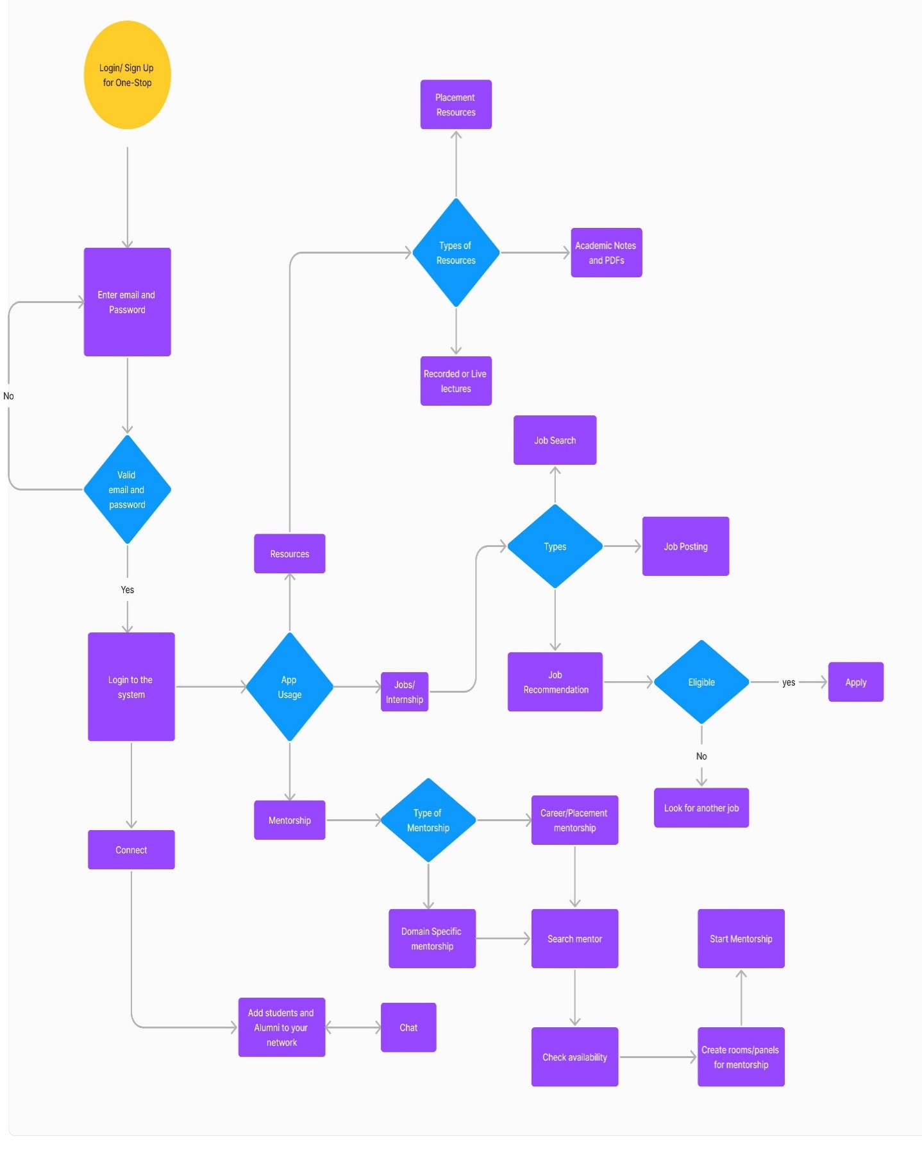

**4.4 ER DIAGRAM**

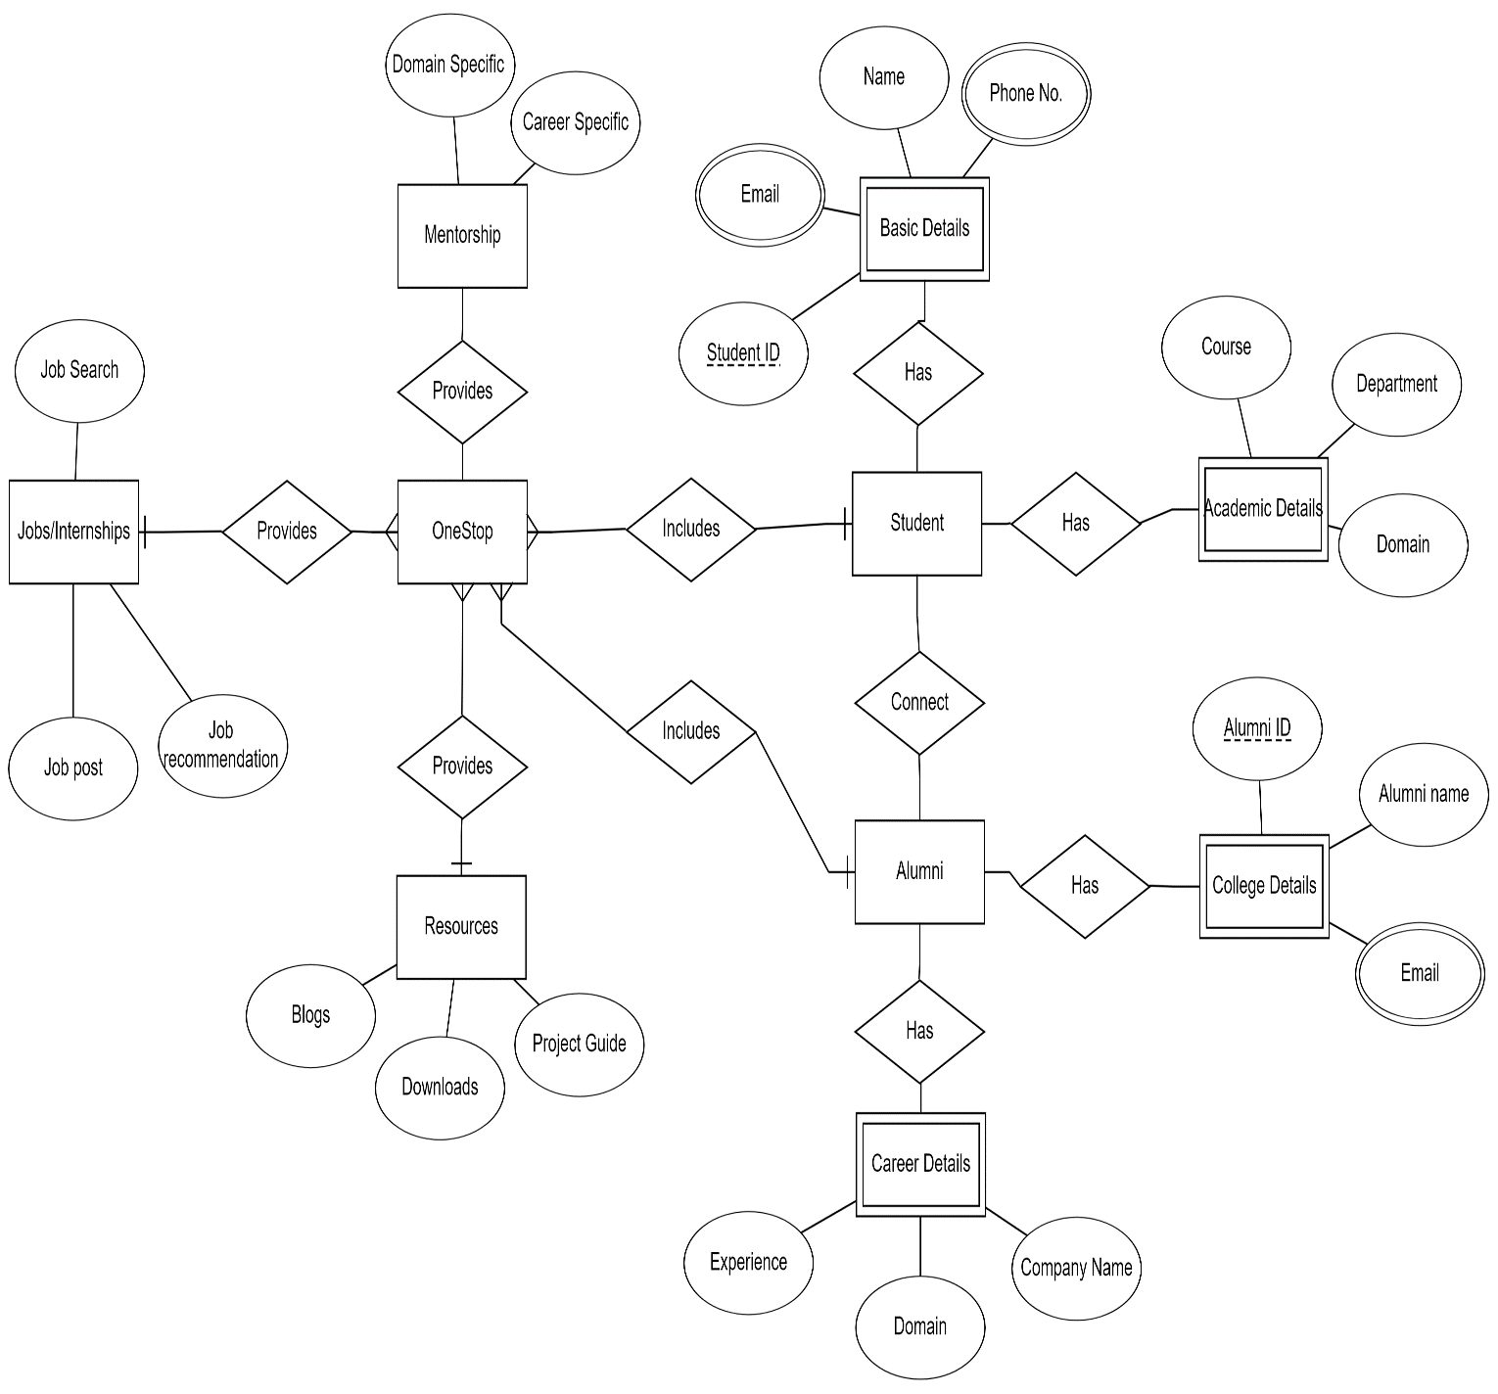

**05. PROJECT PLAN**

* 1. **PROJECT ESTIMATES**

| **Feature** | **Development Time (hours)** | **Testing and QA (hours)** |
| --- | --- | --- |
| Networking | 150 | 50 |
| Mentorship | 200 | 60 |
| Jobs/Internship | 180 | 55 |
| Resources | 160 | 45 |
| Common Features | 250 | 70 |
| Documentation/Deployment | 70 | 30 |
| Contingency | 140 | - |
| **Total** | **1150** | **360** |

**PROJECT RESOURCES**

| **Role** | **Responsibilities** |
| --- | --- |
| Backend Developers | Responsible for backend development using Django framework and database management. |
| Frontend Developers | Responsible for frontend development using Node.js and ensuring a responsive user interface. |
| QA Engineers | Responsible for testing and quality assurance of the platform's functionalities. |
| Designers | Responsible for UI/UX design, ensuring a visually appealing and intuitive user interface. |
| Project Manager | Responsible for project planning, coordination, and communication among team members. |
| System Administrator | Responsible for server setup, deployment, and maintenance of the platform. |
| Documentation Specialist | Responsible for creating comprehensive project documentation including user manuals, API documentation, and technical specifications. |

* 1. **RISK MANAGEMENT**

Complex algorithmic challenges, such as NP-Hard problems in matchmaking and resource allocation, present specific risk factors for this platform. The project's risk management plan addresses these concerns as follows:

**Risk Identification:**

**Computational Complexity:** The matchmaking algorithm's NP-Hard nature can lead to computational inefficiency, slowing down user matching and mentorship processes.

**Optimization Challenges:** The resource-sharing system's complexity can result in optimization challenges, making it difficult to efficiently manage and access resources.

**Risk Mitigation:**

**Algorithm Optimization:** To mitigate the computational complexity risk, the project will focus on optimising the matchmaking algorithm. This includes the use of heuristic approaches and parallel computing to enhance algorithm efficiency.

**Dynamic Resource Allocation:** For the resource-sharing system, the project will employ dynamic resource allocation strategies, ensuring that the system can efficiently allocate and retrieve resources.

**Scalability Planning:** Scalability will be a core consideration for both matchmaking and resource allocation to handle increasing user numbers effectively.

**Testing and Benchmarking:** Rigorous testing and benchmarking will be conducted throughout development to identify and address performance issues.

**Continuous Monitoring:** Ongoing monitoring and performance analysis will ensure that the platform remains efficient as user data and interactions grow.

By addressing these NP-Hard-related challenges, the project aims to create a platform that offers efficient matchmaking and resource allocation, providing a seamless and valuable experience for both students and alumni.

* 1. **PROJECT SCHEDULE**

|  |  |  |  |
| --- | --- | --- | --- |
| Phase | Time Estimate | Resource Estimate | Cost Estimate |
| Design | **2 weeks** | **Figma** | **Free** |
| Front-end Dev | **1-2 months** | **Front-end Developers** | **Free** |
| Back-end Dev | **1-2 months** | **Back-end Developers** | **Monthly Subscription** |
| QA Testing | **1-2 months** | **QA Testers** | **-** |
| Infrastructure/Cloud (Annual) | **N/A** | **Infrastructure Team** | **Monthly Subscription** |
| Third-Party Tools | **N/A** | **Sendbird, LinkedIn, etc** | **Variable** |
| Total | **6-7 months (Estimate)** |  |  |

**PROJECT SCHEDULE**

**1.** **Project Initiation (1-2 weeks)**

* Define project objectives and scope.
* Assemble the project team.
* Create a detailed project plan.
* Set up project management tools and communication channels.

1. **Design Phase (2-3 weeks)**
   * Conduct user research and needs analysis.
   * Create wireframes and design prototypes.
   * Develop the platform's information architecture.
   * Finalise the platform's design and user experience.
2. **Front-End Development (1-2 months)**
   * Develop the user interface using Next.js.
   * Implement responsive design for mobile accessibility.
   * Integrate user registration and login functionalities.
   * Create the homepage, mentorship, resources, job updates, and live sessions pages.
3. **Back-End Development (1-2 months)**

* Set up the server and database using Django or Flask.
* Build the matchmaking algorithm for mentorship.
* Develop the resource-sharing system.
* Create the real-time job and internship updates feature.
* Implement the chat functionality using Sendbird or a similar tool.

1. **Quality Assurance (1-2 months)**

* Conduct testing, including functionality, usability, and security
* Address and fix any identified issues and bugs.
* Ensure the platform meets quality standards.

1. **Deployment (1 month)**

* Prepare the platform for launch.
* Deploy the platform on a cloud infrastructure (e.g., AWS or Azure).
* Conduct final testing and ensure everything is in working order.
* Launch the platform to the public.

1. **Ongoing Support and Maintenance (Continuous)**

* Monitor the platform's performance and security.
* Make necessary updates and improvements.
* Plan for future enhancements and features.

**5.4 TEAM ORGANIZATION**

**5.4.1 Project Structure:**

In the development of the OneStop platform, the project team is structured to efficiently manage tasks and responsibilities despite the limited number of members. The team structure is designed to ensure effective collaboration, coordination, and communication throughout the project lifecycle.

**Team Members:**

1. Frontend Developer 1: Responsible for frontend development tasks such as UI design, layout implementation, and user interaction functionalities.

2. Frontend Developer 2: Collaborates with Frontend Developer 1 to develop frontend components and features, focusing on specific areas or modules of the platform.

3. Backend Developer 1: Leads backend development efforts, responsible for designing and implementing server-side logic, database management, and API integration.

4. Backend Developer 2: Supports Backend Developer 1 in backend development tasks, including coding, testing, and documentation, and assists in ensuring the functionality and reliability of backend components.

**5.4.2 Management, Reporting, and Communication:**

Effective management, reporting, and communication are essential components of the project's success, particularly in a small team setting. The team employs streamlined processes and tools to facilitate efficient coordination and collaboration among team members.

**Management:**

- Task Allocation: Tasks and responsibilities are assigned based on individual strengths, expertise, and project requirements. Each team member is responsible for specific aspects of frontend or backend development.

- Timeline Management: A shared project timeline is established, outlining key milestones, deliverables, and deadlines. Regular progress reviews are conducted to track project status and ensure alignment with timelines.

**Reporting:**

- Progress Updates: Team members provide regular progress updates on their respective tasks, highlighting achievements, challenges, and any impediments encountered.

- Issue Tracking: Any issues or roadblocks encountered during development are promptly reported to the project manager or relevant team members for resolution. A centralized issue tracking system ensures transparency and accountability.

**Communication:**

- Regular Meetings: Weekly or bi-weekly team meetings are held to discuss project status, address concerns, and plan upcoming tasks. These meetings provide an opportunity for team members to synchronize efforts and address any outstanding issues.

- Communication Channels: Team members utilize various communication channels such as email, instant messaging, and video conferencing to facilitate real-time communication and collaboration. Clear communication protocols are established to ensure clarity and avoid misunderstandings.

**Documentation:**

- Project Documentation: Comprehensive project documentation is maintained, including requirements specifications, design documents, and technical documentation. This documentation serves as a reference for team members and stakeholders and ensures continuity in case of personnel changes.

Despite the small team size, the OneStop project team is committed to delivering a high-quality product through effective organization, management, and communication practices. Each team member plays a critical role in contributing to the project's success, and collaboration is key to achieving project objectives within the established timeline and budget.

**06. PROJECT IMPLEMENTATION**

6.1 Overview of Project Modules:

The OneStop platform is structured into several cohesive modules, each designed to address specific functionalities essential for facilitating seamless interaction and collaboration between students and alumni:

1. Networking Module: This module serves as the foundation for user interaction by providing features such as user authentication, profile creation, and networking functionalities. Users can create profiles, view other profiles, send connection requests, and engage in private messaging with connected users. The networking module fosters community building and facilitates meaningful connections between students and alumni.

2. Mentorship Module: The mentorship module leverages advanced algorithms to match students with alumni mentors based on shared interests, academic backgrounds, and career aspirations. Students can request mentorship from alumni mentors, who have the option to accept or decline these requests. The module also includes features for scheduling mentorship sessions and integrating them with users' calendars, ensuring seamless coordination between mentors and mentees.

3. Jobs/Internship Module: Alumni can post job and internship openings on the platform, providing valuable opportunities for students to explore and apply for relevant positions. The module includes comprehensive job/internship listings with detailed descriptions, requirements, and application instructions. A notification system keeps users informed about new job/internship postings and updates, enhancing their chances of securing valuable career opportunities.

4. Resources Module: The resources module serves as a centralized repository for educational materials contributed by alumni and senior students. Users can upload, categorize, and share resources such as lecture notes, textbook PDFs, and video recordings. A robust search algorithm enables users to quickly find relevant resources based on keywords, categories, or tags. Additionally, a rating and feedback system allows users to evaluate the quality and usefulness of resources, fostering a culture of knowledge sharing and collaboration within the OneStop community.

6.2 Tools and Technologies Used:

- Frontend Development: Node.js, HTML5, CSS3, JavaScript for building dynamic and responsive user interfaces.

- Backend Development: Django framework with Python for implementing backend logic, user authentication, and database management.

- Database: SQLite for efficient storage and retrieval of user data, resource metadata, and platform-related information.

- Cloud Services: Firebase for real-time database capabilities, authentication services, and cloud hosting.

- Version Control: Git for collaborative development and version control management.

- Documentation: Markdown for creating project documentation and technical specifications.

6.3 Algorithm Details:

- Mentorship Matching Algorithm: Utilizes machine learning techniques, such as collaborative filtering and content-based recommendation, to analyze user profiles and recommend suitable mentor-mentee pairs. The algorithm considers factors such as academic interests, career goals, industry experience, and geographical location to ensure compatibility between mentors and mentees.

- Search Algorithm: Implements efficient search algorithms, such as binary search and hash tables, to enable fast and accurate retrieval of resources based on user queries. The search algorithm incorporates features like keyword matching, relevance ranking, and filtering options to enhance the user experience and facilitate resource discovery.

- Notification Algorithm: Utilizes event-driven programming and real-time database capabilities to trigger notifications for job/internship updates, new mentorship opportunities, resource uploads, and other relevant events. The notification algorithm ensures timely delivery of notifications to users, keeping them informed and engaged with the platform.

**7. SOFTWARE TESTING**

**7.1 Type of Testing:**

The OneStop platform undergoes comprehensive testing to ensure its functionality, reliability, and security. The following types of testing are conducted:

1. Unit Testing: Individual components of the platform, such as backend services and frontend components, undergo unit testing. This ensures that each unit performs as expected in isolation, and any defects or errors are identified and addressed early in the development process.

2. Integration Testing: Once individual components are tested, integration testing is performed to validate the interaction between different modules and functionalities. This ensures that data flows correctly between components and that the platform functions seamlessly as a whole.

3. Functional Testing: The functional requirements of the platform are thoroughly tested to verify that all features and functionalities work as intended. This includes testing networking capabilities, mentorship matching algorithms, job/internship postings, and resource management functionalities.

4. User Interface (UI) Testing: The user interface of the platform is tested to ensure it is user-friendly, responsive, and visually appealing. UI testing focuses on usability, accessibility, and consistency across different devices and browsers.

5. Performance Testing: Performance testing is conducted to evaluate the platform's responsiveness, scalability, and reliability under various load conditions. This includes stress testing to determine the platform's maximum capacity, load testing to assess its performance under expected usage levels, and scalability testing to ensure it can handle growing user demand.

6. Security Testing: Security testing is performed to identify and mitigate potential vulnerabilities and threats to the platform's security. This includes testing user authentication mechanisms, data encryption, access control, and protection against common security risks such as cross-site scripting (XSS) and SQL injection.

* 1. **Test Cases & Test Results**:

Test cases are developed based on the requirements and specifications of each module and feature of the OneStop platform. These test cases include inputs, expected outputs, and steps to reproduce specific scenarios to validate the functionality and behavior of the software.

During the testing phase, test cases are executed, and test results are recorded. Test results document the outcomes of each test case, including pass/fail status, actual outputs, observed behaviors, and any deviations from expected results. Any defects or issues identified during testing are logged, prioritized, and addressed by the development team to ensure they are resolved before the platform is released to users.

**8. Results**

* 1. **Outcomes**

1. Enhanced Networking Opportunities:

- Increased connections and interactions between students and alumni through the networking feature.

- Facilitated communication and knowledge sharing between current students and alumni, leading to valuable mentorship and career guidance opportunities.

2. Improved Mentorship Program:

- Enhanced mentorship experience for students by leveraging machine learning to recommend mentors based on their fields of interest.

- Increased engagement and participation of alumni as mentors, leading to more personalized and impactful mentorship relationships.

3. Increased Access to Job and Internship Opportunities:

- Expanded access to job and internship openings posted by alumni in their companies, providing students with valuable career opportunities.

- Improved visibility and awareness of job and internship openings among students, leading to higher application rates and placement success.

4. Enriched Learning Resources:

- Access to a diverse range of learning resources, including notes, video recordings, and textbook PDFs, contributed by alumni and senior students.

- Enhanced academic support and learning opportunities for students through the availability of curated and high-quality resources.

5. Strengthened Alumni-Student Community:

- Cultivated a strong and supportive community of alumni and students within the college ecosystem.

- Fostering long-lasting relationships and collaboration opportunities among alumni and students, both academically and professionally.

6. Data-Driven Insights and Continuous Improvement:

- Utilization of data analytics and machine learning techniques to analyze user interactions, preferences, and feedback.

- Continuous improvement of the platform based on insights derived from user data, ensuring alignment with user needs and preferences over time.

7. Positive Impact on Alumni Engagement and Satisfaction:

- Increased alumni engagement and satisfaction with the college through active involvement in mentoring, networking, and contributing resources.

- Strengthened alumni loyalty and connection to the college community, leading to potential benefits such as increased donations and support.

8. Empowered Student Community:

- Empowered students with access to valuable resources, mentorship, and career opportunities, enabling them to make informed decisions and achieve their academic and professional goals.

- Enhanced student experience and satisfaction with the college through the provision of comprehensive support and networking opportunities.

These outcomes highlight the positive impact of the “OneStop” platform on fostering a thriving alumni-student community and empowering students with valuable resources and opportunities for growth and development.

* 1. Screenshots

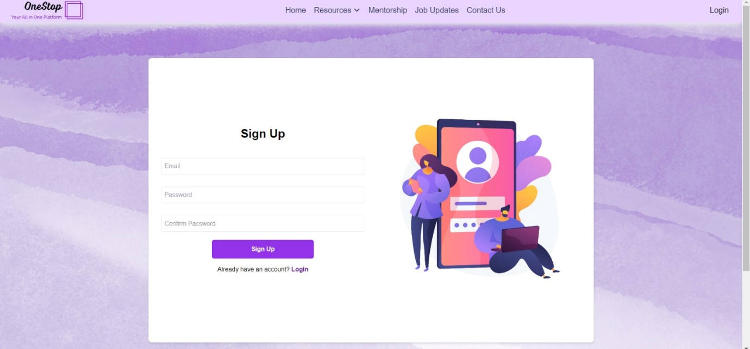

Fig 1. Sign up page

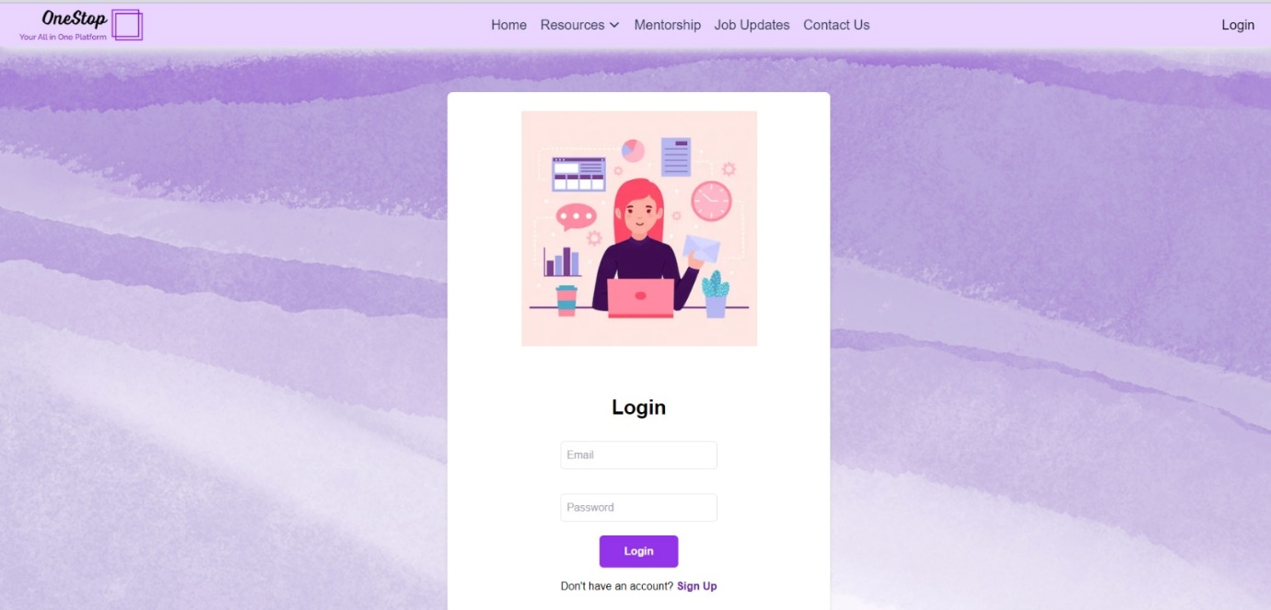

Fig 2. Log in Page

Fig 3. Registration page for Alumni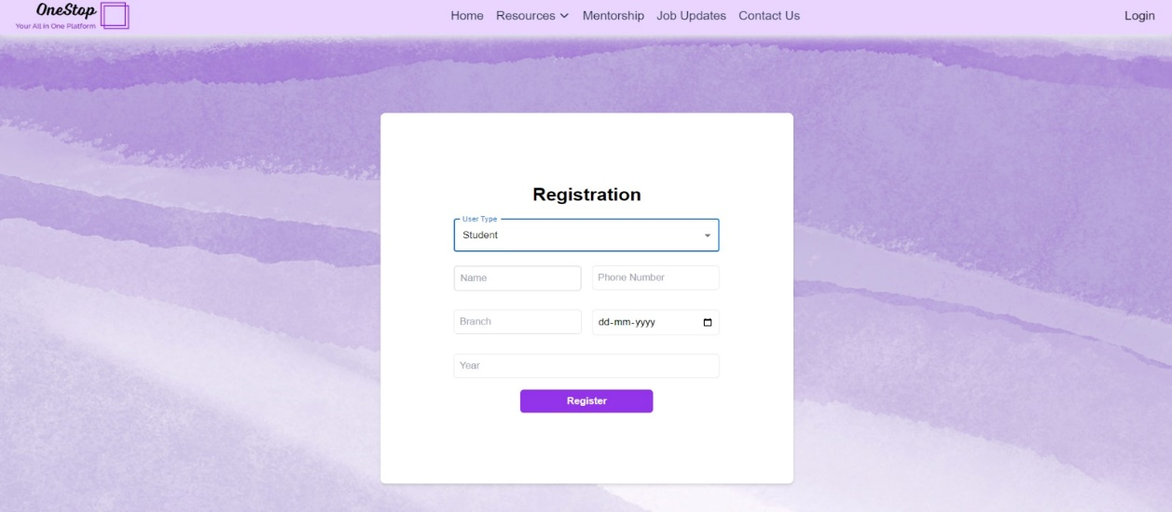

Fig 4. Registration Page for Students

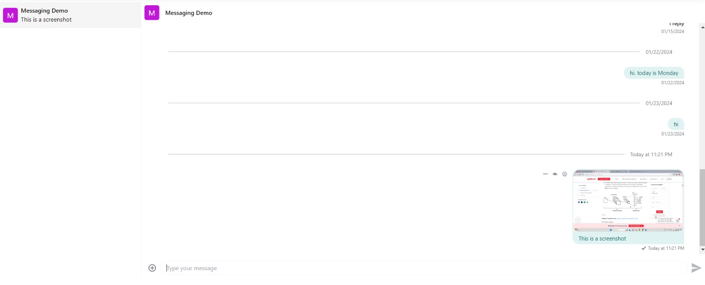

Fig 5. Chat Feature (Enables seamless communication and interaction between alumni and students, fostering mentorship, networking, and collaboration)

Fig 6. Resources Feature (provides a curated repository of educational materials contributed by alumni and students)

Fig 7. Jobs Feature (connects students with relevant job and internship opportunities posted by alumni, facilitating career advancement)

1. **CONCLUSION AND FUTURE WORK**

While developing the One-Stop online platform, we embarked on a journey to bridge the gap between alumni and students, fostering mentorship, resource sharing, and job opportunities. The platform, which combines a user-friendly interface with a robust system architecture, is a testament to the collaborative efforts and commitment of our team.

The success of this project is underscored by the following key achievements. First, our project places a strong emphasis on user experience, with an intuitive Sign Up/Login page, engaging frontend, and seamless communication through chat. We've sought to provide a platform that caters to the needs and expectations of our users.

The efficient system architecture, comprised of frontend, backend, database, hosting, data science, and more, has been meticulously designed to ensure scalability, security, and high performance. It provides a robust foundation for the various functionalities of One-Stop.

Moreover, the incorporation of data science and machine learning techniques empowers our platform with a personalized recommendation system. This, in turn, facilitates effective mentorship connections, resource suggestions, and job opportunities tailored to individual interests and skills.

Our choice of AWS for hosting guarantees scalability and reliability, ensuring the platform can cater to a growing user base while maintaining high availability and fault tolerance. Additionally, a comprehensive security layer is in place to safeguard user data, maintaining the integrity and privacy of user information throughout their interactions with One-Stop.

Our team is committed to monitoring user feedback, addressing issues promptly, and keeping the platform up-to-date with the latest technologies and industry trends. We believe that by doing so, we can further enhance the educational and professional development of our users, and strengthen the bonds between alumni and students.

One-Stop is more than just a project; it is a vision of collaboration and support within an educational community. We look forward to the journey ahead, where the platform will continue to make a meaningful impact on the lives and careers of our users.

We express our sincere gratitude to all those who have contributed to this project and look forward to the growth and success of One-Stop in the future.

9.3 Applications

Here are some potential applications of the OneStop platform:

1. Alumni Networking:

- OneStop provides a centralized platform for alumni to connect with each other, fostering professional networking and collaboration opportunities.

- Alumni can leverage the platform to reconnect with former classmates, mentors, and colleagues, expanding their professional networks and accessing career opportunities.

2. Career Mentorship:

- The platform facilitates mentorship programs where alumni can mentor current students, offering guidance, advice, and industry insights.

- Students benefit from personalized mentorship experiences, gaining valuable career advice and mentorship from experienced professionals in their fields of interest.

3. Job and Internship Opportunities:

- OneStop serves as a hub for alumni to post job and internship openings within their organizations, providing students with direct access to career opportunities.

- Students can explore job listings, apply for positions, and connect with alumni recruiters, streamlining the job search process and enhancing employment prospects.

4. Educational Resources Sharing:

- Alumni and senior students can contribute educational resources such as lecture notes, study guides, and textbooks to the platform's resource repository.

- Students benefit from access to a diverse range of learning materials, supplementing their academic studies and enhancing their learning outcomes.

5. Professional Development Events:

- OneStop hosts professional development events such as workshops, seminars, and networking mixers organized by alumni associations or industry partners.

- Students and alumni can attend these events to enhance their skills, expand their knowledge, and network with professionals in their fields of interest.

6. Alumni Fundraising and Donations:

- The platform facilitates alumni fundraising initiatives, allowing alumni to contribute to scholarship funds, campus projects, or charitable causes.

- Alumni can donate to support their alma mater's initiatives and give back to the community, fostering a culture of philanthropy and generosity.

7. Alumni Chapters and Communities:

- OneStop enables the creation of alumni chapters and communities based on geographic locations, graduation years, or professional affiliations.

- Alumni can join these communities to stay connected with their peers, participate in alumni events, and collaborate on initiatives that benefit the broader alumni community.

8. Alumni Recognition and Awards:

- The platform recognizes outstanding alumni achievements through awards, accolades, and alumni spotlight features.

- Alumni can nominate deserving candidates for recognition, showcasing their accomplishments and contributions to the community.

These applications demonstrate the diverse ways in which the OneStop platform can support alumni engagement, student success, and community building within educational institutions.

**REFERENCES**

[1] Babu M, Sandhiya K, Preetha V, Sankara Eshwari S, Ramya “DESIGN OF ALUMNI PORTAL WITH DATA SECURITY.”, Chitra M Department of Electronics and communication.

[2] Hardik Shetty Vaibhav Navale Dr. Jitendra Saturwar “ALUMINI PORTAL” , Student, Faculty Computer Engineering

[3] Nihalahmed Barudwale, Chaitanya Pandey, Aniket Wagh,Gaurav Bhasme, Prof. Mayuri Khade. “SURVEY ON ALUMNI CONNECT FORUM”

[4] Yash Uttareshwar Mohalkar, Mohammad Monis Umar, Sanskruti Satish Morey Suryan Shailendrakumar Mukane, Ghanshyam Kailas Mugle “A QUALITATIVE APPROACH FOR ALUMNI NETWORk MANAGEMENT SYSTEM”

[5] Raphael Enihe1, Victor Omopariola2, Department of Computer and Information Technology. “ALUMNI PORTAL SYSTEM FOR NIGERIAN UNIVERSITIES “International Journal of Science and Research (IJSR)

[6] Nanseera Peter Clever, Musisi Fred, Baguma Elvis, Jakisa Micheal “AN ALUMNI MANAGEMENT SYSTEM”

[7] Mohit Arora, Ankit Negi, Mohd Salar Khan “STUDENT- ALUMNI NETWORK WEB APP” (IJARIIT)