# Introduction

Coronavirus disease (COVID-19) is an infectious disease caused by the SARS-CoV-2 virus.

Most people infected with the virus will experience mild to moderate respiratory illness and recover without requiring special treatment. However, some will become seriously ill and require medical attention. With the recent outbreak of the pandemic, there have been mass panic among the communities.

A chatbot is an artificial intelligence (AI) software that can simulate a conversation (or a chat) with a user in natural language through messaging applications, websites, mobile apps or through the telephone.

A Chatbot can help us automate the regular responses to general queries, eliminating the need of human intervention. Although a human help can be provided when required.

# RASA

Rasa is an open-source machine learning framework for building AI assistants and chatbots. Rasa has two main modules:

* NLU for understanding user messages
* Core for holding conversations and deciding what to do next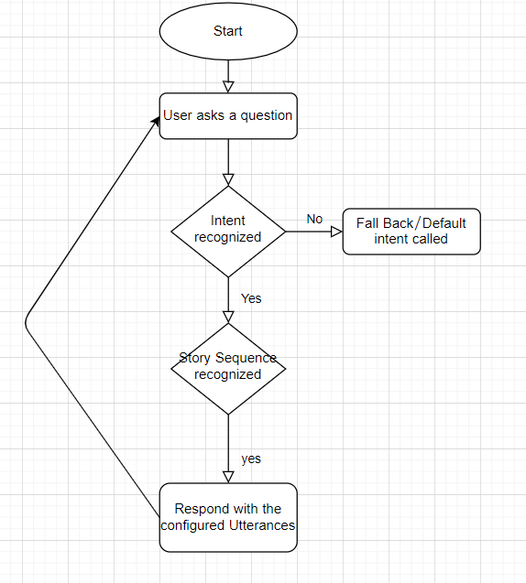

# DATASET

Intents

What the user is implying is called an intent. For example, if a user says one of the following to start the chat:

* Good morning!
* Hi!
* Hey!
* Hello

nlu.yml — houses the NLU training data for our model

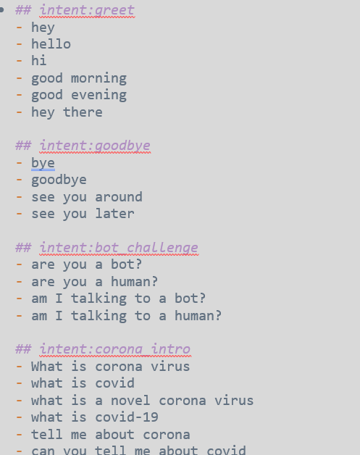

## Entities

Entities are pieces of data that can be extracted from a user message.

## Slots

Slots are the bot’s memory. Any information that needs to persist throughout the conversation, like a user’s name or their destination if you were building a flight booking bot, should be stored as slots.

## Responses

Responses are what the bot says to the user. Naturally, for a bot to give an appropriate response, it has to figure out what the user is trying to say.

Domain.yml

The complete info of all intents, responses and entities This file is a little more complex than the other two. If you look at the domain.yml file provided in the demo bot (post running rasa init ), you’ll notice keys like intents , actions , responses , entities ,etc.

domain.yml — the complete info of all intents, responses and entities

## Stories

Stories give our bot an idea of how the conversation should flow. Returning to our example, where the bot asks the user for their contact details, the conversation went

stories.yml— gives the bot an idea of how the conversation should flow