INTRODUCTION

PROJECT DESCRIPTION

This initiative focuses on rapid hiring with minimal struggle while ensuring a high efficiency rate. It not only helps track the status of various job applications but also enables job seekers to verify candidate pipelines for updates. Additionally, this process provides a secure environment for conducting professional recruitment communications without any risks. Oversight of work related activities is made easy and key features such as AI powered job recommendations and resume assessments can be accessed from any location.
On one side each candidate presents their resume in a unique format. While on the other side organizations utilize various formats for their job descriptions. This exploration into the abilities of the candidates professional profile including skills, work experience, education and projects which are automatically retrieved from the resume constitutes the core focus of this project. Moreover it covers also the entire description of the vacancy such as duties, qualifications, compensation, working place atmosphere, etc.
The core philosophy behind this initiative is to improve flexibility and enhance user independency. Job seekers are equipped with a wide range of tools to customize their profiles and explore the job discovery process. The platform promotes an iterative approach where users can review initial AI generated job suggestions and then fine tune them using specific keywords and skills ensuring that the results are increasingly tailored to their needs. This method enhances both the efficiency and ease of the job search. Furthermore a visual application pipeline allows candidates to easily monitor their progress while recruiters benefit from a more efficient system for handling applicants and effectively screening candidates.
This initiative simplifies the blink between job applicants and recruitment managers. It enables smooth networking and communication ensuring that the application process is clear and fair. The platform features key components designed for efficiency, such as AI powered candidate screening for recruiters and an interview prep chatbot for applicants. This empowers job seekers to proactively manage their career development. Simultaneously, it equips recruiters with tools like a searchable talent pool and automated screening reports to rapidly discover and engage the best candidates.

Objective:
      - The primary objective of this project is to develop an AI driven recommendation engine that assists job seekers by providing them with the most relevant job openings, derived from a comprehensive semantic analysis of their skills and professional background.
      - This project provides a smart resume parsing tool that automatically extract main information from different resume formats and thereafter create a structured and anonymized professional profile in order to guarantee the unbiased initial screening of candidates.
      - This project introduces an interactive AI chatbot that works as an interview coach. Thus, job seekers can get help by analysing their answers to the most frequently asked questions and consequently the chatbot can give them formative feedback for improving.
      - This project provides AI powered candidate screening tool which significantly reduces the manual screening process, by AI analysing, rating, and ranking applicants according to a specific job description.

Scope:
      - This project is primarily developed for professional recruiters and those who are willing to find a job. It can be also transformed for different industries such as Technology, Finance, Healthcare, Marketing and other work types like full time, part time or internships.
      - The system operates in a trustworthy and efficient way by giving registered users secure, role based access.
      - Especially for those that receive a large number of applications, the system gives it to companies of all sizes so that evaluation tasks are performed effectively and hiring is managed efficiently.

LITERATURE SURVEY

EXISTING AND PROPOSED SYSTEM

EXISTING SYSTEM

The existing system for recruitment provides details about the available jobs and the application process. It also enables job seekers to send their resumes directly to companies for those who have vacancies. The system allows the transfer of all the resumes digitally, but the resumes are checked manually. Besides, the system may also be the source of some articles, blog posts, and career guidelines for the user. All the applications and candidates are managed manually through separate tools like email and spreadsheets, which makes it difficult in tracking the details when progress needs to be reviewed by hiring managers.

Limitations of existing systems are:
  - Manual revision of every applicant's resume is inefficient due to the time it takes.
  - Conversations between recruiters and candidates become scattered across various platforms commonly.
  - Applications of candidates may be not well organized or lost in too many emails.
  - Job seekers often find it challenging to monitor the progress of their applications and the process lacks transparency.
  - There are no extra functionalities like intelligent job matching, automated candidate screening, or integrated interview preparation tools.

PROPOSED SYSTEM

This initiative is undoubtedly addressing the challenge of overseeing tasks and activities for both job seekers and recruiters, while simultaneously enhancing the overall efficiency of the hiring process. The project is dependable, simple to understand and there is no confusion when the user goes for the utilization of the contract. The project allows you to have several options when the number of candidates or jobs is huge. It provides an effective categorization of profiles and positions that not only assists you in searching and monitoring your applications, but also keep up with candidates in the future.

Advantages of Proposed system are:
  - The system drastically minimizes the manual work needed from both the recruiters and the job seekers. AI automates such tasks as resume screening, job searching, and initial candidate ranking.
  - Almost all of the manual work being done is eliminated, so the hiring cycle time is cut down drastically. Recruiters can locate the right candidates faster and job seekers can find better relevant openings quicker.
  - The system is set up with role-based access control that gives users the right to see only information that is suitable for their role (Job Seeker, Recruiter, or Admin), hence the issue of data privacy is taken care of.
  - The project has the simple and intuitive user interface with the separate dashboards for each user type; hence, it becomes easy to navigate and carry out all recruitment related tasks from one place.
  - Employing AI for matching, screening, and recommendations results in a very efficient process and hence the quality of matches as well as the effectiveness of the overall hiring process improves.

Module Description:

Admin has the full power to get the information which is in the project. He can know the number of users and recruiters that are registered, the jobs that are posted and the applications that are submitted. Additionally he can monitor the usage of the AI features which are available across the platform.
Recruiter is a person who is responsible for all of the hiring activities of an organization. He is responsible for the recruitment in an organization. He prepares all the job descriptions according to the company's needs and standards. He will know all the information about the candidates who apply, and he can also use the AI tools to screen and shortlist them. Besides managing all job postings, he can also send messages to the candidates through the integrated messaging system.
Job Seeker has to register himself in the project to keep all his professional details in a secure way. He can upload his resume that is automatically parsed by AI to create a professional, anonymized profile. A job seeker can find jobs easily, get AI powered job recommendations, and apply for positions even without leaving the platform. There is no need for files to be transferred through insecure emails. Furthermore, the user has the ability to monitor the status of all their applications and utilize an AI chatbot as a resource for interview preparation.

FEASIBILITY STUDY

Technical feasibility:

  - AI Models and Framework: The core of the platform relies on Large Language Models (LLM’s) accessed via Google’s Genkit and the Gemini family of models. This approach is highly feasible due to the managed nature of these APIs, which handle the complexity of the underlying models. The technical risk is low as we are using a well supported, production grade framework (genkit) and platform (Google AI).
  - Data Availability and Management: The system requires two primary data sources: user provided resumes and recruiter provided job postings. This data is readily available through direct user input. The feasibility of integrating and processing this data (text, PDFs) using Firestore for storage and Genkit for analysis is high. Resumes will be parsed into structured data and job descriptions will be stored for matching.
  - Application Infrastructure: The technical stack, consisting of Next.js, React and Tailwind for the frontend with Firebase (Firestore, Auth, Storage) for the backend, is a modern and highly scalable choice. This serverless architecture is technically feasible and well suited for a web application of this nature, allowing for rapid development and deployment.
  - Performance Measures: The success of the AI features will be measured by the relevance of job recommendations, the accuracy of resume parsing, the quality of AI generated job descriptions and user satisfaction with the interview prep chatbot. For the application itself, performance will be measured by standard web metrics like loading speed of the page, time to interactive and API response times for AI powered features.
  - Scalability and Performance: The architecture is designed for high scalability. Firebase services can handle a large volume of users, data storage and authentication requests. The performance of AI features depends on the latency of the Google AI Platform APIs. The system’s feasibility under load can be ensured by monitoring API usage, optimizing client side data fetching and leveraging Firebase’s scalable.

Economic viability:

  - Cost Analysis: Key costs include:
    - Cloud Services: Firebase (Firestore, Auth, Storage) usage costs, which will scale with the number of users, jobs and application.

    - AI Services: Google AI Platform API costs, based on the volume of calls to Genkit flows for resume parsing, job recommendations and other AI features.
    - Development and Maintenance: Initial development effort and ongoing costs for personal to maintain the platform, update features and provide user support.
  - Return on Investment (ROI): The potential financial benefits are significant. For recruiters, ROI comes from reduced time to hire and improved quality of candidates. For job seekers, the benefit is finding a suitable job faster. Monetization can offset costs and generate profit, leading to a positive ROI.
  - Ongoing Maintenance: Maintenance costs will include regular software updates to the Next.js framework and its dependencies, monitoring and managing Firebase and Google AI usage to control costs and ongoing technical support for the platform.
  - Market Opportunities: The project has several potential revenue streams:
    - Subscription Model for Recruiters: Offer tired plans (e.g., Basic, Pro, Enterprise) for posting jobs, accessing the candidate pool and using advanced AI screening tools.
    - Premium Model for Job Seekers: Basic features are free, with premium features like advanced interview prep, detailed career path analysis, or priority application status available for a fee.
    - Pay per use AI Features: Charge recruiters for specific high value actions, such as running a detailed AI screening on a batch of candidates.

Operational feasibility:

  - User Acceptance (Job Seekers): Job Seekers are highly likely to adopt the platform due to the clear value proposition: free, AI powered assistance in their job search. The ease of uploading a resume and receiving instant job matches and interview preparation tools will be a strong driver of acceptance.
  - User Acceptance (Recruiters): Recruiter will be willing to adopt the platform if it demonstrably saves them time and improves the quality of candidate matches. The key is the effectiveness of the AI screening and recommendation tools. Usability testing will focus on the recruiter dashboard’s efficiency and the clarity of the AI generated candidate reports.

Training and Support:
    - For job seekers, minimal training is needed. An intuitive UI and tooltips will guide them through the process.
    - For recruiters, a brief onboarding tour and documentation will explain how to post jobs and effectively use the AI screening features. A support system (e.g., chat or email) will be established to handle inquiries and technical issues.

TOOLS AND TECHNOLOGIES USED

Next.js (React)

Next.js is a significant and authoritative framework for all application pages which is built using React. Its unique feature is its ability to render in both server and client formats, providing a means of creating simulated applications. This technology is illustrated as hybrid rendering. Routing, page structure, and optimizations are among the features that it provides to consolidate records and prepare web records for page creation.

TypeScript

TypeScript is a generic language that provides standardized and predictable programming. By implementing the same data types and structure, it ensures that variables and functions operate as intended. By using this technique, code is characterized with strong type safety to prevent common errors before execution. This helps to build stronger, more stable and maintenance free software.

Firebase Firestore

Firebase's Firestore is a versatile database that can be expanded upon for its flexibility and adaptability in mobile, web, and server development. It is employed to store and synchronize data for both client side and server siting development. The data stored in Firestore, which includes user profiles, job postings and application records, can be securely kept for management purposes. The system's real time data handling is prepared by this database.

Genkit (Google AI)

Genkit is a modern tool that handles all AI functions in the project. The approach enables the creation of AI flows that interact with influential language models such as Google's Gemini. This governs the AI's reaction, the format of the output, and its interaction with other tools. It's essentially the equivalent of how we define the presence of intelligent features such as resume review, job suggestions and interview bot.

Tailwind CSS

To provide a typical and predictable introduction to the user's interface, Tailwind CSS is crafted using an engineering approach that prioritizes utility. The control of colours, textual style variations, and interlinking are all controlled by it. This feature is primarily employed to depict the visual design of an

application within the markup. With this framework, we can rapidly construct modern and responsive user interfaces.

SOFTWARE AND HARDWARE REQUIREMENTS

Hardware specifications

- Processor : Intel Dual Core processor or higher
- Process Speed : 2.0 GHz or faster
- RAM : 4 GB or more
- Hard Disk : 10 GB of available space (for browser cache and file downloads)
- Network : Broadband Internet Connection

Software specifications

- Operating System : Windows, macOS, or Linux
- Web Browser : Google Chrome, Mozilla Firefox, Microsoft Edge, or Safari
- Front End : Next.js, React, TypeScript, Tailwind CSS
- Back End Logic : Next.js (Server Components, Server Actions)
- Database : Google Firebase Firestore
- AI Integration : Genkit (interfacing with Google AI Platform)
- Runtime Environment : Node.js

SOFTWARE REQUIREMENTS SPECIFICATION

USERS
The major users of this project are the Admin, Recruiter and the Job Seeker.

Admin: Admin has the complete authority to manage the platform’s overall health and solve queries.
Recruiter: He will maintain the job postings and candidate pipelines for his organization. He can add new jobs and screen applicants.
Job Seeker: Here the user can be any individual seeking employment opportunities. They will connect with recruiters to find jobs and manage their applications in a secure way.

User interfaces

- Registration: This page helps in signing up the new users (Job seekers or Recruiters) to the project.
- Login screen: This is used by various users like Admin, Recruiters, or Job seekers for accessing the project. It requires an email and password.
- Admin login: The screen displays the admin dashboard where he is able to view overall platform metrics like user growth, job posting totals, and AI service usage. He can also query the system for specific data using an AI assistant.
- Recruiter login: The display shows the recruiter portal, enabling him to post new job openings, manage current listings and utilize AI for screening applicants. Recruiter can also search the talent pool and communicate with candidates.
- Job Seeker login: The screen displays the user dashboard where he is able to manage his profile, upload and parse his resume, get AI job recommendations, and track his applications.

FUNCTIONAL REQUIREMENTS
This section outlines the functional requirements of the system, which are defined by user needs. These requirements describe the core services and capabilities that the platform will provide. The specific functions are detailed below.
- The project should allow the Job Seeker and Recruiter people to create their profile.
- The project allows the Job Seekers to upload their resume for AI analysis and Recruiters to post detailed job descriptions.
- The Admin can monitor the overall system usage, including user statistics and the performance of AI features.
- The final system must meet all specified user requirements and operates as intended. Furthermore, the user interface and overall workflow must be designed to be intuitive, thereby preventing any ambiguity for end user.

NON FUNCTIONAL REQUIREMENTS

Non Functional requirements define the qualitative attributes of a system, specifying how it should operate rather than what it should do. These requirements describe essential characteristics of the framework, such as its performance, security and usability, which are evaluates during its execution.

Performance

The performance of this project is critical, particularly concerning time management across various AI services and database queries within a single operation. The system must deliver a responsive user experience, with timely completion of page loads and AI driven features like job recommendations and candidate screening. Furthermore, the architecture is designed to scale effectively, handling simultaneous users without performance degenarations, thereby ensuring a positive and seamless user experience.

Security

Security is a primary concern as the system handles user profiles and application data. The framework is required to guarantee that all data is securely stored and that access is strictly managed through role based

authentication. A user should only be able to access data that is relevant to their role (Admin, Recruiter or Job Seeker) protecting personal and professional information from unauthorized access.

Usability

The project should be straightforward to learn and navigate for all user categories. The UI for the Admin, Recruiter and Job Seeker dashboards must be intuitive and self explanatory. The design must be clean and free of clutter, enabling users to accomplish their tasks, such as posting jobs or applying for them, with minimal confusion and effort. The system must provide explicit feedback to the user after every action.

SYSTEM ARCHITECTURE / DESIGN

SYSTEM PERSPECTIVE

System perspective design of AI JobPortal
AI JobPortal

Manage data of Admin, Recruiter, Job Seeker

Registration Module

Admin/ Recruiter/ Job Seeker

Manage profiles/ Job postings/ Screening/
Resumes/
Application status

Figure 4.1: System perspective design of AI JobPortal

The system perspective for AI JobPortal illustrates the high level interaction between users, modules and data. The primary actors Job Seeker, Recruiter and Admin interact with dedicated modules for functions like user management, job postings and AI processing. All system activities and data are centrally managed within the AI JobPortal database to ensure a cohesive and functional platform. This model defines the overall architecture and data flow of the project.

DATAFLOW DIAGRAM / CONTEXT DIAGRAM

Level 0 DFD of AI JobPortal

Uploads resume, AI parsing, apply to job

Job Seeker

Job recommendation,
Track application status

Posts job,
Screen candidates

AI JobPortal
Reports, Logs

Manage users, Monitor systems

Admin

Matched applicants, Summarized resumes

Recruiter

Figure 4.2: Level 0 DFD of AI JobPortal

This represents the overall structure of the project and how the flow of data is taking place in the system. It also shows how the framework is related to external entities and what the functionalities of the individual modules are performing. The central process, AI JobPortal, manages all core functions like, user authentication, data storage, and AI process.
The Job Seeker provides their resume and profile details to the system and in return receives job recommendation and application status updates. The Recruiter submits job description to the system and receives screened candidate lists and performance reports. The Admin manages the system by viewing platform metrics and user activity details.

Level 1 DFD of Admin
Login
log in
Success
Verified
Log Reports
View reports
Retrieved
Admin

Login details

Log Reports

Figure 4.3: Level 1 DFD of Admin

The above figure shows the specific functionalities of the admin and the manner in which data is processed within the same module, including the procedures for storing and retrieving data from the database. Initially, the admin logs into the system, which is authenticated against the login credentials. Upon successful verification, the admin is able to view platform metrics and user activity, which are sourced from their corresponding data repositories.

Level 1 DFD of Recruiter
Registration and log in
Recruiter job Posting and screening
Recruiter

User Database

Log Reports

Job postings

Resume repository

Application status

Figure 4.4: Level 1 DFD of Recruiter

The above figure shows the details and functionalities of the recruiter and how the data is flowing from one process to another within the same module, what are the ways by which data can be accessed from the database. The Recruiter first provides login credentials which are verified against the login details. Upon success, the Recruiter can manage job postings, which involves adding and updating information in the Job Postings data store. They can also initiate the candidate screening process, which retrieves candidate profiles and job descriptions to generate screening results. Finally, the Recruiter can view shortlisted candidates by retrieving their details from the database.

Level 1 DFD of Job Seeker
Registration and log in
Resume upload and parsing
Resume repository
Job matching and recommendation
Application
submission and tracking
Application status
View
Application status
Retrieved
Job Seeker

User Database

Log Reports

Figure 4.5: Level 1 DFD of Job Seeker

The above figure shows the detailed functionalities of the job seeker and how the data is flowing from one process to another within the same module, what are the ways by which data can be accessed from the database. The Job Seeker first provides their credentials to the login process, which are verified against the login details. Upon success, the user is redirected to the dashboard, where he gets options to upload resume and update the profile information. The user can then get job recommendations, which retrieves information from the user profile and job postings data stores to provide a list of suitable jobs. Finally, the user can apply for a job, which creates a new entry in the applications data store and returns the status to the user.

DETAILED DESIGN

USE CASE DIAGRAMS

Use case diagram of Admin

Log In
Manage users
View reports
Monitor AI matching outcomes

Figure 5.1: Use case diagram of Admin

This outlines the use case for the admin role. Where the admin functions as an external actor logging into the system. The use cases of the system include view dashboard, view user growth, monitor AI usage and query system data.

Use case diagram of Recruiter

Register/Log

Post Job description

View applications

Review candidate profiles

Figure 5.2: Use case diagram of Recruiter

This describes the use case of Recruiter where Recruiter acts as external actor who logging into the system. Post Jobs, Manage Postings, Screen Candidates, View Shortlisted Candidates and Communicate with Applications are the use cases of the system.

Use case diagram of Job Seeker

Register/Log In
Upload resume
View Job
recommendations
Apply for job
Track application status

Figure 5.3: Use case diagram of Job Seeker

This describes the use case of Job Seeker where Job Seeker acts as external actor who logging in to the system. Register/ Login, upload resume, view job recommendations, apply for job and track application status are the use cases of the system. Here actor interact with the use cases to perform actions which is required in this project.

SEQUENCE DIAGRAMS

Sequence diagram of Admin
Login
Validate admin credentials

Credentials validated
Login success
View system reports
Fetch reports
Display reports
Report data
Manage users
Retrieve User List
User list
Display user management UI
Manage job postings
Retrieve Job List
Display job management UI
Job list
Database
Database
AI JobPortal
AI JobPortal
Admin
Admin

Figure 5.4: Sequence diagram of Admin

The sequence diagram above illustrates the interactions between objects within the admin module. The process begins with the admin initiating a login request, which the system validates against the database. Upon successful authentication, the admin is presented with the main dashboard. This dashboard serves as the central interface for platform management, providing the administrator with the capabilities to view key platform metrics, monitor the usage of AI services and query system data.

Sequence diagram of Recruiter
Login / Register
Validate credentials
Access granted
Valid
Post job description
Save job posting
Confirmation
Job saved
View recommended candidates
Request matching resumes
Retrieve parsed resumes
Resume data
Show recommended
candidates
Candidate list
Review candidate profiles
Fetch candidate details

Candidate info
Display Candidate Profiles
AI/NLP Engine
AI/NLP Engine
Database
Database
AI JobPortal
AI JobPortal
Recruiter
Recruiter

Figure 5.5: Sequence diagram of Recruiter

The sequence diagram presented above outlines the object interactions within the recruiter module. The workflow begins when a recruiter logs into the system. The system then validates these credentials against the database. Upon successful authentication, access is granted to the recruiter portal. This portal serves as the primary interface for managing the hiring process, providing essential functionalities such as posting new job listings, leveraging AI services for candidate screening and viewing shortlisted candidates.

Sequence diagram of Job Seeker

Login / Register
Validate credentials
Access granted
Valid
Upload Resume
Parse resume
Parsed resume
Save resume data

Request Job
Recommendations
Fetch job listings
Return job list
Display recommendations
Show recommendations
Apply to Job
Save application data

View application status
Display status
AI/NLP Engine
AI/NLP Engine
Database
Database
AI JobPortal
AI JobPortal
Job Seeker
Job Seeker

Figure 5.6: Sequence diagram of Job Seeker

The sequence diagram depicted above maps the object interactions for the job seeker module. The workflow is initiated when a job seeker logs into the platform and their credentials are then validated against the database. Upon successful authentication, the system presents the user dashboard. This personalized dashboard provides the job seeker with access to key functionalities, including the ability to upload their resume for AI analysis, receive tailored job recommendations and track the progress of their applications through the hiring pipeline.



No
Admin Login
Yes
Valid credentials?
Manage users
View Reports
Logout
Monitor AI Matching Outcomes
Access Admin panel

Show error

Figure 5.7: Activity diagram of Admin

The figure above illustrates the activity diagram for the admin module, depicting the flow of data between various activities. This diagram emphasizes information over objects. The rounded rectangles signify actions at the initiation point where the admin will input their ID and password, which are verified by a decision box. Subsequently, the home page will be displayed, providing access to various functionalities such as viewing the Admin Dashboard, monitoring user growth, checking AI service usage and querying system data prior to logging out.

Activity diagram of Recruiter


Yes
Valid
credentials?
No

Show error
Review Candidate Profiles
Shortlist Candidate?
No
Yes
Shortlist Candidate
Schedule interview
View recommended candidates
Post job description
Access Dashboard
Recruiter Login

Figure 5.8: Activity diagram of Recruiter

The figure above illustrates the activity diagram for the recruiter module, depicting the flow of data from ine activity to another. This diagram emphasizes information over objects. The rounded rectangles signify actions at the initiation point where the recruiter inputs their ID and password, which are verified by a decision box. Subsequently, the home page is displayed, providing access to various functionalities such as posting new jobs, managing current postings and screening candidates prior to logging out.

Activity diagram of Job Seeker


Valid credentials?
Show error
View Job Recommendations
Wants to apply?
No
Chatbot Interaction (optional)
Yes
Apply to Job
Track Application Status
Take Skill Assessment
Upload Resume
Access Dashboard
Access Dashboard
Job Seeker Login

Figure 5.9: Activity diagram of Job Seeker

The figure above illustrates the activity diagram of the job seeker module, depicting the flow of data between various activities. This diagram emphasizes information over objects. The rounded rectangles signify actions at the initiation point where the job seeker will input their ID and password, which are verified by a decision box. Following this, the home page will be displayed, providing access to various functionalities such as uploading a resume, receiving job recommendations, applying for jobs and tracking application status prior to logging out.

ER DIAGRAM
The entity relationship diagram illustrates the various connections between elements, considering each objective as a substance. In the AI JobPortal, the elements include User, Job, Application, Profile and Resume while the associations consist of posts, applies, manages and screens.
- This represents the subsequent steps following the gathering of requirements.
- It serves as a crucial intangible model that visually expresses the prerequisite conditions using standard symbols.

ER Diagram of AI JobPortal

Email Password

UserID
RecruiterID Title

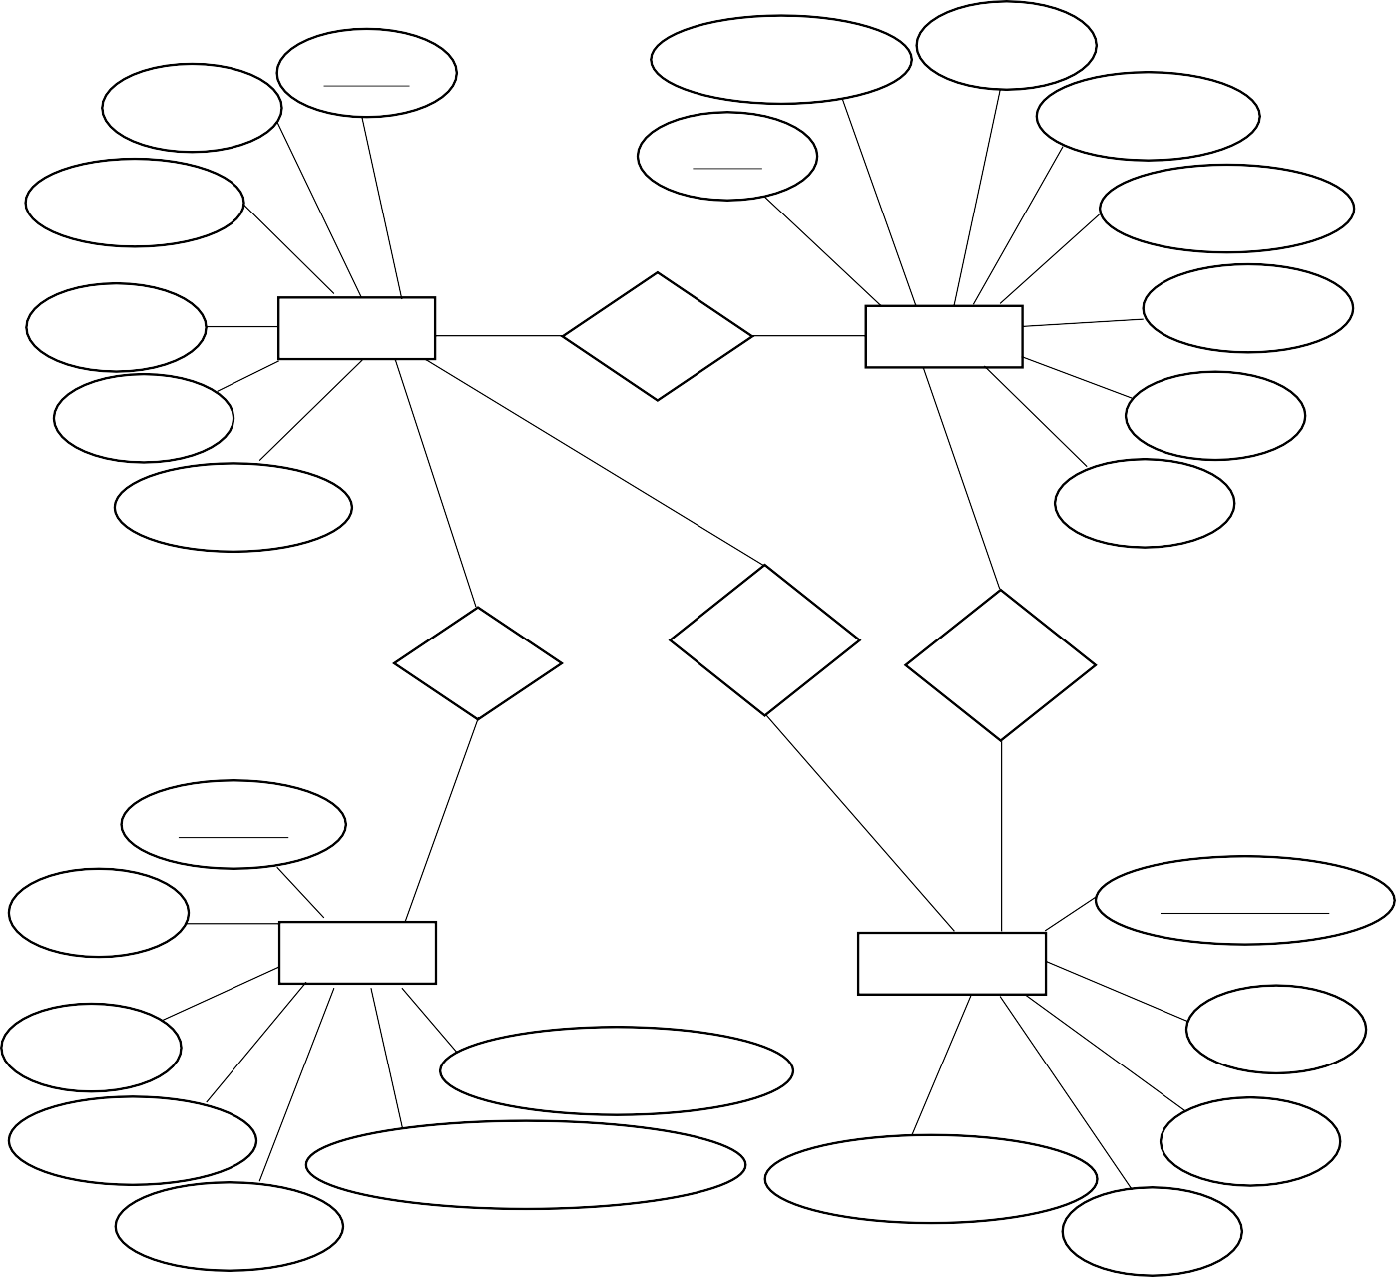
JobID

Company

Description

Role

Name

AvatarUR
User 1

1
Recruiter N
Posts

1

Job

1

Salary
Location

Type

manages
Job Seeker Submits

can have

1 N
ProfileID N
UserID ApplicationID

Skills
Profile

ResumeFilename
Application

JobID

Experience

Education

AnonymizedSummary

ApplicationDate

Status
UserID

Figure 5.10: ER Diagram for AI JobPortal

IMPLEMENTATION
This phase is a very important and crucial part of our project as it transforms the design into a functional system. The implementation gives life to the project’s architecture, enabling users to interact with the features as intended. Each screenshot that follows represents a key component of the AI JobPortal platform, demonstrating the working functionality of our project.

SCREENSHOTS

Main landing page of the application

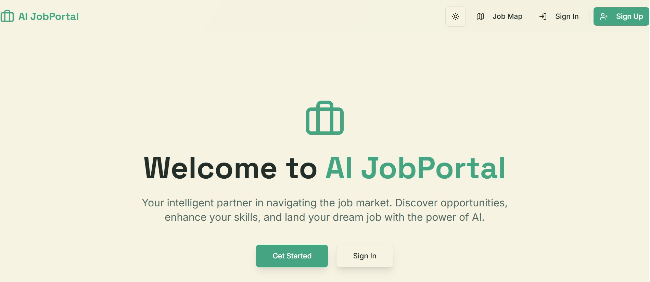

Figure 6.1: Main landing page of the AI JobPortal

This is the primary entry point or landing page for the AI JobPortal. It serves as the gateway for users to access the various features and services offered by the platform.

Sign in page

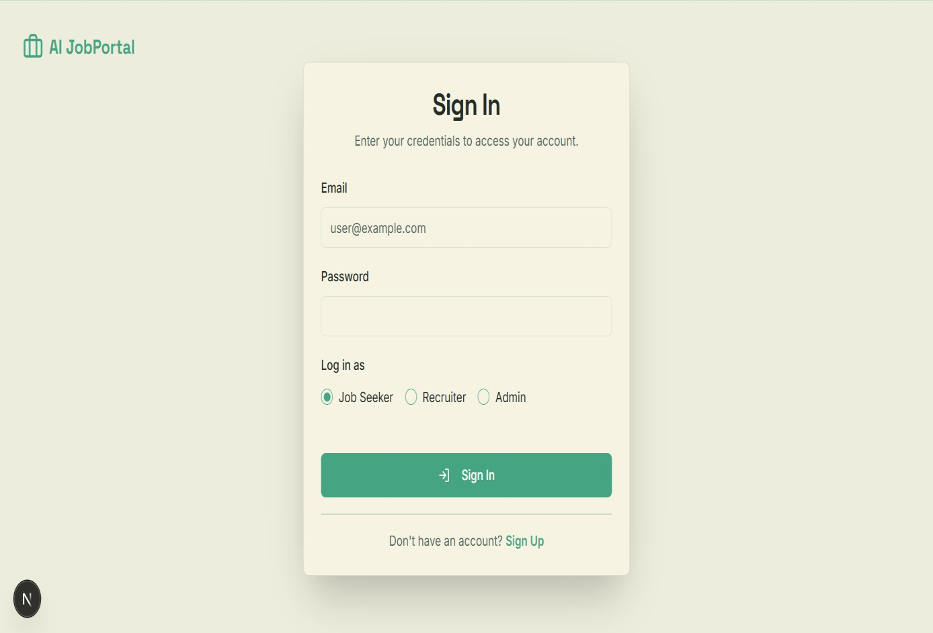

Figure 6.2: Sign in page for AI JobPortal

The above image illustrates the sign in screen for the AI JobPortal. In this page, the registered users can log in by entering their email and password and specifying their role within the system. A successful sign in automatically directs the user to their personalized home page.

Sign up page

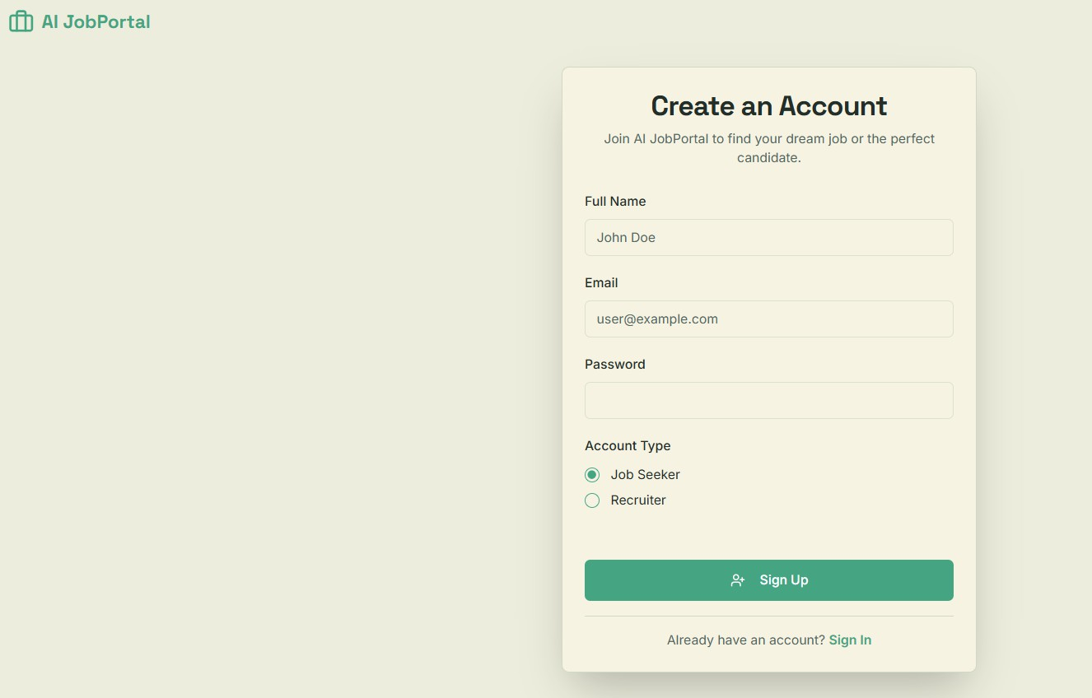

Figure 6.3: Sign up page for AI JobPortal

This is the sign up page for the AI JobPortal system, where the users can get registered by providing the valid details.

Admin dashboard

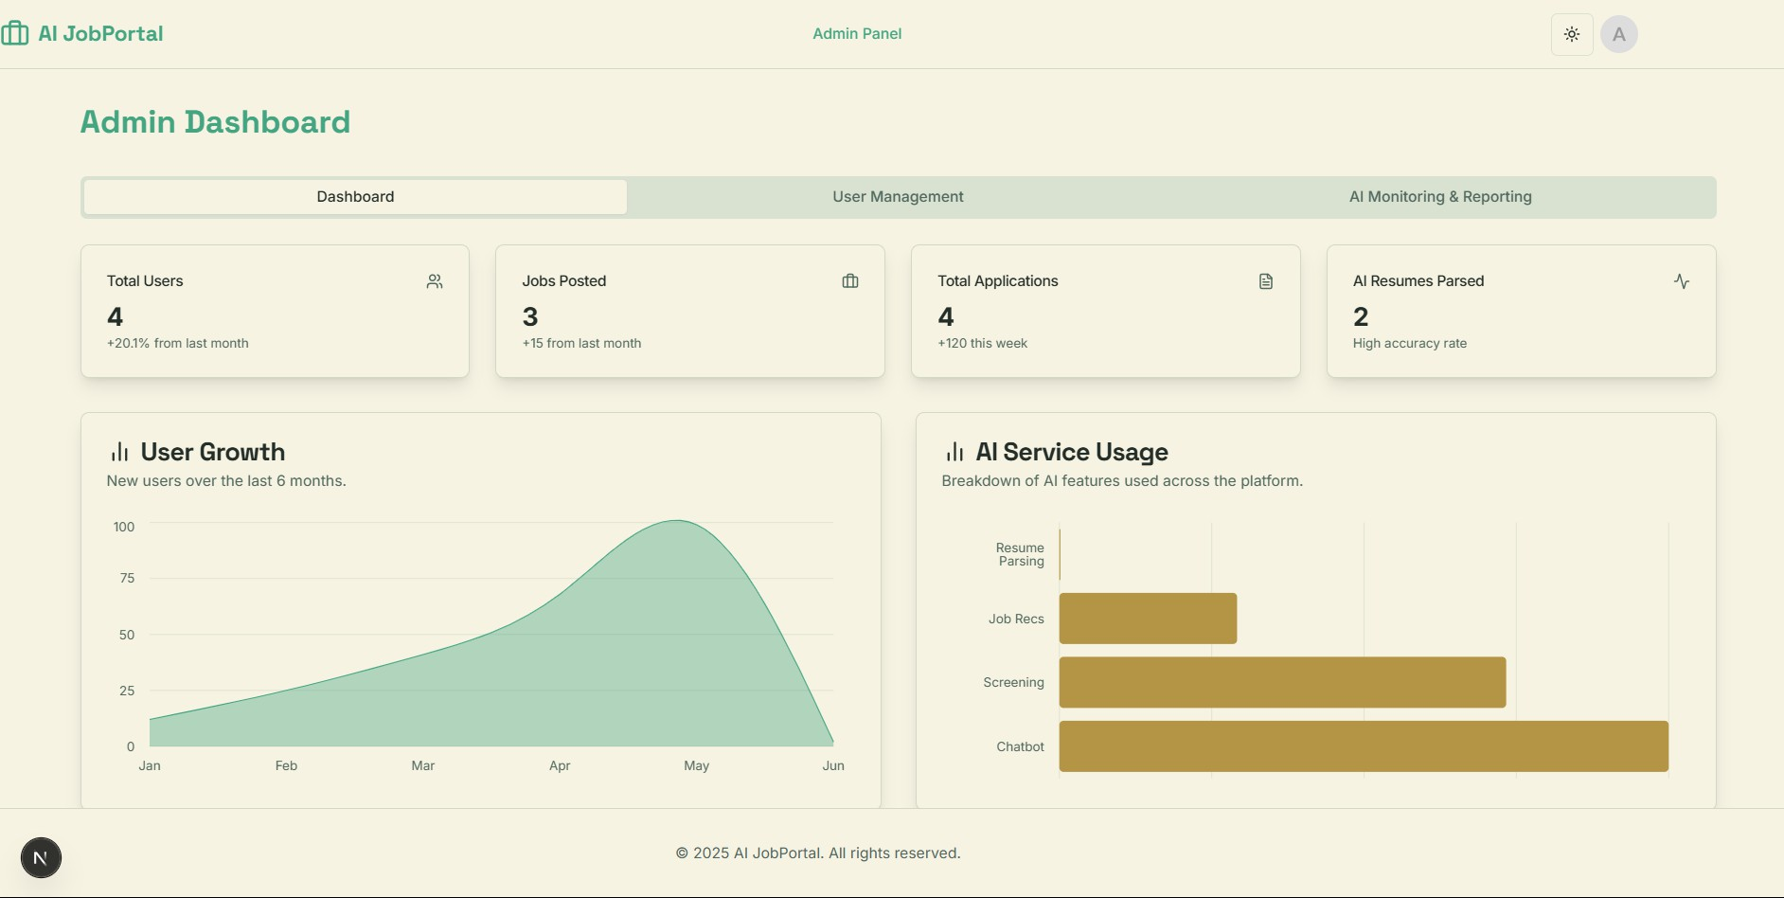

Figure 6.4: Home page for Admin

This is the Home page for admin. When the admin successfully logs into the system, this page will be displayed. This is where admin can see all the statistics of the application.

User management tab

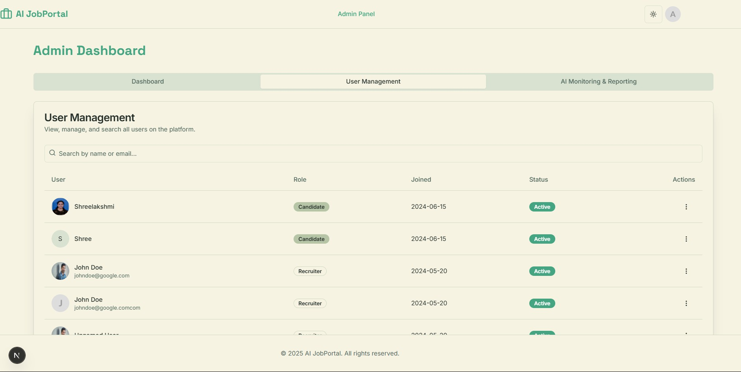

Figure 6.5: User management tab for Admin

This is a dedicated page for admin where admin can manage the users. Manage in the sense, admin can view the profile, suspend or delete the account of a user.

AI monitoring & reporting tab

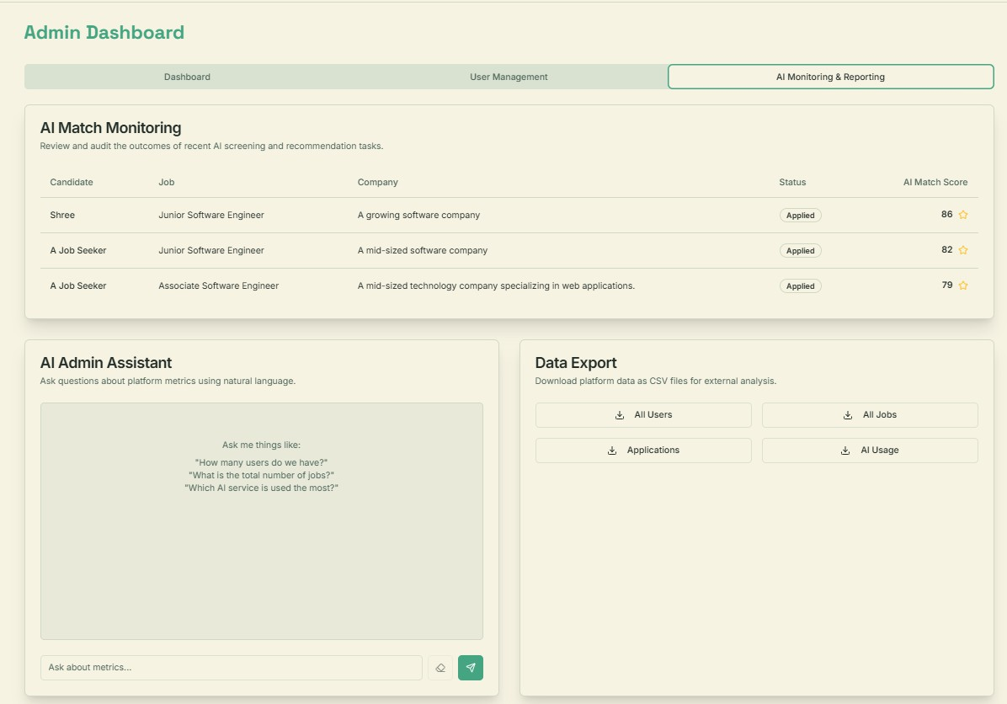

Figure 6.6: AI Monitoring & Reporting tab for Admin

This is a tab in the admin dashboard where he can monitor the performance of the AI. Along with that he can take AI assistance for knowing the platform metrics and he can also export some CSV files like the list of users, list of posted jobs, list of applications.

Recruiter dashboard

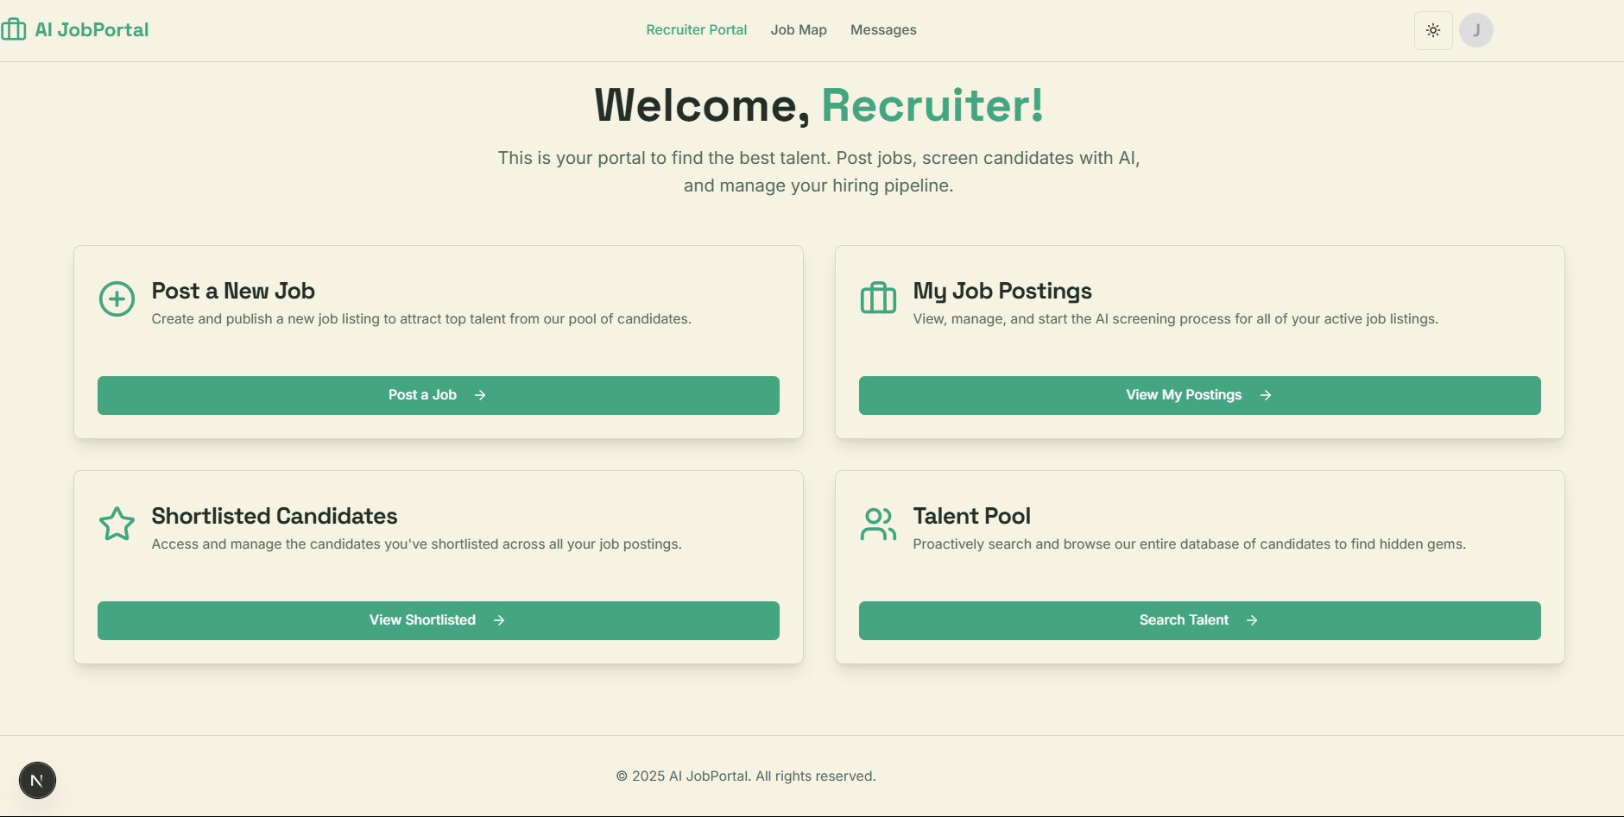

Figure 6.7: Dashboard for recruiter

This is the dashboard page for the recruiter. This page contains the features to post a new job, and to see the job posted by the recruiter, shortlisted candidates after screening process, talent pool which consists of the list on candidates who are registered in the application for searching the job.

Job posting tab

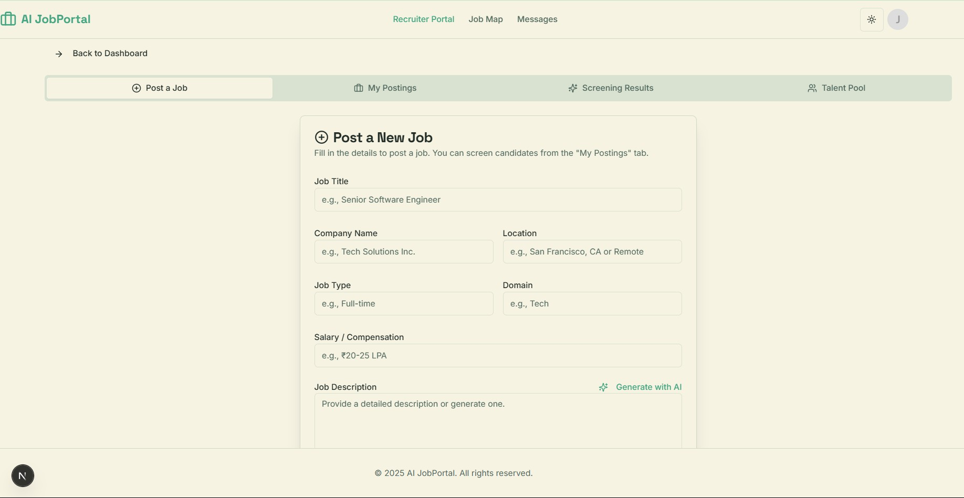

Figure 6.8: Job Posting tab for Recruiter

This page is for the recruiter to post a new job. By providing the required details about the company and job the recruiter can post a new job. Recruiter can take help of the AI to generate the job description by optionally providing the keywords.

My posting tab

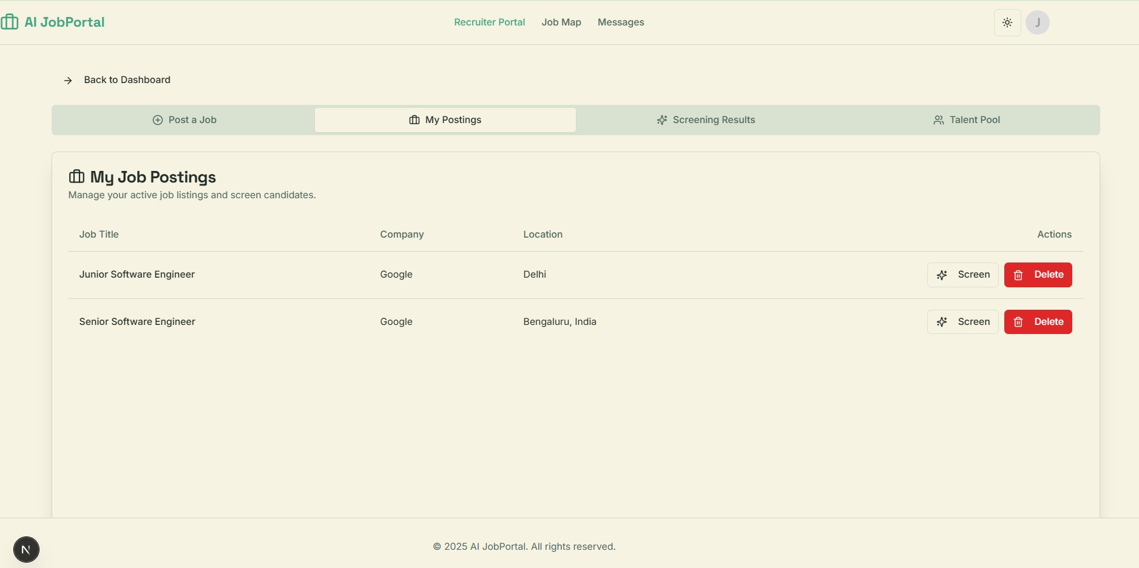

Figure 6.9: My Posting tab for Recruiter

This page is for the recruiter to review the job that the recruiter has posted. In this tab the recruiter can also delete the job that is posted by the recruiter and also can screen the candidates to get the best match for the posted job.

Screening result tab

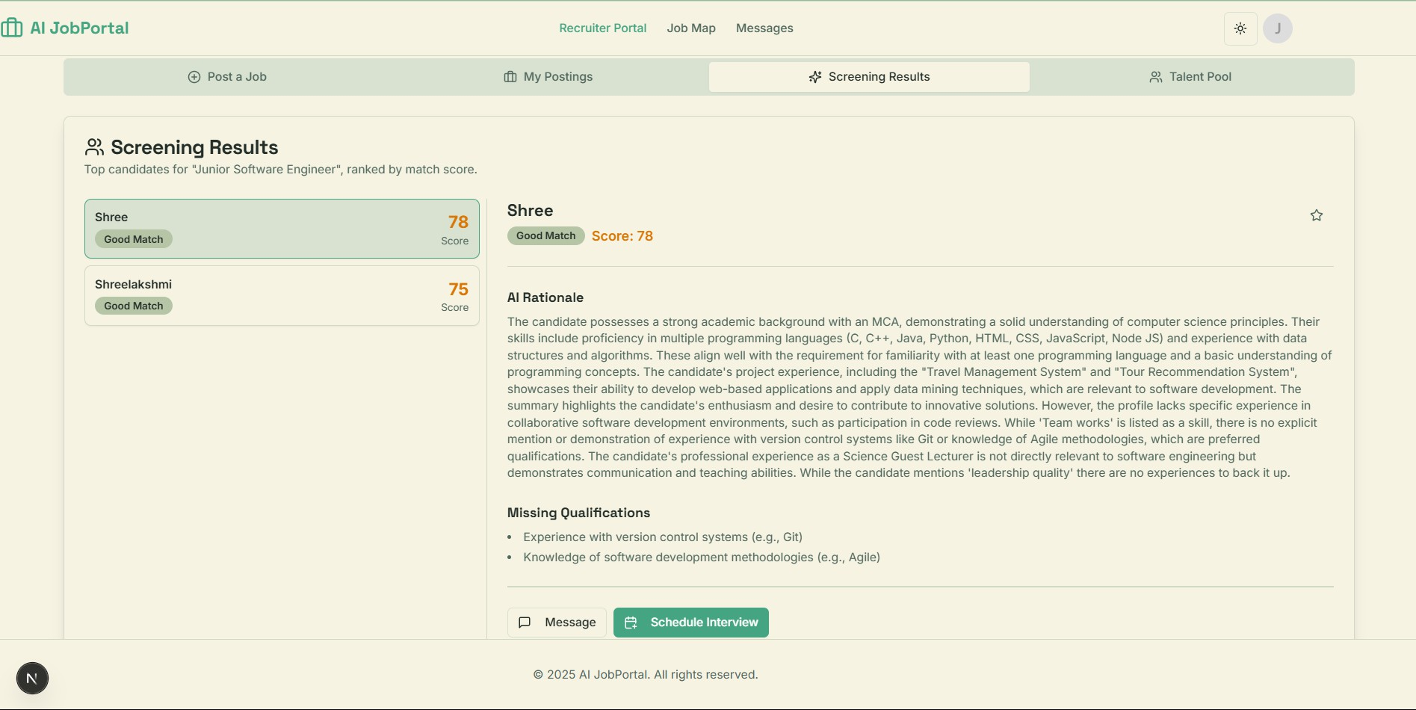

Figure 6.10: Screening result tab for Recruiter

The above figure illustrates the screening results interface, which is presented to the recruiter after the AI completes its candidate analysis. This tab provides a detailed breakdown of suitable candidates for a specific job, including a numerical match score out of 100. Additionally, the interface displays the AI’s rationale for its assessment and lists any missing qualifications. Recruiters are also supplied with options to shortlist, message or schedule an interview with a candidate directly from this page.

Shortlist tab

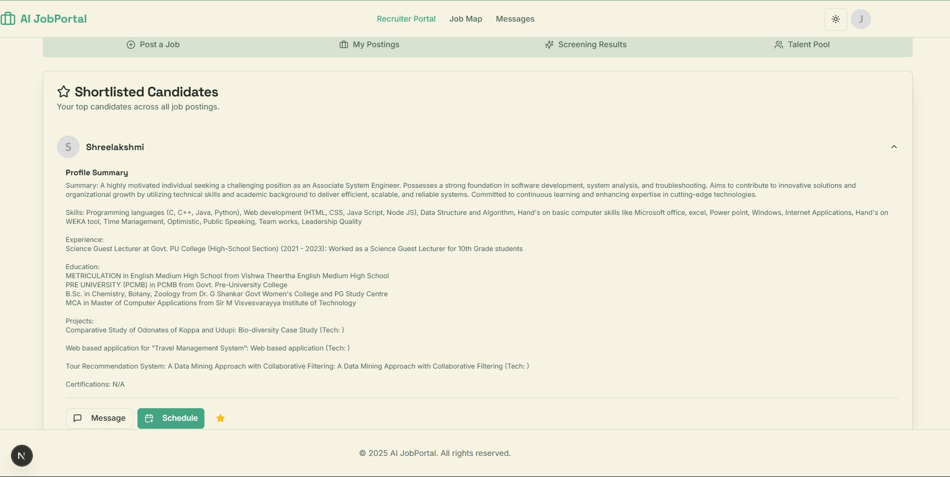

Figure 6.11: Shortlisted tab for Recruiter

This tab is for the recruiters to store the shortlisted candidates list. This tab provides the list of candidate names who are all being shortlisted, along with the profile summary of the candidate. From here, the recruiter can schedule an interview or directly message the candidate for more discussion.

Talent pool tab

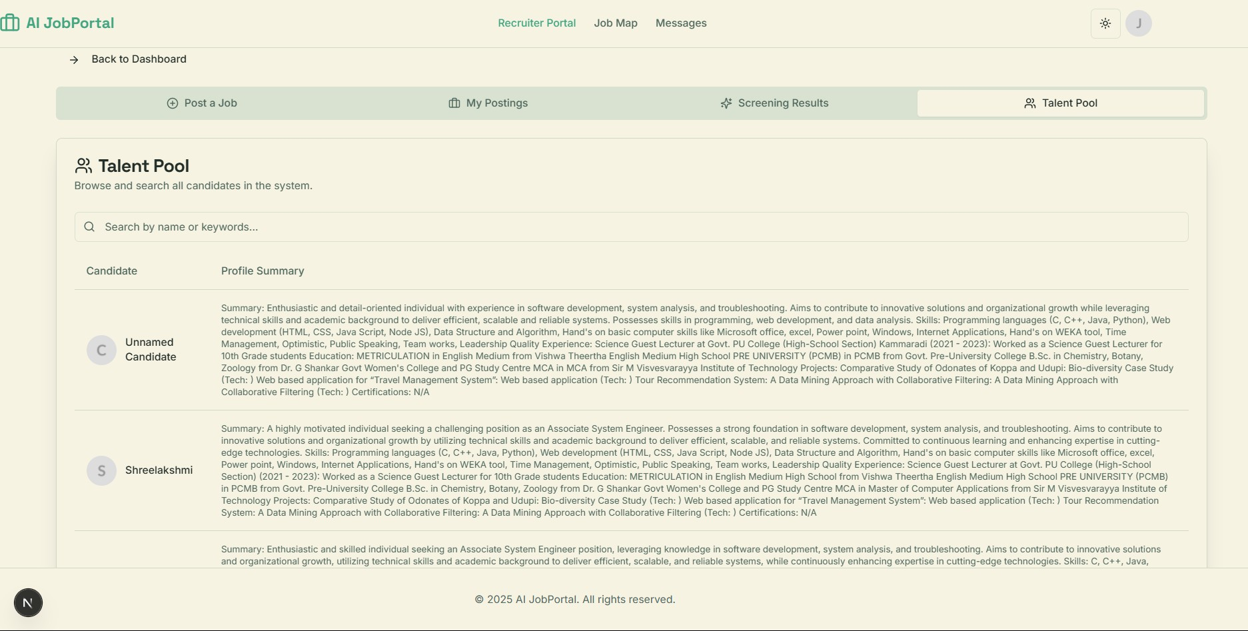

Figure 6.12: Talent pool tab for Recruiter

This talent pool tab is for the recruiters. This tab contains the list of candidates who are all registered in the application. This list also contains the profile summary of the candidates. This feature helps the recruiters to manually review and search a candidate profile.

Job Map page for Recruiter

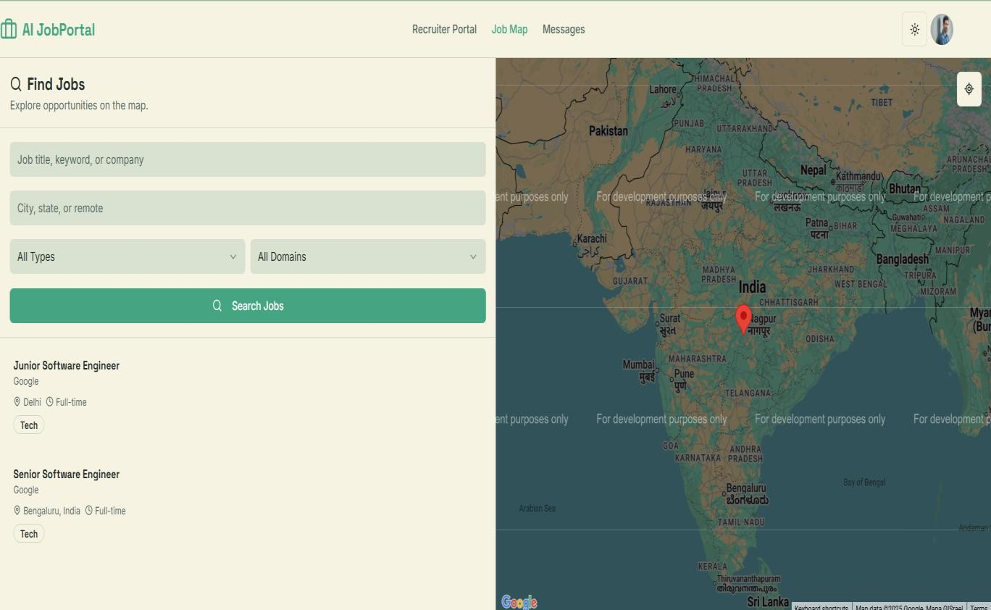

Figure 6.13: Job map page for Recruiter

This Job map section for the recruiter is to see the complete list of the jobs that are posted in the application. This helps the recruiter to identify a potential competition for the job role that the user posted.

Profile settings page for Recruiter

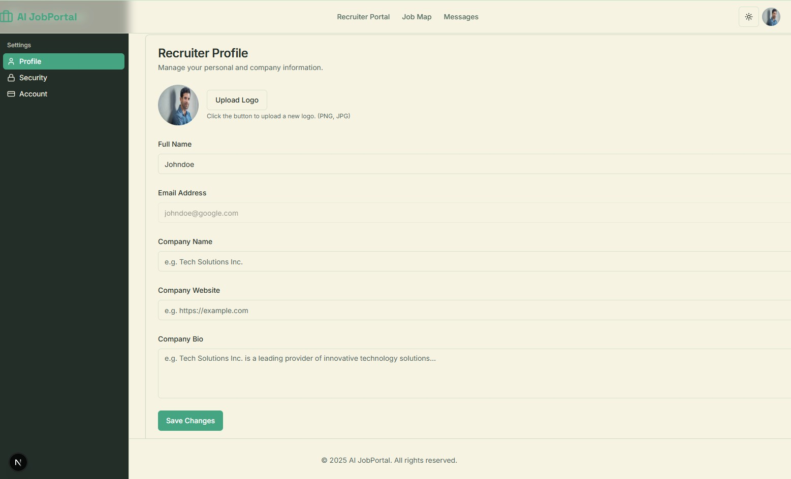

Figure 6.14: Profile settings page for Recruiter

This page is for the recruiter to set their profile. This page provides the feature to add name of the recruiter, company name, company website and company bio.

Security settings page for Recruiter

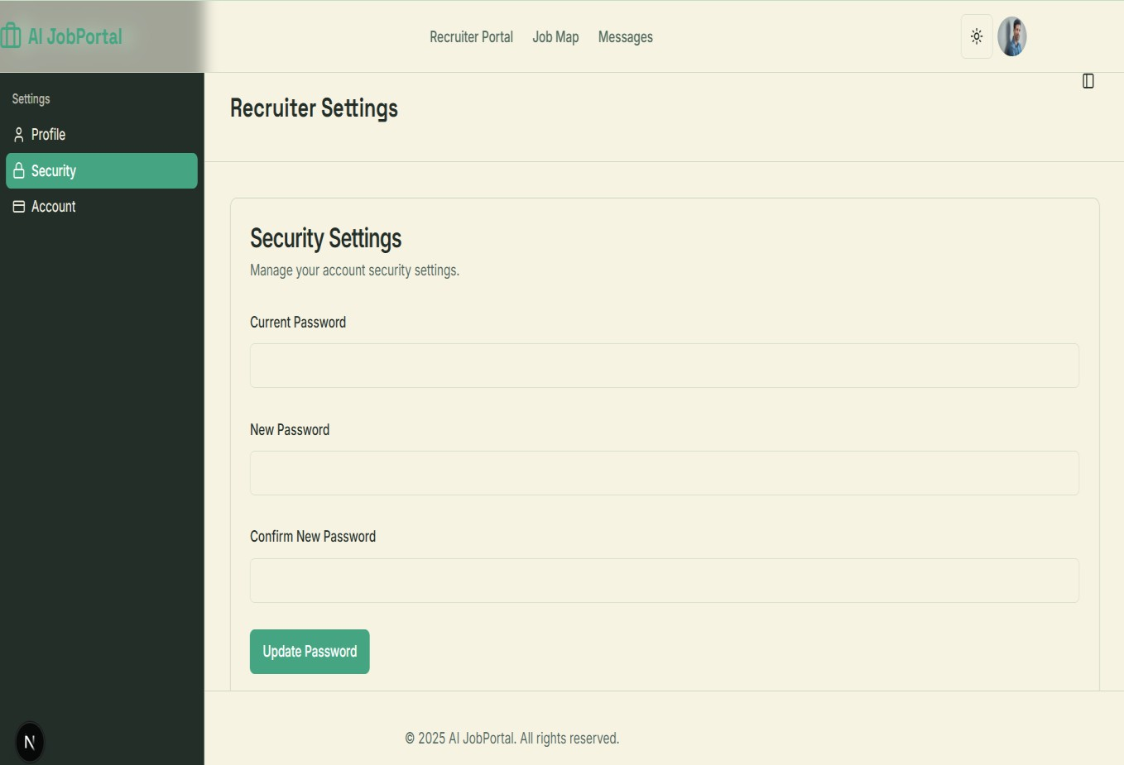

Figure 6.15: Security settings page for Recruiter

This security settings page for the recruiter allows the recruiter to change the password.

Account settings page for Recruiter

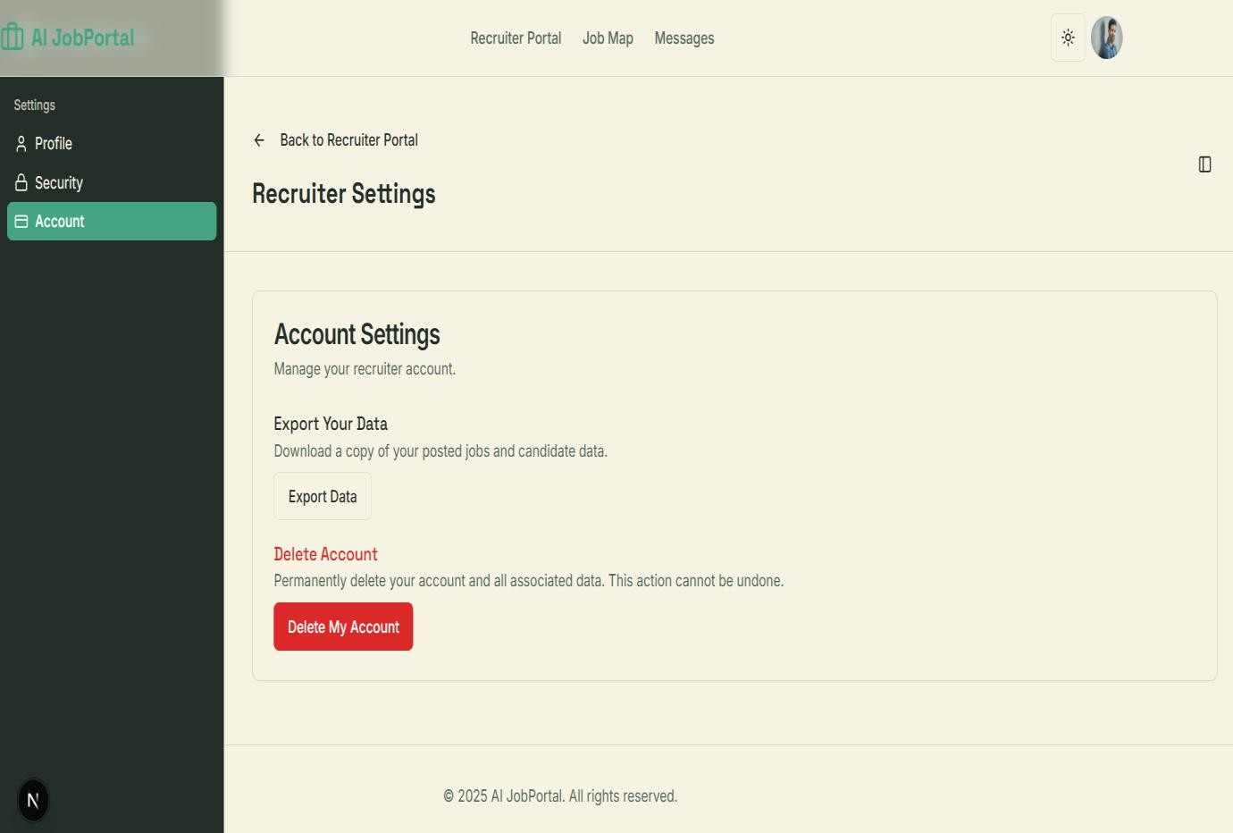

Figure 6.16: Account settings page for Recruiter

The account settings page for the recruiter allows the recruiter to manage their account. The recruiter can export a copy of data about the job that is posted by the recruiter in the website. This page also allows the recruiter to permanently delete their account.

Job Seeker Dashboard

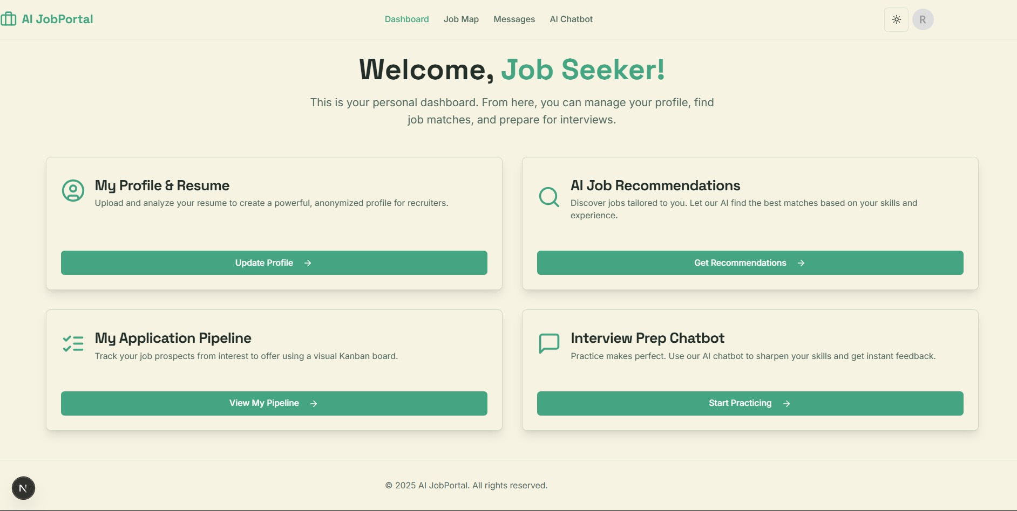

Figure 6.17: Dashboard for Job Seeker

This is the dashboard for the Job Seeker. After the successful login of the job seeker, he will be redirected to this dashboard page. This dashboard provides the navigation options to update the user profile, AI job recommendations, application status and interview preparation chatbot.

Job Map page for the Job Seeker

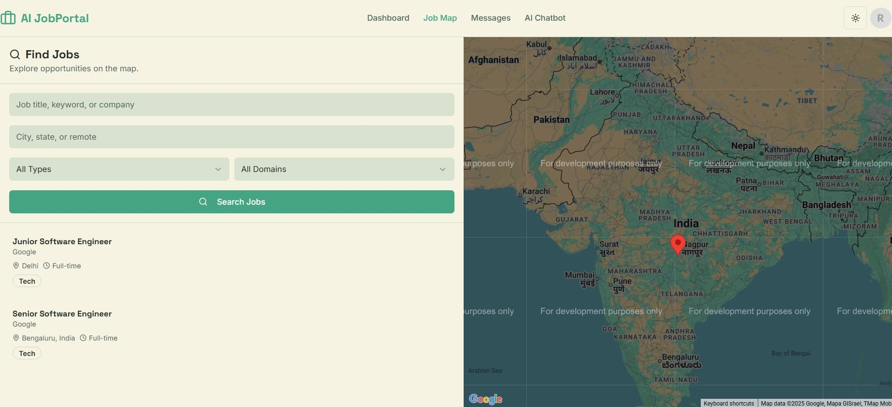

Figure 6.18: Job map for Job Seeker

The above image displays the Job Map interface designed for the job seeker. This feature allows users to discover relevant employment opportunities by providing specific search criteria. Users can input a job title, desired city, employment type and job domain to receive tailored suggestions that match their requirements.

Profile Settings tab

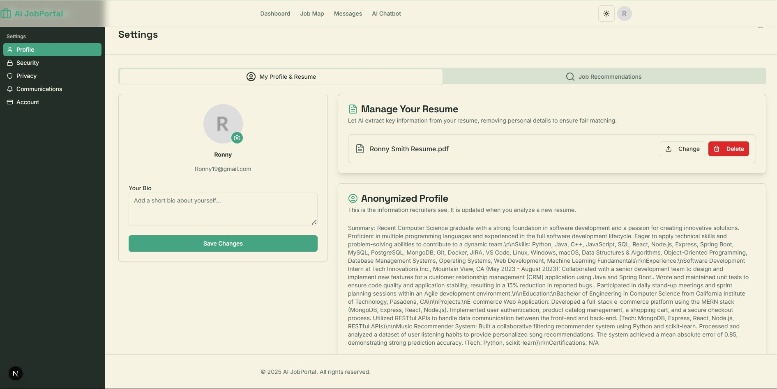

Figure 6.19: Profile Settings tab for Job Seeker

This is a Profile settings page for the Job Seeker. This page offers the personalized space for the Job Seeker to update the profile feature. The page also provides the feature to upload and manage the resume. Once the job seeker uploads the resume, the AI extracts the specific information from the resume, to make the resume anonymized which helps in the unbiased screening.

Job Recommendation tab

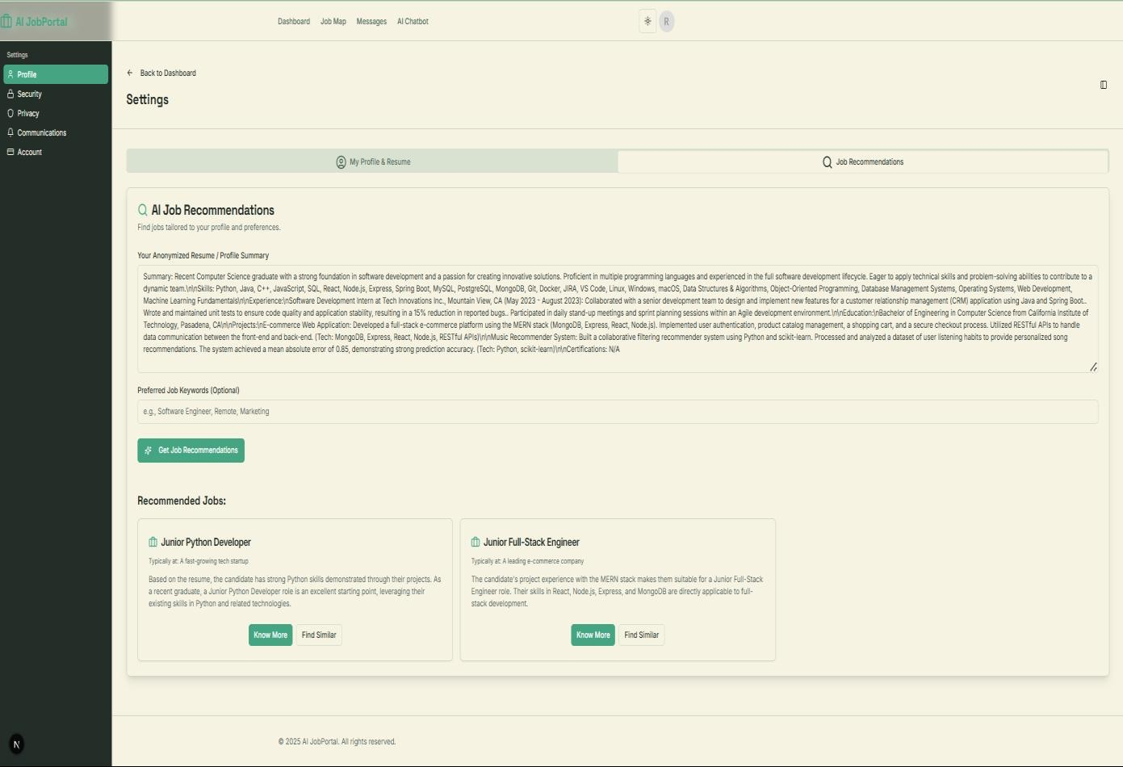

Figure 6.20: Job Recommendation tab for Job Seeker

This page is to get the job recommendation with the help of AI. The AI analyses the profile summary recommends the jobs by semantic matching of the skills with job requirements. The Job Seeker can optionally provide the keywords to get recommendations.

AI Chatbot page

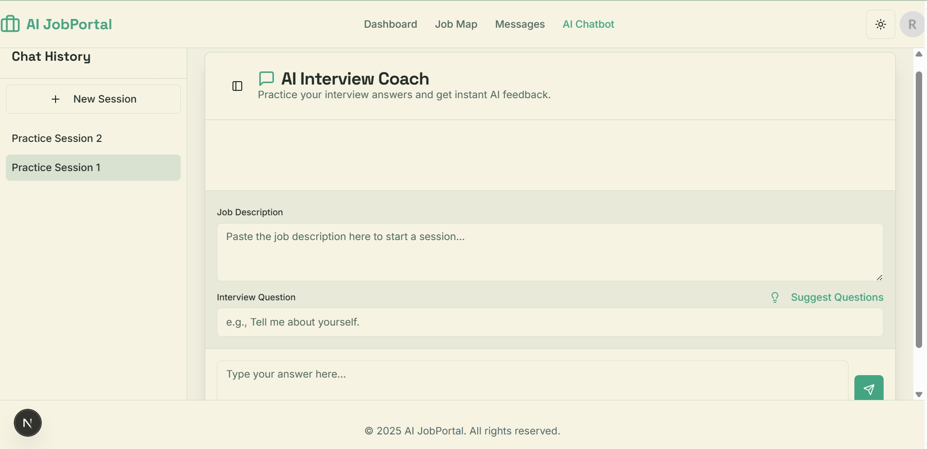

Figure 6.21: AI Chatbot page for the Job Seeker

This page is to help the Job Seeker to prepare for the interview. The chat bot takes the jib description as the input and the AI helps to generate the questions that are potentially asked in the interview. The chat bot analyses the answer provided by the user and gives a score out of 10 and a suggestion course to improve the specific skill.

My Application Pipeline page

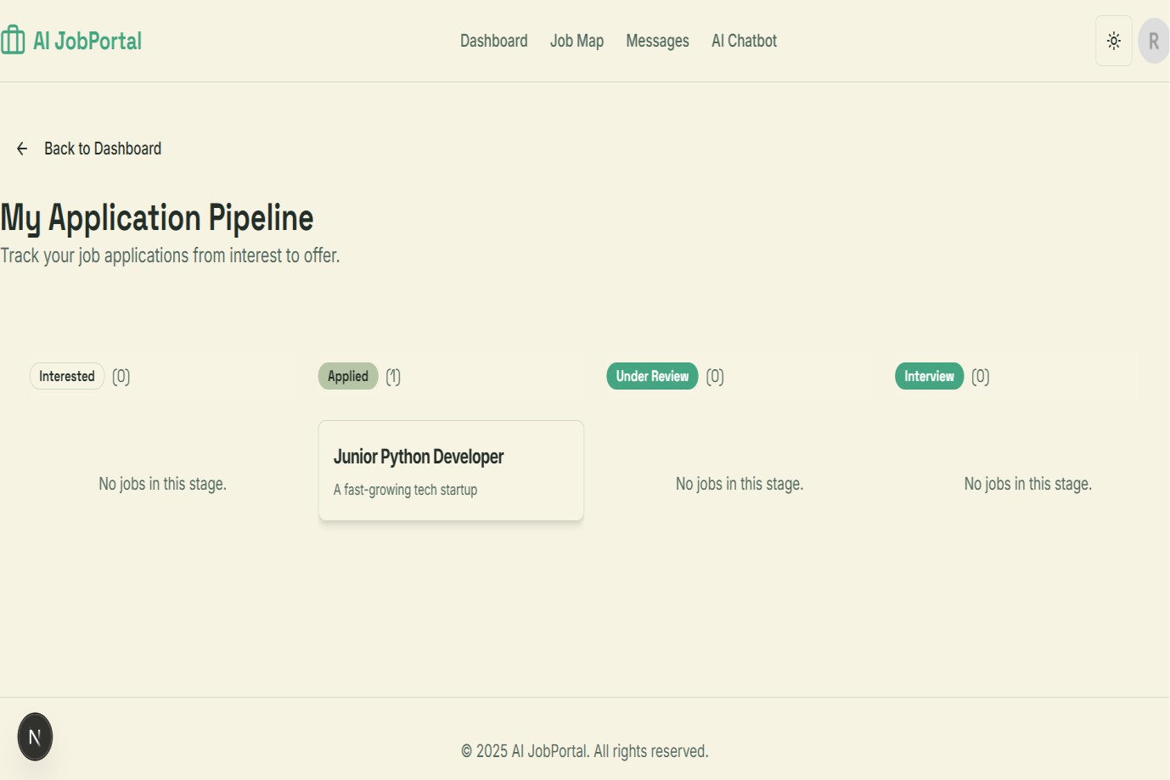

Figure 6.22: My Application Pipeline page for Job Seeker

This application pipeline page allows the job seeker to track the job application.

SOFTWARE TEST CASES
The process involves identifying and eliminating bugs from the project. It serves as a prerequisite for certifying or verifying the project to confirm that it operates as intended. This fundamental process illustrates whether the project’s requirements have been fulfilled or not.

Various kinds of Testing Procedures include:

Unit Testing

Unit testing accesses individual component or modules of the project. The purpose of this testing is to verify that a specific segment of code executes correctly. Unit testing aids in detecting and rectifying errors within a module. For this project we have selected the user login to test, where the authentication for each user role (Job Seeker, Recruiter, Admin) is specifically examined for every module.

Functional Testing

Functional testing is performed by comparing the functionality of each component in the project against its requirements. This involves validating core functionalities like the AI driven resume analysis, the job recommendation engine and the candidate screening process to confirm they operate correctly and meet their design specifications.

Integration Testing

This type of testing focuses on verifying the communication and the data flow between different modules of application to ensure they work together seamlessly. An instance of examining how the AI parsing flow is activated when user uploads resume and then updates their profile in the database.

System Testing

We integrate several subsystems into a cohesive system, to evaluate each module. These subsystems are assembled to create the intended structure. The testing methodology focuses on identifying potential errors that could arise from unforeseen interactions among the different components and subsystems of the entire AI JobPortal application.

Test Data

The primary emphasis here is on accessing the various functional requirements outlined in the Software Requirement Specification. For the AI JobPortal, this entails utilizing sample resumes (PDFs, DOCX), diverse job descriptions and different user inputs (e.g., login credentials for each user role, search queries) to verify system behaviour under realistic scenarios.

Test Report

This gives information regarding the data being input into the modules through predetermined experiments and verify whether modules are functioning correctly. Following the execution of the test cases, results are recorded to demonstrate that user authentication, AI driven analysis and data retrieval functions all operate correctly and fulfil the project’s objectives.

Test Cases

A test case defines a set of inputs and the anticipated results to verify system functionality and identify errors. For this project, testing methodologies are divided into two main categories:
Positive Test Cases and Negative Test Cases.

- In the Positive experiment, the engineer aims to achieve the expected outcome. For instance, a registered user with a valid password should successfully login.
- In the Negative experiment, the designer should not achieve the expected outcome. For example, a user entering an incorrect password should receive an error message and be denied access.

Test Cases of AI JobPortal

Test case  ID | Tese case name | Test description | Test input | Expected result | Actual output | Status
TC01 | Admin login | User name and password is  validated | Username Password | The page should be redirected to admin  dashboard | Login  successful | Pass
TC02 | Recruiter login | Registered  Recruiters can login | Username Password | The page should  be redirected to Recruiter portal | Recruiter Logged in  successfully | Pass
TC03 | Job Seeker login | Verifies that a registered job  seeker can log in  and access their user dashboard. | Username Password | The page should be redirected to User dashboard page | User logs in successfully | Pass
TC04 | Recruiter  registration | Ensures new recruiters can successfully complete the profile  registration  process | Appropriate values | Recruiter  account created | Recruiters registered  successfully | Pass
TC05 | Job Seeker registration | Validates that a new user can  successfully  register as a job seeker. | Valid user details | User account created  successfully | User account created  successfully | Pass

TC06 | Resume Upload & Parsing | A Job Seeker uploads a resume file to be analysed by the AI | PDF or DOCX file | The system  should extract skills,  experience and education and update the  user’s profile | Profile updated  successfully with parsed data | Pass
TC07 | AI Job  Recommendation | A Job Seeker requests job  recommendations based on their  profile | User  profile data and  optional  keywords | The system  should return a list of relevant job postings | Job  recommendati ons are  displayed | Pass
TC08 | Post a New Job | A Recruiter fills out and submits  the form to post a new job opening | Valid job details  (title,  description, etc) | The new job should be  created and appear in the  “My Postings”  list | Job posted successfully | Pass
TC09 | Candidate Screening | A Recruiter initiates AI  screening for a posted job | A job  description and a pool of  candidates | The system  should return a ranked list of candidates with match scores  and rationale | Candidate list is displayed with scores | Pass
TC10 | Application Tracking | A Job Seeker applies for a job and the status is tracked | User  applies for a job | The application should appear in the user’s “Applied”  pipeline and  made accessible to the recruiter  for review. | Application status updated successfully | Pass

Figure 7.1: Table of test cases

CONCLUSION
This project was developed to optimize and improve the hiring workflow for both candidates and hiring managers. By integrating Artificial Intelligence, the platform delivers precise and efficient solutions for connecting qualified professionals with relevant career opportunities
The system is designed to help users with distinct roles register and navigate the platform with ease. For instance, job applicants can submit their resumes for an AI powered skills analysis, which in turn generates personalized job recommendations and allows them to monitor their application status. On the other side, hiring managers have the tools to publish job vacancies, generate compelling descriptions with AI support, and automatically screen through numerous applicant profiles to identify the best qualified individuals. To facilitate these tasks, the system offers a dedicated dashboard for each user role to manage their activities.
Ultimately, this system significantly reduces the manual effort and time typically required for job searching and candidate evaluation. This enhances the precision of the hiring process, making resume analysis, job recommendations, and applicant tracking both simple and highly effective.

FUTURE ENHANCEMENT
The architecture of this project has been designed to be modular and scalable, allowing its components to be adapted or reused for future development. The existing features can be expanded upon, and new functionalities can be integrated to further improve the platform. Potential areas for future enhancement include:
- Advanced AI Analytics: The Admin and Recruiter dashboards could be enhanced with advanced analytics to display hiring trends, salary benchmarks, and in demand skills across the platform.
- Mobile Application: The project could be expanded into a dedicated native application for both iOS and Android, providing users with on the go access to job alerts and application management.
- Skill Gap Analysis: The AI's capabilities could be extended to conduct a detailed analysis of a job seeker's skill gaps and recommend specific online courses or certifications to help them become qualified for their desired roles.
- Company Reviews and Ratings: A feature could be added to allow job seekers to provide anonymous ratings and feedback on companies they have interviewed with, providing valuable insights to other users.

APPENDIX A: BIBLIOGRAPHY

- Srivastava, M., & Singh, S. (2023). ONLINE JOB PORTAL. International Research Journal of Modern Engineering and Technology (IRJMETS). Students, Department of Computer Science and Engineering, School of Management Sciences, Affiliated with APJ Abdul Kalam Technical University, Lucknow, Uttar Pradesh, India.
- Rizvi, F. T., Khan, N. A., Upadhyay, S., Suryawanshi, S., & Pappu, S. (Year). PLACEMENT MANAGEMENT SYSTEM.JETIR. 1Undergrad Student, 2Assistant Professor, 3Associate Professor, Computer Engineering Department, Rizvi College of Engineering, Mumbai, India.
- N. P. A. Sinte, N. S. Sahu, N. R. Kamble, and N. A. Gudduru, “Online Job Portal Management System,” Int. J. Adv. Res. Sci. Commun. Technol., vol. 7, no. 1, pp. 390 - 396, 2022.
- P. Kuhn and M. Skuterud, “Job search methods: Internet versus traditional,” Monthly Labor Review, vol. 123, no. 10, pp. 3–11, Oct. 2000.
- E. T. Welsh, C. R. Wanberg, K. G. Brown, and M. J. Simmering, “E-learning: emerging uses, empirical results and future directions,” Int. J. Train. Dev., vol. 7, no. 4, pp. 245–258, 2003.
- A. Boyce, “Online Job Hunting: A Pew Internet Project Data Memo,” Pew Internet and American Life Project, July 17, 2002.
- P. P. Aparanji and J. P. Tripathi, “Review of Job Portal in Recruitment Process Life Cycle,” J. Emerg. Technol. Innov. Res., vol. 5, no. 1, pp. 367 - 369, 2018.
- J. Smith and A. Johnson, “Enhancing User Experience in Online Job Portals,” in Proc. Int. Conf. Human-Computer Interaction, 2019, pp. 123 - 135.
- M. Brown, “Impact of Artificial Intelligence on Job Matching Algorithms,” Ph.D. dissertation, University of California, Berkeley, 2021.
- K. Acharya, “Online Job Portal Management System,” SSRN Electronic Journal, 2024.

