Software Engineering Lab 1: Requirements Engineering & UML Use-Case Modelling

Name: Rohanth Ganesha C
SRN: PES1UG24AM227
Class: D-Section (5th SEM-AIML)

1. Requirements Table
Internal verification completed before finalization: exactly 5 functional requirements are listed as FR-001 to FR-005, exactly 2 non-functional requirements are listed as NFR-001 to NFR-002, no duplicate IDs are present, all six required columns are included, and the wording of FR-001 and NFR-001 preserves the supplied source intent.
ID | Type | Description | Priority | Acceptance Criteria | Rationale
FR-001 | Functional | The system shall evaluate candidate survey responses against trial protocol inclusion/exclusion criteria and classify eligibility status. | High | Pass: Ineligible candidate flagged with specific failed criteria. Fail: Subject with exclusion criteria marked eligible. | This is the core pre-screening function that determines whether a candidate can proceed in the recruitment process.
FR-002 | Functional | The system shall allow a Trial Candidate to create and maintain a recruitment profile and submit the pre-screening survey responses required for a clinical trial. | High | Pass: A Trial Candidate can save required profile details and submit all mandatory pre-screening answers for a selected trial. Fail: The system accepts an incomplete profile or missing mandatory survey responses as a valid submission. | Candidate profile data and survey responses are necessary inputs for eligibility pre-screening.
FR-003 | Functional | The system shall present the candidate's eligibility status to the Trial Candidate and the Clinical Researcher, including the specific failed criteria when the candidate is classified as ineligible. | Medium | Pass: After evaluation, both actors can view the recorded eligibility status, and an ineligible result displays the exact failed criterion or criteria. Fail: The displayed status omits failed criteria for an ineligible candidate or shows a status that does not match the stored evaluation result. | Recruitment decisions must be visible and understandable to both actors so that next steps can be taken correctly.
FR-004 | Functional | The system shall allow the Clinical Researcher to record and track informed consent milestones and visit compliance logs for each candidate. | High | Pass: A Clinical Researcher can record consent milestone updates and visit compliance entries with status and timestamp for a candidate. Fail: The system stores a consent or compliance update without status tracking or without a timestamp. | The problem statement explicitly requires tracking informed consent milestones and visit compliance logs throughout recruitment.
FR-005 | Functional | The system shall allow the Clinical Researcher to review candidate recruitment information, including profile data, eligibility status, informed consent milestones, and visit compliance logs. | Medium | Pass: A Clinical Researcher can retrieve a candidate record that shows profile data, eligibility status, informed consent milestones, and visit compliance logs together. Fail: The retrieved recruitment record omits one of the required information areas or mixes data from different candidates. | Researchers need a consolidated recruitment view to monitor candidate progress and act on accurate trial information.
NFR-001 | Non-Functional (Performance & Security) | The recruitment database must comply with 21 CFR Part 11 electronic record standards including cryptographic audit trails. | High | Pass: Benchmarking tests confirm target latency and security standards under simulated peak load. | Clinical-trial recruitment records require secure, traceable, and tamper-evident handling appropriate to the healthcare domain.
NFR-002 | Non-Functional (Reliability & Data Integrity) | The system shall preserve committed recruitment, consent, and compliance records through automated backup and recovery controls. | High | Pass: A scheduled backup completes successfully and a restore test recovers candidate profiles, eligibility results, consent milestones, and visit compliance logs without data corruption. Fail: The restore test loses, corrupts, or mismatches any committed recruitment record. | Recruitment operations depend on durable and recoverable records because data loss would disrupt clinical-trial tracking and review.

3. UML Use-Case Diagram

Explicitly Mentioned Actors
- Trial Candidate
- Clinical Researcher

Explicitly Mentioned Use Cases

Primary Use Cases
- Manage Recruitment Profile
- Submit Pre-Screening Survey
- View Eligibility Status
- Track Informed Consent Milestones
- Record Visit Compliance
- Review Recruitment Records

Secondary Use Cases
- Evaluate Eligibility
- View Failed Criteria
The secondary use cases support the primary recruitment workflow. Evaluate Eligibility is mandatory included behavior during pre-screening, and View Failed Criteria is conditional behavior shown only when a candidate is classified as ineligible.
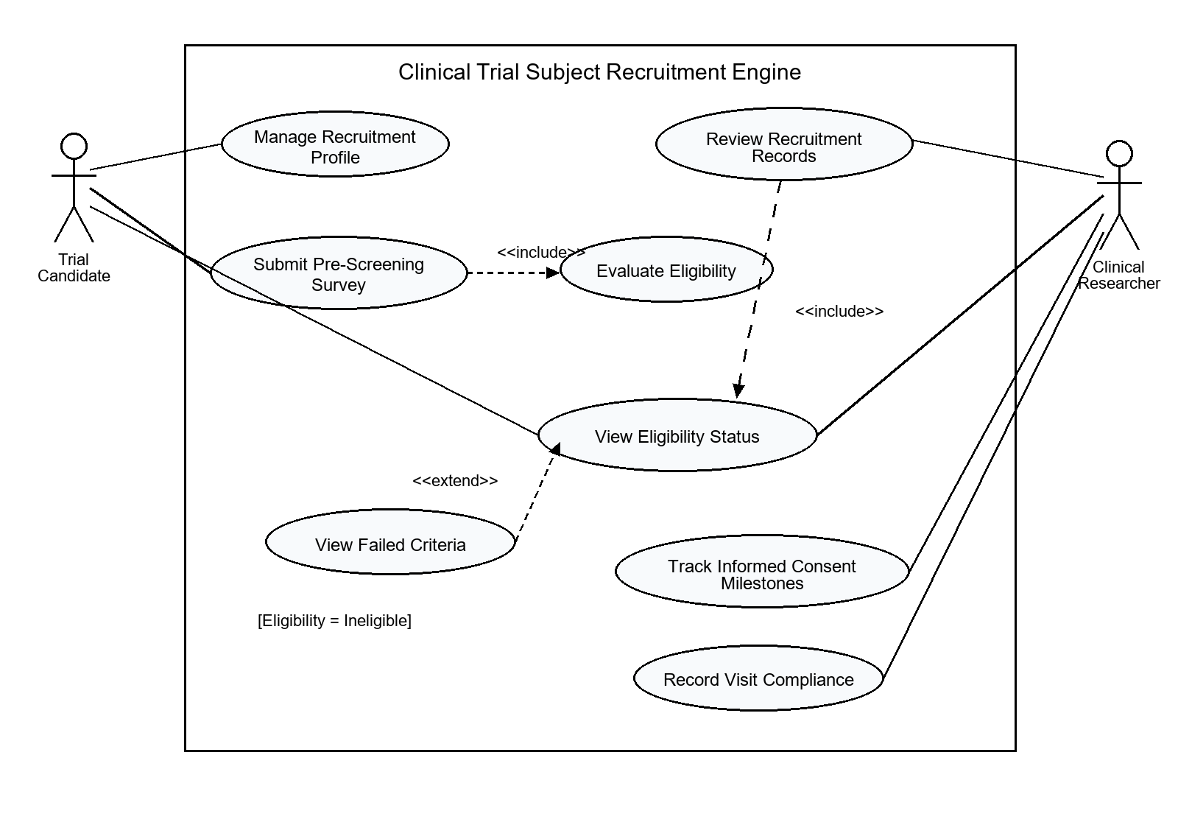
UML Use-Case Diagram for the Clinical Trial Subject Recruitment Engine
Included relationships: Submit Pre-Screening Survey includes Evaluate Eligibility; Review Recruitment Records includes View Eligibility Status. Extended relationship: View Failed Criteria extends View Eligibility Status when eligibility is ineligible.

4. Use-Case Flow Specification-Submit Pre-screening survey

1. Preconditions
- The Trial Candidate has access to the Clinical Trial Subject Recruitment Engine.
- The Trial Candidate has created a recruitment profile with the required profile details.
- A clinical trial with defined inclusion/exclusion criteria is available for pre-screening.

2. Postconditions
- The submitted pre-screening survey responses are stored in the candidate's recruitment record.
- The system has evaluated the responses against the trial protocol inclusion/exclusion criteria.
- The candidate's eligibility status is recorded and available for viewing.
- If the candidate is ineligible, the failed criterion or criteria are stored and displayed with the result.

3. Main Success Scenario
- The Trial Candidate opens the pre-screening survey for a selected clinical trial.
- The system displays the required pre-screening questions linked to the trial protocol criteria.
- The Trial Candidate enters all mandatory survey responses and submits the survey.
- The system validates that all required responses are present and linked to the correct candidate profile.
- The system evaluates the submitted responses against the trial's inclusion criteria and exclusion criteria.
- The system determines that all required inclusion criteria are satisfied and no exclusion criteria are triggered.
- The system classifies the candidate as eligible and records the eligibility result in the recruitment record.
- The system displays the eligibility status to the Trial Candidate and makes the same recorded status available to the Clinical Researcher.

4. Alternate Flow
A1. Candidate is classified as ineligible
- At Step 5, the system detects that one or more inclusion criteria are not satisfied or that one or more exclusion criteria are triggered.
- The system classifies the candidate as ineligible.
- The system records the failed criterion or criteria in the recruitment record.
- The system displays the ineligible status together with the specific failed criterion or criteria to the Trial Candidate and makes the same result available to the Clinical Researcher.

