Business Requirement Document (BRD)

Online Food Ordering System

1. Project Overview
The Online Food Ordering System is designed to provide a seamless digital platform that enables customers to browse restaurants, explore menus, place food orders online, make secure digital payments, and track deliveries in real time. The system focuses on enhancing customer convenience while improving operational efficiency for restaurants by automating the entire food ordering lifecycle.
This platform aims to eliminate manual processes involved in traditional ordering methods and replace them with a faster, more reliable digital solution. It ensures that users can access the system through both web and mobile applications, providing flexibility and wider accessibility across different user groups.The Business Requirement Document (BRD) defines the overall business needs, high-level objectives, expected deliverables, and core functional requirements necessary for successful implementation. The system is designed to improve user satisfaction, reduce manual effort, minimize errors, and strengthen overall order management efficiency.

2. Business Objective
The primary objective of this project is to develop an efficient, scalable, and user-friendly food ordering platform that simplifies restaurant discovery, food ordering, payment processing, and delivery tracking.The system aims to enhance customer experience by reducing ordering time, improving service speed, and providing a smooth and intuitive ordering journey. It also supports restaurants in managing incoming orders more effectively, improving kitchen coordination, and increasing overall operational productivity.
By integrating secure payment gateways and real-time tracking functionality, the platform ensures transparency, reliability, and trust among users. Additionally, this project demonstrates the role of a Business Analyst in gathering requirements, preparing documentation, analyzing workflows, and managing project tasks using Agile methodology tools such as Jira for user stories, task tracking, and sprint management.

3. Stakeholders
The Online Food Ordering System involves multiple stakeholders, each contributing to the successful functioning of the platform.Customers are the primary users who browse restaurants, explore menus, place food orders, and make secure online payments. Restaurant owners are responsible for managing menus, processing incoming orders, and ensuring timely preparation of food items. Delivery partners handle the pickup and delivery of orders while continuously updating delivery status within the system. The Admin oversees the entire platform, manages users, monitors system performance, and ensures smooth operational control across all modules.
Each stakeholder plays a crucial role in maintaining system efficiency, ensuring proper coordination between different entities, and enhancing overall customer satisfaction.

4. Business Requirements
The system must provide secure user registration and login functionality, allowing customers to create accounts and manage their profiles efficiently. Users should be able to browse restaurants, view menus, search for food items, and apply filters based on preferences such as cuisine, price, and ratings.The application should support cart management features, enabling users to add, update, or remove items before final checkout. A secure and reliable payment gateway must be integrated to support multiple payment options including UPI, debit cards, credit cards, and digital wallets.
The system must also provide real-time order tracking to ensure transparency throughout the order lifecycle. Additionally, automated notifications and order confirmations should be triggered after successful order placement and payment completion, improving communication between the system and users.

5. Project Scope
The project scope defines the boundaries of functionalities included in the Online Food Ordering System.The in-scope features include user management, restaurant browsing, menu display, food ordering, secure payment processing, and real-time delivery tracking. These core modules are essential for delivering a complete and efficient food ordering experience to customers and restaurants.
However, certain advanced functionalities are excluded from the current scope due to complexity and external dependencies. These include restaurant kitchen automation systems and delivery vehicle GPS integration. Clearly defining the scope helps maintain project focus, avoid scope creep, and ensure timely delivery of the defined requirements.

6. Expected Outcome
The expected outcome of the Online Food Ordering System is the successful delivery of a reliable, secure, and user-friendly digital platform that enhances the overall food ordering experience.Customers are expected to benefit from faster restaurant discovery, simplified ordering processes, secure payment options, and real-time order tracking. Restaurants are expected to experience improved order management, better customer engagement, and increased operational efficiency through automation.
From a project perspective, the system demonstrates the application of Agile Scrum methodology, structured business analysis, stakeholder communication, and practical project execution using Jira for requirement tracking, task management, and workflow coordination. Overall, the project aims to reduce manual effort, minimize operational errors, and support scalable business growth for restaurants.

7. Stakeholder Interaction Diagram
The following diagram represents the interaction between key stakeholders and the Online Food Ordering System.
The Stakeholder Interaction Diagram represents the communication and workflow relationships between all key participants involved in the Online Food Ordering System. It visually explains how different stakeholders interact with the system and with each other to ensure smooth execution of the food ordering process.
In this system, the Customer interacts with the platform to browse restaurants, place orders, and make payments. Once an order is placed, the system forwards the request to the Restaurant, where the order is confirmed and food preparation begins. After preparation, the system coordinates with the Delivery Partner, who picks up the order and delivers it to the customer while updating the delivery status in real time.
The System acts as the central communication hub that connects all stakeholders and manages data flow between them. It ensures that each action—such as order placement, confirmation, payment success, and delivery updates—is properly recorded and communicated to the relevant party.
The Admin plays a supervisory role by monitoring system activities, managing users, handling exceptions, and ensuring that all operations run smoothly. This interaction model helps maintain transparency, improves coordination among stakeholders, and ensures efficient end-to-end order processing within the platform.

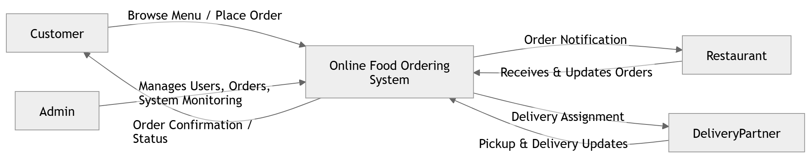

8. Business Process Flowchart
This represents your end-to-end ordering flow:

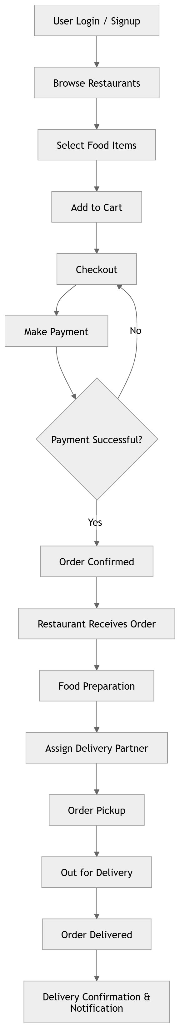

9. Project Scope Visualization (In / Out Scope)
You can represent scope clearly like this:
