Online Food Ordering System – Agile Scrum Project (Jira)
Software Requirements Specification (SRS)

1. Introduction
The Online Food Ordering System is a digital platform designed to simplify food ordering and delivery operations for customers and restaurants. The project was managed using Agile Scrum methodology in Jira, where business analysis and project management practices were simulated in a real-world environment. The system allows customers to browse restaurants, explore menus, place food orders, make secure online payments, and track deliveries in real time. Agile practices such as sprint planning, backlog grooming, and user story management were implemented to ensure smooth project execution. The system improves customer convenience, operational efficiency, and restaurant management through automation and streamlined workflows.

2. Overall Description
The system is a web and mobile-based application that connects customers, restaurants, and delivery services on a single platform. Customers can create accounts, search restaurants, add food items to their carts, and complete payments digitally. Restaurants can manage orders, update menus, and monitor customer requests efficiently. The application was developed conceptually using Agile Scrum methodology, where project tasks were divided into multiple sprints according to business priorities. Jira was used for managing epics, user stories, sprint boards, and workflows. The overall objective of the project was to demonstrate Business Analyst responsibilities while understanding software development lifecycle practices.

3. Functional Requirements
The Online Food Ordering System includes multiple functional modules to ensure smooth operations for both customers and restaurants. The system provides user registration, login, password recovery, and account management functionalities. Customers can browse restaurant listings, search food items, apply filters, and view detailed menus before placing orders. The cart management module enables users to add, remove, or update food items before checkout. The order processing system handles order confirmations, invoice generation, and delivery status updates. Secure online payment integration through UPI, cards, and digital wallets ensures safe transactions. Real-time order tracking and notification systems enhance the user experience significantly.

4. Non-Functional Requirements
The system was designed with a focus on performance, reliability, security, and scalability to ensure an efficient user experience. The application should respond within three seconds for most operations to maintain customer satisfaction. Secure payment processing mechanisms, including encryption and tokenization, are necessary to protect sensitive customer information. The system must provide high availability with minimal downtime to support continuous restaurant operations. A mobile-responsive user interface ensures accessibility across devices such as smartphones, tablets, and desktops. Scalability is another important requirement, allowing the platform to handle multiple users, restaurants, and simultaneous orders without affecting system performance or reliability.

5. Agile Scrum Project Execution
The project execution followed Agile Scrum methodology using Jira as the primary project management tool. The project was divided into three sprints based on business priorities and feature implementation requirements. Epics, user stories, and tasks were created for modules such as User Management, Orders, Payments, and Delivery Tracking. Sprint planning meetings were conducted to assign tasks and estimate workloads effectively. The Agile workflow consisted of stages including To Do, In Progress, and Done to monitor project progress. Backlog grooming and sprint reviews were performed regularly to ensure project goals were aligned with business requirements and customer expectations throughout development.

6. Constraints
The Online Food Ordering System depends heavily on stable internet connectivity for proper operation and communication between users, restaurants, and delivery services. Online payment processing relies on third-party payment gateways such as UPI, debit cards, credit cards, and wallets, making the system dependent on external integrations. Real-time delivery tracking functionality requires accurate backend updates and GPS integration to provide correct location details to customers. The system also requires regular maintenance, server availability, and database management to ensure uninterrupted services. Technical limitations, security concerns, and scalability challenges must be considered while expanding the system for larger business operations.

7. System Workflow Flowchart
The following flowchart represents the complete workflow of the Online Food Ordering System from user authentication to final delivery tracking.
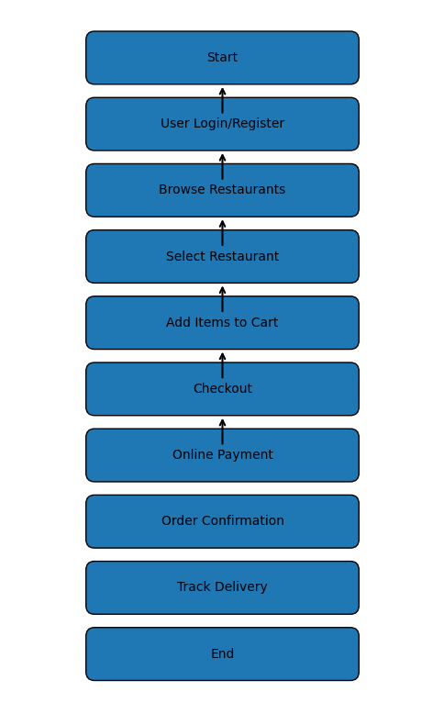

8. Use Case Diagram
The use case diagram below demonstrates the interactions between the customer and the Online Food Ordering System.
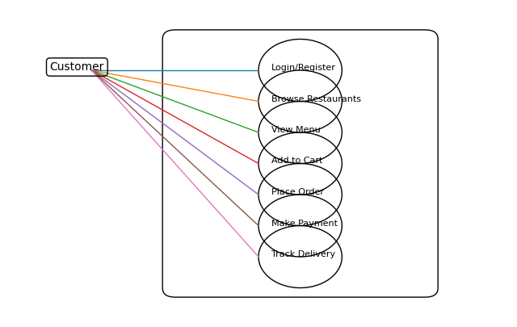

9. Data Flow Diagram (DFD – Level 0)
The Data Flow Diagram explains the movement of information between the user, system processes, and connected databases.
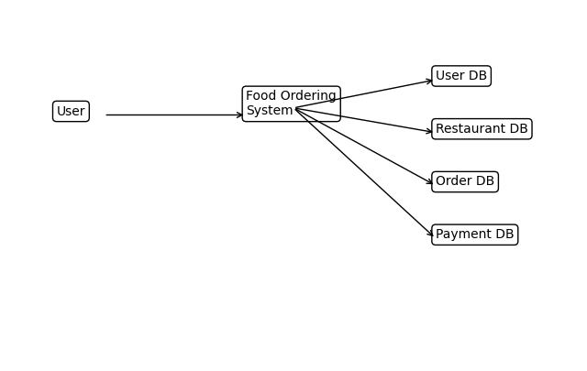

10. Agile Scrum Practices Used
The project implemented various Agile Scrum practices to simulate real-world Business Analyst responsibilities. Jira was used for backlog management, sprint planning, issue tracking, and workflow monitoring. User stories were prioritized according to business value, while sprint reviews and retrospective meetings helped improve team coordination and project delivery. Tasks were tracked through different workflow stages such as To Do, In Progress, and Done to ensure transparency and efficient execution.

11. Future Enhancements
Future enhancements may include AI-based food recommendations, live GPS delivery tracking, chatbot integration, multi-language support, restaurant analytics dashboards, and cloud deployment for improved scalability. Additional Agile project artifacts such as Jira sprint reports, burndown charts, and ER diagrams can also be integrated to strengthen project documentation and presentation quality.

