Mysql –u root –p

Create database csd2204w18;

Show databases;

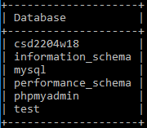

use csd2204w18;

show tables;

create table c1(

-> customerID int(2),

-> name varchar(20),

-> nickname varchar(10),

-> address varchar(50),

-> city varchar(30),

-> postalcode int(6)

-> );

desc c1;

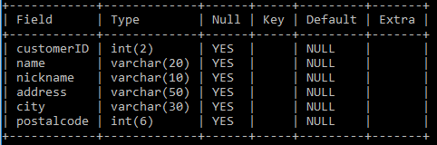

show create table c1;

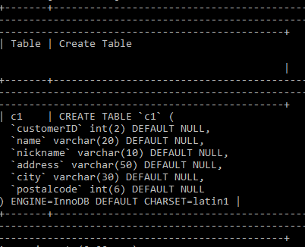

insert into c1 values(1,'Rohan','Raj','North York','Toronto',123456);

select * from c1;

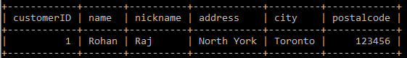

delete from c1 where customerID=1;

insert into c1 values(1,'Ashley','Ash','32 Washington street','WDC',321200);

insert into c1 values(2,'Bob marley','Bm','Keele street','Toronto',100100);

insert into c1 values(3,'Cherlies Theron','Cher','329 Empire state Building','New York',120134);

insert into c1 values(4,'Denial Jack','DJ','Spartan Building, East','Brazil',341020);

insert into c1 values(5,'Donna newman','New','250 Carlson blvd','Toronto',130120);

insert into c1 values(6,'Eston M.','M.','21 York. DV.','Toronto',201023);

insert into c1 values(7,'Bobby Chako','Chac','Kennedy','New York',320300);

insert into c1 values(8,'Ashko Charles','AK','Washington D.C.','USA',421044);

insert into c1 values(9,'Tony Special','Specie','Oakville','GTA',418921);

insert into c1 values(10,'Jack Sp','Sparrow','Oaster village','New Jersy',102301);

select * from c1;

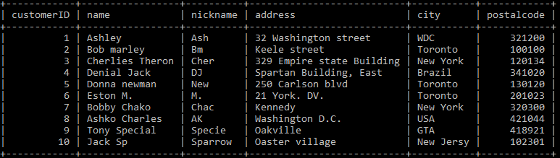

select * from c1 where city='Toronto';

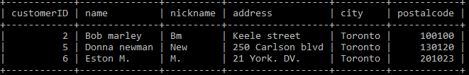

select * from c1 where name='Ashley';

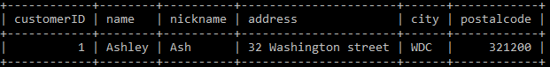

select * from c1 where city='Toronto' OR city='New York';

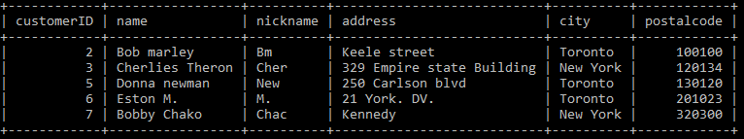

select * from c1 where city='Toronto' AND nickname='Bm';

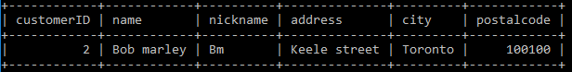

select * from c1 where customerID=4 OR customerID=6;

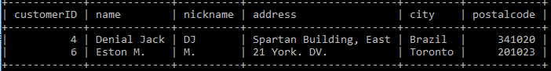

select * from c1 where customerID between 2 and 7;

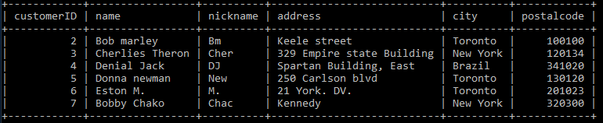

select * from c1 where nickname between 'Bm' and 'New';

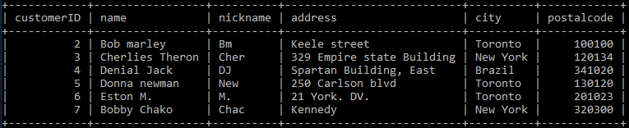

select * from c1 where name like 'D%';

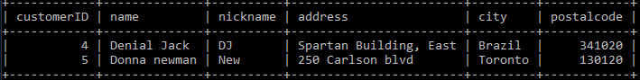

select * from c1 where city like 'N%';

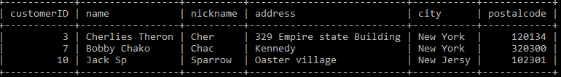

select * from c1 where name like '_o%';

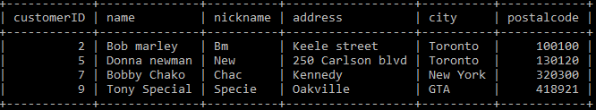

select * from c1 where name like '_on%';

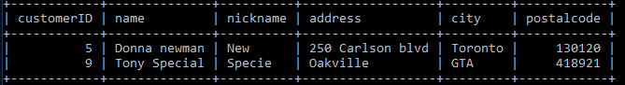

select * from c1 where name like '_o_n%';

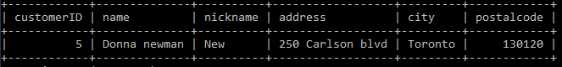

select * from c1 where name like 'D%' and city='Toronto';

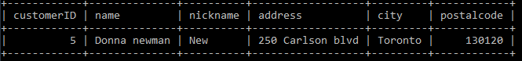

select * from c1 where customerID IN (2,4,7,9);

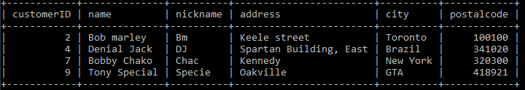

select * from c1 where nickname IN ('Bm','New','DJ');

