**Day4**

select * from c1 where name like '%n';

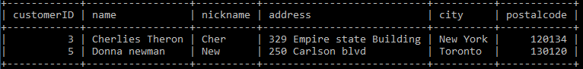

select * from c1 where customerID not between 4 and 7;

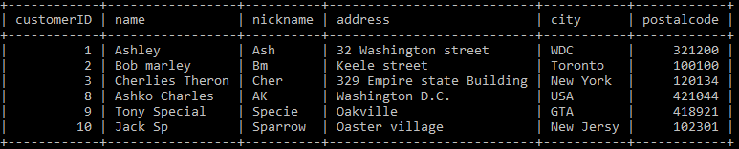

select * from c1 where nickname not IN ('Bm','AK','Sparrow');

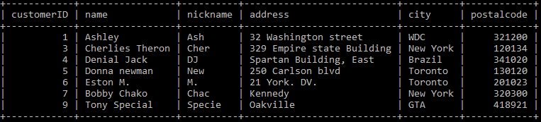

select customerID,name,nickname from c1 where nickname not IN ('Bm','AK','Sparrow');

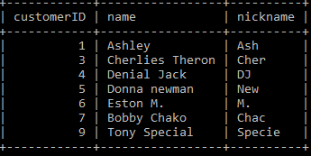

select customerID,name,city from c1 where nickname not IN ('Bm','AK','Sparrow');

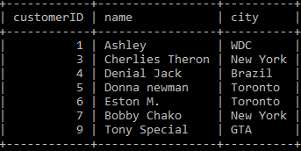

select customerID,name AS "Full Name" from c1 where nickname not IN ('Bm','AK','Sparrow');

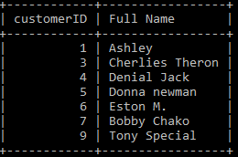

select count(*) from c1 where name like 'A%';

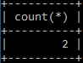

select count(*) AS "Number of customer whose name start with A" from c1 where name like 'A%';

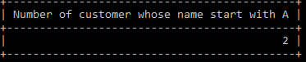

select count(*) AS "Number of customer from Toronto" from c1 where city='Toronto';

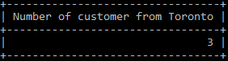

select DISTINCT(city) AS "Distinct city of customer" from c1;

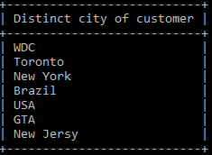

select * from c1 order by name;

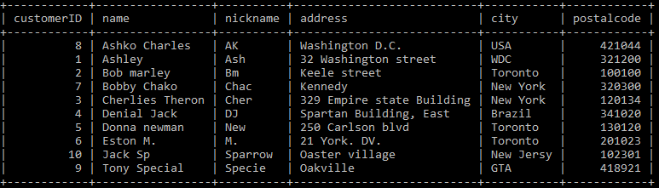

select * from c1 order by name desc;

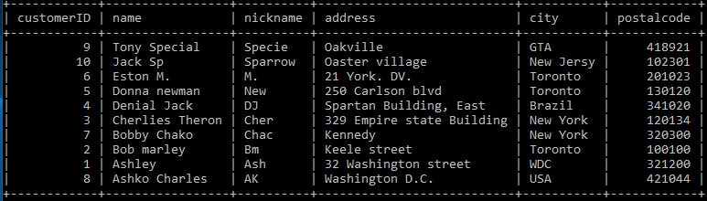

select 'WDC' AS city, count(*) from c1 where city='WDC'

union

select 'Toronto' AS city, count(*) from c1 where city='Toronto'

union

select 'New York' AS city, count(*) from c1 where city='New York'

union

select 'Brazil' AS city, count(*) from c1 where city='Brazil'

union

select 'USA' AS city, count(*) from c1 where city='USA'

union

select 'GTA' AS city, count(*) from c1 where city='GTA'

union

select 'New Jersy' AS city, count(*) from c1 where city='New Jersy';

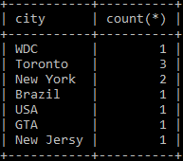

select * from c1 order by postalcode;

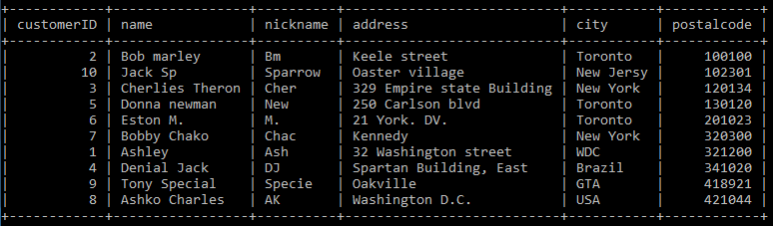

select * from c1 order by city asc;

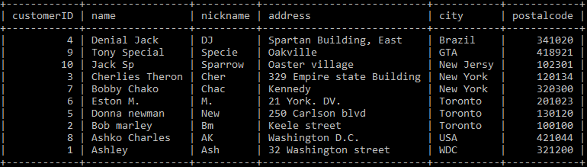

select * from c1 group by postalcode order by city asc;

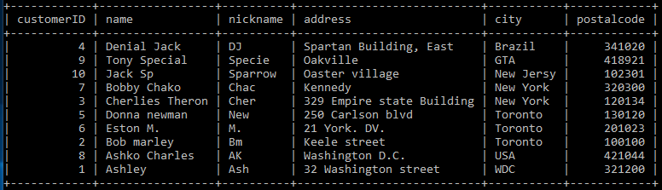

select * from c1 order by city,postalcode asc;

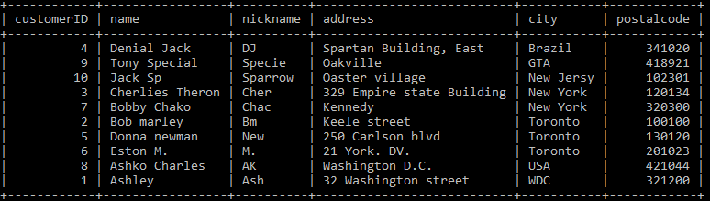

select * from c1 order by city asc,postalcode desc;

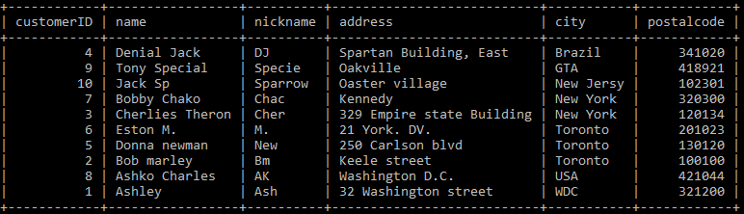

select * from c1 order by customerID desc, name asc, city desc;

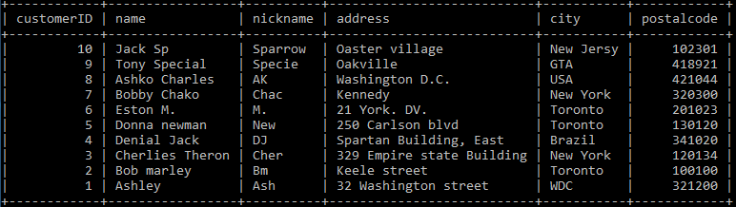

select count(*),city from c1 group by city;

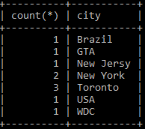

select count(*) AS "Number of city",city from c1 group by city;

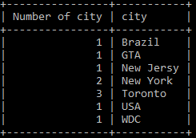

select * from c1 where name like 'D%' group by city ;

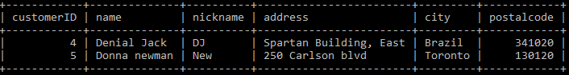

select min(postalcode) from c1;

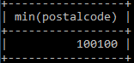

select max(postalcode) from c1;

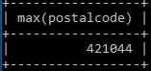

select sum(postalcode) from c1;

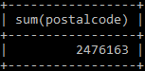

select avg(postalcode) from c1;

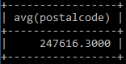

select count(*) AS "Number of people whose name start with A" from c1 where name like 'A%';

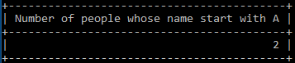

select city, count(city)*100/10 "customer %" from c1 group by city;

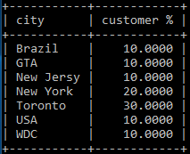

select * from c1 LIMIT 5;

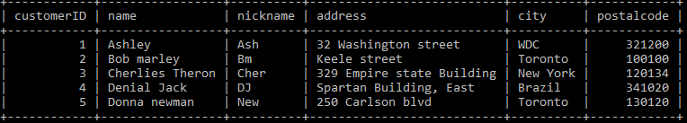

select * from c1 order by customerID desc LIMIT 3;

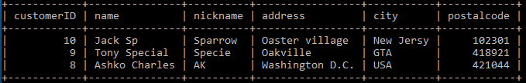

select * from(select * from c1 order by customerID desc LIMIT 3)t order by customerID asc;

OR

(select * from c1 order by customerID desc LIMIT 3) order by customerID asc;

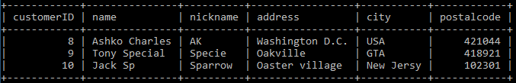

select * from c1;

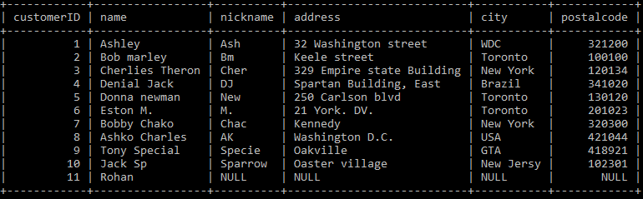

select * from c1 where nickname is NULL;

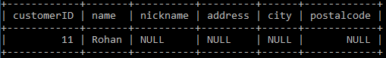

select * from c1 where nickname is not NULL;

