**DAY-5**

create table CityMaster (

CityID integer(4) primary key,

cityName varchar(255) default 'toronto’

);

create table persons(

ID integer(3),

LasteName varchar(255) NOT NULL,

FirstName Varchar(255),

Age integer(3),

CityID integer(4),

constraint pk_persons primary key (ID),

constraint ck_persons check (age>=18),

constraint fk_persons foreign key (CityID)

references CityMaster (CityID)

);

show tables;

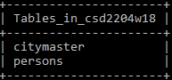

show index from citymaster;



show index from persons;



create table j1 AS select * from c1;

desc j1;

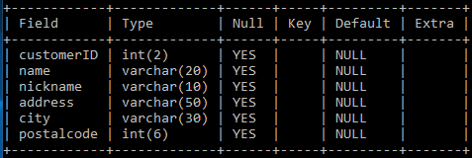

create table j2 AS select * from persons;

desc j2;

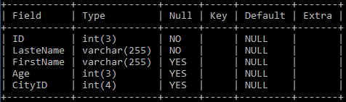

create table j3 like persons;

desc j3;

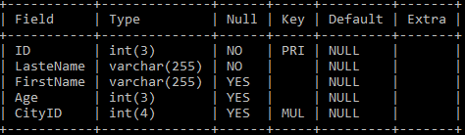

insert into j3 select * from persons;

select * from j3;

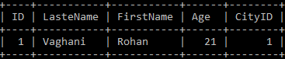

insert into j1 select * from c1 where customerID>5;

select * from j1;

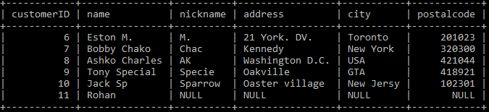

insert into j1 select * from c1 where city like 'New%';

select * from j1;

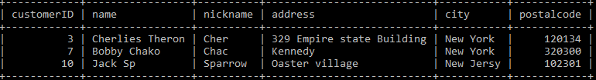

select * from citymaster;

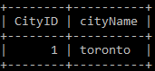

select * from persons;

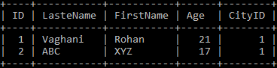

select version ();

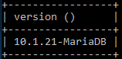

select database ();

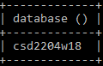

alter table citymaster add column country varchar(100);

desc citymaster;

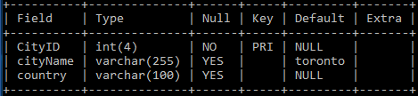

alter table citymaster modify column country varchar(20);

desc citymaster;

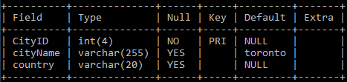

alter table citymaster change column country postalcode int(6);

desc citymaster;

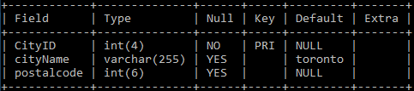

alter table citymaster drop column postalcode;

desc citymaster;

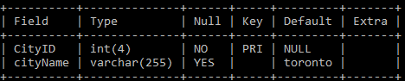

create table citytest AS select * from citymaster;

alter table citytest add primary key (CityID);

desc citytest;

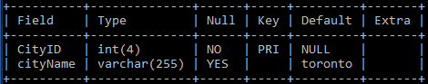

alter table citytest add constraint unique (cityName);

desc citytest;

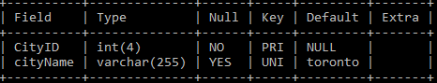

alter table citytest modify cityName varchar(255) not null;

desc citytest;

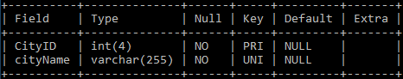

alter table citytest modify cityName varchar(255);

desc citytest;

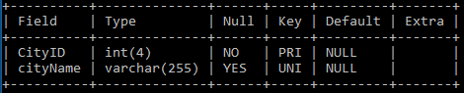

alter table citytest drop primary key;

desc citytest;

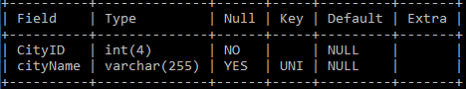

delete from citymaster where cityID=2;

select * from citymaster;

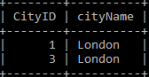

drop table citytest;

show tables;

