Andy (Yuan) Chang

Rohan Garg

JAVAFX Critters Part 2

Our display system is a separate view of the world and a separate controller panel. In the controller panel, we have a combination of buttons, sliders, radio-buttons, etc. to control the world of Critters. The model is inside the code; much of it is the same from the previous project. All of our control buttons and sliders have event handlers, which trigger specific methods and functions from the model. Or controller is built around little typing, so although we cannot put in an exact number, we don’t have to type too much to input critters or number of time steps.

Some problems we faced: (We solved these however)

- Getting the slider to function correctly

- Have a running view of stats

- Resizing the canvas

There were many problems that were different than the problems from the last project. Since the model was the same, we did not worry as much about that. The only ‘model’ component we added was the look function. We were, at first, not sure if this function only allowed Critters to view spaces ahead or actually moved the critter ahead. In the end, we implemented look to move the critter ahead.

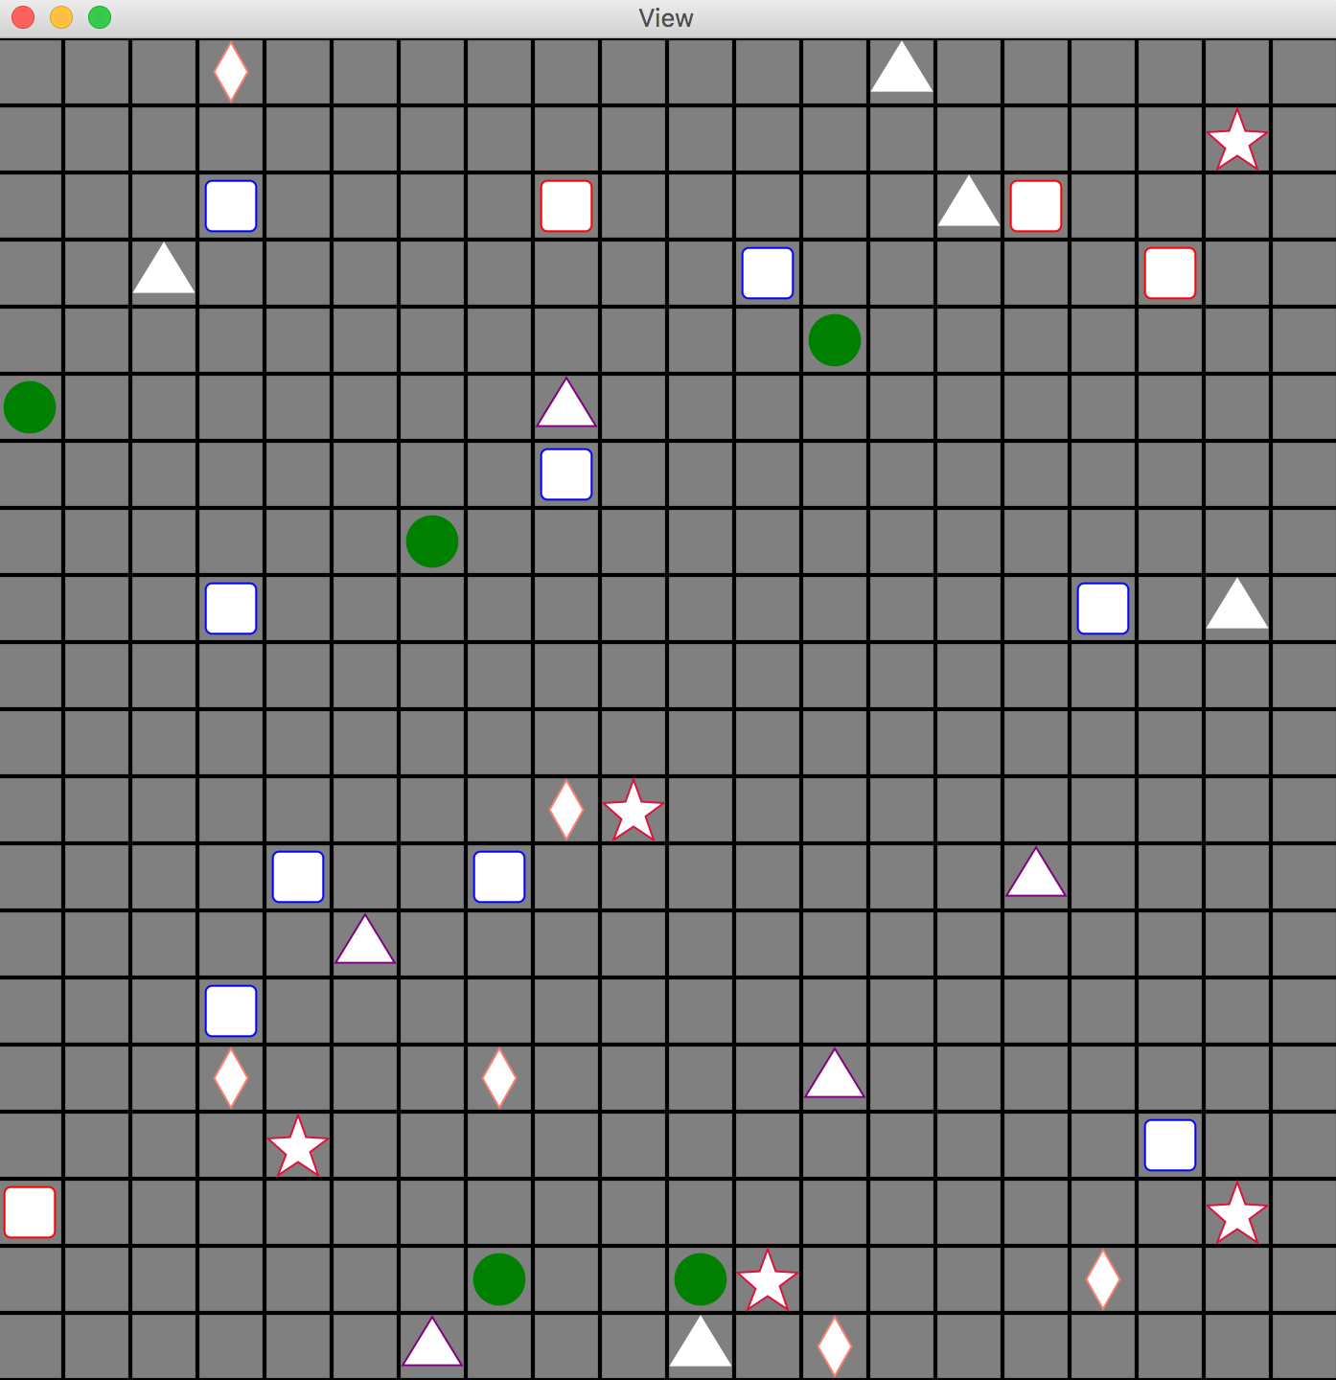This is what our view looks like:

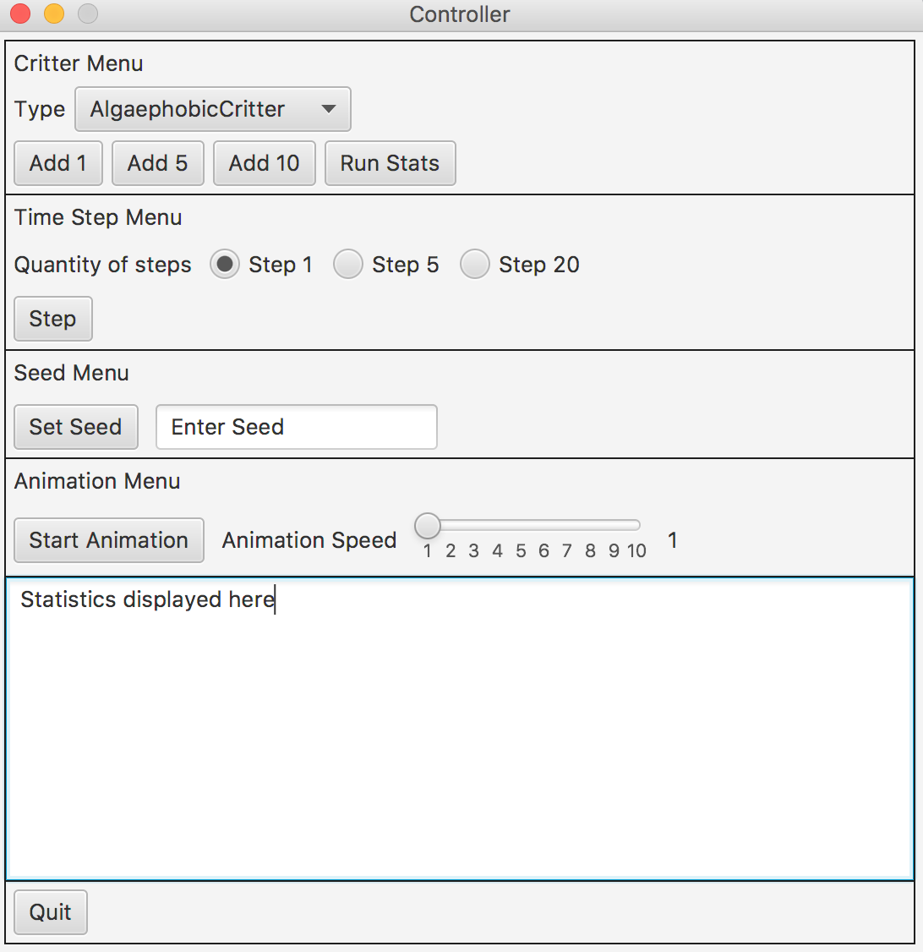This is what our controller looks like:

We chose to integrate run stats into the make section of our controller for ease of use. At first, we made it so that one could add critters as the world was animating. Later, we realized in the document, we were told to disable the rest of the buttons during animation. So, we did this and now if animation is running, nothing else can work.

Work Division:

Andy:

* Wrote Most of View
* Implemented Look
* Fixed many parts of controller

Rohan:

* Wrote much of controller (was later fixed by Andy)
* Put use of look into both critters
* Made Readme