From Tweets to Foreign Trade: How Trump’s Social

Media Shaped International Markets

Rohan Arora

ECON 4198W Proseminar

**Abstract**

This study investigates the effect of Donald Trump’s Twitter activity on foreign exchange volatility, focusing on tweets related to trade policy, international relations, economic policy, and military/security policy. Building on previous research, this study uses high-frequency intraday data and employs Ordinary Least Squares regressions with tweets categorized using the Anthropic Claude Sonnet 3.5 model. The findings indicate that Trump’s tweets significantly impacted currency volatility for major U.S. trading partners, particularly the Turkish Lira, Canadian Dollar, and Mexican Peso. These results suggest that Trump’s tweets were a distinct information shock, affecting foreign exchange markets and demonstrating how individual-driven social media sentiment can influence global financial dynamics. This study contributes to the literature on social media’s role in financial markets and offers insights into the predictive power of sentiment analysis on currency fluctuations.

1. **Introduction**

Platforms like X (formerly Twitter) allow policymakers, executives, and prominent groups or individuals to share information directly and in real-time, impacting investor sentiment and market performance in previously unforeseen ways (Tetlock, 2007). Gabrovsek et al. (2018) and Reboredo et al. (2018) confirm that Twitter sentiment can have predictive power, although it varies across sectors and is strongest during high-volume tweet periods. These findings suggest that Twitter sentiment reflects public opinion and can drive market fluctuations, particularly in response to real-time news or sudden statements by influential figures. This paper finds that tweets by Donald Trump during his presidency, which often included statements on trade policy, economic policy, and international relations, significantly influenced the foreign exchange (FX/FOREX) market's immediate response and volatility, contributing to understanding the interplay between social media and currency markets.

Tetlock (2007) demonstrated that media sentiment influenced stock market movements. Employing vector autoregressions on 16 years of the "Abreast of the Market" column in the Wall Street Journal and corresponding financial data, he revealed that heightened pessimism leads to temporary market price decreases. Gholampour and Van Wincoop built upon Tetlock's research by exploring the impact of social media sentiment on FX markets. Using sentiment analysis, they found a disconnect between rates and fundamentals due to amplified noise shocks and private information on Twitter. However, their study emphasized the role of broader sentiment indicators rather than the influence of individual users. Similarly, Ciftci et al. (2014) demonstrated a significant correlation between 2013 Twitter sentiment and USD/TRY fluctuations through a logistic regression. This suggests that FX markets react to traditional economic signals and sentiment-driven data from social media platforms.

Following significant market reactions to Trump's tweets on Boeing and Toyota, Ge et al. (2019), through a panel regression analysis, showed that his tweets frequently caused changes in stock prices, volatility, and trading volume. By focusing specifically on Trump's Twitter activity during his presidency, this paper provides an individual-centered approach that isolates his influence from broader Twitter sentiment, offering insight into the impact of his tweets on FX rates. Philippides (2021), employing an instrument variable approach, extended this focus on Trump to the FX market, revealing that his tweets throughout his presidency frequently negatively impacted the Turkish Lira, particularly on trade and sanctions. Afanasyeva et al. (2021) and Zhou (2019) found similar effects on the Russian Ruble and the Chinese Yuan. These studies support that Trump's Twitter statements effectively acted as a new type of information shock in FX markets, delivering market-moving sentiment directly to investors and bypassing traditional news channels. This study extends these studies by focusing on additional major trading partners, such as Mexico and Canada, and tweet categorization to capture immediate market responses to Trump's tweets.

This study uses an Ordinary Least Squares (OLS) regression model combined with tweet content categorized by trade policy, security/military policy, economic policy, and diplomatic relations using the Anthropic Claude Sonnet 3.5 model. This approach enables an assessment of how distinct tweets affected the currency values of the U.S.'s major trading partners. By categorizing tweets into specific topics, this approach isolates the effects of individual tweet types on FX volatility, allowing for a granular view of Trump's influence on currency rates. The study uses interaction terms to capture how the impact of these tweets might vary based on content and sentiment, providing a nuanced analysis of the conditions under which specific tweet topics and sentiments may trigger market shifts. Additionally, 30-minute intraday data provides insight into the immediate responses of FX markets to each type of tweet, offering a measurement of volatility shifts and market behavior. This approach enhances our understanding of Trump's influence on FX volatility. It adds to the broader literature on the role of individual-driven sentiment in financial markets, demonstrating how information in the digital age can significantly move global markets.

The results of this study indicate that Trump's tweets, particularly those related to trade policy or international statements, had significant and measurable effects on the FX rates of the Turkish Lira, Canadian Dollar, and Mexican Peso. For example, a single tweet from Trump regarding increased tariffs or sanctions on Turkey correlated with the immediate depreciation of the Lira against the U.S. Dollar, suggesting that market participants actively interpreted his tweets as policy signals (Philippides, 2020). These findings support existing literature while expanding on previous analyses by providing categorized tweet data, which allows for more precise measurements of immediate market impact. This suggests that understanding and monitoring social media sentiment, particularly from influential figures, can be valuable for predicting and managing market volatility.

In conclusion, this paper investigates how Donald Trump's tweets influenced the volatility of foreign exchange rates during his presidency. By focusing on Trump's Twitter activity as an information shock, this study adds to the growing body of literature on the role of social media in financial markets. It highlights the unique influence of individual-driven online communication on market dynamics. The structure of this paper is as follows: Section 2 discusses the data sources; Section 3 describes the methodologies used to analyze the impact of Trump's tweets; Section 4 presents the empirical results; and Sections 5 and 6 conclude with insights and suggestions for future research at the intersection of social media and market behavior.

1. **Data**
   1. **Twitter Data** 
      1. **Cleaning**

The Trump Twitter Archive provides a complete record of tweets from Donald Trump’s Twitter account (@realDonaldTrump) from 2009 to early 2021 when his account was temporarily suspended. This Archive includes over 56,000 tweets, reflecting a substantial increase in Twitter activity during Trump’s political career, especially following his presidential campaign launch in 2015. The Archive provides a unique identifier, the text, date posted, number of retweets, and number of likes for each tweet, along with binary indicators flagging whether the tweet was a retweet or deleted. The primary variables of interest in this study from the Archive are the timestamps, interaction metrics, and the text.

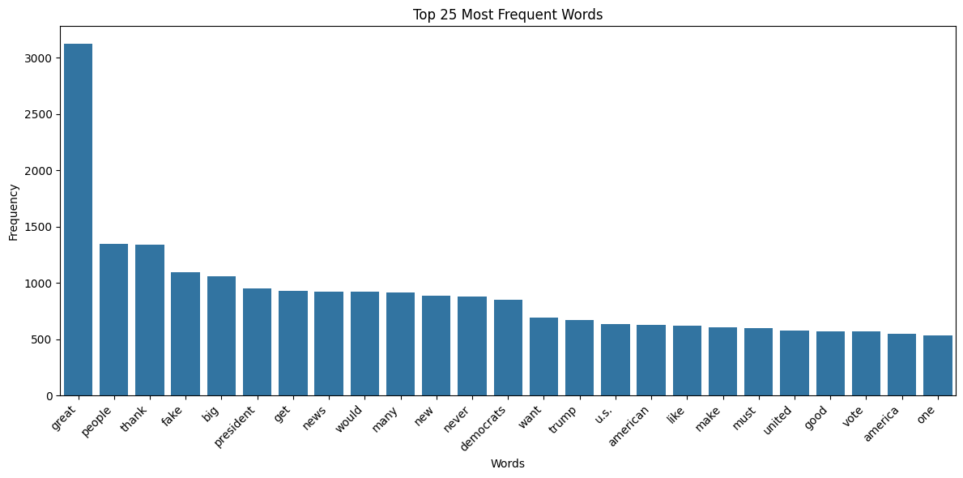

I transformed and filtered the data to identify relevant tweets, focusing only on those posted during the Trump Presidency (1/21/17-1/21/21) in which Trump’s tweets were considered a signal of US policy. I filtered out retweets, tweets containing links, and other posts unlikely to impact exchange rates. Additionally, I removed tweets with phrases like “Happy birthday” or “Happy Thanksgiving” due to their irrelevance. To further refine the dataset, I grouped consecutive tweets marked by ellipses or posted within a five-minute interval. Finally, I removed all tweets with fewer than 20 characters or less than 1,000 favorites, as they have limited visibility and engagement.

* + 1. **Classification**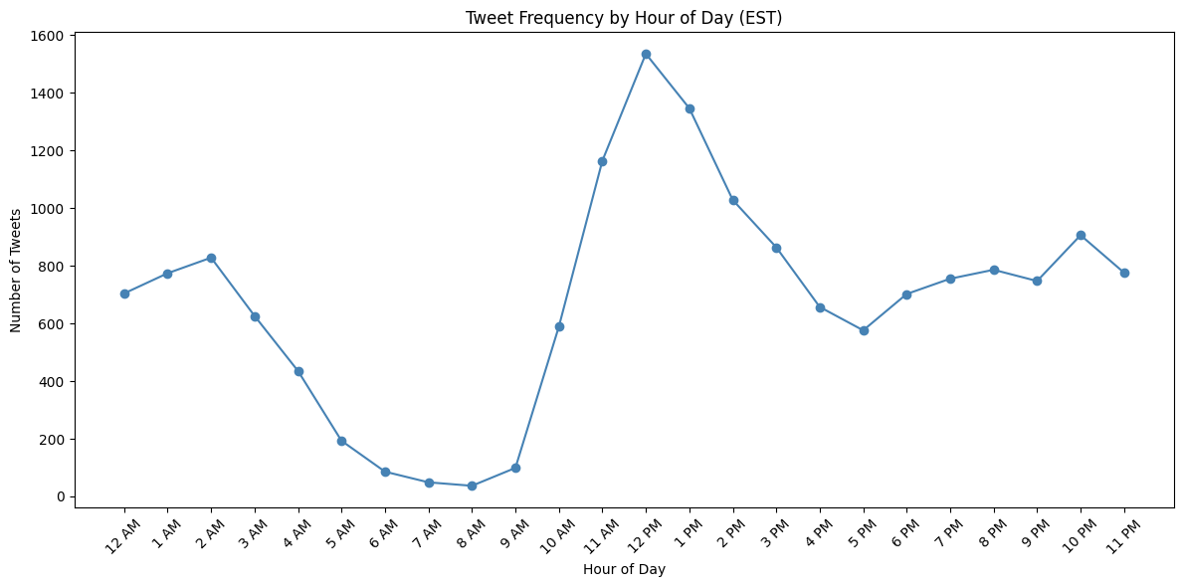

With AI technology only being widely used and available in 2022, the academic literature on classification and categorization remains limited, though recent articles increasingly explore their potential applications. Sachini (2022) utilized the BERT large language model to significantly improve the classification of complex textual data, including academic abstracts. The use of AI to process and classify data has proven effective across diverse contexts, including emergency call data. Costa et al. (2023) used AI trained on English language datasets to classify Brazilian emergency call data into different categories with a 73.9% accuracy rate. My results can achieve greater accuracy and consistency in identifying tweets by leveraging the potential of AI-driven classification models to categorize complex and nuanced textual data, as seen by Costa (2023) and Sanchini (2022).

The Anthropic Claude Sonnet 3.5 model thematically categorized the tweets into four categories: trade policy, security policy, economic policy, and diplomatic relations. The prompt underwent many variations as I manually labeled 10-15% of the country datasets into these groups and confirmed that the prompt correctly categorized tweets. For example, my initial analysis categorized one tweet mentioning countries failing to meet the 2% NATO guideline outside the security policy category while categorizing another tweet referring to NATO within it. To address this error, I included in the prompt that all tweets referring to NATO should count towards security policy. Table 1 presents some general topics of tweets that would count toward the said category. The prompt is attached in the appendix and provides the specific rules used in the model.

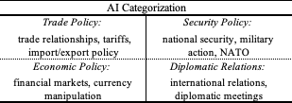

* 1. **Exchange Rate Data**

Exchange Rate data for the used currencies were obtained from the Bloomberg Market Terminal, capturing 30-minute intervals of spot exchange rates during Trump’s Presidency. The dataset spans U.S. trading hours (5 PM EST Sunday to 4 PM Friday), encompassing spot prices for crucial U.S. trading partner currencies based on trade data. The analyzed currencies include the Euro (EUR), Canadian Dollar (CAD), Japanese Yen (JPY), Chinese Yuan (CNH - offshore), Turkish Lira (TRY), and Mexican Peso (MXN).

To measure currency volatility, the log return of each currency’s closing price is as follows: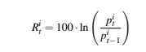

Where *pt​* represents the closing price of currency *i’s* relative to the U.S. Dollar at time *t*, this log-return transformation standardizes price changes and accounts for percentage change in rates, providing a consistent measure of exchange rate volatility. The Dollar rate refers to the number of units of foreign currency equivalent to one USD. This holds throughout this paper, except for the Euro, which is in terms of its value against the U.S. Dollar. Table 2 presents summary statistics of the log return, expressed in percent, for each of the six exchange rates (labeled by associated currency).

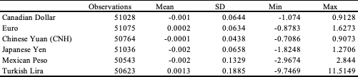

* 1. **Macroeconomic Indices & Technical Indicators**

Alongside the FOREX and Twitter data, I included four technical indicators from Bloomberg Market Terminal as control variables: Relative Strength Index (RSI), Moving Average Convergence/Divergence (MACD), Bollinger Bands (BBANDS), and Stochastic Oscillator (%DS). Each indicator was calculated using default settings to capture trends in momentum and volatility for the securities analyzed. Technical analysts, hedge funds, and other financial institutions use these indicators to analyze price movements.

The S&P 500 index, Bloomberg Dollar Spot Index, and 10-year US Treasury Yield were extracted at the same 30-minute intervals as the FOREX data from Bloomberg Terminal to serve as controls. The Dollar Spot Index tracks the performance of a basket of leading global currencies against the U.S. Dollar. As financial markets often move together, these indices act as efficient controls for foreign exchange rates. The following Table presents the summary statistics for each index's log returns.



* 1. **Testing Financial Data for Stationarity**

To ensure accurate estimation and interpretation of the OLS regression model used in this study, the dependent and independent variables must be “stationary,” meaning the data's mean, variance, and autocorrelation structure remain constant. The most common test to confirm that data is stationary is the augmented Dickey-Fuller Test, which tests the null hypothesis that a unit root is present in a time series sample. If data is nonstationary, then conventional OLS inferences may be misleading. The ADF test results reject the presence of a unit root when applied to the exchange rate return, macroeconomic indices, technical indicators, and Twitter continuous variables.

1. **Model** 
   1. **Setup**

In this study, for each of the six currencies analyzed, I regress the log return of the closing prices on variables such as the number of tweets in the last 30 minutes, the sentiment of said tweets, the frequency of the country's mentions in 30 minutes, the total reactions (favorites + retweets), time of day, and the topic of those tweets. The three financial controls, U.S. 10-year Treasury yield, S&P 500, and BBDXY, are included along with the technical indicators for the FX currency. This study aims to find the estimated effect of the number of Trump’s tweets in the last 30 minutes on the log return of the spot exchange rate through the following regression:

*ln(R)i,t* is the log return of the spot exchange rate *i* at time *t*, *Tweetst* is the number of tweets between *t-1* and *t*, and *Wi,t* is the control variables for the spot exchange rate *i* at time *t*. For three of these control variables, the log of S&P 500, BBDXY, and 10-YR yield do not have the exact timing as the dependent variable as the stock market operates at different hours than the dependent variable. This is corrected by imputing the missing data with a negative constant and including a separate dummy variable equal to one when the variable equals the constant.

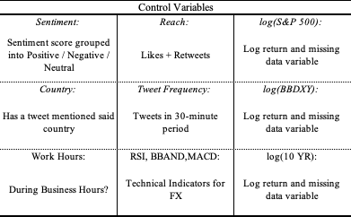

Following Philippides (2021), I estimate a model of Trump’s tweet count on the log returns of spot FX rates, explicitly focusing on major U.S. trading partners. Philippides uses an instrumental variable (IV) framework, leveraging Trump’s golfing habits as an exogenous predictor for tweet frequency to establish causality. In contrast to Philippides, instead of an IV approach, I employ an Ordinary Least Squares (OLS) regression model combined with AI categorization to group tweet content by topic, such as trade policy or international diplomacy. This allows for a more direct analysis of how different tweet types independently affect FX volatility. Similarly, Afanasyeva et al. (2021) examine the impact of Trump’s Twitter sentiment on the Russian ruble using sentiment analysis, focusing specifically on tweets related to U.S.-Russia tensions and sanctions. Unlike Afanasyeva et al., who rely on sentiment polarity, I use sentiment analysis from the text blob package and the Claude Sonnet 3.5 model to classify tweets, providing a more nuanced look at the conditional effects of Trump’s tweets on FX volatility across multiple trading partners.  
 To achieve this, I created two models: (1) a baseline model without interaction terms between sentiment and topic and (2) a model incorporating interaction terms between sentiment and topic. The first model highlights the independent impact of AI-generated topic variables. In contrast, the second model emphasizes the interplay between sentiment and topic in shaping the market effects of Trump’s tweets.

1. **Results**
   1. **Baseline Regression**

Table 5 summarizes the baseline OLS regressions without interaction terms results across the six spot exchange rates in the following order: USD/MXN, USD/TRY, EUR/USD, USD/JPY, USD/CNH, USD/CAD. Note that, as the regression equation in section 3 specified, all coefficients are in percentage terms.

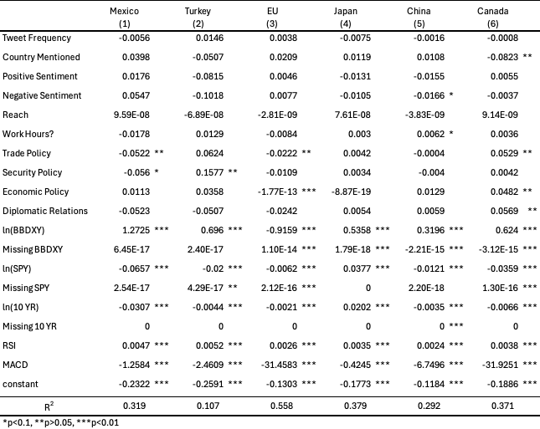

The regression results highlight distinct influence patterns across the six currency pairs, demonstrating that each pair reacts uniquely to social, sentiment, and broader market factors. For instance, the USD/CAD exchange rate is susceptible to tweets on diplomatic relations, trade, and economic policy, where multiple significant positive coefficients suggest that tweets addressing U.S.-Canada trade agreements, relations, and economic policy affect returns. This finding underscores the heightened sensitivity of the Canadian Dollar to uncertainty, given the financial and diplomatic interdependence between Canada and the US. In contrast, other currency pairs, such as USD/JPY, show no significant relationship with any topic (p > 0.05). This divergence underscores the resilience of pairs like USD/JPY, which may be less impacted by sentiment-driven fluctuations due to the stability of Japan's macroeconomic environment.

* 1. **Modified Regression**

Table 6 summarizes the modified OLS regressions with interaction terms results across the six spot exchange rates in the following order: USD/MXN, USD/TRY, EUR/USD, USD/JPY, USD/CNH, USD/CAD. Note that, as the regression equation in section 3 specified, all coefficients are in percentage terms.

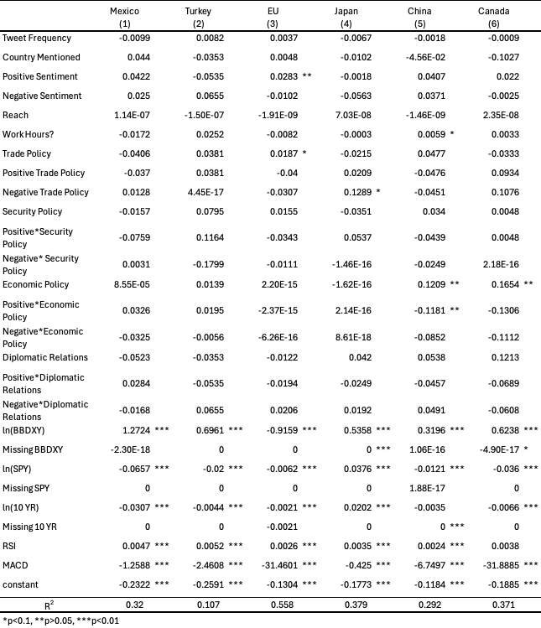

Incorporating interaction terms between sentiment and topics provides a more nuanced understanding of the volatility of spot exchange rates. The modified regressions highlight how sentiment significantly impacts exchange rate volatility when coupled with specific trade, economic, or security policies. For instance, positive sentiment-linked economic policy has a strong and significant association with the USD/CNH (-0.1181), which suggests that optimistic policy tweets about China strengthen the CNH. Conversely, negative sentiment interacting with trade policy increased volatility for USD/JPY (0.1289), indicating that unfavorable trade-related news triggers market reactions that heighten the volatility of the Yen.

Comparing the two, the baseline model offers broad insights into the relationship between specific topics and volatility, emphasizing that policy discussions on trade policy influence volatility, particularly for USD/MXN (-0.052), highlighting the Peso's sensitivity to US-Mexico trade negotiations. It also provides insights into the effect of sentiment and volatility, particularly how negative sentiment can affect exchange rate volatility, particularly for China (-0.0166). The interaction models deepen this understanding by revealing that sentiment effects depend on the context of the associated policy topic. For example, while baseline positive sentiment had limited effect, interactions with economic policy significantly impacted volatility for USD/CNH, underscoring the stabilizing role of optimistic economic policy signals in these contexts. Furthermore, the interaction model shows that trade policy is often contingent on sentiment, with negative trade sentiment amplifying volatility for USD/JPY. These nuanced findings illustrate the importance of considering sentiment and policy context when evaluating FOREX volatility. In both models, S&P 500 and treasury yield returns have statistically significant relationships with exchange rates, indicating that these currencies are sensitive to cross-market factors like equities and bond yields.

These findings have implications for understanding the dynamics of foreign exchange markets. The results underscore the importance of policy communication in shaping market expectations and volatility. Policymakers must be aware of how statements about trade, security, or economic policies on social media, coupled with sentiment, can amplify or dampen volatility in currency markets. For instance, addressing trade-related uncertainty could stabilize the Mexican Peso, given the sensitivity of USD/MXN to trade sentiment. Second, for market participants, these results highlight the need to integrate sentiment analysis into trading strategies. Heightened sensitivity to trade policy in USD/CAD indicates that sentiment-policy interactions might provide early warning signals for short-term volatility spikes.

The broader takeaway is that FX volatility outside of fundamental factors is not just a function of overall sentiment but is linked to the context in which this sentiment occurs. This study demonstrates that understanding exchange rate volatility requires moving beyond sentiment and financial measures and incorporating policy-specific dynamics, providing more precise insights into market behavior, particularly in volatile or uncertain markets. The most critical statistic from this analysis is the R2 for the USD/EUR (0.558), which represents the highest explanatory power across all pairs, underscoring the model's robustness in explaining exchange rate volatility in this context.

1. **Robustness Checks**

In considering robustness checks, several potential criticisms of the current model arise, highlighting areas for further refinement and accuracy improvements. First, multicollinearity is a concern, particularly in currency pairs like USD/JPY and USD/CAD, where high condition numbers suggest that some predictors may be redundant. This issue could undermine the reliability of coefficient estimates, especially for interaction terms, as separating the independent effects of each predictor becomes challenging. To address this, I am employing variance inflation factor (VIF) analysis to identify and manage multicollinear variables. By quantifying the degree of collinearity, VIF allows me to isolate and remove or consolidate redundant predictors, leading to more accurate and stable regression results by ensuring that each variable’s effect is uniquely captured. This analysis saw that half of the technical indicators and interaction terms between reach and all topics had high VIF scores (VIF>10). I removed these variables from my models due to multicollinearity concerns.

Another concern is endogeneity– specifically, the possibility that exchange rate volatility could have influenced sentiment rather than sentiment-driving volatility. To address this, I attempted to follow the IV approach used by Philippides, using golfing as the instrument variable. However, I could not find reliable results for the model. Philippides did not specify how they dealt with null values, so my approach likely didn’t match theirs and, as a result, didn’t get the same results.

Another concern could be sample selection bias, as I was restricted to currency pairs that were accessible to me. The chosen currencies may not represent all FX markets, leading to limited generalizability. Researchers should use a broader set of currency pairs to address this, provided they can access and afford the data. For example, incorporating pairs from emerging markets or less-traded countries could test if the identified relationships hold across different markets.

1. **Conclusion**

This study investigates how Donald Trump's Twitter activity influenced FOREX market volatility during his presidency. I employed an Ordinary Least Squares regression model to analyze the log returns of six major trading partner currencies: the Turkish Lira, Mexican Peso, Chinese Yuan, Canadian Dollar, Euro, and Japanese Yen. To capture the nuances of Trump's tweets, I categorized them using the Anthropic Claude Sonnet 3.5 model into four topics: trade policy, security/military policy, economic policy, and diplomatic relations. I also included interaction terms between sentiment and tweet topics to understand how sentiment-driven volatility changes depending on tweet content.

The baseline regressions revealed that Trump's tweets significantly impacted specific FX pairs, particularly tweets involving trade policy. For example, USD/MXN returns dropped by 0.052% when Trump tweeted about trade policy, reflecting the sensitivity of the Mexican Peso to U.S.-Mexico trade uncertainty. The modified regressions, which included interaction terms, showed that sentiment amplified or dampened volatility based on tweet context. Negative sentiment related to trade policy increased USD/JPY volatility, while positive sentiment on economic policy reduced volatility for USD/CNH.

These results are significant because they highlight how social media-driven information, especially from influential figures like Trump, can act as real-time policy signals that bypass traditional news channels. The study shows that FX volatility depends not just on sentiment and financial fundamentals alone but on the context in which that sentiment occurs. For market participants, integrating sentiment analysis with understanding policy topics can provide valuable insights for predicting short-term volatility. Policymakers should also recognize that their statements on social media can have immediate and measurable market impacts.

While this study provides valuable insights, several limitations remain. Future research could address endogeneity concerns by adopting an instrumental variable (IV) approach, like Philippides, which would be better to isolate tweets' causal impact on FX volatility. With the upcoming Trump presidency, new data could further validate these findings or reveal new dynamics in FX market responses to his tweets. Incorporating a sanctions variable, inspired by Afanasyeva's work, could enhance the model's explanatory power by capturing the economic impact of geopolitical factors on exchange rates. This study highlights how social media acts as a new information shock. With further refinement, future research could yield even deeper insights into how social, political, and economic dynamics influence global currency movements.

In conclusion, this study demonstrates that Trump's tweets significantly influenced FX market volatility, particularly when those tweets addressed sensitive policy topics. These findings contribute to the growing body of literature on the role of social media in financial markets and highlight the need for continued research to understand the complex dynamics between real-time information, sentiment, and market behavior in the digital age.

1. **References**

Afanasyeva, Ekaterina, Derek Burns, and Angela Wong. 2021. "Trump’s Tweets and Market Movements: An Analysis of U.S.-Russia Relations and FX Volatility." *Journal of International Financial Markets, Institutions & Money* 72: 101302.

Chan, Samuel, and Mickey Chong. 2016. "Sentiment Analysis in Financial Texts." *Decision Support Systems* 94: 10.1016/j.dss.2016.10.006.

Colonescu, Constantin. 2018. "The Effects of Donald Trump's Tweets on US Financial and Foreign Exchange Markets." *Athens Journal of Business & Economics* 4(4): 375–388.

Costa, D. B., Pinna, F. C. A., Joiner, A. P., et al. 2023. "AI-Based Approach for Transcribing and Classifying Unstructured Emergency Call Data: A Methodological Proposal." *PLOS Digital Health* 2(12): e0000406. Published 2023 Dec 6.<https://doi.org/10.1371/journal.pdig.0000406>.

Engel, Charles, and Jeffrey Frankel. 1984. "Why Interest Rates React to Money Announcements: An Explanation from the Foreign Exchange Market." *Journal of Monetary Economics* 13(1): 31–39.<https://doi.org/10.1016/0304-3932(84)90006-0>.

Evans, Kevin P., and Alan E. H. Speight. 2010. "Dynamic News Effects in High Frequency Euro Exchange Rates." *Journal of International Financial Markets, Institutions and Money* 20(3): 238–258.<https://doi.org/10.1016/j.intfin.2010.03.002>.

Evans, Martin D. D., and Richard K. Lyons. 2008. "How Is Macro News Transmitted to Exchange Rates?" *Journal of Financial Economics* 88(1): 26–50.<https://doi.org/10.1016/j.jfineco.2007.06.001>.

Ge, Qi, Alexander Kurov, and Marketa Halova Wolfe. 2019. "Do Investors Care about Presidential Company-Specific Tweets?" *Journal of Financial Research*. Published online March 27.<https://doi.org/10.1111/jfir.12177>.

Ghani, M., and U. Ghani. 2023. "Economic Policy Uncertainty and Emerging Stock Market Volatility." *Asia-Pacific Financial Markets*.<https://doi.org/10.1007/s10690-023-09410-1>.

Gholampour, Vahid, and Eric van Wincoop. 2017a. "What Can We Learn from Euro-Dollar Tweets?" *NBER Working Paper No. 23293*.<http://www.nber.org/papers/w23293>.

Gjerstad, Peder, Peter Filip Meyn, Peter Molnár, and Thomas Dowling Næss. 2021. "Do President Trump's Tweets Affect Financial Markets?" *Decision Support Systems* 147: 113577.<https://doi.org/10.1016/j.dss.2021.113577>.

Machus, Tobias, Roland Mestel, and Erik Theissen. 2022. "Heroes, Just for One Day: The Impact of Donald Trump’s Tweets on Stock Prices." *Journal of Behavioral and Experimental Finance* 33: 100594.<https://doi.org/10.1016/j.jbef.2021.100594>.

Nyakurukwa, Kingstone, and Yudhvir Seetharam. 2023. "The Evolution of Studies on Social Media Sentiment in the Stock Market" *Scientific African* 20: e01596.<https://doi.org/10.1016/j.sciaf.2023.e01596>.

Nishimura, Yusaku, Xuyi Dong, and Bianxia Sun. 2021. "Trump's Tweets: Sentiment, Stock Market Volatility, and Jumps." *Journal of Financial Research* 44(3): 497–512.

Ozturk, Serda Selin, and Kursad Ciftci. 2014. "A Sentiment Analysis of Twitter Content as a Predictor of Exchange Rate Movements." *Review of Economic Analysis* 6: 132–140.<http://rofea.org>.

Peter Gabrovšek, and Petra Kralj Novak. 2018. "Forex Trading and Twitter: Spam, Bots, and Reputation Manipulation." *Cornell arXiv e-prints*.<https://doi.org/10.48550/arXiv.1804.02233>.

Philippides, Emily. 2021. "The Effect of Donald J. Trump’s Tweets on Spot Foreign Exchange Rates of Top U.S. Trading Partners." Senior thesis, Princeton University.

Reboredo, Juan C., and Andrea Ugolini. 2018. "The Impact of Twitter Sentiment on Renewable Energy Stocks." *Energy Economics* 76: 153–169.<https://doi.org/10.1016/j.eneco.2018.10.014>.

Sachini, Evi, Konstantinos Sioumalas-Christodoulou, Stefanos Christopoulos, and Nikolaos Karampekios. 2022. "AI for AI: Using AI Methods for Classifying AI Science Documents."

Stallings, L., P. Bhat, J. Jacobs, K. Lynch, and Q. Risch. 2024. "How Artificial Intelligence Can Enable Data Classification for Market Sizing: Insights from Applications in Practice." *International Journal of Information Management Data Insights* 4(2): 100271. ISSN 2667-0968.<https://doi.org/10.1016/j.jjimei.2024.100271>.

Tetlock, Paul C. 2007. "Giving Content to Investor Sentiment: The Role of Media in the Stock Market." *Journal of Finance*.<https://doi.org/10.1111/j.1540-6261.2007.01232.x>.

Zhou, Wen. 2023. "Did Donald Trump's Tweets on Sino–U.S. Trade Affect the Offshore RMB Exchange Rate?" *Finance Research Letters* 58(A): 104283.<https://doi.org/10.1016/j.frl.2023.104283>.

1. **Appendix**

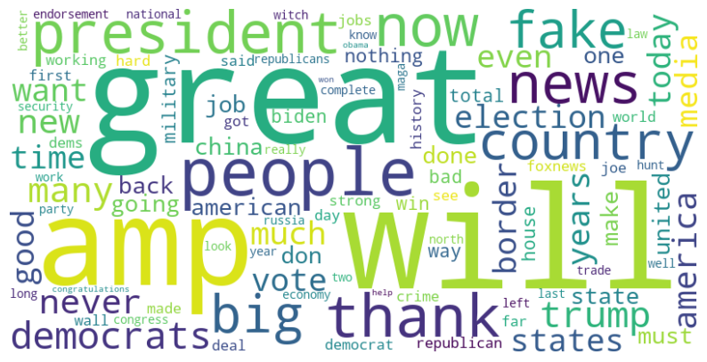

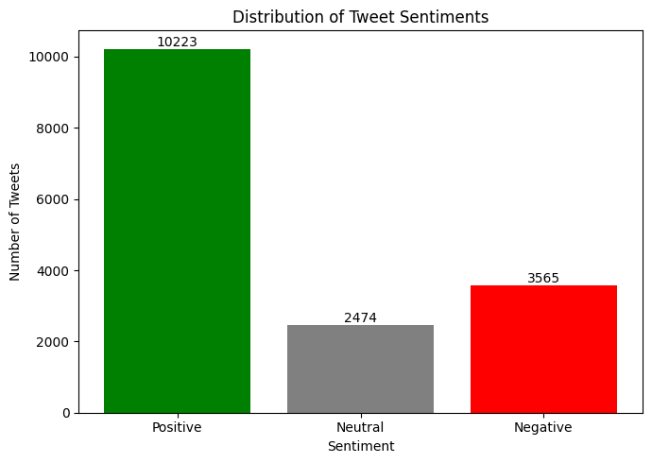



**as**



