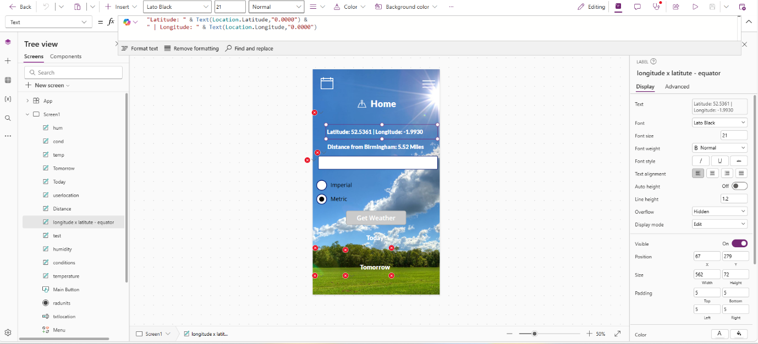
Latitude and Longitude Code

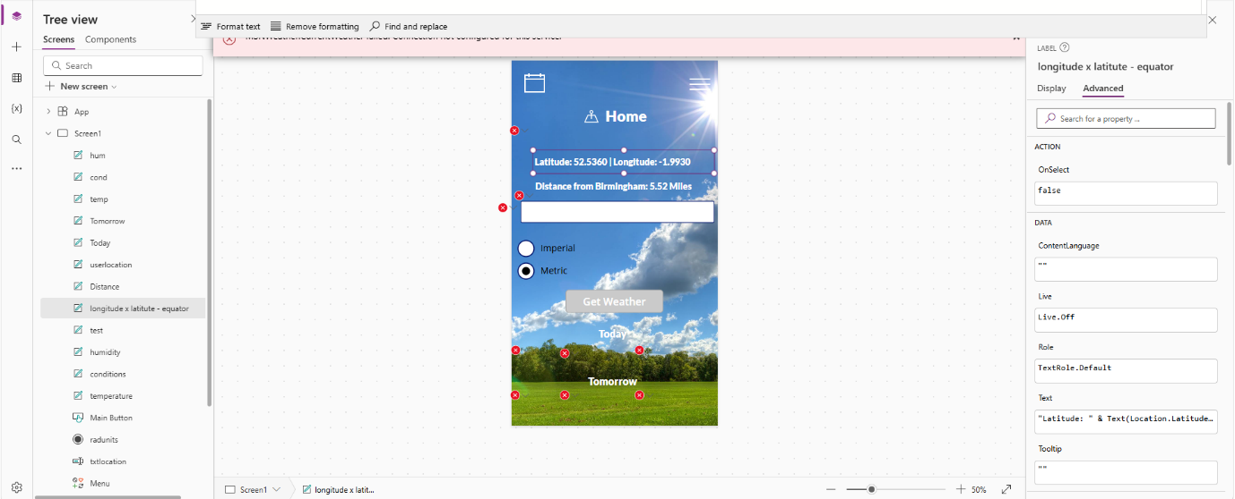
Latitude and Longitude – OnSelect False

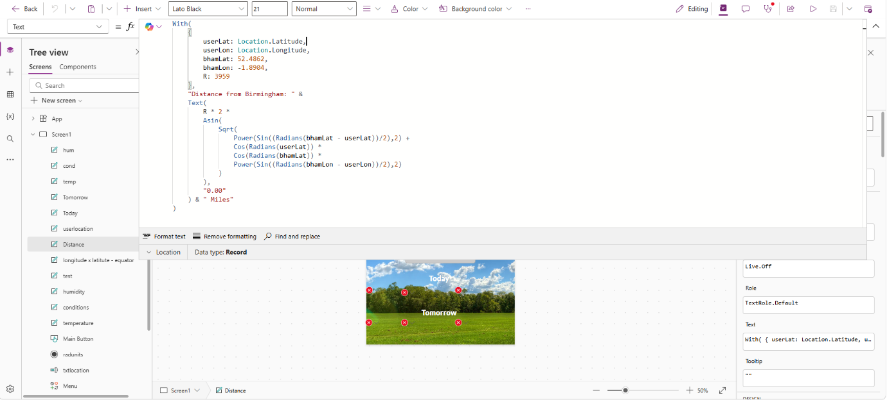
Distance from Birmingham Code

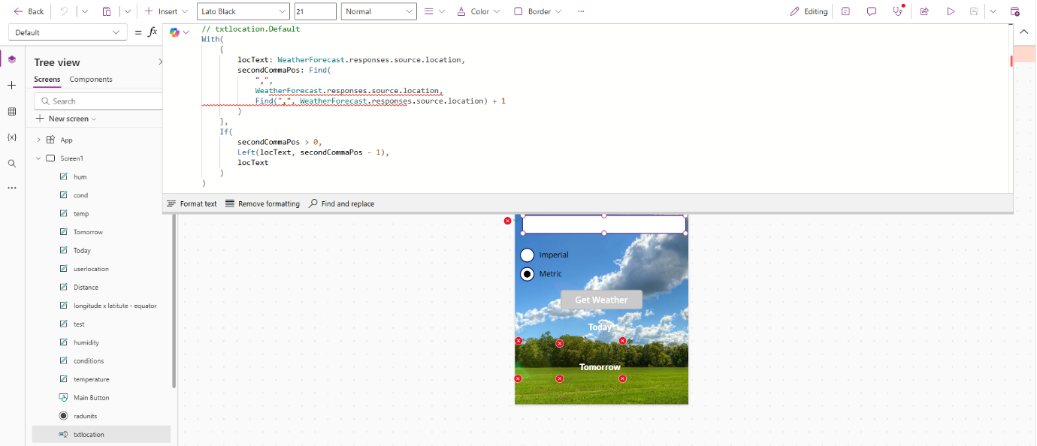
User city text input code

Imperial and Metric code – select radio through insert and then input – code goes in items
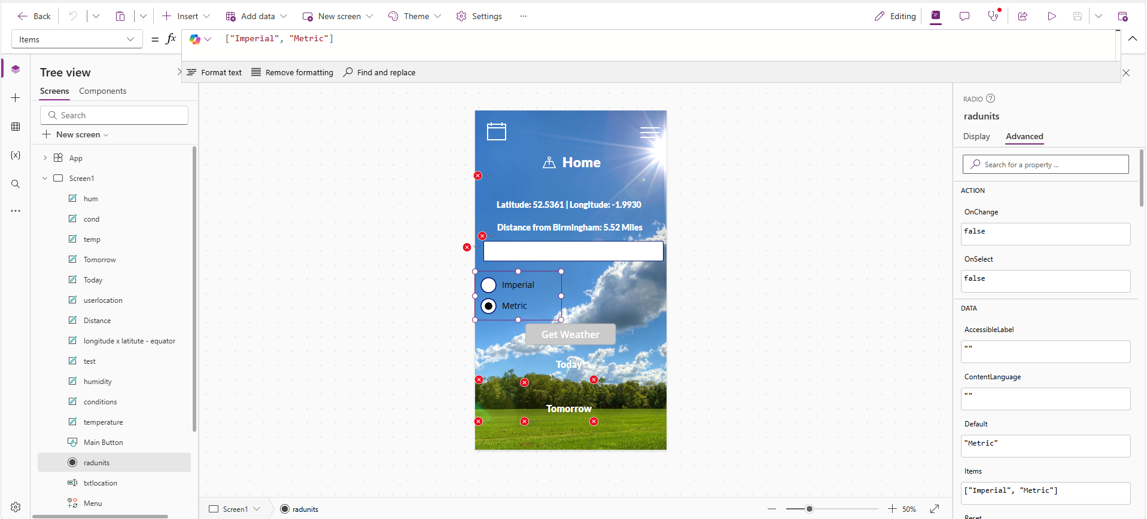

Get Weather button code – goes in OnSelect
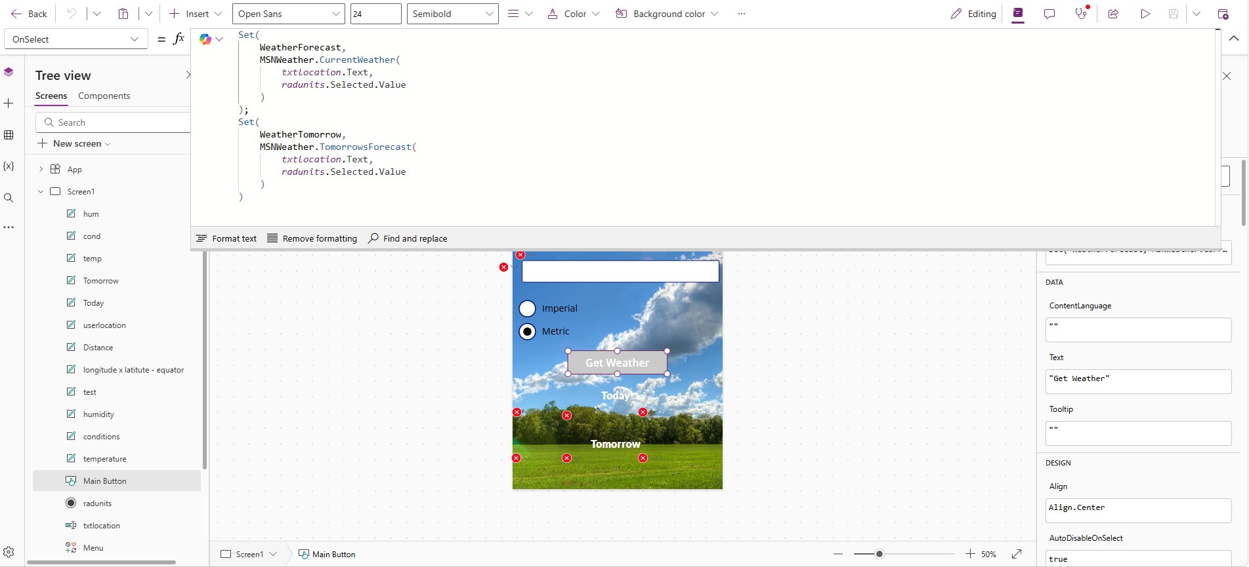

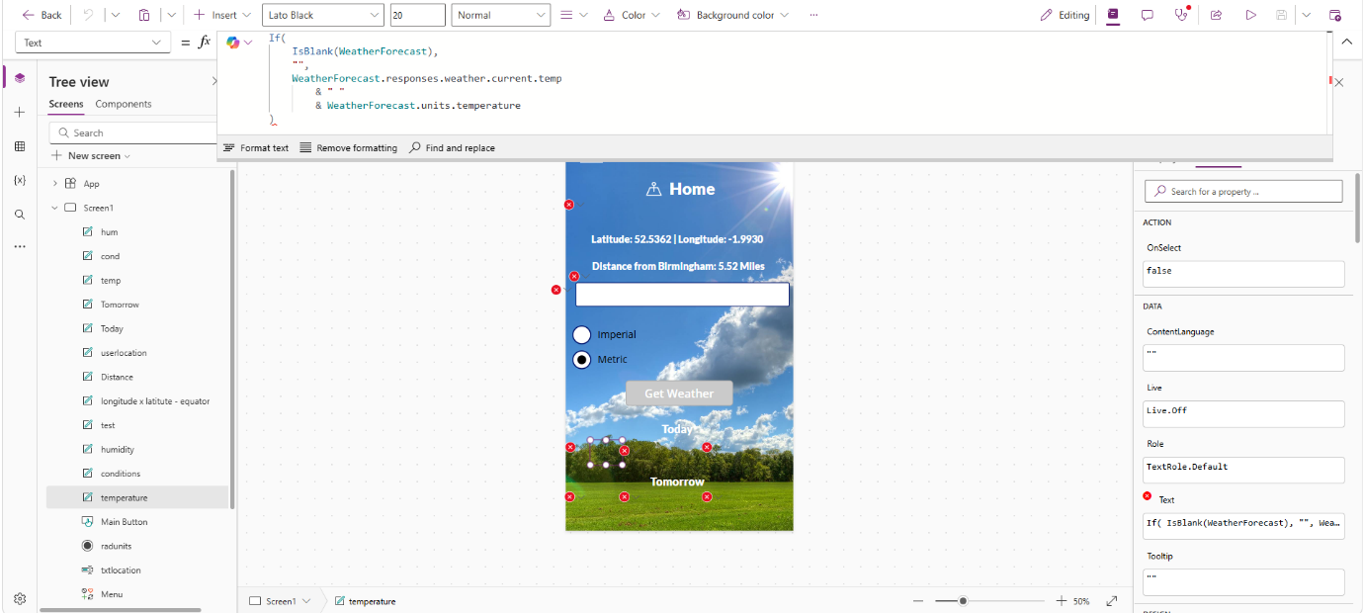
Today Forecast Temperature code – goes in text

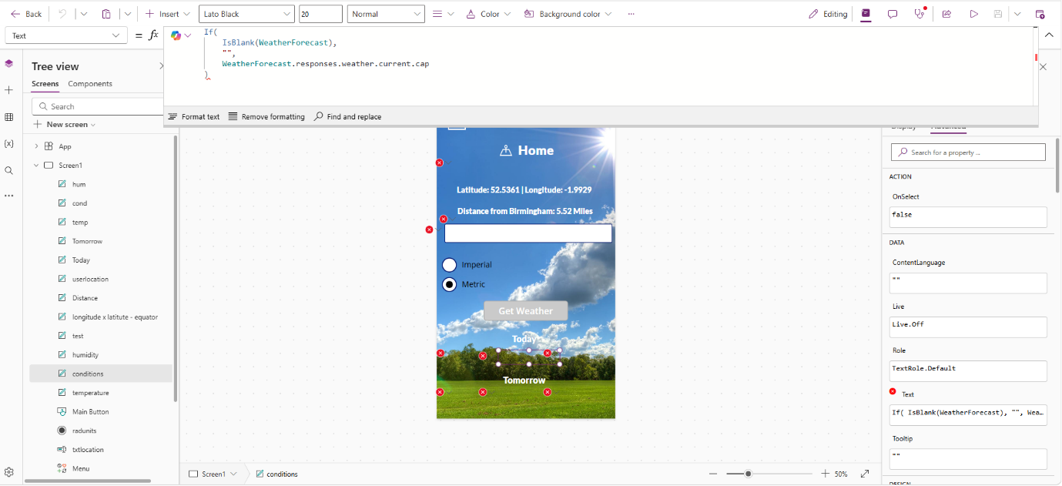
Today forecast conditions code - goes in text

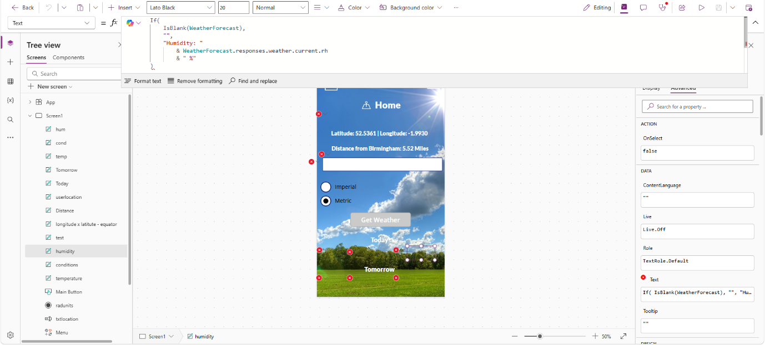
Today forecast humidity code - goes in text

Tomorrow forecast temperature code - goes in text
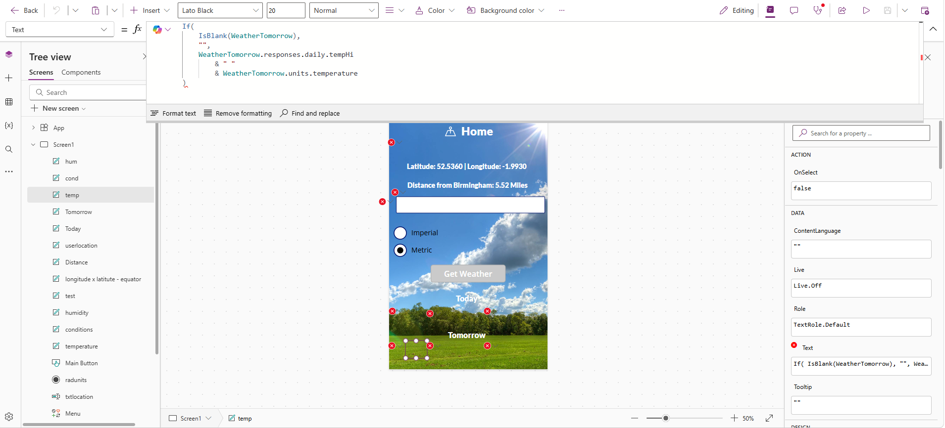

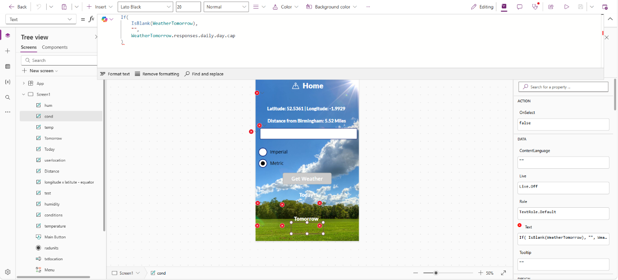
Tomorrow forecast conditions code - goes in text

Tomorrow forecast humidity code - goes in text
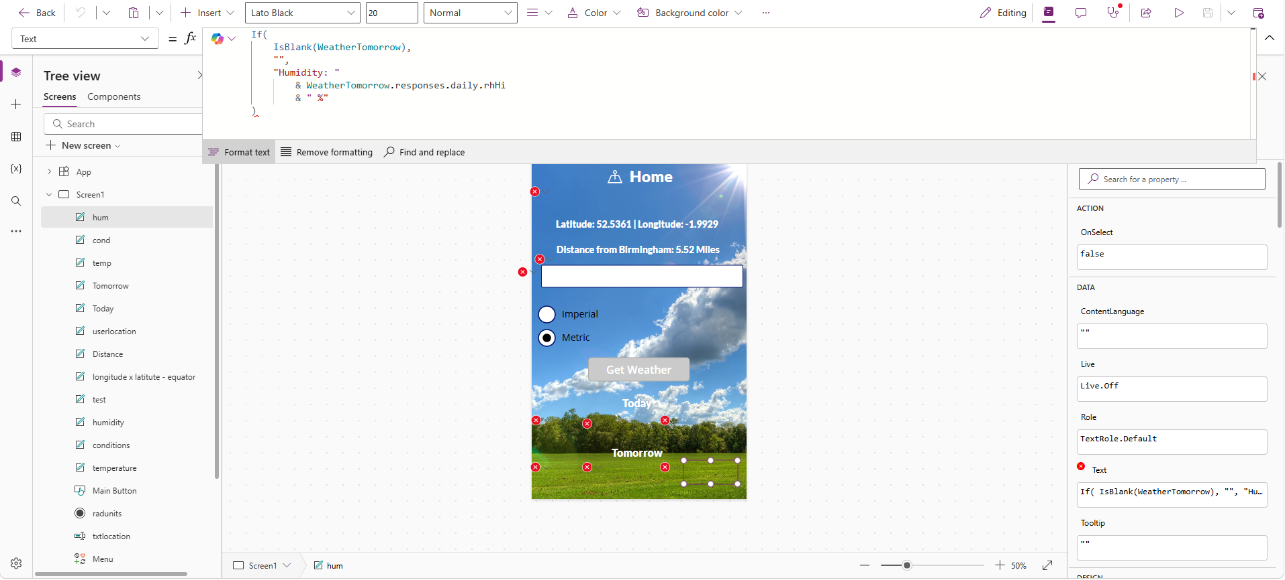

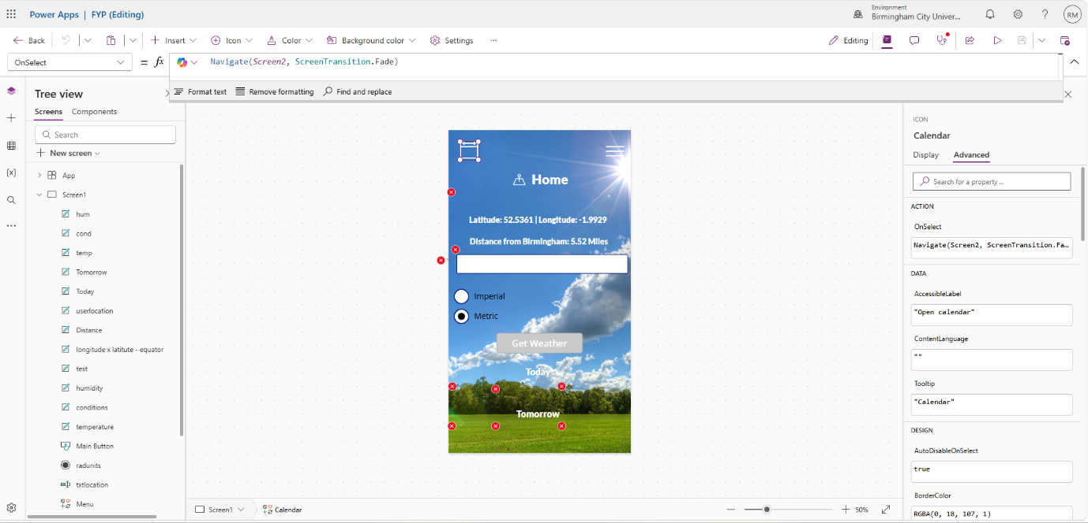
Calendar icon top left code – goes in OnSelect

User Location code goes in text
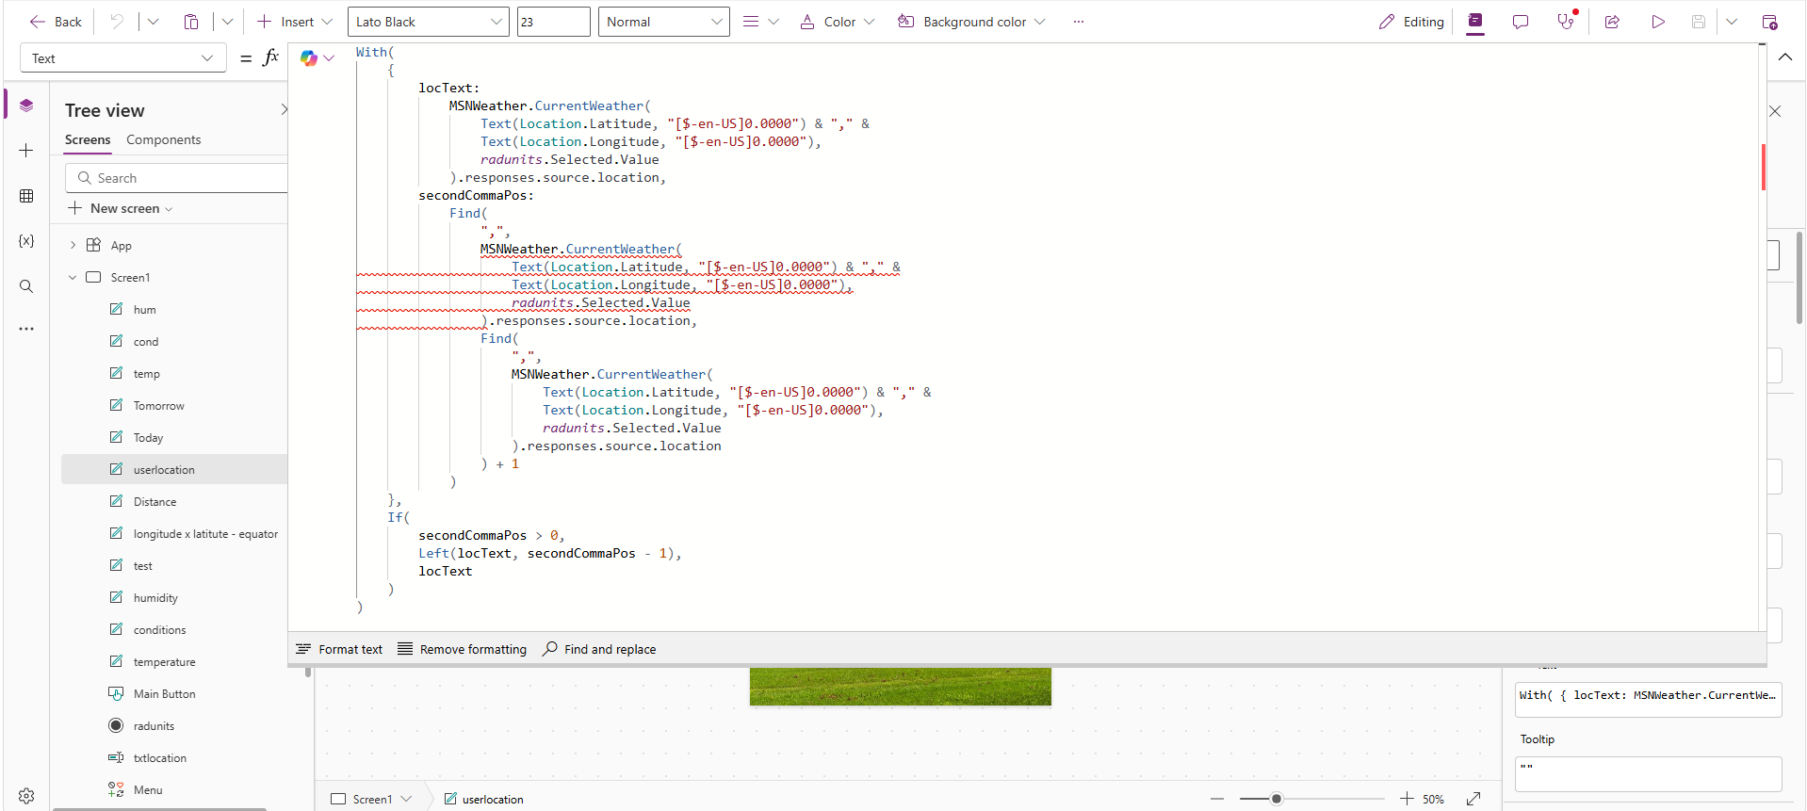

Page 1 Codes
Latitude & Longitude
"Latitude: " & Text(Location.Latitude,"0.0000") &
" | Longitude: " & Text(Location.Longitude,"0.0000")
User Location
With(
{
locText:
MSNWeather.CurrentWeather(
Text(Location.Latitude, "[$-en-US]0.0000") & "," &
Text(Location.Longitude, "[$-en-US]0.0000"),
radunits.Selected.Value
).responses.source.location,
secondCommaPos:
Find(
",",
MSNWeather.CurrentWeather(
Text(Location.Latitude, "[$-en-US]0.0000") & "," &
Text(Location.Longitude, "[$-en-US]0.0000"),
radunits.Selected.Value
).responses.source.location,
Find(
",",
MSNWeather.CurrentWeather(
Text(Location.Latitude, "[$-en-US]0.0000") & "," &
Text(Location.Longitude, "[$-en-US]0.0000"),
radunits.Selected.Value
).responses.source.location
) + 1
)
},
If(
secondCommaPos > 0,
Left(locText, secondCommaPos - 1),
locText
)
)

Distance from Birmingham
With(
{
userLat: Location.Latitude,
userLon: Location.Longitude,
bhamLat: 52.4862,
bhamLon: -1.8904,
R: 3959
},
"Distance from Birmingham: " &
Text(
R * 2 *
Asin(
Sqrt(
Power(Sin((Radians(bhamLat - userLat))/2),2) +
Cos(Radians(userLat)) *
Cos(Radians(bhamLat)) *
Power(Sin((Radians(bhamLon - userLon))/2),2)
)
),
"0.00"
) & " Miles"
)

Text Input
// txtlocation.Default
With(
{
locText: WeatherForecast.responses.source.location,
secondCommaPos: Find(
",",
WeatherForecast.responses.source.location,
Find(",", WeatherForecast.responses.source.location) + 1
)
},
If(
secondCommaPos > 0,
Left(locText, secondCommaPos - 1),
locText
)
)

Imperial and Metric
["Imperial", "Metric"]

Get Weather
Set(
WeatherForecast,
MSNWeather.CurrentWeather(
txtlocation.Text,
radunits.Selected.Value
)
);
Set(
WeatherTomorrow,
MSNWeather.TomorrowsForecast(
txtlocation.Text,
radunits.Selected.Value
)
)

Temperature Today forecast
If(
IsBlank(WeatherForecast),
"",
WeatherForecast.responses.weather.current.temp
& " "
& WeatherForecast.units.temperature
)

Conditions today forecast
If(
IsBlank(WeatherForecast),
"",
WeatherForecast.responses.weather.current.cap
)

Humidity today forecast
If(
IsBlank(WeatherForecast),
"",
"Humidity: "
& WeatherForecast.responses.weather.current.rh
& " %"
)

Temperature tomorrow forecast
If(
IsBlank(WeatherTomorrow),
"",
WeatherTomorrow.responses.daily.tempHi
& " "
& WeatherTomorrow.units.temperature
)

Conditions tomorrow forecast
If(
IsBlank(WeatherTomorrow),
"",
WeatherTomorrow.responses.daily.day.cap
)

Humidity tomorrow forecast
If(
IsBlank(WeatherTomorrow),
"",
"Humidity: "
& WeatherTomorrow.responses.daily.rhHi
& " %"
)

SharePoint List
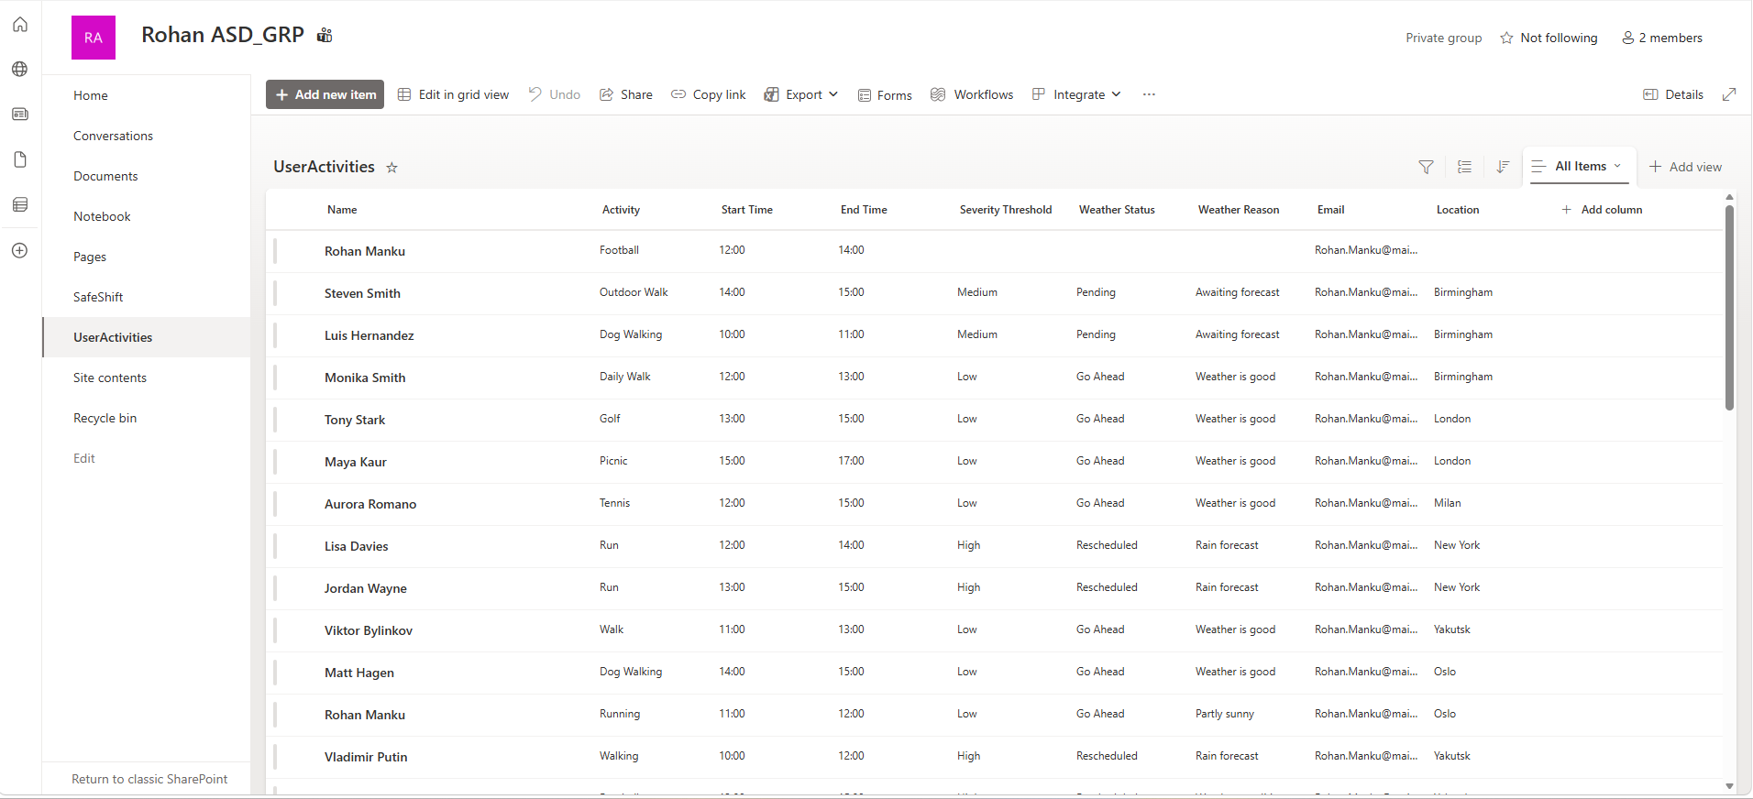

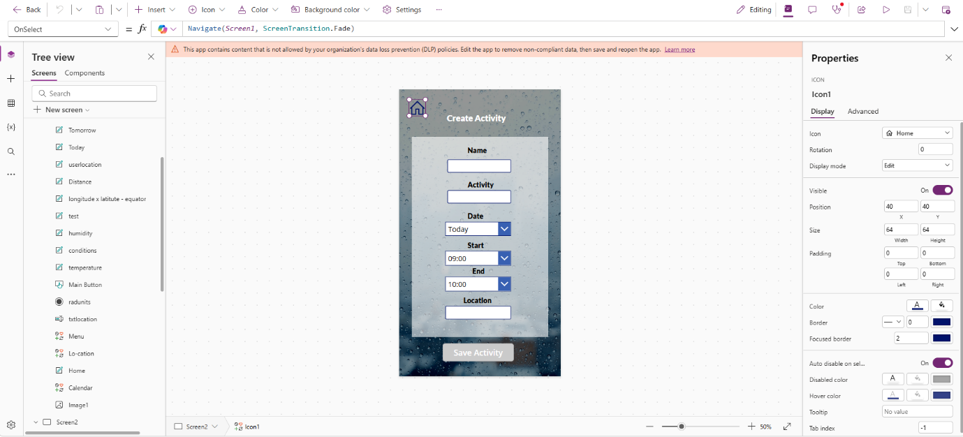
back to home screen

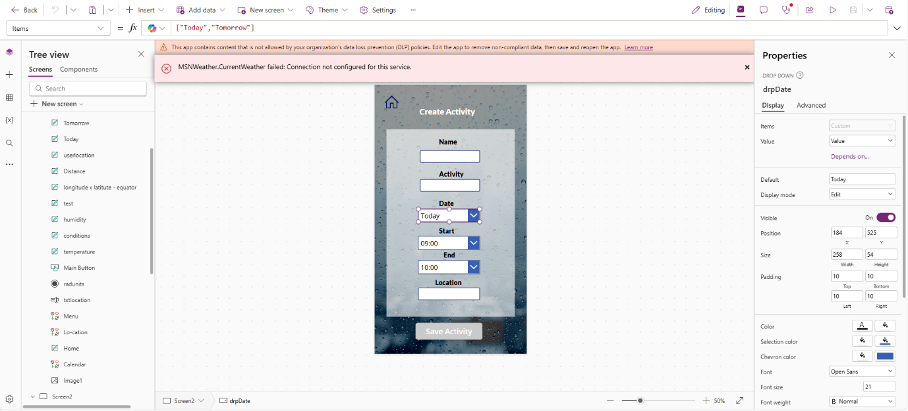
Date – choose dropdown menu

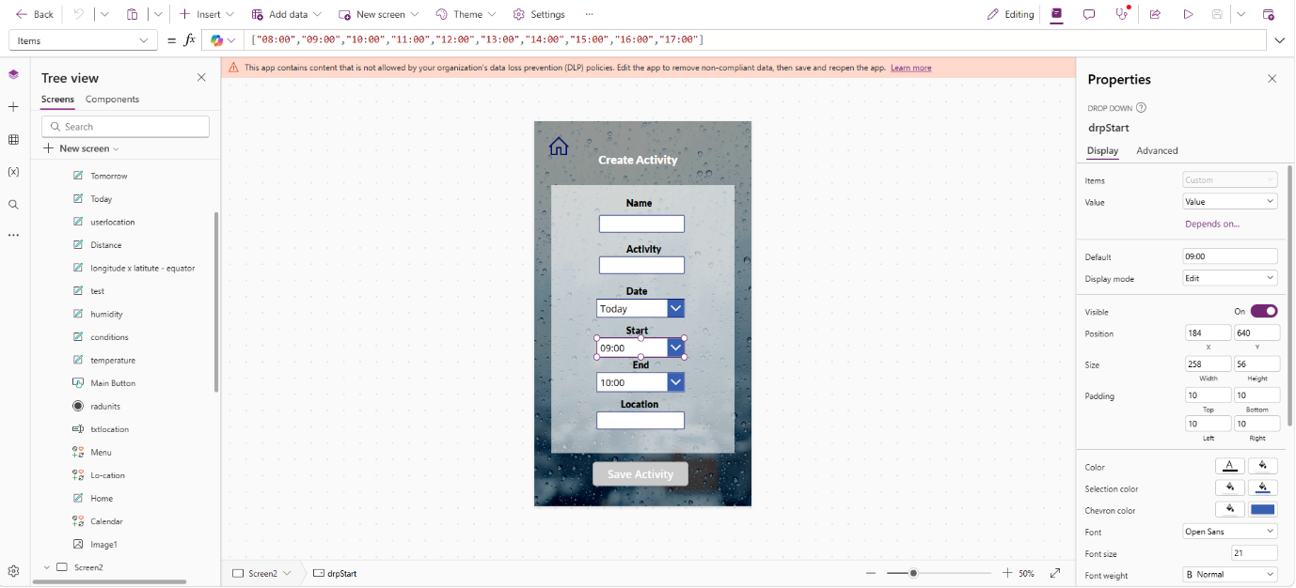
start time – choose dropdown

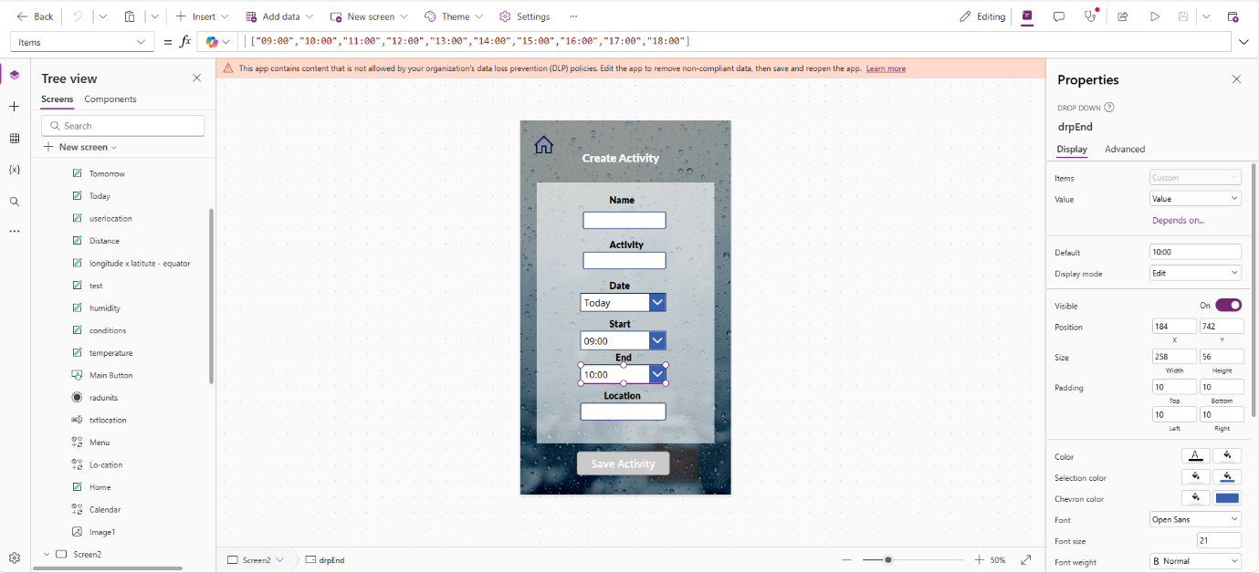
end time – choose dropdown

Save activity button
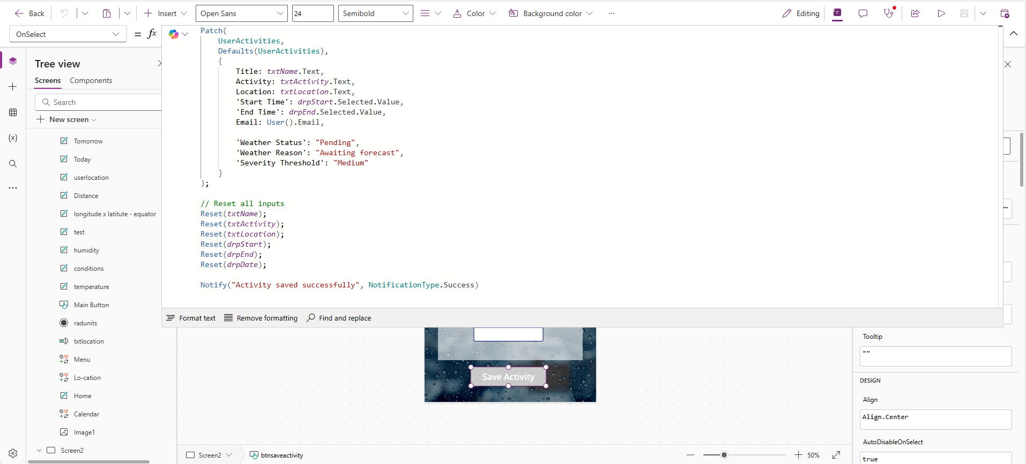

Page 2 Codes
Date (write in items & keep default as “ “ “ Today ”””
["Today","Tomorrow"]

Start (write in items & keep default as 8:00
["08:00","09:00","10:00","11:00","12:00","13:00","14:00","15:00","16:00","17:00"]

End (write in items & keep default as 9:00
["09:00","10:00","11:00","12:00","13:00","14:00","15:00","16:00","17:00","18:00"]

Save Activity (write in OnSelect)
Patch(
UserActivities,
Defaults(UserActivities),
{
Title: txtName.Text,
Activity: txtActivity.Text,
Location: txtLocation.Text,
'Start Time': drpStart.Selected.Value,
'End Time': drpEnd.Selected.Value,
Email: User().Email,

'Weather Status': "Pending",
'Weather Reason': "Awaiting forecast",
'Severity Threshold': "Medium"
}
);

// Reset all inputs
Reset(txtName);
Reset(txtActivity);
Reset(txtLocation);
Reset(drpStart);
Reset(drpEnd);
Reset(drpDate);

Notify("Activity saved successfully", NotificationType.Success)

Power Automate

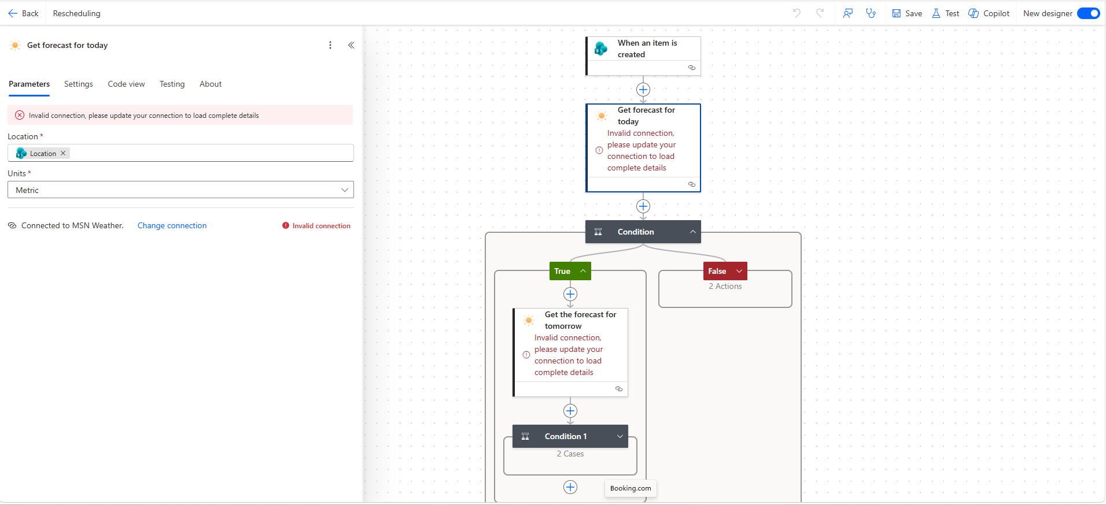
Get forecast for today

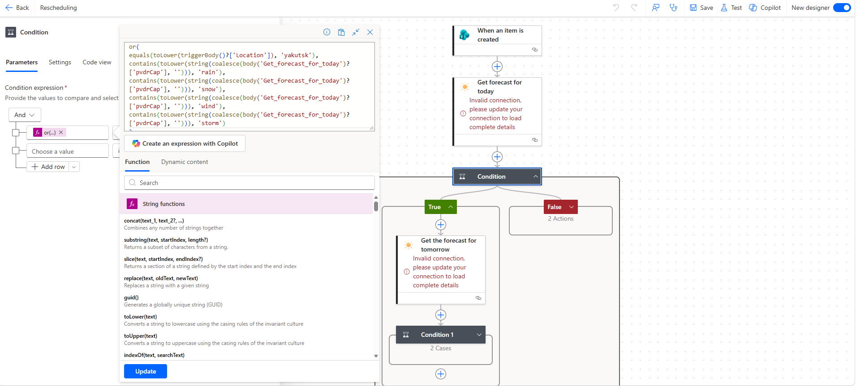
Main condition – use dynamic expressions (is equal to true)

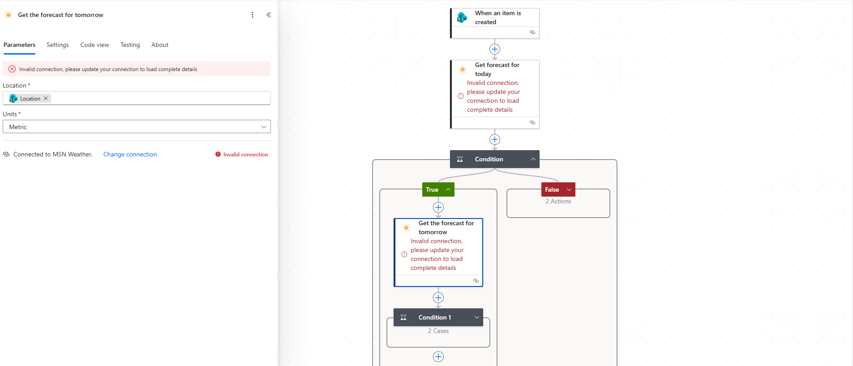
get forecast for tomorrow

condition 1 – use dynamic expressions (is equal to true)
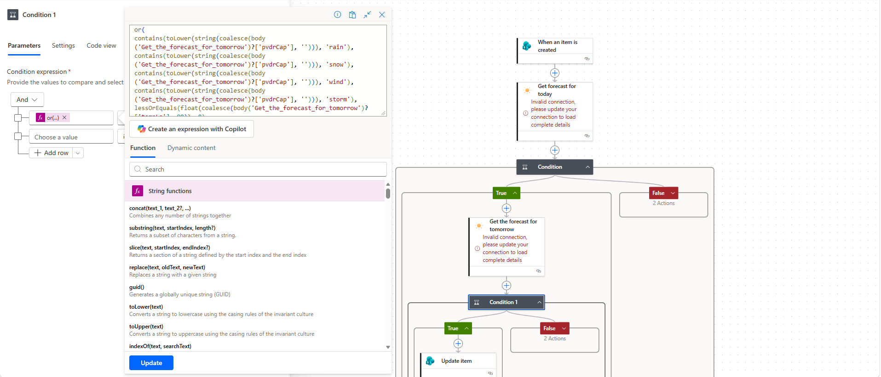

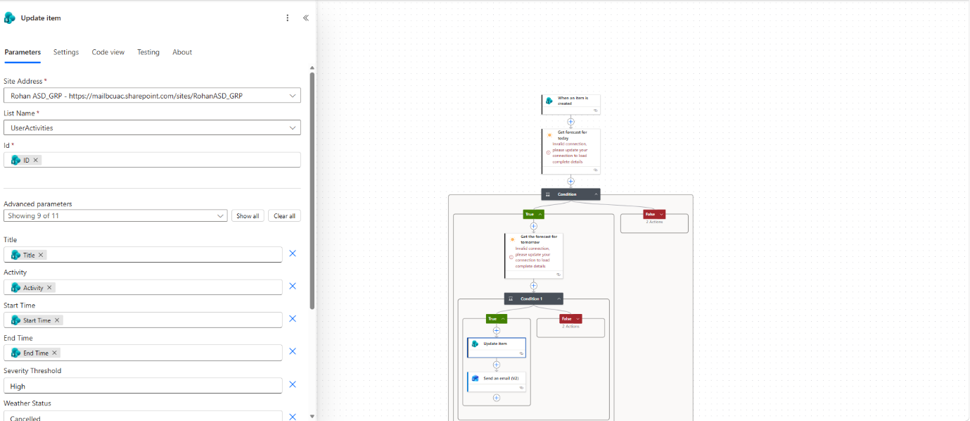
condition 1 update item – true branch

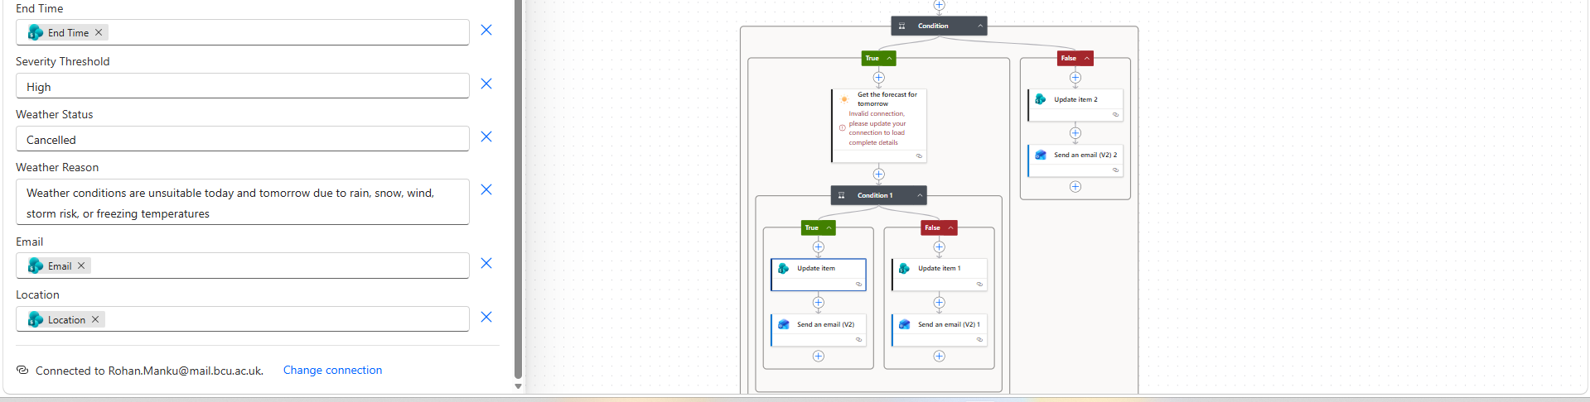

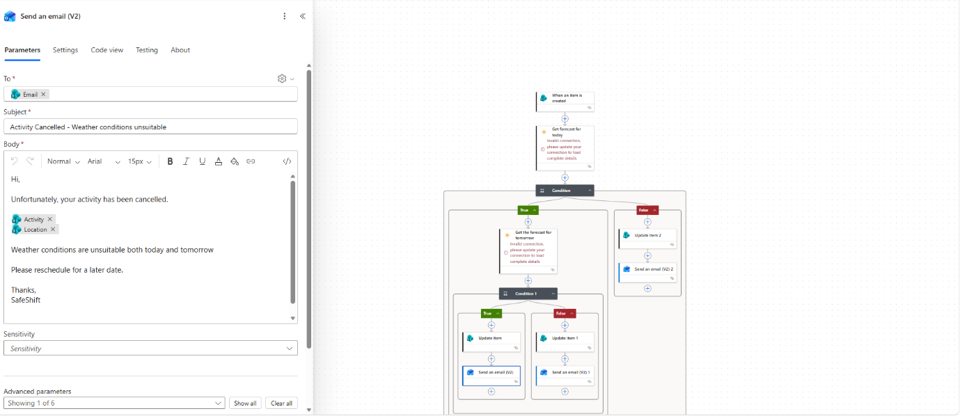
condition 1 send an email v2 – true branch

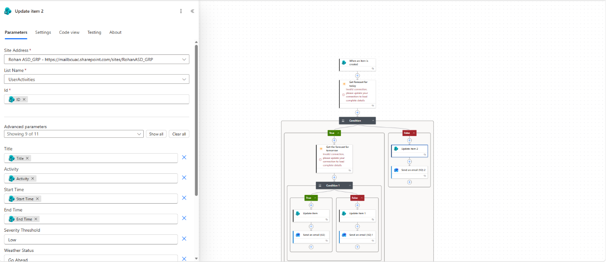
Main condition – update item false branch

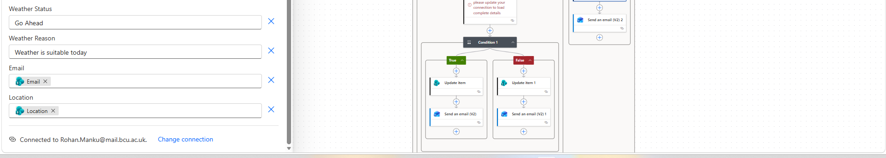

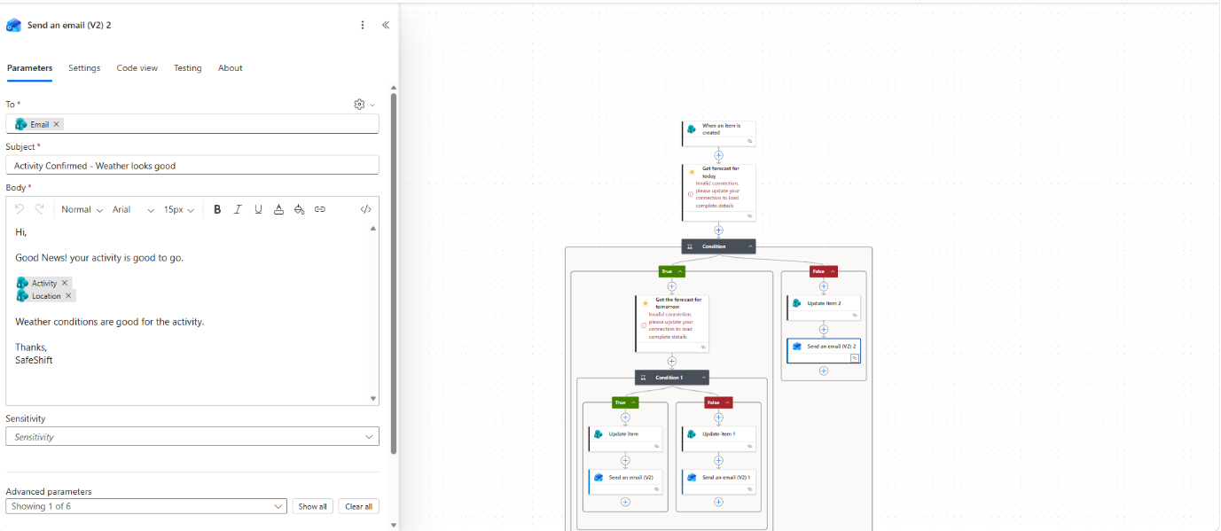
Main condition send an email v2 – false branch

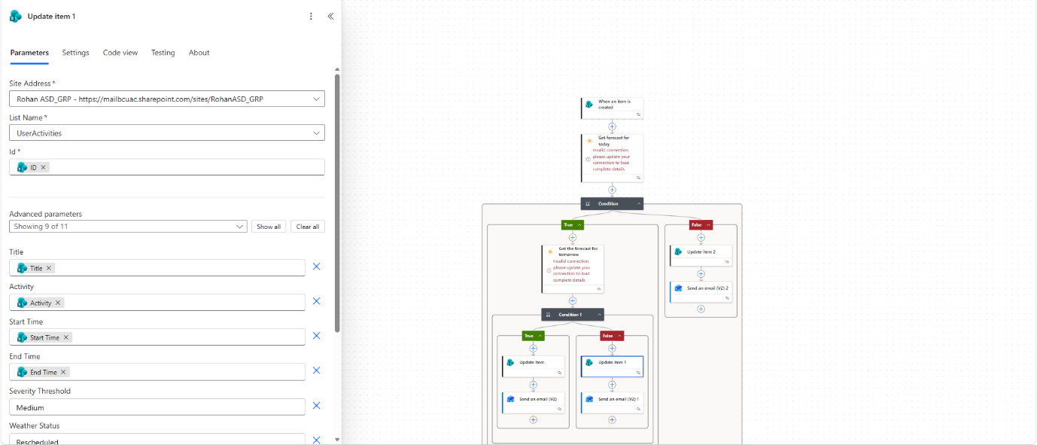
condition 1 update item – false branch

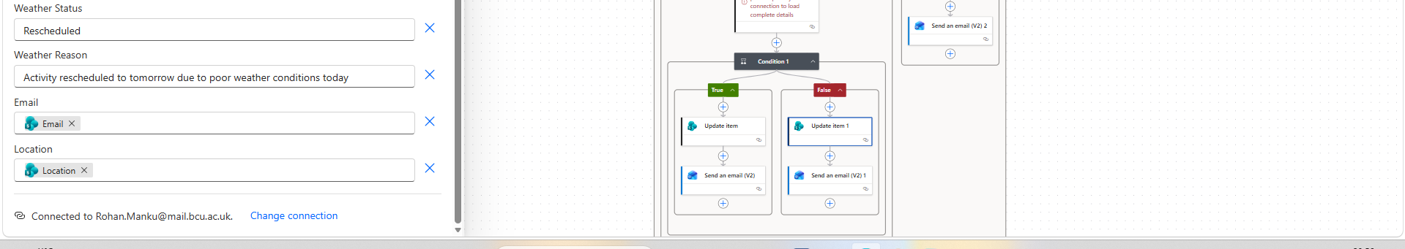

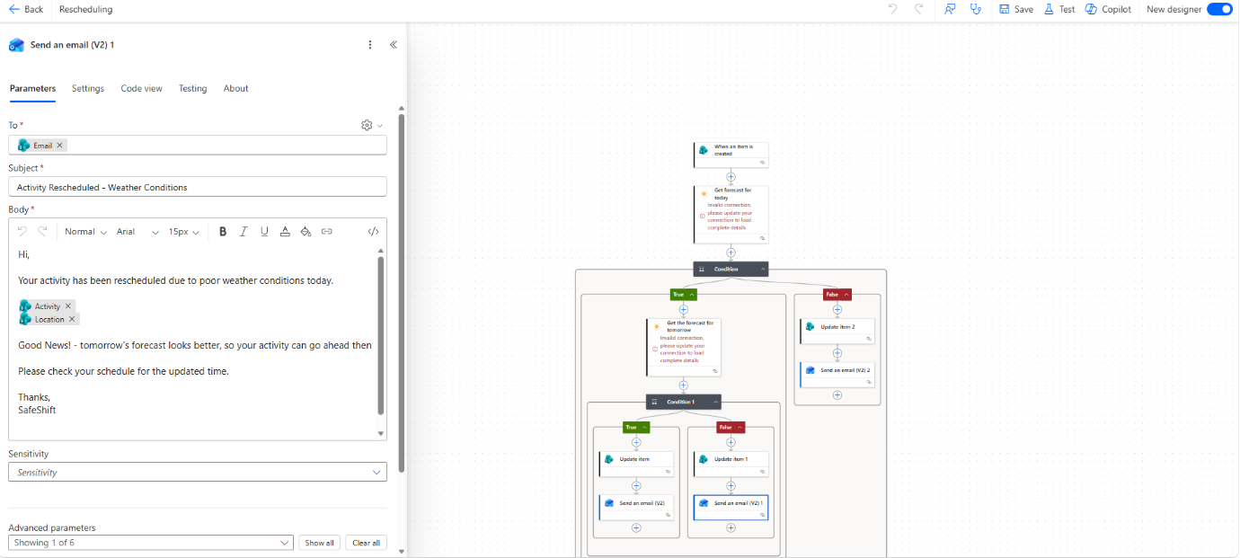
condition 1 send an email v2 – false branch

Power Automate Codes
Main Condition Expression
or(
equals(toLower(triggerBody()?['Location']), 'yakutsk'),
contains(toLower(string(coalesce(body('Get_forecast_for_today')?['pvdrCap'], ''))), 'rain'),
contains(toLower(string(coalesce(body('Get_forecast_for_today')?['pvdrCap'], ''))), 'snow'),
contains(toLower(string(coalesce(body('Get_forecast_for_today')?['pvdrCap'], ''))), 'wind'),
contains(toLower(string(coalesce(body('Get_forecast_for_today')?['pvdrCap'], ''))), 'storm')
)

Condition 1 Expression
or(
contains(toLower(string(coalesce(body('Get_the_forecast_for_tomorrow')?['pvdrCap'], ''))), 'rain'),
contains(toLower(string(coalesce(body('Get_the_forecast_for_tomorrow')?['pvdrCap'], ''))), 'snow'),
contains(toLower(string(coalesce(body('Get_the_forecast_for_tomorrow')?['pvdrCap'], ''))), 'wind'),
contains(toLower(string(coalesce(body('Get_the_forecast_for_tomorrow')?['pvdrCap'], ''))), 'storm'),
lessOrEquals(float(coalesce(body('Get_the_forecast_for_tomorrow')?['tempLo'], 99)), 0)
)

