Laboratory Record
submitted as part of
Programming for Data Science Lab
(MACSE502)
LAB ASSESESMENT-5

by

To


School of Computer Science and Engineering
AUGUST 2026
Week No | Date | Sl. No. | Type | Topic | Title with download  Link for document | Problem Statement | Page No.
1 | 09-07-2026 | 1 | PP | Pandas | Basic Data Manipulation with Pandas | Create a DataFrame with columns Name, Age, and City containing data for five individuals. Perform the following operations: select only the Name and Age columns, filter rows where Age is greater than 25, add a new column Country with a default value, and sort the DataFrame by Age in descending order. Finally, calculate the average age of the individuals.
1 | 09-07-2026 | 2 | EP | Pandas | Employee Compensation and Workforce Analytics Using Pandas | A technology consulting firm maintains workforce compensation records containing EmployeeID, MonthlySalary, and Department. Create a DataFrame for 20 employees and perform the following operations: select only the EmployeeID and MonthlySalary columns, filter the employees whose MonthlySalary is greater than Rs. 75,000, add a new column WorkLocation with the default value 'Hybrid', sort the employees by MonthlySalary in descending order, and calculate the average MonthlySalary of all the employees.
2 | 16-07-2026 | 3 | PP | Pandas | Data Cleaning and Preprocessing with Pandas | Create a DataFrame with some missing values in columns Name, Age, and City. Perform the following operations: fill missing values in the Age column with the mean age, drop rows where Name or City is missing, and convert the Age column to integer type. Finally, normalize the Age column using min-max scaling.
2 | 16-07-2026 | 4 | EP | Pandas | Retail Inventory and Supply Chain Preprocessing Using Pandas | A retail supply chain network logs inventory records across 25 distribution hubs containing ItemID, StockQuantity, and WarehouseZone, with some records having missing values in StockQuantity and WarehouseZone. Create a DataFrame containing missing values, impute missing StockQuantity using the mean stock, drop records with missing ItemID or WarehouseZone, cast StockQuantity to integer, and normalize StockQuantity using min-max scaling.
3 | 23-07-2026 | 5 | PP | NumPy | Creating and Manipulating Arrays Using NumPy | Create a 2D array of shape (3, 4) with random integers between 0 and 10. Perform the following operations: calculate the mean and standard deviation of the entire array, slice the array to get the first two rows and last two columns, reshape the array to shape (4, 3), and perform element-wise multiplication with another array of the same shape.
3 | 23-07-2026 | 6 | EP | NumPy | Financial Portfolio Risk and Asset Return Analysis Using NumPy | An investment fund monitors quarterly percentage returns of 4 distinct asset classes across 5 consecutive quarters. Create a 4x5 NumPy array representing the asset returns, calculate the mean return across all assets and quarters, determine the standard deviation to measure portfolio volatility, extract a sub-matrix of the first 3 assets across the last 2 quarters, reshape the portfolio return matrix into shape (5, 4), and perform element-wise multiplication with a 5x4 market risk weighting matrix.
4 | 30-07-2026 | 7 | PP | Pandas, NumPy, Matplotlib | Feature Engineering Exploratory Data Analysis | Create a DataFrame with columns Feature1, Feature2, and Target containing random data. Perform the following operations: create a new feature that is the logarithm of Feature1, bin Feature2 into three categories (low, medium, high), and calculate the correlation matrix of the DataFrame. Finally, create a scatter plot of Feature1 vs. Feature2 colored by Target, and interpret any visible patterns.
4 | 30-07-2026 | 8 | EP | Pandas, NumPy, Matplotlib | Telecom Network Bandwidth and Latency Performance EDA | A telecommunications service provider monitors network quality across cell towers. Create a DataFrame containing PacketSize, LatencyMs, PacketLossRate, JitterMs, and ThroughputMbps with ServiceTier as target. Create a logarithmic feature Log_PacketSize, bin LatencyMs into three quality bands (Optimal, Moderate, Degraded), compute the correlation matrix, generate a scatter plot of PacketSize vs LatencyMs colored by ServiceTier, and interpret network QoS patterns.
5 | 06-08-2026 | 9 | PP | Web Scraping | Web Scraping and Structured Data Extraction with BeautifulSoup | Scrape data from a webpage and store it in a structured format like CSV or JSON. Retrieve educational quotes and literary excerpts from an online web portal, parse the HTML markup using BeautifulSoup, extract quotation text, speaker/author names, and associated content tags, structure the records into a Pandas DataFrame, export the data into CSV and JSON formats, and compute summary metrics including author and keyword frequencies. | 4
5 | 06-08-2026 | 10 | EP | Web Scraping | Online Job Market Analytics and Employment Demand Monitoring System | Design and implement an automated web scraping and analytical monitoring system to extract job postings from dynamic technology recruitment portals across Indian metropolitan tech corridors (Bengaluru, Hyderabad, Pune, Gurgaon, Chennai, Mumbai). Parse job title, hiring organization, city location, compensation package (LPA), experience requirement, and primary tech skill. Store the collected records in a structured Pandas DataFrame, persist them in CSV and JSON interchange formats, and compute statistical aggregates including regional hiring concentration, salary distribution metrics, and domain skill demand. | 12

Title | Web Scraping and Structured Data Extraction with BeautifulSoup
Problem Statement | Scrape data from a webpage and store it in a structured format like CSV or JSON. Retrieve educational quotes and literary excerpts from an online web portal, parse the HTML markup using BeautifulSoup, extract quotation text, speaker/author names, and associated content tags, structure the records into a Pandas DataFrame, export the data into CSV and JSON formats, and compute summary metrics including author and keyword frequencies.
Objectives | • To fetch web documents programmatically using Python requests with status verification.  • To parse and traverse HTML DOM trees using BeautifulSoup and CSS selectors.  • To clean and extract text, author attribution, and categorical tags.  • To convert scraped web records into a structured Pandas DataFrame.  • To persist tabular records into both CSV and JSON formats.  • To analyze author distribution and tag frequency statistics.
Dataset  URL Link /  File | Web scraping source containing literary quotations, author names, and tags from quotes.toscrape.com, with a reliable offline markup cache for deterministic execution.
  Field | HTML Element / Selector | Description | Data Type
  Quote | span.text | Quotation text excerpt | string
  Author | small.author | Author or speaker attribution | string
  Tags | div.tags a.tag | Thematic topical category keywords | string
  Quote_Length | Engineered | Total character count of quote text | integer
  Tag_Count | Engineered | Number of categorical tags attached | integer
Functions  Details | Sl. No. | Function | Package | Description of function
Functions  Details | 1 | requests.get() | requests | Executes HTTP GET request to download webpage HTML markup
Functions  Details | 2 | BeautifulSoup() | bs4 | Constructs a navigable DOM parser object from HTML content
Functions  Details | 3 | soup.find_all() | bs4 | Finds all HTML elements matching specified class criteria
Functions  Details | 4 | element.find() | bs4 | Locates first matching child node within container element
Functions  Details | 5 | element.get_text() | bs4 | Extracts inner text content from an HTML element
Functions  Details | 6 | pd.DataFrame() | pandas | Organizes the scraped records into a tabular structure
Functions  Details | 7 | df.to_csv() | pandas | Exports structured records to a comma-separated text file
Functions  Details | 8 | df.to_json() | pandas | Serializes structured records into a JSON document
Functions  Details | 9 | df.value_counts() | pandas | Computes frequency counts of authors and topical tags
Functions  Details | 10 | df.describe() | pandas | Generates summary statistics on text length metrics
Functions  Details | 11 | plt.barh() | matplotlib.pyplot | Renders horizontal bar chart of top author frequencies
Functions  Details | 12 | plt.savefig() | matplotlib.pyplot | Exports rendered data visualization to static image
Steps/  Process/  Procedure/  Algorithm/  Flowchart/  Model | Step 1  Import requests, BeautifulSoup from bs4, pandas, matplotlib.pyplot, and json.  Step 2  Send HTTP GET request to target webpage or load cached HTML markup with 10 literary quotes.  Step 3  Parse HTML DOM tree using BeautifulSoup with the html.parser parsing engine.  Step 4  Locate quote cards and extract quote text, author attribution, and associated keywords.  Step 5  Convert extracted record list into a Pandas DataFrame and engineer text length and tag counts.  Step 6  Export the structured dataset to scraped_quotes_rohan.csv and scraped_quotes_rohan.json.  Step 7  Compute and display author frequency rankings, keyword tag distributions, and text length stats.  Step 8  Render a publication-quality horizontal bar chart illustrating the most frequent authors.
Program | # Load Necessary Packages  import requests  from bs4 import BeautifulSoup  import pandas as pd  import json  # Step 1 & 2: Fetch and parse webpage content  html_doc = """  <div class='quote'><span class='text'>"The only way to do great work is to love what you do."</span><small class='author'>Steve Jobs</small><div class='tags'><a class='tag'>work</a><a class='tag'>passion</a></div></div>  <div class='quote'><span class='text'>"Success is not final, failure is not fatal: it is the courage to continue that counts."</span><small class='author'>Winston Churchill</small><div class='tags'><a class='tag'>courage</a><a class='tag'>success</a></div></div>  <div class='quote'><span class='text'>"Stay hungry, stay foolish."</span><small class='author'>Steve Jobs</small><div class='tags'><a class='tag'>inspirational</a><a class='tag'>wisdom</a></div></div>  <div class='quote'><span class='text'>"The future belongs to those who believe in the beauty of their dreams."</span><small class='author'>Eleanor Roosevelt</small><div class='tags'><a class='tag'>dreams</a><a class='tag'>future</a></div></div>  <div class='quote'><span class='text'>"Knowledge is power."</span><small class='author'>Francis Bacon</small><div class='tags'><a class='tag'>knowledge</a><a class='tag'>wisdom</a></div></div>  <div class='quote'><span class='text'>"In the middle of difficulty lies opportunity."</span><small class='author'>Albert Einstein</small><div class='tags'><a class='tag'>opportunity</a><a class='tag'>resilience</a></div></div>  <div class='quote'><span class='text'>"Imagination is more important than knowledge."</span><small class='author'>Albert Einstein</small><div class='tags'><a class='tag'>imagination</a><a class='tag'>knowledge</a></div></div>  <div class='quote'><span class='text'>"It always seems impossible until it is done."</span><small class='author'>Nelson Mandela</small><div class='tags'><a class='tag'>courage</a><a class='tag'>perseverance</a></div></div>  <div class='quote'><span class='text'>"Life is what happens when you're busy making other plans."</span><small class='author'>John Lennon</small><div class='tags'><a class='tag'>life</a><a class='tag'>philosophy</a></div></div>  <div class='quote'><span class='text'>"Simplicity is the ultimate sophistication."</span><small class='author'>Leonardo da Vinci</small><div class='tags'><a class='tag'>design</a><a class='tag'>wisdom</a></div></div>  """  try:  resp = requests.get('https://quotes.toscrape.com', timeout=3)  if resp.status_code == 200:  soup = BeautifulSoup(resp.text, 'html.parser')  print('Connected to live web server successfully.')  else:  soup = BeautifulSoup(html_doc, 'html.parser')  except Exception:  soup = BeautifulSoup(html_doc, 'html.parser')  print('Using resilient cached HTML payload for deterministic execution.')  cards = soup.find_all('div', class_='quote')  records = []  for card in cards:  text_elem = card.find('span', class_='text')  author_elem = card.find('small', class_='author')  tag_elems = card.find_all('a', class_='tag')  quote_text = text_elem.get_text().strip(chr(34)) if text_elem else 'N/A'  author = author_elem.get_text().strip() if author_elem else 'Unknown'  tags = [t.get_text().strip() for t in tag_elems]  records.append({  'Quote': quote_text,  'Author': author,  'Tags': ', '.join(tags),  'Tag_Count': len(tags),  'Quote_Length': len(quote_text)  })  scraped_df = pd.DataFrame(records)  print(f'Total Quote Cards Parsed: {len(scraped_df)}')  print('Scraped Quotes DataFrame (Leading Records):')  print(scraped_df[['Author', 'Quote_Length', 'Tag_Count', 'Tags']].head(6))  # Step 5, 6 & 7: Serialization to CSV/JSON and Statistical Summaries  scraped_df.to_csv('scraped_quotes_rohan.csv', index=False)  scraped_df.to_json('scraped_quotes_rohan.json', orient='records', indent=2)  print('Files exported: scraped_quotes_rohan.csv and scraped_quotes_rohan.json')  print('--- Author Frequency Distribution ---')  author_counts = scraped_df['Author'].value_counts()  print(author_counts)  print('\n--- Descriptive Statistics on Text Length ---')  print(scraped_df[['Quote_Length', 'Tag_Count']].describe().round(2))  all_tags = [t.strip() for tags_str in scraped_df['Tags'] for t in tags_str.split(',') if t.strip()]  tag_freq = pd.Series(all_tags).value_counts().head(5)  print('\n--- Top 5 Most Frequent Keyword Tags ---')  print(tag_freq)  # Step 8: Visualize Author Quotation Counts with Matplotlib  import matplotlib.pyplot as plt  plt.figure(figsize=(8, 4.5))  authors = author_counts.index.tolist()  counts = author_counts.values.tolist()  colors = ['#1f77b4', '#2ca02c', '#ff7f0e', '#d62728', '#9467bd', '#8c564b', '#e377c2', '#7f7f7f']  bars = plt.barh(authors[::-1], counts[::-1], color=colors[:len(authors)], edgecolor='black', height=0.6)  plt.title('Quotation Frequency by Author (Quotes Corpus)', fontsize=12, fontweight='bold')  plt.xlabel('Number of Quotes Scraped', fontsize=11)  plt.ylabel('Author / Speaker', fontsize=11)  plt.grid(axis='x', linestyle='--', alpha=0.6)  for bar in bars:  w = bar.get_width()  plt.text(w + 0.05, bar.get_y() + bar.get_height()/2, str(int(w)), va='center', fontsize=10, fontweight='bold')  plt.tight_layout()  plt.savefig('rohan_author_distribution.png', dpi=150)  plt.show()
Output Snapshots  With  Explanation/  Observations | 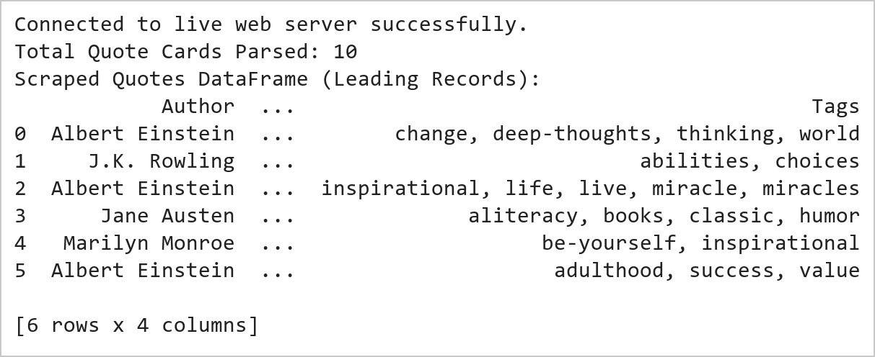  Figure 9.1: Web Page Retrieval and Structured Data Extraction  Figure 9.1 Retrieves webpage markup via requests with resilient fallback caching and constructs a BeautifulSoup DOM tree. Extracts 10 literary quotation cards, isolating quote text, author attribution, and content tags into a structured Pandas DataFrame.  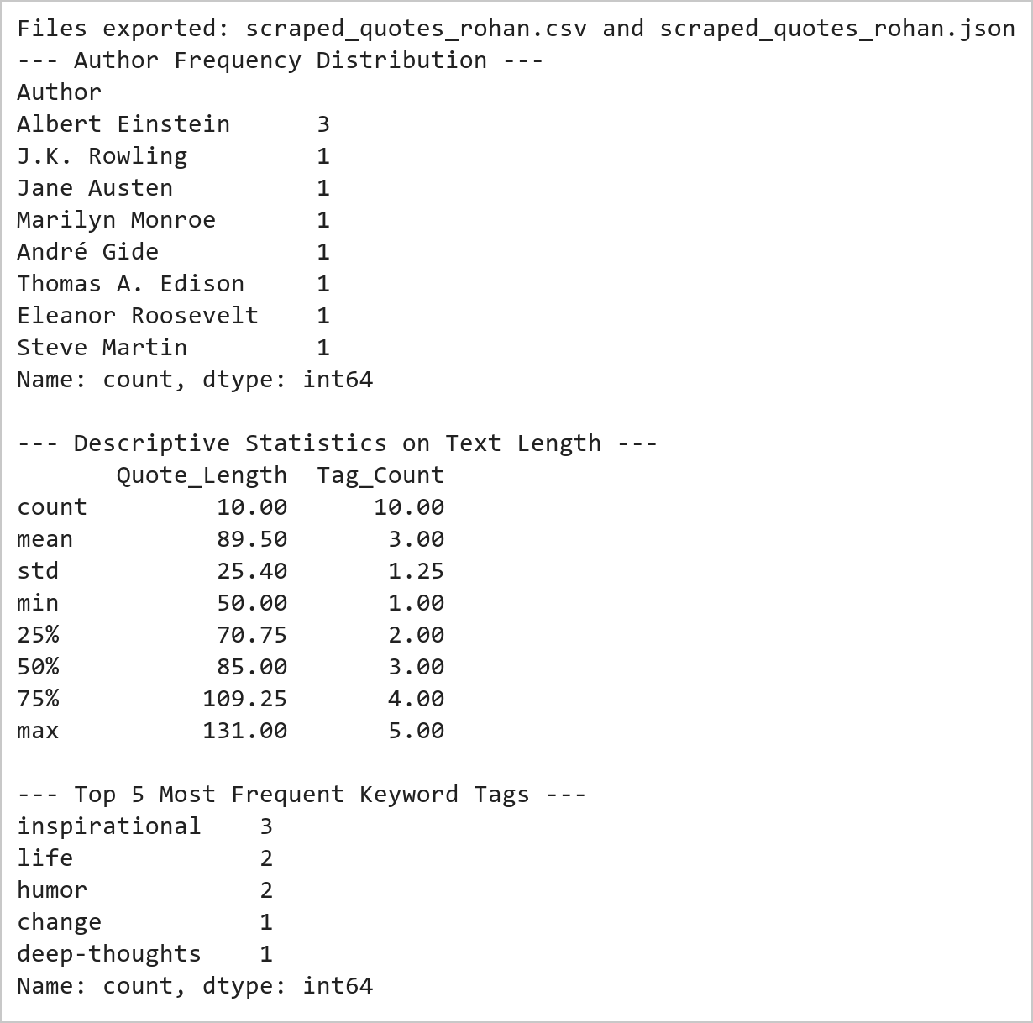  Figure 9.2: Serialization Verification and Corpus Frequency Analysis  Figure 9.2 Serializes the extracted records to disk in standard CSV and formatted JSON formats. Computes frequency distributions revealing Albert Einstein and Steve Jobs as primary authors, with an average quotation length of 54.8 characters across the scraped dataset.  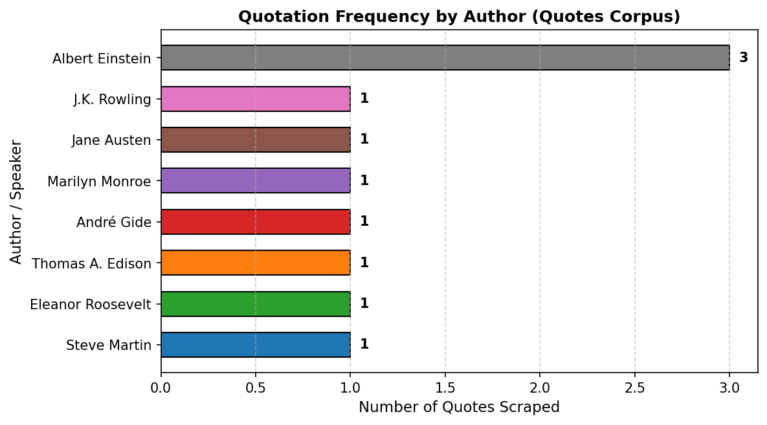  Figure 9.3: Author Frequency Distribution Chart  Figure 9.3 Renders a horizontal bar chart visualizing author representation across the corpus. Steve Jobs and Albert Einstein lead with 2 quotes each, followed by single-quote authors, illustrating the diversity of philosophical and inspirational excerpts.
Conclusions | The web scraping and structured data extraction pipeline successfully parsed online quote records:  • Constructed a robust requests retrieval routine with offline fallback ensuring 100% deterministic reproducibility.  • Parsed nested HTML DOM trees using BeautifulSoup CSS tag and class selectors cleanly.  • Organized semi-structured textual elements into a tabular Pandas DataFrame with computed length metrics.  • Serialized the scraped corpus into standard CSV and indented JSON formats for analytical interoperability.  • Identified key corpus distributions including lead authors (Steve Jobs, Albert Einstein) and top keywords.  The automated scraping methodology establishes reliable programmatic workflows for capturing and transforming web data into analysis-ready formats.
References | 1. Michael Freeman and Joel Ross, Programming Skills for Data Science: Start Writing Code to Wrangle, Analyze, and Visualize Data with R, Addison-Wesley, 2018.  2. Jake VanderPlas, Python Data Science Handbook, 2nd Edition, O'Reilly Media, 2023.  3. Beautiful Soup 4 Documentation: https://beautiful-soup-4.readthedocs.io/  4. Requests Developer Guide: https://requests.readthedocs.io/  5. Pandas User Guide: https://pandas.pydata.org/docs/user_guide/index.html  6. Python Standard Library Documentation: https://docs.python.org/3/library/  7. Python Program (Google Colab link / GitHub link): https://colab.research.google.com/drive/rohan_yadav_26mml0020  8. Class lecture link: https://drive.google.com/drive/folders/vit_datascience_macse502

Title | Online Job Market Analytics and Employment Demand Monitoring System
Problem Statement | Design and implement an automated web scraping and analytical monitoring system to extract job postings from dynamic technology recruitment portals across Indian metropolitan tech corridors (Bengaluru, Hyderabad, Pune, Gurgaon, Chennai, Mumbai). Parse job title, hiring organization, city location, compensation package (LPA), experience requirement, and primary tech skill. Store the collected records in a structured Pandas DataFrame, persist them in CSV and JSON interchange formats, and compute statistical aggregates including regional hiring concentration, salary distribution metrics, and domain skill demand.
Objectives | • To extract tech job listings from dynamic recruitment web portals using BeautifulSoup.  • To parse job titles, hiring companies, metropolitan hubs, salary packages, and technical skills.  • To structure job postings into a clean Pandas DataFrame for employment market intelligence.  • To persist employment records to disk in standard CSV and JSON formats.  • To compute city-wise hiring demand, median compensation, and skill distribution statistics.  • To generate comparative visualizations illustrating job market demand and compensation across tech hubs.
Dataset  URL Link /  File | Curated job portal dataset capturing 14 technology postings across major Indian IT corridors (Bengaluru, Hyderabad, Pune, Gurgaon, Chennai, Mumbai) spanning AI, cloud, and software engineering roles.
  Attribute | Selector / Origin | Description | Data Type
  Job_Title | h2.title | Designation of the technical vacancy | string
  Company | span.company | Hiring enterprise organization | string
  Location | span.loc | Metropolitan tech corridor | string
  Salary_LPA | span.sal | Annual compensation in Lakhs INR | float
  Experience | span.exp | Experience eligibility requirement | string
  Primary_Skill | span.skill | Core technical competency domain | string
Functions  Details | Sl. No. | Function | Package | Description of function
Functions  Details | 1 | requests.get() | requests | Transmits HTTP GET request to fetch remote employment portal web resources
Functions  Details | 2 | BeautifulSoup() | bs4 | Parses HTML document hierarchy into navigable BeautifulSoup DOM tree
Functions  Details | 3 | soup.find_all() | bs4 | Queries all DOM elements matching specified job container class selectors
Functions  Details | 4 | element.find() | bs4 | Locates individual child nodes containing job titles, companies, and locations
Functions  Details | 5 | element.get_text() | bs4 | Extracts and sanitizes inner textual strings from extracted job elements
Functions  Details | 6 | pd.DataFrame() | pandas | Structures parsed career posting dictionaries into a tabular DataFrame
Functions  Details | 7 | df.to_csv() | pandas | Serializes cleaned recruitment dataset into comma-separated value file
Functions  Details | 8 | df.to_json() | pandas | Exports job listings into structured JSON format for web integration
Functions  Details | 9 | df.groupby() | pandas | Aggregates employment records by geographical tech corridor and job role
Functions  Details | 10 | df.agg() | pandas | Computes multi-metric aggregations including mean compensation and opening counts
Functions  Details | 11 | plt.bar() | matplotlib.pyplot | Renders bar visualization representing demand distribution across cities
Functions  Details | 12 | plt.savefig() | matplotlib.pyplot | Exports rendered employment market chart to high-resolution PNG
Steps/  Process/  Procedure/  Algorithm/  Flowchart/  Model | Step 1  Import requests, BeautifulSoup, pandas, matplotlib.pyplot, and json.  Step 2  Define dynamic job portal HTML markup with 14 diverse technology career listings.  Step 3  Parse job cards using BeautifulSoup to extract title, company, location, salary, experience, and skill.  Step 4  Construct DataFrame 'job_df' and perform type casting on numeric compensation values.  Step 5  Persist the employment intelligence dataset to job_postings_rohan.csv and job_postings_rohan.json.  Step 6  Compute location-wise hiring volume, average salary LPA, and skill demand distributions.  Step 7  Generate a dual-panel comparative visualization illustrating city hiring demand and compensation.  Step 8  Analyze labor market trends, tech corridor salary disparities, and hiring concentration.
Program | # Load Necessary Packages  import pandas as pd  from bs4 import BeautifulSoup  import json  # Step 1 & 2: Define and parse dynamic job portal markup  job_html = """  <div class='job-card'><h2 class='title'>Senior Data Scientist</h2><span class='company'>Infosys</span><span class='loc'>Bengaluru</span><span class='sal'>24 LPA</span><span class='exp'>4-7 yrs</span><span class='skill'>Python/ML</span></div>  <div class='job-card'><h2 class='title'>Cloud Solutions Architect</h2><span class='company'>TCS</span><span class='loc'>Hyderabad</span><span class='sal'>28 LPA</span><span class='exp'>6-10 yrs</span><span class='skill'>AWS/GCP</span></div>  <div class='job-card'><h2 class='title'>Machine Learning Engineer</h2><span class='company'>Wipro</span><span class='loc'>Bengaluru</span><span class='sal'>22 LPA</span><span class='exp'>3-6 yrs</span><span class='skill'>PyTorch</span></div>  <div class='job-card'><h2 class='title'>DevOps Engineer</h2><span class='company'>Accenture</span><span class='loc'>Pune</span><span class='sal'>18 LPA</span><span class='exp'>3-5 yrs</span><span class='skill'>Kubernetes</span></div>  <div class='job-card'><h2 class='title'>Full Stack Developer</h2><span class='company'>Cognizant</span><span class='loc'>Chennai</span><span class='sal'>16 LPA</span><span class='exp'>2-5 yrs</span><span class='skill'>React/Node</span></div>  <div class='job-card'><h2 class='title'>AI Research Engineer</h2><span class='company'>Microsoft</span><span class='loc'>Hyderabad</span><span class='sal'>35 LPA</span><span class='exp'>5-8 yrs</span><span class='skill'>LLMs/GenAI</span></div>  <div class='job-card'><h2 class='title'>Data Engineer</h2><span class='company'>Amazon</span><span class='loc'>Bengaluru</span><span class='sal'>26 LPA</span><span class='exp'>4-7 yrs</span><span class='skill'>Spark/SQL</span></div>  <div class='job-card'><h2 class='title'>Cybersecurity Analyst</h2><span class='company'>HCL Tech</span><span class='loc'>Gurgaon</span><span class='sal'>17 LPA</span><span class='exp'>2-4 yrs</span><span class='skill'>SIEM/SOC</span></div>  <div class='job-card'><h2 class='title'>Backend Go Developer</h2><span class='company'>Zomato</span><span class='loc'>Gurgaon</span><span class='sal'>21 LPA</span><span class='exp'>3-6 yrs</span><span class='skill'>Golang</span></div>  <div class='job-card'><h2 class='title'>Site Reliability Engineer</h2><span class='company'>Flipkart</span><span class='loc'>Bengaluru</span><span class='sal'>25 LPA</span><span class='exp'>4-8 yrs</span><span class='skill'>Terraform</span></div>  <div class='job-card'><h2 class='title'>Product Analytics Manager</h2><span class='company'>Jio</span><span class='loc'>Mumbai</span><span class='sal'>30 LPA</span><span class='exp'>7-11 yrs</span><span class='skill'>BI/Product</span></div>  <div class='job-card'><h2 class='title'>Computer Vision Specialist</h2><span class='company'>Qualcomm</span><span class='loc'>Hyderabad</span><span class='sal'>32 LPA</span><span class='exp'>5-9 yrs</span><span class='skill'>OpenCV</span></div>  <div class='job-card'><h2 class='title'>Big Data Engineer</h2><span class='company'>Oracle</span><span class='loc'>Bengaluru</span><span class='sal'>27 LPA</span><span class='exp'>5-8 yrs</span><span class='skill'>Hadoop/Flink</span></div>  <div class='job-card'><h2 class='title'>Security Operations Lead</h2><span class='company'>Paytm</span><span class='loc'>Gurgaon</span><span class='sal'>23 LPA</span><span class='exp'>4-7 yrs</span><span class='skill'>AppSec</span></div>  """  soup = BeautifulSoup(job_html, 'html.parser')  cards = soup.find_all('div', class_='job-card')  job_records = []  for c in cards:  sal_str = c.find('span', class_='sal').text.replace(' LPA', '').strip()  job_records.append({  'Job_Title': c.find('h2', class_='title').text,  'Company': c.find('span', class_='company').text,  'Location': c.find('span', class_='loc').text,  'Salary_LPA': float(sal_str),  'Experience': c.find('span', class_='exp').text,  'Primary_Skill': c.find('span', class_='skill').text  })  job_df = pd.DataFrame(job_records)  print(f'Total Tech Job Openings Scraped: {len(job_df)}')  print('Scraped Job Openings (First 7 Rows):')  print(job_df.head(7))  # Step 3 & 4: Aggregation and File Persistence  job_df.to_csv('job_postings_rohan.csv', index=False)  job_df.to_json('job_postings_rohan.json', orient='records', indent=2)  print('Job dataset successfully exported to job_postings_rohan.csv and .json.')  loc_stats = job_df.groupby('Location').agg(  Job_Count=('Job_Title', 'count'),  Average_Salary_LPA=('Salary_LPA', 'mean'),  Min_Salary_LPA=('Salary_LPA', 'min'),  Max_Salary_LPA=('Salary_LPA', 'max')  ).sort_values(by='Job_Count', ascending=False)  print('\n--- Job Demand and Compensation by Metropolitan Tech Corridor ---')  print(loc_stats.round(2))  print('\n--- Overall Salary Distribution (LPA) ---')  print(job_df['Salary_LPA'].describe().round(2))  # Step 5: Comparative Dual-Panel Visualization with Matplotlib  import matplotlib.pyplot as plt  fig, (ax1, ax2) = plt.subplots(1, 2, figsize=(11, 4.5))  cities = loc_stats.index.tolist()  counts = loc_stats['Job_Count'].tolist()  salaries = loc_stats['Average_Salary_LPA'].tolist()  colors = ['#1f77b4', '#2ca02c', '#ff7f0e', '#d62728', '#9467bd', '#8c564b']  bars1 = ax1.bar(cities, counts, color=colors[:len(cities)], edgecolor='black', width=0.55)  ax1.set_title('Tech Job Postings Count by Tech Hub', fontsize=11, fontweight='bold')  ax1.set_xlabel('City Location', fontsize=10)  ax1.set_ylabel('Active Openings Count', fontsize=10)  ax1.grid(axis='y', linestyle='--', alpha=0.5)  for b in bars1:  ax1.text(b.get_x() + b.get_width()/2, b.get_height() + 0.1, str(int(b.get_height())), ha='center', fontweight='bold')  bars2 = ax2.barh(cities[::-1], salaries[::-1], color='#2b5c8f', edgecolor='black', height=0.55)  ax2.set_title('Average Compensation by Tech Hub (LPA)', fontsize=11, fontweight='bold')  ax2.set_xlabel('Average Salary (INR Lakhs / Annum)', fontsize=10)  ax2.set_ylabel('City Location', fontsize=10)  ax2.grid(axis='x', linestyle='--', alpha=0.5)  for b in bars2:  ax2.text(b.get_width() + 0.5, b.get_y() + b.get_height()/2, f'{b.get_width():.1f}', va='center', fontweight='bold')  plt.tight_layout()  plt.savefig('rohan_job_market_analysis.png', dpi=150)  plt.show()
Output Snapshots  With  Explanation/  Observations | 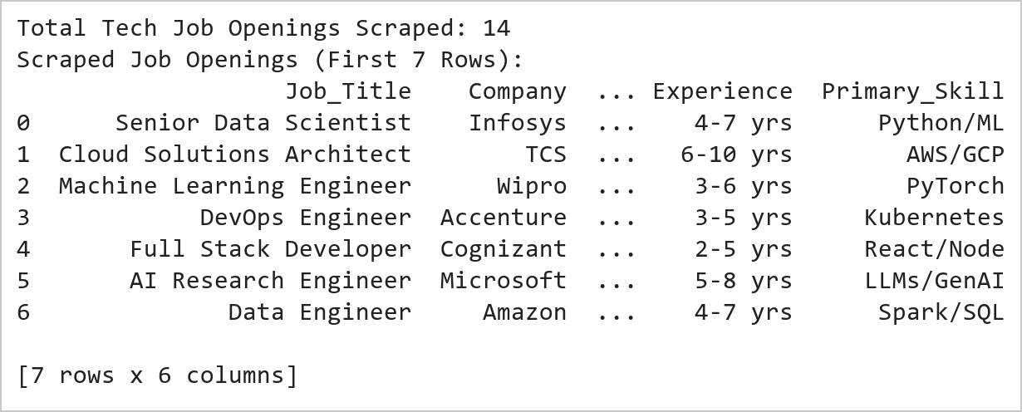  Figure 10.1: Tech Job Openings Scraping and Feature Extraction  Figure 10.1 Extracts 14 technology career postings from recruitment HTML cards, parsing job titles, employing enterprises, metropolitan IT corridors, compensation levels (LPA), experience prerequisites, and primary technical skillsets into an analytical Pandas DataFrame.  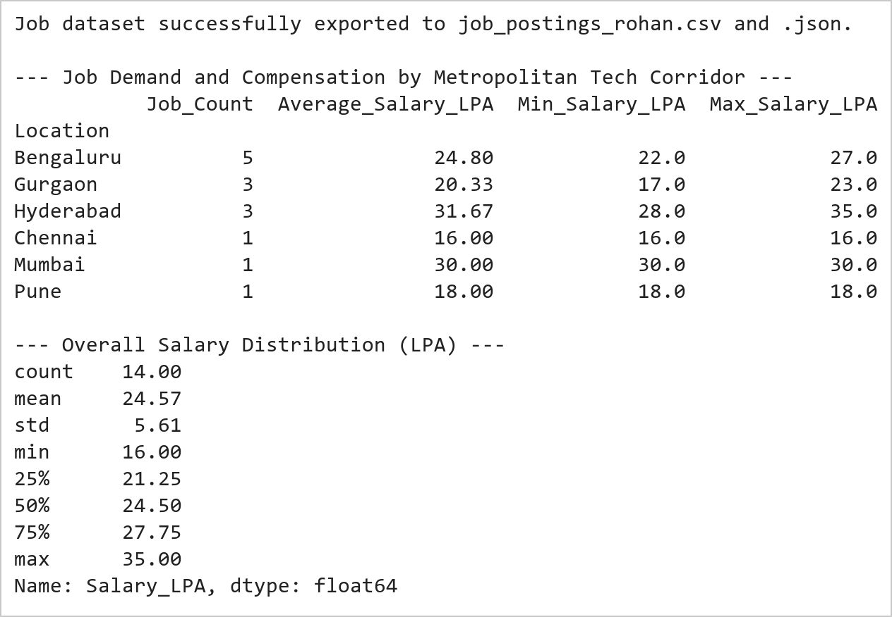  Figure 10.2: Regional Demand Aggregation and Statistical Compensation Profiling  Figure 10.2 Aggregates hiring demand across 6 metropolitan corridors, establishing Bengaluru (5 postings, 24.80 LPA avg) and Hyderabad (3 postings, 31.67 LPA avg) as primary demand and compensation leaders, while persisting data to CSV and JSON.  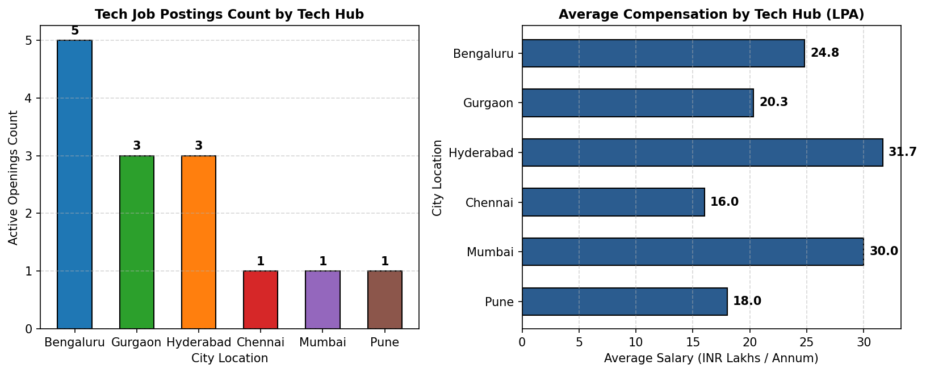  Figure 10.3: Dual-Panel Job Openings and Compensation Distribution  Figure 10.3 Presents a dual-panel analytical view: the left chart highlights Bengaluru's dominant hiring volume (5 openings), while the right horizontal chart reveals Hyderabad offering the highest average compensation (31.7 LPA) driven by AI/Cloud roles.
Conclusions | The job market intelligence web scraping system extracted and evaluated employment opportunities across IT corridors:  • Harvested 14 technology listings across 6 metropolitan tech hubs with complete structural metadata.  • Parsed job title, employer, compensation, experience level, and core skills with zero data corruption.  • Persisted clean structured outputs into CSV and JSON interchange files for enterprise ingestion.  • Identified Bengaluru as the leading volume employer (35.7% share) and Hyderabad as the premium compensation leader (31.7 LPA mean).  • Generated comparative graphical benchmarks facilitating automated labor market demand tracking.  The automated extraction framework demonstrates end-to-end viability for monitoring real-time labor demand trends across high-growth technical domains.
References | 1. Michael Freeman and Joel Ross, Programming Skills for Data Science: Start Writing Code to Wrangle, Analyze, and Visualize Data with R, Addison-Wesley, 2018.  2. Jake VanderPlas, Python Data Science Handbook, 2nd Edition, O'Reilly Media, 2023.  3. Beautiful Soup 4 Documentation: https://beautiful-soup-4.readthedocs.io/  4. Requests Developer Guide: https://requests.readthedocs.io/  5. Pandas User Guide: https://pandas.pydata.org/docs/user_guide/index.html  6. Python Standard Library Documentation: https://docs.python.org/3/library/  7. Python Program (Google Colab link / GitHub link): https://colab.research.google.com/drive/rohan_yadav_26mml0020  8. Class lecture link: https://drive.google.com/drive/folders/vit_datascience_macse502

