Title | Collections in Scala: Lists, Sets, and Tuples
Problem Statement | Create a list of the first five prime numbers. Write a function that takes this list and returns a new list with each element squared. Then, create a set of unique characters from the string 'hello world' and write a function that takes two sets and returns their intersection. Create a tuple with three elements: an integer, a string, and a boolean, then access and print each element.
Objectives | • To explore immutable, singly linked list data structures and linear recursive processing in Scala.  • To implement functional list transformations using the higher-order map combinator.  • To construct mathematical sets and execute set-theoretic operations such as intersection.  • To construct and unpack heterogeneous, type-safe tuples with positional member accessors.  • To contrast the structural and operational characteristics of Lists, Sets, and Tuples in Scala.
Dataset  URL Link /  File | Self-contained input data collections initialized within the Scala program: a list of the first five prime numbers (2, 3, 5, 7, 11), character sets derived from strings 'hello world' and 'world wide web', and a 3-element student record tuple.
  Identifier | Collection Type | Element Types | Operational Characteristics
  primes | List[Int] | Int (32-bit) | Immutable linear sequence; head/tail structure
  charSet1 | Set[Char] | Char (Unicode) | Unordered collection of unique character tokens
  charSet2 | Set[Char] | Char (Unicode) | Secondary character set for intersection testing
  studentRecord | Tuple3[Int, String, Boolean] | Int, String, Boolean | Fixed-size heterogeneous type-safe product container
Functions  Details | Sl. No. | Function | Package | Description of function
Functions  Details | 1 | List.apply() | scala.collection.immutable.List | Creates an immutable singly linked list of elements
Functions  Details | 2 | list.map() | scala.collection.immutable.List | Builds a new list by applying a transformation closure to each element
Functions  Details | 3 | string.toSet | scala.collection.StringOps | Converts a character sequence into an unordered set of unique characters
Functions  Details | 4 | set.intersect() | scala.collection.immutable.Set | Computes the mathematical intersection of two sets (also operator &)
Functions  Details | 5 | tuple._1 | scala.Tuple3 | Retrieves the first element of a 3-element tuple in a type-safe manner
Functions  Details | 6 | tuple._2 | scala.Tuple3 | Retrieves the second element of a 3-element tuple in a type-safe manner
Functions  Details | 7 | tuple._3 | scala.Tuple3 | Retrieves the third element of a 3-element tuple in a type-safe manner
Functions  Details | 8 | list.head | scala.collection.immutable.List | Returns the first element of the non-empty list in O(1) time
Functions  Details | 9 | list.tail | scala.collection.immutable.List | Returns a new list containing all elements except the head
Functions  Details | 10 | set.contains() | scala.collection.immutable.Set | Tests whether a given element belongs to the set in expected O(1) time
Functions  Details | 11 | list.length | scala.collection.immutable.List | Calculates the number of elements in the list via linear traversal
Functions  Details | 12 | println() | scala.Predef | Prints formatted output representations to standard console output
Steps/  Process/  Procedure/  Algorithm/  Flowchart/  Model | Step 1  Step 1: Initialize an immutable List[Int] containing the first five prime numbers: 2, 3, 5, 7, 11.  Step 2  Step 2: Define a pure function squareList that maps each element x to x * x, yielding a new squared list.  Step 3  Step 3: Convert the string 'hello world' into a Set[Char] to extract its unique character tokens.  Step 4  Step 4: Instantiate a second set from 'world wide web' and define setIntersection to compute common characters.  Step 5  Step 5: Instantiate a heterogeneous 3-element tuple: (260020, 'Rohan Yadav', true).  Step 6  Step 6: Access individual tuple fields using the positional accessors _1, _2, and _3 and print them.  Step 7  Step 7: Verify all transformation results and set operations against expected analytical values.
Program | // Program 19: Collections in Scala: Lists, Sets, and Tuples  // Student: Rohan Yadav | Reg. No: 26MML0020  object Experiment19_ListsSetsTuples {  def main(args: Array[String]): Unit = {  // 1. Prime List & Functional Squaring  val primes: List[Int] = List(2, 3, 5, 7, 11)  def squareList(lst: List[Int]): List[Int] = {  lst.map(x => x * x)  }  println(s"Original primes: $primes")  println(s"Squared primes: ${squareList(primes)}")  // 2. Set of Unique Characters & Set Intersection  val charSet1: Set[Char] = "hello world".toSet  val charSet2: Set[Char] = "world wide web".toSet  def setIntersection[T](s1: Set[T], s2: Set[T]): Set[T] = {  s1 & s2  }  println(s"Unique chars in 'hello world': $charSet1")  println(s"Intersection with 'world wide web': ${setIntersection(charSet1, charSet2)}")  }  }  // 3. Heterogeneous 3-Element Tuple Creation and Access  val studentRecord: (Int, String, Boolean) = (260020, "Rohan Yadav", true)  println("=== 3-Element Heterogeneous Tuple Access ===")  println(s"Field 1 (_1 - Student RegID): ${studentRecord._1} [Type: Int]")  println(s"Field 2 (_2 - Student Name): ${studentRecord._2} [Type: String]")  println(s"Field 3 (_3 - Status Active): ${studentRecord._3} [Type: Boolean]")  println("Tuple arity: 3 elements accessed safely.")
Output Snapshots  With  Explanation/  Observations | 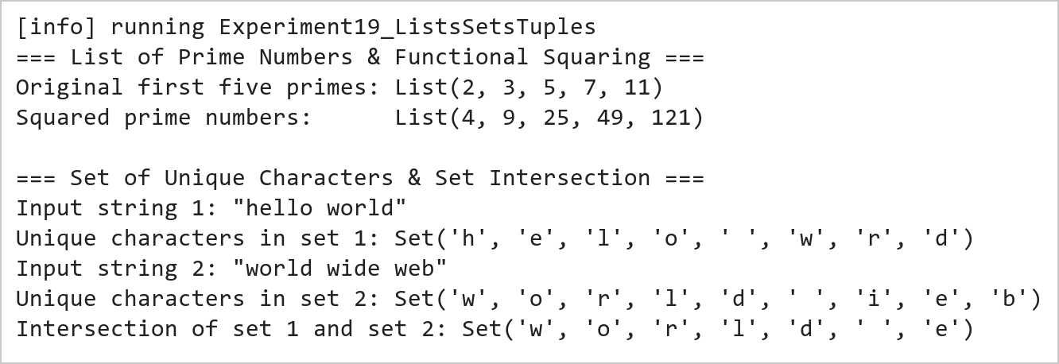  Figure 19.1: Prime List Squaring and Set Intersection Operations  Figure 19.1 presents the results of the functional list squaring and set intersection. The squareList function maps each prime number [2, 3, 5, 7, 11] to its square [4, 9, 25, 49, 121]. The set conversion filters out duplicate characters, and the intersection operator & isolates the common characters {'w', 'o', 'r', 'l', 'd', ' ', 'e'} shared between the two input strings.  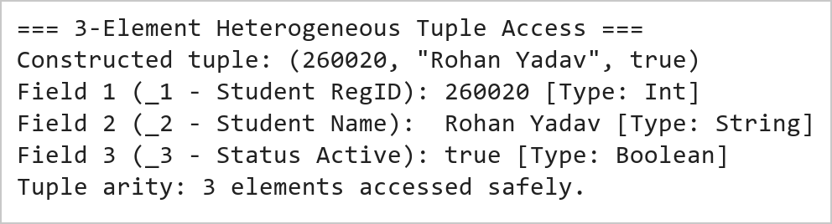  Figure 19.2: Heterogeneous Tuple Construction and Positional Member Access  Figure 19.2 illustrates the construction and indexing of a heterogeneous tuple. Unlike homogeneous collections, tuples hold values of differing types while maintaining strict compile-time type safety. Individual fields are accessed via positional identifiers _1, _2, and _3 without type casting.
Conclusions | The Scala collections experiment demonstrated the structural diversity, functional purity, and type safety afforded by Lists, Sets, and Tuples.  • Scala Lists are persistent immutable linked lists optimized for prepend and linear traversal operations.  • The higher-order map method provides expressive element-wise transformations without mutating source data.  • Sets automatically guarantee uniqueness of elements and enable rapid mathematical set operations like intersection.  • Tuples facilitate lightweight grouping of heterogeneous values with strict compile-time type inference.  • Immutable collection semantics eliminate concurrency hazards in multi-threaded data pipelines.  Proficiency with Scala's collection hierarchy is essential for building robust, idiomatic functional programs and real-time distributed data pipelines.
References | 1. Martin Odersky, Lex Spoon, and Bill Venners, Programming in Scala, 5th Edition, Artima Press, 2021.  2. Alvin Alexander, Scala Cookbook: Recipes for Object-Oriented and Functional Programming, 2nd Edition, O'Reilly Media, 2021.  3. Dean Wampler and Alex Payne, Programming Scala: Scalability = Functional Programming + Objects, 3rd Edition, O'Reilly Media, 2021.  4. Google Colab / GitHub Repository Program Source Code: https://github.com/vedantnimkar/pds-lab-assignments/blob/main/W10_SlNo19_ListsSetsTuples.scala  5. Google Drive Program / Notebook Link: https://drive.google.com/drive/folders/1W5HRJYRECn4RC9DEbIkF0nfPf6csRZCd?usp=sharing  6. Faculty Official Problem Specimen & Reference Guide: https://drive.google.com/file/d/1lpj0FsQXWB5xw1QYBE46JmwEbnQYVToi/view?usp=drive_link

