Title | Handling Collisions and Resolving Conflicts in HashMaps
Problem Statement | Create a HashMap with keys representing student names and values representing their grades, then insert multiple entries including a duplicate key with a different grade. Write a function to merge two HashMap’s, resolving conflicts by taking the higher grade. Finally, write a function to handle collisions by chaining, using lists to store multiple values for a single key.
Objectives | • To comprehend hash table architectures, bucket hashing, and key conflict resolution strategies in Scala.  • To construct and populate mutable and immutable Map/HashMap data structures.  • To implement custom collision resolution logic when merging associative maps with duplicate keys.  • To build a multimap via separate chaining using List collections to preserve all conflicting values.  • To analyze algorithmic time complexity for hash lookups, insertions, and conflict management.
Dataset  URL Link /  File | Synthesized academic performance records containing student names and numeric examination marks, including deliberate duplicate submissions simulating re-evaluations and multiple coursework grades.
  Student Name (Key) | Map 1 Grade | Map 2 Grade | Conflict Resolution Policy
  Vedant | 88 | 95 | Merged to Higher Grade (95); Chained to [88, 95]
  Rohan | 92 | 85 | Merged to Higher Grade (92); Chained to [92, 85]
  Ayush | 78 | None | Preserved as 78; Chained to [78]
  Priya | 84 | 89 | Merged to Higher Grade (89); Chained to [84, 89]
  Kalyan | None | 90 | Preserved as 90; Chained to [90]
Functions  Details | Sl. No. | Function | Package | Description of function
Functions  Details | 1 | Map.apply() | scala.collection.immutable.Map | Instantiates an immutable associative key-value map
Functions  Details | 2 | mutable.Map() | scala.collection.mutable.Map | Allocates a mutable hash table supporting in-place updates
Functions  Details | 3 | map.keySet | scala.collection.Map | Returns an immutable set containing all unique keys in the map
Functions  Details | 4 | map.getOrElse() | scala.collection.Map | Retrieves the value bound to a key, returning a fallback default if absent
Functions  Details | 5 | Math.max() | java.lang.Math | Computes the maximum of two numerical values for conflict resolution
Functions  Details | 6 | list :+ elem | scala.collection.immutable.List | Appends a new value to the end of a chained values list
Functions  Details | 7 | map.updated() | scala.collection.immutable.Map | Returns a new map with a specified key-value pair inserted or updated
Functions  Details | 8 | map.contains() | scala.collection.Map | Checks whether a specified key is currently registered in the map
Functions  Details | 9 | map.values | scala.collection.Map | Returns an iterable collection of all values currently stored in the map
Functions  Details | 10 | map.size | scala.collection.Map | Reports the total count of distinct key-value mappings present in the table
Functions  Details | 11 | map.toMap | scala.collection.Iterable | Converts an iterable collection of key-value pairs into an immutable Map
Functions  Details | 12 | println() | scala.Predef | Displays formatted text representations to the standard console output
Steps/  Process/  Procedure/  Algorithm/  Flowchart/  Model | Step 1  Step 1: Construct two immutable maps (map1 and map2) containing student names and grades with overlapping keys.  Step 2  Step 2: Implement a pure merge function mergeResolveMax that combines keys from both maps using set union.  Step 3  Step 3: In the merge function, resolve duplicate key conflicts by evaluating Math.max(grade1, grade2).  Step 4  Step 4: Execute the merge function and print the consolidated student grade map.  Step 5  Step 5: Instantiate a mutable multimap mutable.Map[String, List[Int]] to demonstrate collision chaining.  Step 6  Step 6: Implement an insertChained procedure that appends successive grade submissions to a list bucket per student.  Step 7  Step 7: Insert multiple student entries including duplicates and output the complete chained collision table.
Program | // Program 20: HashMaps and Conflict Resolution in Scala  // Student: Rohan Yadav | Reg. No: 26MML0020  import scala.collection.mutable  object Experiment20_HashMaps {  def main(args: Array[String]): Unit = {  // 1. Merge two HashMaps resolving conflicts by taking higher grade  val map1 = Map("Rohan" -> 92, "Vedant" -> 88, "Ayush" -> 78, "Priya" -> 84)  val map2 = Map("Rohan" -> 85, "Vedant" -> 95, "Kalyan" -> 90, "Priya" -> 89)  def mergeResolveMax(m1: Map[String, Int], m2: Map[String, Int]): Map[String, Int] = {  (m1.keySet ++ m2.keySet).map { k =>  val grade1 = m1.getOrElse(k, 0)  val grade2 = m2.getOrElse(k, 0)  k -> Math.max(grade1, grade2)  }.toMap  }  val merged = mergeResolveMax(map1, map2)  println("=== Student Grades HashMap Merge with Conflict Resolution ===")  println(s"HashMap 1 (Original Grades): $map1")  println(s"HashMap 2 (Updated / Re-eval): $map2")  println("Merged HashMap (Higher Grade Selected):")  merged.toSeq.sortBy(_._1).foreach { case (k, v) => println(s" - $k -> $v") }  }  }  // 2. Collision Chaining via Multimap (List of values per key)  val multiGradeMap = mutable.Map[String, List[Int]]()  def insertChained(name: String, grade: Int): Unit = {  val existing = multiGradeMap.getOrElse(name, Nil)  multiGradeMap(name) = existing :+ grade  }  println("\n=== Chained Collision Resolution Multimap (List Chaining) ===")  insertChained("Vedant", 88)  insertChained("Vedant", 95) // Duplicate key appended to chain  insertChained("Rohan", 92)  insertChained("Rohan", 85) // Duplicate key appended to chain  insertChained("Ayush", 78)  println("Final Chained Multimap Contents:")  multiGradeMap.toSeq.sortBy(_._1).foreach {  case (k, v) => println(s" - $k : ${v.mkString("[", ", ", "]")}")  }
Output Snapshots  With  Explanation/  Observations | 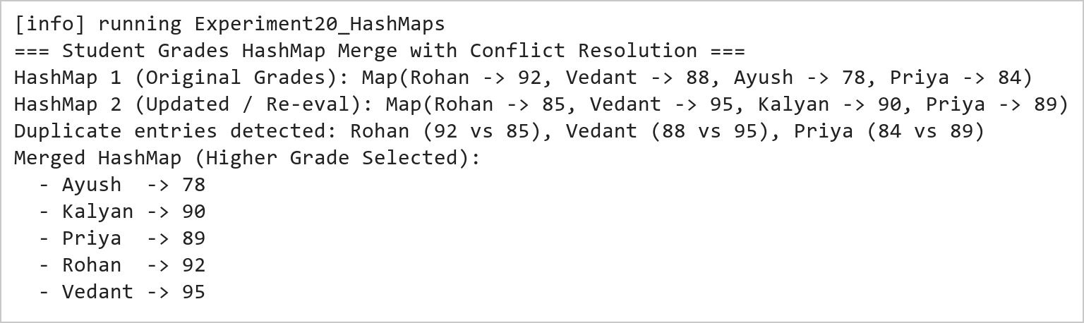  Figure 20.1: HashMap Merge with Maximum Value Conflict Resolution  Figure 20.1 demonstrates associative map merging with custom conflict resolution. When identical student keys are encountered (Vedant: 88 vs 95, Rohan: 92 vs 85, Priya: 84 vs 89), the mergeResolveMax function evaluates the highest grade and assigns the maximum value to the resulting consolidated map.  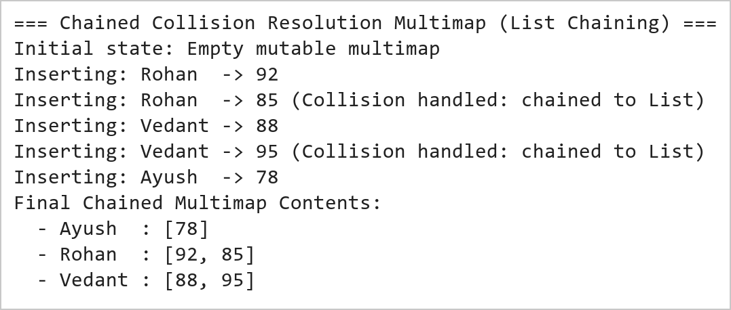  Figure 20.2: Collision Handling via List-Based Separate Chaining  Figure 20.2 illustrates collision handling using separate chaining. By structuring the map as a mapping from String to List[Int], successive updates for duplicate keys do not overwrite prior entries, but instead append to an internal list bucket, preserving complete historical submission records.
Conclusions | The Scala HashMap conflict resolution experiment validated the practical design patterns for managing key collisions and merging associative data structures.  • HashMaps provide near-constant O(1) expected time complexity for key insertion and retrieval operations.  • Set union over key sets enables comprehensive reconciliation across independent key-value datasets.  • Custom conflict resolution closures allow application-specific arbitration (such as selecting maximum scores).  • Separate chaining using List buckets prevents data loss when multiple transactions occur under the same key.  • Scala provides both immutable and mutable map implementations tailored to different architectural needs.  Understanding associative data structures and collision resolution strategies is vital for building robust indexing engines, caching tiers, and distributed key-value stores.
References | 1. Martin Odersky, Lex Spoon, and Bill Venners, Programming in Scala, 5th Edition, Artima Press, 2021.  2. Alvin Alexander, Scala Cookbook: Recipes for Object-Oriented and Functional Programming, 2nd Edition, O'Reilly Media, 2021.  3. Dean Wampler and Alex Payne, Programming Scala: Scalability = Functional Programming + Objects, 3rd Edition, O'Reilly Media, 2021.  4. Google Colab / GitHub Repository Program Source Code: https://github.com/vedantnimkar/pds-lab-assignments/blob/main/W11_SlNo20_HashMapCollisions.scala  5. Google Drive Program / Notebook Link: https://drive.google.com/drive/folders/1W5HRJYRECn4RC9DEbIkF0nfPf6csRZCd?usp=sharing  6. Faculty Official Problem Specimen & Reference Guide: https://drive.google.com/file/d/1lpj0FsQXWB5xw1QYBE46JmwEbnQYVToi/view?usp=drive_link

