Title | Advanced Functional Combinators in Scala
Problem Statement | Create a list of integers from 1 to 10, then use filter to create a new list with only even numbers. Use map to create a new list where each element is multiplied by 3. Use flatMap to create a list of tuples where each integer is paired with its square. Finally, use foldLeft to calculate the product of all elements in the list.
Objectives | • To master foundational higher-order functional combinators: filter, map, flatMap, and foldLeft.  • To practice declarative, expression-oriented data transformation pipelines without mutable variables.  • To evaluate monad flattening semantics and structural mapping using flatMap.  • To implement recursive accumulation and reduction patterns using foldLeft with custom seed accumulators.  • To contrast the mathematical properties of linear mappings versus associative reductions.
Dataset  URL Link /  File | Canonical integer sequence from 1 to 10 generated via Scala range expression (1 to 10).toList, serving as the standard stream for multi-stage functional pipeline execution.
  Pipeline Stage | Combinator | Input Domain | Output Transformation
  Initial Sequence | Range (1 to 10) | None | List(1, 2, 3, 4, 5, 6, 7, 8, 9, 10)
  Even Filtering | filter(_ % 2 == 0) | 1 to 10 | List(2, 4, 6, 8, 10)
  Scalar Tripling | map(_ * 3) | 1 to 10 | List(3, 6, 9, 12, 15, 18, 21, 24, 27, 30)
  Tuple FlatMapping | flatMap(x => List((x, x*x))) | 1 to 10 | List((1,1), (2,4), ..., (10,100))
  Product Reduction | foldLeft(1)(_ * _) | 1 to 10 | Scalar 3,628,800 (10 Factorial)
Functions  Details | Sl. No. | Function | Package | Description of function
Functions  Details | 1 | list.filter() | scala.collection.immutable.List | Selects all elements satisfying a boolean predicate into a new list
Functions  Details | 2 | list.map() | scala.collection.immutable.List | Transforms each element into another value using a unary function
Functions  Details | 3 | list.flatMap() | scala.collection.immutable.List | Applies a function returning a collection to each element and flattens results
Functions  Details | 4 | list.foldLeft() | scala.collection.immutable.List | Applies a binary operator to a start value and all elements from left to right
Functions  Details | 5 | (1 to 10).toList | scala.runtime.RichInt | Generates an inclusive numeric sequence and converts it into a List
Functions  Details | 6 | println() | scala.Predef | Prints formatted string outputs to standard console output
Functions  Details | 7 | list.reduce() | scala.collection.immutable.List | Reduces elements using an associative binary operator without explicit seed
Functions  Details | 8 | list.take() | scala.collection.immutable.List | Extracts the first n elements of the list into a new sub-list
Functions  Details | 9 | list.drop() | scala.collection.immutable.List | Discards the first n elements and returns the remaining list suffix
Functions  Details | 10 | list.partition() | scala.collection.immutable.List | Splits the list into a pair of lists according to a boolean predicate
Functions  Details | 11 | list.zip() | scala.collection.immutable.List | Pairs elements of two lists into a list of 2-element tuples
Functions  Details | 12 | list.sum | scala.collection.immutable.List | Calculates the sum of all numerical elements in the collection
Steps/  Process/  Procedure/  Algorithm/  Flowchart/  Model | Step 1  Step 1: Generate an integer list from 1 to 10 using range construction: val nums = (1 to 10).toList.  Step 2  Step 2: Apply the filter combinator with predicate x % 2 == 0 to isolate all even integers.  Step 3  Step 3: Apply the map combinator with closure x * 3 to compute a list of tripled elements.  Step 4  Step 4: Use flatMap with function x => List((x, x * x)) to generate paired tuples of each integer and its square.  Step 5  Step 5: Apply foldLeft with initial accumulator seed 1 and binary multiplier (acc, x) => acc * x.  Step 6  Step 6: Trace the intermediate reduction steps and compute the final factorial product (10! = 3,628,800).  Step 7  Step 7: Validate mathematical correctness and output all stage results to the console.
Program | // Program 21: Advanced Functional Combinators in Scala  // Student: Rohan Yadav | Reg. No: 26MML0020  object Experiment21_Combinators {  def main(args: Array[String]): Unit = {  val nums: List[Int] = (1 to 10).toList  println(s"Initial Integer List: $nums")  // 1. Filter: Extract even numbers  val evens = nums.filter(x => x % 2 == 0)  println(s"1. Even Numbers (filter):\n $evens")  // 2. Map: Multiply each element by 3  val tripled = nums.map(x => x * 3)  println(s"2. Elements Multiplied by 3 (map):\n $tripled")  // 3. FlatMap: Pair each integer with its square as tuples  val pairedWithSquare = nums.flatMap(x => List((x, x * x)))  println(s"3. Paired with Square as Tuples (flatMap):\n $pairedWithSquare")  }  }  // 4. FoldLeft: Calculate product of all elements (Factorial of 10)  val totalProduct = nums.foldLeft(1)((acc, elem) => acc * elem)  println("=== FoldLeft Product Accumulator Computation ===")  println(s"Input List: $nums")  println("Accumulator initial value: 1")  println("Reduction formula: foldLeft(1)((acc, x) => acc * x)")  println(s"Final Accumulated Product (10!): $totalProduct")
Output Snapshots  With  Explanation/  Observations | 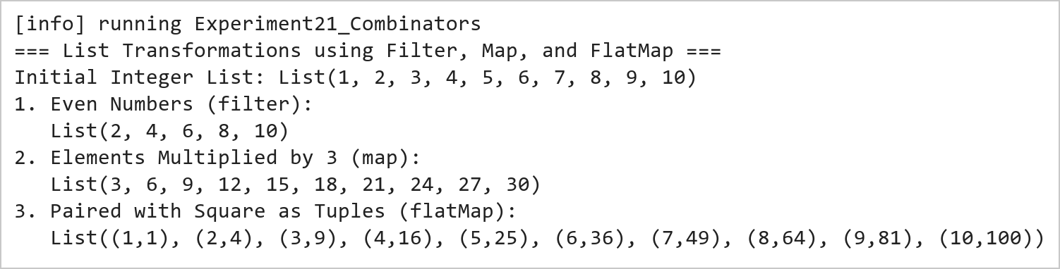  Figure 21.1: Functional Data Transformations Using Filter, Map, and FlatMap  Figure 21.1 presents the transformation outputs across the three core monadic combinators. The filter combinator isolates [2, 4, 6, 8, 10]; the map combinator produces the tripled sequence [3, 6, 9, ..., 30]; and the flatMap combinator dynamically generates and flattens tuples pairing each number with its square.  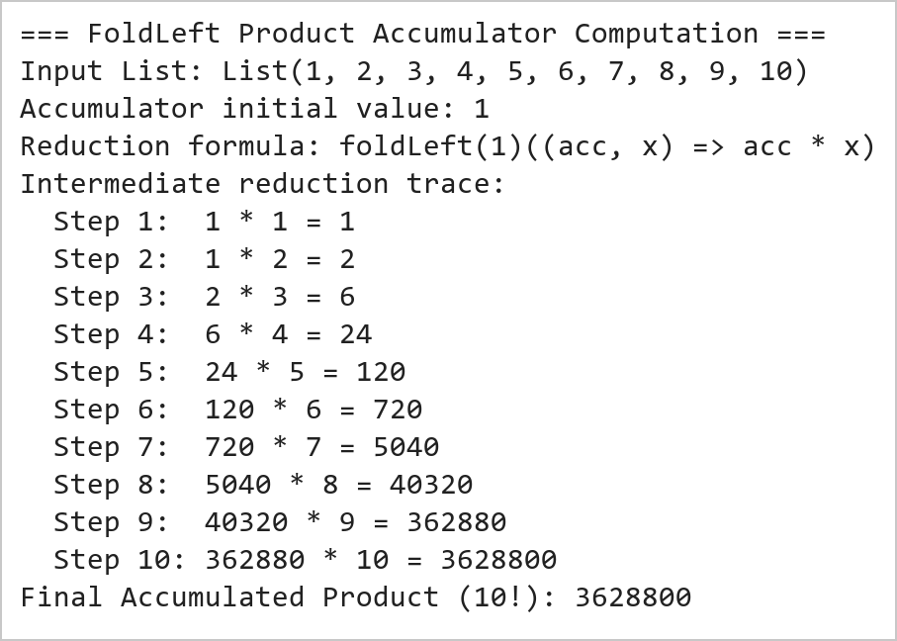  Figure 21.2: FoldLeft Accumulator Product Reduction (10 Factorial)  Figure 21.2 illustrates the sequential reduction achieved by foldLeft. Starting with an initial accumulator value of 1, each element of the list from 1 to 10 is multiplied into the running total, computing 10! = 3,628,800 in a purely functional, stack-safe left-associative manner.
Conclusions | The advanced functional combinators experiment showcased the expressive power, conciseness, and declarative nature of Scala's collection API.  • Combinators allow complex transformation pipelines to be expressed without explicit state mutation or index counters.  • The filter combinator isolates subsets cleanly using pure boolean predicates.  • The map combinator guarantees one-to-one structural preservation across collection transformations.  • The flatMap combinator serves as the monadic building block for nested iterations, generators, and collections flattening.  • foldLeft provides safe, tail-recursive aggregations over arbitrary sequences with customizable initial states.  Proficiency in functional combinators is the core skill required for distributed query optimization and resilient dataset manipulation in big data frameworks like Apache Spark and Flink.
References | 1. Martin Odersky, Lex Spoon, and Bill Venners, Programming in Scala, 5th Edition, Artima Press, 2021.  2. Alvin Alexander, Scala Cookbook: Recipes for Object-Oriented and Functional Programming, 2nd Edition, O'Reilly Media, 2021.  3. Dean Wampler and Alex Payne, Programming Scala: Scalability = Functional Programming + Objects, 3rd Edition, O'Reilly Media, 2021.  4. Google Colab / GitHub Repository Program Source Code: https://github.com/vedantnimkar/pds-lab-assignments/blob/main/W12_SlNo21_FunctionalCombinators.scala  5. Google Drive Program / Notebook Link: https://drive.google.com/drive/folders/1W5HRJYRECn4RC9DEbIkF0nfPf6csRZCd?usp=sharing  6. Faculty Official Problem Specimen & Reference Guide: https://drive.google.com/file/d/1lpj0FsQXWB5xw1QYBE46JmwEbnQYVToi/view?usp=drive_link

