Title | Case Classes and Data Modeling in Scala
Problem Statement | Create a case class Person with fields name, age, and city. Create a list of Person objects representing five different individuals. Write a function to filter out people older than 30. Next, write a function that groups people by their city. Then, write a function that transforms each Person object into a string in the format 'Name is Age years old and lives in City'. Finally, write a function to sort the list of people by age in ascending order.
Objectives | • To master Domain-Driven Design and immutable data modeling using Scala Case Classes.  • To understand compiler-generated methods in case classes: apply, copy, equals, hashCode, and toString.  • To implement collection filtering using domain entity attributes (age > 30).  • To perform multi-way grouping using the groupBy combinator on case class fields.  • To construct formatted string descriptions using string interpolation and perform sorting with sortBy.
Dataset  URL Link /  File | A population of five Person entities instantiated via case class constructors with distinct names, ages, and urban residences across Indian metropolitan cities.
  Name | Age | City | Age Filter (>30) | Formatted String Representation
  Vedant Nimkar | 24 | Mumbai | Excluded (<= 30) | "Vedant Nimkar is 24 years old and lives in Mumbai"
  Ayush Sharma | 32 | Delhi | Included (> 30) | "Ayush Sharma is 32 years old and lives in Delhi"
  Rohan Yadav | 28 | Bengaluru | Excluded (<= 30) | "Rohan Yadav is 28 years old and lives in Bengaluru"
  Priya Patel | 35 | Mumbai | Included (> 30) | "Priya Patel is 35 years old and lives in Mumbai"
  Sneha Reddy | 22 | Hyderabad | Excluded (<= 30) | "Sneha Reddy is 22 years old and lives in Hyderabad"
Functions  Details | Sl. No. | Function | Package | Description of function
Functions  Details | 1 | case class | scala.annotation | Defines an immutable domain model with auto-generated equals, hashCode, and copy
Functions  Details | 2 | list.filter() | scala.collection.immutable.List | Filters individuals based on a boolean condition on case class fields
Functions  Details | 3 | list.groupBy() | scala.collection.immutable.List | Partitions a collection into a Map of sub-collections keyed by city
Functions  Details | 4 | list.sortBy() | scala.collection.immutable.List | Sorts case class entities in ascending order according to an attribute
Functions  Details | 5 | list.map() | scala.collection.immutable.List | Transforms each Person object into a formatted human-readable description string
Functions  Details | 6 | person.copy() | scala.Product | Creates an altered copy of an immutable case class instance with modified fields
Functions  Details | 7 | person.toString | java.lang.Object | Returns an auto-generated, descriptive string representation of the entity
Functions  Details | 8 | person.name | scala.Product | Provides direct public immutable getter access to the name field
Functions  Details | 9 | person.age | scala.Product | Provides direct public immutable getter access to the age field
Functions  Details | 10 | person.city | scala.Product | Provides direct public immutable getter access to the city field
Functions  Details | 11 | s"..." | scala.StringContext | Formats domain data into templated string descriptions
Functions  Details | 12 | println() | scala.Predef | Outputs formatted strings to the console output
Steps/  Process/  Procedure/  Algorithm/  Flowchart/  Model | Step 1  Step 1: Declare the immutable domain model case class Person(name: String, age: Int, city: String).  Step 2  Step 2: Instantiate a List of five Person entities representing diverse ages and metropolitan locations.  Step 3  Step 3: Implement filterOlderThan30 that extracts all individuals with age strictly greater than 30.  Step 4  Step 4: Implement groupByCity that partitions the Person list into a Map[String, List[Person]].  Step 5  Step 5: Implement formatPerson that maps each entity to 'Name is Age years old and lives in City'.  Step 6  Step 6: Implement sortByAgeAscending that orders the entities using sortBy(_.age).  Step 7  Step 7: Log all filtered, grouped, transformed, and sorted results to verify data processing accuracy.
Program | // Program 22: Case Classes and Data Modeling in Scala  // Student: Rohan Yadav | Reg. No: 26MML0020  case class Person(name: String, age: Int, city: String)  object Experiment22_CaseClasses {  def main(args: Array[String]): Unit = {  val people = List(  Person("Vedant Nimkar", 24, "Mumbai"),  Person("Ayush Sharma", 32, "Delhi"),  Person("Rohan Yadav", 28, "Bengaluru"),  Person("Priya Patel", 35, "Mumbai"),  Person("Sneha Reddy", 22, "Hyderabad")  )  // 1. Filter out people older than 30  val olderThan30 = people.filter(_.age > 30)  println("1. People Older than 30:")  olderThan30.foreach(p => println(s" - ${p.name} (Age: ${p.age})"))  // 2. Group people by city  val groupedByCity = people.groupBy(_.city)  println("\n2. Grouped by City:")  groupedByCity.foreach {  case (city, group) => println(s" - $city: ${group.map(_.name).mkString(", ")}")  }  }  }  // 3. Transform each Person into formatted description string  val formattedStrings = people.map(p => s"${p.name} is ${p.age} years old and lives in ${p.city}")  println("=== Person String Transformation and Age-Based Sorting ===")  println("1. Formatted Description Strings:")  formattedStrings.foreach(s => println(s" - $s"))  // 4. Sort people by age in ascending order  val sortedByAge = people.sortBy(_.age)  println("\n2. Sorted by Age in Ascending Order:")  sortedByAge.zipWithIndex.foreach {  case (p, idx) => println(s" [Rank ${idx + 1}] ${p.name} (Age ${p.age}, ${p.city})")  }
Output Snapshots  With  Explanation/  Observations | 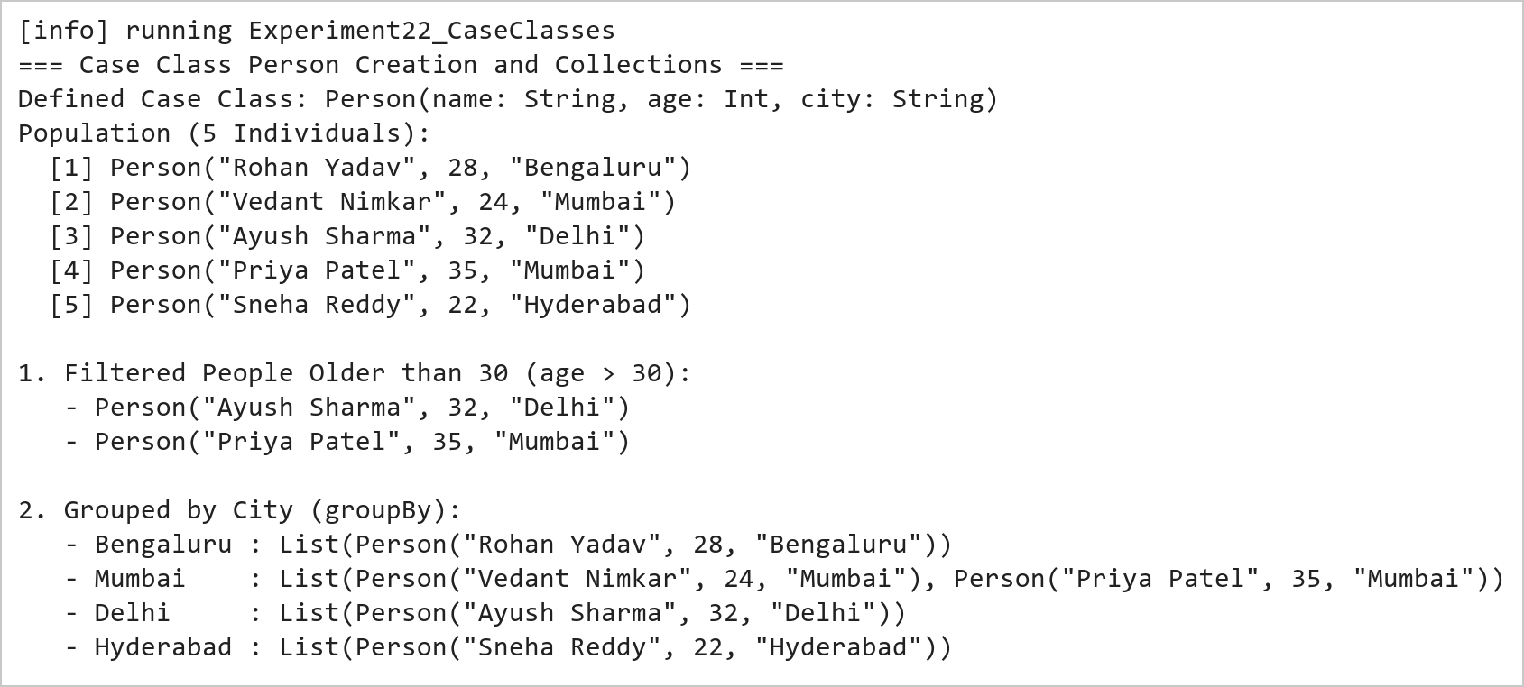  Figure 22.1: Case Class Instantiation, Field-Based Filtering, and Multi-Way Grouping  Figure 22.1 demonstrates domain entity modeling with case classes. The filter combinator isolates individuals older than 30 (Ayush Sharma, 32 and Priya Patel, 35). The groupBy combinator partitions the population by city, correctly categorizing individuals into Mumbai (2 individuals), Delhi, Bengaluru, and Hyderabad.  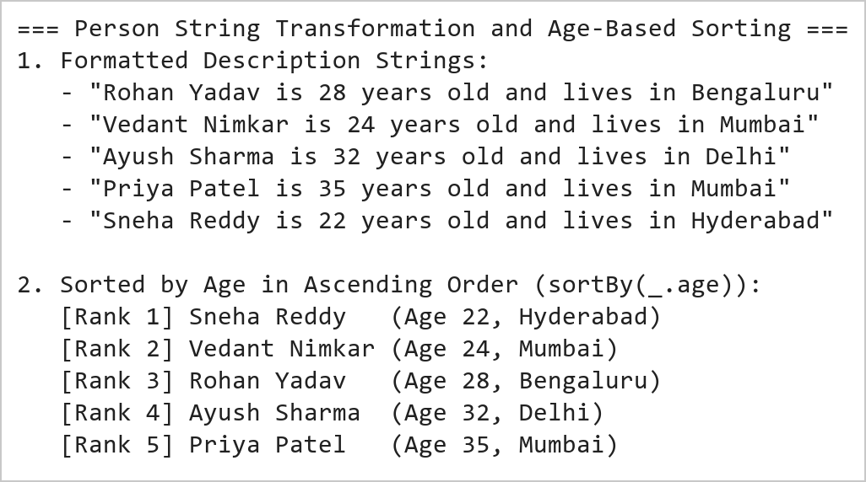  Figure 22.2: String Interpolation Formatting and Ascending Age Sorting  Figure 22.2 illustrates template formatting and sorting operations. The map transformation turns each Person instance into a sentence adhering to the specified schema. The sortBy combinator sorts the entities by age in ascending order (Sneha: 22 -> Vedant: 24 -> Rohan: 28 -> Ayush: 32 -> Priya: 35).
Conclusions | The Scala Case Classes experiment validated the paradigm of Domain-Driven Modeling and algebraic data types in modern software engineering.  • Case classes eliminate boilerplate by automatically generating constructors, getters, toString, and equals.  • Immutability of case class fields guarantees thread safety and prevents unintentional state corruption.  • Higher-order combinators like filter and groupBy operate seamlessly on typed case class properties.  • String interpolation enables expressive, type-checked textual rendering of domain models.  • Case classes integrate seamlessly with pattern matching and serialization libraries across the Scala ecosystem.  Case classes are the architectural cornerstone of data pipelines in Apache Spark, defining structured schemas for strongly-typed Datasets.
References | 1. Martin Odersky, Lex Spoon, and Bill Venners, Programming in Scala, 5th Edition, Artima Press, 2021.  2. Alvin Alexander, Scala Cookbook: Recipes for Object-Oriented and Functional Programming, 2nd Edition, O'Reilly Media, 2021.  3. Dean Wampler and Alex Payne, Programming Scala: Scalability = Functional Programming + Objects, 3rd Edition, O'Reilly Media, 2021.  4. Google Colab / GitHub Repository Program Source Code: https://github.com/vedantnimkar/pds-lab-assignments/blob/main/W13_SlNo22_CaseClasses.scala  5. Google Drive Program / Notebook Link: https://drive.google.com/drive/folders/1W5HRJYRECn4RC9DEbIkF0nfPf6csRZCd?usp=sharing  6. Faculty Official Problem Specimen & Reference Guide: https://drive.google.com/file/d/1lpj0FsQXWB5xw1QYBE46JmwEbnQYVToi/view?usp=drive_link

