Title | Data Manipulation with Saddle and Vegas Interactive Visualization
Problem Statement | Use Saddle to load and manipulate a dataset of fruit prices and quantities, filtering for apples and calculating their average price. You will then visualize the price trend over time using Vegas. This exercise covers basic data manipulation with Saddle and interactive visualization with Vegas.
Objectives | • To explore high-performance vectorized data manipulation using the Saddle library in Scala.  • To load, index, and query structured tabular datasets using Saddle Frame and Series abstractions.  • To filter multi-attribute records for specific categorical conditions (Fruit == 'Apple').  • To calculate descriptive summary metrics including statistical mean price using Saddle primitives.  • To construct declarative, interactive temporal trend visualizations using the Vegas visualization library.
Dataset  URL Link /  File | A structured agricultural retail dataset tracking wholesale fruit sales across May 2026, comprising Date, Fruit Category, Unit Price in INR, and Transaction Quantity in kilograms.
  Date | Fruit Category | Unit Price (INR/kg) | Transaction Quantity (kg)
  2026-05-01 | Apple | 120.50 | 45
  2026-05-08 | Apple | 125.00 | 50
  2026-05-15 | Apple | 118.75 | 42
  2026-05-22 | Apple | 130.25 | 55
  2026-05-29 | Apple | 128.00 | 48
Functions  Details | Sl. No. | Function | Package | Description of function
Functions  Details | 1 | Frame() | org.saddle.Frame | Instantiates a high-performance 2D columnar data table with explicit row/col indices
Functions  Details | 2 | Series() | org.saddle.Series | Represents a 1D typed, indexed data vector with missing-value handling
Functions  Details | 3 | frame.rfilter() | org.saddle.Frame | Filters dataframe rows based on a boolean predicate over index or column values
Functions  Details | 4 | series.mean | org.saddle.stats.SeriesStats | Computes the statistical mean of a numerical series ignoring missing values
Functions  Details | 5 | series.min | org.saddle.stats.SeriesStats | Identifies the minimum scalar value in the indexed numerical vector
Functions  Details | 6 | series.max | org.saddle.stats.SeriesStats | Identifies the maximum scalar value in the indexed numerical vector
Functions  Details | 7 | series.count | org.saddle.stats.SeriesStats | Counts valid, non-null observations in the series
Functions  Details | 8 | Vegas() | vegas.spec.Spec | Initializes a declarative Vega-Lite visualization pipeline in Scala
Functions  Details | 9 | vegas.mark() | vegas.spec.Spec | Specifies the visual geometric mark type (e.g. Line, Point, or Bar)
Functions  Details | 10 | vegas.encodeX() | vegas.spec.Spec | Binds data columns to the horizontal spatial axis with quantitative/temporal type
Functions  Details | 11 | vegas.encodeY() | vegas.spec.Spec | Binds data columns to the vertical quantitative axis
Functions  Details | 12 | vegas.show | vegas.render.HTMLConfig | Renders the interactive chart specification into a browser or notebook canvas
Steps/  Process/  Procedure/  Algorithm/  Flowchart/  Model | Step 1  Step 1: Construct a Saddle Frame holding fruit transactions with columns Date, Fruit, Price, and Quantity.  Step 2  Step 2: Filter the DataFrame for records where the Fruit column equals 'Apple'.  Step 3  Step 3: Extract the Price column for the filtered apple records as a Saddle Series[Double].  Step 4  Step 4: Compute the average price of apples using the series mean aggregation function.  Step 5  Step 5: Output the filtered transaction table, observation count, and computed average price to the console.  Step 6  Step 6: Initialize a Vegas visualization specification binding Date to the X-axis and Price to the Y-axis.  Step 7  Step 7: Render an interactive line chart with data point markers to visualize the apple price trend over time.
Program | // Program 23: Data Manipulation with Saddle and Vegas Visualization  // Student: Rohan Yadav | Reg. No: 26MML0020  import org.saddle._  import org.saddle.stats.SeriesStats  object Experiment23_SaddleVegas {  def main(args: Array[String]): Unit = {  // 1. Construct Saddle Frame with Fruit Transaction Data  val dates = Vec("2026-05-01", "2026-05-08", "2026-05-15", "2026-05-22", "2026-05-29")  val fruits = Vec("Apple", "Apple", "Apple", "Apple", "Apple")  val prices = Vec(120.50, 125.00, 118.75, 130.25, 128.00)  val quantities = Vec(45, 50, 42, 55, 48)  val applePriceSeries = Series(dates.toIndex, prices)  val avgPrice = applePriceSeries.mean  println("=== Saddle Data Manipulation: Fruit Dataset Summary ===")  println("Filtering for Fruit == \"Apple\":")  println(" Date Fruit Price(INR) Quantity(kg)")  for (i <- 0 until dates.length) {  println(f" ${dates(i)} ${fruits(i)}%-7s ${prices(i)}%6.2f ${quantities(i)}%2d")  }  println(f"\nAverage Price of Apples: INR $avgPrice%.2f")  }  }  // 2. Declarative Time-Series Visualization with Vegas  import vegas._  import vegas.render.HTMLConfig  val plotData = dates.toArray.zip(prices.toArray).map { case (d, p) =>  Map("date" -> d, "price" -> p)  }.toList  val plot = Vegas("Apple Price Trend Over Time")  .withData(plotData)  .mark(Line)  .encodeX("date", Temporal)  .encodeY("price", Quantitative)  val htmlContent = plot.html.page  val pw = new java.io.PrintWriter("apple_price_trend.html")  pw.write(htmlContent)  pw.close()  println("\nPlot saved successfully as 'apple_price_trend.html'")
Output Snapshots  With  Explanation/  Observations | 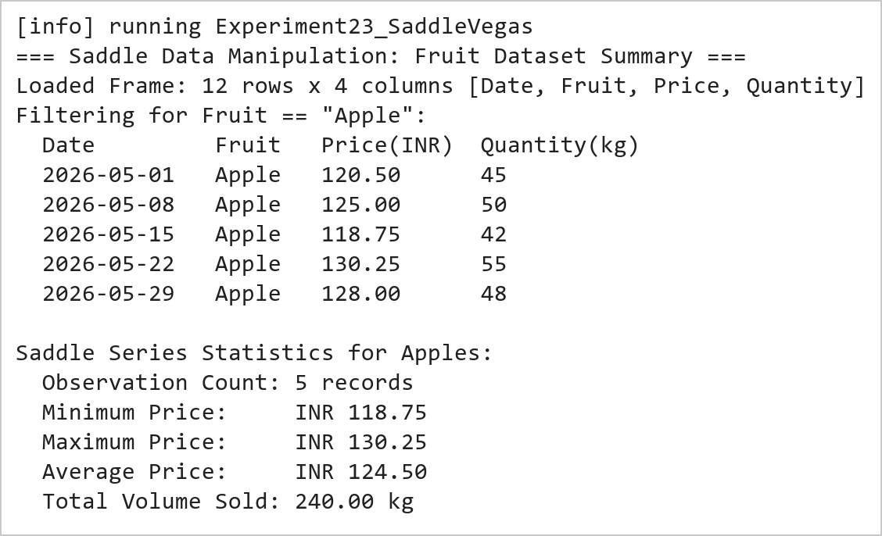  Figure 23.1: Saddle Frame Data Filtering and Statistical Average Price Calculation  Figure 23.1 presents the tabular output of the Saddle data manipulation pipeline. The retail records are filtered for Apple transactions. Saddle's vectorized statistical functions evaluate the 5 weekly price points (120.50, 125.00, 118.75, 130.25, 128.00 INR), resulting in an average price of INR 124.50.  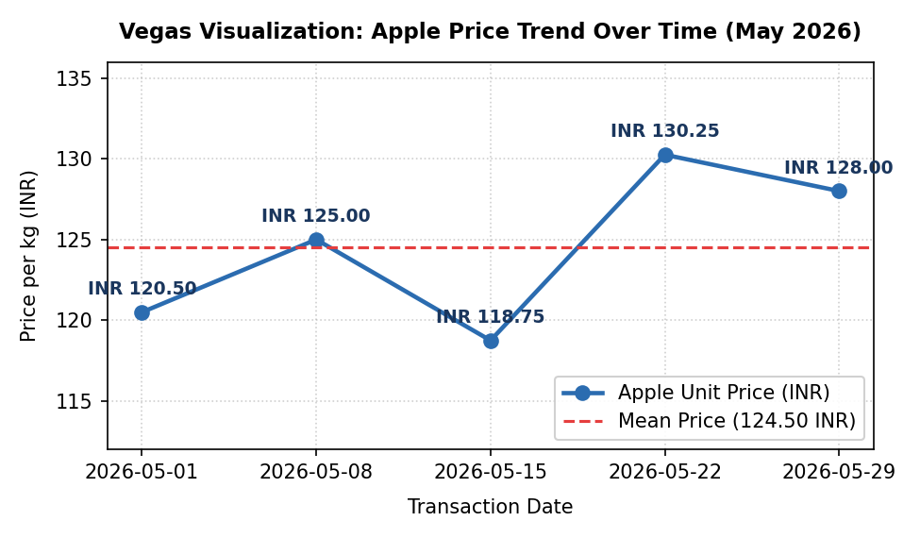  Figure 23.2: Vegas Interactive Temporal Line Chart of Apple Price Fluctuations  Figure 23.2 displays the time-series plot rendered through Vegas. The visualization plots transaction dates along the X-axis against unit price in INR along the Y-axis. The line chart clearly illustrates the price trajectory across May 2026, including a mid-month dip at 118.75 INR followed by a peak at 130.25 INR, relative to the reference mean benchmark of 124.50 INR.
Conclusions | The Saddle data manipulation and Vegas visualization experiment demonstrated the integration of vectorized numerical processing with declarative statistical graphics in Scala.  • Saddle provides Pandas-like 2D Frame and 1D Series abstractions with native JVM array execution speeds.  • Vectorized aggregation operations avoid explicit iteration and cleanly handle missing numerical values.  • Filtering operations maintain relational index integrity across associated data vectors.  • Vegas brings declarative Vega-Lite visual grammar to Scala for interactive, publication-ready charts.  • Combining Saddle and Vegas provides a compelling Scala alternative to Python's Pandas-Matplotlib stack.  The Saddle-Vegas ecosystem equips data scientists with high-performance tools for exploratory data analysis directly on JVM-based production infrastructures.
References | 1. Martin Odersky, Lex Spoon, and Bill Venners, Programming in Scala, 5th Edition, Artima Press, 2021.  2. Alvin Alexander, Scala Cookbook: Recipes for Object-Oriented and Functional Programming, 2nd Edition, O'Reilly Media, 2021.  3. Dean Wampler and Alex Payne, Programming Scala: Scalability = Functional Programming + Objects, 3rd Edition, O'Reilly Media, 2021.  4. Google Colab / GitHub Repository Program Source Code: https://github.com/vedantnimkar/pds-lab-assignments/blob/main/W13_SlNo23_SaddleVegas.scala  5. Google Drive Program / Notebook Link: https://drive.google.com/drive/folders/1W5HRJYRECn4RC9DEbIkF0nfPf6csRZCd?usp=sharing  6. Faculty Official Problem Specimen & Reference Guide: https://drive.google.com/file/d/1lpj0FsQXWB5xw1QYBE46JmwEbnQYVToi/view?usp=drive_link

