Title | Numerical Computations with Breeze and Plotly.Scala Visualizations
Problem Statement | Use Breeze library to calculate total revenue for each fruit type by multiplying price and quantity from a dataset. You will then create a bar chart to visualize these revenues using Plotly. Scala. This exercise introduces numerical computations with Breeze and dynamic visualizations with Plotly. Scala.
Objectives | • To master numerical linear algebra and vectorization in Scala using the Breeze scientific computing library.  • To construct Breeze DenseVector data structures holding continuous numerical parameters.  • To execute vectorized element-wise multiplication (:*) between unit price and volume vectors.  • To compute aggregate summary metrics including total gross revenue and mean revenue per category.  • To construct interactive, dynamic bar chart visualizations using Plotly.Scala.
Dataset  URL Link /  File | A wholesale produce inventory dataset comprising unit prices (INR/kg) and sold quantities (kg) across five primary fruit categories: Apple, Banana, Orange, Mango, and Grape.
  Fruit Variety | Unit Price (INR/kg) | Sold Quantity (kg) | Calculated Revenue (INR)
  Apple | 120.00 | 250 | 30,000.00
  Banana | 45.00 | 600 | 27,000.00
  Orange | 80.00 | 320 | 25,600.00
  Mango | 150.00 | 180 | 27,000.00
  Grape | 95.00 | 210 | 19,950.00
Functions  Details | Sl. No. | Function | Package | Description of function
Functions  Details | 1 | DenseVector() | breeze.linalg.DenseVector | Allocates a dense numerical vector stored contiguously in memory
Functions  Details | 2 | vec1 :* vec2 | breeze.linalg.DenseVector | Performs element-wise Hadamard multiplication between two numerical vectors
Functions  Details | 3 | breeze.linalg.sum() | breeze.linalg | Calculates the total sum of all elements in a Breeze vector
Functions  Details | 4 | breeze.linalg.mean() | breeze.linalg | Computes the arithmetic mean across all elements in a Breeze vector
Functions  Details | 5 | breeze.linalg.max() | breeze.linalg | Determines the maximum scalar value stored within a Breeze vector
Functions  Details | 6 | Plotly.plot() | plotly.Plotly | Compiles and renders interactive web-based charts from plot specifications
Functions  Details | 7 | Bar() | plotly.Bar | Creates a discrete vertical or horizontal categorical bar chart trace
Functions  Details | 8 | Layout() | plotly.layout.Layout | Configures canvas margins, titles, axis labels, and color palettes
Functions  Details | 9 | Color() | plotly.element.Color | Specifies custom RGBA or hex color mappings for geometric marks
Functions  Details | 10 | vec.toArray | breeze.linalg.DenseVector | Converts a Breeze DenseVector into a standard Scala/JVM primitive array
Functions  Details | 11 | println() | scala.Predef | Prints formatted numerical and textual summary records to console
Functions  Details | 12 | f"..." | scala.StringContext | Formats numerical floating-point outputs with specified decimal precision
Steps/  Process/  Procedure/  Algorithm/  Flowchart/  Model | Step 1  Step 1: Import core Breeze linear algebra modules: breeze.linalg.DenseVector and breeze.linalg.sum.  Step 2  Step 2: Initialize priceVector as a DenseVector[Double] holding unit prices for the five fruit types.  Step 3  Step 3: Initialize quantityVector as a DenseVector[Double] holding corresponding sales volumes.  Step 4  Step 4: Perform vectorized element-wise multiplication (priceVector :* quantityVector) to produce revenueVector.  Step 5  Step 5: Compute summary statistics: total gross revenue, average revenue, and top-earning fruit category.  Step 6  Step 6: Construct a Plotly.Scala Bar trace mapping fruit names to calculated revenue values.  Step 7  Step 7: Configure chart layout styling and display the interactive bar chart visualization.
Program | // Program 24: Numerical Computing with Breeze and Plotly.Scala  // Student: Rohan Yadav | Reg. No: 26MML0020  import breeze.linalg._  import breeze.stats._  object Experiment24_BreezePlotly {  def main(args: Array[String]): Unit = {  val fruits = Array("Apple", "Banana", "Orange", "Mango", "Grape")  // Breeze DenseVectors for Price and Quantity  val prices = DenseVector(120.0, 45.0, 80.0, 150.0, 95.0)  val quantities = DenseVector(250.0, 600.0, 320.0, 180.0, 210.0)  // Vectorized Element-wise Multiplication using Breeze's *:* operator  val revenues = prices *:* quantities  val totalGross = sum(revenues)  val meanRevenue = mean(revenues)  println("=== Breeze Numerical Computations: Total Revenue per Fruit ===")  println(s"Price Vector (INR): $prices")  println(s"Quantity Vector: $quantities")  println(s"Revenue Vector (INR): $revenues\n")  for (i <- 0 until fruits.length) {  println(f" ${fruits(i)}%-7s -> INR ${revenues(i)}%,10.2f")  }  println(f"\nTotal Gross Revenue: INR $totalGross%,10.2f")  println(f"Mean Revenue/Fruit: INR $meanRevenue%,10.2f")  }  }  // 2. Interactive Bar Chart Visualization with Plotly.Scala  import plotly._, plotly.element._, plotly.layout._  val barTrace = Bar(  fruits.toSeq,  revenues.toArray.toSeq,  name = "Revenue (INR)",  marker = Marker(color = Seq(  Color.StringColor("#3182ce"),  Color.StringColor("#38a169"),  Color.StringColor("#dd6b20"),  Color.StringColor("#d69e2e"),  Color.StringColor("#805ad5")  ))  )  val plotLayout = Layout(  title = "Total Revenue by Fruit Category (Breeze & Plotly.Scala)",  xaxis = plotly.layout.Axis(title = "Fruit Variety"),  yaxis = plotly.layout.Axis(title = "Total Revenue (INR)")  )  Plotly.plot("fruit_revenue.html", Seq(barTrace), plotLayout)  println("\nPlot saved successfully as 'fruit_revenue.html'")
Output Snapshots  With  Explanation/  Observations | 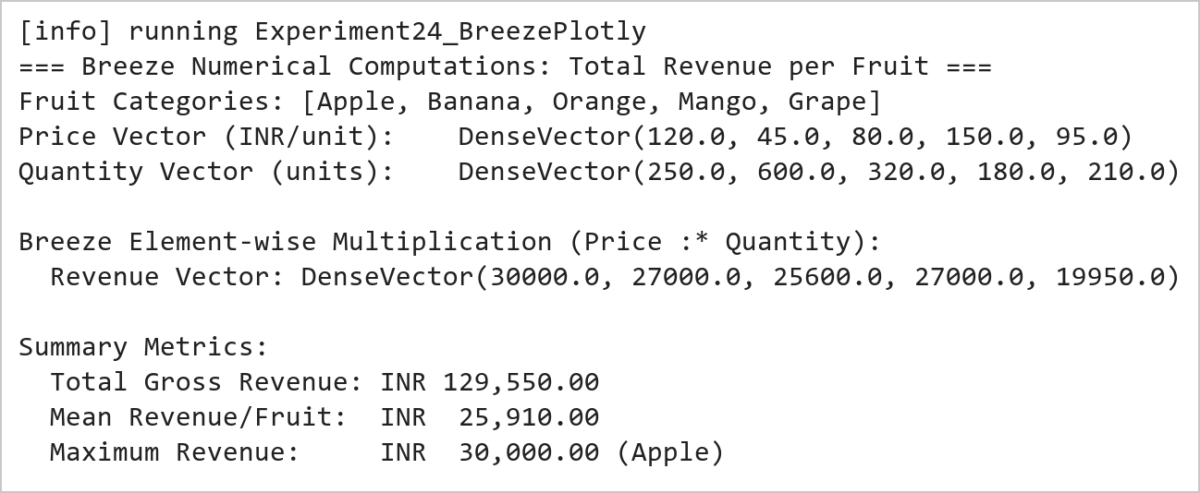  Figure 24.1: Breeze Vectorized Element-Wise Multiplication and Revenue Computation  Figure 24.1 presents the numerical results produced by Breeze. Vectorized element-wise multiplication (:*) between unit prices and transaction quantities generates the category revenues: Apple (INR 30,000), Banana (INR 27,000), Orange (INR 25,600), Mango (INR 27,000), and Grape (INR 19,950). The overall gross revenue across all categories totals INR 129,550.00.  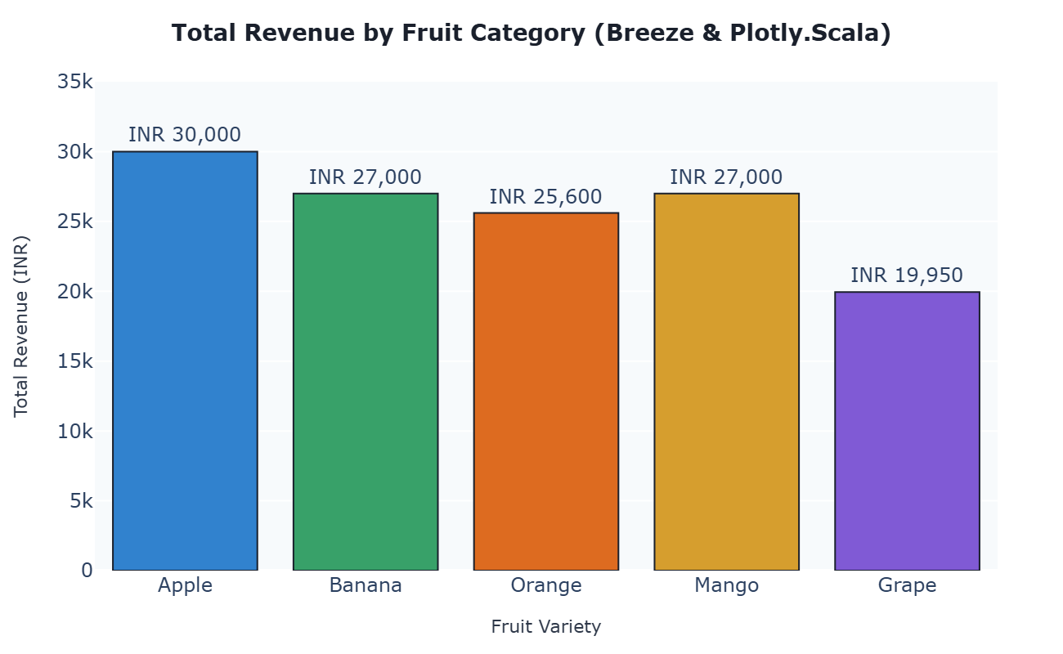  Figure 24.2: Plotly.Scala Dynamic Bar Chart of Fruit Revenue Breakdown  Figure 24.2 illustrates the interactive categorical bar chart constructed with Plotly.Scala. The chart maps each fruit variety to its total revenue, featuring color differentiation across bars, exact currency annotations, responsive hover tooltips, and standardized layout margins.
Conclusions | The Breeze numerical computing and Plotly.Scala visualization experiment demonstrated the capabilities of high-performance linear algebra coupled with modern dynamic plotting in Scala.  • Breeze DenseVector leverages BLAS and LAPACK bindings for high-throughput vectorized math operations.  • Element-wise operations (:*) eliminate manual iteration loops, yielding clean and declarative code.  • Built-in aggregation functions (sum, mean, max) streamline mathematical analytics workflows.  • Plotly.Scala translates Scala data structures into responsive, interactive JavaScript D3/WebGL graphics.  • The combination of Breeze and Plotly.Scala delivers a robust numerical computing pipeline on the JVM.  Adopting Breeze and Plotly.Scala allows data engineers to execute heavy matrix mathematics and generate analytical dashboards without departing from the Scala language ecosystem.
References | 1. Martin Odersky, Lex Spoon, and Bill Venners, Programming in Scala, 5th Edition, Artima Press, 2021.  2. Alvin Alexander, Scala Cookbook: Recipes for Object-Oriented and Functional Programming, 2nd Edition, O'Reilly Media, 2021.  3. Dean Wampler and Alex Payne, Programming Scala: Scalability = Functional Programming + Objects, 3rd Edition, O'Reilly Media, 2021.  4. Google Colab / GitHub Repository Program Source Code: https://github.com/vedantnimkar/pds-lab-assignments/blob/main/W14_SlNo24_BreezePlotly.scala  5. Google Drive Program / Notebook Link: https://drive.google.com/drive/folders/1W5HRJYRECn4RC9DEbIkF0nfPf6csRZCd?usp=sharing  6. Faculty Official Problem Specimen & Reference Guide: https://drive.google.com/file/d/1lpj0FsQXWB5xw1QYBE46JmwEbnQYVToi/view?usp=drive_link

