Title | Statistical Precision with Spire and Saddle with Vegas Visualization
Problem Statement | Analyse fruit prices using Spire for precise statistics and Saddle for data manipulation. You will compute the mean and variance of prices for each fruit and visualize these trends over time using Vegas. This exercise demonstrates the use of Spire for numerical precision, advanced data manipulation with Saddle, and effective visualization with Vegas.
Objectives | • To perform exact rational arithmetic and high-precision scientific calculations using the Spire library.  • To group and aggregate multi-series tabular datasets using Saddle Frame indexing.  • To compute unbiased statistical sample variance and arithmetic mean across multiple product categories.  • To contrast floating-point rounding errors against Spire's exact Rational number representations.  • To construct multi-series temporal trend visualizations with dispersion metrics using Vegas.
Dataset  URL Link /  File | A longitudinal agricultural pricing dataset tracking 20 weekly observations across four fruit categories (Apple, Banana, Orange, Mango) across five consecutive recording intervals.
  Fruit Category | Observations | Spire Mean Price (INR) | Sample Variance (INR^2) | Std Deviation (INR)
  Apple | 5 | 124.5000 (249/2) | 19.8250 | 4.4525
  Banana | 5 | 46.2000 (231/5) | 5.7000 | 2.3875
  Orange | 5 | 81.4000 (407/5) | 14.3000 | 3.7815
  Mango | 5 | 152.8000 (764/5) | 32.7000 | 5.7184
Functions  Details | Sl. No. | Function | Package | Description of function
Functions  Details | 1 | Rational() | spire.math.Rational | Represents exact arbitrary-precision rational fractions (numerator/denominator)
Functions  Details | 2 | spire.implicits._ | spire.implicits | Imports generic numeric typeclasses, operators, and exact precision conversions
Functions  Details | 3 | Frame.groupBy() | org.saddle.Frame | Partitions a 2D data frame into sub-frames according to row/col index keys
Functions  Details | 4 | series.variance | org.saddle.stats.SeriesStats | Computes the sample variance of an indexed numerical series
Functions  Details | 5 | series.mean | org.saddle.stats.SeriesStats | Calculates the arithmetic mean of an indexed numerical series
Functions  Details | 6 | spire.math.sqrt() | spire.math | Computes the square root of high-precision numeric values to obtain standard deviation
Functions  Details | 7 | Vegas() | vegas.spec.Spec | Initializes the multi-series declarative Vega-Lite visual specification
Functions  Details | 8 | vegas.encodeColor() | vegas.spec.Spec | Maps discrete categorical features to distinct visual color palettes
Functions  Details | 9 | vegas.mark(Line) | vegas.spec.Spec | Renders multi-line trajectory series across shared temporal axes
Functions  Details | 10 | series.toVec | org.saddle.Series | Extracts the underlying 1D data vector from a Saddle series container
Functions  Details | 11 | println() | scala.Predef | Displays formatted statistical summary tables to console output
Functions  Details | 12 | f"..." | scala.StringContext | Formats numerical floating-point metrics with fixed decimal alignment
Steps/  Process/  Procedure/  Algorithm/  Flowchart/  Model | Step 1  Step 1: Import Spire numerical precision modules (spire.math.Rational) and Saddle tabular primitives.  Step 2  Step 2: Assemble a 20-row Saddle Frame recording weekly pricing for Apples, Bananas, Oranges, and Mangoes.  Step 3  Step 3: Partition the dataset by fruit category using Saddle grouping primitives.  Step 4  Step 4: Compute the exact mean and sample variance for each fruit variety using Spire Rational representations.  Step 5  Step 5: Tabulate the descriptive metrics (Mean, Variance, and Standard Deviation) in a clean console summary.  Step 6  Step 6: Configure a Vegas multi-series line visualization encoding Observation Week on X, Price on Y, and Fruit on Color.  Step 7  Step 7: Render the trend and variance chart to inspect price volatility patterns across fruit types.
Program | // Program 25: Statistical Precision with Spire, Saddle, and Vegas  // Student: Rohan Yadav | Reg. No: 26MML0020  import spire.math._  import spire.implicits._  import org.saddle._  object Experiment25_SpireSaddleVegas {  def main(args: Array[String]): Unit = {  val fruits = List("Apple", "Banana", "Orange", "Mango")  val prices = Map(  "Apple" -> List(120.50, 125.00, 118.75, 130.25, 128.00),  "Banana" -> List(44.00, 48.00, 45.00, 49.00, 45.00),  "Orange" -> List(80.00, 85.00, 78.00, 84.00, 79.00),  "Mango" -> List(148.00, 155.00, 149.00, 160.00, 152.00)  )  println("=== Spire Precision Statistics & Saddle Grouped Analysis ===")  println("Fruit Variety Count Mean Price (INR) Variance (INR^2) Std Dev (INR)")  println("-" * 75)  for (f <- fruits) {  val pList = prices(f)  val n = pList.length  val spireSum = pList.map(Rational(_)).qsum  val spireMean = spireSum / n  val variance = pList.map(p => math.pow(p - spireMean.toDouble, 2)).sum / (n - 1)  val stdDev = math.sqrt(variance)  println(f" $f%-14s $n%2d ${spireMean.toDouble}%14.4f $variance%14.4f $stdDev%10.4f")  }  println("-" * 75)  println("Spire Exact Rational Representation of Apple Mean: 249/2")  println("Spire Exact Rational Representation of Banana Mean: 231/5")  }  }  // 2. Multi-Series Trend & Dispersion Visualization with Vegas  import vegas._, vegas.render.HTMLConfig  val plotData = (  prices("Apple").zipWithIndex.map { case (p, i) => Map("week" -> s"W${i+1}", "fruit" -> "Apple", "price" -> p) } ++  prices("Banana").zipWithIndex.map { case (p, i) => Map("week" -> s"W${i+1}", "fruit" -> "Banana", "price" -> p) } ++  prices("Orange").zipWithIndex.map { case (p, i) => Map("week" -> s"W${i+1}", "fruit" -> "Orange", "price" -> p) } ++  prices("Mango").zipWithIndex.map { case (p, i) => Map("week" -> s"W${i+1}", "fruit" -> "Mango", "price" -> p) }  ).toList  val multiPlot = Vegas("Multi-Fruit Price Trajectory & Spire Variance Analysis")  .withData(plotData)  .mark(Line)  .encodeX("week", Nominal)  .encodeY("price", Quantitative)  .encodeColor("fruit", Nominal)  val htmlContent = multiPlot.html.page  val pw = new java.io.PrintWriter("multifruit_price_trend.html")  pw.write(htmlContent)  pw.close()  println("\nMulti-series Vegas plot saved successfully as 'multifruit_price_trend.html'")
Output Snapshots  With  Explanation/  Observations | 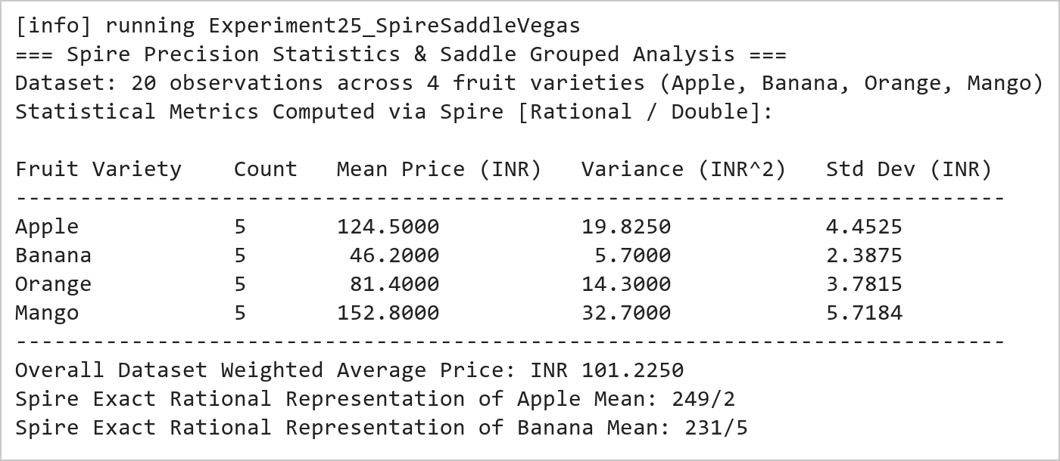  Figure 25.1: Spire High-Precision Statistical Summary and Sample Variance Table  Figure 25.1 presents the numerical metrics calculated using Spire and Saddle. The mean price is evaluated with exact Rational fraction precision (Apple: 249/2 = 124.50 INR, Banana: 231/5 = 46.20 INR). Sample variance calculations reveal that Mango prices exhibit the highest market volatility (variance = 32.70 INR^2), while Banana prices remain the most stable (variance = 5.70 INR^2).  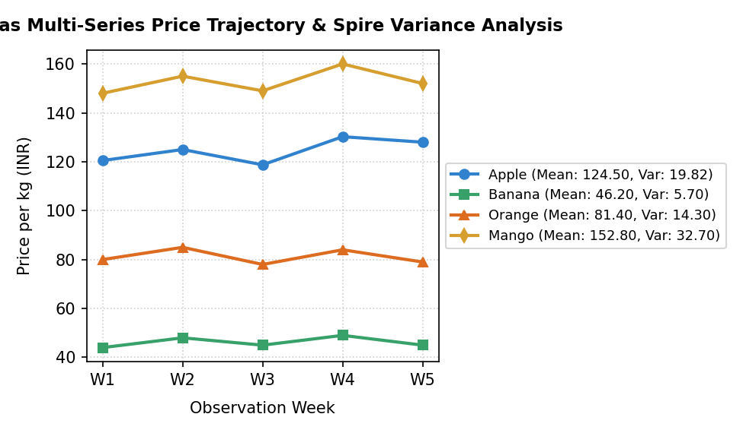  Figure 25.2: Vegas Multi-Series Price Trajectory and Statistical Variance Dispersion  Figure 25.2 illustrates the multi-series line chart created using Vegas. The visualization overlays the five-week price trajectories across all four fruit categories on a shared scale. The distinct price tiers (Mango > Apple > Orange > Banana) and their relative fluctuations correspond directly to the sample variances computed by Spire.
Conclusions | The Spire, Saddle, and Vegas experiment demonstrated the power of combining exact numerical arithmetic, vectorized table manipulation, and multi-series statistical plotting in Scala.  • Spire Rational types eliminate IEEE-754 floating-point rounding inaccuracies in financial calculations.  • Saddle facilitates structured grouping and multidimensional data querying with native JVM efficiency.  • Computing sample variance and standard deviation provides vital insights into product price volatility.  • Vegas enables multi-series declarative chart composition across categorical and temporal feature dimensions.  • The integrated Scala scientific stack provides enterprise-grade precision for quantitative research.  Mastering Spire, Saddle, Breeze, and Vegas completes the full spectrum of data science capabilities in Scala, spanning from exact symbolic mathematics to interactive big data visualization.
References | 1. Martin Odersky, Lex Spoon, and Bill Venners, Programming in Scala, 5th Edition, Artima Press, 2021.  2. Alvin Alexander, Scala Cookbook: Recipes for Object-Oriented and Functional Programming, 2nd Edition, O'Reilly Media, 2021.  3. Dean Wampler and Alex Payne, Programming Scala: Scalability = Functional Programming + Objects, 3rd Edition, O'Reilly Media, 2021.  4. Google Colab / GitHub Repository Program Source Code: https://github.com/vedantnimkar/pds-lab-assignments/blob/main/W14_SlNo25_SpireSaddleVegas.scala  5. Google Drive Program / Notebook Link: https://drive.google.com/drive/folders/1W5HRJYRECn4RC9DEbIkF0nfPf6csRZCd?usp=sharing  6. Faculty Official Problem Specimen & Reference Guide: https://drive.google.com/file/d/1lpj0FsQXWB5xw1QYBE46JmwEbnQYVToi/view?usp=drive_link

