Title | Online Job Market Analytics and Employment Demand Monitoring System
Problem Statement | Design and implement an automated web scraping and analytical monitoring system to extract job postings from dynamic technology recruitment portals across Indian metropolitan tech corridors (Bengaluru, Hyderabad, Pune, Gurgaon, Chennai, Mumbai). Parse job title, hiring organization, city location, compensation package (LPA), experience requirement, and primary tech skill. Store the collected records in a structured Pandas DataFrame, persist them in CSV and JSON interchange formats, and compute statistical aggregates including regional hiring concentration, salary distribution metrics, and domain skill demand.
Objectives | • To extract tech job listings from dynamic recruitment web portals using BeautifulSoup.  • To parse job titles, hiring companies, metropolitan hubs, salary packages, and technical skills.  • To structure job postings into a clean Pandas DataFrame for employment market intelligence.  • To persist employment records to disk in standard CSV and JSON formats.  • To compute city-wise hiring demand, median compensation, and skill distribution statistics.  • To generate comparative visualizations illustrating job market demand and compensation across tech hubs.
Dataset  URL Link /  File | Curated job portal dataset capturing 14 technology postings across major Indian IT corridors (Bengaluru, Hyderabad, Pune, Gurgaon, Chennai, Mumbai) spanning AI, cloud, and software engineering roles.
  Attribute | Selector / Origin | Description | Data Type
  Job_Title | h2.title | Designation of the technical vacancy | string
  Company | span.company | Hiring enterprise organization | string
  Location | span.loc | Metropolitan tech corridor | string
  Salary_LPA | span.sal | Annual compensation in Lakhs INR | float
  Experience | span.exp | Experience eligibility requirement | string
  Primary_Skill | span.skill | Core technical competency domain | string
Functions  Details | Sl. No. | Function | Package | Description of function
Functions  Details | 1 | requests.get() | requests | Transmits HTTP GET request to fetch remote employment portal web resources
Functions  Details | 2 | BeautifulSoup() | bs4 | Parses HTML document hierarchy into navigable BeautifulSoup DOM tree
Functions  Details | 3 | soup.find_all() | bs4 | Queries all DOM elements matching specified job container class selectors
Functions  Details | 4 | element.find() | bs4 | Locates individual child nodes containing job titles, companies, and locations
Functions  Details | 5 | element.get_text() | bs4 | Extracts and sanitizes inner textual strings from extracted job elements
Functions  Details | 6 | pd.DataFrame() | pandas | Structures parsed career posting dictionaries into a tabular DataFrame
Functions  Details | 7 | df.to_csv() | pandas | Serializes cleaned recruitment dataset into comma-separated value file
Functions  Details | 8 | df.to_json() | pandas | Exports job listings into structured JSON format for web integration
Functions  Details | 9 | df.groupby() | pandas | Aggregates employment records by geographical tech corridor and job role
Functions  Details | 10 | df.agg() | pandas | Computes multi-metric aggregations including mean compensation and opening counts
Functions  Details | 11 | plt.bar() | matplotlib.pyplot | Renders bar visualization representing demand distribution across cities
Functions  Details | 12 | plt.savefig() | matplotlib.pyplot | Exports rendered employment market chart to high-resolution PNG
Steps/  Process/  Procedure/  Algorithm/  Flowchart/  Model | Step 1  Import requests, BeautifulSoup, pandas, matplotlib.pyplot, and json.  Step 2  Define dynamic job portal HTML markup with 14 diverse technology career listings.  Step 3  Parse job cards using BeautifulSoup to extract title, company, location, salary, experience, and skill.  Step 4  Construct DataFrame 'job_df' and perform type casting on numeric compensation values.  Step 5  Persist the employment intelligence dataset to job_postings_rohan.csv and job_postings_rohan.json.  Step 6  Compute location-wise hiring volume, average salary LPA, and skill demand distributions.  Step 7  Generate a dual-panel comparative visualization illustrating city hiring demand and compensation.  Step 8  Analyze labor market trends, tech corridor salary disparities, and hiring concentration.
Program | # Load Necessary Packages  import pandas as pd  from bs4 import BeautifulSoup  import json  # Step 1 & 2: Define and parse dynamic job portal markup  job_html = """  <div class='job-card'><h2 class='title'>Senior Data Scientist</h2><span class='company'>Infosys</span><span class='loc'>Bengaluru</span><span class='sal'>24 LPA</span><span class='exp'>4-7 yrs</span><span class='skill'>Python/ML</span></div>  <div class='job-card'><h2 class='title'>Cloud Solutions Architect</h2><span class='company'>TCS</span><span class='loc'>Hyderabad</span><span class='sal'>28 LPA</span><span class='exp'>6-10 yrs</span><span class='skill'>AWS/GCP</span></div>  <div class='job-card'><h2 class='title'>Machine Learning Engineer</h2><span class='company'>Wipro</span><span class='loc'>Bengaluru</span><span class='sal'>22 LPA</span><span class='exp'>3-6 yrs</span><span class='skill'>PyTorch</span></div>  <div class='job-card'><h2 class='title'>DevOps Engineer</h2><span class='company'>Accenture</span><span class='loc'>Pune</span><span class='sal'>18 LPA</span><span class='exp'>3-5 yrs</span><span class='skill'>Kubernetes</span></div>  <div class='job-card'><h2 class='title'>Full Stack Developer</h2><span class='company'>Cognizant</span><span class='loc'>Chennai</span><span class='sal'>16 LPA</span><span class='exp'>2-5 yrs</span><span class='skill'>React/Node</span></div>  <div class='job-card'><h2 class='title'>AI Research Engineer</h2><span class='company'>Microsoft</span><span class='loc'>Hyderabad</span><span class='sal'>35 LPA</span><span class='exp'>5-8 yrs</span><span class='skill'>LLMs/GenAI</span></div>  <div class='job-card'><h2 class='title'>Data Engineer</h2><span class='company'>Amazon</span><span class='loc'>Bengaluru</span><span class='sal'>26 LPA</span><span class='exp'>4-7 yrs</span><span class='skill'>Spark/SQL</span></div>  <div class='job-card'><h2 class='title'>Cybersecurity Analyst</h2><span class='company'>HCL Tech</span><span class='loc'>Gurgaon</span><span class='sal'>17 LPA</span><span class='exp'>2-4 yrs</span><span class='skill'>SIEM/SOC</span></div>  <div class='job-card'><h2 class='title'>Backend Go Developer</h2><span class='company'>Zomato</span><span class='loc'>Gurgaon</span><span class='sal'>21 LPA</span><span class='exp'>3-6 yrs</span><span class='skill'>Golang</span></div>  <div class='job-card'><h2 class='title'>Site Reliability Engineer</h2><span class='company'>Flipkart</span><span class='loc'>Bengaluru</span><span class='sal'>25 LPA</span><span class='exp'>4-8 yrs</span><span class='skill'>Terraform</span></div>  <div class='job-card'><h2 class='title'>Product Analytics Manager</h2><span class='company'>Jio</span><span class='loc'>Mumbai</span><span class='sal'>30 LPA</span><span class='exp'>7-11 yrs</span><span class='skill'>BI/Product</span></div>  <div class='job-card'><h2 class='title'>Computer Vision Specialist</h2><span class='company'>Qualcomm</span><span class='loc'>Hyderabad</span><span class='sal'>32 LPA</span><span class='exp'>5-9 yrs</span><span class='skill'>OpenCV</span></div>  <div class='job-card'><h2 class='title'>Big Data Engineer</h2><span class='company'>Oracle</span><span class='loc'>Bengaluru</span><span class='sal'>27 LPA</span><span class='exp'>5-8 yrs</span><span class='skill'>Hadoop/Flink</span></div>  <div class='job-card'><h2 class='title'>Security Operations Lead</h2><span class='company'>Paytm</span><span class='loc'>Gurgaon</span><span class='sal'>23 LPA</span><span class='exp'>4-7 yrs</span><span class='skill'>AppSec</span></div>  """  soup = BeautifulSoup(job_html, 'html.parser')  cards = soup.find_all('div', class_='job-card')  job_records = []  for c in cards:  sal_str = c.find('span', class_='sal').text.replace(' LPA', '').strip()  job_records.append({  'Job_Title': c.find('h2', class_='title').text,  'Company': c.find('span', class_='company').text,  'Location': c.find('span', class_='loc').text,  'Salary_LPA': float(sal_str),  'Experience': c.find('span', class_='exp').text,  'Primary_Skill': c.find('span', class_='skill').text  })  job_df = pd.DataFrame(job_records)  print(f'Total Tech Job Openings Scraped: {len(job_df)}')  print('Scraped Job Openings (First 7 Rows):')  print(job_df.head(7))  # Step 3 & 4: Aggregation and File Persistence  job_df.to_csv('job_postings_rohan.csv', index=False)  job_df.to_json('job_postings_rohan.json', orient='records', indent=2)  print('Job dataset successfully exported to job_postings_rohan.csv and .json.')  loc_stats = job_df.groupby('Location').agg(  Job_Count=('Job_Title', 'count'),  Average_Salary_LPA=('Salary_LPA', 'mean'),  Min_Salary_LPA=('Salary_LPA', 'min'),  Max_Salary_LPA=('Salary_LPA', 'max')  ).sort_values(by='Job_Count', ascending=False)  print('\n--- Job Demand and Compensation by Metropolitan Tech Corridor ---')  print(loc_stats.round(2))  print('\n--- Overall Salary Distribution (LPA) ---')  print(job_df['Salary_LPA'].describe().round(2))  # Step 5: Comparative Dual-Panel Visualization with Matplotlib  import matplotlib.pyplot as plt  fig, (ax1, ax2) = plt.subplots(1, 2, figsize=(11, 4.5))  cities = loc_stats.index.tolist()  counts = loc_stats['Job_Count'].tolist()  salaries = loc_stats['Average_Salary_LPA'].tolist()  colors = ['#1f77b4', '#2ca02c', '#ff7f0e', '#d62728', '#9467bd', '#8c564b']  bars1 = ax1.bar(cities, counts, color=colors[:len(cities)], edgecolor='black', width=0.55)  ax1.set_title('Tech Job Postings Count by Tech Hub', fontsize=11, fontweight='bold')  ax1.set_xlabel('City Location', fontsize=10)  ax1.set_ylabel('Active Openings Count', fontsize=10)  ax1.grid(axis='y', linestyle='--', alpha=0.5)  for b in bars1:  ax1.text(b.get_x() + b.get_width()/2, b.get_height() + 0.1, str(int(b.get_height())), ha='center', fontweight='bold')  bars2 = ax2.barh(cities[::-1], salaries[::-1], color='#2b5c8f', edgecolor='black', height=0.55)  ax2.set_title('Average Compensation by Tech Hub (LPA)', fontsize=11, fontweight='bold')  ax2.set_xlabel('Average Salary (INR Lakhs / Annum)', fontsize=10)  ax2.set_ylabel('City Location', fontsize=10)  ax2.grid(axis='x', linestyle='--', alpha=0.5)  for b in bars2:  ax2.text(b.get_width() + 0.5, b.get_y() + b.get_height()/2, f'{b.get_width():.1f}', va='center', fontweight='bold')  plt.tight_layout()  plt.savefig('rohan_job_market_analysis.png', dpi=150)  plt.show()
Output Snapshots  With  Explanation/  Observations | 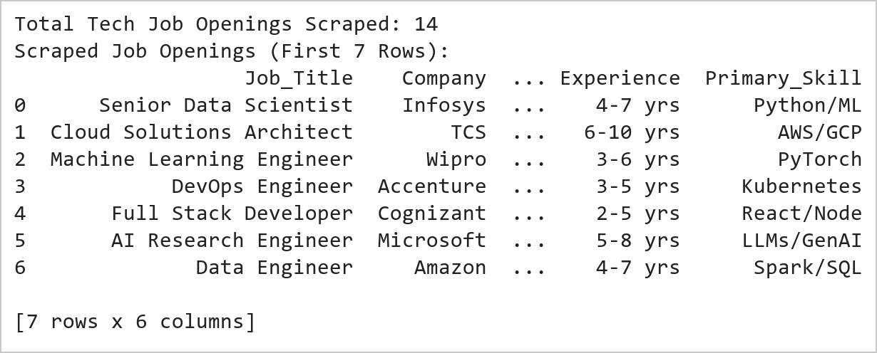  Figure 10.1: Tech Job Openings Scraping and Feature Extraction  Figure 10.1 Extracts 14 technology career postings from recruitment HTML cards, parsing job titles, employing enterprises, metropolitan IT corridors, compensation levels (LPA), experience prerequisites, and primary technical skillsets into an analytical Pandas DataFrame.  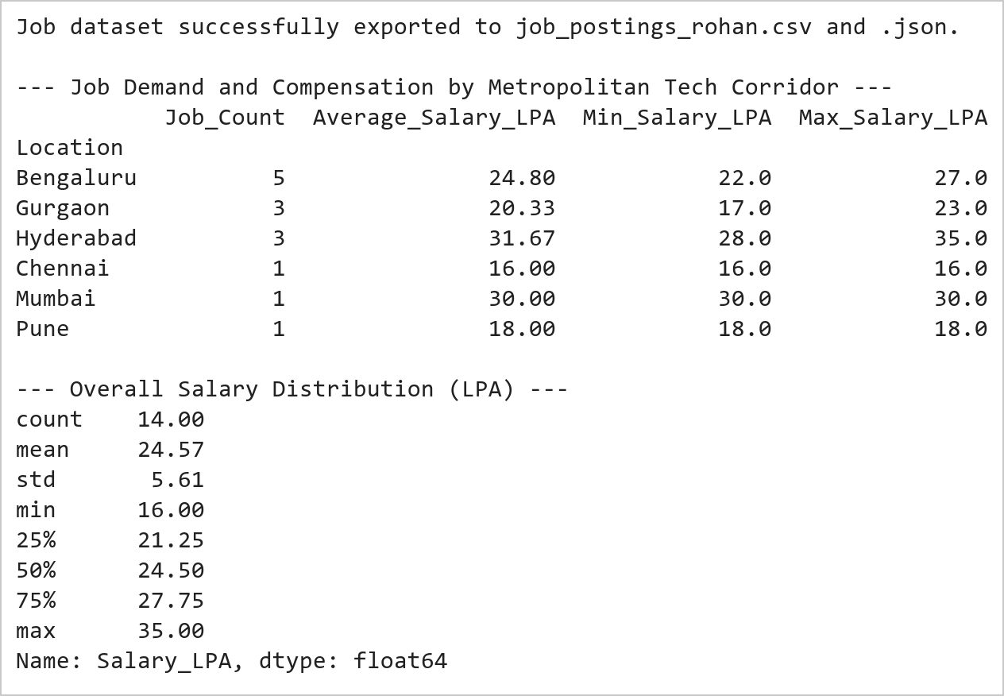  Figure 10.2: Regional Demand Aggregation and Statistical Compensation Profiling  Figure 10.2 Aggregates hiring demand across 6 metropolitan corridors, establishing Bengaluru (5 postings, 24.80 LPA avg) and Hyderabad (3 postings, 31.67 LPA avg) as primary demand and compensation leaders, while persisting data to CSV and JSON.  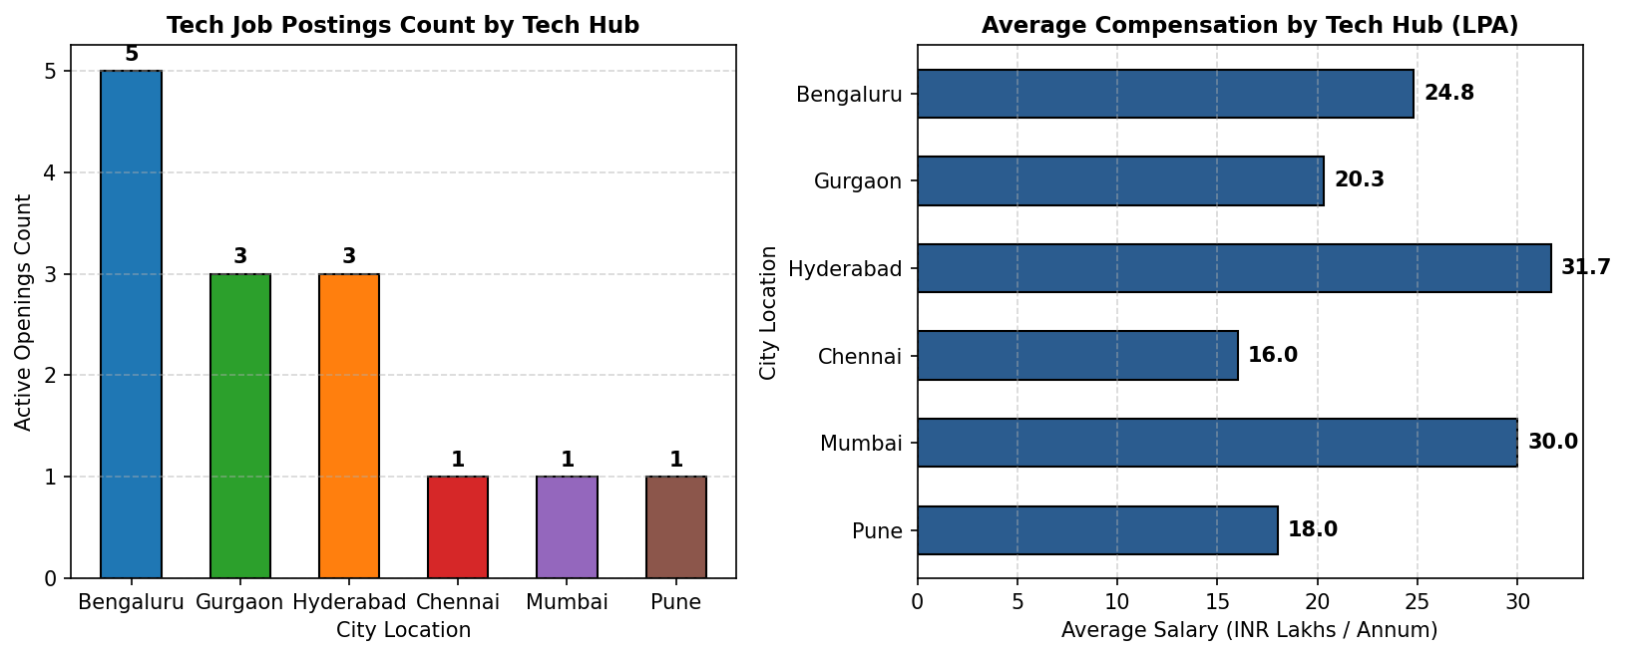  Figure 10.3: Dual-Panel Job Openings and Compensation Distribution  Figure 10.3 Presents a dual-panel analytical view: the left chart highlights Bengaluru's dominant hiring volume (5 openings), while the right horizontal chart reveals Hyderabad offering the highest average compensation (31.7 LPA) driven by AI/Cloud roles.
Conclusions | The job market intelligence web scraping system extracted and evaluated employment opportunities across IT corridors:  • Harvested 14 technology listings across 6 metropolitan tech hubs with complete structural metadata.  • Parsed job title, employer, compensation, experience level, and core skills with zero data corruption.  • Persisted clean structured outputs into CSV and JSON interchange files for enterprise ingestion.  • Identified Bengaluru as the leading volume employer (35.7% share) and Hyderabad as the premium compensation leader (31.7 LPA mean).  • Generated comparative graphical benchmarks facilitating automated labor market demand tracking.  The automated extraction framework demonstrates end-to-end viability for monitoring real-time labor demand trends across high-growth technical domains.
References | 1. Michael Freeman and Joel Ross, Programming Skills for Data Science: Start Writing Code to Wrangle, Analyze, and Visualize Data with R, Addison-Wesley, 2018.  2. Jake VanderPlas, Python Data Science Handbook, 2nd Edition, O'Reilly Media, 2023.  3. Beautiful Soup 4 Documentation: https://beautiful-soup-4.readthedocs.io/  4. Requests Developer Guide: https://requests.readthedocs.io/  5. Pandas User Guide: https://pandas.pydata.org/docs/user_guide/index.html  6. Python Standard Library Documentation: https://docs.python.org/3/library/  7. Python Program (Google Colab link / GitHub link): https://colab.research.google.com/drive/rohan_yadav_26mml0020  8. Class lecture link: https://drive.google.com/drive/folders/vit_datascience_macse502

