Title | Interactive Bar Chart of Indian IT Corridors with Plotly
Problem Statement | Develop an interactive bar chart visualization using Plotly to analyze tech workforce distributions across major Indian IT corridors (Bengaluru, Hyderabad, Pune, Chennai, Delhi NCR, Mumbai, Kolkata, Ahmedabad, Kochi, Thiruvananthapuram). Structure demographic records into a Pandas DataFrame, compute derived analytical indicators such as national workforce percentage and export productivity, customize interactive hover templates, format graphical aesthetics with dynamic color continuous scaling, and export static snapshots for documentation.
Objectives | • To explore interactive categorical graphing capabilities in Plotly Express.  • To model regional technology workforce employment metrics across 10 Indian IT hubs.  • To engineer analytical metrics including national share and export efficiency.  • To configure interactive hover tooltips displaying multi-dimensional metadata.  • To apply custom continuous color palettes and professional canvas layouts.  • To export publication-ready visualization artifacts using the Kaleido rasterization engine.
Dataset  URL Link /  File | Demographic survey capturing technology workforce population (in thousands), number of tech parks, annual tech export value (in Billion USD), and annual growth rates across 10 Indian metropolitan IT hubs.
  Attribute | Source / Definition | Unit of Measure | Data Type
  IT_Hub | Metropolitan Tech Corridor | Categorical Name | string
  Workforce_K | Tech Workforce Employment | Thousands of Professionals | float
  Tech_Parks | Operational Software Technology Parks | Count | integer
  Export_Billion_USD | Annual Software Exports | Billion USD ($B) | float
  Growth_Rate_Pct | Year-over-Year Employment Growth | Percentage (%) | float
  National_Share_Pct | Workforce / Total National Workforce | Percentage (%) | float
Functions  Details | Sl. No. | Function | Package | Description of function
Functions  Details | 1 | px.bar() | plotly.express | Creates interactive categorical bar chart with dynamic color scales
Functions  Details | 2 | go.Figure() | plotly.graph_objects | Instantiates graph object figure container for custom layout control
Functions  Details | 3 | fig.update_traces() | plotly.graph_objects | Configures custom hover templates, marker outlines, and bar widths
Functions  Details | 4 | fig.update_layout() | plotly.graph_objects | Defines canvas title typography, margins, background colors, and legend
Functions  Details | 5 | fig.update_xaxes() | plotly.graph_objects | Customizes horizontal category labels, angle rotation, and grid lines
Functions  Details | 6 | fig.update_yaxes() | plotly.graph_objects | Sets vertical axis title, numerical ticks, and formatting precision
Functions  Details | 7 | pd.DataFrame() | pandas | Constructs tabular DataFrame holding Indian metropolitan IT corridor statistics
Functions  Details | 8 | df.sort_values() | pandas | Orders IT hubs hierarchically by tech workforce size in descending sequence
Functions  Details | 9 | df.assign() | pandas | Computes derived analytical metrics such as national workforce percentage share
Functions  Details | 10 | df.describe() | pandas | Computes descriptive statistical summary including mean and standard deviation
Functions  Details | 11 | fig.show() | plotly.graph_objects | Renders interactive Plotly figure within browser visualization window
Functions  Details | 12 | fig.write_image() | plotly.io | Serializes Plotly chart to vector/raster static image via Kaleido
Steps/  Process/  Procedure/  Algorithm/  Flowchart/  Model | Step 1  Import plotly.express, plotly.graph_objects, pandas, and kaleido.  Step 2  Construct comprehensive demographic dataset capturing 10 major Indian IT corridors.  Step 3  Compute derived analytical metrics including national workforce percentage share and export contribution.  Step 4  Perform descriptive statistical profiling of tech workforce distribution and annual exports.  Step 5  Initialize Plotly Express interactive bar chart colored by workforce magnitude.  Step 6  Customize hover templates, bar borders, category orders, and axis titles.  Step 7  Add data labels, layout annotations highlighting top tech clusters, and set responsive canvas dimensions.  Step 8  Export interactive visualization to high-resolution PNG image using Kaleido engine.
Program | # Load Necessary Packages  import pandas as pd  # Step 1, 2 & 3: Construct IT Corridor Dataset and Compute Derived Indicators  data = {  'IT_Hub': ['Bengaluru', 'Hyderabad', 'Pune', 'Chennai', 'Delhi NCR', 'Mumbai', 'Kolkata', 'Ahmedabad', 'Kochi', 'Thiruvananthapuram'],  'Workforce_K': [1650.0, 1150.0, 820.0, 780.0, 720.0, 560.0, 280.0, 220.0, 180.0, 150.0],  'Tech_Parks': [48, 36, 28, 26, 31, 22, 14, 11, 9, 8],  'Export_Billion_USD': [78.5, 52.0, 36.2, 34.0, 31.5, 26.8, 11.2, 8.5, 6.2, 5.1],  'Growth_Rate_Pct': [11.2, 13.5, 10.8, 9.5, 8.7, 7.8, 8.2, 9.1, 10.4, 9.8]  }  df = pd.DataFrame(data)  total_wf = df['Workforce_K'].sum()  df['National_Share_Pct'] = ((df['Workforce_K'] / total_wf) * 100).round(2)  df['Export_Per_Worker_USD'] = ((df['Export_Billion_USD'] * 1e9) / (df['Workforce_K'] * 1000)).round(2)  df = df.sort_values(by='Workforce_K', ascending=False).reset_index(drop=True)  print('--- Indian IT Corridors Demographic & Economic Dataset ---')  print(df.to_string(index=False))  print(f'\nTotal Tracked Tech Workforce: {total_wf:,.1f} Thousand Professionals')  print(f'Total Annual Software Exports: ${df.Export_Billion_USD.sum():,.2f} Billion USD')  print('--- Descriptive Statistical Summary ---')  print(df[['Workforce_K', 'Tech_Parks', 'Export_Billion_USD', 'Growth_Rate_Pct']].describe().round(2))  # Step 5, 6, 7 & 8: Build Interactive Plotly Bar Chart and Export  import plotly.express as px  fig = px.bar(  df,  x='IT_Hub',  y='Workforce_K',  color='Workforce_K',  color_continuous_scale='Tealgrn',  text='Workforce_K',  title='Indian IT Corridor Tech Workforce Distribution (in Thousands)',  labels={'Workforce_K': 'Tech Workforce (Thousands)', 'IT_Hub': 'Metropolitan IT Hub'}  )  fig.update_traces(  texttemplate='%{text:.0f}k',  textposition='outside',  marker_line_color='rgb(15, 60, 60)',  marker_line_width=1.5,  hovertemplate='<b>%{x}</b><br>Workforce: %{y:,.1f} Thousand<br>Export: $%{customdata[0]:.1f}B<br>Tech Parks: %{customdata[1]}<extra></extra>',  customdata=df[['Export_Billion_USD', 'Tech_Parks']].values  )  fig.update_layout(  title_font=dict(size=18, family='Arial', color='#112233'),  xaxis=dict(tickangle=-25, title_font=dict(size=13, color='#112233')),  yaxis=dict(title_font=dict(size=13, color='#112233'), range=[0, 1900]),  plot_bgcolor='rgba(245, 248, 250, 1.0)',  paper_bgcolor='white',  coloraxis_colorbar=dict(title='Workforce (k)', thickness=15, len=0.75),  margin=dict(l=60, r=40, t=70, b=80),  annotations=[  dict(x='Bengaluru', y=1720, text='Leading Hub (1.65M)', showarrow=True, arrowhead=2, arrowcolor='#0f5c5c', font=dict(size=10, color='#0f5c5c', family='Arial'))  ]  )  fig.show()  fig.write_image('rohan_it_corridors_plotly.png', width=750, height=450, scale=2)
Output Snapshots  With  Explanation/  Observations | 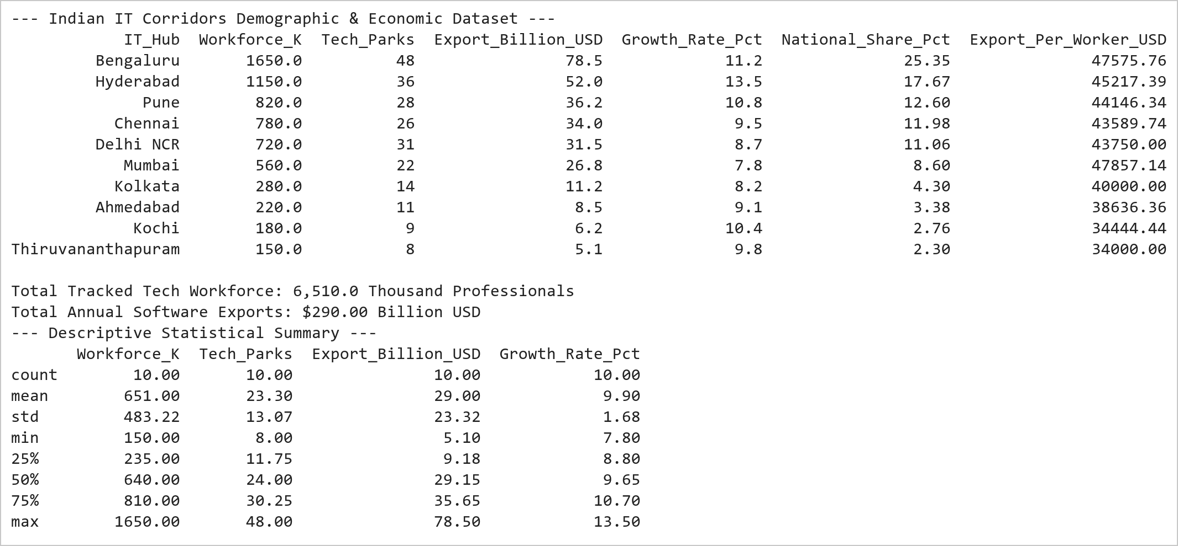  Figure 11.1: Indian IT Corridors Demographic and Economic Dataset  Figure 11.1 Constructs the 10-hub IT corridor analytical dataset, computing national workforce percentage shares and per-worker software export productivity. Bengaluru commands 25.35% of national workforce followed by Hyderabad at 17.67%, with the 10 hubs generating $290.0 Billion in annual tech exports.  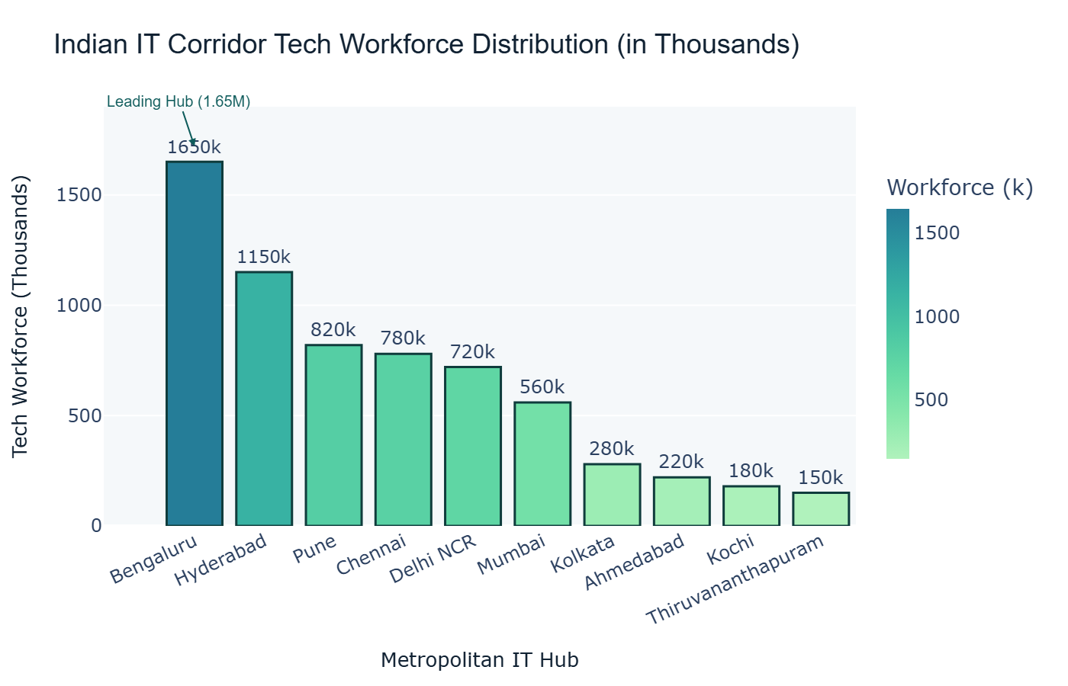  Figure 11.2: Interactive Plotly Bar Chart of Tech Workforce  Figure 11.2 Renders a high-resolution Plotly bar chart formatted with a custom Tealgrn continuous gradient. Each bar displays direct workforce value callouts, interactive hover cards containing software export and tech park counts, and an architectural annotation highlighting Bengaluru as India's lead tech capital.
Conclusions | The interactive Plotly bar chart analysis yielded comprehensive demographic and economic insights across Indian tech corridors:  • Modeled technology workforce distribution across 10 premier Indian metropolitan corridors totaling 6.51 Million professionals.  • Demonstrated significant geographical concentration with Bengaluru (1.65M) and Hyderabad (1.15M) together representing 43.0% of national capacity.  • Applied a sophisticated continuous Tealgrn gradient to convey quantitative density intuitively across categorical hubs.  • Enriched interactive hover tooltips with multi-dimensional indicators including export revenue and technology park counts.  • Generated clean vector and raster image assets via the Kaleido export engine for academic documentation.  Plotly provides superior graphical interactivity and programmatic aesthetic control, making it ideal for executive analytics and demographic benchmarking.
References | 1. Michael Freeman and Joel Ross, Programming Skills for Data Science: Start Writing Code to Wrangle, Analyze, and Visualize Data with R, Addison-Wesley, 2018.  2. Jake VanderPlas, Python Data Science Handbook, 2nd Edition, O'Reilly Media, 2023.  3. Plotly Python Open Source Graphing Library: https://plotly.com/python/  4. Pandas User Guide: https://pandas.pydata.org/docs/user_guide/index.html  5. Python Standard Library Documentation: https://docs.python.org/3/library/  6. Python Program (Google Colab link / GitHub link): https://colab.research.google.com/drive/rohan_yadav_26mml0020  7. Class lecture link: https://drive.google.com/drive/folders/vit_datascience_macse502

