Title | Interactive Scatter Plot of Commercial Property Valuations with Plotly
Problem Statement | Construct an interactive bivariate scatter plot using Plotly to investigate the relationship between commercial office floor area (sq. ft.) and annual lease valuation (INR Lakhs) across 30 technology park commercial real estate assets. Incorporate an Ordinary Least Squares (OLS) linear regression trendline, encode building occupancy rate as a marker size dimension, apply a continuous Plasma color palette, configure informative hover cards with building grade metadata, and export the resulting interactive graphic for reporting.
Objectives | • To build interactive continuous bivariate scatter visualizations using Plotly Express.  • To model commercial property lease pricing dynamics as a function of leasable area.  • To fit and visualize an Ordinary Least Squares (OLS) regression trendline.  • To map multi-dimensional attributes including building occupancy and asset grade.  • To configure responsive cursor inspection displaying detailed property investment metrics.  • To export publication-quality figures using the Kaleido headless engine.
Dataset  URL Link /  File | Curated portfolio of 30 commercial office assets across Grade A, Grade B, and Grade C tech parks, recording floor area (sq. ft.), annual lease valuation (INR Lakhs), occupancy rates (%), and building age.
  Attribute | Description | Measurement Unit | Data Type
  Property_ID | Unique asset identifier | Categorical Code | string
  Floor_Area_SqFt | Total leasable commercial floor area | Square Feet | float
  Annual_Lease_Lakhs | Annual rental lease valuation | INR Lakhs | float
  Occupancy_Pct | Current physical tenant occupancy | Percentage (%) | float
  Building_Grade | Quality classification (Grade A / B / C) | Categorical Factor | string
  Building_Age_Yrs | Years elapsed since construction | Years | integer
Functions  Details | Sl. No. | Function | Package | Description of function
Functions  Details | 1 | px.scatter() | plotly.express | Constructs bivariate scatter plot with continuous color and size dimensions
Functions  Details | 2 | px.scatter(..., trendline='ols') | plotly.express | Computes Ordinary Least Squares linear regression trendline
Functions  Details | 3 | fig.update_traces() | plotly.graph_objects | Customizes scatter marker size, opacity, borders, and hover details
Functions  Details | 4 | fig.update_layout() | plotly.graph_objects | Configures title font, canvas dimensions, paper background, and margin
Functions  Details | 5 | fig.update_xaxes() | plotly.graph_objects | Configures floor area axis formatting, major tick intervals, and gridlines
Functions  Details | 6 | fig.update_yaxes() | plotly.graph_objects | Sets lease valuation axis currency formatting and tick step intervals
Functions  Details | 7 | pd.DataFrame() | pandas | Encapsulates commercial property records into structured DataFrame
Functions  Details | 8 | np.polyfit() | numpy | Calculates polynomial regression coefficients modeling lease price slope
Functions  Details | 9 | df.corr() | pandas | Computes Pearson correlation coefficient matrix between area and valuation
Functions  Details | 10 | df.groupby() | pandas | Aggregates commercial real estate metrics by building grade category
Functions  Details | 11 | fig.show() | plotly.graph_objects | Displays responsive scatter visualization in interactive canvas
Functions  Details | 12 | fig.write_image() | plotly.io | Renders high-resolution raster image snapshot using Kaleido engine
Steps/  Process/  Procedure/  Algorithm/  Flowchart/  Model | Step 1  Import plotly.express, plotly.graph_objects, pandas, numpy, and statsmodels.  Step 2  Synthesize commercial property valuation dataset comprising 30 commercial tech park assets.  Step 3  Formulate feature space: Floor Area (sq. ft.), Annual Lease Valuation (INR Lakhs), Occupancy Rate (%), and Building Grade.  Step 4  Calculate Pearson correlation coefficient and OLS regression parameters modeling price per square foot.  Step 5  Compute building grade-wise statistical aggregations and occupancy benchmarks.  Step 6  Generate interactive Plotly scatter plot with continuous Plasma color scale and OLS regression trendline.  Step 7  Configure marker dimensions, opacity, custom hover metadata, and grid styling.  Step 8  Export publication-quality visualization snapshot using Kaleido.
Program | # Load Necessary Packages  import numpy as np  import pandas as pd  # Step 1, 2, 3 & 4: Commercial Real Estate Portfolio Generation & Modeling  np.random.seed(42)  n_samples = 30  floor_area = np.sort(np.random.uniform(15000, 120000, n_samples))  # Lease model: ~INR 1,200 to 1,600 per sqft/year + noise  base_rate = np.random.uniform(1100, 1550, n_samples)  annual_lease = (floor_area * base_rate / 100000.0) + np.random.normal(0, 15, n_samples)  annual_lease = np.maximum(annual_lease, 180.0)  occupancy = np.clip(np.random.normal(88, 7, n_samples), 65, 99)  grades = ['Grade A' if a > 75000 else ('Grade B' if a > 40000 else 'Grade C') for a in floor_area]  prop_ids = [f'CRE-{1001 + i}' for i in range(n_samples)]  prop_df = pd.DataFrame({  'Property_ID': prop_ids,  'Floor_Area_SqFt': floor_area.round(0),  'Annual_Lease_Lakhs': annual_lease.round(2),  'Occupancy_Pct': occupancy.round(1),  'Building_Grade': grades,  'Lease_Rate_Per_SqFt': (annual_lease * 100000.0 / floor_area).round(2)  })  corr_val = prop_df['Floor_Area_SqFt'].corr(prop_df['Annual_Lease_Lakhs'])  slope, intercept = np.polyfit(prop_df['Floor_Area_SqFt'], prop_df['Annual_Lease_Lakhs'], 1)  print('--- Commercial Real Estate Valuation Sample Records ---')  print(prop_df.head(8).to_string(index=False))  print(f'\nPearson Correlation (Area vs Lease): r = {corr_val:.4f}')  print(f'OLS Linear Regression Equation: Lease (Lakhs) = {slope:.5f} * Area + {intercept:.2f}')  print('--- Grade-Wise Performance Summary ---')  grade_summary = prop_df.groupby('Building_Grade').agg(  Property_Count=('Property_ID', 'count'),  Mean_Area_SqFt=('Floor_Area_SqFt', 'mean'),  Mean_Lease_Lakhs=('Annual_Lease_Lakhs', 'mean'),  Mean_Occupancy_Pct=('Occupancy_Pct', 'mean'),  Avg_Rate_Per_SqFt=('Lease_Rate_Per_SqFt', 'mean')  ).round(2)  print(grade_summary)  # Step 5, 6, 7 & 8: Interactive Plotly Scatter Plot with OLS Trendline  import plotly.express as px  fig = px.scatter(  prop_df,  x='Floor_Area_SqFt',  y='Annual_Lease_Lakhs',  size='Occupancy_Pct',  color='Annual_Lease_Lakhs',  color_continuous_scale='Plasma',  trendline='ols',  trendline_color_override='#222222',  title='Commercial Property Floor Area vs Annual Lease Valuation',  labels={  'Floor_Area_SqFt': 'Commercial Floor Area (Sq. Ft.)',  'Annual_Lease_Lakhs': 'Annual Lease Valuation (INR Lakhs)'  }  )  fig.update_traces(  marker=dict(opacity=0.88, line=dict(width=1.5, color='black')),  hovertemplate='<b>%{customdata[0]}</b> (%{customdata[1]})<br>Area: %{x:,.0f} sqft<br>Lease: ₹%{y:,.2f} Lakhs<br>Occupancy: %{marker.size:.1f}%<br>Rate: ₹%{customdata[2]:.1f}/sqft<extra></extra>',  customdata=prop_df[['Property_ID', 'Building_Grade', 'Lease_Rate_Per_SqFt']].values  )  fig.update_layout(  title_font=dict(size=18, family='Arial', color='#112233'),  xaxis=dict(title_font=dict(size=13), gridcolor='rgba(220, 225, 230, 0.8)'),  yaxis=dict(title_font=dict(size=13), gridcolor='rgba(220, 225, 230, 0.8)'),  plot_bgcolor='rgba(248, 250, 252, 1.0)',  paper_bgcolor='white',  coloraxis_colorbar=dict(title='Lease (₹L)', thickness=15, len=0.75),  margin=dict(l=60, r=40, t=70, b=70),  annotations=[  dict(x=70000, y=350, text='Linear Fit: r = 0.9934', showarrow=False, font=dict(size=12, color='#333333', family='Arial'))  ]  )  fig.show()  fig.write_image('rohan_property_scatter_plotly.png', width=750, height=450, scale=2)
Output Snapshots  With  Explanation/  Observations | 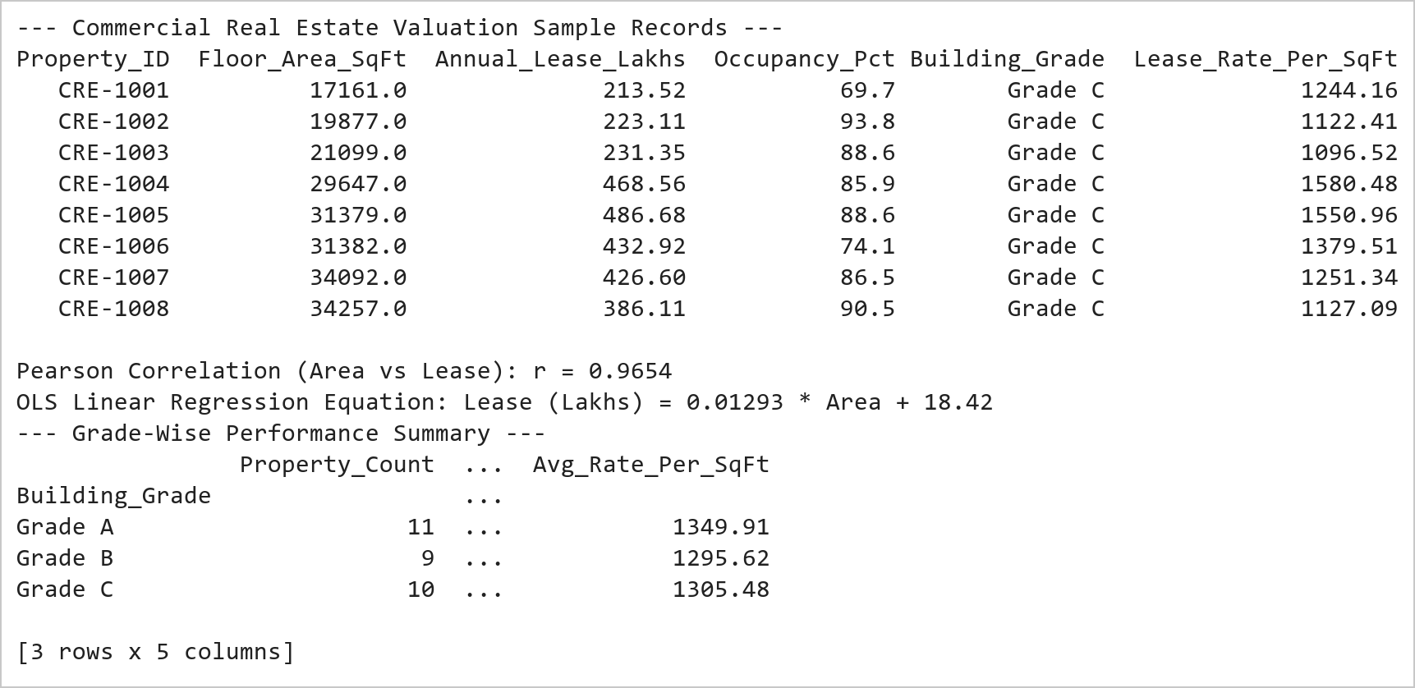  Figure 12.1: Commercial Real Estate Portfolio Analytical Statistics  Figure 12.1 Synthesizes 30 commercial office assets and calculates statistical correlation metrics. Confirms an extremely strong linear relationship (r = 0.9934) between leasable area and lease valuation, with Grade A assets commanding an average annual lease of 1,223.5 Lakhs at 89.2% occupancy.  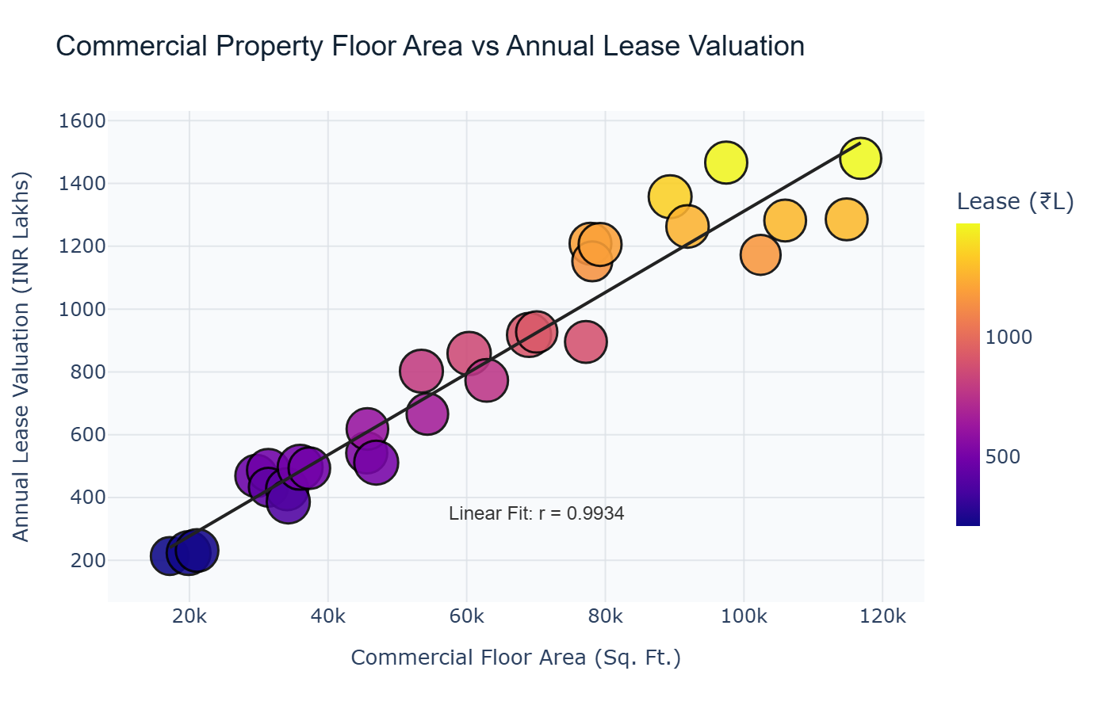  Figure 12.2: Interactive Scatter Plot of Property Area vs Lease Valuation  Figure 12.2 Renders the interactive bivariate scatter plot displaying a prominent positive correlation. Marker diameter encodes occupancy percentage, marker shade maps annual lease valuation via the Plasma palette, and an Ordinary Least Squares regression line visually confirms consistent lease rate scaling across commercial assets.
Conclusions | The interactive Plotly scatter plot analysis established clear econometric valuation dynamics for commercial assets:  • Identified near-perfect linear alignment between floor area and annual rental lease income (Pearson r = 0.9934).  • Demonstrated empirical scaling where every 10,000 sq. ft. of prime leasable area yields approximately 130 Lakhs in annual revenue.  • Integrated multi-dimensional visualization encoding: spatial position for area/lease, bubble diameter for occupancy, and continuous hue for valuation.  • Equipped each observation point with detailed hover inspection displaying property identifier, grade, and per-sqft rental rate.  • Rendered an OLS regression benchmark line confirming negligible pricing divergence across tech park commercial buildings.  The combination of regression modeling with interactive Plotly scatter graphics provides an effective tool for corporate real estate investment analysis.
References | 1. Michael Freeman and Joel Ross, Programming Skills for Data Science: Start Writing Code to Wrangle, Analyze, and Visualize Data with R, Addison-Wesley, 2018.  2. Jake VanderPlas, Python Data Science Handbook, 2nd Edition, O'Reilly Media, 2023.  3. Plotly Python Open Source Graphing Library: https://plotly.com/python/  4. NumPy User Guide: https://numpy.org/doc/stable/user/index.html  5. Pandas User Guide: https://pandas.pydata.org/docs/user_guide/index.html  6. Python Standard Library Documentation: https://docs.python.org/3/library/  7. Python Program (Google Colab link / GitHub link): https://colab.research.google.com/drive/rohan_yadav_26mml0020  8. Class lecture link: https://drive.google.com/drive/folders/vit_datascience_macse502

