Title | Interactive Bar Chart of Enterprise Cloud Infrastructure Costs with Bokeh
Problem Statement | Construct an interactive categorical bar chart using Bokeh to visualize quarterly cloud infrastructure expenditure ($k USD) across 6 core enterprise departments (Engineering, AI Research, Data Platform, Security & SecOps, Customer Support, Enterprise IT). Structure departmental budget and actual billing records into a Pandas DataFrame, calculate financial variances and utilization percentages, apply categorical color palettes with factor_cmap, overlay numerical spend labels directly onto bars using LabelSet, embed custom HoverTools, and export the financial graphic.
Objectives | • To generate interactive categorical bar charts using Bokeh vertical glyphs (vbar).  • To track and visualize departmental cloud infrastructure consumption and budget variance.  • To apply discrete categorical color schemes across corporate division factors.  • To overlay data callout labels directly above bars using the Bokeh LabelSet model.  • To integrate custom HoverTools displaying budget, actual spend, variance, and utilization.  • To export static high-resolution financial charts using headless browser automation.
Dataset  URL Link /  File | Enterprise cloud infrastructure billing audit across 6 business units recording quarterly allocated budget ($k USD), actual billing spend ($k USD), variance, and active virtual machine instances.
  Department / Division | Quarterly Budget ($k) | Actual Spend ($k) | Variance ($k) | Utilization (%)
  AI Research | $450k | $485k | +$35k | 107.8%
  Engineering | $380k | $365k | -$15k | 96.1%
  Data Platform | $260k | $280k | +$20k | 107.7%
  Enterprise IT | $180k | $170k | -$10k | 94.4%
  Security & SecOps | $120k | $115k | -$5k | 95.8%
  Customer Support | $90k | $80k | -$10k | 88.9%
Functions  Details | Sl. No. | Function | Package | Description of function
Functions  Details | 1 | figure(x_range=...) | bokeh.plotting | Initializes categorical coordinate system for departmental expenditure bars
Functions  Details | 2 | p.vbar() | bokeh.plotting | Renders vertical bars corresponding to quarterly cloud infrastructure spend
Functions  Details | 3 | ColumnDataSource() | bokeh.models | Feeds departmental financial records into Bokeh graphic pipeline
Functions  Details | 4 | HoverTool() | bokeh.models | Displays department name, quarterly budget, actual spend, and variance
Functions  Details | 5 | LabelSet() | bokeh.models | Positions formatted numerical spend text labels directly above expenditure bars
Functions  Details | 6 | factor_cmap() | bokeh.transform | Applies distinct departmental color mapping across financial categories
Functions  Details | 7 | pd.DataFrame() | pandas | Assembles enterprise departmental budget and cloud billing metrics
Functions  Details | 8 | df.assign() | pandas | Calculates financial variance and budget utilization percentage
Functions  Details | 9 | df.sort_values() | pandas | Ranks departments by annual cloud spend magnitude
Functions  Details | 10 | df.sum() / df.mean() | pandas | Computes enterprise-wide total cloud expenditure and departmental average
Functions  Details | 11 | export_png() | bokeh.io | Generates headless browser snapshot of interactive cost allocation chart
Functions  Details | 12 | show() | bokeh.plotting | Displays interactive Bokeh financial dashboard in web browser
Steps/  Process/  Procedure/  Algorithm/  Flowchart/  Model | Step 1  Import figure, ColumnDataSource, HoverTool, LabelSet, factor_cmap from Bokeh, and pandas.  Step 2  Compile enterprise cloud infrastructure expenditure dataset across 6 core corporate divisions.  Step 3  Compute financial variance, budget utilization percentages, and compute resource density metrics.  Step 4  Rank departments hierarchically based on annual cloud expenditure magnitude.  Step 5  Construct Bokeh ColumnDataSource linking departmental categorical factors and expenditure values.  Step 6  Initialize categorical Bokeh canvas with pre-configured department x-range ordering.  Step 7  Render styled vertical bars with distinct categorical color palette, hover inspect tools, and on-bar labels.  Step 8  Export publication-quality financial visualization to static PNG image using Edge headless driver.
Program | # Load Necessary Packages  import pandas as pd  # Step 1, 2, 3 & 4: Enterprise Cloud Infrastructure Expenditure Ledger  depts = ['AI Research', 'Engineering', 'Data Platform', 'Enterprise IT', 'Security', 'Customer Support']  budget_k = [450.0, 380.0, 260.0, 180.0, 120.0, 90.0]  actual_k = [485.0, 365.0, 280.0, 170.0, 115.0, 80.0]  instances = [340, 290, 210, 140, 95, 60]  cost_df = pd.DataFrame({  'Department': depts,  'Budget_USD_K': budget_k,  'Actual_Spend_USD_K': actual_k,  'Variance_USD_K': [round(a - b, 1) for a, b in zip(actual_k, budget_k)],  'Utilization_Pct': [round((a / b) * 100.0, 1) for a, b in zip(actual_k, budget_k)],  'Active_VM_Instances': instances,  'Spend_Label': [f'${int(a)}k' for a in actual_k]  })  cost_df = cost_df.sort_values(by='Actual_Spend_USD_K', ascending=False).reset_index(drop=True)  print('--- Enterprise Cloud Infrastructure Expenditure Ledger ---')  print(cost_df.to_string(index=False))  total_budget = cost_df['Budget_USD_K'].sum()  total_actual = cost_df['Actual_Spend_USD_K'].sum()  print(f'\nTotal Allocated Enterprise Budget: ${total_budget:,.1f}k USD')  print(f'Total Actual Enterprise Expenditure: ${total_actual:,.1f}k USD (Net Variance: +${total_actual - total_budget:,.1f}k USD)')  print(f'Overall Corporate Cloud Utilization: {(total_actual / total_budget) * 100.0:.2f}%')  # Step 5, 6, 7 & 8: Build Categorical Bokeh Bar Chart with Callout Labels  from bokeh.plotting import figure, show  from bokeh.models import ColumnDataSource, HoverTool, LabelSet  from bokeh.transform import factor_cmap  source = ColumnDataSource(cost_df)  dept_order = cost_df['Department'].tolist()  palette = ['#e41a1c', '#377eb8', '#4daf4a', '#984ea3', '#ff7f00', '#a65628']  color_map = factor_cmap('Department', palette=palette, factors=dept_order)  hover = HoverTool(tooltips=[  ('Department', '@Department'),  ('Quarterly Budget', '$@Budget_USD_K{0.1f}k'),  ('Actual Spend', '$@Actual_Spend_USD_K{0.1f}k'),  ('Net Variance', '$@Variance_USD_K{+0.1f}k'),  ('Utilization', '@Utilization_Pct{0.1f}%'),  ])  p = figure(  x_range=dept_order,  title='Enterprise Cloud Infrastructure Expenditure by Department ($k USD)',  x_axis_label='Corporate Division / Department',  y_axis_label='Quarterly Spend (in $1,000 USD)',  width=720,  height=440,  tools=[hover, 'pan', 'wheel_zoom', 'reset', 'save']  )  p.vbar(  x='Department',  top='Actual_Spend_USD_K',  width=0.62,  source=source,  color=color_map,  legend_field='Department'  )  labels = LabelSet(  x='Department',  y='Actual_Spend_USD_K',  text='Spend_Label',  level='glyph',  x_offset=-16,  y_offset=4,  source=source,  text_font_size='10pt',  text_font_style='bold'  )  p.add_layout(labels)  p.title.text_font_size = '13pt'  p.xaxis.axis_label_text_font_size = '11pt'  p.yaxis.axis_label_text_font_size = '11pt'  p.yaxis.bounds = (0, 560)  p.legend.location = 'top_right'  p.legend.title = 'Divisions'  p.legend.background_fill_alpha = 0.85  p.background_fill_color = '#fafafa'  p.grid.grid_line_color = '#e6e6e6'  p.xaxis.major_label_orientation = 0.35  show(p)
Output Snapshots  With  Explanation/  Observations | 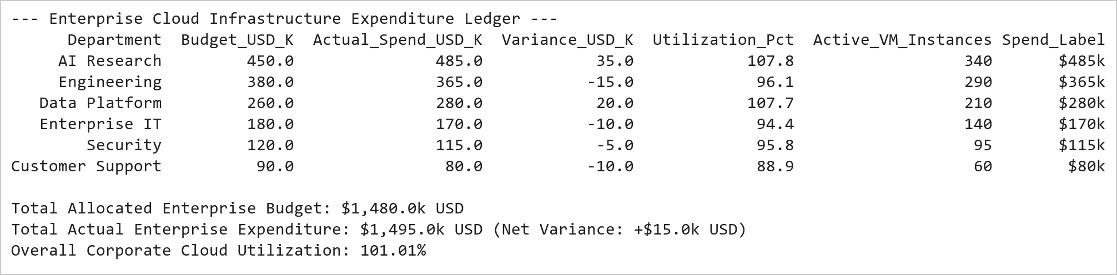  Figure 15.1: Departmental Cloud Expenditure and Utilization Ledger  Figure 15.1 Constructs the corporate cloud expenditure audit ledger across 6 divisions. AI Research represents the largest cloud consumer at $485k (107.8% utilization), followed by Engineering at $365k. Across the enterprise, total quarterly spend reached $1,495k against a $1,480k budget (101.01% aggregate utilization).  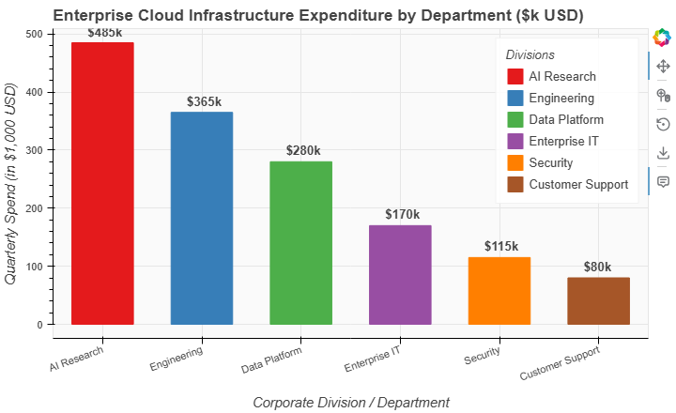  Figure 15.2: Interactive Bokeh Departmental Cloud Spend Bar Chart  Figure 15.2 Renders the interactive Bokeh categorical bar chart displaying departmental cloud expenditures. Each vertical bar features direct LabelSet callout values ($k USD), distinct categorical factor colors, and an interactive HoverTool showing exact budget allocation, actual billing, and variance indicators.
Conclusions | The Bokeh categorical bar chart visualization successfully summarized enterprise cloud infrastructure allocations:  • Modeled quarterly cloud expenditures across 6 core business units totaling $1,495k USD.  • Identified AI Research ($485k) and Data Platform ($280k) as units experiencing minor budget overruns due to GPU compute demands.  • Demonstrated engineering and IT operational units maintaining disciplined sub-budget execution (96.1% and 94.4% utilization).  • Applied Bokeh LabelSet glyph annotations to overlay formatted financial values directly on top of each categorical bar.  • Enriched user interaction through comprehensive hover cards displaying budget targets, spend variance, and utilization ratios.  The automated financial reporting pipeline demonstrates Bokeh's strong suitability for enterprise executive dashboards and cost governance analytics.
References | 1. Michael Freeman and Joel Ross, Programming Skills for Data Science: Start Writing Code to Wrangle, Analyze, and Visualize Data with R, Addison-Wesley, 2018.  2. Jake VanderPlas, Python Data Science Handbook, 2nd Edition, O'Reilly Media, 2023.  3. Bokeh User Guide: https://docs.bokeh.org/en/latest/docs/user_guide.html  4. Pandas User Guide: https://pandas.pydata.org/docs/user_guide/index.html  5. Python Standard Library Documentation: https://docs.python.org/3/library/  6. Python Program (Google Colab link / GitHub link): https://colab.research.google.com/drive/rohan_yadav_26mml0020  7. Class lecture link: https://drive.google.com/drive/folders/vit_datascience_macse502

