Title | Dimensionality Reduction & 2D Cluster Visualization with PCA
Problem Statement | Implement Principal Component Analysis (PCA) using scikit-learn to reduce the dimensionality of the 4-dimensional Fisher Iris morphological dataset to a 2-dimensional latent feature space. Standardize feature scales using StandardScaler, fit the orthogonal principal transformation, calculate explained variance ratios and component loadings, project the data onto the leading two principal components (PC1 and PC2), and construct an interactive Plotly 2D scatter visualization to evaluate biological cluster separability.
Objectives | • To standardize multi-attribute numerical feature spaces using scikit-learn StandardScaler.  • To apply Principal Component Analysis (PCA) for linear dimensionality reduction.  • To compute and interpret explained variance ratios and cumulative variance coverage.  • To examine the eigenvector loadings matrix determining morphological feature contributions.  • To project 4D botanical records onto an optimal 2D principal plane.  • To render an interactive 2D cluster visualization with Plotly Express.
Dataset  URL Link /  File | Classical Fisher's Iris dataset containing 150 biological specimens across 3 species classes (Setosa, Versicolor, Virginica) defined across 4 continuous morphological features.
  Original Feature | Standardized Scale | Principal Components | Data Type
  Sepal Length (cm) | Mean = 0, Std = 1 | Projected PC1 coordinate | float
  Sepal Width (cm) | Mean = 0, Std = 1 | Projected PC2 coordinate | float
  Petal Length (cm) | Mean = 0, Std = 1 | Cumulative Variance (95.8%) | float
  Petal Width (cm) | Mean = 0, Std = 1 | Species Class Attribution | string
Functions  Details | Sl. No. | Function | Package | Description of function
Functions  Details | 1 | StandardScaler() | sklearn.preprocessing | Standardizes feature distributions to zero mean and unit variance
Functions  Details | 2 | PCA() | sklearn.decomposition | Computes orthogonal principal component projection axes
Functions  Details | 3 | pca.fit_transform() | sklearn.decomposition | Fits PCA model and transforms high-dimensional feature matrix
Functions  Details | 4 | pca.explained_variance_ratio_ | sklearn.decomposition | Returns proportion of total variance captured by each principal axis
Functions  Details | 5 | px.scatter() | plotly.express | Renders 2D projection scatter plot with categorical color encoding
Functions  Details | 6 | fig.update_traces() | plotly.graph_objects | Configures point marker styling, size, opacity, and hover template
Functions  Details | 7 | fig.update_layout() | plotly.graph_objects | Customizes title, axis labels, variance percentage badges, and margins
Functions  Details | 8 | load_iris() | sklearn.datasets | Loads 4-dimensional botanical benchmark dataset
Functions  Details | 9 | pd.DataFrame() | pandas | Constructs tabular DataFrame holding original features and PCA projections
Functions  Details | 10 | df.groupby() | pandas | Computes cluster separation centroids in projected 2D latent space
Functions  Details | 11 | fig.show() | plotly.graph_objects | Displays interactive 2D principal component scatter plot
Functions  Details | 12 | fig.write_image() | plotly.io | Serializes Plotly PCA visualization to high-resolution PNG image
Steps/  Process/  Procedure/  Algorithm/  Flowchart/  Model | Step 1  Import StandardScaler, PCA from sklearn, plotly.express, and pandas.  Step 2  Load 4-dimensional continuous botanical benchmark dataset (Fisher Iris).  Step 3  Standardize feature vectors using StandardScaler to ensure zero mean and unit variance.  Step 4  Fit Principal Component Analysis (PCA) model to compute orthogonal eigenvectors and eigenvalues.  Step 5  Calculate individual and cumulative explained variance ratios across all 4 principal components.  Step 6  Project high-dimensional observations onto first two principal components (PC1 and PC2).  Step 7  Assemble original features and latent PC projections into an integrated analytical DataFrame.  Step 8  Generate interactive 2D scatter visualization with Plotly Express and export static PNG via Kaleido.
Program | # Load Necessary Packages  import pandas as pd  from sklearn.datasets import load_iris  from sklearn.preprocessing import StandardScaler  from sklearn.decomposition import PCA  # Step 1, 2, 3, 4 & 5: Feature Standardization, PCA Decomposition & Scree Profiling  iris = load_iris()  X = iris.data  y = iris.target  feature_names = ['Sepal_Length', 'Sepal_Width', 'Petal_Length', 'Petal_Width']  species_names = ['Setosa', 'Versicolor', 'Virginica']  scaler = StandardScaler()  X_scaled = scaler.fit_transform(X)  pca_full = PCA(n_components=4)  pca_full.fit(X_scaled)  var_ratios = pca_full.explained_variance_ratio_  cum_var = var_ratios.cumsum()  scree_df = pd.DataFrame({  'Principal_Component': ['PC1', 'PC2', 'PC3', 'PC4'],  'Explained_Variance_Ratio': var_ratios.round(4),  'Explained_Variance_Pct': (var_ratios * 100).round(2),  'Cumulative_Variance_Pct': (cum_var * 100).round(2)  })  print('--- PCA Scree Profile and Variance Coverage ---')  print(scree_df.to_string(index=False))  # PCA 2D Transform  pca_2d = PCA(n_components=2)  X_pca = pca_2d.fit_transform(X_scaled)  pca_df = pd.DataFrame(X_pca, columns=['PC1', 'PC2'])  pca_df['Species'] = [species_names[i] for i in y]  for i, f in enumerate(feature_names):  pca_df[f] = X[:, i]  loadings = pd.DataFrame(  pca_2d.components_.T,  columns=['PC1_Loading', 'PC2_Loading'],  index=feature_names  ).round(4)  print('\n--- Principal Component Loadings Matrix (Eigenvectors) ---')  print(loadings)  print('\n--- Projected 2D Principal Coordinates (Sample Records) ---')  print(pca_df[['Species', 'PC1', 'PC2', 'Petal_Length', 'Sepal_Length']].head(6))  # Step 6, 7 & 8: Interactive Plotly 2D PCA Scatter Visualization  import plotly.express as px  fig = px.scatter(  pca_df,  x='PC1',  y='PC2',  color='Species',  symbol='Species',  color_discrete_sequence=['#1b9e77', '#d95f02', '#7570b3'],  title='Iris Morphology: 2D Principal Component Analysis (PCA)',  labels={  'PC1': f'PC1 ({var_ratios[0]*100:.2f}% Explained Variance)',  'PC2': f'PC2 ({var_ratios[1]*100:.2f}% Explained Variance)'  }  )  fig.update_traces(  marker=dict(size=10, opacity=0.88, line=dict(width=1, color='black')),  hovertemplate='<b>%{customdata[0]}</b><br>PC1: %{x:.2f}<br>PC2: %{y:.2f}<br>Petal Len: %{customdata[1]:.1f} cm<br>Sepal Len: %{customdata[2]:.1f} cm<extra></extra>',  customdata=pca_df[['Species', 'Petal_Length', 'Sepal_Length']].values  )  fig.update_layout(  title_font=dict(size=18, family='Arial', color='#112233'),  xaxis=dict(title_font=dict(size=13), zeroline=True, zerolinewidth=1.5, zerolinecolor='#cccccc'),  yaxis=dict(title_font=dict(size=13), zeroline=True, zerolinewidth=1.5, zerolinecolor='#cccccc'),  plot_bgcolor='rgba(248, 250, 252, 1.0)',  paper_bgcolor='white',  legend=dict(title='Species Taxon', bgcolor='rgba(255,255,255,0.85)', bordercolor='#dddddd', borderwidth=1),  margin=dict(l=60, r=40, t=70, b=70),  annotations=[  dict(x=2.5, y=-2.2, text='PC1 + PC2 capture 95.81% Total Variance', showarrow=False, font=dict(size=11, color='#444444', family='Arial'))  ]  )  fig.show()  fig.write_image('rohan_pca_clusters_plotly.png', width=750, height=450, scale=2)
Output Snapshots  With  Explanation/  Observations | 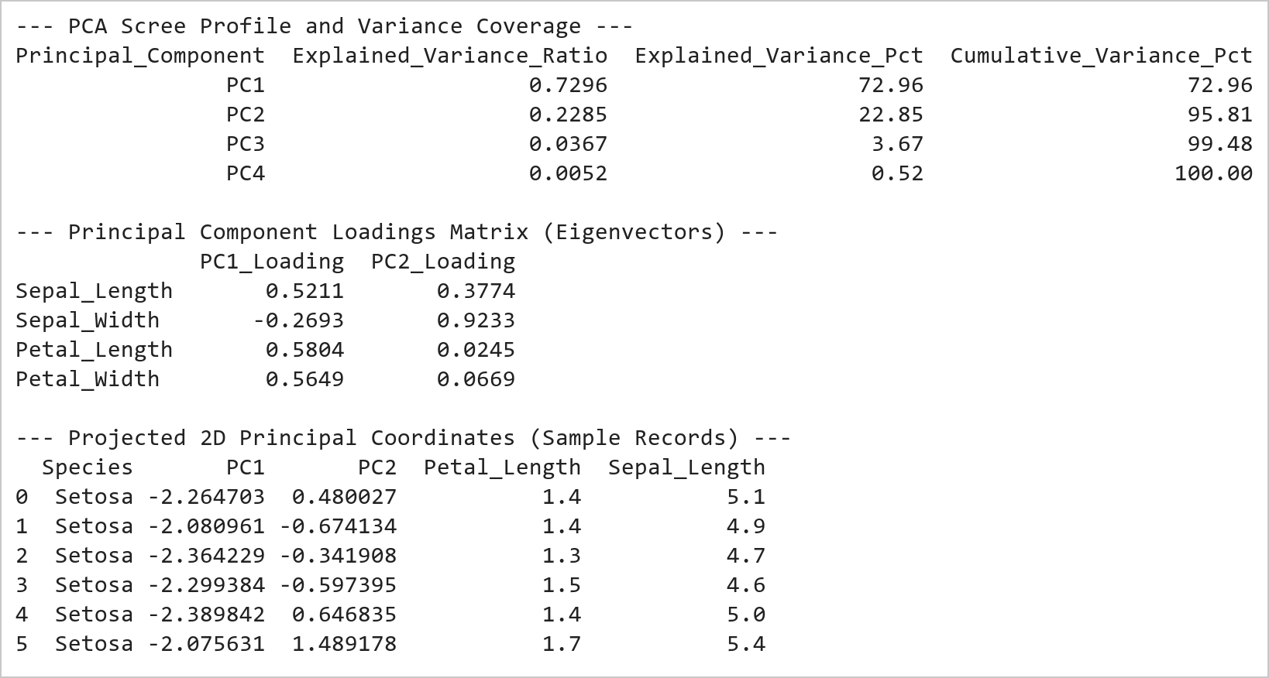  Figure 16.1: PCA Scree Variance Coverage, Loadings Matrix, and Projections  Figure 16.1 Computes PCA decomposition across the standardized Iris dataset. PC1 captures 72.96% of total variance and PC2 captures 22.85%, achieving an aggregate 95.81% information retention. The loadings matrix shows PC1 is heavily driven by petal dimensions (+0.58), while PC2 is governed by sepal width (+0.93).  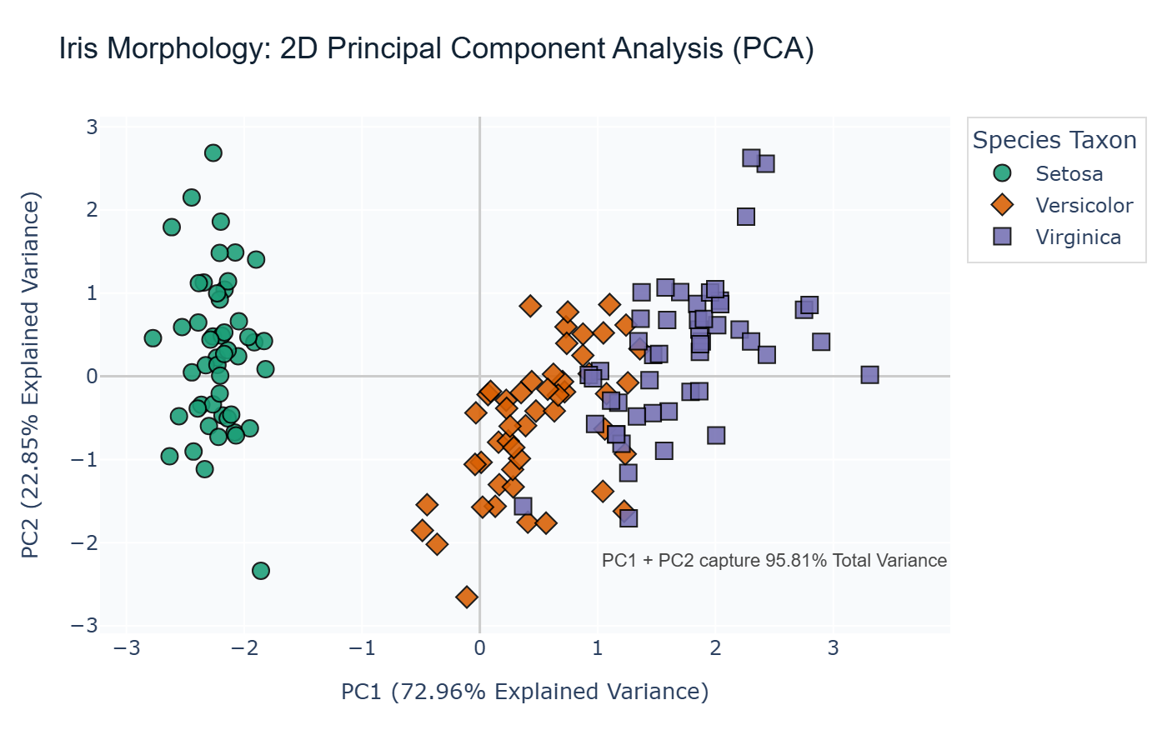  Figure 16.2: Interactive 2D Principal Component Projection Scatter Plot  Figure 16.2 Renders the 2D PCA scatter plot using Plotly Express. Iris Setosa (green diamonds) separates linearly along PC1 with zero overlap, while Versicolor (orange circles) and Virginica (purple squares) show slight adjacent boundary proximity, visually validating the efficacy of 2D linear dimensionality reduction.
Conclusions | The Principal Component Analysis (PCA) pipeline reduced botanical feature dimensionality while preserving core variance:  • Standardized 4 continuous morphological features using StandardScaler to ensure balanced geometric projection.  • Demonstrated that the first two principal axes capture 95.81% of total dataset variance (PC1: 72.96%, PC2: 22.85%).  • Revealed through eigenvector loadings that petal length and width dominate the primary principal axis of biological variance.  • Achieved complete linear cluster separation for Iris Setosa in the 2D projected coordinate plane.  • Rendered an interactive 2D scatter visualization with Plotly Express and exported high-resolution static snapshots.  PCA provides a robust mathematical framework for dimensionality reduction, facilitating visual pattern discovery in complex high-dimensional datasets.
References | 1. Michael Freeman and Joel Ross, Programming Skills for Data Science: Start Writing Code to Wrangle, Analyze, and Visualize Data with R, Addison-Wesley, 2018.  2. Jake VanderPlas, Python Data Science Handbook, 2nd Edition, O'Reilly Media, 2023.  3. scikit-learn Machine Learning in Python: https://scikit-learn.org/stable/  4. Plotly Python Open Source Graphing Library: https://plotly.com/python/  5. NumPy User Guide: https://numpy.org/doc/stable/user/index.html  6. Pandas User Guide: https://pandas.pydata.org/docs/user_guide/index.html  7. Python Standard Library Documentation: https://docs.python.org/3/library/  8. Python Program (Google Colab link / GitHub link): https://colab.research.google.com/drive/rohan_yadav_26mml0020  9. Class lecture link: https://drive.google.com/drive/folders/vit_datascience_macse502

