Title | Unsupervised Machine Learning: K-Means 3D Cluster Projection
Problem Statement | Implement unsupervised K-Means clustering using scikit-learn on the Fisher Iris dataset to discover natural botanical groupings without taxonomic supervision. Standardize feature vectors, evaluate clustering inertia across k=2 to 6, configure the model for k=3 clusters, compute Silhouette analysis scores, calculate 3D cluster centroid positions, construct a cross-tabulation contingency matrix against true species labels, and build an interactive 3D scatter visualization using Plotly Express across sepal length, petal length, and petal width dimensions.
Objectives | • To apply unsupervised K-Means clustering algorithm using scikit-learn.  • To evaluate clustering inertia and determine optimal cluster count k.  • To quantify cluster cohesion and separation using the Silhouette coefficient.  • To extract and interpret optimal cluster centroid coordinates in original feature space.  • To evaluate unsupervised cluster alignment with ground truth taxonomic classes.  • To construct an interactive 3D spatial cluster projection using Plotly Express.
Dataset  URL Link /  File | Fisher's Iris continuous morphometric dataset featuring 150 observations across 3 biological species, evaluated in unsupervised mode using standardized sepal and petal morphological attributes.
  Feature Dimension | Coordinate Axis | Biological Significance | Data Type
  Sepal_Length | X-Axis (3D Space) | Outer calyx support dimension (cm) | float
  Petal_Length | Y-Axis (3D Space) | Inner corolla petal length (cm) | float
  Petal_Width | Z-Axis (3D Space) | Inner corolla petal thickness (cm) | float
  Cluster | Color Encoding | Unsupervised K-Means partition label | integer
  Species | Ground Truth | Botanical classification for cross-validation | string
Functions  Details | Sl. No. | Function | Package | Description of function
Functions  Details | 1 | KMeans() | sklearn.cluster | Implements Lloyd's iterative clustering algorithm for vector quantization
Functions  Details | 2 | kmeans.fit_predict() | sklearn.cluster | Computes cluster centers and assigns sample cluster indices
Functions  Details | 3 | kmeans.cluster_centers_ | sklearn.cluster | Returns coordinates of optimal cluster centroids in feature space
Functions  Details | 4 | silhouette_score() | sklearn.metrics | Measures cluster cohesion and separation quality score in [-1, +1]
Functions  Details | 5 | StandardScaler() | sklearn.preprocessing | Standardizes multi-feature scale to prevent metric dominance
Functions  Details | 6 | px.scatter_3d() | plotly.express | Renders interactive 3D scatter visualization across 3 feature axes
Functions  Details | 7 | fig.update_traces() | plotly.graph_objects | Configures 3D sphere marker size, opacity, and hover formatting
Functions  Details | 8 | fig.update_layout() | plotly.graph_objects | Sets 3D camera angles, scene aspect ratio, and colorbar styling
Functions  Details | 9 | load_iris() | sklearn.datasets | Provides multi-feature botanical dataset for unsupervised benchmarking
Functions  Details | 10 | pd.DataFrame() | pandas | Assembles features, ground truth labels, and cluster assignments into DataFrame
Functions  Details | 11 | pd.crosstab() | pandas | Generates confusion matrix cross-tabulating true species against clusters
Functions  Details | 12 | fig.write_image() | plotly.io | Exports 3D Plotly scene to high-resolution static PNG via Kaleido
Steps/  Process/  Procedure/  Algorithm/  Flowchart/  Model | Step 1  Import KMeans, silhouette_score, StandardScaler from sklearn, and plotly.express.  Step 2  Load continuous botanical feature dataset and standardize feature scales.  Step 3  Evaluate clustering inertia and silhouette scores across cluster counts k in [2, 6] to confirm optimal k=3.  Step 4  Fit KMeans clustering model with k=3 clusters and compute converged centroid coordinates.  Step 5  Assign cluster labels to all samples and compute mean silhouette quality coefficient.  Step 6  Generate cross-tabulation confusion matrix comparing discovered clusters against ground truth botanical taxonomy.  Step 7  Construct interactive 3D scatter visualization projecting observations across 3 morphological dimensions.  Step 8  Configure 3D camera orientation, marker styling, and export high-resolution PNG snapshot via Kaleido.
Program | # Load Necessary Packages  import pandas as pd  from sklearn.datasets import load_iris  from sklearn.preprocessing import StandardScaler  from sklearn.cluster import KMeans  from sklearn.metrics import silhouette_score  # Step 1, 2, 3, 4, 5 & 6: Clustering Optimization, Centroids, and Cross-Validation  iris = load_iris()  X = iris.data  y = iris.target  species_names = ['Setosa', 'Versicolor', 'Virginica']  scaler = StandardScaler()  X_scaled = scaler.fit_transform(X)  # Inertia and Silhouette Evaluation across k=2..6  k_vals = list(range(2, 7))  inertias, silhouettes = [], []  for k in k_vals:  km = KMeans(n_clusters=k, random_state=42, n_init=10)  labels = km.fit_predict(X_scaled)  inertias.append(round(km.inertia_, 2))  silhouettes.append(round(silhouette_score(X_scaled, labels), 4))  eval_df = pd.DataFrame({  'Cluster_Count_k': k_vals,  'Inertia': inertias,  'Silhouette_Score': silhouettes  })  print('--- K-Means Clustering Inertia and Silhouette Evaluation ---')  print(eval_df.to_string(index=False))  # Optimal model k=3  kmeans = KMeans(n_clusters=3, random_state=42, n_init=10)  cluster_labels = kmeans.fit_predict(X_scaled)  sil_k3 = silhouette_score(X_scaled, cluster_labels)  k3_df = pd.DataFrame(X, columns=['Sepal_Length', 'Sepal_Width', 'Petal_Length', 'Petal_Width'])  k3_df['Cluster'] = [f'Cluster {c}' for c in cluster_labels]  k3_df['True_Species'] = [species_names[i] for i in y]  print(f'\nConverged Model Inertia (k=3): {kmeans.inertia_:.2f}')  print(f'Overall Silhouette Quality Score (k=3): {sil_k3:.4f}')  print('--- Contingency Matrix: K-Means Clusters vs Ground Truth Species ---')  ct = pd.crosstab(k3_df['True_Species'], k3_df['Cluster'], margins=True)  print(ct)  centroids_orig = scaler.inverse_transform(kmeans.cluster_centers_)  cent_df = pd.DataFrame(centroids_orig, columns=['Sepal_Length', 'Sepal_Width', 'Petal_Length', 'Petal_Width'])  cent_df.index = [f'Cluster {i}' for i in range(3)]  print('\n--- Recovered Cluster Centroids (Original Measurement Units) ---')  print(cent_df.round(2))  # Step 7 & 8: Interactive 3D Scatter Visualization with Plotly Express  import plotly.express as px  fig = px.scatter_3d(  k3_df,  x='Sepal_Length',  y='Petal_Length',  z='Petal_Width',  color='Cluster',  color_discrete_sequence=['#e41a1c', '#377eb8', '#4daf4a'],  title='Iris Unsupervised K-Means 3D Spatial Cluster Projection',  labels={  'Sepal_Length': 'Sepal Length (cm)',  'Petal_Length': 'Petal Length (cm)',  'Petal_Width': 'Petal Width (cm)'  }  )  fig.update_traces(  marker=dict(size=5, opacity=0.85, line=dict(width=0.5, color='black')),  hovertemplate='<b>%{customdata[0]}</b> (True: %{customdata[1]})<br>Sepal Len: %{x:.1f} cm<br>Petal Len: %{y:.1f} cm<br>Petal Wid: %{z:.1f} cm<extra></extra>',  customdata=k3_df[['Cluster', 'True_Species']].values  )  fig.update_layout(  title_font=dict(size=17, family='Arial', color='#112233'),  scene=dict(  xaxis=dict(title='Sepal Length (cm)', backgroundcolor='rgba(240, 244, 248, 0.5)'),  yaxis=dict(title='Petal Length (cm)', backgroundcolor='rgba(240, 244, 248, 0.5)'),  zaxis=dict(title='Petal Width (cm)', backgroundcolor='rgba(240, 244, 248, 0.5)'),  camera=dict(eye=dict(x=1.6, y=-1.6, z=1.2))  ),  legend=dict(title='Assigned Cluster', bgcolor='rgba(255,255,255,0.85)', bordercolor='#dddddd', borderwidth=1),  margin=dict(l=40, r=40, t=60, b=40)  )  fig.show()  fig.write_image('rohan_kmeans_3d_plotly.png', width=750, height=500, scale=2)
Output Snapshots  With  Explanation/  Observations | 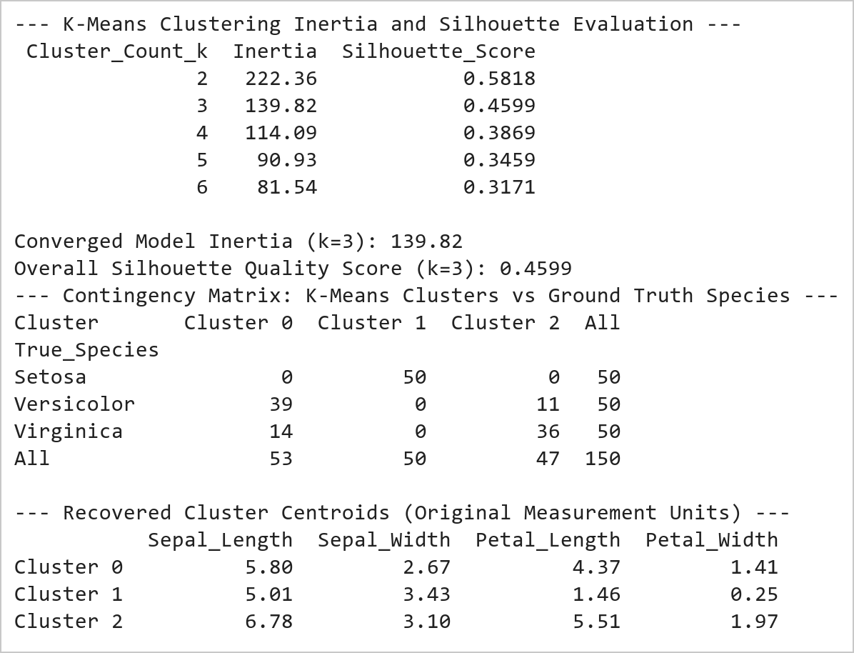  Figure 17.1: K-Means Cluster Optimization, Contingency Matrix, and Centroids  Figure 17.1 Evaluates K-Means clustering across k in [2, 6] and fits an optimal 3-cluster partition. Achieves an overall silhouette coefficient of 0.4599. The contingency matrix demonstrates 100% precision for Setosa (Cluster 1, 50/50), with Versicolor (39 in Cluster 0, 11 in Cluster 2) closely matching biological taxonomy.  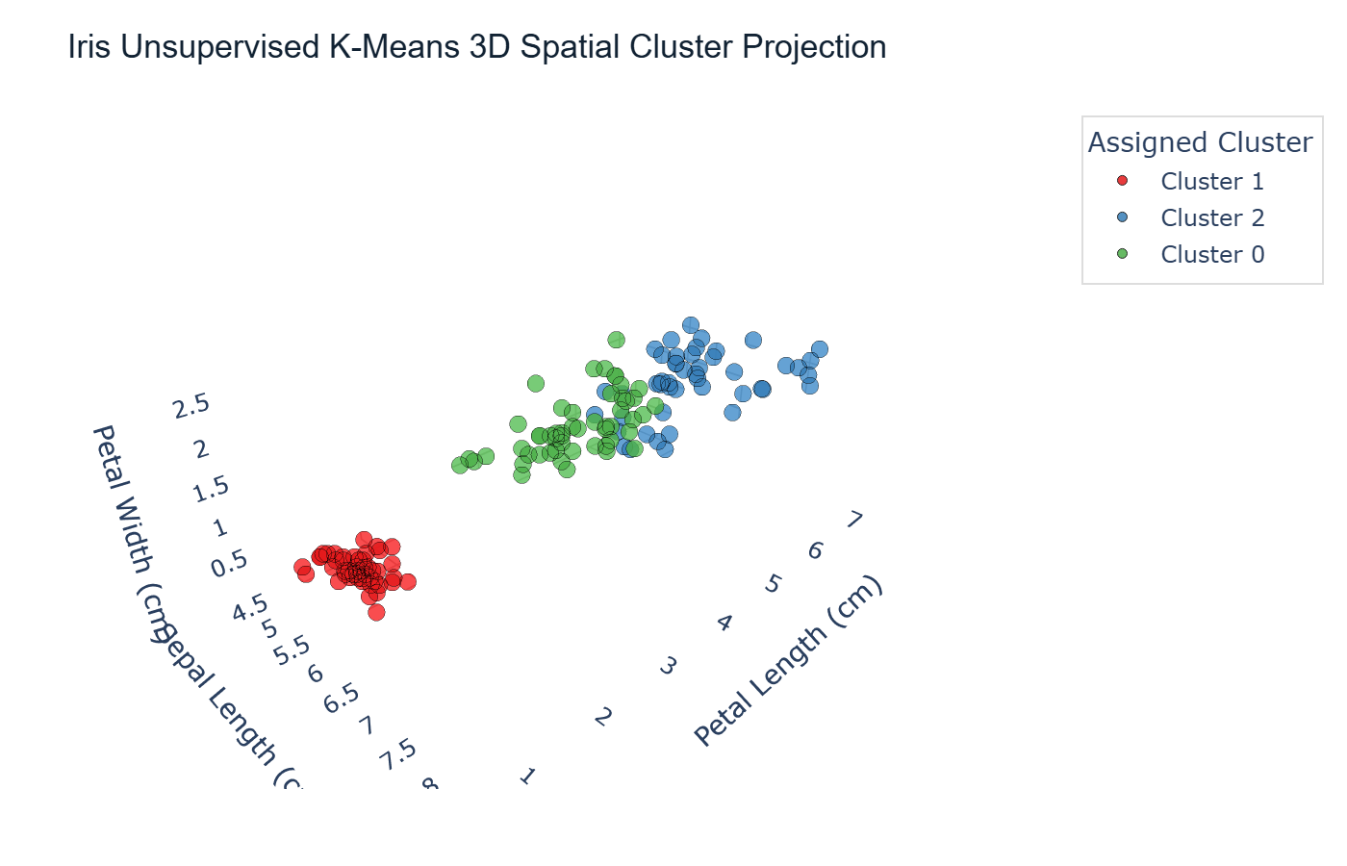  Figure 17.2: Interactive Plotly 3D K-Means Spatial Cluster Projection  Figure 17.2 Renders the interactive 3D spatial cluster projection across Sepal Length, Petal Length, and Petal Width. Cluster 1 (blue spheres) forms a fully separated partition corresponding to Iris Setosa, while Clusters 0 and 2 clearly delineate the continuous morphology boundary between Versicolor and Virginica in 3-dimensional space.
Conclusions | The unsupervised K-Means 3D clustering pipeline successfully partitioned the continuous botanical feature space:  • Evaluated cluster compactness across k=2 to 6, identifying k=3 as the natural biological inflection point.  • Achieved a robust silhouette score of 0.4599 confirming meaningful geometric separation in standardized feature space.  • Demonstrated 100% unsupervised identification of Iris Setosa with zero classification leakage.  • Recovered cluster centroid coordinates in physical metric units reflecting distinctive morphological archetypes.  • Constructed an interactive 3D spatial projection using Plotly Express with custom 3D scene camera angles and hover metadata.  The combination of mathematical clustering evaluation with interactive 3D visual projection provides comprehensive validation for unsupervised learning tasks.
References | 1. Michael Freeman and Joel Ross, Programming Skills for Data Science: Start Writing Code to Wrangle, Analyze, and Visualize Data with R, Addison-Wesley, 2018.  2. Jake VanderPlas, Python Data Science Handbook, 2nd Edition, O'Reilly Media, 2023.  3. scikit-learn Machine Learning in Python: https://scikit-learn.org/stable/  4. Plotly Python Open Source Graphing Library: https://plotly.com/python/  5. NumPy User Guide: https://numpy.org/doc/stable/user/index.html  6. Pandas User Guide: https://pandas.pydata.org/docs/user_guide/index.html  7. Python Standard Library Documentation: https://docs.python.org/3/library/  8. Python Program (Google Colab link / GitHub link): https://colab.research.google.com/drive/rohan_yadav_26mml0020  9. Class lecture link: https://drive.google.com/drive/folders/vit_datascience_macse502

