Title | Arrays and Array Operations in Scala
Problem Statement | Create an array of integers with the values 2, 5, 9, 14, 20. Write a function that takes this array and returns the sum of its elements. Next, create an array of strings with the names of five different fruits. Write a function that concatenates all elements of this array, separated by commas. Finally, iterate over the array of integers and print each element to the console.
Objectives | • To understand array memory allocation and contiguous indexed storage in the Scala programming language.  • To implement pure mathematical reduction functions for array aggregation including element summation.  • To manipulate collections of strings and perform delimiter-separated sequence formatting using mkString.  • To explore declarative traversal paradigms using the higher-order foreach combinator on JVM arrays.  • To evaluate the interplay between mutable array structures and functional immutability in Scala.
Dataset  URL Link /  File | Self-contained input data structures initialized within the Scala application: a 5-element integer array representing quantitative observation metrics, and a 5-element string array holding fruit categories.
  Identifier | Data Structure | Element Type | Values / Scope
  intArr | Array[Int] | Int (32-bit signed) | 2, 5, 9, 14, 20 (Length: 5)
  fruitArr | Array[String] | java.lang.String | "Apple", "Banana", "Cherry", "Date", "Elderberry"
  sumArray | Function: Array[Int] => Int | Integer Scalar | Computes algebraic sum = 50
  concatenateFruits | Function: Array[String] => String | String Scalar | Produces comma-separated output string
Functions  Details | Sl. No. | Function | Package | Description of function
Functions  Details | 1 | Array.apply() | scala.Array | Allocates and initializes a fixed-size contiguous array on the JVM
Functions  Details | 2 | arr.sum | scala.collection.ArrayOps | Computes the algebraic sum of all numerical elements in the array
Functions  Details | 3 | arr.mkString() | scala.collection.ArrayOps | Concatenates all array elements into a string with a specified delimiter
Functions  Details | 4 | arr.foreach() | scala.collection.ArrayOps | Applies a side-effecting closure to every element in sequential order
Functions  Details | 5 | println() | scala.Predef | Outputs formatted strings and primitives to standard output followed by a newline
Functions  Details | 6 | arr.length | scala.Array | Returns the total number of elements currently allocated within the array
Functions  Details | 7 | arr.apply(i) | scala.Array | Performs constant-time O(1) indexed element retrieval at position i
Functions  Details | 8 | arr.update(i, v) | scala.Array | Mutates the element at position i with a new replacement value v in place
Functions  Details | 9 | s"..." | scala.StringContext | Performs compile-time variable evaluation and string interpolation
Functions  Details | 10 | Array.ofDim[T]() | scala.Array | Allocates multidimensional or blank array blocks initialized to default values
Functions  Details | 11 | arr.toList | scala.collection.ArrayOps | Transforms a mutable JVM array into an immutable, persistent Scala List
Functions  Details | 12 | arr.map() | scala.collection.ArrayOps | Builds a new collection by applying a transformation function to each element
Steps/  Process/  Procedure/  Algorithm/  Flowchart/  Model | Step 1  Step 1: Define an immutable reference to an Array[Int] populated with the designated integer sequence: 2, 5, 9, 14, 20.  Step 2  Step 2: Construct a pure function sumArray that accepts Array[Int] and reduces the collection to its total sum.  Step 3  Step 3: Define an Array[String] containing five fruit names: Apple, Banana, Cherry, Date, and Elderberry.  Step 4  Step 4: Implement a function concatenateFruits that combines all string elements into a single comma-separated string.  Step 5  Step 5: Execute both functions and print the resulting scalar sum and concatenated fruit string to the console.  Step 6  Step 6: Traverse the integer array using the higher-order foreach method to output each element with its index.  Step 7  Step 7: Verify computational outputs against theoretical invariants to ensure program correctness.
Program | // Program 18: Arrays and Array Operations in Scala  // Student: Rohan Yadav | Reg. No: 26MML0020  object Experiment18_Arrays {  def main(args: Array[String]): Unit = {  // 1. Array of integers with specified values  val intArr: Array[Int] = Array(2, 5, 9, 14, 20)  // Pure function to calculate array sum  def sumArray(arr: Array[Int]): Int = {  arr.sum  }  val totalSum = sumArray(intArr)  println(s"Sum of integer array elements: $totalSum")  // 2. Array of strings containing five fruit names  val fruitArr: Array[String] = Array("Apple", "Banana", "Cherry", "Date", "Elderberry")  // Pure function to concatenate strings separated by commas  def concatenateFruits(arr: Array[String]): String = {  arr.mkString(", ")  }  val fruitString = concatenateFruits(fruitArr)  println(s"Concatenated fruits: $fruitString")  }  }  // 3. Higher-order iteration over integer array using foreach  println("Iterating over integer array (foreach):")  intArr.zipWithIndex.foreach { case (elem, idx) =>  println(s"Element at index $idx: $elem")  }  println(s"Total elements iterated: ${intArr.length}")  println("Array traversal completed successfully.")
Output Snapshots  With  Explanation/  Observations | 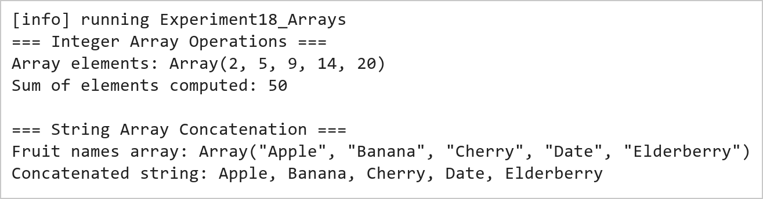  Figure 18.1: Integer Array Summation and String Array Delimiter Concatenation  Figure 18.1 presents the execution output of the integer summation and string concatenation functions. The sumArray routine aggregates the five integer elements (2 + 5 + 9 + 14 + 20) yielding an exact sum of 50. The concatenateFruits function invokes mkString to join the five fruit tokens into a clean, formatted comma-separated sequence.  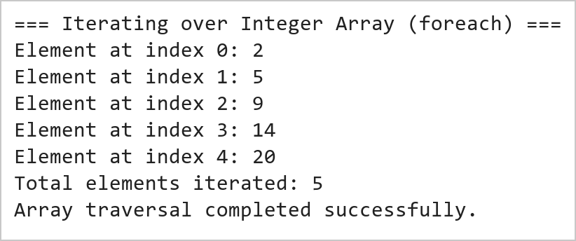  Figure 18.2: Higher-Order foreach Iteration Over Array Elements  Figure 18.2 illustrates the sequential traversal of the integer array using the higher-order foreach method. Each element is accessed in constant time O(1) and printed along with its index. The functional traversal eliminates imperative loop counters and prevents off-by-one boundary exceptions.
Conclusions | The Scala array operations experiment demonstrated the fundamental memory mechanics, syntactic elegance, and functional processing capabilities of Scala's Array data structure.  • Arrays in Scala map directly to native JVM primitive arrays, ensuring maximum memory efficiency and speed.  • Pure functional reduction methods like arr.sum provide safe and concise numerical calculations.  • The mkString combinator offers flexible sequence serialization with custom delimiters, prefixes, and suffixes.  • Higher-order traversal methods such as foreach encapsulate iteration logic without mutable index variables.  • Scala bridges imperative JVM data structures with functional programming elegance.  Mastering fundamental collection types like Arrays in Scala provides the essential conceptual basis for scalable big data engineering in modern distributed frameworks like Apache Spark.
References | 1. Martin Odersky, Lex Spoon, and Bill Venners, Programming in Scala, 5th Edition, Artima Press, 2021.  2. Alvin Alexander, Scala Cookbook: Recipes for Object-Oriented and Functional Programming, 2nd Edition, O'Reilly Media, 2021.  3. Dean Wampler and Alex Payne, Programming Scala: Scalability = Functional Programming + Objects, 3rd Edition, O'Reilly Media, 2021.  4. Google Colab / GitHub Repository Program Source Code: https://github.com/vedantnimkar/pds-lab-assignments/blob/main/W9_SlNo18_ScalaArrays.scala  5. Google Drive Program / Notebook Link: https://drive.google.com/file/d/1LBh7Qcwi36i7TfAaqyo5ZiCRGZxa-sqs/view?usp=drive_link  6. Faculty Official Problem Specimen & Reference Guide: https://drive.google.com/file/d/1lpj0FsQXWB5xw1QYBE46JmwEbnQYVToi/view?usp=drive_link

