

Impact of Generative AI on Creators and Consumers

School Of Computer Science and Engineering

M. Tech Artificial Intelligence and Machine Learning
Fall Semester 2026

Course Title: Technical Report Writing
Course Code:MAENG501
Slot: TF2

SUBMITTED TO:
DR. MARY JENNIFER J
SCHOOL OF SOCIAL SCIENCE AND LANGUAGES

SUBMITTED BY:
SARANYA DALAL- 26MML0007
DIVYA VIJAYKUMAR PUJARI – 26MML0009
ROHAN YADAV – 26MML0020
RIVIN JOSE MELVIN – 26MML0035
SINDHIYA 26MML0069

ABSTRACT

This study examines how generative artificial intelligence (GenAI) affects content creators who use it and consumers who encounter AI-generated work. It combines a review of research on creative productivity, human–AI collaboration, originality, authenticity, and audience trust with a mixed-methods questionnaire survey. A total of 80 valid responses were collected, although some creator-related and attitudinal items had smaller response bases. Quantitative responses were summarized using descriptive statistics and charts, while the questionnaire also included open-ended items. The findings indicate a substantial consumer penalty associated with GenAI use: 91.3% reported negative feelings toward a creator or brand using GenAI, and 87.5% reported taking at least one action, including reducing engagement or unfollowing. Although 85.0% preferred disclosure to concealment, 57.5% said disclosure did not fully prevent a decline in perception. Creator responses were more mixed: reported time savings were modest, while many reported reduced creative control and lower quality. Overall, the study highlights a divergence between creators’ efficiency motives and consumers’ concerns about authenticity, effort, and trust.

TABLE OF CONTENTS

Title | Page No
Abstract | i
List of figures | ii
List of contents | iii
1. Introduction
2. Literature Review
3. Research Questions
4. Methodology
5. Discussion and Findings
5.1 Based on Chart
5.2 Themes from open ended Responses
5.3 Overall survey findings
6. Conclusions
7. Bibliography
8. Appendices

List of Figures
Figure 1: Age Group Distribution of Survey Participants (Question 1; N = 80)
Figure 2: Primary Professional Roles of Survey Participants (Question 2; N = 80)
Figure 3: Frequency of Generative AI Tool Usage (Question 3; 1=Never, 5=Frequently; N = 80)
Figure 4: Frequency of Encountering AI Advertisements (Question 17; N = 80)
Figure 5: Confidence in Identifying AI Advertisements (Question 18; 1=Not confident, 5=Very Confident; N = 80)
Figure 6: Evolution of Ability to Recognize AI Advertisements Over Time (Question 21; N = 80)
Figure 7: Primary Visual Cues Used to Identify AI Advertisements (Question 19; Multi-Select; N = 80)
Figure 8: Inferred Primary Drivers for Expanding Use of AI in Advertising (Question 20; Multi-Select; N = 80)
Figure 9: Impact of AI-Generated Content on Trust in Information (Question 22; 1=Decreases Trust, 5=Increases Trust; N = 80)
Figure 10: Consumer Sentiment Toward Creator/Brand Upon Learning AI Was Used (Question 13; N = 80)
Figure 11: Creator Perceptions Most Affected by AI Discovery (Question 14; Multi-Select; N = 80)
Figure 12: Impact of Creator AI Disclosure on Audience Perception (Question 15; N = 80)
Figure 13: Active Behavioral Disengagement Steps Taken (Question 16; Multi-Select; N = 80)
Figure 14: Distribution of Weekly Hours Saved by Generative AI (Question 4; N = 48)
Figure 15: Agreement on Output Acceleration & Turnaround Speed (Question 5; 1=Strongly Disagree, 5=Strongly Agree; N = 51)
Figure 16: Aspect Experiencing Most Significant Positive Transformation (Question 8; N = 49)
Figure 17: Extent GenAI Improved Productivity via Time Reduction (Question 9; 1=Not at all, 5=Very Significantly; N = 48)
Figure 18: Quality and Polish of AI-Assisted Work Compared to Manual Production (Question 7; N = 47)
Figure 19: Impact of Generative AI on Sense of Creative Control (Question 6; N = 48)
Figure 20: Effect of GenAI Dependence on Originality & Creative Thinking (Question 10; 1=Negatively, 5=Very Positively; N = 50)
Figure 21: Influence of Ethics, Copyright & Privacy on AI Adoption (Question 11; 1=No Influence, 5=Major Influence; N = 55)
Figure 22: Projected Impact on Creator Employment Opportunities Over Next 5 Years (Question 12; N = 55)

List of Tables
Table 1: Age Bracket Distribution of Survey Participants (Question 1)
Table 2: Primary Professional Roles of Survey Participants (Question 2)
Table 3: Frequency of Generative AI Tool Usage Rating (Question 3)
Table 4: AI Advertisement Exposure Frequency (Question 17)
Table 5: Detection Confidence Rating for AI Advertisements (Question 18)
Table 6: Evolution of Ability to Recognize AI Advertisements Over Time (Question 21)
Table 7: Primary Visual Cues Used to Identify AI Advertisements (Question 19)
Table 8: Inferred Primary Drivers for Expanding Use of AI in Advertising (Question 20)
Table 9: Impact of AI-Generated Content on Trust in Presented Information (Question 22)
Table 10: Consumer Sentiment Reaction Categories Upon Learning AI Was Used (Question 13)
Table 11: Creator Perceptions Most Affected by AI Discovery (Question 14)
Table 12: Impact of Creator AI Disclosure on Audience Perception (Question 15)
Table 13: Active Behavioral Disengagement Steps Taken (Question 16)
Table 14: Distribution of Weekly Hours Saved by Generative AI (Question 4)
Table 15: Agreement on Output Acceleration & Turnaround Speed (Question 5)
Table 16: Aspect Experiencing Most Significant Positive Transformation (Question 8)
Table 17: Extent GenAI Improved Productivity via Time Reduction (Question 9)
Table 18: Quality and Polish of AI-Assisted Work Compared to Manual Production (Question 7)
Table 19: Impact of Generative AI on Sense of Creative Control (Question 6)
Table 20: Effect of GenAI Dependence on Originality & Creative Thinking (Question 10)
Table 21: Influence of Ethics, Copyright & Privacy on AI Adoption (Question 11)
Table 22: Projected Impact on Creator Employment Opportunities Over Next 5 Years (Question 12)

1. INTRODUCTION
Generative Artificial Intelligence (GenAI) is rapidly transforming the ways in which creative content is produced, distributed, and consumed. From generating visual art and written material to assisting with music production and digital advertising, GenAI tools are increasingly becoming part of contemporary creative practices. This growing presence has sparked considerable debate about their implications for human creativity and the future of creative industries.
Existing research highlights the potential benefits of GenAI, including increased productivity, reduced production costs, and greater accessibility to creative tools. At the same time, its growing adoption raises concerns about authenticity, originality, copyright, consumer trust, and the evolving role of human creators. These contrasting perspectives reflect a broader divide between the perceived value of GenAI as a tool for creative expression and concerns about the nature and credibility of AI-generated content.
This study explores the impact of GenAI from two interconnected perspectives: individuals who use it in their creative processes and audiences who view or consume AI-generated content. By examining the motivations and perceived benefits associated with GenAI-assisted creation alongside public perceptions of AI-generated content, the study seeks to better understand the factors shaping its acceptance, the concerns surrounding its use, and the relationship between technological innovation and human creativity.

2. LITERATURE REVIEW
Generative Artificial Intelligence (GenAI) is rapidly transforming both the creation and consumption of creative content. Recent studies have explored how individuals use GenAI as a creative tool, as well as how audiences perceive and engage with AI-generated content. The literature highlights both opportunities, such as increased creativity, productivity, and accessibility, and concerns related to authenticity, originality, trust, copyright, and the changing role of human creativity.

COMMON FINDINGS: Creators using Gen AI
Research shows that Generative AI supports the creation of ideas and content across story writing, poetry, visual art, and professional writing. [1] found that AI-generated story ideas improved creativity and writing quality, particularly among less-creative writers. Similarly, [2] reported improvements in creativity associated with the use of ChatGPT. Beyond supporting idea generation, Generative AI can also improve productivity and performance in creative and knowledge-based tasks. [3] reported that ChatGPT reduced the time required to complete professional writing tasks while improving output quality. Likewise, [1] found improvements in the creativity and quality of AI-assisted stories, while [6] reported increased creative productivity through text-to-image AI. These findings suggest that Generative AI can support both the development of creative ideas and the efficient completion of creative tasks.
However, human participation remains an important component of AI-assisted creation. [4] highlighted the role of prompting and experimentation in artistic work, while [5] emphasized human–AI co-creation in poetry. Additionally, [6] highlighted the importance of human selection and evaluation of AI-generated outputs, suggesting that human creativity and judgement continue to influence the final result. The benefits of Generative AI may also vary depending on users’ initial levels of creativity or performance. [1] found that less-creative writers benefited more from AI-assisted story writing, while [3] reported greater improvements among lower-performing workers. This suggests that Generative AI may help individuals overcome initial limitations and improve their creative output or work performance, although the extent of these benefits may differ across users.
Although Generative AI can enhance individual creativity and productivity, it may also affect the diversity and novelty of creative outputs. [1] found that AI-assisted stories became more similar to one another despite improvements in individual creativity. Similarly, [6] reported declining novelty over time in AI-assisted artistic creation. These findings indicate a potential trade-off between improving individual creative performance and maintaining diversity across collectively produced content. Overall, the literature suggests that Generative AI supports creative idea generation, improves productivity, and facilitates human–AI collaboration, while its effects on the diversity and novelty of creative outputs remain important considerations when evaluating its broader impact on creativity.

COMMON FINDINGS: Consumers viewing and interacting with GenAI content
Research on audience responses to AI-generated content reveals four major findings across advertising, art, creative writing, and journalism.
First, identical content is often evaluated less favourably when it is believed to be AI-generated. [8] found across 16 pre-registered experiments that disclosure of AI involvement reduced evaluations of creative writing by 6.2%. Similarly, [7] found that participants devalued AI-labelled artwork, even when they reported that it was indistinguishable from human-created work. Furthermore, [9] found a moderate negative overall effect in a meta-analysis of 37 studies.
Second, perceived authenticity plays an important role in shaping these negative evaluations [8, 10]. Another explanation focuses on the perceived effort behind the content. [11] found that consumers were less forgiving of misrepresentative advertisements created using AI, as AI involvement could signal lower levels of care and oversight. Together, these findings suggest that audiences evaluate not only the final product but also the process behind its creation.
Third, negative perceptions can extend beyond the content itself to the creator, brand, or organisation responsible for publishing it. [12] found that AI-generated advertisements could reduce brand credibility and positive brand attitudes, with consequences for purchase intentions. Similarly, [13] reported that news disclosed as AI-generated was perceived as less trustworthy, suggesting that audiences may use AI disclosure to form judgements about the organisation behind the content.
Fourth, negative responses appear to depend on the perceived extent of automation rather than simply on whether AI is used. [14] found that scepticism toward AI-labelled headlines was associated with the assumption that they had been produced without human supervision. The Reuters Institute report [15] also documented differences in audience comfort with news produced entirely by AI compared with news produced by humans. In a related finding, [16] showed that the perceived eeriness of AI-generated advertisements can reduce consumer acceptance.
Overall, these studies primarily examine audience attitudes, perceptions, and trust. An important research gap remains in understanding whether negative perceptions of AI-generated content lead to actual behavioural disengagement, such as unfollowing creators, reducing engagement, or avoiding brands.

CONTRASTING FINDINGS: Creators using Gen AI
While generative AI offers unprecedented capabilities in content creation, research reveals severe economic, legal, and ethical consequences for human creators and their communities. These negative impacts center on the exploitation of intellectual property, the disruption of creative labor markets, and the erosion of authentic audience relationships.
A major point of divergence in the creative ecosystem is the contrast between AI's generative power and the uncompensated use of original artwork. AI models fundamentally rely on absorbing the stylistic signatures of human artists, challenging current intellectual property frameworks. When algorithms replicate these distinctive outputs, a severe legal and economic penalty emerges for original creators. Human artists struggle to retain ownership over their own styles, which dynamically disincentivizes future human innovation and leaves creators legally vulnerable without fair compensation structures[17–20]. [17], [18], [19], [20].
Content platforms appreciate the sheer volume and speed of AI-generated media. Yet, this influx highlights a critical disruption: the algorithmic oversupply radically alters the established market equilibrium for creative labor. This conflict means human creators face severe economic displacement, as the flooded market drives down their commission rates, project volume, and overall visibility. While platforms benefit from quick content generation, human artists are pushed toward long-term professional deskilling and the homogenization of artistic output, stripping the market of independent skill development[21].
The digital consumption of rapid AI content often contradicts the foundational need for authentic human connection. Implicitly, digital spaces are becoming saturated with profit-driven synthetic media. Explicitly, however, this over-reliance breeds a "Generative AI Paradox," where communities experience a detached reality that degrades fundamental trust. This creates a paradigm where unmitigated biases and exploitative practices propagate freely, while audiences actively alienate themselves from content operators who prioritize sheer volume over genuine passion. Ultimately, preserving cultural value requires a shift away from technological replacement and toward ethical human-AI synergy[17–20].

CONTRASTING FINDINGS: Consumers viewing and interacting with GenAI content
While consumers generally demand high-quality, visually appealing, and engaging media, research reveals sharp ideological and psychological contradictions in how people evaluate and accept AI-generated content. These conflicting findings center on aesthetic value versus perceived authenticity, emotional engagement, and implicit versus explicit consumer biases.
A major point of divergence in consumer behavior is the contrast between technical quality perception and origin-based devaluation. Studies show that when consumers are blind to the source of a work, AI-generated content frequently matches or exceeds human-created content in technical execution, novel framing, and visual appeal. However, when explicit disclosures are introduced, a strong psychological penalty emerges. Consumers systematically downgrade identical pieces of content—rating them lower in emotional depth, beauty, profundity, and monetary value—simply because they carry an "AI-generated" label [7]. This demonstrates a clear conflict between objective sensory enjoyment and subjective human valuation: the brain appreciates the aesthetic output, but the ego rejects the non-human source.
Consumers appreciate the sheer speed, availability, and hyper-personalized nature of AI-generated content feeds. Yet, contrasting findings highlight that consumers derive value not just from the final output, but from the perceived human labor and intentionality behind it. This conflict—known as the "effort heuristic"—means consumers feel a sense of detachment or cheapening when they realize a piece required zero human strain. While users consume AI media for quick utility or entertainment, they reserve deep emotional connection, brand loyalty, and financial investment for content backed by authentic human effort and personal narratives. [11, 12, 13].
​Unconscious consumption patterns often contradict explicitly stated user preferences. Implicitly, users scroll through, like, and share AI-generated images, videos, and text across digital platforms without resistance, enjoying the novelty. Explicitly, however, consumers voice ethical concerns regarding copyright integrity, lack of attribution, deepfakes, and the displacement of real human artists. This creates a paradox where consumer behavior at a practical level accepts AI content daily, while moral and economic values drive active pushback against AI saturation in creative industries. [17, 18, 19, 20].

CONCLUSIONS
Overall, the reviewed literature demonstrates that Generative AI is significantly influencing both the creation and consumption of creative content. For creators, GenAI provides opportunities to generate ideas, improve productivity, enhance creative performance, and support human–AI collaboration. These benefits are particularly evident among less-creative or lower-performing users. However, the literature also identifies important concerns, including reduced diversity and novelty, intellectual property issues, economic displacement, deskilling, and the possible erosion of authentic human creativity. [1, 3, 4, 5, 6, 17, 18, 19, 20, 21].
From the consumer perspective, research shows that people may appreciate the quality, convenience, and accessibility of AI-generated content, but their evaluations are strongly influenced by whether they believe the content was created by AI. Disclosure of AI involvement can reduce perceived creativity, authenticity, trust, and value, particularly when consumers associate AI with limited human effort or supervision. At the same time, consumers may continue to engage with AI-generated content while expressing ethical concerns about copyright, attribution, deepfakes, and the displacement of human creators. [7, 8, 9, 10, 12, 15, 16].
Thus, the literature suggests that GenAI offers substantial creative and practical benefits while creating complex challenges for both creators and consumers, highlighting the importance of understanding how these two groups perceive and respond to the growing presence of AI-generated content. [1, 3, 7, 12, 17, 18, 19, 20, 21].

3. RESEARCH QUESTIONS
Research Question 1
How has the adoption of AI tools transformed day-to-day productivity, creative control, and overall work quality and to what extent does Generative AI improve the efficiency and productivity of content creation?
Research Question 2
How does AI generated content influence consumer perceptions about the creators and does it result in active measures to disengage with the content?
Research Question 3
What factors are driving the increased frequency of AI-generated advertisements in digital and physical spaces, and how does exposure frequency correlate with audience recognition of AI-generated content?
Research Question 4
How do ethical and legal concerns influence the adoption of Generative AI tools that replicate identifiable stylistic elements of their work?

4. METHODOLOGY
This section outlines the research design, target population, sample size, data collection procedures, questionnaire structure, and data analysis methods utilized to investigate the impact of generative AI on content creators and consumers.

4.1 Research Design
This study adopted a mixed-methods survey design, combining quantitative metrics with qualitative open-ended feedback. This approach allowed the research team to gather statistical patterns regarding AI adoption, creator workflows, and consumer attitudes while also capturing nuanced personal insights, concerns, and real-world behavioral responses from participants.

4.2 Participants and Sampling Method
Target Population: The target population comprised individuals who actively utilize AI tools, digital content consumers, and professional or amateur content creators. Sampling Technique: A convenience and purposive sampling approach was utilized to recruit digital natives, active creators, and technology users who have direct experience or engagement with generative AI tools.

4.3 Sample Size
A total of 80 valid responses were collected and successfully integrated into the final dataset for empirical analysis.

4.4 Data Collection
The data collection process followed a systematic workflow:
- *Form Creation: Based on insights gathered from the preliminary literature review, a structured questionnaire was designed.
- *Digital Distribution: The questionnaire was digitized into an online survey form and distributed across relevant online channels and networks.
- Data Gathering: Responses were compiled over the active distribution window, resulting in the final sample of 80 completed submissions.

4.5 Questionnaire Structure
The final questionnaire consisted of 25 carefully formulated questions designed to evaluate both creator workflows and consumer perceptions:
* Close-Ended Questions (20 items): Included multiple-choice questions (MCQs) and multiple-selection questions (MSQs) to capture measurable metrics regarding productivity gains, production costs, and behavioral disengagement indicators.
* Open-Ended Questions (5 items): Designed to capture qualitative feedback, allowing respondents to share detailed opinions, major concerns, and personal suggestions regarding the rise of generative AI.

4.6 Data Analysis
The collected survey data was analyzed using a combination of quantitative and qualitative techniques:
* Quantitative Analysis: Statistical tools within Microsoft Excel were utilized to compute frequencies, percentages, and descriptive metrics for the close-ended questions.
* Data Visualization: Custom visual charts (including pie charts) were generated for each survey question to clearly illustrate trends and response distributions.
* Qualitative & Comparative Analysis: Open-ended responses underwent thematic analysis to summarize major themes and concerns. These findings were subsequently cross-referenced with common and contrasting themes identified in the academic literature review to substantiate the final conclusions of the study.

5. RESULTS AND DISCUSSION
Participants in this study exhibited a significant opposition to the implementation of AI, with a considerable majority taking action: 87.5% engaged in at least one measure against creators utilizing GenAI. Those creators reported a mixed range of experiences, noting slight time efficiencies but also perceiving declines in both quality and oversight. Below, each outcome specifies its own sample size (n = 80 for every respondent, 55 for two attitude questions, and between 47 and 51 for the section concerning creators).

5.1 Findings Based on Responses

5.1.0 Participant Demographics and Usage Baseline (n = 80)
The group surveyed (N = 80) is largely made up of individuals who have grown up in the digital age, with 50.0% of them aged 18–24 (n = 40) and 38.8% falling within the 25–34 age range (n = 31), signifying that 88.8% belong to the demographic groups most engaged in consuming digital content and adopting AI technologies. In terms of professional background, students constitute the largest category (48.8%, n = 39), whereas professional creators in areas such as content production (16.3%, n = 13), technology innovation (16.3%, n = 13), and marketing or advertising (8.8%, n = 7) together account for 41.4% of those surveyed.
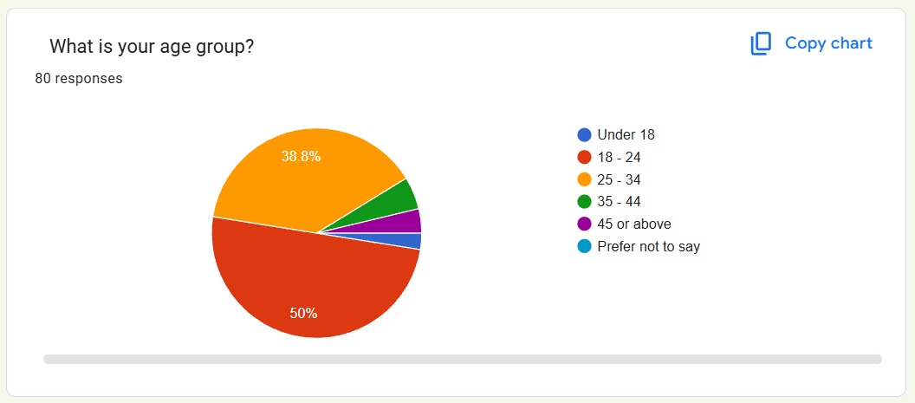
Figure 1: Age Group Distribution of Survey Participants (Question 1; N = 80)
Age Bracket | Frequency (n) | Percentage (%)
Under 18 | 2 | 2.5%
18 - 24 | 40 | 50.0%
25 - 34 | 31 | 38.8%
35 - 44 | 4 | 5.0%
45 or above | 3 | 3.8%
Total | 80 | 100.0%

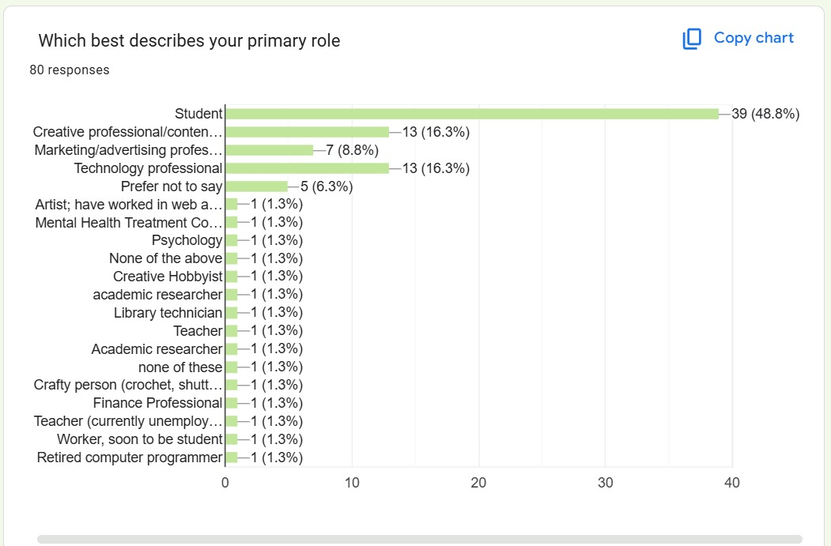
Figure 2: Primary Professional Roles of Survey Participants (Question 2; N = 80)
Primary Professional Role | Frequency (n) | Percentage (%)
Student | 39 | 48.8%
Creative professional / content creator | 13 | 16.3%
Technology professional | 13 | 16.3%
Marketing / advertising professional | 7 | 8.8%
Prefer not to say | 5 | 6.3%
Other specialized categories | 3 | 3.8%
Total | 80 | 100.0%

Regarding the frequency of tool usage (Question 3), a distinct operational division is evident: 43.8% of participants (n = 35) claim to have never employed Generative AI tools (serving as a solid baseline for assessing straightforward consumer attitudes), while 56.2% (n = 45) confirm they actively engage with these tools at various intervals (with 15.0% using GenAI daily), establishing the defined creator subgroup analyzed subsequently.
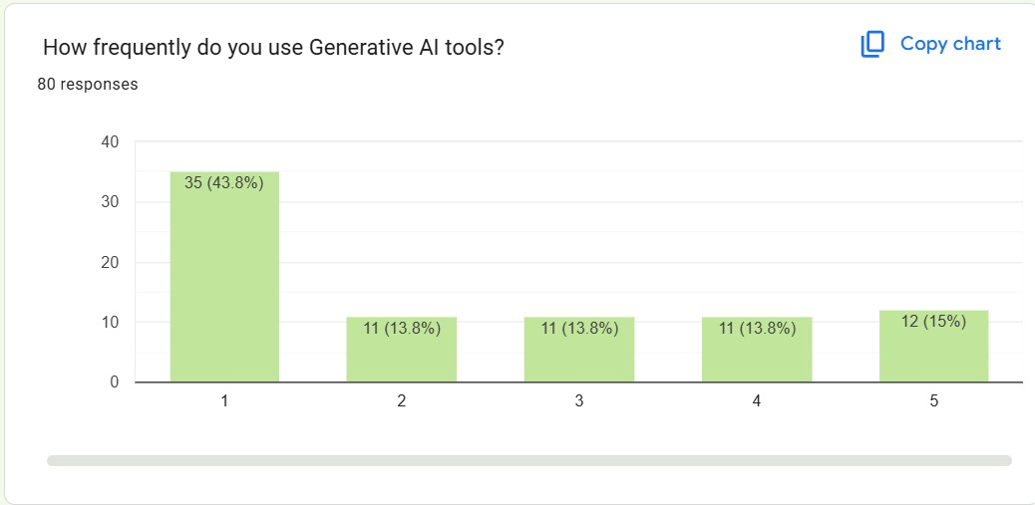
Figure 3: Frequency of Generative AI Tool Usage (Question 3; 1=Never, 5=Frequently; N = 80)
Usage Frequency Rating (1-5) | Frequency (n) | Percentage (%) | Description
1 - Never | 35 | 43.8% | Non-user / Pure Consumer
2 - Rarely | 11 | 13.8% | Occasional experimentation
3 - Moderately | 11 | 13.8% | Intermittent workflow use
4 - Often | 11 | 13.8% | Regular operational use
5 - Frequently | 12 | 15.0% | Daily intensive adoption
Total Respondents | 80 | 100.0% | Mean: 2.33 / 5.0 (StdDev: 1.48)

5.1.1 Exposure and recognition of AI advertising (n = 80)
There is substantial exposure to advertisements generated by AI. A remarkable 62.5% encounter such ads daily or multiple times within a single day, and an additional 30.0% encounter them a few times weekly, meaning that 92.5% come across them at least once each week. The ability to identify such advertisements is notably high: 70.0% rated their confidence at 4 or 5 on a five-point scale, while 23.8% opted for a 3, and only 6.3% rated it at 1 or 2. Moreover, 83.8% of participants reported an improvement in their ability to recognize AI-generated content over time (with 37.5% indicating a significant increase and 46.3% noting a slight enhancement), while 12.5% perceived no change at all.
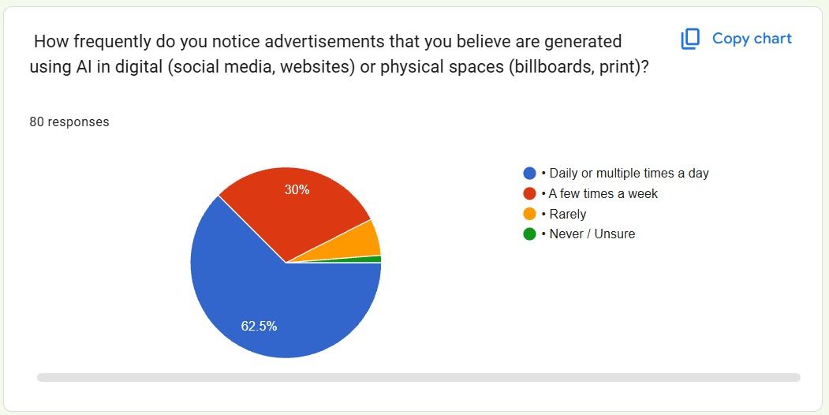
Figure 4: Frequency of Encountering AI Advertisements (Question 17; N = 80)
AI Advertisement Exposure Frequency | Frequency (n) | Percentage (%)
Daily or multiple times a day | 50 | 62.5%
A few times a week | 24 | 30.0%
Rarely | 5 | 6.3%
Never / Unsure | 1 | 1.3%
Total Respondents | 80 | 100.0%

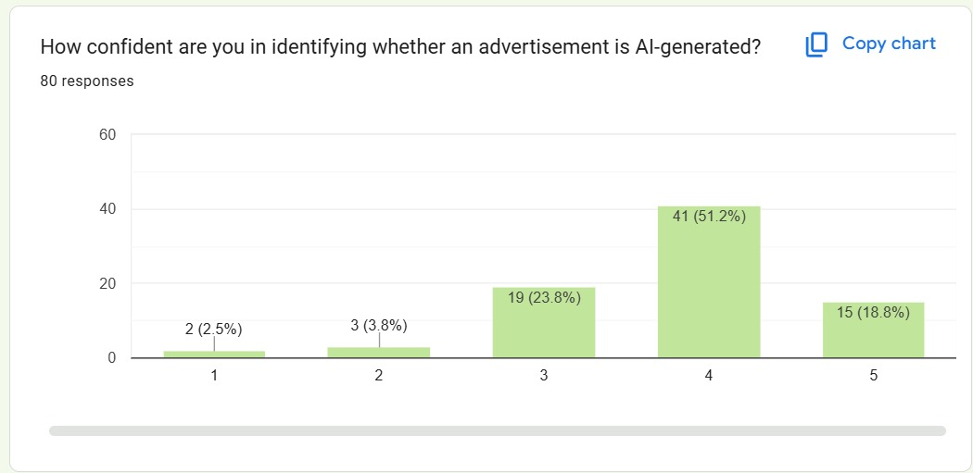
Figure 5: Confidence in Identifying AI Advertisements (Question 18; 1=Not confident, 5=Very Confident; N = 80)
Detection Confidence Rating (1-5) | Frequency (n) | Percentage (%) | Confidence Level
1 - Not confident at all | 2 | 2.5% | Low Acuity: 6.3%
2 | 3 | 3.8% | Low Acuity
3 - Moderately confident | 19 | 23.8% | Moderate Acuity: 23.8%
4 - Confident | 41 | 51.2% | High Acuity: 70.0%
5 - Very Confident | 15 | 18.8% | High Acuity
Total Respondents | 80 | 100.0% | Mean: 3.80 / 5.0 (StdDev: 0.86)

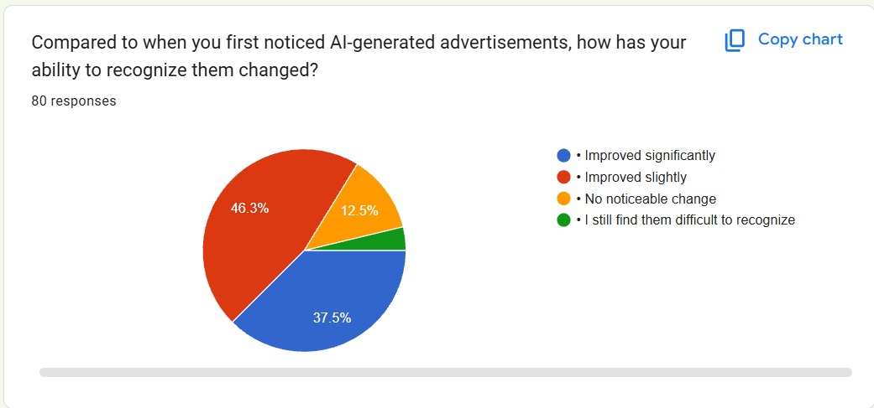
Figure 6: Evolution of Ability to Recognize AI Advertisements Over Time (Question 21; N = 80)
Recognition Acuity Change | Frequency (n) | Percentage (%) | Longitudinal Trend
Improved slightly | 37 | 46.3% | Enhanced Discernment: 83.8%
Improved significantly | 30 | 37.5% | Enhanced Discernment
No noticeable change | 10 | 12.5% | Static Acuity: 12.5%
I still find them difficult to recognize | 3 | 3.8% | Persistent Difficulty: 3.8%
Total | 80 | 100.0% | Rapid Consumer Learning Curve

Respondents primarily identify AI-generated advertisements by their visual characteristics rather than by explicit labels. The most prevalent indicator was an excessively polished or artificial look (70 respondents, 87.5%), followed by implausible visual elements (62, 77.5%) and any mention of AI disclosure or labels (26, 32.5%). Merely 2 respondents (2.5%) mentioned they typically struggle to distinguish them. A few isolated observations, such as the consistency in artistic styles across different ads, feelings of eeriness, and unusual sentence constructions, support this finding. This aligns with the research by Gu et al. (2024), which associates apparent digital polish and textural irregularities with discomfort. This contrasts with Bellaiche et al. (2023), who found that AI-generated art and human-created art were indistinguishable without labels, though the survey reflects self-reported confidence rather than tested accuracy.
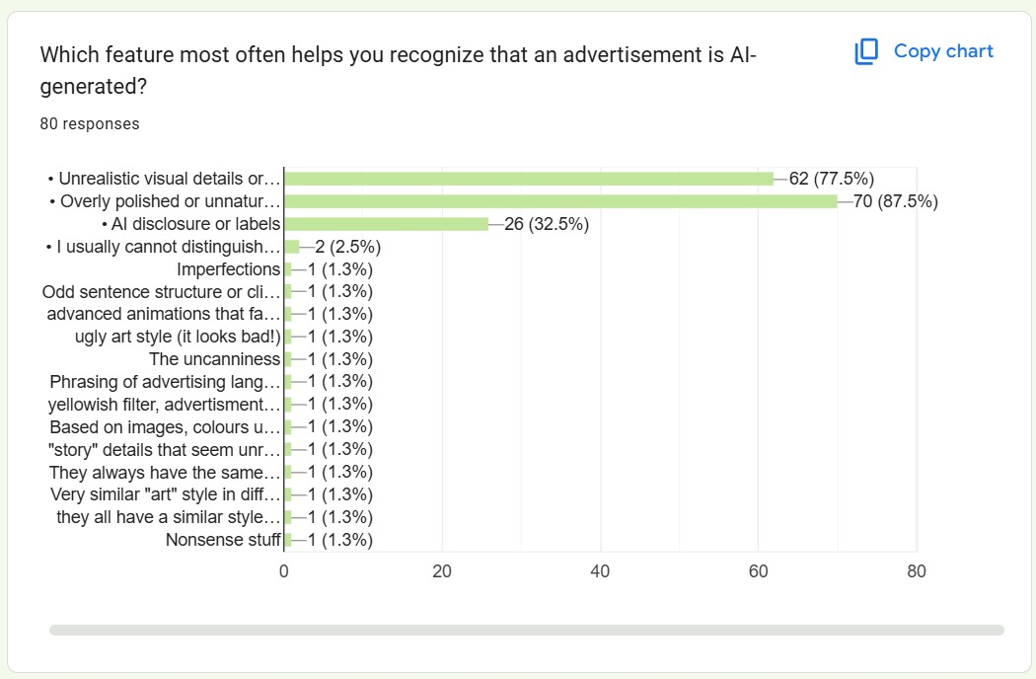
Figure 7: Primary Visual Cues Used to Identify AI Advertisements (Question 19; Multi-Select; N = 80)
Detection Cue / Diagnostic Feature | Responses (n) | Percentage (%) | Detection Heuristic
Overly polished or unnatural appearance | 70 | 87.5% | Uncanny aesthetic sheen
Unrealistic visual details or artifacts | 62 | 77.5% | Anatomy / perspective flaws
AI disclosure or labels | 26 | 32.5% | Formal transparency tags
I usually cannot distinguish AI advertisements | 2 | 2.5% | Detection failure (Negligible)

5.1.2 Perceived reasons for AI advertising (n = 80, multi-select)
Participants view the prevalence of AI advertising as a reflection of advertisers’ desire for efficiency. The aspects of reduced production expenses (67 respondents, 83.8%) and quicker content creation (58, 72.5%) are significantly more recognized than advancements in AI technologies (25, 31.3%) and tailored advertising strategies (13, 16.3%). Few believe there is an advantage to the consumers. This perspective is consistent with the findings of Sands et al. (2025) and Bhoumik (2026), who portray the adoption of AI as indicative of corporate cost-cutting and a lack of commitment.
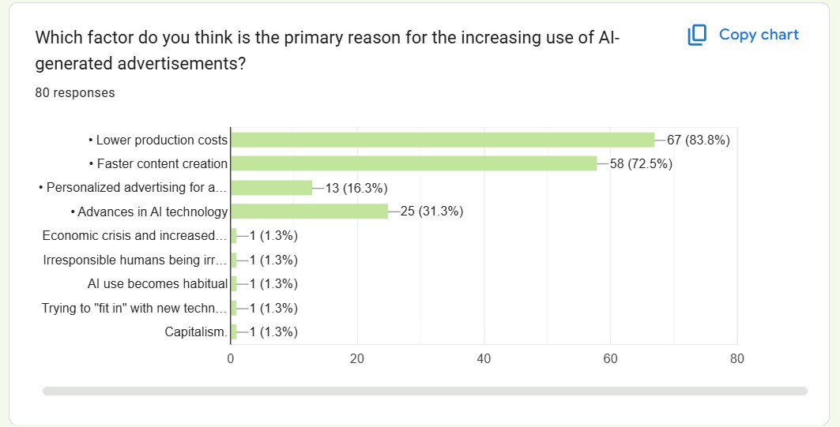
Figure 8: Inferred Primary Drivers for Expanding Use of AI in Advertising (Question 20; Multi-Select; N = 80)
Perceived Commercial Driver | Responses (n) | Percentage (%) | Inferred Motivation
Lower production costs | 67 | 83.8% | Corporate budget reduction
Faster content creation | 58 | 72.5% | Velocity / Turnaround acceleration
Advances in AI technology | 25 | 31.3% | Technological enablement
Personalized advertising for audiences | 13 | 16.3% | Consumer value enhancement

5.1.3 Trust and perception of creators and brands (n = 80)
Regarding the trust aspect, 67.5% (54 individuals) selected 1, 13.8% (11 individuals) opted for 2, 12.5% picked 3, 5.0% went with 4, and only 1.3% chose 5, indicating that 81.3% of participants feel a significant decline in trust towards the information presented (67.5% indicating 1: 'Trust Decreases Significantly', and 13.8% choosing 2: 'Trust Decreases Moderately'), while merely 6.3% noted an increase in trust.
Perceptions regarding the creator or brand are predominantly unfavorable. A significant 66.3% express a strongly negative sentiment, viewing the creator as unmotivated or misleading, while 25.0% hold a slightly negative view, regarding the work as less genuine. This totals to 91.3%, with just 8.7% feeling neutral or positive.
When respondents were queried about which aspects of the creator were negatively impacted, they had the option to select multiple answers. The authenticity of the work topped the list (63, 78.8%) along with the perceived effort put forth (62, 77.5%), followed closely by the level of skill or talent (56, 70.0%) and trustworthiness or integrity (53, 66.3%). Only one individual (1.3%) did not select any.
Thus, the repercussions reach the individual or brand associated with the content, as noted in Sands et al. (2025) and Toff and Simon (2025). The elevated ratings concerning authenticity and effort bolster the authenticity pathway (Raj et al., 2026; Shi & Jiang, 2026) as well as the effort heuristic (Bhoumik, 2026). The fact that 70.0% also indicate that perceived skill is impacted suggests that audiences conclude a decrease in ability, not merely in effort.
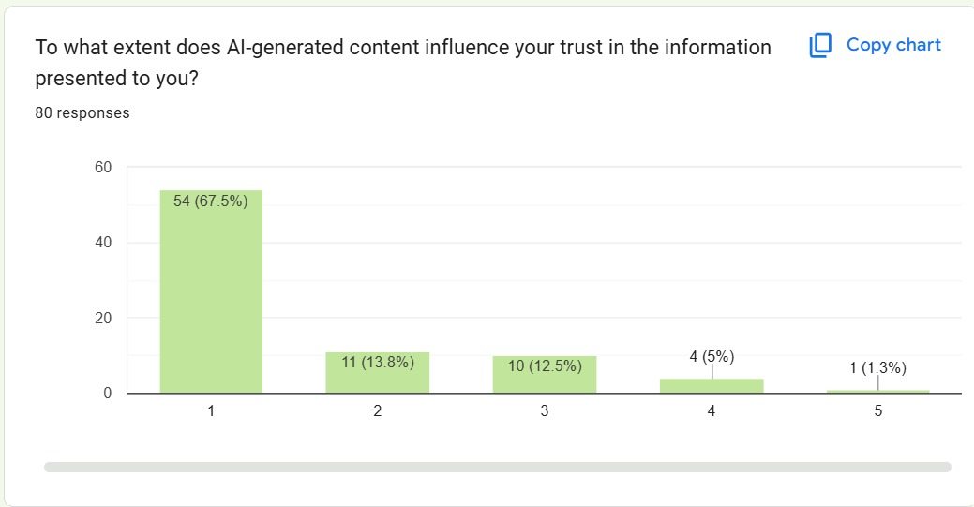
Figure 9: Impact of AI-Generated Content on Trust in Information (Question 22; 1=Decreases Trust, 5=Increases Trust; N = 80)
Trust Influence Rating (1-5) | Frequency (n) | Percentage (%) | Epistemic Consequence
1 - Decreases Trust Significantly | 54 | 67.5% | Catastrophic Trust Loss: 81.3%
2 - Decreases Trust Moderately | 11 | 13.8% | Trust Loss
3 - Neutral / No Impact | 10 | 12.5% | Indifferent: 12.5%
4 - Increases Trust Moderately | 4 | 5.0% | Trust Gain: 6.3%
5 - Increases Trust Significantly | 1 | 1.3% | Trust Gain
Total Respondents | 80 | 100.0% | Mean: 1.59 / 5.0 (Severe Epistemic Deficit)

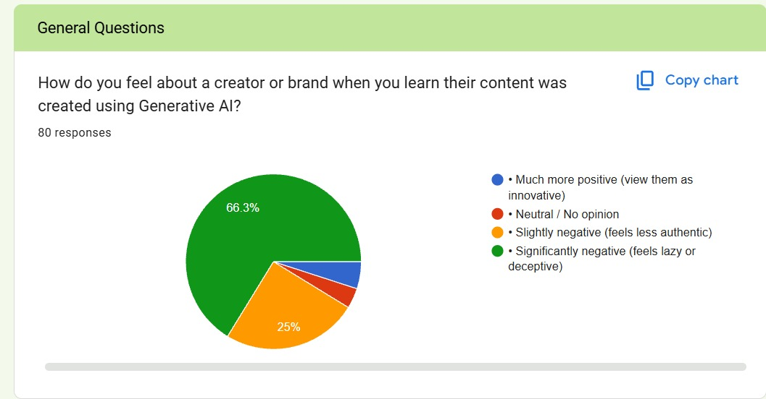
Figure 10: Consumer Sentiment Toward Creator/Brand Upon Learning AI Was Used (Question 13; N = 80)
Consumer Reaction Category | Frequency (n) | Percentage (%) | Interpretation
Much more positive (view them as innovative) | 4 | 5.0% | Positive endorsement
Neutral / No opinion | 3 | 3.8% | Indifferent
Slightly negative (feels less authentic) | 20 | 25.0% | Authenticity deficit
Significantly negative (feels lazy or deceptive) | 53 | 66.3% | Severe reputational rejection
Total Participants | 80 | 100.0% | 91.3% Net Negative Sentiment

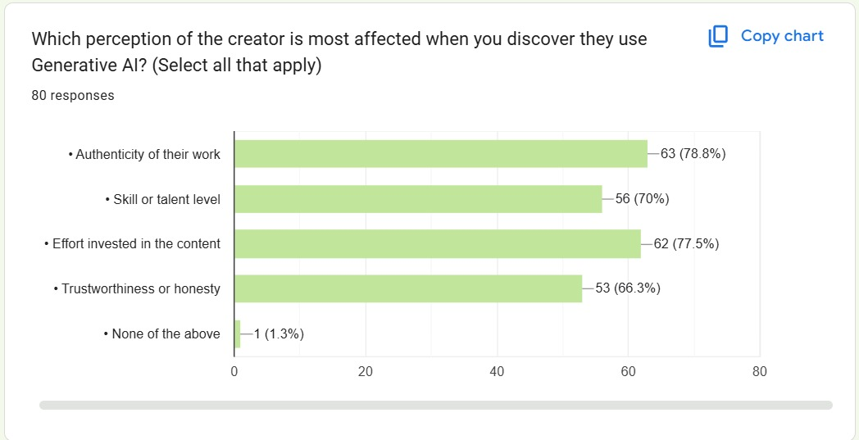
Figure 11: Creator Perceptions Most Affected by AI Discovery (Question 14; Multi-Select; N = 80)
Damaged Perceptual Dimension | Responses (n) | Percentage (%) | Rank
Authenticity of their work | 63 | 78.8% | 1
Effort invested in the content | 62 | 77.5% | 2
Skill or talent level | 56 | 70.0% | 3
Trustworthiness or honesty | 53 | 66.3% | 4
None of the above | 1 | 1.3% | 5

5.1.4 Effect of disclosure (n = 80)
Disclosure provides some assistance, but it is limited. A total of 57.5% indicated that it offers minimal help, yet their views still decline, while 27.5% believe that undisclosed AI usage is significantly more detrimental than when it is disclosed. Only 13.8% noticed no change, and 1.3% expressed indifference. Therefore, 85.0% favor transparency over secrecy; however, the majority indicate that it does not mend the harm caused. This aligns with the findings of Raj et al. (2026), which revealed that disclosure itself diminished overall assessments and implies that the negative impact is associated with the use of AI, rather than just with the act of being deceived.
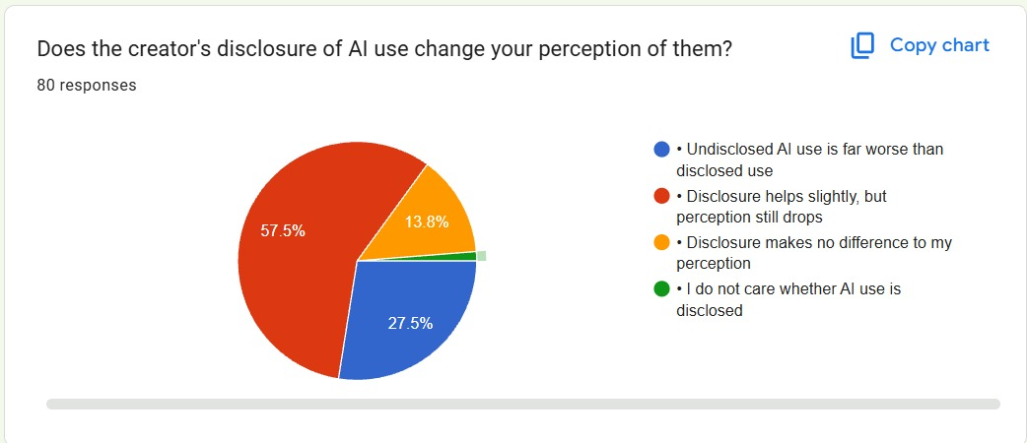
Figure 12: Impact of Creator AI Disclosure on Audience Perception (Question 15; N = 80)
Disclosure Reaction Category | Frequency (n) | Percentage (%) | Analytical Takeaway
Disclosure helps slightly, but perception still drops | 46 | 57.5% | Disclosure cannot reverse penalty
Undisclosed AI use is far worse than disclosed use | 22 | 27.5% | Deception penalty is acute
Disclosure makes no difference to my perception | 11 | 13.8% | Fixed origin devaluation
I do not care whether AI use is disclosed | 1 | 1.3% | Indifference is virtually nonexistent
Total Respondents | 80 | 100.0% | The Disclosure Dilemma Confirmed

5.1.5 Behavioural disengagement (n = 80, multi-select)
This represents the primary contribution of the research. A total of 87.5% (70 participants) took at least one action upon realizing that a creator utilized AI-generated content, while merely 10 individuals (12.5%) maintained their usual level of interaction. The action most frequently taken was a decrease in engagement, which included lesser liking, sharing, or buying (62 individuals, 77.5%), followed by unfollowing or unsubscribing (49 individuals, 61.3%) and blocking or hiding the creator or channel (41 individuals, 51.2%). One out of four respondents (20 individuals, 25.0%) terminated a paid subscription, membership, or intended purchase, and 12 individuals (15.0%) expressed their dissatisfaction through negative comments.
Although lower-cost actions were prevalent, a quarter of the participants indeed opted to withdraw funds. Hence, negative sentiments were reflected in their actions, addressing the discrepancy highlighted in Section 3 (where attitudes are frequently assessed, but behaviors are seldom examined). The findings do not replicate the 'implicit acceptance versus explicit rejection' contradiction found in existing literature, despite the fact that 92.5% still frequently encounter AI advertisements. These actions are based on self-reports (Section 4.9).
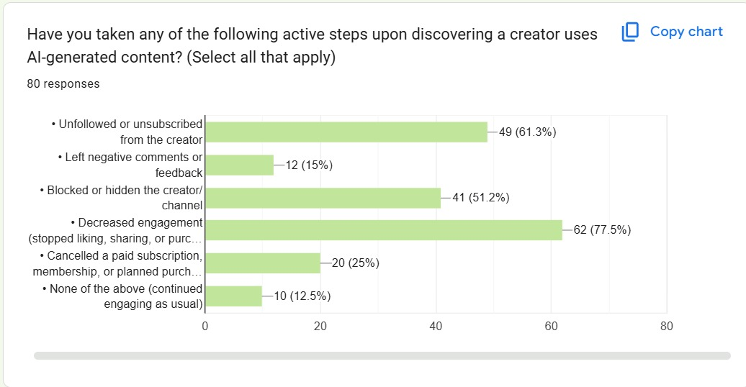
Figure 13: Active Behavioral Disengagement Steps Taken (Question 16; Multi-Select; N = 80)
Active Behavioral Disengagement Action | Frequency (n) | Percentage (%) | Severity Level
Decreased engagement (stopped liking, sharing, purchasing) | 62 | 77.5% | Broad social withdrawal
Unfollowed or unsubscribed from the creator | 49 | 61.3% | Audience severance
Blocked or hidden the creator / channel | 41 | 51.2% | Platform-level filter / suppression
Cancelled a paid subscription, membership, or purchase | 20 | 25.0% | Direct financial boycott
Left negative comments or feedback | 12 | 15.0% | Public vocal pushback
None of the above (continued engaging as usual) | 10 | 12.5% | Passive tolerance (Minority)

5.1.6 Creators: productivity and time savings (n = 47–51)
The advantages in productivity are present, although they are modest and inconsistent. About half of the creators (47.9%) report saving less than two hours each week, 29.2% save two to five hours, 10.4% benefit from six to ten hours saved, and 12.5% achieve savings exceeding ten hours, meaning that 77.1% are saving under five hours. Views regarding whether GenAI has reduced development time are mixed: 41.7% selected ratings of 4 or 5, 27.1% rated it as a 3, and 31.3% indicated 1 or 2. The claim that GenAI has greatly boosted output and sped up processes received nearly equal levels of agreement (43.1%) and disagreement (39.2%), with 17.6% remaining neutral.
When participants were asked to identify the most beneficial change, 30.6% said there were none. The remaining individuals pointed to fewer repetitive tasks (24.5%), the capacity to perform complex technical tasks without previous skills (20.4%), quicker idea generation (14.3%), and improved aesthetic or structural quality (10.2%).
These improvements are less significant than those noted by Noy and Zhang (2023) and Zhou and Lee (2024). The most appreciated changes, namely fewer repetitive tasks and the ability to handle technical work without existing skills, align with evidence that GenAI assists users with less experience (Doshi & Hauser, 2024), even though the survey did not assess skill levels.
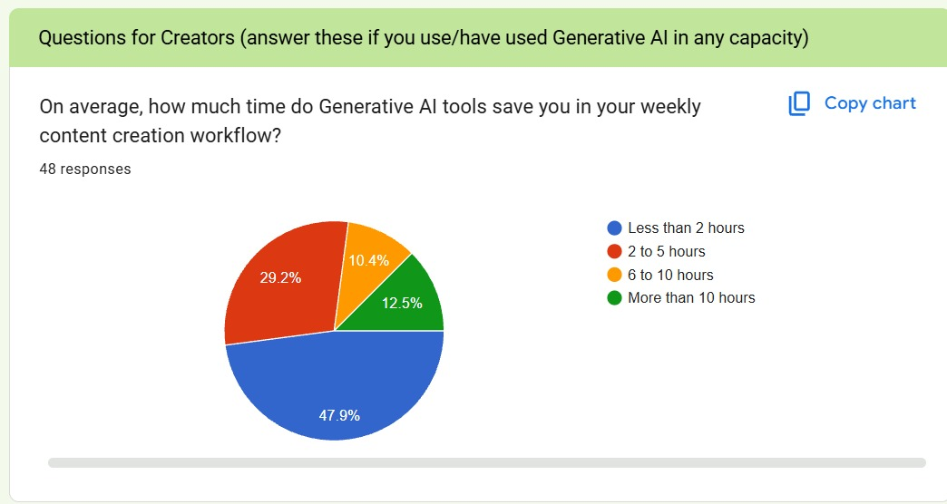
Figure 14: Distribution of Weekly Hours Saved by Generative AI (Question 4; N = 48)
Weekly Time Saved Category | Frequency (n) | Percentage (%) | Cumulative %
Less than 2 hours | 23 | 47.9% | 47.9%
2 to 5 hours | 14 | 29.2% | 77.1%
6 to 10 hours | 5 | 10.4% | 87.5%
More than 10 hours | 6 | 12.5% | 100.0%

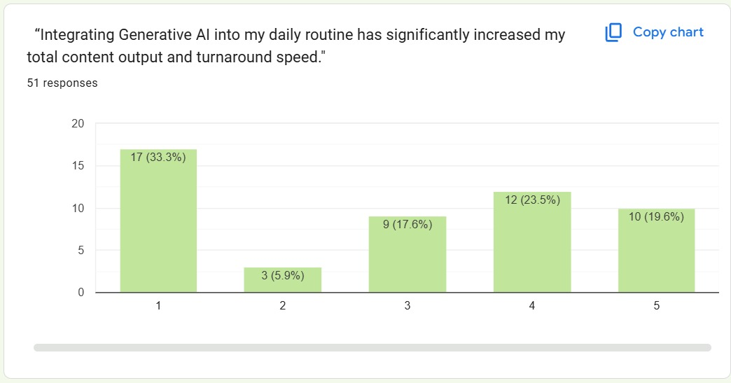
Figure 15: Agreement on Output Acceleration & Turnaround Speed (Question 5; 1=Strongly Disagree, 5=Strongly Agree; N = 51)
Likert Scale Rating | Frequency (n) | Percentage (%) | Interpretation
1 - Strongly Disagree | 17 | 33.3% | High velocity rejection
2 - Disagree | 3 | 5.9% | Mild disagreement
3 - Neutral | 9 | 17.6% | Negligible change
4 - Agree | 12 | 23.5% | Meaningful speed gain
5 - Strongly Agree | 10 | 19.6% | Transformative speed gain
Total Valid Responses | 51 | 100.0% | Mean: 2.90 / 5.0 (StdDev: 1.57)

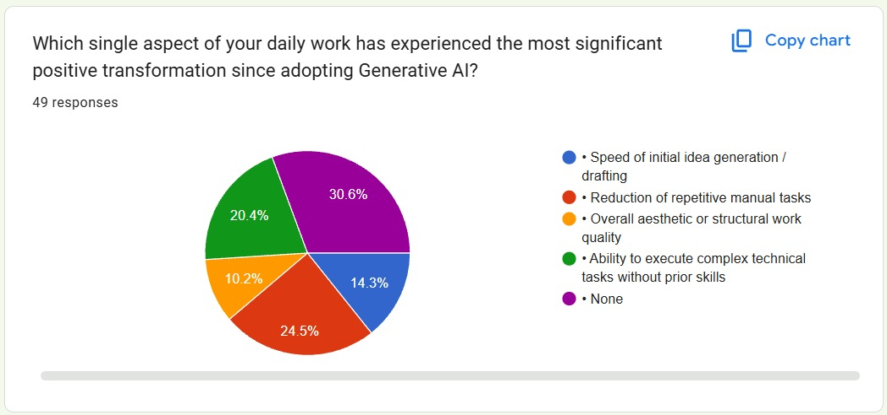
Figure 16: Aspect Experiencing Most Significant Positive Transformation (Question 8; N = 49)
Transformed Workflow Dimension | Frequency (n) | Percentage (%)
None | 15 | 30.6%
Reduction of repetitive manual tasks | 12 | 24.5%
Ability to execute complex technical tasks without prior skills | 10 | 20.4%
Speed of initial idea generation / drafting | 7 | 14.3%
Overall aesthetic or structural work quality | 5 | 10.2%
Total Valid Responses | 49 | 100.0%

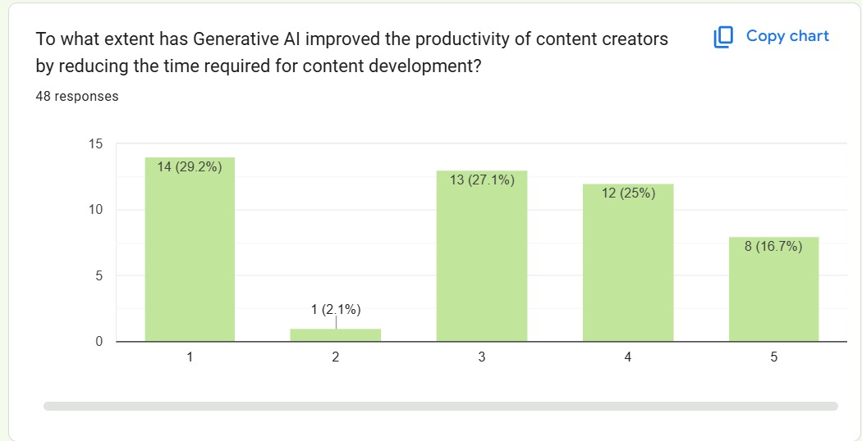
Figure 17: Extent GenAI Improved Productivity via Time Reduction (Question 9; 1=Not at all, 5=Very Significantly; N = 48)
Productivity Rating (1-5) | Frequency (n) | Percentage (%) | Interpretation
1 - Not at all | 14 | 29.2% | No measurable productivity boost
2 | 1 | 2.1% | Minimal productivity boost
3 | 13 | 27.1% | Moderate productivity boost
4 | 12 | 25.0% | Substantial productivity boost
5 - Very Significantly | 8 | 16.7% | High productivity transformation
Total | 48 | 100.0% | Mean: 2.98 / 5.0 (StdDev: 1.45)

5.1.7 Creators: quality, control, and originality (n = 47–50)
Creators indicate that the disadvantages outweigh the advantages concerning quality and oversight. When evaluating work supported by AI against traditional methods, 48.9% considered it to be of lesser quality (25.5% significantly lower, 23.4% moderately lower), while 38.3% deemed it to be of better quality (10.6% significantly higher, 27.7% moderately higher), and 12.8% felt it was of equal quality. Regarding creative control, 58.3% believed AI tools reduced their level of control (33.3% slightly reduced, 25.0% substantially reduced), 22.9% perceived no change, and 18.8% felt it increased.
This finding aligns with the observations made by Chang et al. (2023) regarding the effort required for curation and the loss of control, reinforcing the 'creator reality gap' noted in Section 3: while time savings are minimal, there is a relinquishment of control.
The impact on originality was noted to be less significant. In a five-point scale, 34% selected 1, 14% selected 2, 32% chose 3, 12% opted for 4, and 8% picked 5, illustrating that nearly half of the active creators (48.0%) report a negative influence on their originality and independent creative thought (34.0% very negatively, 14.0% negatively), in contrast to 32.0% indicating no effect and merely 20.0% recognizing a positive influence. The declines in diversity and innovation documented by Doshi and Hauser (2024) as well as Zhou and Lee (2024) manifest across numerous outputs and throughout time, which an individual creator may overlook in their own creations.
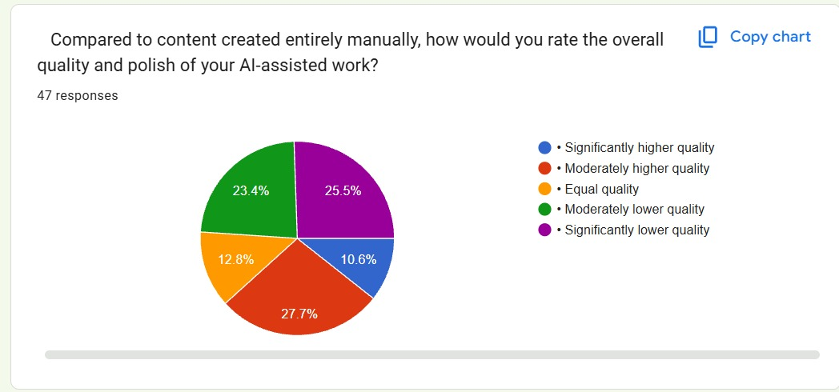
Figure 18: Quality and Polish of AI-Assisted Work Compared to Manual Production (Question 7; N = 47)
Perceived Work Quality Category | Frequency (n) | Percentage (%) | Grouping
Significantly higher quality | 5 | 10.6% | Higher Quality: 38.3%
Moderately higher quality | 13 | 27.7% | Higher Quality
Equal quality | 6 | 12.8% | Equivalent: 12.8%
Moderately lower quality | 11 | 23.4% | Lower Quality: 48.9%
Significantly lower quality | 12 | 25.5% | Lower Quality
Total Valid Responses | 47 | 100.0% | Net Negative Quality Sentiment

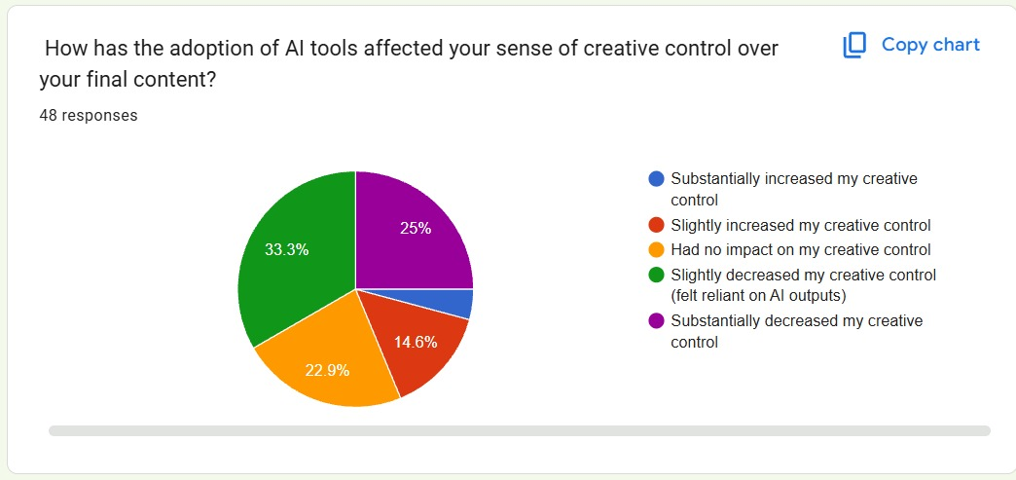
Figure 19: Impact of Generative AI on Sense of Creative Control (Question 6; N = 48)
Impact on Creative Control | Frequency (n) | Percentage (%) | Categorical Grouping
Substantially increased my creative control | 2 | 4.2% | Enhanced Agency (18.8%)
Slightly increased my creative control | 7 | 14.6% | Enhanced Agency
Had no impact on my creative control | 11 | 22.9% | Preserved Agency (22.9%)
Slightly decreased (felt reliant on AI outputs) | 16 | 33.3% | Eroded Agency (58.3%)
Substantially decreased my creative control | 12 | 25.0% | Eroded Agency

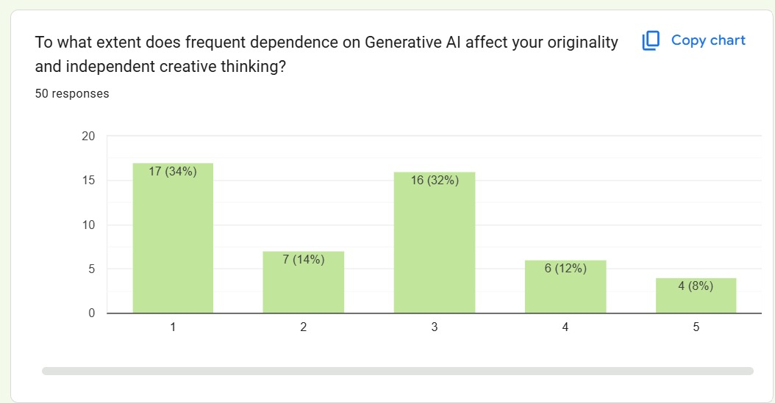
Figure 20: Effect of GenAI Dependence on Originality & Creative Thinking (Question 10; 1=Negatively, 5=Very Positively; N = 50)
Originality Impact Rating (1-5) | Frequency (n) | Percentage (%) | Interpretation
1 - Negatively | 17 | 34.0% | Acute loss of original thinking
2 | 7 | 14.0% | Mild erosion of creative thought
3 - Neutral | 16 | 32.0% | No discernible impact
4 | 6 | 12.0% | Mildly positive impact
5 - Very Positively | 4 | 8.0% | Substantial creative stimulation
Total Valid Responses | 50 | 100.0% | Mean: 2.46 / 5.0 (48.0% Net Negative)

5.1.8 Ethical concerns and employment outlook (n = 55)
Concerns regarding ethics related to copyright, privacy, and the spread of misinformation heavily influence the readiness to adopt GenAI: 52.7% rated it a 5 and 21.8% rated it a 4, resulting in a total of 74.5%, compared to 9.1% who rated it a 1 or 2. Concerning employment, 72.7% anticipate that GenAI will diminish job prospects for professional creators within the upcoming five years (49.1% foresee a decrease, while 23.6% expect a significant decrease). An additional 10.9% believe there will be minimal or no effect, and 16.3% forecast an increase in opportunities (12.7% to some extent, 3.6% substantially). These perspectives align with the existing literature on issues such as intellectual property, displacement, and deskilling (Murray, 2023; Zhang et al., 2023; Xu et al., 2024).
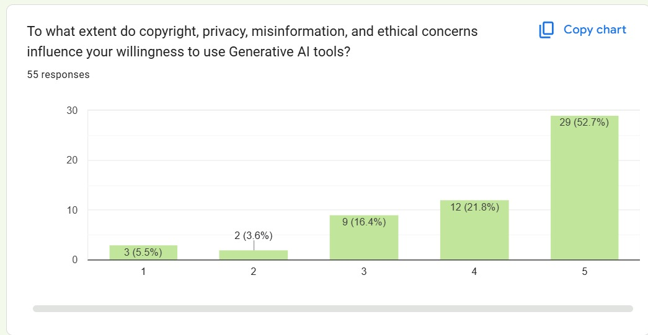
Figure 21: Influence of Ethics, Copyright & Privacy on AI Adoption (Question 11; 1=No Influence, 5=Major Influence; N = 55)
Influence Rating (1-5) | Frequency (n) | Percentage (%) | Significance
1 - No Influence | 3 | 5.5% | Unaffected by ethical concerns
2 | 2 | 3.6% | Low ethical friction
3 | 9 | 16.4% | Moderate consideration
4 | 12 | 21.8% | High ethical concern
5 - Major Influence | 29 | 52.7% | Decisive ethical inhibitor
Total | 55 | 100.0% | Mean: 4.13 / 5.0 (74.5% High Influence)

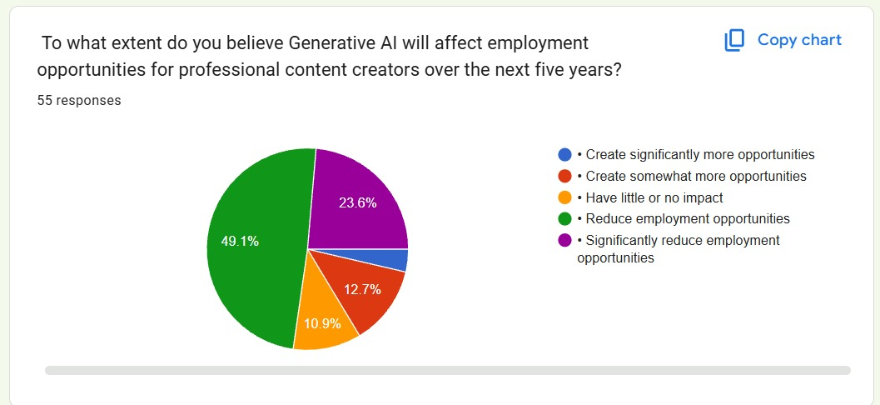
Figure 22: Projected Impact on Creator Employment Opportunities Over Next 5 Years (Question 12; N = 55)
5-Year Employment Projection | Frequency (n) | Percentage (%) | Categorical Outlook
Create significantly more opportunities | 2 | 3.6% | Optimistic: 16.3%
Create somewhat more opportunities | 7 | 12.7% | Optimistic
Have little or no impact | 6 | 10.9% | Neutral: 10.9%
Reduce employment opportunities | 27 | 49.1% | Pessimistic: 72.7%
Significantly reduce employment opportunities | 13 | 23.6% | Pessimistic
Total Valid Responses | 55 | 100.0% | Severe Labor Disruption Expected

5.2 Themes from Open-Ended Responses
The open-ended replies offer further understanding regarding how individuals perceive the increasing application of Generative Artificial Intelligence (GenAI) within creative industries, marketing, and digital media consumption. The replies were analyzed thematically to uncover common views, worries, and the circumstances under which participants might embrace AI-generated material. Six principal themes emerged: diminished authenticity and human creativity, concerns about jobs and economics, issues of copyright and privacy, validity and misinformation, ecological consequences, and the necessity of clarity and human contribution.
Theme 1: Decline of Authenticity and Human Creativity
A significant theme that emerged was the perceived erosion of authenticity, uniqueness, and human engagement in creative endeavors. Numerous respondents believed that AI-generated outputs lacked the emotional depth, personal input, and distinctiveness typically present in human-created works. Additionally, some raised apprehensions that an increased reliance on GenAI might undermine individual thought processes and creative abilities.
One individual remarked, "Creative content loses its human essence, diminishing its allure. It does not elicit the intended feelings and seems artificial and hollow. "
Another participant noted that they had gained “greater appreciation for art created by people, even if it’s flawed. ”
These sentiments imply that respondents assess artistic content not just based on visual appeal or quality but also by the human effort and intent that contribute to it. This theme aligns with the quantitative results in Section 5.1.3, where authenticity and effort were identified as aspects significantly influenced by the implementation of GenAI. It also relates to Section 5.1.7, indicating that 58.3% of creators felt a decline in their creative authority.
Theme 2: Job and Economic Worries for Human Creators
Another common worry was the potential for GenAI to diminish job prospects and earnings for artists, designers, writers, and other creative professionals. Respondents conveyed concern that businesses might deploy AI mainly to cut costs instead of providing fair compensation for human creators. Some expressed fears that the rising availability of low-cost AI-generated content would hinder new artists from acquiring experience and building their professional identities.
One participant stated, “I think AI-generated content encourages companies to avoid paying individuals for creative roles, meaning creative professionals are missing out on paid opportunities. ”
Another described the potential impact on creative professions as a “Significant setback for human creators regarding job openings, income, and so forth. ”
These comments reveal that respondents considered the integration of GenAI to be an issue that encompasses economic and professional dimensions in addition to its technological aspects. This theme supports the findings in Section 5.1.8, where 72.7% of participants anticipated that GenAI would lead to a decrease in job opportunities for professional content creators over the next five years.
Theme 3: Copyright, Privacy, and Consent
Participants expressed worries regarding the application of already existing creative pieces and personal data for training or producing AI content. The primary concerns involved unauthorized usage of artists' creations, instances of plagiarism, insufficient crediting, and the acquisition or application of information without express permission. These apprehensions indicate that the acceptance of GenAI is partly contingent upon whether its creation and application are perceived as just and legal.
One participant encapsulated this worry with the phrase "theft of art, ecological harm due to data centers, and unequal effects on underrepresented groups. "
Another individual remarked that they would be more inclined to interact with AI-generated material if "the databases exclusively featured work that artists permitted to be utilized. "
These reactions emphasize the significance of consent, proper attribution, and ethical data handling. They further underline the ethical dilemmas explored in Section 5.1.8, where issues surrounding copyright, privacy, misinformation, and related ethical challenges significantly shaped participants’ openness toward GenAI.
Theme 4: Misinformation, Deception, and Reliability
Participants raised alarms about the potential for AI-generated ads and various digital content to misrepresent products, harbor inaccuracies, or blur the line between genuine information and fabricated content. Several respondents noted that they have grown more wary about online material and often verify whether advertisements or pictures accurately reflect the promoted products.
One participant stated, "It might deceive consumers by marketing products/services that are more attractive than what is actually provided. "
Another noted, "I fear that individuals (especially older family members) might be tricked by pictures that are not real, and I’m concerned for the future of artists. "
These insights reveal that the perceived dangers of GenAI go beyond the quality of creative work to encompass consumer safety and trust in digital information. They align with the findings in Section 5.1.3 regarding diminished trust in creators and brands as well as Section 5.1.1 concerning how participants identify AI-created advertisements.
Theme 5: Environmental Impact and Wider Social Consequences
Sustainability for the environment was another prominent concern. Respondents pointed out the ecological toll linked to AI infrastructure, including data centers and consumption of resources. Some related these worries to broader inquiries about whether the speed of content generation adequately justifies its ecological and societal impacts.
One respondent expressed unease about "The impact it has and will perpetuate on the environment," in addition to unemployment and opportunities lost for individuals to create autonomously.
Another participant underscored "the severe negative environmental repercussions, the individuals whose employment is lost, and the communities devastated by Gen AI data centers. "
This theme illustrates that participants viewed GenAI in a larger ethical framework, instead of assessing it solely based on convenience or efficiency. It aligns with the ethical concerns noted in Section 5.1.8 and suggests that thoughtful integration must take into account ecological and social ramifications alongside technical efficacy.
Theme 6: Openness and Significant Human Participation
While a considerable number of participants voiced their strong disapproval of creative content produced by AI, some mentioned that their willingness to accept it might increase if creators revealed their use of AI, verified the correctness of the results, and maintained significant human participation. Generally, respondents showed a greater inclination to view AI as a complementary tool rather than a substitute for human creativity. They proposed several conditions, which included explicit labeling, ethical use of training information, human oversight, and the selective application of AI for activities like brainstorming or organizing.
One participant remarked, “If it is distinctly marked as AI-generated, verified by a person for accuracy, while still being creative and beneficial, rather than deceptive or misleading. ”
Another noted that their acceptance hinged on “Clear revelation and openness regarding where it was utilized, the purpose and method of use, and making sure it's not employed unnecessarily. ”
Nonetheless, some participants were not prepared to change their stance. A few explicitly indicated that no conditions could make them trust or engage with AI-produced creative work. This difference suggests that while transparency may enhance acceptance for certain groups, it might not alleviate fundamental dissent among others.
This theme corresponds with Section 5.1.4, where 85.0% indicated a preference for disclosure over secrecy, although 57.5% observed that their perception still diminished even in cases where there was acknowledgment of AI use.
Comprehensive Interpretation of the Open-Ended Feedback
In general, the responses to open-ended questions illustrate a conflict between the practical advantages of GenAI and worries about its impact on human creativity, job availability, authenticity, and trust. Some respondents recognized benefits like quicker work processes, easier documentation, research assistance, and support for novices. However, numerous individuals expressed anxiety that these advantages might undermine human abilities, fair remuneration, trustworthy information, and significant creative expression.
The feedback also suggests that participants do not uniformly oppose all uses of GenAI for identical reasons. Some disapproved of its presence in creative fields entirely, while others were conditionally supportive when AI was applied selectively, clearly disclosed, and assessed by humans. These qualitative insights enhance the quantitative findings and reinforce the principal conclusion of the study: public acceptance of GenAI is influenced not only by its production capabilities but also by the manner of its application, the clarity of its involvement, and whether human creativity and accountability remain integral to the process.

5.3 Overall Survey Findings
The empirical findings across all 22 survey questions and qualitative open-ended responses reveal a profound systemic tension characterizing the contemporary generative AI landscape, defined here as the 'Dual Asymmetry' of Generative AI:
1. Answering Research Question 1 (The Creator 'Efficiency–Autonomy Paradox'): Although generative AI tools contribute to slight reductions in working hours (77.1% achieve less than 5 hours saved weekly, with 47.9% achieving under 2 hours) and enhance the drafting process for certain creators (43.1%), these improvements come with significant artistic and mental costs. A substantial portion (58.3%) experiences a decrease in creative autonomy and finds themselves reliant on algorithm-generated outputs, 48.9% regard AI-aided output as lower quality compared to traditional methods, and 48.0% notice a decline in their originality and independent thought. Claims from commercial entities of revolutionary tenfold productivity are therefore undermined by heavy requirements for prompt engineering and a decline in cognitive skills.
2. Answering Research Question 2 (Attitudinal Penalties and Concrete Behavioral Boycotts): A significant 91.3% of users express negative feelings upon discovering that a creator or brand employs generative AI, which greatly diminishes perceived authenticity (78.8%), assumed effort (77.5%), artistic talent (70.0%), and trustworthiness of the organization (66.3%). Importantly, this survey addresses a key gap in the current literature by illustrating that consumer dissatisfaction translates directly into strong punitive measures: 87.5% have taken steps to actively disengage, which includes decreased social interactions (77.5%), unfollowing or unsubscribing (61.3%), blocking content channels (51.2%), and initiating direct financial boycotts by cancelling paid memberships or purchases (25.0%). Ethical mandatory disclosure (Question 15) is necessary but falls short: 57.5% indicate that perceptions still worsen even after such disclosure.
3. Answering Research Question 3 (Advertising Proliferation, Visual Acuity, and Epistemic Collapse): The prevalence of AI-driven advertisements has reached widespread levels (92.5% of individuals have recurrent exposure, 62.5% encounter them daily), yet consumers show remarkable detection abilities: 70.0% express high confidence in identifying these ads, while 83.8% feel that their ability to detect has improved over time. Consumers primarily recognize AI advertisements through perceptual cues that evoke strong reactions—particularly unnatural glossy finishes (87.5%) and visual errors (77.5%)—instead of relying on formal labels (32.5%), associating the use of AI with reductions in corporate spending (83.8%) and faster production speeds (72.5%) rather than benefits to viewers (16.3%). As a result, 81.3% report that AI-generated content erodes trust in the information presented (mean: 1.59 / 5.0), which constitutes a significant epistemic risk for commercial communicators.
4. Answering Research Question 4 (Ethical Friction and Structural Labor Precarity): Ethical concerns create substantial barriers to adoption: 74.5% indicate that issues such as copyright infringement, privacy breaches, and misinformation greatly influence their willingness to utilize generative AI (mean: 4.13 / 5.0). Additionally, 72.7% foresee negative implications for employment among professional creators over the next five years, with 23.6% predicting serious job losses. Thematic qualitative analysis supports that public resistance stems from a strong moral objection to the unauthorized appropriation of styles, data harvesting, and the perceived commercialization of human culture.
Master Theoretical Integration — The 'Dual Asymmetry': Creators sacrifice their creative authority and originality to gain minimal enhancements in workflow efficiency, ultimately generating artificial content that audiences easily recognize, which in turn leads to moral disapproval and punitive measures through decreased engagement and commercial boycotts. Thus, unfiltered AI production acts as a net detriment to both artistic integrity and economic brand value. To achieve sustainable integration, it is essential to establish transparent, human-focused co-creation frameworks where AI's role is confined to routine operational assistance under strict human editorial oversight.

6. CONCLUSIONS
This study examined the impact of generative AI on creators who use it and on consumers who encounter its output, combining a literature review with a mixed-methods survey of 80 respondents.
The literature showed that GenAI can raise creativity and productivity, especially for less-experienced users, while raising concerns about diversity, intellectual property, displacement, and deskilling. On the audience side, it showed that people devalue content once they know it is AI-made, mainly because of perceived authenticity and human effort, and that this distrust spreads to the creator or brand.
The survey supports the consumer side strongly. 91.3% feel negative toward a creator or brand that uses GenAI, authenticity (78.8%) and effort (77.5%) are the perceptions most affected, and 83.8% see lower production costs as a main reason for AI advertising. Most importantly, these attitudes turn into action: 87.5% took at least one step, including unfollowing (61.3%) and cancelling a paid subscription, membership, or planned purchase (25.0%). This fills the gap in the literature, which mostly measures attitudes and intentions.
The creator side is more mixed than the literature suggests. Respondents who use GenAI report modest time savings (77.1% save under five hours a week), and 58.3% report less creative control. Opinion on quality is divided, with 38.3% rating AI-assisted work higher and 48.9% lower. The most valued benefits are fewer repetitive tasks and the ability to do technical work without prior skills.
Overall, acceptance of GenAI depends less on whether it is used and more on how it is used and how openly. Disclosure matters (85.0% prefer it to concealment) but does not remove the penalty (57.5% say their perception still drops), so visible human effort and judgement appear central to keeping audience trust. Creators and audiences are moving in different directions: creators adopt GenAI for efficiency, while audiences devalue and distrust work known to be AI-made.

APPENDIX

The following are the questionnaires circulated through google forms

Section A: Demographic questions:
1. What is your age group?
· Under 18
· 18–24
· 25–34
· 35–44
· 45 or above
· Prefer not to say

2. Which best describes your primary role?
· Student
· Creative professional/content creator
· Marketing/advertising professional
· Technology professional
· Other
· Prefer not to say

3. How frequently do you use Generative AI tools?
· Never
· Rarely
· Sometimes
· Often
· Very frequently
Section B: Questions for Creators (answer these if you use/have used Generative AI in any capacity)
4. On average, how much time do Generative AI tools save you in your weekly content creation workflow?
· Less than 2 hours
· 2 to 5 hours
· 6 to 10 hours
· More than 10 hours

5. “Integrating Generative AI into my daily routine has significantly increased my total content output and turnaround speed."
· Strongly Agree
· Agree
· Neutral
· Disagree
· Strongly Disagree

6. How has the adoption of AI tools affected your sense of creative control over your final content?
· Substantially increased my creative control
· Slightly increased my creative control
· Had no impact on my creative control
· Slightly decreased my creative control (felt reliant on AI outputs)
· Substantially decreased my creative control

7. Compared to content created entirely manually, how would you rate the overall quality and polish of your AI-assisted work?
· Significantly higher quality
· Moderately higher quality
· Equal quality
· Moderately lower quality
· Significantly lower quality

8. Which single aspect of your daily work has experienced the most significant positive transformation since adopting Generative AI?
· Speed of initial idea generation / drafting
· Reduction of repetitive manual tasks
· Overall aesthetic or structural work quality
· Ability to execute complex technical tasks without prior skills
· None

9. To what extent has Generative AI improved the productivity of content creators by reducing the time required for content development?
· Very significantly
· Significantly
· Moderately
· Slightly
· Not at all

10. To what extent does frequent dependence on Generative AI affect your originality and independent creative thinking?
· Very negatively
· Negatively
· No significant impact
· Positively
· Very positively

11. To what extent do copyright, privacy, misinformation, and ethical concerns influence your willingness to use Generative AI tools?
· Major influence
· Moderate influence
· Minor influence
· No influence

12. To what extent do you believe Generative AI will affect employment opportunities for professional content creators over the next five years?
· Create significantly more opportunities
· Create somewhat more opportunities
· Have little or no impact
· Reduce employment opportunities
· Significantly reduce employment opportunities

Section C: General Questions
13. How do you feel about a creator or brand when you learn their content was created using Generative AI?
· Much more positive (view them as innovative)
· Neutral / No opinion
· Slightly negative (feels less authentic)
· Significantly negative (feels lazy or deceptive)

14. Which perception of the creator is most affected when you discover they use Generative AI? (Select all that apply)
· Authenticity of their work
· Skill or talent level
· Effort invested in the content
· Trustworthiness or honesty
· None of the above

15. Does the creator's disclosure of AI use change your perception of them?
· Undisclosed AI use is far worse than disclosed use
· Disclosure helps slightly, but perception still drops
· Disclosure makes no difference to my perception
· I do not care whether AI use is disclosed

16. Have you taken any of the following active steps upon discovering a creator uses AI-generated content? (Select all that apply)
· Unfollowed or unsubscribed from the creator
· Left negative comments or feedback
· Blocked or hidden the creator/channel
· Decreased engagement (stopped liking, sharing, or purchasing)
· Cancelled a paid subscription, membership, or planned purchase
· None of the above (continued engaging as usual)

17. How frequently do you notice advertisements that you believe are generated using AI in digital (social media, websites) or physical spaces (billboards, print)?
· Daily or multiple times a day
· A few times a week
· Rarely
· Never / Unsure

18. How confident are you in identifying whether an advertisement is AI-generated?
· Very confident
· Somewhat confident
· Slightly confident
· Not confident at all

19. Which feature most often helps you recognize that an advertisement is AI-generated?
· Unrealistic visual details or artifacts
· Overly polished or unnatural appearance
· AI disclosure or labels
· I usually cannot distinguish AI-generated advertisements

20. Which factor do you think is the primary reason for the increasing use of AI-generated advertisements?
· Lower production costs
· Faster content creation
· Personalized advertising for audiences
· Advances in AI technology

21. Compared to when you first noticed AI-generated advertisements, how has your ability to recognize them changed?
· Improved significantly
· Improved slightly
· No noticeable change
· I still find them difficult to recognize

22. To what extent does AI-generated content influence your trust in the information presented to you?
· Increases trust significantly
· Increases trust slightly
· Has no significant impact
· Decreases trust slightly
· Decreases trust significantly

Section D: Open-Ended Questions (The word limit for your response is 80 words)
23. How has Generative AI changed the way you create, consume, or interact with digital content?

24. What concerns, if any, do you have about the increasing use of AI-generated content in advertisements and other forms of creative work?

25. What would make you more or less willing to trust or engage with content that you know was created using Generative AI?

Ethical Declaration
Participation in this questionnaire is voluntary. Participants are informed about the general purpose of the study and may choose not to participate or discontinue their participation without penalty. No unnecessary personally identifying information will be collected. Responses will be treated as confidential and used only for the stated academic/research purpose. The information provided will be reported in an aggregated or anonymized manner wherever possible. Participants are encouraged to answer honestly, and there are no expected penalties or disadvantages for choosing not to answer a question.
Participant Consent:
By completing this questionnaire, I confirm that I understand the purpose of the study and voluntarily agree to participate.
☐ I agree to participate in this study.

