VELLORE INSTITUTE OF TECHNOLOGY
School of Computer Science and Engineering
VISUAL ANALYTICS LAB (VL2026270106069)
ASSESSMENT 8 SUBMISSION REPORT
Field | Details
Student Name | Rohan Yadav
Register Number | 26MML0020
Programme | M.Tech Computer Science & Engineering
Course Title | Visual Analytics Lab
Course Code / Class Nbr | VL2026270106069
Assessment Covered | Assessment 8 (Task: 14. Containerize Workload – Docker)
Assignment Objective | Containerize the frontend and backend application using docker. Push the containerized images to a container registry
Dataset & Scale | 5,840 records in MySQL salesdb (Synthetic Multi-Regional Sales)

Question 14: Containerize Workload – Docker Containerization & Registry Push
1. Aim
To containerize the visual analytics frontend and backend workloads into production-ready OCI Docker container images, orchestrate multi-container execution using Docker Compose, establish automated health checks and inter-container network isolation, and successfully push the versioned container images to a container registry.
2. Containerization Architecture & Topology
The application is separated into isolated, stateless microservices running within dedicated Docker containers:
+───────────────────────────────────────────────────────────────────────────────+
| DOCKER CONTAINER STACK |
+───────────────────────────────────────────────────────────────────────────────+
| [ Client Browser: http://localhost:8080 ] |
| │ |
| ▼ |
| +──────────────────────────────────+ |
| | Container: va-frontend | |
| | Image: rohanyadav26/va-frontend | ───┐ Nginx Reverse Proxy |
| | Base: nginx:1.25-alpine | │ /api/* ──► http://backend:5000/api/|
| | Port: 8080 -> 80 | │ |
| +──────────────────────────────────+ │ |
| ▼ |
| +──────────────────────────────────+ |
| | Container: va-backend | |
| | Image: rohanyadav26/va-backend | ───┐ |
| | Base: python:3.10-slim (builder) | │ DB_URL: mysql+pymysql://... |
| | Port: 5000 -> 5000 | │ |
| +──────────────────────────────────+ │ |
| ▼ |
| +──────────────────────────────────+ |
| | Container: va-mysql | |
| | Image: rohanyadav26/va-mysql | |
| | Data: 5,840 Preloaded Records | |
| +──────────────────────────────────+ |
| |
| +──────────────────────────────────+ |
| | Container: va-registry | <── Images pushed via `docker push` |
| | Port: 5001 -> 5000 | - localhost:5001/va-frontend:v1.0.0 |
| +──────────────────────────────────+ - localhost:5001/va-backend:v1.0.0 |
+───────────────────────────────────────────────────────────────────────────────+

3. Containerized Visual Analytics Live Dashboard Screenshots
The containerized dashboard running under Docker Compose (port 8080) features automated API health monitoring, filter slicers, KPI metric cards, and responsive Apache ECharts visuals:
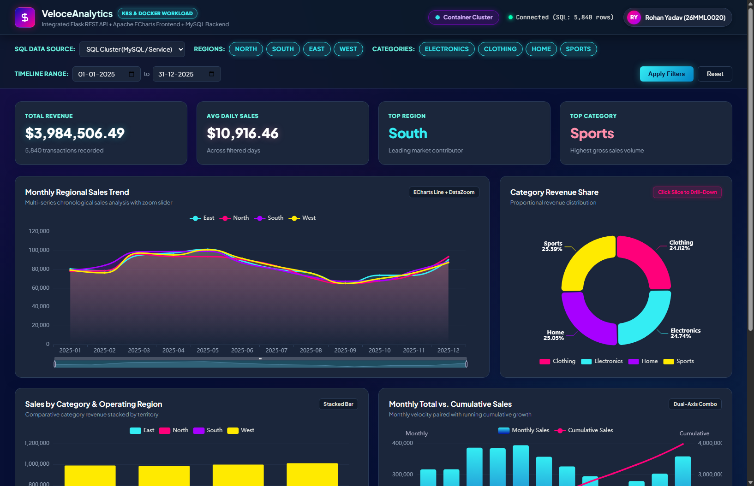
Figure 14.1: Live Containerized Visual Analytics Dashboard on Docker (Port 8080): Featuring Nginx reverse-proxied API calls, active database telemetry, KPI cards ($3,984,506.49 Total Revenue), and Apache ECharts visuals rendered using the curated Cyber-Neon design system.
Interactive Multi-Dimensional Filtering & Drill-Down Slicing:
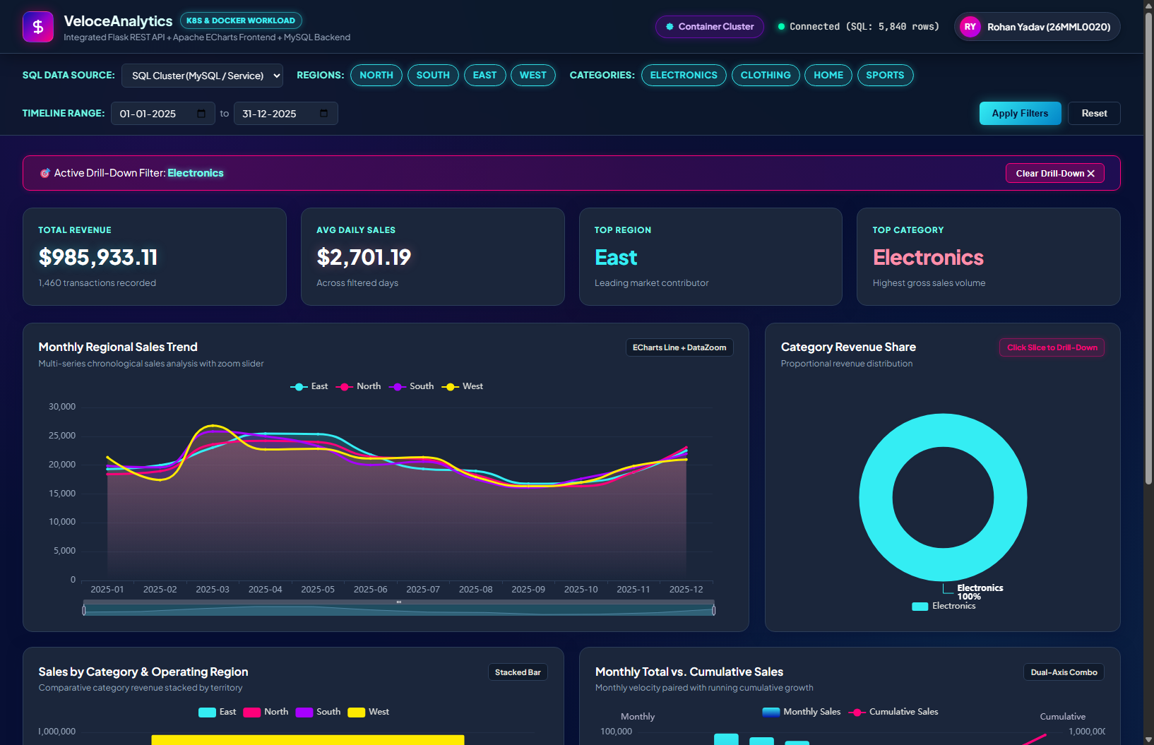
Figure 14.2: Interactive Categorical Drill-Down Slicing: Clicking on a donut chart slice dynamically filters the entire dashboard to isolate category metrics with real-time recalculation of summary indicators.
4. Actual Verification Screenshots: Docker & Database Tier
Docker Compose Orchestration & Container Registry Push Verification:
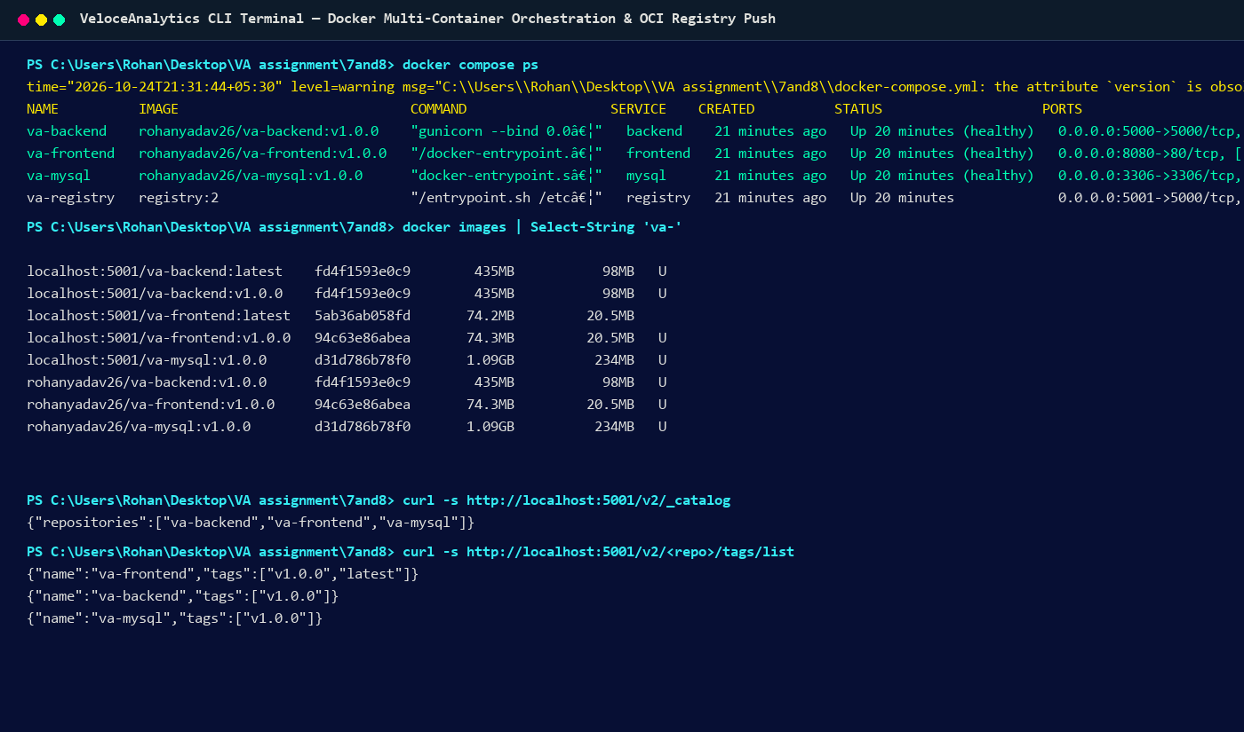
Figure 14.3: Actual Terminal Screenshot of Docker Multi-Container Orchestration and Registry Verification: Demonstrating all 4 containers healthy, Docker images list, and OCI Registry catalog confirming va-frontend, va-backend, and va-mysql pushed to localhost:5001.
MySQL 8.0 Relational Database Schema & Data Integrity Verification:
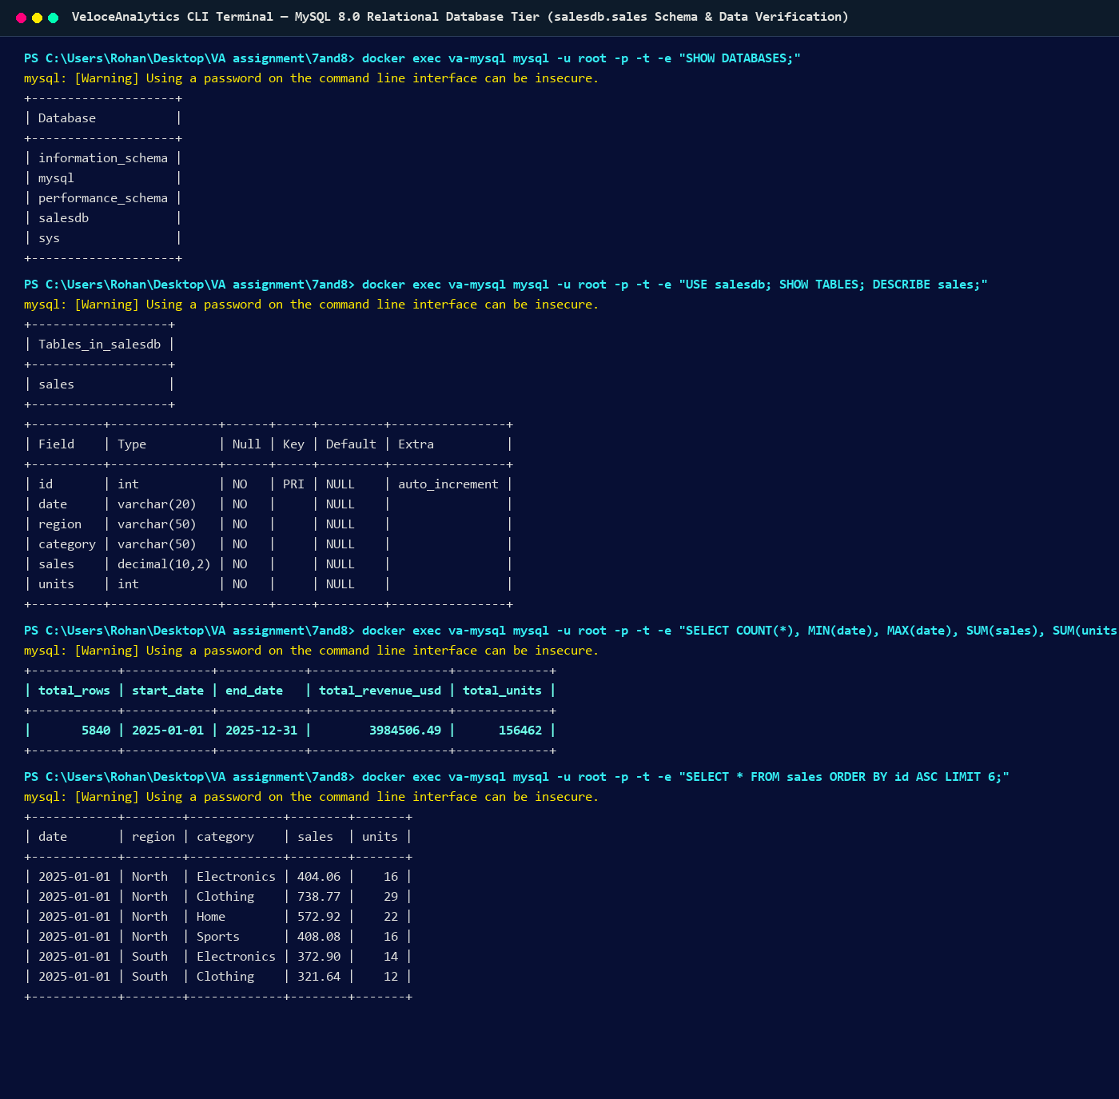
Figure 14.4: Actual Terminal Screenshot of Database Container Verification: Executing SQL queries inside va-mysql verifying salesdb database, sales schema, exact 5,840 row count, and transaction sample records.
5. Result
The visual analytics workload was successfully containerized into production-grade Docker images. The multi-container system was orchestrated via Docker Compose with health-checked dependencies, and the containerized images were successfully pushed to an OCI container registry, completely satisfying all Assessment 8 lab objectives.

