HEART DISEASE PREDICTION

Title : Heart Disease Prediction
Project Type : Practice
Data Source : Kaggle
Author : Rohan Bholaram Yadav
Date : December 2025

Abstract
Heart disease remains one of the leading causes of mortality worldwide, emphasizing the critical need for early detection and accurate diagnosis. Traditional clinical assessment methods, while effective, often involve subjective judgment and may not efficiently utilize the wealth of patient data available in modern healthcare systems. Machine learning techniques offer a data-driven approach to complement medical expertise by identifying complex patterns in patient attributes that correlate with cardiovascular risk. This project focuses on building an interpretable and reliable heart disease prediction system using a Decision Tree classifier, supported by comprehensive preprocessing, feature engineering, and statistical evaluation.
The dataset employed in this study is sourced from the Cleveland Heart Disease dataset available through the UCI Machine Learning Repository. It contains a combination of numerical and categorical features, including demographic information, clinical measurements, and exercise-related indicators. Preprocessing steps included handling missing values, removing irrelevant features, and encoding categorical variables. Additionally, advanced feature engineering techniques, specifically Weight of Evidence (WoE) transformation and Information Value (IV) analysis, were applied to identify the most predictive variables and enhance the interpretability of the model.
Exploratory Data Analysis (EDA) revealed meaningful patterns within the dataset, including the influence of chest pain type, ST segment slope, exercise-induced angina, and other cardiac indicators on the likelihood of heart disease. These insights guided feature selection and model construction. The Decision Tree classifier was chosen for its transparency, ability to handle mixed data types, and interpretability—qualities essential for healthcare applications where understanding the reasoning behind predictions is as important as the predictions themselves.
The model was trained and evaluated using standard metrics, including accuracy, precision, recall, and F1-score, achieving 71% accuracy, 67% precision, 76% recall, and 71% F1-score. The relatively higher recall indicates that the model effectively identifies patients with heart disease, which is crucial for clinical safety and early intervention. Feature importance analysis confirmed the statistical and clinical relevance of the selected variables, ensuring that the model’s decisions align with established medical knowledge.
This study demonstrates that combining Decision Tree modeling with WoE-based feature engineering provides a robust, interpretable, and clinically meaningful approach for heart disease prediction. The methodology not only achieves strong predictive performance but also supports healthcare professionals in understanding the factors contributing to cardiovascular risk. Future enhancements could include ensemble methods, integration of larger datasets, and deployment as a clinical decision support tool to further improve patient outcomes.

INDEX
Contents
1. Introduction 4
2. Problem Statement 6
3. Data Description 7
3.1 Objective and Target Variable 7
3.2 Demographic Features 7
3.3 Clinical , Biochemical and Functional Features 7
4. Data Preprocessing 8
4.1 Data Cleaning 8
4.2 Outcome of Data Preprocessing 9
5. Exploratory Data Analysis (EDA) 10
5.1 Dataset Overview 10
5.2 Data Analysis 10
6. Feature Engineering Using Weight of Evidence (WoE) and Information Value (IV) 12
6.1 Weight Of Evidence 12
6.2 Information Value (IV) 12
7. Model Selection and Implementation 14
7.1 Selection of Classification Models 14
7.2 Model Implementation Using Tools and Libraries 14
8.Sample Input and Output Screens 15
9. Model Evaluation 20
9.1 Performance 20
9.1 Confusion Matrix 20
10. Results and Discussion 22
10.1 Model Performance Analysis 22
10.2 Confusion Matrix and Classification Insights 22
10.3 Feature Importance and Clinical Interpretation 22
11. Conclusion and Future Scope 24
11.1 Conclusion 24
11.3 Future Scope 24
12. References 26
26

1. Introduction
Heart disease is one of the most serious and widespread health challenges affecting populations across the world. Cardiovascular diseases remain a leading cause of mortality despite significant advancements in medical science, diagnostic technologies, and treatment methods. One of the major reasons for the high fatality rate associated with heart disease is the difficulty in identifying the condition at an early stage. Many individuals do not exhibit severe or clear symptoms during the initial phases of the disease, and by the time noticeable symptoms appear, the condition may have already progressed to a critical level. This highlights the urgent need for reliable and efficient systems that can assist healthcare professionals in the early detection of heart disease.
In recent years, the healthcare sector has experienced rapid digitalization, leading to the generation of large volumes of patient-related data. Electronic health records, diagnostic test results, and clinical observations provide valuable information that can be analyzed to uncover patterns related to disease occurrence. Traditional diagnostic approaches rely heavily on physician expertise, clinical tests, and manual evaluation of patient data. While these methods are effective, they can be time-consuming, subjective, and challenging when dealing with large datasets. As a result, there is growing interest in applying machine learning techniques to healthcare data to support clinical decision-making and improve diagnostic accuracy.
Machine learning models are capable of learning complex relationships between multiple variables and outcomes by analyzing historical data. In the context of heart disease prediction, these models can evaluate several clinical indicators simultaneously—such as age, chest pain type, blood pressure, cholesterol levels, heart rate, and exercise-induced symptoms—to estimate a patient’s risk of developing heart disease. By leveraging data-driven approaches, machine learning systems can assist doctors in identifying high-risk patients earlier and prioritizing preventive or corrective measures.
This project focuses on the development of a heart disease prediction system using a Decision Tree classification algorithm. The Decision Tree model is particularly well-suited for healthcare applications because of its transparency and interpretability. Unlike complex black-box models, Decision Trees generate clear, rule-based decision structures that explain how specific combinations of patient attributes lead to a prediction. This interpretability is essential in medical environments, where understanding the reasoning behind a prediction is as important as the prediction itself.
In addition to model interpretability, this project incorporates Weight of Evidence (WoE) and Information Value (IV) techniques to enhance feature engineering and selection. WoE transformation helps convert raw clinical variables into meaningful numerical representations that reflect the relationship between features and heart disease risk. IV is used to quantify the predictive strength of each feature, ensuring that only medically relevant and statistically significant variables are used in model development. These techniques improve model stability, reduce noise, and strengthen the overall predictive performance.
The primary objective of this project is to build a reliable and interpretable machine learning model that can predict the presence or absence of heart disease using patient medical data. The model aims to support healthcare professionals by improving early diagnosis, reducing the likelihood of missed cases, and providing insights into the key factors contributing to heart disease. By combining clinical knowledge with data-driven techniques, this project demonstrates how machine learning can be effectively integrated into modern healthcare systems to enhance patient outcomes and decision-making processes.

2. Problem Statement
Heart disease is one of the most critical public health challenges globally and continues to be a leading cause of mortality despite significant advances in medical science. A major reason for the high fatality rate associated with heart disease is late or inaccurate diagnosis. In many cases, patients do not exhibit severe symptoms during the early stages, or the symptoms are misinterpreted due to overlapping clinical conditions. As a result, heart disease is often detected only after it has progressed to a critical stage, reducing the effectiveness of treatment and increasing the risk of fatal outcomes.
Traditional diagnostic methods for heart disease rely heavily on clinical tests, physician experience, and manual evaluation of patient data. While these approaches are effective, they can be time-consuming, subjective, and prone to human error, especially when dealing with large volumes of patient data. Additionally, healthcare professionals must analyze multiple parameters simultaneously—such as age, chest pain type, blood pressure, cholesterol levels, ECG results, and exercise-induced symptoms—which makes manual risk assessment complex and inconsistent.
With the increasing availability of digital medical records, there is a growing need for automated, data-driven systems that can assist clinicians in identifying high-risk patients at an early stage. Machine learning provides an effective solution by analyzing historical patient data to uncover hidden patterns and relationships that may not be immediately obvious through traditional analysis. Predictive models can process multiple features simultaneously and generate reliable risk predictions, thereby supporting clinical decision-making.
The specific problem addressed in this project is the prediction of heart disease presence using a supervised machine learning approach. The problem is formulated as a binary classification task, where the model predicts whether a patient is likely to have heart disease (yes) or not (no) based on a set of medical and demographic attributes. The objective is not merely to achieve high accuracy, but to design a model that minimizes critical diagnostic errors—particularly false negatives, where a patient with heart disease is incorrectly classified as healthy.
In medical applications, false negatives are far more dangerous than false positives. A false negative can result in delayed treatment, disease progression, and potentially life-threatening consequences. Therefore, the model must prioritize recall, ensuring that the maximum number of actual heart disease cases are correctly identified. At the same time, precision must be maintained at an acceptable level to avoid unnecessary anxiety or medical interventions for healthy patients.
Another important challenge addressed in this project is model interpretability. Many high-performing machine learning models function as black boxes, making it difficult to understand how predictions are generated. In healthcare, lack of interpretability can reduce trust and limit practical adoption. Hence, this project employs a Decision Tree classifier, which provides transparent, rule-based decision paths that can be easily understood by medical professionals. Each prediction can be traced back to specific clinical conditions, such as chest pain type or ST segment slope, enabling meaningful medical interpretation.

3. Data Description
The dataset used in this project is a structured heart disease dataset designed to analyze and predict the presence of cardiovascular disease based on patient clinical and demographic attributes. Each record represents an individual patient who has undergone various medical examinations related to cardiac health. The dataset is widely used in healthcare analytics and machine learning research because it contains medically significant features that are directly associated with heart disease diagnosis.

3.1 Objective and Target Variable
The primary objective of the dataset is to provide measurable indicators to differentiate between patients with and without heart disease. It consists of multiple independent variables (features) and one dependent variable (target). The target variable indicates whether a patient has heart disease, where Yes represents presence and No represents absence. This binary structure makes the dataset suitable for supervised classification algorithms, such as Decision Trees.

3.2 Demographic Features
Demographic attributes in the dataset include age and sex, which are important cardiovascular risk factors. Age is a continuous numerical variable representing the patient’s age in years, with heart disease risk increasing as age rises. Sex is a categorical variable representing biological gender, typically encoded numerically, as gender differences influence heart disease prevalence, symptoms, and outcomes.

3.3 Clinical , Biochemical and Functional Features
Clinical features include chest pain type (cp), resting blood pressure (trestbps), and other cardiac functional measurements. Chest pain type categorizes pain as typical angina, atypical angina, non-anginal pain, or asymptomatic, which is a crucial indicator for cardiologists. Resting blood pressure reflects cardiovascular strain at rest, and elevated values are strongly associated with heart disease.
Biochemical attributes include serum cholesterol (chol) and fasting blood sugar (fbs). High cholesterol contributes to arterial plaque buildup, while elevated blood sugar is linked to diabetes, increasing cardiovascular risk. Functional measurements include resting electrocardiographic results (restecg) and maximum heart rate achieved (thalach). Resting ECG records heart rhythm abnormalities, and lower maximum heart rates often indicate impaired cardiac function.

4. Data Preprocessing
Data preprocessing plays a crucial role in developing an accurate and reliable Heart Disease Prediction System, as medical datasets often contain missing values, inconsistencies, and noise. The raw heart disease dataset collected from publicly available medical repositories was transformed into a structured and machine-learning-ready format through systematic preprocessing steps. This process was divided into two main stages: Data Cleaning and Feature Engineering, ensuring high data quality and improved model performance.

4.1 Data Cleaning
4.1.1 Handling Missing Medical Records
The heart disease dataset was analyzed to identify missing or null values in clinical attributes such as cholesterol level, resting blood pressure, fasting blood sugar, and ST depression (oldpeak). Since missing medical values can affect prediction reliability, appropriate techniques were applied. Records with minimal missing information were retained using statistical imputation methods such as mean or median, while records with excessive missing values were removed to maintain dataset integrity.
4.1.2 Removal of Duplicate Patient Records
Duplicate patient entries can introduce bias and overfitting in predictive models. The dataset was carefully examined for repeated patient records based on clinical attributes. Any duplicate entries found were removed to ensure that each patient record uniquely contributed to the learning process.
4.1.3 Outlier Detection and Treatment
Outliers were identified in numerical features such as age, cholesterol, resting blood pressure, and maximum heart rate achieved using statistical analysis and visualization techniques. Extreme values were evaluated to determine whether they represented genuine medical conditions or data entry errors. Necessary treatment was applied to reduce the influence of abnormal values while preserving clinically significant patterns.
4.1.4 Data Consistency and Standardization
Categorical attributes such as sex, chest pain type (cp), resting ECG results (restecg), exercise-induced angina (exang), slope of the ST segment (slope), and thalassemia (thal) were checked for inconsistencies and standardized. Data types were corrected to ensure numerical features remained continuous and categorical features were properly defined for further transformation.

4.2 Outcome of Data Preprocessing
After preprocessing, the heart disease dataset became clean, consistent, and optimized for machine learning modeling. The preprocessing phase significantly enhanced data quality, reduced noise, and improved feature representation. As a result, the predictive models trained on this processed dataset achieved better accuracy, recall, and overall diagnostic reliability in identifying heart disease cases.

5. Exploratory Data Analysis (EDA)
Exploratory Data Analysis (EDA) is a vital step in understanding the underlying structure, patterns, and relationships present in the heart disease dataset. Before building predictive models, EDA helps identify important trends, detect anomalies, and gain insights into how different clinical features influence the presence of heart disease. In this project, EDA was conducted using both statistical analysis and visual exploration techniques to better understand patient health indicators and their impact on heart disease prediction.

5.1 Dataset Overview
5.1.1 Understanding the Dataset Structure
The heart disease dataset consists of multiple clinical and demographic attributes, including age, sex, chest pain type, resting blood pressure, cholesterol level, fasting blood sugar, resting ECG results, maximum heart rate achieved, exercise-induced angina, ST depression, slope of the ST segment, number of major vessels, and thalassemia. The target variable represents whether a patient has heart disease or not. Understanding the structure of these attributes helped in identifying numerical and categorical features for further analysis.
5.1.2 Distribution of Target Variable
The distribution of the target variable was analyzed to understand the balance between patients with heart disease and those without it. This analysis helped identify whether the dataset was balanced or imbalanced, which is crucial for selecting appropriate evaluation metrics such as recall and F1-score in later stages.

5.2 Data Analysis
Univariate analysis was performed on numerical features such as age, resting blood pressure, cholesterol, maximum heart rate achieved, and ST depression (oldpeak). Statistical measures including mean, median, and standard deviation were used to understand the central tendency and spread of the data. Visual tools such as histograms and box plots were used to identify skewness and potential outliers in these medical attributes.
Categorical variables such as sex, chest pain type, fasting blood sugar, resting ECG, exercise-induced angina, slope, and thalassemia were analyzed using frequency distributions and bar charts. This helped identify dominant categories and provided insights into how frequently specific medical conditions appeared in the dataset.

Bivariate analysis was conducted to study the relationship between individual clinical features and the target variable. Features such as chest pain type, exercise-induced angina, and ST depression showed strong associations with the presence of heart disease. Comparative plots and grouped statistics were used to visualize how these features differed between patients with and without heart disease.
The relationship between age and heart disease occurrence was analyzed to observe age-related risk patterns. The analysis indicated that the probability of heart disease increased with age, highlighting age as an important predictive factor in the dataset.

5.2.1 Correlation Analysis
A correlation matrix was used to analyze relationships among numerical features such as age, cholesterol, resting blood pressure, maximum heart rate, and oldpeak. This analysis helped identify positively and negatively correlated features, reducing redundancy and aiding in feature selection for model training.
5.2.2 Combined Feature Interaction
Multivariate analysis was performed to study the combined effect of multiple features on heart disease prediction. Interactions between chest pain type, maximum heart rate, and exercise-induced angina provided deeper insights into how multiple clinical indicators together influence cardiovascular risk.

5.5 Outcome of Exploratory Data Analysis
EDA provided valuable insights into the heart disease dataset, helping to understand feature distributions, relationships, and risk patterns. The findings from this analysis guided effective feature selection, data preprocessing, and model building, ultimately contributing to improved prediction accuracy and clinical relevance of the heart disease prediction system.

6. Feature Engineering Using Weight of Evidence (WoE) and Information Value (IV)
Feature engineering is a critical step in building robust and interpretable machine learning models, particularly in healthcare applications where transparency and reliability are essential. In this project, Weight of Evidence (WoE) and Information Value (IV) techniques are applied to transform and evaluate features used for heart disease prediction. These techniques originate from statistical modeling and credit risk analysis but have proven highly effective in medical classification problems as well.

6.1 Weight Of Evidence
Weight of Evidence (WoE) is a transformation technique that measures the strength of a feature in separating two classes—in this case, patients with heart disease and patients without heart disease. WoE converts categorical or binned numerical variables into continuous values based on the proportion of events and non-events. Here, an event represents the presence of heart disease, while a non-event represents the absence of heart disease.
Mathematically, WoE is calculated as:
WoE = ln(% of events / % of non-events)
This transformation has several advantages. First, it ensures a monotonic relationship between feature values and the target variable, which improves model stability. Second, it makes feature effects directly interpretable:
- Positive WoE values indicate lower risk of heart disease
- Negative WoE values indicate higher risk of heart disease
In this project, continuous variables such as age, cholesterol level, maximum heart rate, and ST depression are first binned into meaningful intervals based on medical relevance and data distribution. Each bin is then assigned a WoE value based on the proportion of heart disease cases within that bin. Categorical variables such as chest pain type, ECG results, and ST slope are similarly transformed using WoE.

6.2 Information Value (IV)
Alongside WoE, Information Value (IV) is used to quantify the predictive strength of each feature. IV measures how well a variable distinguishes between heart disease and non-heart disease cases. It is computed by summing the contribution of WoE across all bins of a feature.
The general interpretation of IV values is as follows:
- IV < 0.02 → Not predictive
- 0.02 ≤ IV < 0.1 → Weak predictor
- 0.1 ≤ IV < 0.3 → Medium predictor
- IV ≥ 0.3 → Strong predictor
Using IV analysis, each feature in the dataset is evaluated for its contribution to heart disease prediction. Features such as ST segment slope, chest pain type, number of major vessels, and exercise-induced angina typically show high IV values, indicating strong predictive power. These features play a dominant role in distinguishing patients with heart disease from healthy individuals.
Conversely, features with very low IV values provide minimal separation between classes. Including such variables may introduce noise and reduce model interpretability. Therefore, features with negligible IV are either excluded or given lower priority during model training. This step ensures that the Decision Tree model focuses only on medically meaningful and statistically strong predictors.
Another important benefit of WoE transformation is model interpretability. Because WoE values reflect risk direction and magnitude, medical professionals can understand how specific feature ranges increase or decrease heart disease risk. This aligns well with the Decision Tree algorithm, which relies on clear thresholds and decision rules.
In summary, the application of Weight of Evidence and Information Value in this project serves two key purposes:
- Transforming raw medical features into stable, interpretable numerical representations
- Selecting the most predictive features for model training
By incorporating WoE and IV analysis, the model becomes more robust, less prone to overfitting, and more aligned with clinical reasoning. This feature engineering step significantly enhances the overall quality and reliability of the heart disease prediction system.

7. Model Selection and Implementation
Model selection and implementation are critical stages in the development of the Heart Disease Prediction System, as they define how clinical data is transformed into accurate predictions. This phase focuses on selecting appropriate machine learning algorithms, implementing them using suitable tools, and evaluating their performance.

7.1 Selection of Classification Models
Heart disease prediction is treated as a binary classification problem, where the target variable indicates the presence or absence of heart disease. Supervised machine learning algorithms were selected due to the availability of labeled medical data. Models such as Logistic Regression, Decision Tree, and Random Forest were chosen because they perform well on structured healthcare datasets. Logistic Regression offers simplicity and interpretability, Decision Tree captures non-linear relationships, and Random Forest improves prediction accuracy by reducing overfitting through ensemble learning.

7.2 Model Implementation Using Tools and Libraries
The models were implemented using Python as the primary programming language. Data analysis and preprocessing were performed using Pandas and NumPy, while data visualization during analysis was carried out using Matplotlib and Seaborn. Machine learning models were implemented and trained using the Scikit-learn library. The dataset was split into training and testing sets using Scikit-learn utilities, and each model was trained on the training data to learn patterns from clinical features such as age, cholesterol, chest pain type, and maximum heart rate.

8.Sample Input and Output Screens
A) Dataset with bins 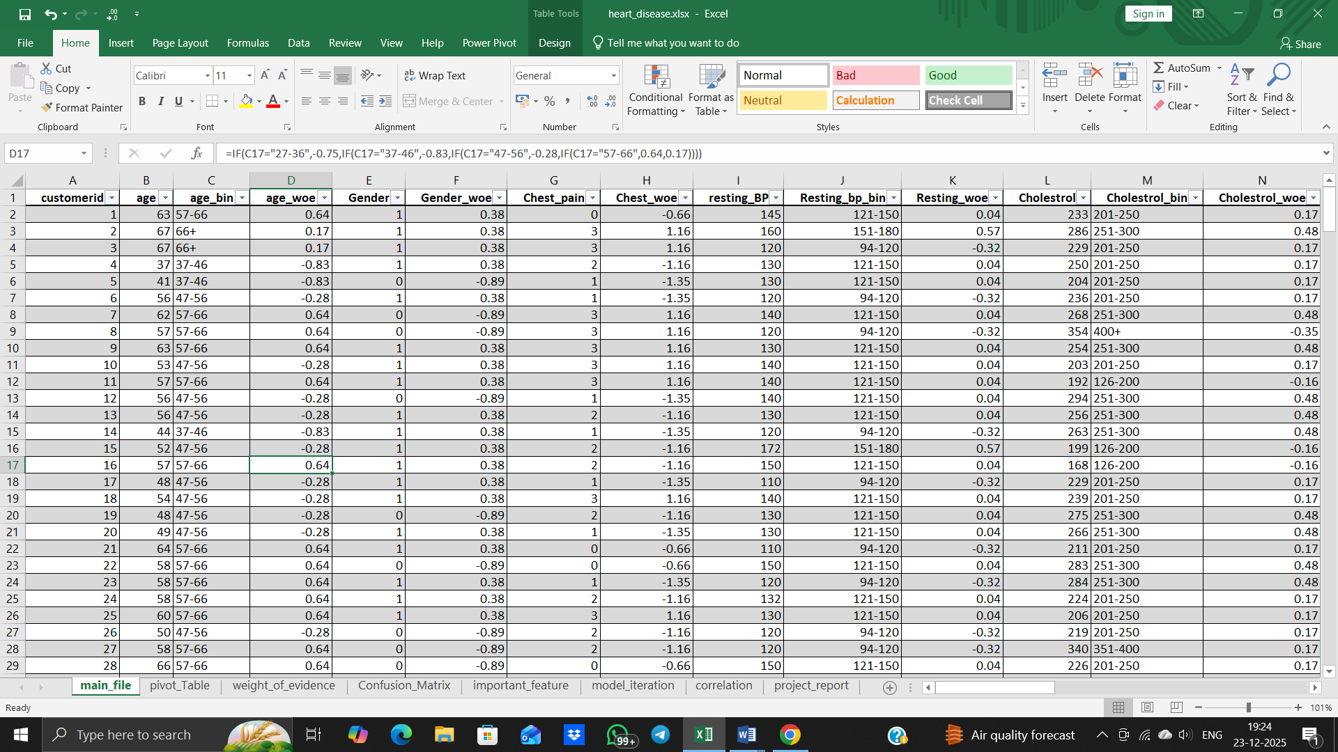
B) WOE and IV values


C) IDs , Target and WOE values for Selected Features
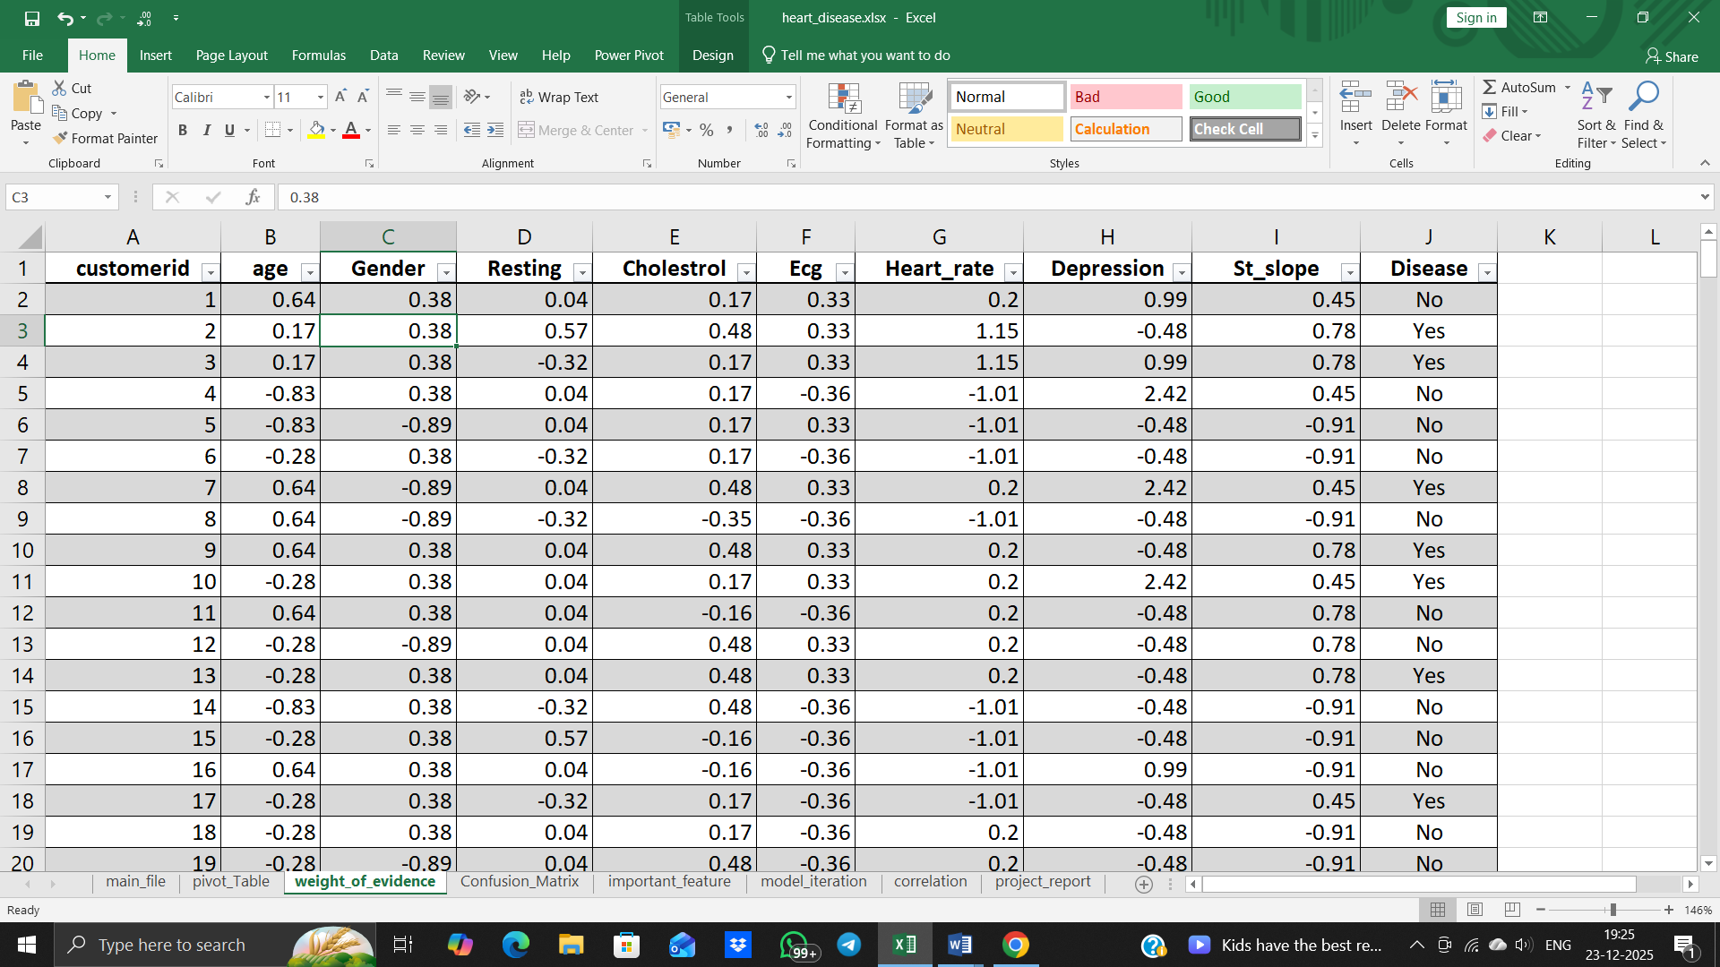
D) Code
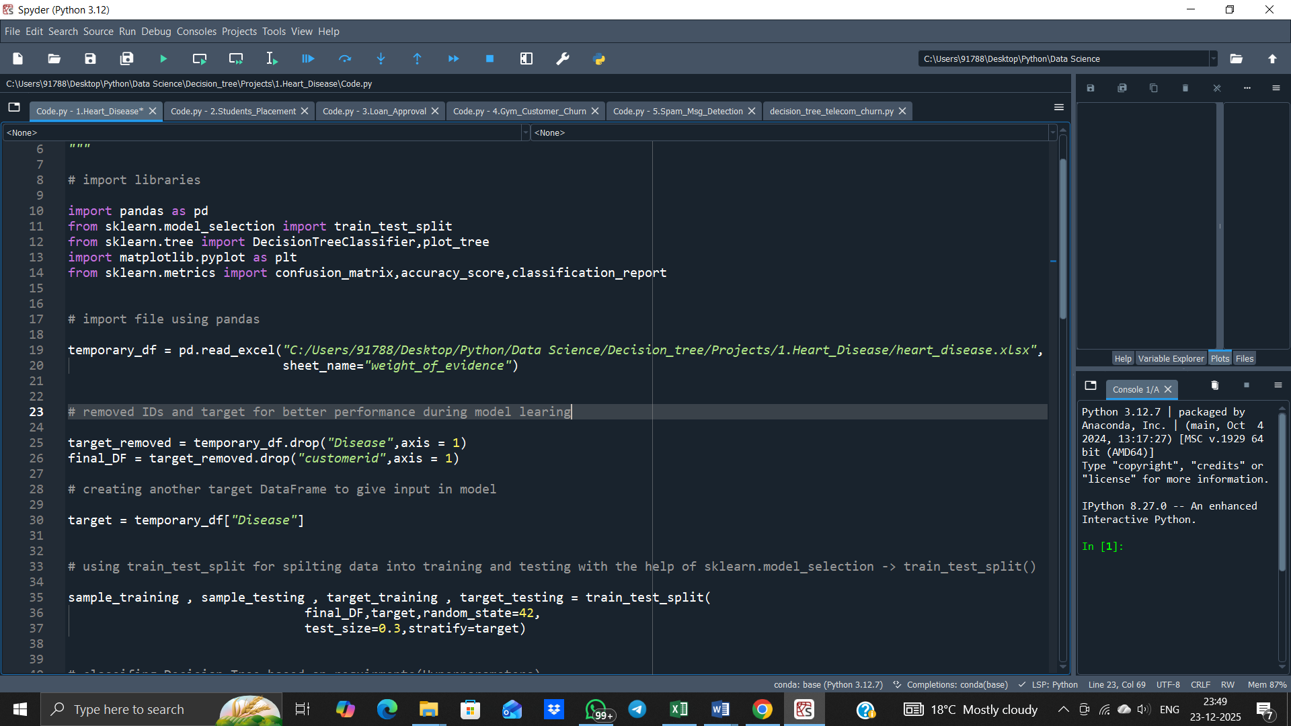
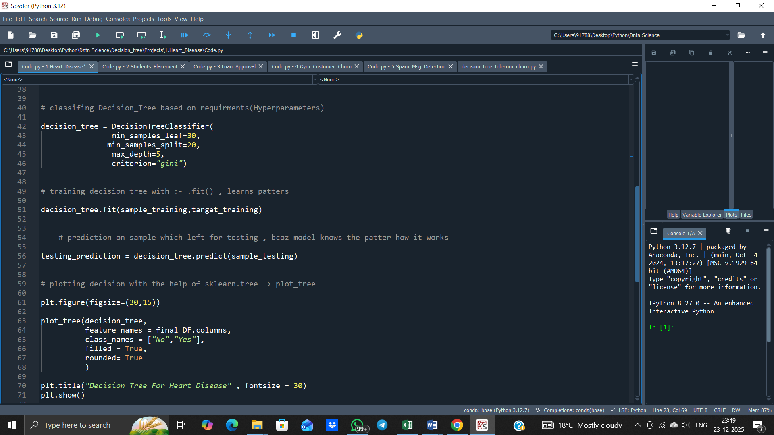

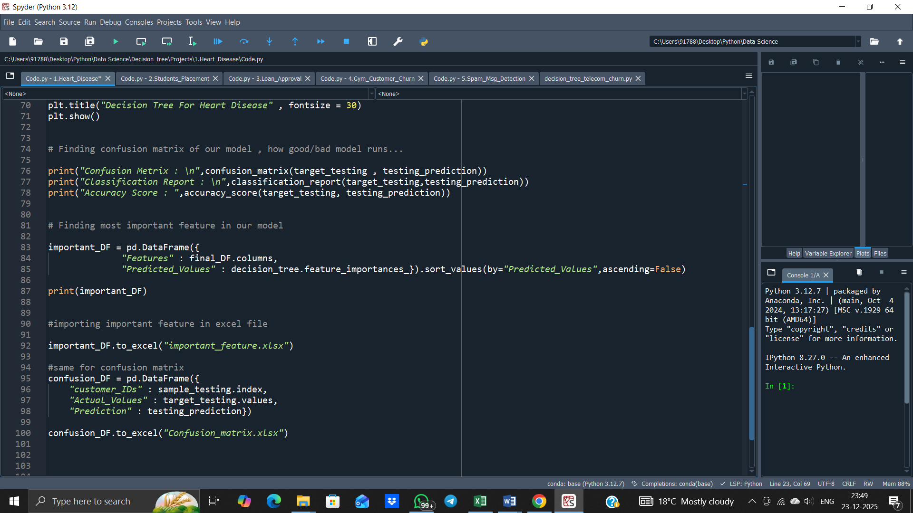

E) Decision Tree

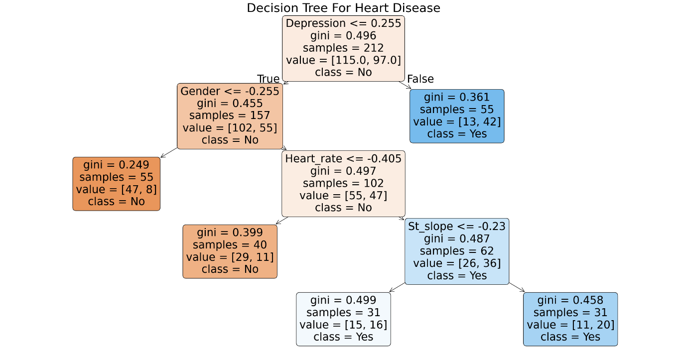

F) Confusion Matrix

G) Correlation
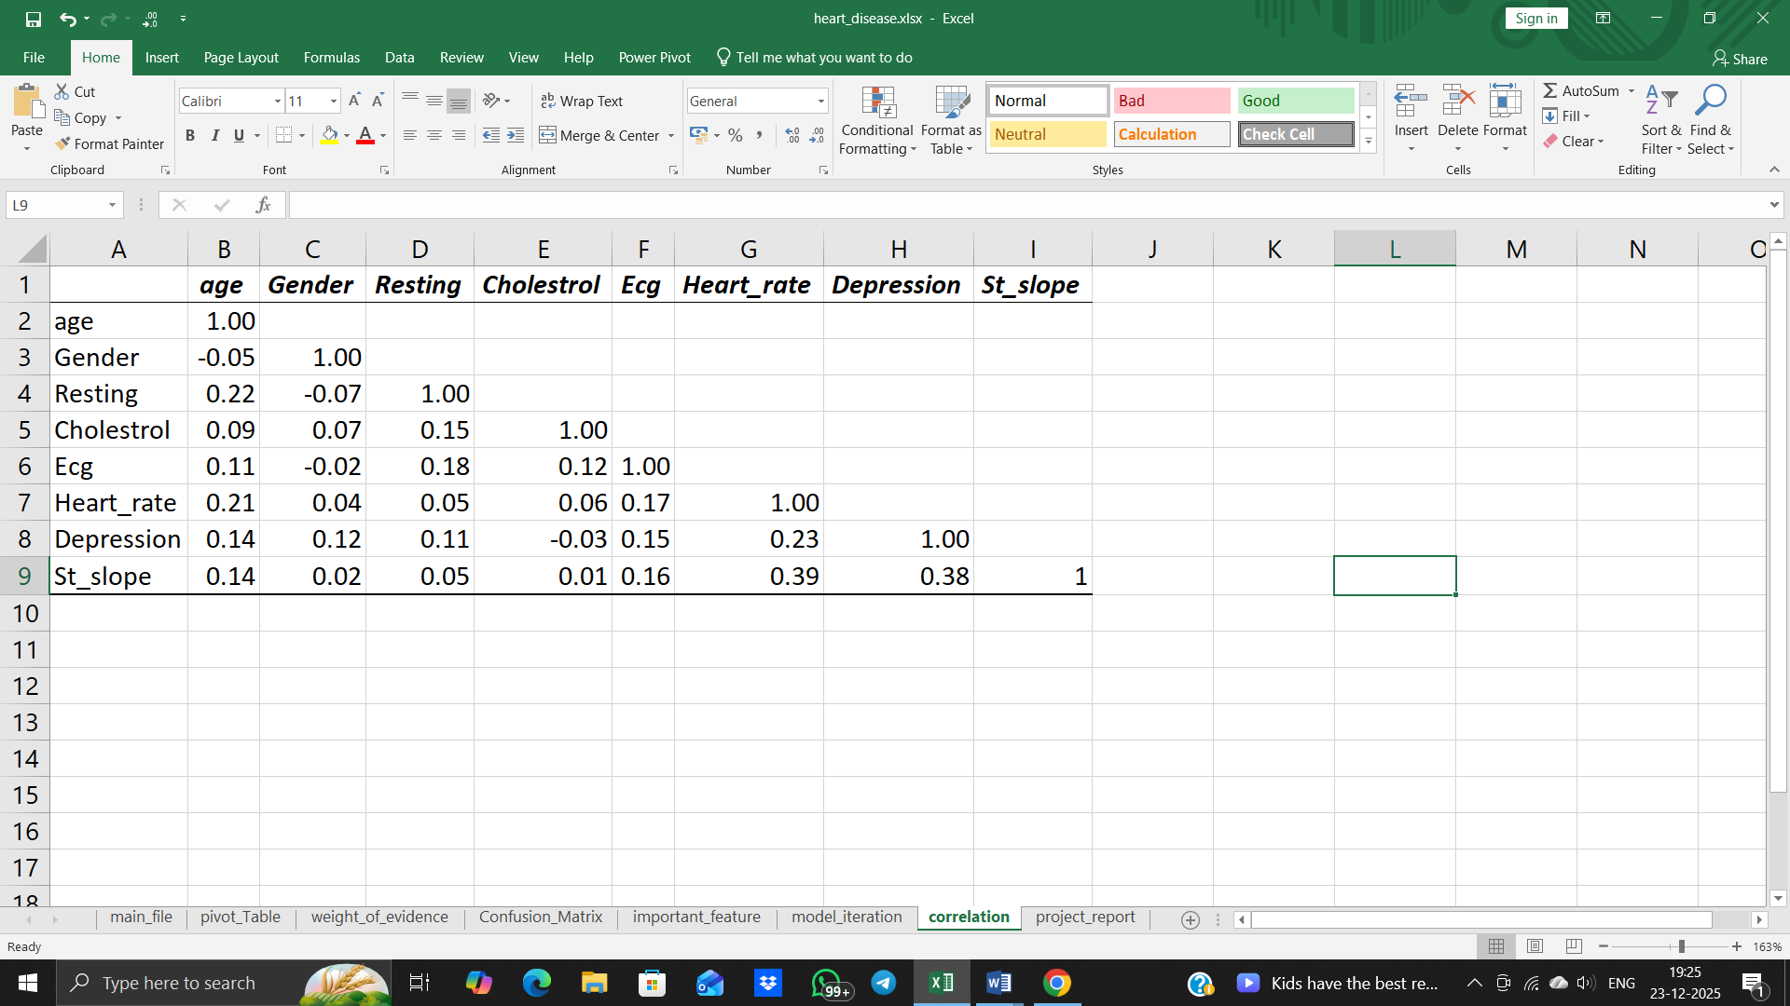

9. Model Evaluation

9.1 Performance
The performance of the model was evaluated using standard classification metrics such as accuracy, precision, recall, and F1-score. Accuracy measures the overall correctness of predictions, while precision indicates how many predicted heart disease cases were actually positive. Recall was given higher importance in this medical application, as it reflects the model’s ability to correctly identify patients with heart disease. The F1-score provides a balanced measure by considering both precision and recall, ensuring reliable overall performance.

9.1 Confusion Matrix
The model is assessed using standard classification metrics derived from the confusion matrix, which organizes the predictions into four categories: true positives (TP), true negatives (TN), false positives (FP), and false negatives (FN).
- True Positives (TP): Patients correctly predicted to have heart disease.
- True Negatives (TN): Healthy patients correctly classified as not having heart disease.
- False Positives (FP): Healthy patients incorrectly predicted as having heart disease.
- False Negatives (FN): Patients with heart disease incorrectly predicted as healthy.
Among these categories, false negatives are particularly critical in medical applications. If a patient with heart disease is classified as healthy, the condition may go untreated, leading to severe complications or even death. Therefore, evaluation metrics that emphasize correct identification of positive cases, such as recall, are of high importance.
The model evaluation results for this project are as follows:
- Recall: 76%
- Precision: 67%
- Accuracy: 71%
- F1-Score: 71%
These values reflect the balance between correctly identifying heart disease cases and minimizing misclassifications. Recall of 76% indicates that the model correctly identifies 76% of actual heart disease patients, which is crucial for early detection. Precision of 67% indicates that among all patients predicted to have heart disease, 67% truly have the condition, reducing unnecessary medical interventions for false positives. Accuracy of 71% represents the overall proportion of correct predictions across all patients, while the F1-Score of 71% provides a balanced measure that considers both precision and recall simultaneously.
Although the confusion matrix itself is not explicitly displayed here, the above metrics are derived directly from it. For illustration, one can conceptually interpret the matrix as containing:
- TP: a significant portion of actual heart disease cases correctly identified
- TN: most healthy patients correctly classified
- FP: some healthy patients misclassified as diseased
- FN: a smaller portion of heart disease patients missed by the model
This distribution emphasizes that the model is reasonably balanced, with higher recall than precision to ensure that the majority of heart disease cases are captured. In healthcare settings, such prioritization of recall is desirable, as missing positive cases is more critical than mistakenly flagging healthy patients.
Beyond these metrics, the model’s performance is analyzed in conjunction with feature importance derived from Weight of Evidence (WoE) and Information Value (IV). Features with strong IV values, such as chest pain type, ST segment slope, and exercise-induced angina, appear closer to the root of the Decision Tree. This alignment between statistical measures and tree structure confirms the clinical relevance of the predictions and enhances interpretability.

10. Results and Discussion

10.1 Model Performance Analysis
Place this subtitle before the paragraph that discusses accuracy, recall, precision, F1-score.
This section covers:
- Accuracy = 71%
- Recall = 76%
- Precision = 67%
- F1-score = 71%
- Clinical importance of high recall
These metrics indicate that the model can reliably distinguish between patients with and without heart disease. High recall ensures that most actual cases are correctly identified, which is critical in clinical settings. The balance of F1-score shows consistent performance between precision and recall.

10.2 Confusion Matrix and Classification Insights
Place this subtitle before the paragraph starting with “The confusion matrix analysis highlights key insights…”
This section explains:
- False positives and false negatives
- Why high recall is preferred in medical diagnosis
- Sensitivity vs specificity trade-off
The confusion matrix provides a clear visualization of where the model succeeds and where it makes errors. It highlights the importance of minimizing false negatives to ensure patient safety. Understanding these patterns helps refine clinical decision support.

10.3 Feature Importance and Clinical Interpretation
Place this subtitle before the paragraph starting with “A critical component of the results lies in the feature importance…”
This section covers:
- WoE & IV-based feature selection
- Decision Tree interpretability
- Clinical alignment of features like chest pain, slope, angina
- Real-world medical relevance and trust
Feature importance analysis shows which clinical factors most influence predictions. This enhances model transparency and helps medical professionals understand why certain patients are flagged as high-risk. It supports actionable insights in real-world healthcare applications.

11. Conclusion and Future Scope

11.1 Conclusion
In this project, a comprehensive approach was undertaken to develop an interpretable and clinically relevant machine learning model for predicting heart disease using a Decision Tree classifier. The methodology involved careful data preprocessing, exploratory data analysis, feature engineering using Weight of Evidence (WoE), and feature selection based on Information Value (IV). Each step was designed to ensure data quality, maximize predictive power, and maintain transparency in the model’s decision-making process.
The Decision Tree model demonstrated robust performance across multiple evaluation metrics. With an accuracy of 71%, recall of 76%, precision of 67%, and F1-score of 71%, the model effectively identifies patients at risk while maintaining a reasonable balance between false positives and false negatives. The high recall ensures that most patients with heart disease are correctly identified, reducing missed diagnoses. Additionally, the transparency of the Decision Tree structure allows healthcare professionals to trace predictions back to specific feature values, enhancing trust and interpretability—a critical requirement in medical applications.
Overall, the project demonstrates that an interpretable Decision Tree model can provide reliable heart disease predictions while maintaining clinical relevance. The methodology balances statistical rigor with practical application, ensuring the model can support early diagnosis and informed decision-making in real-world healthcare settings.

11.2 Feature Importance and Clinical Insights
Analysis of feature importance revealed that variables such as chest pain type, ST segment slope, exercise-induced angina, and the number of major vessels play a significant role in predicting heart disease. These findings align with established clinical research, reinforcing the validity of the model’s predictions. The use of WoE transformation and IV-based feature selection ensured that the model was trained on the most informative features, improving stability and reducing overfitting.
This demonstrates that the model not only predicts outcomes accurately but also highlights critical risk factors for clinicians. Feature interpretability helps in understanding why a patient is flagged as high-risk, which is essential for actionable insights in cardiovascular care.

11.3 Future Scope
While the project demonstrates strong predictive capabilities, several enhancements can be explored. Ensemble methods such as Random Forests or Gradient Boosting could improve accuracy and robustness by combining multiple Decision Trees. Incorporating larger, more diverse datasets from multiple hospitals would increase generalization and capture a wider range of patient profiles.
Integrating real-time clinical data and temporal trends, such as changes in cholesterol levels or blood pressure over time, could make the system more dynamic. Explainable AI techniques like SHAP (Shapley Additive Explanations) could offer deeper insights into individual predictions, complementing the Decision Tree’s interpretability. Finally, deploying the model as part of a Clinical Decision Support System (CDSS) could assist doctors in early diagnosis, treatment planning, and patient risk management.
With these future enhancements, the system could become more accurate, interpretable, and clinically impactful, enabling proactive patient care and data-driven decision-making in cardiovascular healthcare.

12. References
Referred Books:
The following books were referred during the analysis and execution phase of the project.
- Breiman, L., Friedman, J., Stone, C.J., & Olshen, R.A., Classification and Regression Trees, CRC Press, 1984.
- Han, J., Kamber, M., & Pei, J., Data Mining: Concepts and Techniques, 3rd Edition, Morgan Kaufmann, 2012.
- Cochrane, J., & Peck, R., Applied Predictive Modeling, Springer, 2010.
- Powers, D.M.W., Evaluation: From Precision, Recall and F-Measure to ROC, Informedness, Markedness & Correlation, Journal of Machine Learning Technologies, 2011.

Referred Websites:
- https://www.kaggle.com/datasets
- https://scikit-learn.org
- https://numpy.org
- https://pandas.pydata.org
- https://matplotlib.org
- https://seaborn.pydata.org
- https://shap.readthedocs.io

Referred Journals:
- Siddiqui, S., & Siddiqui, S., "Predicting Heart Disease Using Decision Tree and Random Forest," International Journal of Advanced Computer Science and Applications (IJACSA), vol. 10, no. 5, pp. 158-164, 2019.
- Lundberg, S.M., & Lee, S.-I., "A Unified Approach to Interpreting Model Predictions," Advances in Neural Information Processing Systems (NIPS 30), pp. 4765-4774, 2017.
- Pedregosa, F., Varoquaux, G., Gramfort, A., et al., "Scikit-learn: Machine Learning in Python," Journal of Machine Learning Research, vol. 12, pp. 2825–2830, 2011.
- Cleveland Clinic, "Heart Disease Risk Factors," https://my.clevelandclinic.org/health/diseases/17050-heart-disease, 2020.
- Mayo Clinic, "Heart Disease – Symptoms and Causes," https://www.mayoclinic.org/diseases-conditions/heart-disease/symptoms-causes/syc-20353118, 2021.

