-----------DB Exercise-----------------

Questions:

- Create Database
- Design Schema
- Create tables
- Insert sample data
- Find the sales person have multiple orders.
- Find the all sales person details along with order details
- Create index
- How to show index on a table
- Find the order number, sale person name, along with the customer to whom that order belongs to

Ans 2:

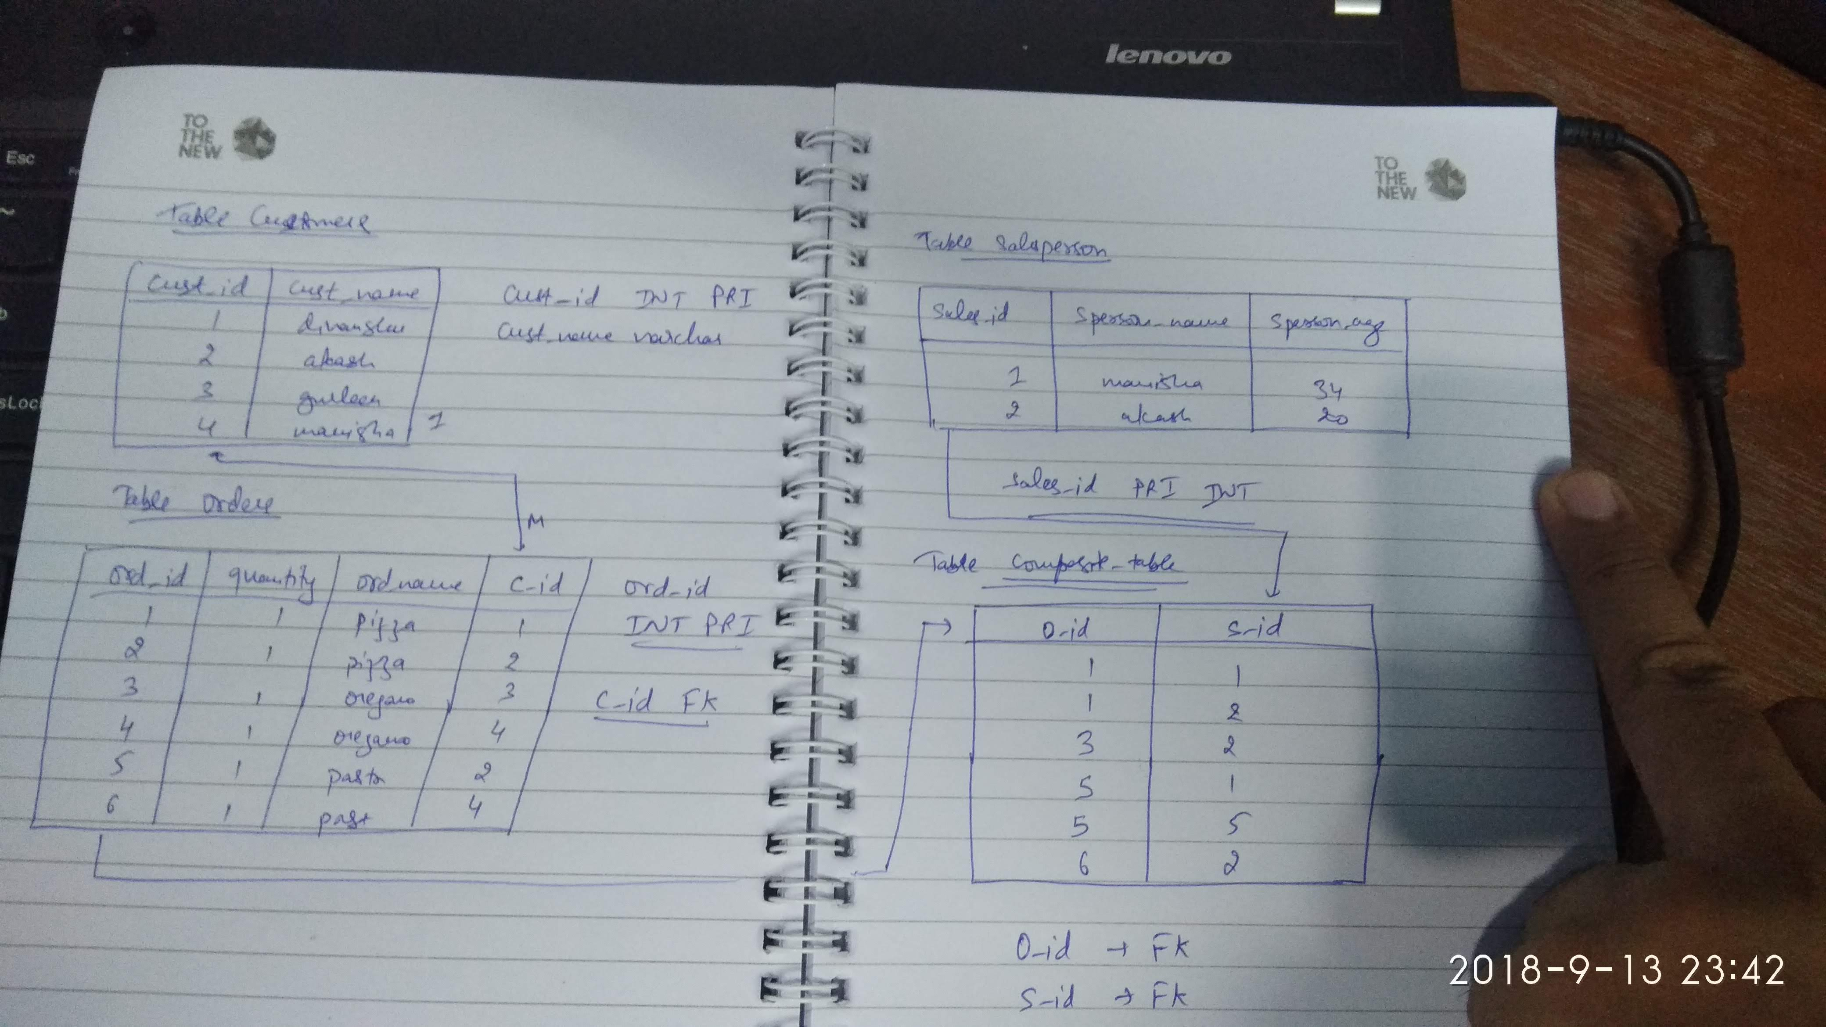

[divyanshu@divanshu ~]$ mysql -u root -p
Enter password:
Welcome to the MySQL monitor. Commands end with ; or \g.
Your MySQL connection id is 5
Server version: 5.7.23-0ubuntu0.16.04.1 (Ubuntu)

Copyright (c) 2000, 2018, Oracle and/or its affiliates. All rights reserved.

Oracle is a registered trademark of Oracle Corporation and/or its
affiliates. Other names may be trademarks of their respective
owners.

Type 'help;' or '\h' for help. Type '\c' to clear the current input statement.

Ans 1. mysql> show databases;
+--------------------+
| Database |
+--------------------+
| information_schema |
| bootcamp |
| dbexercise |
| mysql |
| performance_schema |
| sys |
+--------------------+
6 rows in set (0.00 sec)

mysql> use bootcamp;
Reading table information for completion of table and column names
You can turn off this feature to get a quicker startup with -A

Database changed
mysql> show tables;
+--------------------+
| Tables_in_bootcamp |
+--------------------+
| user |
| user_ttn |
+--------------------+
2 rows in set (0.00 sec)

Ans3.: mysql> create table customers(
-> cust_id int(10) not null primary key auto_increment,
-> cust_name varchar(100) not null);
Query OK, 0 rows affected (0.01 sec)

mysql> create table orders(
-> ord_id int(10) not null primary key auto_increment,
-> quantity int(10) not null,
-> ord_name varchar(100) not null,
-> c_id INT references customers(cust_id)
-> );
Query OK, 0 rows affected (0.03 sec)

mysql> create table salesperson(
-> sales_id int(10) not null auto_increment primary key,
-> sperson_name varchar(100) not null,
-> sperson_age int(10) not null);
Query OK, 0 rows affected (0.02 sec)

mysql>
Ans 4.: mysql> insert into customers(cust_name) values ('divanshu');
Query OK, 1 row affected (0.01 sec)

mysql> insert into customers(cust_name) values ('akash');
Query OK, 1 row affected (0.00 sec)

mysql> insert into customers(cust_name) values ('gurleen');
Query OK, 1 row affected (0.00 sec)

mysql> insert into customers(cust_name) values ('manisha');
Query OK, 1 row affected (0.00 sec)

mysql> desc customers;
+-----------+--------------+------+-----+---------+----------------+
| Field | Type | Null | Key | Default | Extra |
+-----------+--------------+------+-----+---------+----------------+
| cust_id | int(10) | NO | PRI | NULL | auto_increment |
| cust_name | varchar(100) | NO | | NULL | |
+-----------+--------------+------+-----+---------+----------------+
2 rows in set (0.00 sec)

mysql>
mysql> select * from customers;
+---------+-----------+
| cust_id | cust_name |
+---------+-----------+
| 1 | divanshu |
| 2 | akash |
| 3 | gurleen |
| 4 | manisha |
+---------+-----------+
4 rows in set (0.00 sec)

mysql>

mysql> insert into orders(ord_name,quantity,c_id) values('pizza',1,1);
Query OK, 1 row affected (0.00 sec)

mysql> insert into orders(ord_name,quantity,c_id) values('pizza',1,2);
Query OK, 1 row affected (0.00 sec)

mysql> insert into orders(ord_name,quantity,c_id) values('pizza',1,3);
Query OK, 1 row affected (0.00 sec)

mysql> insert into orders(ord_name,quantity,c_id) values('pizza',1,4);
Query OK, 1 row affected (0.00 sec)

mysql> insert into orders(ord_name,quantity,c_id) values('oregano',1,);
ERROR 1064 (42000): You have an error in your SQL syntax; check the manual that corresponds to your MySQL server version for the right syntax to use near ')' at line 1
mysql> insert into orders(ord_name,quantity,c_id) values('oregano',1,2);
Query OK, 1 row affected (0.00 sec)

mysql> insert into orders(ord_name,quantity,c_id) values('oregano',1,4);
Query OK, 1 row affected (0.00 sec)

mysql> insert into orders(ord_name,quantity,c_id) values('pasta',1,1);
Query OK, 1 row affected (0.00 sec)

mysql> insert into orders(ord_name,quantity,c_id) values('pasta',1,3);
Query OK, 1 row affected (0.01 sec)

mysql> select * from orders;
+--------+----------+----------+------+
| ord_id | quantity | ord_name | c_id |
+--------+----------+----------+------+
| 1 | 1 | pizza | 1 |
| 2 | 1 | pizza | 2 |
| 3 | 1 | pizza | 3 |
| 4 | 1 | pizza | 4 |
| 5 | 1 | oregano | 2 |
| 6 | 1 | oregano | 4 |
| 7 | 1 | pasta | 1 |
| 8 | 1 | pasta | 3 |
+--------+----------+----------+------+
8 rows in set (0.00 sec)

mysql> mysql> insert into salesperson(sperson_name,sperson_age) value('manisha',34);
ERROR 1146 (42S02): Table 'bootcamp.salespersonsperson' doesn't exist
mysql> insert into salesperson(sperson_name,sperson_age) value('manisha',34);
Query OK, 1 row affected (0.00 sec)

mysql> insert into salesperson(sperson_name,sperson_age) value('akash',20);
Query OK, 1 row affected (0.01 sec)

mysql> show tables;
+--------------------+
| Tables_in_bootcamp |
+--------------------+
| customers |
| orders |
| salesperson |
| user |
| user_ttn |
+--------------------+
5 rows in set (0.00 sec)

mysql> select * from salesperson;
+----------+--------------+-------------+
| sales_id | sperson_name | sperson_age |
+----------+--------------+-------------+
| 1 | manisha | 34 |
| 2 | akash | 20 |
+----------+--------------+-------------+
2 rows in set (0.00 sec)

mysql> create table composite_table(
-> o_id INT references orders(ord_id),
-> s_id INT references salesperson(sales_id));
Query OK, 0 rows affected (0.02 sec)

mysql> show tables;
+--------------------+
| Tables_in_bootcamp |
+--------------------+
| composite_table |
| customers |
| orders |
| salesperson |
| user |
| user_ttn |
+--------------------+
6 rows in set (0.01 sec)

mysql> mysql> insert composite_table(o_id,s_id) values(1,1);
ERROR 1064 (42000): You have an error in your SQL syntax; check the manual that corresponds to your MySQL server version for the right syntax to use near 'composite_table(o_id,s_id) values(1,1)' at line 1
mysql> insert into composite_table(o_id,s_id) values(1,1);
Query OK, 1 row affected (0.00 sec)

mysql> select * from orders;
+--------+----------+----------+------+
| ord_id | quantity | ord_name | c_id |
+--------+----------+----------+------+
| 1 | 1 | pizza | 1 |
| 2 | 1 | pizza | 2 |
| 3 | 1 | pizza | 3 |
| 4 | 1 | pizza | 4 |
| 5 | 1 | oregano | 2 |
| 6 | 1 | oregano | 4 |
| 7 | 1 | pasta | 1 |
| 8 | 1 | pasta | 3 |
+--------+----------+----------+------+
8 rows in set (0.00 sec)

mysql> insert into composite_table(o_id,s_id) values(1,2);
Query OK, 1 row affected (0.00 sec)

mysql> insert into composite_table(o_id,s_id) values(1,3);
Query OK, 1 row affected (0.00 sec)

mysql> insert into composite_table(o_id,s_id) values(3,2);
Query OK, 1 row affected (0.00 sec)

mysql> insert into composite_table(o_id,s_id) values(3,1);
Query OK, 1 row affected (0.01 sec)

mysql> insert into composite_table(o_id,s_id) values(3,5);
Query OK, 1 row affected (0.00 sec)

mysql> insert into composite_table(o_id,s_id) values(5,5);
Query OK, 1 row affected (0.00 sec)

mysql> insert into composite_table(o_id,s_id) values(5,2);
Query OK, 1 row affected (0.00 sec)

mysql> insert into composite_table(o_id,s_id) values(6,2);
Query OK, 1 row affected (0.00 sec)

mysql> insert into composite_table(o_id,s_id) values(6,1);
Query OK, 1 row affected (0.00 sec)

mysql> insert into composite_table(o_id,s_id) values(8,1);
Query OK, 1 row affected (0.00 sec)

mysql> select * from composite_table;
+------+------+
| o_id | s_id |
+------+------+
| 1 | 1 |
| 1 | 2 |
| 1 | 3 |
| 3 | 2 |
| 3 | 1 |
| 3 | 5 |
| 5 | 5 |
| 5 | 2 |
| 6 | 2 |
| 6 | 1 |
| 8 | 1 |
+------+------+
11 rows in set (0.00 sec)

mysql> insert into salesperson(sperson_name,sperson_age) value('gurleen',26);
Query OK, 1 row affected (0.00 sec)

5. mysql> select * from salesperson s where s.sales_id IN (select s_id from composite_table ct GROUP BY ct.s_id HAVING COUNT(ct.s_id) > 1);
+----------+--------------+-------------+
| sales_id | sperson_name | sperson_age |
+----------+--------------+-------------+
| 1 | manisha | 34 |
| 2 | akash | 20 |
+----------+--------------+-------------+
2 rows in set (0.00 sec)

6. mysql> select s.sales_id,s.sperson_name,sperson_age, ct.o_id,od.quantity,od.ord_name,od.c_id FROM salesperson s JOIN composite_table ct ON(s.sales_id = ct.s_id) JOIN orders od ON (ct.o_id = od.ord_id);
+----------+--------------+-------------+------+----------+----------+------+
| sales_id | sperson_name | sperson_age | o_id | quantity | ord_name | c_id |
+----------+--------------+-------------+------+----------+----------+------+
| 1 | manisha | 34 | 1 | 1 | pizza | 1 |
| 2 | akash | 20 | 1 | 1 | pizza | 1 |
| 3 | gurleen | 26 | 1 | 1 | pizza | 1 |
| 2 | akash | 20 | 3 | 1 | pizza | 3 |
| 1 | manisha | 34 | 3 | 1 | pizza | 3 |
| 2 | akash | 20 | 5 | 1 | oregano | 2 |
| 2 | akash | 20 | 6 | 1 | oregano | 4 |
| 1 | manisha | 34 | 6 | 1 | oregano | 4 |
| 1 | manisha | 34 | 8 | 1 | pasta | 3 |
+----------+--------------+-------------+------+----------+----------+------+
rows in set (0.00 sec)

mysql> select * from orders;
+--------+----------+----------+------+
| ord_id | quantity | ord_name | c_id |
+--------+----------+----------+------+
| 1 | 1 | pizza | 1 |
| 2 | 1 | pizza | 2 |
| 3 | 1 | pizza | 3 |
| 4 | 1 | pizza | 4 |
| 5 | 1 | oregano | 2 |
| 6 | 1 | oregano | 4 |
| 7 | 1 | pasta | 1 |
| 8 | 1 | pasta | 3 |
+--------+----------+----------+------+
8 rows in set (0.00 sec)

7. mysql> alter table orders add index order_name(ord_name);
Query OK, 0 rows affected (0.02 sec)
Records: 0 Duplicates: 0 Warnings: 0

mysql> desc orders;
+----------+--------------+------+-----+---------+----------------+
| Field | Type | Null | Key | Default | Extra |
+----------+--------------+------+-----+---------+----------------+
| ord_id | int(10) | NO | PRI | NULL | auto_increment |
| quantity | int(10) | NO | | NULL | |
| ord_name | varchar(100) | NO | MUL | NULL | |
| c_id | int(11) | YES | | NULL | |
+----------+--------------+------+-----+---------+----------------+
4 rows in set (0.00 sec)

8. mysql> show index from orders;
+--------+------------+------------+--------------+-------------+-----------+-------------+----------+--------+------+------------+---------+---------------+
| Table | Non_unique | Key_name | Seq_in_index | Column_name | Collation | Cardinality | Sub_part | Packed | Null | Index_type | Comment | Index_comment |
+--------+------------+------------+--------------+-------------+-----------+-------------+----------+--------+------+------------+---------+---------------+
| orders | 0 | PRIMARY | 1 | ord_id | A | 8 | NULL | NULL | | BTREE | | |
| orders | 1 | order_name | 1 | ord_name | A | 3 | NULL | NULL | | BTREE | | |
+--------+------------+------------+--------------+-------------+-----------+-------------+----------+--------+------+------------+---------+---------------+
2 rows in set (0.00 sec)

mysql> show create table orders;
+--------+-----------------------------------------------------------------------------------------------------------------------------------------------------------------------------------------------------------------------------------------------------------------------------------------+
| Table | Create Table |
+--------+-----------------------------------------------------------------------------------------------------------------------------------------------------------------------------------------------------------------------------------------------------------------------------------------+
| orders | CREATE TABLE `orders` (
`ord_id` int(10) NOT NULL AUTO_INCREMENT,
`quantity` int(10) NOT NULL,
`ord_name` varchar(100) NOT NULL,
`c_id` int(11) DEFAULT NULL,
PRIMARY KEY (`ord_id`),
KEY `order_name` (`ord_name`)
) ENGINE=InnoDB AUTO_INCREMENT=9 DEFAULT CHARSET=latin1 |
+--------+-----------------------------------------------------------------------------------------------------------------------------------------------------------------------------------------------------------------------------------------------------------------------------------------+
1 row in set (0.00 sec)

mysql> explain alter table orders add index order_name(ord_name);
ERROR 1064 (42000): You have an error in your SQL syntax; check the manual that corresponds to your MySQL server version for the right syntax to use near 'alter table orders add index order_name(ord_name)' at line 1
mysql> explain show create table orders;
ERROR 1064 (42000): You have an error in your SQL syntax; check the manual that corresponds to your MySQL server version for the right syntax to use near 'show create table orders' at line 1
mysql>
mysql> SELECT
-> ct.o_id as order_details,
-> s.sperson_name,c.cust_name,
-> from salesperson s JOIN composite_table ct ON (s.sales_id = ct.s_id)
-> JOIN orders od ON (ct.o_id = od.ord_id)
-> JOIN customers c ON (od.c_id = c.cust_id);
ERROR 1064 (42000): You have an error in your SQL syntax; check the manual that corresponds to your MySQL server version for the right syntax to use near 'from salesperson s JOIN composite_table ct ON (s.sales_id = ct.s_id)
JOIN orders' at line 4

9. mysql> SELECT ct.o_id as order_details, s.sperson_name,c.cust_name from salesperson s JOIN composite_table ct ON (s.sales_id = ct.s_id) JOIN orders od ON (ct.o_id = od.ord_id) JOIN customers c ON (od.c_id = c.cust_id);
+---------------+--------------+-----------+
| order_details | sperson_name | cust_name |
+---------------+--------------+-----------+
| 1 | manisha | divanshu |
| 1 | akash | divanshu |
| 1 | gurleen | divanshu |
| 3 | akash | gurleen |
| 3 | manisha | gurleen |
| 5 | akash | akash |
| 6 | akash | manisha |
| 6 | manisha | manisha |
| 8 | manisha | gurleen |
+---------------+--------------+-----------+
9 rows in set (0.00 sec)

