JS Exercise:
Questions:

- Prompt for amount, interest rate and no. of years and calculate simple interest.
- is palindrome string
- Area of circle
- Copy information of one object to another and log it to console.
- create a list of objects of Employee with info as follow :
  - Name, age, salary ,DOB
  - filter all employees with salary greater than 5000
  - group employee on the basis of their age
  - fetch employees with salary less than 1000 and age greater than 20. Then give them an increment 5 times their salary.

Answers:

1.
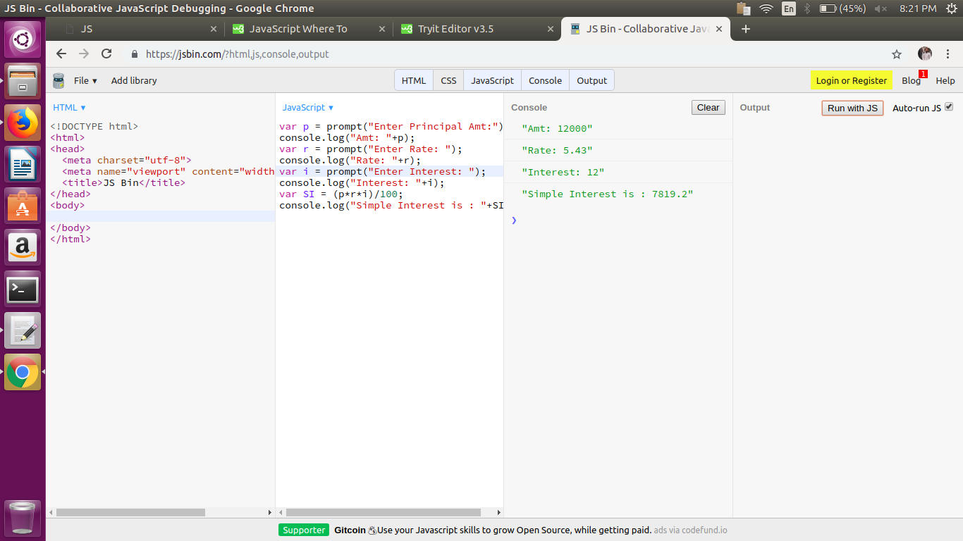
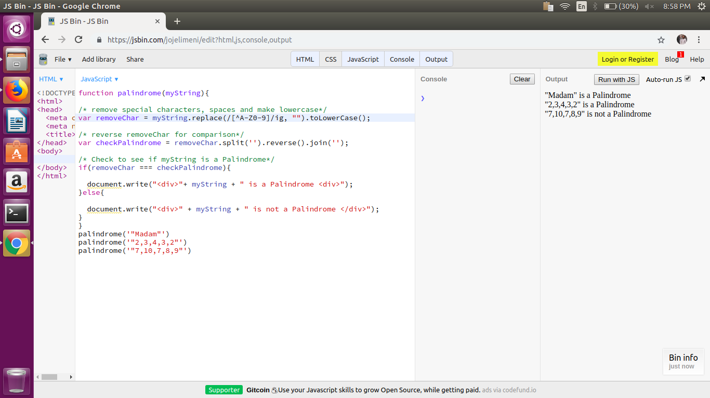
2.

3.
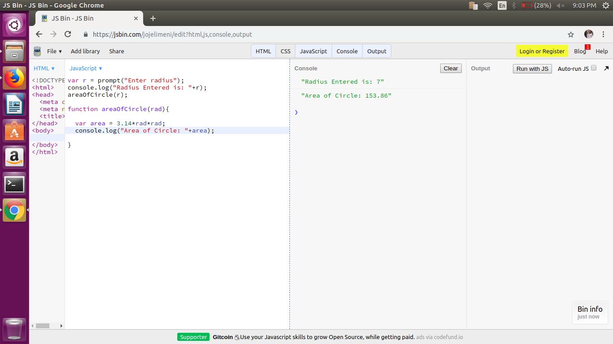

4.
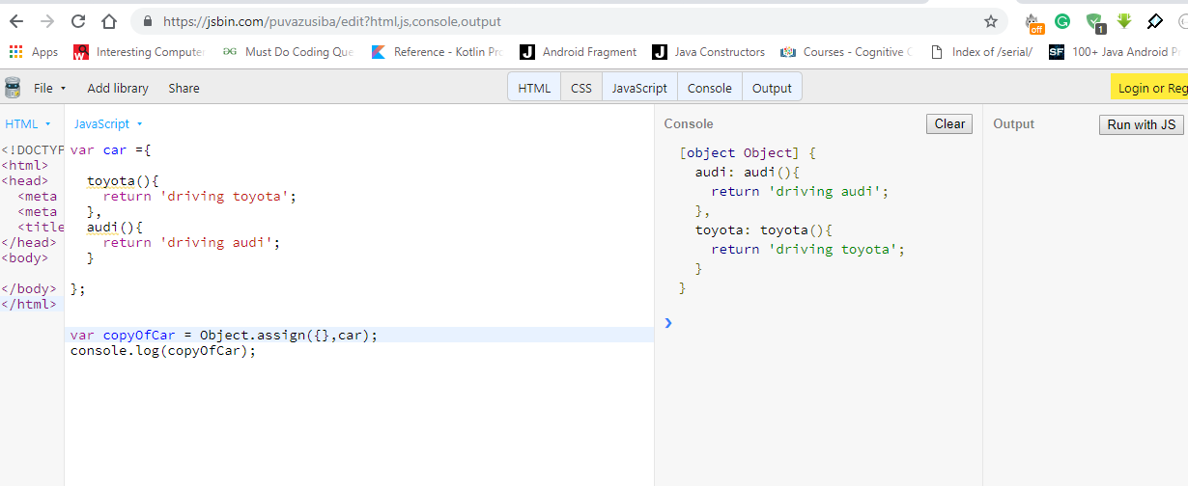

5.a
var employee=[

{name:'Divanshu',age:25,salary:4000,DOB:'1993-10-01'},
{name:'Manisha',age:28,salary:34000,DOB:'1993-10-01'},
{name:'Vaibhav',age:30,salary:30000,DOB:'1993-10-01'},
{name:'Manav',age:15,salary:43000,DOB:'1993-10-01'},
{name:'Vaima',age:20,salary:23000,DOB:'1993-10-01'},
{name:'Nivai',age:23,salary:1300,DOB:'1993-10-01'},
{name:'Dipa',age:20,salary:1400,DOB:'1993-10-01'},
{name:'Shushant',age:25,salary:1200,DOB:'1992-10-01'},

]

console.log(employee);

5.b

for(var i=0;i<employee.length;i++){

if(employee[i].salary > 5000 ){

console.log("Salary greater than 5K: "+employee[i].name+"
And Amt is : "+employee[i].salary);
}
}

5.c
for(var j=0;j<employee.length;j++){
if(employee[j].salary > 1000 && employee[j].age > 20){

employee[j].salary = employee[j].salary * 5;
console.log("New Salary : "+employee[j].salary);

console.log("---------------------------------------");

}

}

5.d

function transformArr(orig) {
var newArr = [],
employees = {},
i, j, cur;
for (i = 0, j = orig.length; i < j; i++) {
cur = orig[i];
if (!(cur.age in employees)) {
employees[cur.age] = {type: cur.age, employees: []};
newArr.push(employees[cur.age]);
}
employees[cur.age].employees.push(cur.age);
}
return newArr;
}

console.log(transformArr(employee));

