Garrett Rohde
Assignment5.2
06/28/2025
CSD310

- SUBSTRING or SUBSTR – used to extract a substring from a string
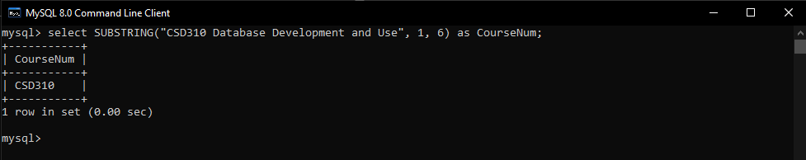
SQL Statement: select SUBSTRING("CSD310 Database Development and Use", 1, 6) as CourseNum;

- TRUNCATE – used to truncate a number without rounding to a specified number of decimal places; positive 2 keeps two decimal places to the right, negative 2 truncates to the left of the decimal place by zeroing out the digits.
select TRUNCATE(3.14159, 2) as Truncated;
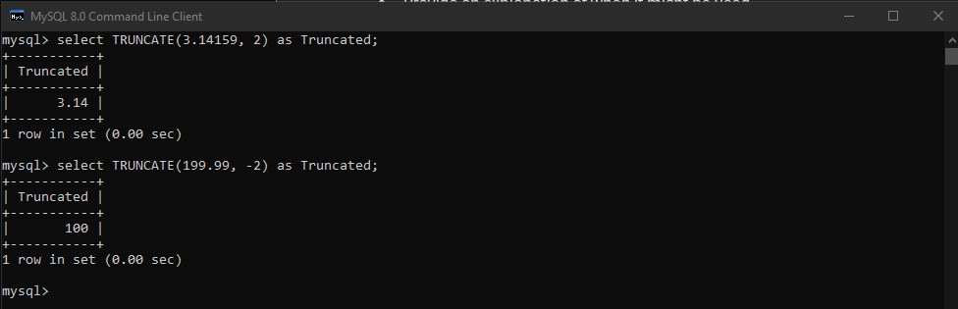
select TRUNCATE(199.99, -2) as Truncated;

- CURRENT_USER – used to find the username and hostname of the MySQL account that the server used to authenticate the current client.
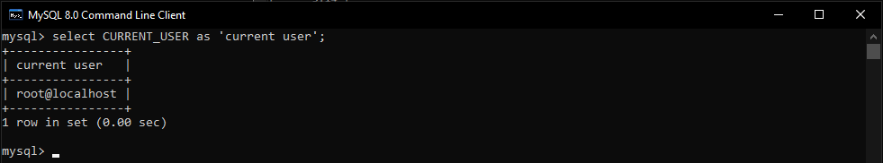
select CURRENT_USER as 'current user';

